PEACEBUILDING NATIONAL YOUTH DESIGN CHALLENGE 2026
Culture Swap Wall
Where cultures meet, story by story.
PROJECT REPORT
A safe online wall where students share small, real pieces of their culture.
Digital Peacebuilding: Bridging Cultural Divides

Prepared by Yash Abhegoda, Muzamel Tokhi and Arnold Kipletting
October 2026 · Australia

Contents
- Executive Summary
- 1. The Idea
- 2. What the Client Asked For
- 3. The Problem
- 4. What Students Told Us
- 5. Who It Is For and What It Must Do
- 6. Ideas and Choices
- 7. The Wall and the Culture Bridge
- 8. The Prototype
- 9. Testing
- 10. Safety, Ethics and Accessibility
- 11. The Plan and How We Will Measure It
- 12. Limits
- 13. What We Learned
- 14. Conclusion
- References
- Appendix A: The First Prototype
- Appendix B: Interview Guide and Comment Rubric

Executive Summary
We built the Culture Swap Wall because of something we kept seeing at school. Students talk about their culture all the time in person, but almost never online. When they do post, they get nervous. A joke can turn into a stereotype in one comment, and then the person who posted wishes they had said nothing.
Culture Swap Wall is a small, supervised website for students aged about 12 to 20. Instead of a feed, it is a wall of culture tiles. Each tile is one specific story: a greeting, a recipe, a song, a family celebration, or something ordinary such as the way a grandmother answers the phone. Every tile has a context card where the author explains what the story means and what they do not want people to assume. Visitors can search and filter, and nothing goes live until a person has reviewed it.
Our main new idea is the Culture Bridge, a three-step path after a story: Discover, Understand, Connect. A visitor reads the story, then the context, then chooses a respectful response instead of typing into an open comment box. That pause is the whole point. Most online hurt happens in the two seconds between seeing something and replying to it.
We built a first prototype and tested it informally with students, teachers and family. The feedback was useful but thin: one tester, Arnold, gave comments we recorded word for word, and other testers asked for search and more categories. We have not run a proper usability test with students yet, and Section 9 says so plainly. The next step is to test the interactive site with supervision and consent, fix what fails, and then run a small pilot with one class.

1. The Idea
Australia is one of the most culturally mixed countries in the world, and students meet that mix every day: in class, in sport, in group chats and in the comments under videos. The challenge brief describes hundreds of cultures and languages, and defines peacebuilding as more than the absence of conflict. It is “the presence of understanding, fairness, connection, and respect” (Young Change Agents [YCA], 2026a).
That definition matters. Culture Swap Wall will not stop a war or settle a long-running community argument. It works on a much smaller moment that happens all the time: a student decides whether to share something about their culture, and then someone else decides how to reply.
We chose two of the five challenge themes. The main one is Digital Peacebuilding, which asks how we can make the online world safer and more supportive for young people. The second is Bridging Cultural Divides, which is about reducing racism and prejudice through empathy and positive contact (YCA, 2026a). The two fit together: a space that feels safer is also a space where cross-cultural contact can actually happen.
The project also connects to schoolwork. The brief names Humanities and Social Sciences and English, and the Australian Curriculum describes students as both media consumers and media creators (Australian Curriculum, Assessment and Reporting Authority [ACARA], 2022). A teacher could use the wall as a writing task, a HASS inquiry into culture and identity, or a media lesson about how a platform’s design changes the way people talk to each other.
One thing we want to be clear about: this is not a museum of facts about countries, and it is not a place where one student has to represent a whole culture. Cultures are lived differently by different people. One family’s New Year story is worth reading because it is that family’s story, not because it speaks for everyone with the same background.

2. What the Client Asked For
The brief recorded the client as “Youth Agents” and listed four requirements: spread cultural ideas, find creative ways to do it, use technology, and provide a safe space for sharing culture online. It named culturally and linguistically diverse (CALD) communities, learners, school students and teachers as the audience, described the tone as “colourful, expressive”, and listed Facebook, Instagram, YouTube and Twitter as competitors.
Those requirements are a starting point, not something we can measure. “Spread cultural ideas” does not tell us what success looks like, and “safe” does not tell us who decides what safe means. So we turned each requirement into something we could check.
Table 1. Turning the brief into something we can check
What the brief asked for | What we decided that means
Spread cultural ideas through technology | A student can publish a specific cultural story in under five minutes.
Be creative and different | The wall is curated and finite, and it asks visitors to understand before they respond.
Provide a safe space | Harmful content is unlikely to reach the wall, and users can act quickly when it does.
Reach CALD communities and schools | It works for different languages, abilities and devices, not just confident users.
Warm, colourful tone | It feels welcoming without looking childish or noisy.
Keep updating | There is a content plan for the first term, so the wall is not empty.
Compete with social media | It is a better choice for one task, not a replacement for Instagram.

There are real limits. We have no budget, no engineering team, a competition deadline in early November 2026 (YCA, 2026a), and the users are minors. Adults have to moderate the content, and we cannot promise that nothing bad will ever get through. So the design stays small and supervised. Promising more than that would be dishonest.

3. The Problem
The original document described the problem in one line: social media can be full of misinformation, plus a note saying “need more”. The interviews went further. Students talked about being scared of being bullied, about stereotypes, about mean comments, about not knowing enough about other cultures, and about being nervous to post at all.
Five barriers kept coming up. Fear of judgement. Stereotyping, where a culture is flattened into a joke or one story. Bullying and offensive comments. Misunderstanding, where students did not know enough to reply well and felt embarrassed to ask. And a skills gap, which is different from not wanting to share: some students wanted to, but did not know how to describe their culture without it sounding wrong.
The interviews are small, and the original document does not record how many students took part, how they were chosen or what questions were asked. That does not make the findings wrong, but it means we treat them as strong leads, not proof. The next round of testing has to find out which students feel this way, when, and what would change it.
The wider research backs up the direction of what students said. In Mission Australia’s 2019 survey, 21 per cent of respondents aged 15–19 said they had been bullied in the past year, and 37 per cent of those said it included cyberbullying (Australian Institute of Health and Welfare [AIHW], 2021). That does not mean 37 per cent of young people are cyberbullied: the base is different, and the source is careful about it. A separate 2020 survey found that 44 per cent of 12–17-year-olds had at least one negative online experience in the previous six months, which is a wider measure that includes upsetting content (AIHW, 2021).
Culture makes the risk uneven. In longitudinal Australian data, 31 per cent of teenagers who spoke a language other than English at home reported racial discrimination between 12 and 17, compared with 19 per cent of all teenagers (Australian Institute of Family Studies [AIFS], 2021). That is discrimination in general, not online, so we do not quote it as an online figure. It still shows that cultural background changes what a young person has to deal with.
Research with young Asian Australians during the pandemic found anti-Asian content online was common for the people who answered: 36.3 per cent said “sometimes”, 15.5 per cent “often” and 5.1 per cent “all the time” (Melbourne Asia Review, 2021). That sample was self-selected and went up to age 30, so it is a signal rather than a national picture. A study of African Australian young people adds something important: Gatwiri and Moran (2023) describe young people using social media to name racism, assert identity and build belonging. They are not just victims. A platform that only protects people and never lets them speak would miss that.
So why not just use Instagram? Because general platforms are built for a different job. They earn money by keeping attention, and the easiest way to keep attention is content that gets a strong reaction. Their default is a public post with an open comment box and a like count. That is fine for a general network, but it is a bad fit for a classroom conversation about culture, where the goal is understanding, not reach.
Moderation is the second gap. Automated filters catch obvious abuse, but they are bad at context: dialect, humour, reclaimed words, cultural references. New America’s analysis of content moderation explains that hate speech is hard to detect automatically because meaning depends on community and region, and training data is uneven across languages (New America, 2019). A school needs someone who can tell the difference between a student quoting a stereotype to criticise it and a student repeating it as a joke.
The third gap is scale and relationship. Instagram cannot know that the student who left a dismissive comment sits two rows behind the student whose family celebration was mocked. A teacher can. That is the space this project is trying to use.
Four questions would sharpen all of this, and none of them needs a big study to answer. Do students avoid posting because of strangers, or because of people they know? Does a context card change what someone notices, or do people skip it? Do structured prompts produce better replies than an open box, or just shorter ones? And what would make a teacher confident enough to leave the wall running between lessons? Section 9 turns these into a test plan.
PROBLEM STATEMENT Young people, especially students from culturally and linguistically diverse backgrounds, have cultural stories they are willing to share but often choose not to, because online spaces expose them to stereotyping, mockery and hostile comments, and because they do not always have the language or confidence to describe their culture accurately. The result is a double loss: students do not see their own culture treated with respect, and they do not build the understanding of other cultures that peaceful coexistence needs.

DESIGN QUESTION How might we help young people move from seeing a culture to understanding it, and from understanding it to speaking about it respectfully, in a space where they feel safe enough to contribute?

4. What Students Told Us
Design Thinking starts with empathy, because a solution built from guesses usually solves the designer’s problem instead of the user’s. The original document describes this stage as trying to see the platform from the point of view of the people who would use it. We kept that work and added the context needed to read it.
The literature describes empathy as watching users, talking to them and putting yourself in their situation to understand needs they might not say out loud (Brown, 2008). For student designers, that does not mean pretending to know what it is like to belong to another cultural group. It means listening properly, noticing what people avoid as well as what they say, and being honest that our own view is limited.
The original document names five groups: students from different cultural backgrounds, students who are nervous about posting, students learning about other cultures, teachers, and frequent social media users. Each comes to the wall for a different reason. We added two groups that were missing: parents and caregivers, who need to know what gets published, and school leaders, who carry the duty of care. We treat those two as secondary audiences and do not base design decisions on them without evidence.
Our methods were interviews about sharing culture online, watching how people interact at events, and watching behaviour in group chats. Those are good methods for an early project: interviews give you the words people actually use, and observation shows what people do, which is not always what they say they do.
They also have limits. The original document does not record how many students were interviewed, whether they consented, what questions were asked or how notes were taken. Watching group chats raises privacy questions even when you are a member. And what we notice depends on where we are standing. A stronger version of the same methods would use a short agreed interview guide, a defined group, anonymous notes and a simple coding step that groups comments into themes.
Six insights came out of the original work. We have kept each one and added what it means for the design.
- Fear of judgement is the main barrier. Students are not worried about the technology; they are worried about the audience. So the design cuts exposure: no follower counts, no direct messages, no ranking of stories, and a plain statement of who can see what.
- Some students do not know how to share culture respectfully. That is a skills problem, not a motivation problem. Prompts, examples and a preview step do more than a warning message.
- Students want learning about culture to be fun and easy. Curiosity gets them in, so lead with a strong image or a 20-second sound, then offer depth.
- Students need a place free from bullying and offence. Safety is a precondition, not a feature. Moderation and reporting have to be visible before anyone is asked to contribute.
- Audio and images help people feel connected. Voice carries tone, accent and personality in a way text does not, so audio is a first-class format, with transcripts.
- Simple designs beat complicated ones: one clear action per screen, plain language, and enough space to breathe.
One insight deserves more space than the original document gave it. Students may want to share their culture and still not know what counts as culture. School projects reach for festivals, food and national dress, which makes everyday life invisible and pushes students to perform. That is why “Everyday Life” is a category. A family’s ordinary dinner counts, and so does the way a grandmother answers the phone. It opens the wall to students who do not have a spectacular story.
The empathy work changed the project in three ways. It moved the design from a general culture platform to a safety-first space for one kind of sharing: small, contextual and written by the author. It added features that exist only because students said they were afraid. And it changed the main question from “how do we get students to post?” to “what would make posting feel worth the risk?”
The second question is harder, because no feature list answers it. The site has to earn trust: say who can see a story, show what happens after a report, and prove that the adults in the space will act. Our prototype tested whether the wall looked warm. The next test has to find out whether it feels safe enough to use.

5. Who It Is For and What It Must Do
The Define stage turns all of that into a target. The original document moves from the broad problem to a list of requirements: the platform must be safe, must have rules, must be easy to use, must be fun and visual, must encourage kindness and must celebrate cultures. Those are qualities, not features, which makes them a good starting point and a bad test plan.
Our main users are secondary students aged about 12 to 16 who have a cultural story they might share and who are not confident it will be safe. They need four things: safety from mockery, control over how their culture is shown, a low-effort way to contribute, and a reason to expect curiosity instead of judgement. The barriers are the ones in Section 3: fear, limited knowledge, not knowing what to say, and platforms designed for attention.
Six criteria came out of that, and each one has a test. If we cannot test a criterion, it is just a slogan.
Table 2. Design criteria and how we would check them
What good looks like | How we would check it
Harmful content is unlikely to reach the wall, and users can act quickly when it does. | Moderation log; number and resolution time of reports; perceived-safety ratings.
Community rules are visible, specific and applied the same way every time. | Comprehension check with users; consistency audit of moderator decisions.
A first-time visitor can find and open a story without instructions. | Task success rate and time on task; watching someone use it for the first time.
The wall invites exploration and feels good to use. | Short engagement and enjoyment ratings; interview comments.
The interface asks for a respectful response before it allows a reaction. | Comment quality against a rubric; how many responses add a question or context.
Stories are specific and presented as one person’s experience. | Content audit for specificity and consent; feedback from cultural advisers.

The criteria fight each other, and those fights are design decisions. Safety pulls against openness: every rule blocks some harmful speech and some legitimate speech. Ease pulls against depth: a context card that really explains a celebration takes longer to read than a caption. Fun pulls against seriousness: the wall should feel warm without turning culture into entertainment. We settled those arguments the same way each time. Safety and understanding beat reach and speed, because that is the whole reason the project exists.
Five principles follow. They are the tests we keep coming back to.
- Safety before sharing. Nobody should have to choose between taking part and feeling safe. If a feature makes sharing easier and exposure worse, it is out.
- Context before comment. The story has to be clear before the interface asks for a reaction.
- People decide the hard cases. Automation can sort, but a person who knows the context should make the call.
- Small is a feature. A class-sized wall is easier to moderate, more likely to feel safe and realistic to keep going.
- Accessible by default. If it does not work for the least confident user, it does not work.
This matters for peacebuilding because it decides what the site is for. If the goal were engagement, we would optimise for time on site and reactions. If the goal is understanding, we optimise for context, reflection and respectful exchange, even when that means fewer interactions. That choice sets everything else.

6. Ideas and Choices
The Ideate stage produced more ideas than we could use. The original document records five techniques: Crazy 8s, mind mapping, asking “How might we…?” questions, sketching, and group brainstorming. It then lists fourteen ideas and six final choices. We kept that process visible and added the reasoning for what we cut.
Crazy 8s is a timed sketch sprint: fold a page into eight boxes and draw eight different solutions in eight minutes. The point is not good drawings. It is that the obvious ideas run out fast, so less obvious ones appear. Mind mapping goes the other way, starting from “sharing culture” and branching into formats, audiences, barriers and feelings. Group brainstorming adds ideas one person would never reach alone.
The original document records five “How might we” questions: make sharing culture fun, stop mean posts, encourage kindness, make culture easy to explore, and use audio to help people connect. The last one is narrower than the rest because it already contains its answer. The challenge guidance says a “How might we” question should not include the solution, because that closes off other options (YCA, 2026a). A better version is: how might we help people feel a culture’s atmosphere, not just read about it? Audio then becomes one answer next to video, soundscapes, recipes and object stories. The question sets the size of the answer.
The fourteen ideas fall into four groups, and naming the groups made the choices easier to defend.
Table 3. Ideas from the ideation stage, grouped by purpose
Purpose | Ideas | Why it matters
Make culture visible and explorable | Culture tiles, pop-up stories, interactive map, daily spotlight, random generator, celebration calendar | Gives a visitor somewhere to start and makes exploring feel like walking through a mural, not scrolling a feed.
Carry tone and personality | Audio greetings, audio player for cultural sounds | Voice, accent and music say things text cannot, and audio lowers the pressure to write perfect English.
Support specific kinds of story | Food stories, gallery for art and clothing | Gives shape to contributions and shows that everyday culture belongs here, not just festivals.
Keep the space safe | Upload filters, report button, moderator queue, kindness reminder | Stops what it can before it reaches the wall, and gives people a clear next step when it does not.

Here is what happened to all fourteen ideas, so nothing disappears without a reason.
Table 4. Every idea and what happened to it
Idea | What happened | Why
Grid of culture tiles | Built | The core unit, and strong on every criterion.
Pop-up story with comments | Built, comments replaced | Keeps your place on the wall; the comment box became the Culture Bridge.
Audio greetings | Built | Adds voice and lowers the pressure to write perfect English.
Audio player for cultural sounds | Merged into the tile | One player inside the story is simpler than a separate page.
Food stories section | Kept as a category | Food is a strong way in, but it does not need its own site.
Gallery for art and clothing | Partly kept | Images are central; clothing raises consent and ownership questions.
Safe upload filters | Built, server-side needed | Useful, but not enough on its own.
Report button | Built | Core safety control, but it needs a workflow behind it.
Moderator queue | Built as a demo | Essential for a supervised space.
Kindness reminder | Built | Cheap to add, and testers responded well to it.
Interactive map of cultures | Delayed to phase 2 | Hard to represent cultures and diaspora fairly; accessibility cost.
Daily spotlight | Delayed to phase 2 | Needs a content pipeline and moderation capacity first.
Random culture generator | Delayed to phase 2 | Fun, but adds little until the wall has depth.
Celebration calendar | Delayed to phase 2 | Useful for classrooms, but dates need local, accurate review.

Two things stood out. First, the original ideas are strong on looking and weak on replying. Most of them help a visitor look at culture; only the comment box, which was implied rather than designed, helps them answer it. That gap is why the Culture Bridge exists. Second, every safety idea is procedural: filters, reports, queues, reminders. Procedures are necessary, but they do not teach anyone how to speak. A platform that only blocks bad behaviour assumes people already know what good behaviour looks like.
The list also shows how much was cut. Ten of the fourteen ideas are built, kept or merged into another feature, and four are delayed to a second phase. Nothing was dropped without a reason, and most cuts came down to what a small team can actually moderate and maintain.
Six features made the cut in the original document: culture tiles, image and audio support, moderation, a report button, a kindness reminder, and six categories. The choices were sound, but the document never explained what was dropped. The matrix below rates each candidate from 1 (weak) to 3 (strong) on six criteria. The ratings are our judgement, not measurements, and another designer could score them differently.
Table 5. Feature-selection matrix (1 = weak, 3 = strong; our judgement)
Feature | Peace | Safety | Ease | Feasible | Access | Different | Decision
Culture tiles with context cards | 3 | 3 | 3 | 3 | 3 | 3 | Build
Images and audio with transcripts | 3 | 2 | 2 | 3 | 2 | 3 | Build
Category filters and search | 2 | 3 | 3 | 3 | 3 | 2 | Build
Human moderation and reporting | 3 | 3 | 2 | 2 | 3 | 3 | Build
Kindness reminder and response prompts | 3 | 3 | 3 | 3 | 3 | 3 | Build
Culture Bridge sequence | 3 | 3 | 2 | 3 | 2 | 3 | Build
Interactive map of cultures | 2 | 2 | 2 | 1 | 1 | 3 | Later
Open comments and public likes | 2 | 1 | 3 | 3 | 2 | 1 | Reject

The result is clear. The top features do more than one job: tiles with context support discovery, safety and understanding at once, and response prompts support kindness and peacebuilding together. The map scores low on feasibility and accessibility, and not because it is a bad idea. A map raises hard questions: cultures do not fit inside borders, diasporic communities would appear in the “wrong” place, and a political map suggests a culture belongs to a state. So it is delayed to a second phase, where it can become a culture atlas.
We rejected open comments and public likes. Both are normal on social media, and both recreate the conditions we are trying to change. An open box rewards the fastest reply, not the most thoughtful one. Likes turn culture into a competition with a number attached. The wall keeps a private count for moderators only, so the team can see if the space is being used without turning culture into a score.

7. The Wall and the Culture Bridge
Culture Swap Wall is a curated wall of cultural stories. A visitor lands on a grid of tiles. Each tile has an image, a short title, a category and the name or pseudonym of the person who shared it. Opening one shows the story, its context and, if the author recorded it, audio. Search and category filters sit above the wall. From any story, a visitor can move to a respectful response. Nothing publishes without a person reviewing it.
The concept comes from our first prototype, not from nowhere. The tile grid, pop-up story, categories, audio, report button and kindness reminder all came from the original design. What we added is an answer to the question the prototype left open: after someone reads a story, what should they do next? The prototype had a comment box. This design replaces it.
A tile is deliberately small: an image, or a colour block if the author does not want to use a photo, a title of eight words or fewer, a category, and a one-line invitation such as “A sound from my grandmother’s kitchen”. Opening it shows four things.
- The story. Two to five sentences in the author’s own words, written against prompts instead of a blank box.
- The context card. What the story means, written or approved by the author, including what they want people to understand and what they do not want assumed.
- The media. An image with alt text, plus optional audio with a transcript. Audio stops at 60 seconds so the form stays quick to fill in and the wall stays quick to browse.
- The response area. A few respectful prompts and a report control. No open comment field and no public likes.
The context card is the most important part, because it is where the wall stops being a feed. A photo of a dish with no context invites you to consume it. A card that says who makes it, when, and what it means turns the same photo into an invitation to understand. It also protects the author, because they set the terms before anyone else replies.
Here is what a finished tile would look like. The example is made up for this report, so it shows the fields rather than a real student’s story.
Table 6. A tile, field by field (illustrative example)
Part of the tile | What the author fills in
Title (eight words max) | “Saturday morning tea”
Category | Food
The story | “Every Saturday my dad makes tea the way his mum did, with too much sugar and the same chipped pot. Nobody else in our street does it like this. I used to think it was a bit embarrassing. Now I think it is the best part of the week.”
Context card | “This is my family’s version, not the only one. Other families make it with milk, or with spices, or not at all.”
What I do not want assumed | “That everyone from my background drinks tea like this, or that this is a tradition from one country.”
Media | A photo of the pot, plus 20 seconds of the pour, with a transcript.

That example shows why the context card matters. Without it, the photo is just a pot of tea. With it, a visitor knows what to notice and what not to assume.
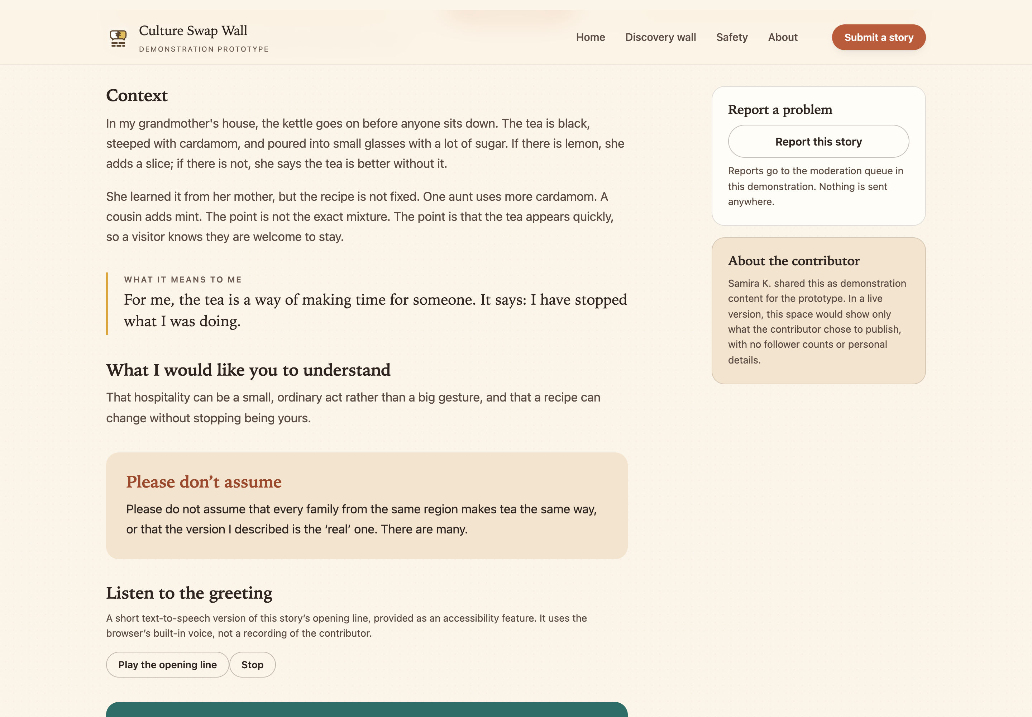
Figure 1. A story page: the context, what the story means to its author, and what they would rather you did not assume.
The Culture Bridge is a three-step path a visitor can choose after opening a story. It is the main new idea in this report, and we have not tested it with users yet. Its job is to make the move from seeing to speaking deliberate, and to give someone who does not know what to say a respectful way to say something.
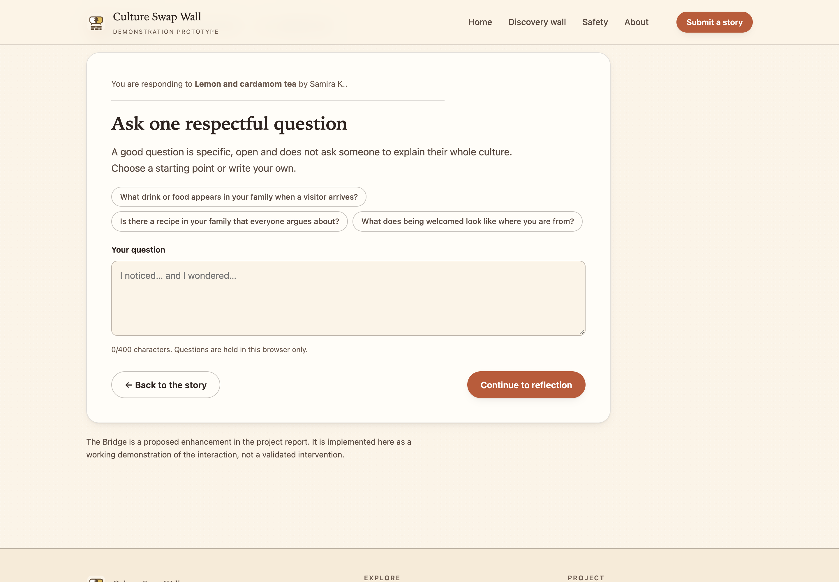
Figure 2. The Culture Bridge: ask one respectful question, reflect, then connect.

8. The Prototype
We built a first version of the website to see how people would use it. The original document lists what it had: a grid of culture tiles, a pop-up with images and audio, an upload form, a word filter, a moderator queue, a report button, placeholder images and audio, and soft colours. Under the working title “CultureShare” it had a navigation bar, a hero section, featured stories and a story view with comments. Appendix A records what it contained and what changed. It is a useful record of the idea early on, and it also shows how much of the safety plan was still a promise rather than something you could click.
The main metaphor is a wall, not a feed. Tiles sit in a grid that looks like a mural: different sizes, warm colours, images, short titles. The grid is finite and grouped by category, so you can see the whole collection instead of scrolling forever. Opening a tile shows a pop-up rather than a new page, which keeps your place on the wall. There is always a close button. A pop-up you cannot escape is bad design, and for some people it is genuinely distressing.
The upload form asks for a title, a category, a short story, an image and optional audio, then shows a preview before anything is sent. The preview is not decoration. It lets the author see their story the way other people will, and that is when a lot of people decide to remove a detail they are not comfortable sharing. The form also asks what the story means and what the author wants people to understand. That question is what turns an upload into a tile.
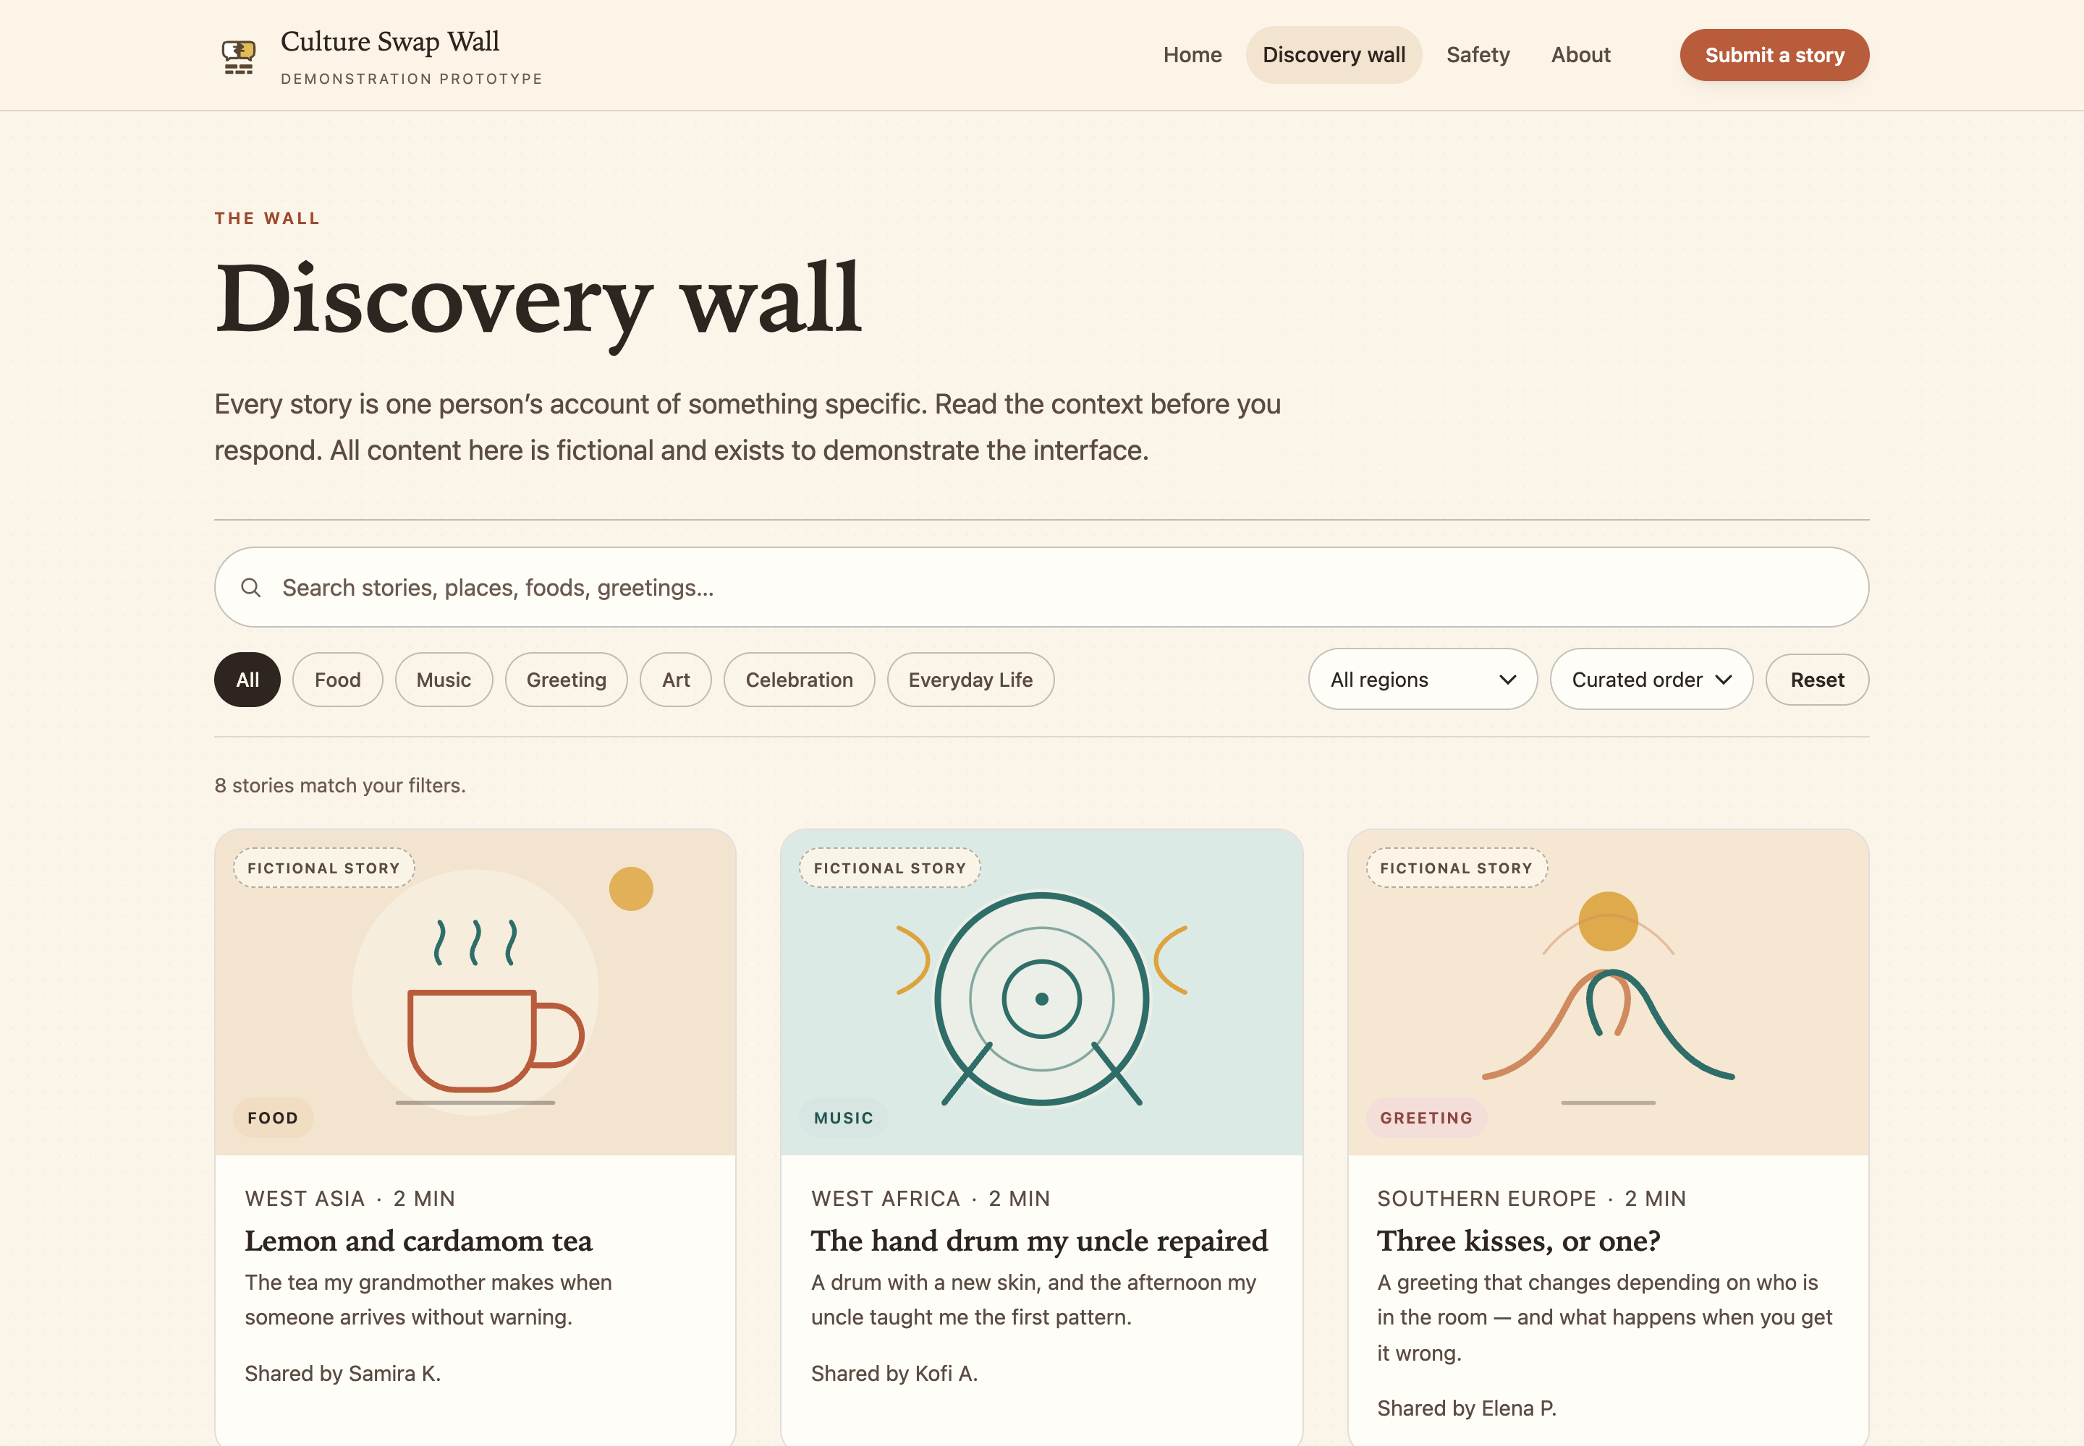
Figure 3. The discovery wall: search, categories and a finite, curated grid of story tiles.
A wall is not a social network, but students will compare it with one, so we wrote the comparison down. Instagram is built for reach, so it rewards speed, volume and reaction; the wall is built for understanding, so it rewards context, reading and a considered reply. Both can host a story about a family recipe. Only one of them is designed so that a nervous 13-year-old can post it without bracing for the comments.
So the value is not a feature someone could copy in a week. It is the combination: a finite, curated collection, an interaction designed for understanding, and real moderation inside a school. Each part is small. Together they set a different deal: the wall is not trying to make students post more, it is trying to make the posts that do happen worth reading.
There are four ways we think this could support peacebuilding. We call them mechanisms, but they are hypotheses.
- Perspective-taking. The context card and the “what did you assume?” prompt ask a visitor to imagine the author’s point of view.
- Positive contact. The prompts create a structured, low-stakes exchange between people who might not otherwise speak. The digital contact research says this can reduce prejudice on average, with small effects (da Costa et al., 2024).
- Clear norms. Visible rules, kindness reminders and consistent moderation show what is normal here. Norms are one of the things that make school cyberbullying programmes work, along with skills and clear consequences (Gaffney et al., 2019).
- Speaking for yourself. Letting students describe their own culture answers the experience of being talked about. Gatwiri and Moran (2023) show young people already use social media to assert identity; the wall tries to make that easier to do safely.
None of that is proof. Plausible mechanisms are not evidence that this site produces those outcomes, which is why Sections 9 and 11 set out how we would test them.

9. Testing
The first test was a small, informal round with Arnold, a student who used the prototype and gave feedback that we recorded word for word, along with comments from other testers, teachers and family. It was not a usability test. There was no script, no defined tasks, no scoring and no second observer. What it could tell us was whether the wall felt warm, whether the idea made sense, and whether anything was obviously broken. It could not tell us whether someone outside a culture would understand the audio greetings, or whether the site works with a screen reader. Those need different methods and different people. One friendly tester is a start, not a validation.
The five changes that mattered most are below. The table links each one to what caused it.
Table 7. What changed after the first test, and why
Change | What caused it | What it shows
Larger tiles and text | Testers found the grid dense and the text small. | Readability and touch accuracy, especially for younger users.
Stronger colour contrast | Text was hard to read on some warm backgrounds. | Warm palettes often fail contrast checks; this one needed fixing.
Report button on every tile | People wanted a way to act on harmful content. | A report control is a promise that someone will respond, so it needs a workflow behind it.
Close button on the pop-up | People felt trapped in the story view. | A basic usability fix, and a dignity issue for anyone who gets upset.
More categories and search | Testers said six categories felt limiting. | Categories are how people find stories, and they signal that everyday culture is welcome.

Two of those matter more than the rest. The report button changes the deal between the platform and the user: it says harmful content is not your job to put up with. The close button looks small and is not. Someone who cannot exit a story may feel trapped, which makes it an accessibility problem and a safety one at the same time.
The original document describes the cycle in our own words: we made a prototype, tested it, improved it, tested it again and then made this version. That is the right shape for Design Thinking, and the changes above show it happened. The second test is not documented in detail, so we describe this as one documented round plus a refinement, not two separate rounds of evidence.
The next round needs to test three things the first one could not: whether people can use it without help, whether the Culture Bridge produces better responses than an open comment box, and whether it works with assistive technology. The plan below is proposed, and it has not run yet.
Table 8. Planned testing sessions
Session | Who | What they do | What we record | What would count as working
Usability | 5–8 students aged 12–16, at least two new to it | Find a story in a named category, open it, find the context card, submit a practice story. | Task success, time on task, think-aloud notes, difficulty rating. | Most people finish without help; no critical errors.
Safety and reply quality | 2 groups of 4–6 students, one with comments and one with the Bridge | Read the same three stories and reply normally, then rate how safe it felt. | Comment quality against a rubric, safety ratings, short interviews. | Bridge replies include more questions and fewer judgements; no rise in discomfort.
Accessibility | 2–3 people using a screen reader, keyboard or magnification | Navigate the wall, open a story, play audio, submit a form. | Barrier log, WCAG 2.2 AA checklist, comments. | All core tasks possible; no blocking barriers.

Each session needs a teacher present, a quiet room and a clear statement that anyone can stop. Practice stories stay fictional, and nobody is asked to hand over personal cultural material to the research. Notes are anonymised before analysis. If someone gets upset, the session stops and the school’s wellbeing process takes over. That is not paperwork; it is the difference between testing a design and putting young people through the thing the design is supposed to prevent.

10. Safety, Ethics and Accessibility
Safety is the first criterion and the easiest one to overstate. No platform can promise that a young person will not be hurt. What it can do is make harm less likely, shorten it when it happens, support the person affected, and learn from it.
The design uses four layers instead of one filter. That matches eSafety’s Safety by Design guidance, which says safety should be built in from the start rather than added after something goes wrong (eSafety Commissioner, n.d.). Prevention is the rules, the response prompts, no direct messages and no public popularity numbers. Detection is the automated check, user reports and moderator review. Response is hiding content, contacting the author, supporting the person affected and escalating to the school. Learning is looking at reports for patterns and changing the rules that are not working.
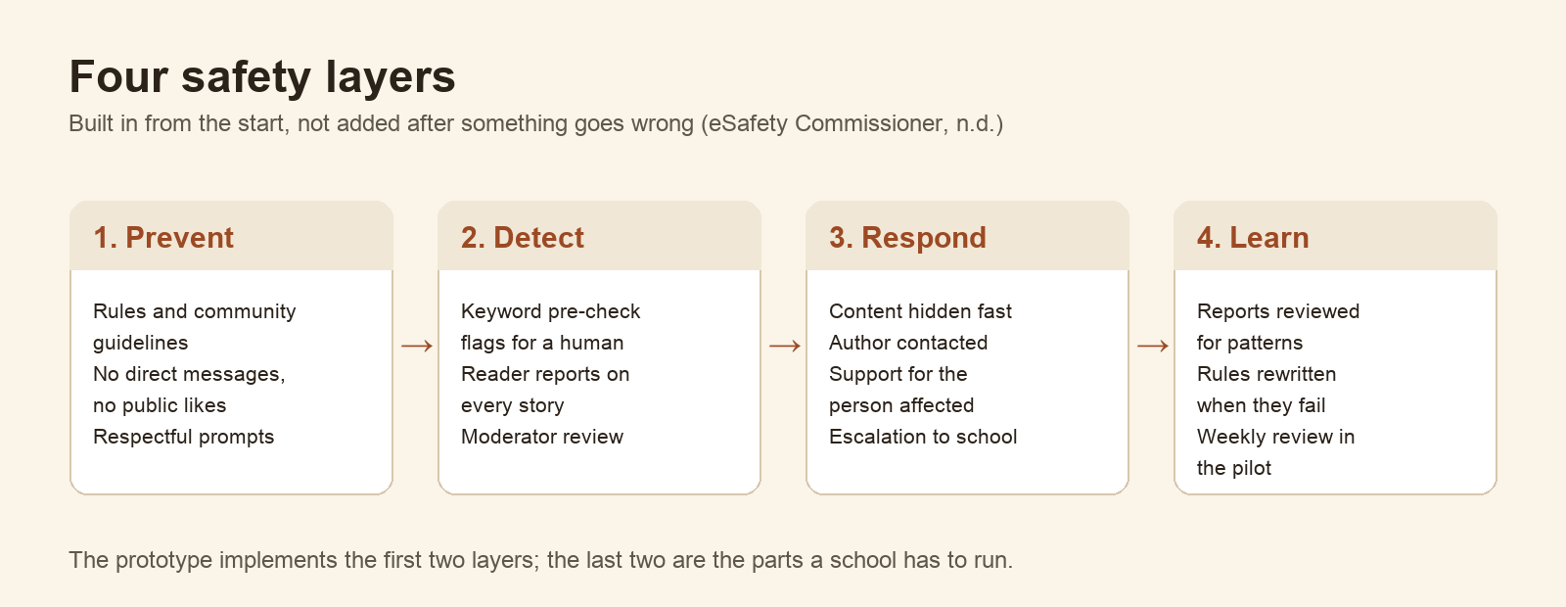
Figure 4. Four safety layers: prevent, detect, respond, learn.
Automated filters are not moderation. A keyword list misses context, sarcasm, coded language and images, and it over-blocks ordinary discussion of racism or identity. In the prototype the filter only raises a warning for a person to read; the decision always belongs to a human. That is also why the site has no automatic publishing, no open comments, no direct messages and no like counts. Each of those is easy to add and hard to make safe.
Consent is treated as a process, not a checkbox. Contributors can only share their own experience or one they have permission to describe, cannot publish identifiable images or audio of other people without consent, and cannot share restricted or sacred knowledge that is not theirs. Recipes and songs can belong to families or communities rather than individuals, which is why the form asks about permission rather than authorship alone.
Privacy is deliberately minimal. A live version would store a display name, a passwordless sign-in, the story and a moderation record. No location tracking, no contact imports and no advertising identifiers. Contributors could withdraw a story at any time, and withdrawn stories would be purged from backups on a published schedule.
Accessibility is not a separate feature; it is a set of decisions across the interface. The target is WCAG 2.2 Level AA: keyboard operation for every control, visible focus, text alternatives for images, transcripts for audio, 4.5:1 contrast for body text, resizable text and reduced-motion support. The wall uses a regional board rather than a geographic map, because precise pins are hard to use with a keyboard or screen reader and imply a false precision about where a culture belongs.
First Nations content needs its own protocols. Aboriginal and Torres Strait Islander communities have diverse rules about images, names and knowledge, and folding them into a generic “Indigenous” tile would repeat the flattening this project is trying to avoid. The prototype contains no First Nations stories, because doing that responsibly needs consultation we have not yet undertaken.
None of this makes the wall safe by itself. What it does is make the promises specific enough to test, and small enough to keep.

11. The Plan and How We Will Measure It
The plan has three phases. Phase 1 is readiness: write the moderation guidelines, recruit two teacher moderators, prepare twelve seed stories with author permission, and finish the accessibility pass. Phase 2 is testing: run the three sessions in Table 8, fix what fails, and rewrite any rule that testers found confusing. Phase 3 is a supervised pilot with one class for four weeks, with a teacher present, a weekly review of reports and a stop rule if a serious incident occurs.
We are deliberately not scaling before the pilot. A wall that is hard to moderate does not become easier with more users, and a cultural story that is mishandled once can cost a student more than the project is worth.
Measurement follows the criteria in Table 2. The indicators below are the ones we would report, and none of them has a baseline yet.
Table 9. Impact framework (planned, not measured)
Activity | Output | Short-term outcome | Indicator and method
Publish and browse stories | Stories with context and assumptions | Recognition that a practice is specific, not generic | Pre/post response to a scenario; coded reflections
Complete the Bridge | One question and one reflection per story | Greater confidence in asking respectful questions | Self-report scale plus quality of written question
Moderation and reporting | Reviewed stories and resolved reports | Users perceive the space as safe | Perceived-safety survey; report resolution time
Accessibility design | Keyboard and screen-reader operable interface | Users with disabilities can participate equally | WCAG 2.2 AA audit; tasks with assistive technology

Three numbers would tell us whether phase 3 worked: the share of sessions where a student completed the Bridge without help, the share of Bridge responses that include a question or a piece of context rather than a judgement, and the median time to resolve a report. A website cannot be shown to reduce racism. The realistic claim is narrower: it can increase the frequency and quality of one respectful intercultural exchange, and it can be evaluated on that.

12. Limits
- The evidence is thin. One recorded feedback cycle, a small and unrecorded group of interviewees, and no controlled comparison. The findings are leads, not proof.
- The Culture Bridge is untested. It is the central idea in this report, and no student has yet used it in a study. Everything we say about it is a hypothesis.
- There is no live service. The prototype has no accounts, uploads, email, database or real moderation, and everything stays in one browser.
- Content is fictional. The eight demonstration stories are written to show the interface, not to represent any community, and must not be cited as evidence.
- Moderation is simulated. The keyword check is a short list used to show that filters flag for humans rather than decide.
- Accessibility is targeted, not certified. There has been no screen-reader testing and no independent audit.
- We are a student team with no budget, and the timeline is set by a competition deadline rather than by what the work needs.

13. What We Learned
The biggest lesson is that the interesting design work happened after the features. The first prototype was a reasonable list of things a culture site could do. It became a peacebuilding project when we started removing things: open comments, public likes, follower counts, and a map that looked impressive and explained nothing. Every removal made the remaining interaction easier to defend.
The second lesson is about evidence. It is easy to write a report that sounds certain. We had one recorded conversation and a lot of reading, so we tried to say what we knew, what we assumed and what we still had to test. That made the report less impressive and more useful, and it set the agenda for the next phase.
The third lesson is about working as a team. Splitting the research, the prototyping and the writing meant each part was challenged by someone who had not built it, which caught problems we would have missed alone, including the assumption that a shared culture means a shared story.

14. Conclusion
Culture Swap Wall is a small answer to a small moment: a student deciding whether to share something real about their culture, and another student deciding how to respond. The design puts context before comment, replaces the open reply box with a guided path, and keeps a human in the loop before anything is published.
What we have is a tested-in-form prototype, a documented design process, and an honest account of what is still unproven. What we do not have is evidence that it changes behaviour. The next step is the pilot described in Section 11: a class-sized wall, supervised by teachers, measured on whether students can cross the Bridge without help and whether the replies they write are worth reading. If it fails that test, the idea should change rather than the standard.

References
Australian Curriculum, Assessment and Reporting Authority. (2022). The Australian Curriculum: English and Humanities and Social Sciences. ACARA.
Australian Institute of Family Studies. (2021). Longitudinal Study of Australian Children: Experiences of racial discrimination in adolescence. AIFS.
Australian Institute of Health and Welfare. (2021). Australia’s youth: Bullying and negative online experiences. AIHW.
Brown, T. (2008). Design thinking. Harvard Business Review, 86(6), 84–92.
da Costa, S., Bousfield, C., & colleagues. (2024). Digital intergroup contact and prejudice reduction: A meta-analysis.
eSafety Commissioner. (n.d.). Safety by Design. Australian Government.
Gaffney, H., Ttofi, M. M., & Farrington, D. P. (2019). Evaluating the effectiveness of school-bullying prevention programs: An updated meta-analytical review. Aggression and Violent Behavior, 45, 111–133.
Gatwiri, K., & Moran, C. (2023). Social media as a site of resistance: African Australian young people naming racism and building belonging.
Melbourne Asia Review. (2021). Anti-Asian racism online during the COVID-19 pandemic: Survey findings.
New America. (2019). Content moderation and hate speech: Why context is the hard problem.
Young Change Agents. (2026a). Peacebuilding National Youth Design Challenge: Brief and design guidance.

Appendix A: From the First Prototype to This Version
The first build used the working title “CultureShare” and demonstrated the core idea before the Culture Bridge existed. It had a navigation bar, a hero section with featured stories, a grid of tiles and a story view with an open comment box. The safety plan was described in the interface rather than enforced by it, which is the main difference between that version and the prototype described in Sections 7 and 8.
Table A1. What changed between the first build and this version
Element | First build | This version | Why it changed
Response to a story | Open comment box | Culture Bridge: question, reflection, connection | An open box rewards the fastest reply; the Bridge asks for context first.
Safety | Described in the interface | Pre-check, report control and a human review step | A promise in the copy is not a control.
Discovery | One long grid | Search, categories and a finite curated wall | Testers found the grid dense and hard to navigate.
Context | Caption under an image | A context card with meaning and assumptions | A caption explains the photo; the card explains the practice.
Audio | Separate audio page | Optional audio inside the story, with a transcript | One player is simpler and keeps the story in one place.

Appendix B: Interview Guide and Comment Rubric
These are the instruments we would use in the next round of testing. They exist because the first round had no script, which is the main reason its findings are leads rather than results.

Interview guide (20 minutes, one student at a time)
- Have you ever posted something about your culture online? What happened?
- What would make you decide not to post something?
- When you see a cultural story from someone else, what do you usually want to do next?
- What would you want a reader to know before they reply to your story?
- Is there anything about culture that school projects always get wrong?
- If this wall existed in your school, who would you want to be allowed to see your story?
Notes are taken anonymously, with no names and no identifying details, and coding groups answers into the six insight categories in Section 4 plus any new category that appears at least three times.

Comment rubric (for comparing Bridge replies with open comments)
Table B1. Coding rubric for reply quality
Criterion | 0 | 1 | 2
Adds context | Not present | A general reference | Names a specific detail from the story
Asks a question | No question | A closed question | An open question about the practice, not the whole culture
Judgement | Judges or generalises | Neutral but empty | Describes the reader’s own assumption
Tone | Hostile or mocking | Flat | Warm and specific

Two researchers code each reply independently, and disagreements are resolved before the scores are compared. The rubric measures the quality of a written reply, not the character of the student who wrote it.

