**Analyzing Customer Churn: A Key to Success for Telco Companies**

**INTRODUCTION**

In the highly competitive telecommunications market, understanding customer behavior is crucial for maintaining a thriving business. Customer churn, the rate at which customers leave a service, can significantly impact a company's bottom line. Analyzing churn data provides valuable insights that can help telco companies retain customers and foster long-term success. In this article, we will explore how to analyze customer churn datasets, the key insights it offers, and the strategies to reduce churn.

**Key Concepts**

* Importance of Churn Analysis
* Understanding Churn Reasons
* Improving Customer Retention
* Enhancing Customer Satisfaction
* Driving Long-Term Success
* Revenue Protection
* Fostering Customer Loyalty
* Ensuring Sustainability

**Performing Detailed Analysis**



This query will show what are the avg monthly charges of customers who has churned and what was their age, gender and what was the contract type.

**Result**

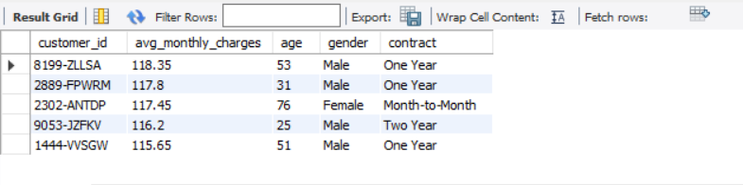

60% of the churned customers are older, indicating that age may play a role in retention strategies. A significant portion of the churned customers are male, which could inform targeted marketing efforts. Many churned customers were on One Year contract, suggesting a need for incentives to encourage renewals or upgrades. They should be provided with better incentives and deals so then the retention of customers can be improved.

**Performing Detailed Analysis**

This query indicates the churn reasons of customers.

**Result**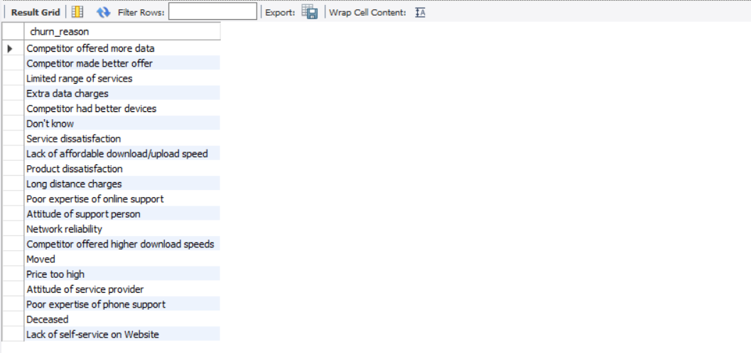

This result show number of the churn reasons of the customers. Most of them churned because competitor had better devices, highlighting the importance of product offerings. The second reason is Competitor made better offer, indicates company should provide customers with many and better offers.

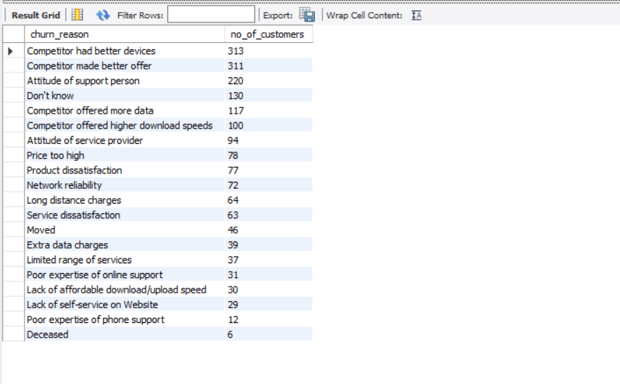

**Performing Detailed Analysis**



This query will show the number of customers using which payment method.

**Result**

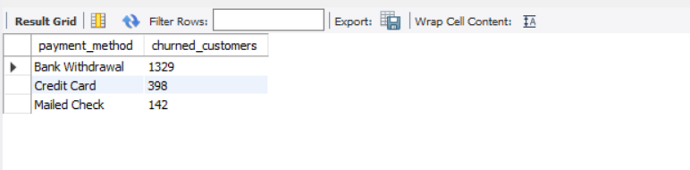

1,329 customers who churned used the Bank Withdrawal payment method, while those who paid with a Credit Card came in second.

**Strategies to Reduce Churn**

Based on the insights gained from the analysis, telco companies can implement several strategies:

1. **Tailored Retention Campaigns**: Target customers identified as high risk of churning with personalized offers or incentives.
2. **Improve Service Quality**: Address common pain points leading to churn, such as service interruptions or customer service responsiveness.
3. **Flexible Payment Options**: To enhance customer satisfaction, consider offering more payment methods or discounts for long-term commitments.
4. **Regular Engagement**: Maintain ongoing communication with customers to keep them engaged and informed about new services or changes.

**Conclusion**

Analyzing customer churn data is essential for telecommunications companies aiming to thrive in a competitive market. By understanding the reasons behind churn and implementing targeted strategies, companies can improve customer retention, enhance customer satisfaction, and ultimately drive long-term success. Leveraging insights from churn analysis not only protects revenue but also fosters a loyal customer base, ensuring a sustainable future in the telecommunications industry.