ORIC FAST-NUCES
Message from Director Office of Research, Innovation and Commercialization (ORIC)


At FAST—NUCES, the Office of Research, I nn ovati on & Co m me rci ali zati on (ORIC) drives our commitment to research excellence, innovation, and im pactfu I chan ge. I n a sw ift ly advancing world, we believe in the transformative power of research-d r i v e n s o I u t i o n s , i n d u s t r y collaborations, and knowledge that ad d resses real-wo rid challenges. ORIC is more than an office — it is a dynam ic ecosystem that i nspires lac u lty, stu d e nts, and indu stry partners to dream big, search the unknown, and turn creative ideas into existence.

Our focus is threefold: to increase research quality, encourage a culture of innovation, and create pathways for commercialization. Over the years, 0 RI C ha s cu lti vate d a th riv in g e nviro n ment of inte rd isciplin ary co llab oratio n, b rin gin g to gethe r diverse minds to tackle intricate challenges and develop progress across fields of science, technology, engineeri ng, manageme nt, social sciences, and humanities.
What sets ORIC apart is its ability to link academia and industry. We take p ride i n o ur collaborations with leading industries, global institutions, and research organizations, enabling a continuous exchange of knowledge, re s o u re e s, a n d o p p o rt u n it i e s. Through these collaborations, we equip our researchers and students w ith th e to o is a nd men tors h i p needed to thrive in a competitive, innovation-d riven world.
0 RI C's i m pact exte nd s b eyo nd research and innovation. It's about building a legacy of excellence, where ideas are encouraged to their fullest potential. It's about empowering the next generation of thinkers, creators, and leaders who will shape the future of Pakistan and beyond. It's about

Prospectus 2025
adopting a culture where novelty is honoured, tasks are supported, and co lla boratio n is at the heart of everything we do.
As we look ahead, ORIC remains persistent in its dedication to steering innovation, research excellence, and societal impact. We invite you to join us on this stimulating journey — a journey where ideas come to life, innovation knows no bounds, and the future is shaped by passionate individuals. Together, let's unlock the vast potential within our community and pave the way for a brighter, more innovative future.
Dr Muhammad AsifNaeem

Director
Office of Research, lnnovation and Commercialization

Overview
The University, true to the innovative spirit of its founders, is alive to the cause of research and development. The breadth, depth and assortment of research activities in the university have contributed to the nation al socio - economic stream through technological pursuits.

ORIC is established to channelize re s ea r h a n d i n n o v a t i o n ie d i n i t i a t I V e s. I t offe rs s e rv i ces
c o n n e c t e d t o r e s e a r c h a n d
d e v e I o p m e n t , i n n o v a t i o n , commercialization, collaboration, capacity bu ild ing and facilitates researchers in the processing of project/research grants.

Vision
The vision of ORIC is to promote research and innovation in the local context.

Mission
To ta k e Pa k i s ta n fo r w a r d b y contin uously improving quality of
research, building partnerships with the industry, and being able to capitalize on outcomes that result from research and development activities.

Functions
- Encourage pragmatic research in the context of Pakistan's socio-economic needs
- Identify and inform the faculty m e m b e r s a b o u t r e s e a r c h opportunities
- Facilitate joint research ventures and academic collaborations
- Promote publication of research work being conducted in the University
- Assist faculty in acquiring funds from international and national funding agencies
- P ro m ote e nt re p re n eu rs h i p, te c h n o I o gy - I ra n sfe r a n d commercialization activities that support both local and national economies
- Co m m e re i al i ze re sea re h i n colldboration with industry
- Arrange awareness semin ars, symposia and workshops for the benefit of faculty and students
- I n t r o d u c i n g d R e s e a r c h
EXCPllence Awdrd
- P r o ce s S i n§ dn d g ra d i ng of Research Publications for rewdrd

Services
- Educate faculty about university research policy dnd process grant requests
- D e v e I o p , m a i n t a i n , a n d com m un icate pre and post-award administrative procedures for externally sponsored projects
- S u p p o rt fa c u Qty re gd rd i n g contracts, progress reports, dnd other sponsor grants dctions
- Connect faculty and students with prospective industrial partners
- Assist stu d ents, facu lty and a I u m n u s i n p u r s u i t o f

FA S T- N U C E 5

technologiCdl or socidl
innovations
  - Mentor the promising start-ups during the initial period when they are most susceptible
  - Assist i n pate nt fi li ng and licensing
  - Keep web and social med ia presence to share the latest resea rch, sch o lars hip, and entrepreneurialopportunities

ORIC Team
Office of Research, Innovation and Commercialization (ORIC)

Name | Designation | Campus/Location
Dr. Muhammad Asif Naeem | Director | NUCES-HQ
Mr. Muhammad Aatif Sail Khan | Mdnager Research Management | NUCES-HQ
Mr. Rana Muhammad Ayaz Yousaf | Manager Innovation and Commercialization | NUCES-HQ

Sayeda Sadia Batool | Grants Management Officer | NUCES-HQ
Ms. Maryam Mehtab | Research Officer | NUCES-HQ
Mr. Bashir Muhammad | Coordinator | Lahore
Ms. Zain Ullah Khattak | Coordinator | Islamabad
Ms. Nooria Fatima | Coordinator | Chiniot-Faisalabad
Ms. Tooba | Coordinator | Karachi
Mr. Riaz Nawab | Coordinator | Peshawar


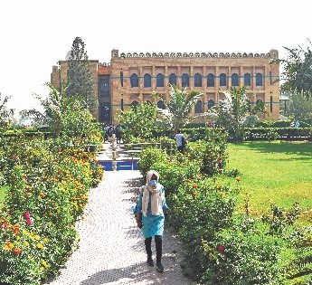
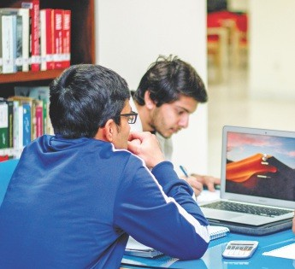
Accomplishments
N oteworthy ach ievem ents of our department include:
  - ORIC is duly recognized by HEC.
  - To achieve the HEC's accreditation dnd ranking, policies were framed to streamline processes for the s m o o t h e xe c u t i o n o f t h e Extram ural Fund ing, Research R ewa rd s, Re se a rc h Eth i cs, lntramural Research Funding for th e fre s h a n d ex p e r i e n ce d researchers (Faculty Research Support Grant), International and In land Travel Grants, I n- ki nd Research Su p port, Tech nical Entrep rene urship for Faculty, FYPs, Plagidrism, etc. to improve p e d e s ta I o I re s e a r c h a n d d evelop m ent. Th ese po li ci es co I le ct i ve ly co n tr i b u te d to i mp rovi ng th e resea rch an d d e v e I o p m e n t I a n d s c a p e , p r o m o t i n g t r a n s p a r e n c y, dCcountability, and excellence in dll aspects of research activities within the university.
- Identified aven ues of research fund raising, mobilized faculty, partne red with th e busi ness co mmun ity and i nd u stry fo r research commercialization.
- I n ces sa ntly ed u cate d lac ulty a b o u t e m e rg i n g r e s e a r c h avenues that resulted in over 250 research proposals submissions for external research funding in the period 2018 -2025.
- Competitive research grants over Rs. 500 million were secured in the period 2018 -2025.
- De sign ed a nd la un ch ed th e Impact Factor Publication Reward (I FPR) module, an i nnovative digital platform that automates and simplifies the process of rewarding faculty for high-impact re s ea re h p u b I i ca t i o n s. T h e module streamlined submission and verification by integrating with jou rn al da tab ase s and u ti lize d mu ltiple m etrics for transparent reward calculations, including Eigenfactor Score (EGF),
Article Influence Score (AIF), and Impact Factor (IF) from Web of Science (WoS), as well as H-index (HI), Citation Distribution (CD2), and SNIP (Source Normalized Impact per Paper) from SClmago Journal Rank(SjR) and SNIP CWTD. Fe aI u r i n g a u s e r - fr i e n d ty interface, real-time tracking, and n o t i fi c at i o n s, t h e s y s te m eliminates manudl paperwork, reduces administrative workload, en h an ces acces si bi lity, an d ensures transparency through seamless digital documentation and reporting.
- To incentivize and acknowledge o u t s I a n d i n g r e s e a r c h publications, faculty received research rewards exceeding Rs. 61 million from 2021 -2025. This program hasdemonsrabytedto an increase in the number of high-quality faculty impact factor publications during the reported period.
- Our campuses hosted a wide

Prospectus 2025

Office of Research, Innovation and Commercialization (ORIC) FAST-NUCES

range of train i ng worksh ops, co nIe re n ces, sem i na rs, and symposiums. Facu Qty and staff members actively participated in t h e s e e v e n ts , a I o n g w iI h c o nIe re n ce s a n d s e m i n a rs organized by other universities and industry partners. These engagements provided valuable professional development and n e tw o r k i n g o p p o rt u n i t i e s, enriching the expertise of our team.
  - The portfolio of ORIC extramural funding expands to haVP ä tdb dffitiated with each of the four Natio nd t Centers i n Emerging Te ch no togi es lu nded by th e Pu b ti c Se cto r D eve I o p m ent Program (PSDP): National Center of Artificiat Intelligence, National Cente r of B ig Dütd & CIO U Ô Computing, Nationd I Center of Ro boti cS & AU tO M dti o n, d nd Ndtiondl Center of Cyber Security. Thèse projects have developed prototypes that dre being pitched to th e i nvestors for p rod u ct licensing and commercialization.
  - T h e N U C E S e n c o u r a g e s i n te r n at i o n a I co I I d bo rat ive research. The faculty researchers have exeCuted European Union's ERASMUS projects.
  - A host of research projects with defence dnd commercial vertiCdlS dre also being executed.
  - The University dn nounced the Resedrch Excellence Awdrds 2024 to recognize exceptiondl research c o n t r i b u t i o n s b y Bd C u I ty, reüecti ng its com m itm ent to f o s t e r i n g d c u I t u r e o f c o I I d b o rd t i ve d n d d p p I i e d resedrch. In the inaugurdl cycle, Dr. Jawwad Ahmed Shamsi was declared the Best Researcher through d MPticulously evolved competitive rubric. His ded ÎCdtion to co lld bo rdtive dnd ap p lied resedrch exemplifies the spirit of excellence the dwdrd seeks to


Prospectus 2025
re c ogn i z e, s h owca s i n g th e
s u cc es s of th e u n ive rs i ty's research-en handing initiatives.
- National Grdssroots ICT Research Initiative (NGIRI) program under Ignite dims to assist finds year undergraduate students of ICT related disciplines by providing them financial assistance for developing prototypes / working m od e is of thei r F i na I Ye ar P roj e cts (FY P) to i n c re a se credtivity, innovdtion, and hands on engineering and development skills. The University has been participating in this programme dnd won over 200 projects from 2014 -2025.
- In 2024-2025, under the ORIC um brella, NUCES su ccessfully o rga n ize d th re e presti gi ous international conferences: the lnterndtional Conference on IT dnd I ndu str i dI Te ch no logi es (lClT24) at the Chiniot- FaiSdlabad C d m p u s, t h e I n te r n d t i o n a I Conference on Emerging Trends in Smart Technologies (ICETST24) dt the Kdrdchi campus, dnd the 1st lnternationdl Conference on Al & C A L L: R e s h a p i n g A p p l i e d Li n gu is tics (A ICRAL25) at th e La hore cdm puS. These events highlighted NUCES's commitment to fostering globdl COlldbordtion, i nn ovatio n, dnd cutti n g-ed ge research across diverse fields.
- We m a i n ta i n d st r o n g a n d consistent socidl MPdid presence, dctively sharing a wide range of n at i o n al a n d i n te rn ati o nd I research project opportunities, interndtional sCholarships, and HEC rules dnd opportunities for our faculty and students. Through o u r F a c e b o o k p d § P (https://www.facebook.com/FA STN U 0 RIC/), w e e ffi c i e n t ly d issem i nate this i nform ation, ensuring our audience stays well-i n fo rmed dnd co n ne cte d to valuable academic and research
prospects with just a click.
- Facilitate to increase acddemia-industry coltabordtions through meetings, M0Us and consultancy dgreements aimed to add ress i ndustry ch allenges. To d ate, (2018-2025) our institution has secured over 71.23 million rupees in consultancy projects from various organizations.
- I n an effo rt to i nc rease th e resedrch capab ilitiPS Of fdCLl It me m bers, O RIC has in iti ated intrdmural funding through the Faculty Research Support Grant ( F R S G ) p r o g r d m . To d d t e dpproximately Rs. 118 million has be en fu nd ed acro ss all fi ve campuses of the university. Under the recent FRSG call (Fall 2024), the university hds funded 28 projects each of worth Rs 1.5 million.
- Till now our departm ent has signed 201 Mem orand ums of Understand ing (MoUs) with a diverse range of nationdl dnd international universities, as well ds industridl organizations. These MoUs were strategically crafted to foster collaborations between dcademia and industry, diming to prom ote knowledge exchange, joint research initiatives, and MUtUdlly beneficial pdrtnerships. T h ro ugh th ese co lla b ora ti ve efforts, we hdve been able to b r i d g e t h P § d b e I w e e n th eo ret i cal kn ow ie d ge a n d prdctical application, fdCilitating innovation and creating avenues for impactful resedrch outcomes.
- As pdrt of our commitment to foster dn entrepreneurial culture withi n th e un ive rs ity, lac ulty members are dctively encourdged tO PStdblish resedrch ldbs. To d a te, we h dve s u cce ssfU Ily commercidlized 42 resedrch ldbs dcross vari ous Cdm p uses of NUCES. Further detdils regarding the projects dnd dChievements of

FAST-NUCES
Office of Research, Innovation and Commercialization (ORIC)

th ese research tabs can be accessed through our official
0 R I C w e b s i t e a t https://www.nu.edu.pk/Oric/Oric Research Labs. This platfo rm serves as a gateway for national and international organizations to connect with relevant research labs for collaborative research and deve top m ent i niti a tives. Such collaborations ultimately prove beneficial for the university and its stakeholders
  - A new Chip design centre has been established at Islamabad campus with the collaboration of GS Microelectronics US Inc. The centre, named GF-Metrc, focuses primarily on Integrated Circuit(IC)
design, research, training, and fo s te r i n g i n n o v a t i o n a n d commercialization, leveraging the partnership with GSME.
- A n I n c u b a t i o n C e n t r e i s operational at Peshawar campus for students. It is networked with e n t r e p r e n e u r i a I h u b fo r m e n to r i n g t h e i n c u b a te s. Additionatly, a MOU has been signed with National Incubation Centre (NIC), Islamabad to help NUCES Students in the process of their Start-ups.
- ORIC is supporting its faculty mem be rs and researchers i n establishing their technical start-ups, including providing support throughout the trademark and
patent filing processes. Notably, recently a new Start up (iParahi) h a s a c h i e v e d s u c c e s s i n t r a d e m a r k r e g i s t r a t i o n . Ad d itio n ally, th e fou nd er is actively engaged in the process of filing a patent application for his forthcoming product.
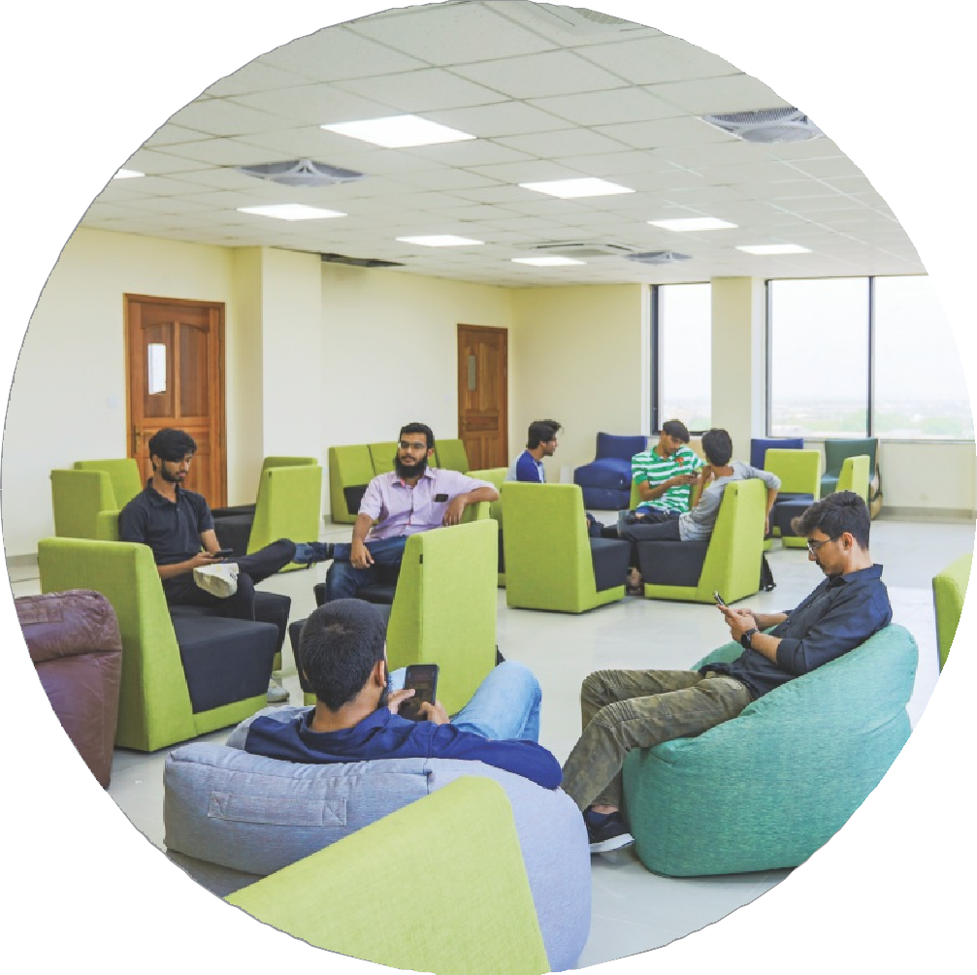
- ORIC consistently disseminates information regarding exchange p rogram s a nd i nte rn ati o n al internship opportunities for stu dents. Both students and facu Qty mem be rs h ave been a c t i v e I y u t i I i z i n g t h e s e opportunities to enhance their aca d em i c an d p rofess i on al pursuits.


Prospectus 2025

