Architecture Flow
Flow diagram for the Face Recognition based Entry System:
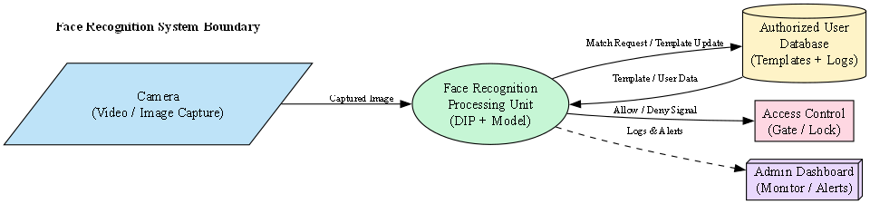
Legend:
- Camera: captures image/video
- Processing: DIP + recognition model
- Database: stores templates and logs
- Access Control: gate/lock which receives allow/deny signal
- Admin Dashboard: monitoring and alerts

