System Models

Use Case Diagram
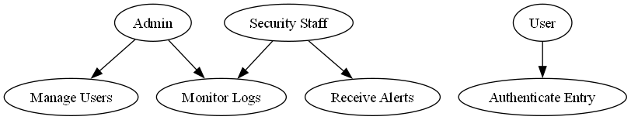

Data Flow Diagram
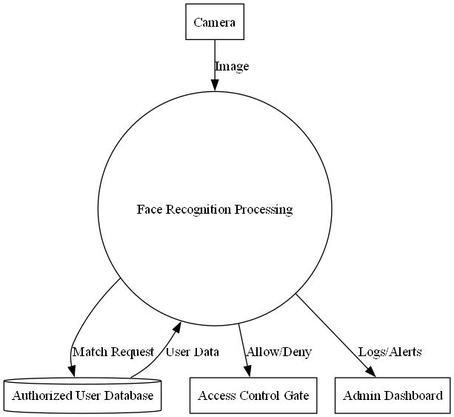

ER Diagram
