System Models

Use Case Diagram
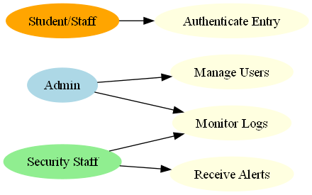

Data Flow Diagram (DFD)
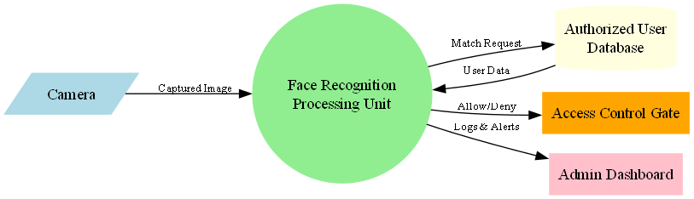

ER Diagram
