# HERE IS A SOME EXPLATION AND HISTORY OF THE WORLD;

* **This world is around 4.5 billion years old. It started with the formation of our planet , earth from cosmic dust and gas .over time ,life emerged in the form of simple organisms, eventually evolving into more complex creatures.**
* The history of humans dates back to around 200,000 years ago. We evolved from early hominids and developed various civilizations throughout time. From ancient civilization like Mesopotamia and Egypt to rise and fall of great empire, human history is filled with fascinating stories.
* Advancement in technology such as the invention of the printing press and the industrials revolution, transformed societies and lead to major shifts in how we live and interact.
* THE 20TH CENTURY SAW SIGNIFICANTS EVENTS LIKE A WORLD WAR, THE SPACE AGE, AND THE RICE OF GLOBALIZATION.
* Today, we continue to evolve and face new challenges, from climate change to technological advancements. Our history and evolution are a testament to resilience and adaptability of the humans species.
* The Renaissance: A period of cultural and intellectual rebirth in Europe, marked by advancements in art, science, and philosophy. Think Leonardo da Vinci and Michelangelo!
* The Age of Exploration: Discoveries made by explorers like Christopher Columbus and Vasco da Gama, leading to the expansion of European empires and the establishment of global trade routes.
* The Industrial Revolution: A time of rapid industrialization and technological advancements, transforming societies from agrarian to industrial. Steam engines, factories, and mass production changed the world.

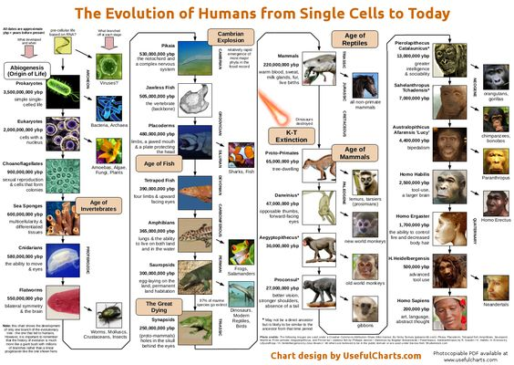

* The world Wars: Two major global conflicts that reshaped the political and social landscape. World War I and II had a profound impact on nations, leading to the rise of new powers and the establishment of international organizations like the United Nations.
* The Space Age: The exploration of space, from the first human landing on the moon to the creation of space stations and satellites. It opened up new frontiers for scientific research and expanded our understanding of the universe.

**The**

**End**