**University Of West Attica**

**Design principles**

**Human-Computer Interaction**

**Home assistant UI**

**By**

**Ahmad Hijazi**

**Contents:**

Introduction 3

Clarity and simplicity 3

Consistency and familiarity……………………………………3

Clear hierarchy and navigation 4

Visual feedback and affordance 5

Responsive and fast performance 6

Accessibility and inclusivity……………………………………6

User testing and iteration 7

Conclusion 8

**Introduction:**

Designing an intuitive and accessible user interface (UI) requires a thoughtful approach that considers the diverse needs and preferences of users. The following design principles were followed to create an intuitive and accessible UI for our app:

1. **Clarity and Simplicity:**

* Keep the UI clean and uncluttered, using whitespace effectively.
* Use clear and concise language in labels, instructions, and error messages.
* Simplify complex tasks and information to reduce cognitive load.

**Implementation:**

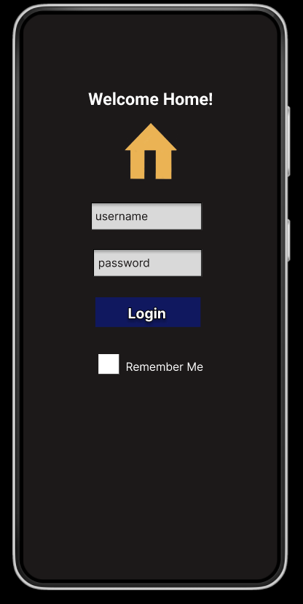

1. **Consistency and Familiarity:**

* Maintain consistency in visual elements, such as colors, typography, and iconography, throughout the app.
* Follow platform-specific design guidelines to provide a familiar experience for users.
* Ensure consistent navigation patterns and interactions across the app.

**Implementation:** This was done by using the same style icons and font and color throughout the UI, for example:

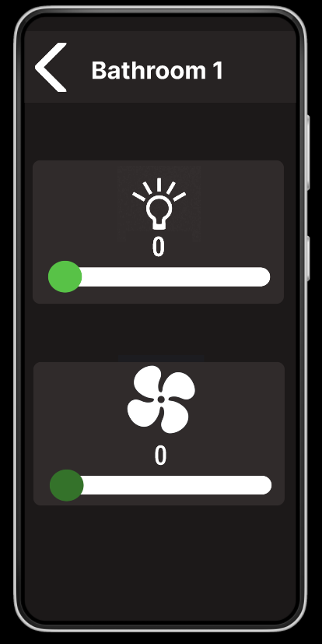

1. **Clear Hierarchy and Navigation:**

* Establish a clear information hierarchy to guide users and help them understand the app's structure.
* Use intuitive navigation patterns, such as menus, tabs, and breadcrumbs, to help users find their way within the app.
* Provide clear and descriptive labels for navigation elements to minimize confusion.

**Implementation:**

1. **Visual Feedback and Affordance:**

* Provide visual feedback to indicate system status, actions, and changes, such as loading indicators, progress bars, and success messages.
* Use appropriate affordances, such as buttons, sliders, and switches, to make interactive elements clear and recognizable.
* Employ animations and transitions to enhance the user's understanding of their actions and the app's response.

**Implementation:** Sliders and On/Off button that change color based on state were used

1. **Responsive and Fast Performance:**

* Ensure the app's responsiveness by minimizing loading times and delays in user interactions.
* Optimize the app's performance to provide a seamless and smooth experience, even on lower-end devices.
* Prioritize content and features based on their relevance and frequency of use.

1. **Accessibility and Inclusivity:**

* Design with accessibility in mind, adhering to WCAG (Web Content Accessibility Guidelines) standards to ensure the app is usable by individuals with disabilities.
* Provide alternative text for images, captions for multimedia content, and transcripts for audio and video.
* Support assistive technologies, such as screen readers, voice control, and keyboard navigation.

**Implementation:**

1. **User Testing and Iteration:**

* Conduct usability testing with a diverse group of users to identify pain points and areas for improvement.
* Actively seek and incorporate user feedback to continuously refine the UI and enhance the user experience.
* Iterate on the design based on user testing results, making data-driven decisions to address usability issues.

**Implementation:** 2 set of surveys and 1 set of interviews were conducted, first survey was to checkout user needs before building the UI, then the second survey was the user’s response to the built UI and finally the interviews at the end were to satisfy user needs and finalize the UI design.

**Conclusion:**

In conclusion, creating an easy-to-use and inclusive user interface (UI) requires a thoughtful and user-centered approach. By following the design principles mentioned above, we can develop a UI that is simple to understand, navigate, and interact with for a wide range of users. The application of these principles involves different strategies such as maintaining clarity and simplicity, consistency and familiarity, clear organization and navigation, visual cues and responsiveness, fast performance, accessibility and inclusivity, as well as user testing and improvement.

By keeping the UI neat, using straightforward language, and simplifying complex tasks, we ensure that users can easily grasp and accomplish their objectives. Consistency in visual elements and following design guidelines specific to the platform provide a familiar experience, reducing mental effort and enhancing usability. Clear organization and intuitive navigation patterns help users comprehend the app's structure and find their way around effortlessly.

Visual cues and responsiveness play a crucial role in guiding users and giving them feedback on their actions. By using Sliders and on/off buttons that change based on their state so the user will be provided with an answer to their actions.

Also providing assistive technology like accessibility settings Ensures accessibility and inclusivity which is vital to provide equal access to all users.

Lastly, user testing and improvement are crucial steps in the design process. By actively involving users and incorporating their feedback, we continuously refine the UI and address any usability issues. Conducting surveys and interviews helps us gather insights into user needs and preferences, ensuring that the final UI design meets their expectations.

In summary, by following these design principles and implementing them effectively, we can create a user-friendly and inclusive UI that caters to the diverse needs and preferences of users, resulting in a positive and enjoyable user experience.