**University Of West Attica**

**Report**

**Human-Computer Interaction**

**Home assistant UI**

**By**

**Ahmad Hijazi**

**Contents:**

Introduction 3

Background 3

Methodology……………………………………………………3

Survey Results 3

Findings 3

Design recommendations 4

1st iteration………….……………………………………………4

Survey results 4

Findings 6

Design updates 6

2nd iteeration 7

Findings…….……………………………………………………7

Design updates 7

Conclusion 9

**Introduction:**

User research is an essential part of the design process, providing valuable insights into user behavior, preferences, and needs. This report summarizes the findings of user research and how they informed the design of the user interface for a new mobile app.

**Background:**

The challenge we faced was designing a mobile app that meets the needs of its target audience. To do this effectively, we needed to conduct user research to gain insights into user behavior, preferences, and needs. The objective of the research was to inform the design of the user interface, ensuring that the app is user-friendly, intuitive, and meets the needs of its target audience. The ultimate goal was to increase user engagement and satisfaction, as measured by key performance indicators (KPIs) such as user retention, session length, and overall satisfaction with the app's functionality.

**Methodology:**

To achieve this goal, we conducted user research through surveys and interviews with potential users of the mobile app. Participants were selected based on their demographics and their interest in the app's purpose.

This allowed us to collect both qualitative and quantitative data to gain a comprehensive understanding of user needs and preferences. We used Likert scales to gather quantitative data and open-ended questions to gather qualitative data. The data collected was analyzed to identify key insights that would inform the design of the user interface.

**Survey Results:**

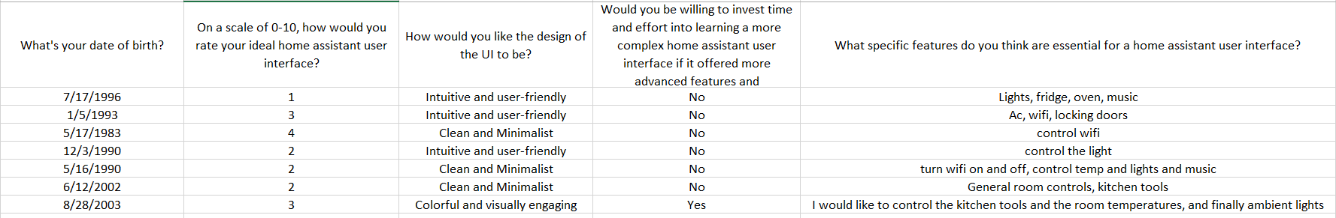

**Findings:**

**User Goals and Expectations**: Users want a simple, easy-to-use interface that helps them achieve their goals quickly. They expect the app to be fast, intuitive, and responsive.

**Navigation**: Users prefer clear and consistent navigation. They expect to be able to find what they need easily and quickly. Users like a hierarchical navigation system with clear labels and categories.

**Visual Design**: Users prefer a clean, minimalist design with easy-to-read fonts and colors. They like the use of icons to represent actions and information.

**Feedback and Confirmation**: Users expect feedback when they interact with the app. They want to know that their actions have been recognized and are being processed. Users also want confirmation when an action has been completed.

**Complexity**: Users are not willing to invest time to learn how to navigate through the app so the app should focus on simplicity, and nothing should be left ambiguous.

**Design Recommendations:**

* Keep the interface simple and easy to use.
* Use a hierarchical navigation system with clear labels and categories.
* Use a clean, minimalist design with easy-to-read fonts and colors.
* Provide feedback and confirmation for user actions.
* Provide help and support readily available when needed.

**1st iteration:**

After the Initial UI was made a second survey was made and sent to potential users.

This report outlines the process, survey results, key findings, and the subsequent design updates based on user feedback.

**Survey Results:**

The survey consisted of questions related to the overall experience, visual appeal, ease of use.

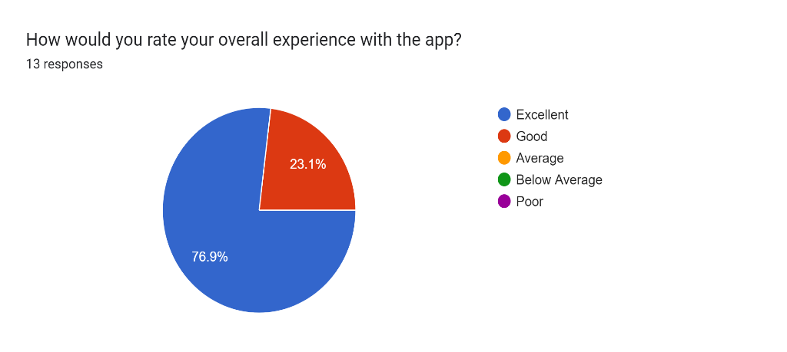

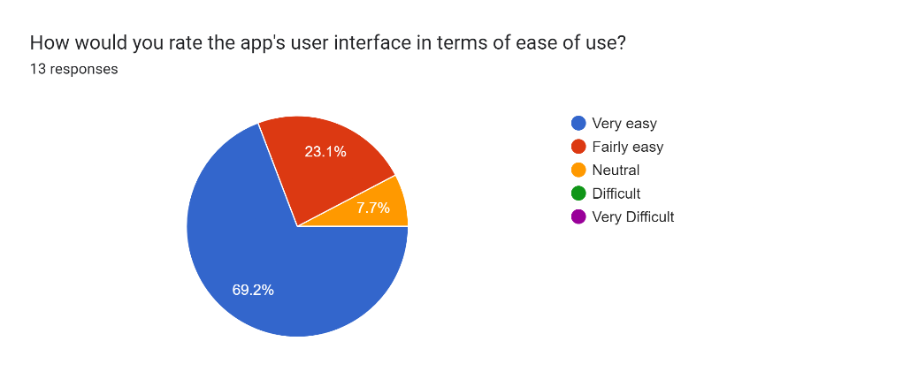

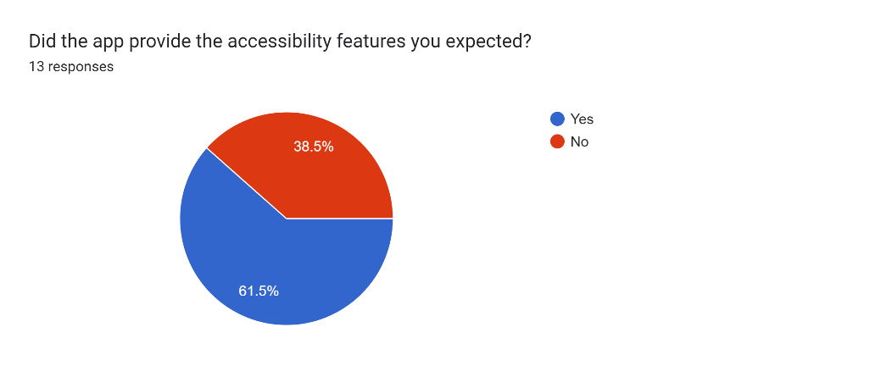

The survey results indicated a positive response to the introduction of the Light mode option. Approximately 38.5% of the respondents expressed dissatisfaction with the UI’s accessibility features.

So, this led to adding more accessibility features to the UI based on what the users specified.

**Findings:**

Based on the survey results and further analysis, several key findings emerged:

**Accessibility Considerations**: Users with visual impairments or Hearing impairments expressed a need for additional accessibility options, such as Screen Reader and Voice control.

**Design**: the design of the UI is already simple and received good user reviews with approx. 92% of reviews finding it easy to use. as it is simple enough but still manages to provide what the user and homeowner needs.

**Design Updates:**

To address the feedback and capitalize on the positive response, the following design updates have been implemented:

* Accessibility Customization: Additional accessibility options, including Screen Reader and Voice control, have been incorporated into the UI to accommodate individual preferences and specific accessibility needs.

By incorporating these design updates, we aim to provide an enhanced user experience that caters to a wider range of preferences and accessibility requirements.

**Implementation:**

**2nd iteration:**

A second round of user testing happened when the UI was presented to several people who answered the first 2 surveys.

An interview was conducted with each of them and the findings were the following.

**Findings:**

**Visual Appeal**: A significant majority of participants found the Light mode visually appealing, citing its clean and modern aesthetic as a refreshing alternative to the existing Dark mode.

**Personal Preference**: The survey results highlighted the importance of catering to users' personal preferences. Providing a choice between Dark and Light modes allowed individuals to align the app's appearance with their visual comfort and personal style.

**Design Updates:**

* Enhanced Contrast: The Light mode now features improved contrast between text and background elements to ensure optimal readability and accessibility for all users.
* UI Refinement: The visual aesthetics of both Dark and Light modes have been further refined to maintain a cohesive and visually pleasing experience throughout the app.

**Implementation:**

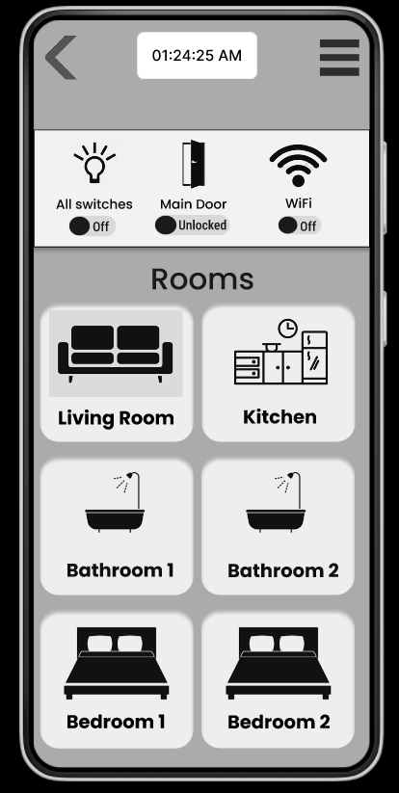

**Conclusion:**

In conclusion, user research was crucial in shaping the design of the user interface for our mobile app. By conducting surveys, interviews, and user testing, we were able to gather valuable insights into what our users wanted and needed. This information guided us in creating an interface that meets their goals, expectations, and preferences.

During the first round of user research, we discovered that simplicity, clear navigation, and a minimalist visual design were highly desired by our users. They wanted an interface that was easy to use, intuitive, and responsive. Taking these findings into account, we developed an initial design that included a hierarchical navigation system, clean fonts and colors, and the use of icons for actions and information. We also incorporated feedback and confirmation features to ensure that users felt confident in their interactions with the app.

In the second round of user research, we focused on accessibility considerations and personal preferences. Users with visual or hearing impairments emphasized the importance of additional accessibility options, such as Screen Reader and Voice Control. Furthermore, we learned that offering both Light mode and Dark mode was appreciated by users, as it allowed them to personalize the app's appearance based on their visual comfort and personal style.

Overall, the insights gained from user research played a pivotal role in guiding our design decisions and iterations of the user interface. By actively incorporating user feedback and considering their needs and preferences, we were able to create a user-friendly, intuitive, visually appealing, and accessible mobile app. These improvements are expected to lead to increased user engagement, satisfaction, and ultimately contribute to the app's success in achieving its intended goals.