BMP

Project Specifications

Team Name: Brigade Node

Project Introduction
- Background and Motivation
The construction sector in Tunisia is still highly fragmented and relies on manual and informal processes such as paper documents, phone calls, and physical visits. This leads to inefficiency, lack of organization, and limited transparency.
Artisans face difficulties in managing projects, generating professional invoices, and tracking chantier progress. Experts lack structured access to technical knowledge and visibility over available artisans. Manufacturers have limited digital channels to reach artisans and experts, especially for small-scale projects.
To solve these issues, BMP.tn proposes a centralized digital platform that organizes projects, technical knowledge, and commercial interactions in one ecosystem.
- Study of the existing
Artisans mainly manage projects manually or with basic tools (calls, WhatsApp, notebooks).
Project tracking is informal and not standardized.
Some digital solutions exist but cover only specific needs:
Procore / Buildertrend: project management and documentation for construction teams.
Houzz / Houzz Pro: visibility for professionals and product marketplace.
Buildaily / BuildMate: material sourcing and supplier marketplaces.
Experts rely on personal experience or scattered online resources, with no centralized technical knowledge library.
There is limited digital visibility between experts, artisans, and manufacturers.
Product purchasing is still mostly offline through physical suppliers.
Payments, invoices, and project data are not centralized in one system.
No unified platform currently connects projects, technical solutions, artisans, and suppliers in a single structured digital workflow.

- Project Objective
The main objectives of BMP are:
-To build a multi-profile platform for artisans, experts, manufacturers, and administrators.
-To simplify project and chantier management for artisans .
-To provide experts with access to a technical library, visibility over available artisans, and the ability to purchase products from suppliers.
-To offer manufacturers a digital sales and visibility channel.

Business Features Specifications
- Functional Requirements:
User Authentication & Role Management :
- Users can create an account, log in, and recover their password.
- The administrator assigns user roles: Artisan, Expert, Manufacturer, Admin.
- Each role has controlled access to specific features based on permissions.

Artisan Module :
- Create construction projects initiated by:
  - a client request, or
  - an expert.
- Request and generate quotes .
- Generate invoices after project completion.
- Track chantier progress using simple status updates.
- Browse and purchase products from the marketplace.
- Manage payments received from clients through the platform.
- Access the platform through a monthly subscription model.

Expert Module :
. Access a technical knowledge library containing common construction problems and standardized solutions.
. View a list of available artisans and contact them for project opportunities.
. Browse supplier catalogs and purchase products or materials.
. Initiate projects and forward them to artisans when needed.

Manufacturer Module :
- Upload and manage product catalogs including prices and technical documentation.
- Sell products directly through the platform.
- Track product sales and visibility.
- Receive payments for sold products via the platform.

Payment Management :
- Clients pay for services and projects through the platform.
- Payments are automatically processed and distributed to:
  - artisans for executed work,
  - manufacturers for products sold,
  - the platform as commission.
- All transactions are recorded and visible in user dashboards.

- Non-Functional Requirements:

Performance: Fast load times, support for multiple users.
Security: Encrypted authentication, secure payments.
Availability: 24/7 uptime, regular backups.
Usability: Mobile-friendly, intuitive design.

- Detailed User stories (product backlog) :

Module Artisan :
As an artisan :
- I want to create a project initiated by a client so that I can manage my work.
- I want to receive a project initiated by an expert.
- I want to request and generate quotes for projects.
- I want to generate invoices after completing a project.
- I want to track chantier progress using simple status updates.
- I want to browse and purchase products from the marketplace.
- I want to receive payments for completed work through the platform.
- I want to manage my subscription status (activate, renew, expire).

Module Expert :
As an expert :
- I want to access a technical knowledge library to understand construction problems and solutions.
- I want to view a list of available artisans.
- I want to contact artisans to propose project execution.
- I want to initiate a project and forward it to an artisan.
- I want to browse supplier catalogs and purchase products or materials.
- I want to make secure payments for purchased products.

Module Manufacturer :
As a manufacturer :
- I want to upload and manage my product catalog.
- I want to attach technical documentation to products.
- I want to sell products through the platform.
- I want to receive payments for products sold.
- I want to track product sales and visibility.

System Design and Architecture

High-Level Architecture Diagram

1-Logical Architecture Diagram :
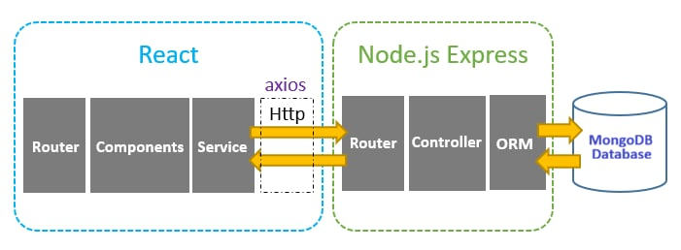

2-Physical Architecture Diagram :

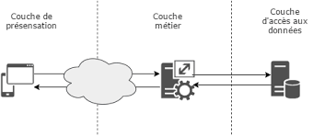

2-Data Model :

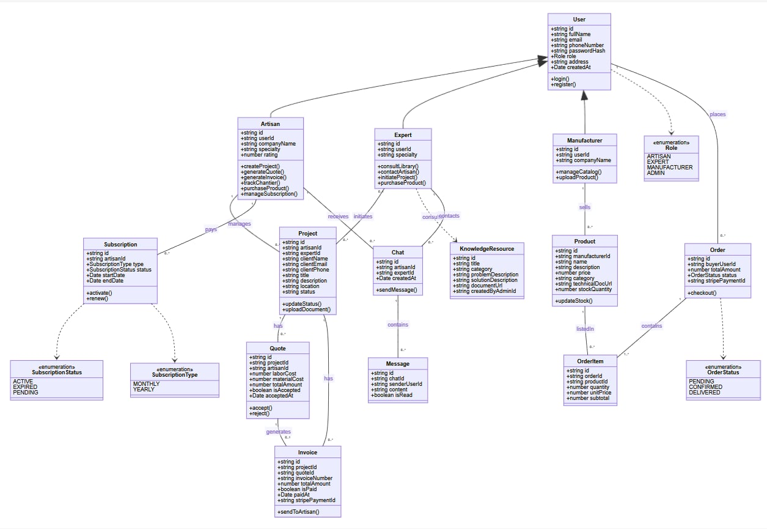

3-Technology Stack choice :
Frontend :

- React.js

Backend :
- Node.js + Express.js
Database:
- MongoDB
DevOps/CI/CD Tools :
- Git & GitHub
- GitHub Actions for CI/CD
- Docker

4-Security and Compliance Considerations :
- .Encrypted user credentials.
- .Secure payment transactions.
- .Compliance with local data protection laws.
- .Role-based access control.

CI/CD and DevOps Strategy

  - Version Control Plan:

Tool: Git with GitHub

Repository Management:

-The project source code is hosted on GitHub.
-All team members work on the same centralized repository.
-Access rights are managed by the administrator.

Branching Strategy (Git Flow):
We use a Git Flow model to organize development:

Main Branches:
main → Contains stable and production-ready code.
develop → Contains the latest development version.

Workflow:
-Developers create feature branches from develop.
-After testing, changes are merged into develop.
-When ready, develop is merged into main.
This strategy ensures code stability and team collaboration.

2 - CI/CD Pipeline Setup Plan:

1-Tools Used:

- GitHub Actions (CI/CD automation)
- Docker (for deployment)

2-Continuous Integration (CI) :

Every time a developer pushes code to GitHub:
-Code is automatically checked out.
-Dependencies are installed.
-Automated tests are executed.
-Code quality is verified.
-Build is generated.
-If any step fails, the pipeline stops and notifies the team.

3-Continuous Deployment (CD) :
After CI validation, code is built, packaged, deployed to the server, and activated automatically. Development deployments are automatic, while production deployments require approval.

4-Testing Strategy:
- Unit Tests: Test individual functions (login, payments, quotes).
- Integration Tests: Test communication between modules (auth, marketplace, payments).
- Automated Tests: All tests run automatically in the CI/CD pipeline.
- Manual Tests: UI and security testing before major releases.

Timeline and Sprint Planning / Or other if it’s not scrum
Timeline and Sprint Planning
1- Sprint Overview:
SPRINT 1: Product & Manufacturer Management
Business Features Focus:
- Manufacturer product catalog management.
- Product technical documentation upload.
- Product purchase flow (artisan & expert).
- Order tracking for manufacturers.
- Sales visibility and reports for manufacturers.
Key Deliverables:
- Product marketplace interface.
- Order management system.
- Manufacturer dashboard.
- Product sales tracking.

SPRINT 2: Expert Technical Library & Artisan Visibility
Business Features Focus:
- Technical knowledge library for experts (problems & solutions).
- Search and filtering within the technical library.
- List of available artisans with contact details.
- Expert-initiated project creation and assignment to artisans.
- Expert access to supplier product catalogs (view only).
Key Deliverables:
- Technical library interface.
- Artisan directory for experts.
- Project initiation flow by experts.
- Role-specific expert dashboard.

SPRINT 3: Artisan Project Management
Business Features Focus:
- Project creation by artisans (from client or expert).
- Project listing and dashboard for artisans.
- Simple chantier progress tracking (statuses).
- Document upload for project-related files.
- Client visibility on project status (read-only).
Key Deliverables:
- Project creation and management interface.
- Project status workflow (Created → In Progress → Completed).
- File upload functionality.
- Artisan project dashboard.

SPRINT 4: Quoting & Invoicing System
Business Features Focus:
- Quote request and generation by artisans.
- Cost breakdown (labor, materials).
- Client approval or rejection of quotes.
- Invoice generation from approved quotes.
- Invoice and document history per project.
Key Deliverables:
- Quote creation and management.
- Approval workflow.
- Invoice generation system.
- Financial overview for artisans.

SPRINT 5: Payment & Subscription Management
Business Features Focus:
- Secure online payment for clients.
- Payment distribution logic:
  - Artisan (service)
  - Manufacturer (products)
  - Platform commission
- Artisan subscription management (activation, renewal).
- Payment history and receipts.
- Basic error handling for payments.
Key Deliverables:
- Integrated payment gateway.
- Payment distribution engine.
- Subscription management module.
- Transaction history dashboards.

SPRINT 6: Authentication & User Management
Business Features Focus:
- User registration and login system.
- Role management: Artisan, Expert, Manufacturer, Admin.
- Role-based access control.
- User profile management (basic information).
- Admin panel for user and role management.
Key Deliverables:
- Secure authentication system.
- Role-based routing and permissions.
- User database structure.
- Basic admin dashboard.

SPRINT 7: Analytics, Monitoring & Platform Stabilization
Business Features Focus:
- Platform analytics (projects, users, transactions).
- Role-based dashboards (Admin, Artisan, Expert, Manufacturer).
- Activity monitoring for admin.
- Performance optimization (mobile-first).
- Bug fixing and UX improvements.
Key Deliverables:
- Analytics dashboards.
- System monitoring tools.
- Improved performance and usability.
- Final MVP stabilization.

