**Name**: Ahmed Mostafa Sayed Mostafa

**B.N**: 138

**Topic**: Computer Engineering Role in COVID-19 Pandemic

**GitHub Link:** https://github.com/Ahmed-3007/ECE001

**GitHub Pages:** https://ahmed-3007.github.io/ECE001/

*Computer Engineering Role in COVID-19 Pandemic:*

We talk through our topic about the role of technology in treating the Corona virus and we reviewed some important points such as the impressive technological progress that China in particular and the world in general reached and a large role for it in treating the virus or in its resistance as China has become using technology in ambulances and has become cars without a driver and that is to prevent for mixing, some countries have also used robots to deliver medicines and medical supplies, and some other, undeniable, technology. Technology has a great role in tackling the epidemic.

*Source Code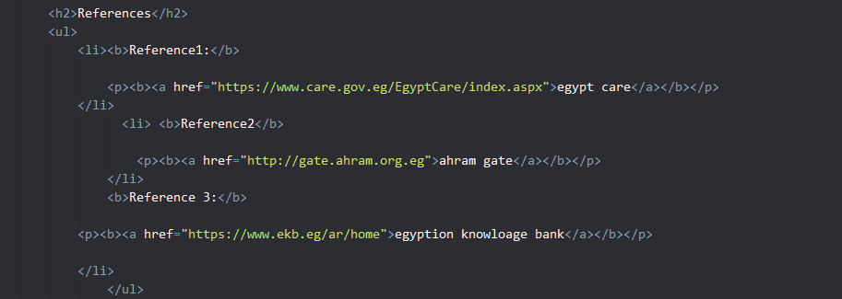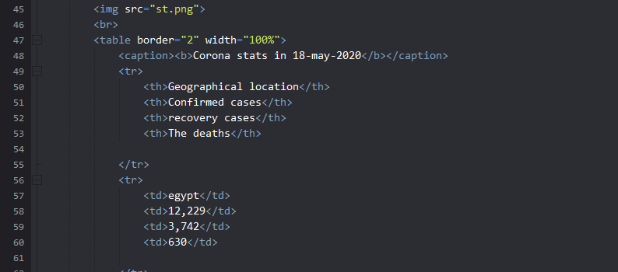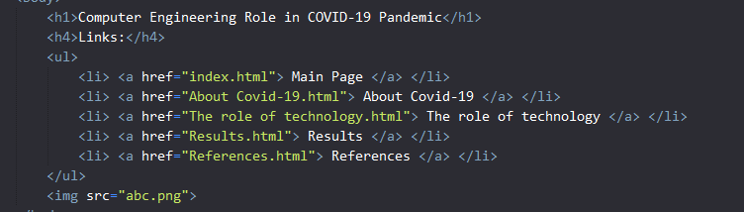:*

*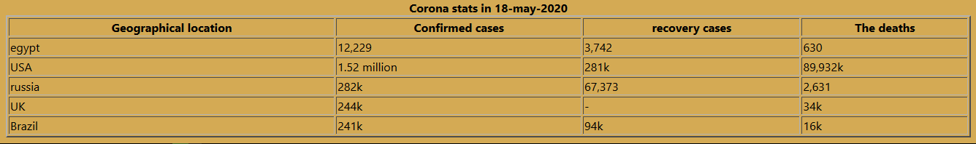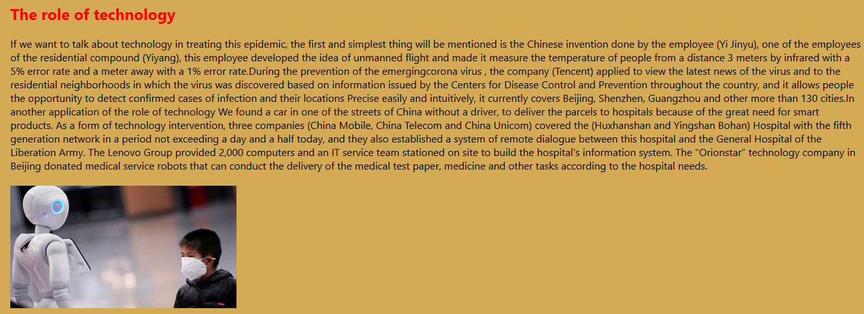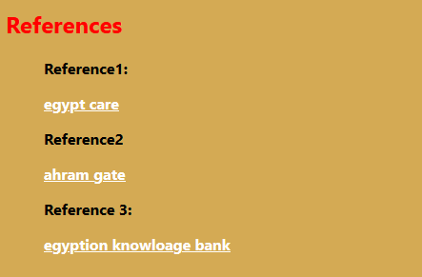Screenshots:*