Freight Rate Prediction
Approach, validation and December forecast | Machine Learning Engineer assessment | Ahmed Akram Amer

1. Summary
The task is to predict posted_rate for 12,000 loads dated 1 Nov to 31 Dec 2025, using 48,000 labelled loads from 1 Jan to 31 Oct 2025. The final model is a tuned Gradient Boosting regressor (scikit-learn). On a time-based hold-out (Sep-Oct 2025, never seen during fitting) it reaches R² = 0.825, MAE = $131 and RMSE ≈ $639 (average load rate is about $2,370).
The report covers the data-quality issues found and how they were handled, the train/validation design, model comparison, the validation predictions, the fixed December chart produced by score.py, and the main limitations.

2. Data and quality checks
Training data: 48,000 rows, 14 columns, dates 2025-01-01 to 2025-10-31. Validation data: 12,000 rows, 2025-11-01 to 2025-12-31, without the target. The validation set lies entirely after the training period.
Issue | Found | Treatment
Missing weight | Train 0.62% (300 rows); validation 1.38% | Median weight of the same equipment type, computed on train
Missing market_index | Train 0.78% (374 rows); validation 2.08% | Train: median of the same calendar day, interpolated across days. Validation / December: train global median
Negative weight | Train 292 rows; validation 145 rows | Absolute value (assumed sign error)
Duplicates | None found | No action
Text / dates / equipment | Free-text columns, date strings, categorical equipment | Whitespace stripped, dates parsed, equipment label-encoded (fit on train, unseen label falls back to the first class)

Observation: missing and negative values are roughly two to three times more frequent in the validation set than in training, so the pipeline had to impute rather than drop rows. All 12,000 validation loads receive a prediction.
Features (14): distance, weight, market_index, quote_signal, equipment, month, day of week, pickup/delivery latitude and longitude, latitude and longitude differences, and distance × market_index.

3. Train / validation approach
The loads are chronological and the real validation set is the future relative to training. A random split would mix later loads into training and overstate accuracy, so a time-based split is used:
Set | Period | Rows | Use
Training | Jan-Aug 2025 (months 1-8) | 38,477 (80.2%) | Fitting and hyperparameter search
Hold-out test | Sep-Oct 2025 (months 9-10) | 9,523 (19.8%) | Final comparison of models

- Hyperparameters were tuned only on the training period with RandomizedSearchCV (20 candidates, 5-fold CV, scoring on mean squared error).
- Imputation statistics and the equipment encoder are fitted on training data and reused unchanged for validation and December.
- The three tuned models were compared on the hold-out and the best one was selected, so the hold-out score is slightly optimistic.

4. Models and results
Four model families were trained with default-style settings, then the three strongest were tuned. Hold-out results (Sep-Oct 2025):
Model | R² (base) | MAE (base) | R² (tuned) | MAE (tuned) | MSE (tuned)
Gradient Boosting | 0.8248 | 132.38 | 0.8248 | 131.26 | 408,034
Random Forest | 0.8223 | 150.91 | 0.8239 | 134.37 | 410,007
Linear Regression | 0.8229 | 149.66 | 0.8233 | 146.96 | 411,490
Linear SVR | 0.8174 | 176.53 | not tuned | - | -

Selected model: Gradient Boosting (150 trees, learning rate 0.05, max depth 3, subsample 0.8). It has the lowest MAE and MSE of all candidates. The R² gap between all models is small (0.817-0.825), which suggests that most of the remaining error is not explained by the available features, for example noise in the target.

5. Validation predictions
validation_predictions.csv contains exactly load_id and predicted_rate for the 12,000 load_ids in the template, with no missing values. Predicted rates: mean $2,325, median $2,009, min $276, max $7,763, in line with the training distribution (mean about $2,370).

6. December prediction chart
The chart below was produced by score.py from the completed December file. Inputs are fixed to Lexington to Fort Wayne, 360 miles, Dry Van, 32,000 lb; only the date changes.
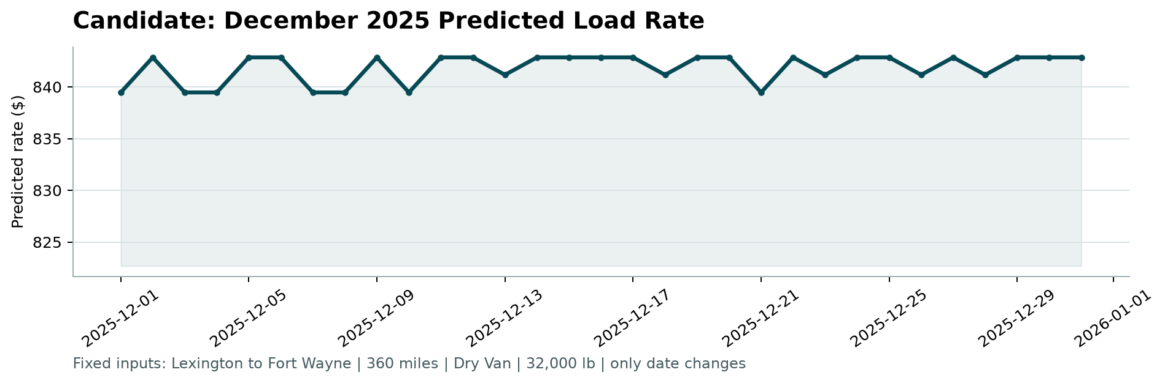
The December file contains only six input columns, so the remaining model inputs were filled with assumptions:
- City coordinates: median coordinates of the two cities in the training data.
- market_index: training median with small random noise (±2.5%, seed 42), giving values of 1.005-1.098.
- quote_signal: training median with small random noise (±2%), giving values of 1.975-2.132.
Result: predicted rates stay between $839.46 and $842.85 (mean $841.82). For comparison, the median of the 32 historical loads on this lane in training is about $849. The line is nearly flat because every input except the date is fixed; the small zigzag comes from the assumed market values and the day of week, and should not be read as a seasonal forecast.

7. Limitations and next steps
- Final fit on Jan-Aug only. The selected model was not refitted on Sep-Oct before predicting Nov-Dec. Refitting on all ten months is the most direct improvement.
- Outliers in the target. posted_rate reaches $25,533 and rate per mile reaches about $14, against a typical $2.2. Such loads inflate squared-error training; screening them or using a robust loss should help.
- quote_signal stability. In exploratory checks, its correlation with rate per mile changes sign between months, so its behaviour in Nov-Dec is uncertain. Training without it, and comparing hold-out error, would show how much the model depends on it.
- December inputs. market_index could be taken from the daily values in validation.csv instead of a noisy constant.
- Unseen months. Months 11 and 12 do not appear in training, so the month feature cannot learn December effects.
- Tuning folds. The 5-fold search is not forward-chaining; a time-series CV would match the deployment setting better.

