Interactive Genetic-Algorithm Optimization of Steel and Reinforced Concrete Structures for Minimum Weight and Embodied Carbon
[Author names and affiliations]
An open educational framework: fifteen validated benchmarks, one optimization workbench
Abstract
Weight- and cost-driven sizing has dominated structural optimization for five decades, yet the discipline’s most urgent modern application is the reduction of embodied carbon. This paper presents an open, interactive framework that unifies both objectives in a single, fully verified workbench spanning fifteen benchmark problems: five minimum-weight steel truss and frame problems, a discrete AISC-LRFD moment-frame benchmark, two AISC 360 built-up I-beam design problems (ASD and LRFD) carrying the complete compact/noncompact/slender classification of flanges and webs for laterally supported or unbraced spans, three frequency-constrained sizing problems, and four reinforced concrete (RC) problems whose objective is embodied CO₂ computed from unit-emission data. The analysis engine (direct-stiffness finite elements, consistent-mass modal analysis, and strain-compatibility RC section mechanics) and a real-coded genetic algorithm with adaptive operators are implemented from first principles in NumPy/SciPy and exposed through a live web interface designed for teaching. Three methodological elements are highlighted: (i) full flexural search spaces for RC members, in which both section dimensions and both steel layers—including asymmetric column faces—are design variables resolved by doubly-reinforced strain compatibility; (ii) a frequency-error-driven penalty that ranks infeasible designs by their distance to the frequency target, shown to recover feasibility on a benchmark previously misreported as unattainable; and (iii) a selectable steel-production route (2.82–0.36 kg CO₂/kg) that reprices reinforcement so optima respond to supply-chain decisions. The framework reproduces published optima across all families, the ASD and LRFD beam optima differ by exactly the φΩ capacity ratio, and a route study demonstrates carbon reductions of 22–56% at the optimum accompanied by systematic concrete-to-steel substitution. All formulations, verification tests and results are reproducible from the accompanying open implementation.
Keywords: structural optimization; genetic algorithm; embodied carbon; reinforced concrete; steel frames; frequency constraints; engineering education
1. Introduction
Sizing optimization of skeletal structures is among the oldest and best-documented applications of numerical optimization in engineering. The approximation concepts of Schmit and Farshi [1] established the canonical truss test set, and the arrival of genetic algorithms (GAs) [2, 3] made gradient-free search practical for the discrete, non-convex design spaces typical of practice; Rajeev and Krishnamoorthy [4] first demonstrated GA-based discrete sizing of trusses. Sedaghati [5] later assembled a coherent suite of truss and frame benchmarks—static, stress- and displacement-constrained, and frequency-constrained—solved by an integrated force method, which remains a common validation target. Frequency-constrained sizing, reviewed by Grandhi [6], is a particularly demanding subclass because natural frequencies are non-monotonic in the member areas: added material increases stiffness and mass simultaneously, so the feasible region is disconnected and penalty design becomes decisive.
For steel frames designed to code, the two-bay, three-storey moment frame of Pezeshk, Camp and Chen [7] is the canonical discrete benchmark: one W-shape is selected for all beams and one W10 shape for all columns under AISC-LRFD interaction with sway effective lengths. It has been re-solved by ant colony optimization [8], harmony search [9], teaching–learning-based optimization [10] and many other metaheuristics, always converging to the W24×62/W10×60 design of 18,792 lb. Practical implementations rely on the Dumonteil closed form for sway effective-length factors [11] and the LRFD B₁/B₂ moment-amplification procedure [12]. At the member scale, AISC 360 [27] organizes flexural design of I-sections by the slenderness classification of flange and web—compact, noncompact or slender—and by the unbraced length, with one nominal strength serving both the allowable-strength (ASD) and load-and-resistance-factor (LRFD) formats; comparing the two on identical demands is a staple of steel-design instruction that benchmark suites rarely include.
The last fifteen years have redirected the objective function itself. Concrete and steel together account for a dominant share of construction’s embodied emissions, and a substantial literature now optimizes RC members and frames for CO₂ rather than cost: Paya-Zaforteza et al. [16] optimized building frames by simulated annealing using unit emissions from the BEDEC database [22]; Yepes et al. [17] treated retaining walls; Camp and Huq [18] optimized RC frames of two to four bays and up to eight storeys for cost and CO₂ under ACI 318 [13], building on GA flexural design by Camp, Pezeshk and Hansson [14] and Lee and Ahn [15]; Camp and Assadollahi [19] treated spread footings with coupled geotechnical and structural limit states; de Medeiros and Kripka [20] optimized columns against several environmental indicators; and Yeo and Potra [21] showed that CO₂-optimal and cost-optimal RC designs differ systematically. A consistent finding is that the two objectives are closely aligned under today’s prices—but that alignment depends entirely on the carbon intensity assigned to reinforcing steel, which varies by a factor of five to eight between ore-based and scrap-based production routes [23–26].
Three gaps motivate the present work. First, the benchmark corpus is fragmented across papers, codes and unit systems; reproducing it requires re-implementation choices that are rarely stated, and honest discrepancies (an unattainable tolerance here, a stricter check there) are seldom documented. Second, published RC formulations typically fix part of the flexural search space—symmetric column cages, prescribed top steel—so the optimizer cannot express legitimate engineering trade-offs. Third, virtually all CO₂ studies hard-code a single steel emission factor, although the production route is precisely the supply-chain decision a designer can influence. Finally, none of this is accessible interactively: students and practitioners cannot watch a constrained search unfold, interrogate the governing constraint, or see what a procurement choice does to the carbon optimum.
The objectives of this work are therefore:
- to implement, verify and document a unified fifteen-problem benchmark suite spanning minimum-weight steel sizing (continuous, discrete, and code-based member design to AISC 360 under both ASD and LRFD), frequency-constrained sizing, and minimum-CO₂ RC design;
- to formulate RC members with their complete flexural search space—both dimensions and both steel layers, including asymmetric column faces—resolved by doubly-reinforced strain compatibility with the ACI φ transition;
- to make the reinforcing-steel carbon factor a first-class, source-cited design decision spanning five production routes, and to quantify how optima respond;
- to design the constraint-handling so that the search is driven by the engineering target itself (illustrated by a frequency-error penalty), and
- to deliver the whole as a live, open web workbench suitable for undergraduate and graduate instruction and for practitioners exploring carbon-aware design.
The paper is organized as follows. Section 2 states the objective functions and constraint sets for the weight- and carbon-driven families. Section 3 describes the computational framework: the analysis engine, the genetic algorithm and its penalty mapping, the verification methodology, and the interactive layer. Section 4 presents numerical studies on representative problems of each family, including the production-route study. Section 5 concludes with limitations and prospects.
2. Problem formulations
2.1 Minimum-weight steel structures
For the continuous truss and frame problems the design vector x collects member (or group) cross-sectional areas and the objective is the structural mass, m(x) = ρΣAᵢLᵢ, equivalent under fixed density and unit price to volume or member cost. Stress constraints bound the axial (trusses) or combined axial-plus-bending fibre stress (frames, with section properties tied to the area through the published relations of [5]); displacement or storey-drift constraints bound selected degrees of freedom; the 25-bar tower additionally applies the code-based compression allowable, coupling capacity to the design itself. The frequency-constrained problems replace the stress set by targets on natural frequencies, f₁ within a stated tolerance band of the published target, evaluated by consistent-mass modal analysis.
The discrete moment-frame benchmark [7] selects one beam shape from a 31-shape economical W-catalogue and one column shape from all eighteen W10 sections for a two-bay × 36 ft, three-storey × 10 ft frame under 2.8 kip/ft gravity and 5/5/2.5-kip lateral loads (A36 steel). Members are checked against the AISC-LRFD H1 interaction equations with sway effective lengths from the Dumonteil expression [11] (G = 1 at the fixed bases), Ky = 1, and B₁/B₂ amplification computed rigorously from separated no-translation and lateral-translation analyses—exact here because the frame and its gravity load are symmetric.
Two built-up I-beam problems complete the steel family with code-based member design [27]. A doubly symmetric welded section is sized by four plate variables—flange width and thickness, web height and thickness—for minimum mass under a moment demand M over a span L (defaults 100 kN·m and 7 m, Fy = 345 MPa, all editable per run together with the bracing condition). The formulation carries the complete flexural machinery of AISC 360 Chapters F2–F5, so every classification the code recognizes is designed correctly: compact, noncompact or slender flanges (F3 flange local buckling with the built-up kc factor) and compact, noncompact or slender webs (F4 with Rpc, F5 with the Rpg bending-strength reduction), each laterally supported (Lb = 0) or unbraced (Lb = L or a user value) with lateral-torsional buckling per the governing chapter at Cb = 1. Shear follows G2 with the G1 φ/Ω exception, serviceability limits the live-level deflection to L/360, and the proportioning rules h/tw ≤ 0.40E/Fy (F13.2), aw ≤ 10 (F5) and tf ≥ tw complete the six-check set. The ASD variant reads M as the service moment and checks M ≤ Mn/1.67; the LRFD variant reads M as factored and checks M ≤ 0.90Mn; because the nominal strength is identical, the two philosophies differ by the fixed factor φΩ = 1.503 in capacity, and the optimizer exposes how that propagates into mass.
2.2 Minimum embodied-carbon reinforced concrete
Four RC problems minimize the embodied CO₂ of the member or frame,
E(x) = V_{c}·e_{c} + W_{s}·e_{s} + A_{f}·e_{f} (+ V_{x}·e_{x}) (1)
where concrete volume, reinforcing-steel mass, formwork area and (for the footing) excavation volume carry the BEDEC unit emissions e_{c} = 224.94 kg/m³, e_{f} = 2.24 kg/m² and e_{x} = 13.16 kg/m³ [16, 22], while the steel factor e_{s} is a user decision (Section 2.3). Each member exposes its complete flexural search space (Table 1): the simply supported beam optimizes width, depth and both steel layers (top steel bounded below by the 2Ø 12 hanger minimum of 226 mm²); the column, whose design moment has a fixed sense, optimizes both dimensions and the steel on each face independently, so asymmetric cages are admissible; the spread footing optimizes plan dimensions, thickness and the bottom mats in both directions (top steel is deliberately excluded—flexural tension under concentric bearing occurs at the bottom face only); and the three-storey, two-bay moment frame optimizes beam dimensions with independent top and bottom steel plus column dimensions with a symmetric cage, symmetry being the correct layout because seismic lateral load reverses.
The beam constraint set comprises six inequalities: factored flexure φMn ≥ Mu from the doubly-reinforced analysis below; shear φ(V_{c} + V_{s,max}) ≥ Vu with stirrups sized (and carbon-priced) from the demand; the minimum tension ratio ρ ≥ max(0.25√f′c, 1.4)/fy; net tensile strain εt ≥ 0.004 for ductility; a live-load deflection limit of span/360 on a cracked effective inertia; and the proportion h/b ≤ 3. The column set comprises the interaction check φPn(e) ≥ Pu at e = max(Mu/Pu, emin), the axial cap 0.80φPo, the sway-slenderness limit, the proportion limit, and the total-ratio window 1% ≤ ρ ≤ 4%.
Beam-type capacity is evaluated by doubly-reinforced strain compatibility: the neutral-axis depth is solved from section equilibrium with the compression-steel stress following its strain (no yield assumption), the strength-reduction factor follows the ACI transition from φ = 0.90 (tension-controlled) to 0.65, and ductility is enforced as εt ≥ 0.004 [13]. Columns use the analogous unequal-face P–M interaction surface, with φPn(e) located by bisection at the design eccentricity and the total ratio bounded to 1–4%. The frame is analysed elastically with ACI cracked stiffnesses (0.35I_{g} beams, 0.70I_{g} columns) under 1.2D+1.6L and 1.2D+1.0L+1.0E, and enforces beam flexure and shear, column interaction, sway slenderness, and the strong-column/weak-beam provision ΣMnc ≥ 1.2ΣMnb at every joint below the roof [13].
2.3 Selectable steel-production route
Reinforcing steel is the only constituent whose carbon intensity is primarily a procurement decision. The framework therefore prices rebar through one of five source-cited routes (Table 2), from the BEDEC cradle-to-site placed-rebar value that keeps continuity with the CO₂-optimization literature, through primary ore-based and world-average production, to scrap-based electric-arc-furnace (EAF) steel on grid or low-carbon electricity [23–26]. Because the factor enters the objective directly, the optimizer’s material balance—not merely its reported total—responds to the route.
Table 1. Benchmark suite (design variables n, constraints m; references are published optima for steel and multi-seed studio calibrations at the default route for RC).
Problem | Family | n | Objective | Governing checks | Reference
10/25/72-bar trusses | steel | 10–16 | mass (kg) | stress, displacement | 2299.7 / 649.7 / 172.2
10-/25-member frames | steel | 10–25 | mass (kg) | combined stress, drift | 3307.2 / 9508.3
3-storey steel MRF [7] | steel | 2 (discr.) | weight (lb) | LRFD H1 + B1/B2 | 18,792 lb
Built-up I-beam, ASD / LRFD [27] | steel | 4 | mass (kg) | F2–F5, G2, L/360, F13 | 312.7 / 276.7
10-/72-bar, portal (freq.) | frequency | 6–16 | mass (kg) | f₁ target band | 2637.9 / 287.1 / 4272.3
RC beam | CO₂ | 4 | CO₂ (kg) | flexure, shear, εt, defl. | 728.3
RC column | CO₂ | 4 | CO₂ (kg) | P–M, ρ ∈ [1,4]% | 163.0
RC footing [19] | CO₂ | 5 | CO₂ (kg) | bearing, punching, flexure | 1155.8
RC 3-storey frame [18] | CO₂ | 7 | CO₂ (kg) | ACI + SCWB 18.7.3.2 | 5301.9
Table 2. Selectable reinforcing-steel production routes (kg CO₂ per kg rebar).
Route | Factor | Source
BEDEC placed rebar (default) | 2.82 | ITeC BEDEC, cradle-to-site incl. fabrication [22]
BF–BOF primary (ore-based) | 1.99 | New Steel Construction / Eurofer system expansion [26]
World-average crude steel | 1.85 | World Steel Association weighted average [23]
EAF scrap, grid electricity | 0.67 | Columbia CBS steel sector overview [25]
EAF scrap, low-carbon electricity | 0.36 | secondary route, high scrap share [24, 26]
3. Computational framework
Figure 1 shows the architecture. A benchmark library supplies each problem’s geometry, groups, loads, bounds and constraint set. A self-contained analysis engine—implemented entirely in NumPy/SciPy with no external structural or optimization packages—provides 2-D/3-D direct-stiffness statics with cached assemblies, consistent-mass generalized eigenanalysis, the embedded AISC W-shape catalogue with LRFD machinery, the AISC 360 F2–F5/G2 module for built-up plate sections, and the RC strain-compatibility routines of Section 2.2. A carbon-accounting layer converts optimized quantities into a CO₂ breakdown by source under the selected steel route. The optimizer and the interactive layer close the loop.
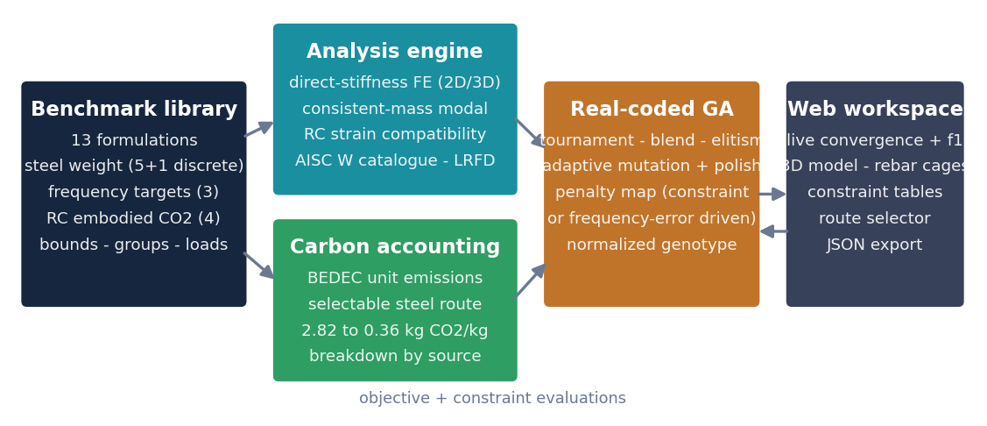
Fig. 1. Framework architecture: formulations, analysis, carbon accounting, optimizer and interactive layer.
3.1 Real-coded genetic algorithm and penalty design
The optimizer is a deliberately transparent real-coded GA: tournament selection (k = 3), blend crossover, Gaussian mutation whose scale decays over the run with a widening burst on stagnation, elitism that always preserves the best-so-far design, and a short coordinate-descent polish of the final design. Heterogeneous and discrete variables are handled through a normalized genotype in [0, 1]ᴺ mapped to physical bounds or catalogue indices, so the same operators serve continuous areas, RC dimensions and W-shape selection alike. Constraint handling maps every candidate to a single fitness value
F(x) = m(x) if feasible; P + w·v(x) + m(x) otherwise (2)
with P = 10¹⁰ so any feasible design dominates any infeasible one. The violation measure v is the decisive design choice. For stress/displacement problems a violation count suffices, because shrinking any area moves the design toward feasibility monotonically. For frequency targets it fails: frequencies are non-monotonic in the areas [6], a violation count offers no gradient among infeasible designs, and the mass tie-breaker then drags the search toward degenerate light structures. The framework therefore ranks infeasible frequency designs by their normalized distance to the target band, v = Σ max(0, |f–f*|/f* – tol), so the search homes in on the frequency itself and only then minimizes mass along the band. Section 4.2 shows this recovering feasibility on a case an earlier implementation had misreported as unattainable—and the best design’s target-mode frequency is tracked every generation so that convergence toward the target is itself observable.
3.2 Verification methodology
Every mechanical ingredient is verified against a closed-form or enumerable truth: fixed-end-force handling of member loads reproduces the clamped-beam wL²/12 and wL²/24 moments to machine precision; global equilibrium of base reactions is asserted under combined loading; the discrete MRF space (31 × 18 = 558 designs) is brute-forced to certify the model’s global optimum; published designs are re-evaluated and must emerge feasible with near-active governing constraints; and an import-blocking test proves the absence of hidden solver dependencies. Where the implemented checks and the literature diverge, the divergence is quantified and documented rather than tuned away—Section 4 gives two examples. At the section level, the doubly-reinforced solver reproduces the closed-form singly-reinforced strength to machine precision (relative deviation below 1e-13) throughout the closed form's validity range, and the column interaction surface passes through the independently computed axial cap, balanced point and pure-bending anchor, the latter agreeing to 0.06% with the separate flexural solver; the complete verification set accompanies the paper as supplementary material.
3.3 Interactive layer and educational workflow
A lightweight web workspace (Fig. 2) exposes every problem as a card with population/generation controls, the steel-route selector for RC problems, a live convergence chart (frequency-vs-target for the frequency family), an orbitable 3-D model in which concrete is rendered translucent so the optimized reinforcement cage is visible, and full constraint-utilisation tables with demand, capacity and governing member. The intended workflow—run, read the governing constraint, perturb one decision (a bound, the route, the budget), re-run—turns each benchmark into an experiment. The suite spans a deliberate difficulty gradient, from the ten-variable planar truss an undergraduate can reason about to the code-checked frames a practitioner will recognize, so the same tool serves introductory courses, graduate optimization classes and continuing education on embodied carbon.
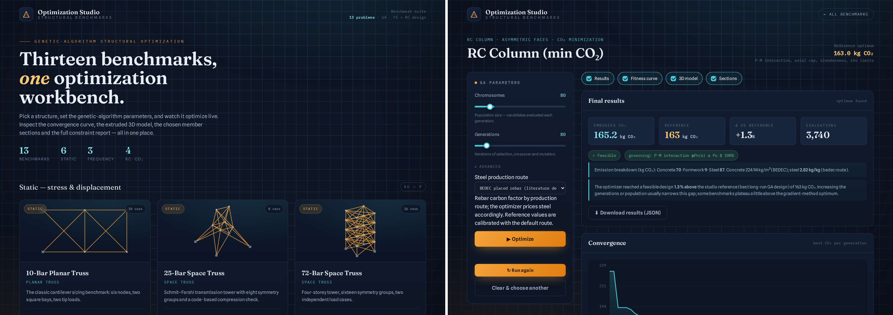
Fig. 2. Interactive workspace: benchmark library (left) and a completed RC-column run with constraint tables and the translucent-concrete reinforcement view (right).
The difficulty gradient maps naturally onto audiences. Undergraduates begin with the 10-bar truss, where every constraint can be checked by hand, and progress to reading utilisation tables as a design narrative: which limit state governs, and what relieving it would cost. Graduate optimization courses use the suite as a controlled laboratory—the frequency family for penalty design (Section 4.2), the discrete MRF for enumeration versus stochastic search, the RC members for constraint-activity analysis—with fixed seeds making every claim in this paper a homework-reproducible experiment. Practitioners and continuing-education audiences enter through the code-checked problems they recognize (LRFD interaction, ACI 318 provisions, strong-column/weak-beam) and through the route selector, which converts an abstract emission factor into a procurement question with a quantified answer. Because the entire stack is open and dependency-light, instructors can also assign extensions—a new constraint, a new section law, a new emission dataset—as term projects rather than software engineering exercises.
4. Numerical studies
Table 3 first summarizes one reproducible sample run per problem across the entire suite (fixed seeds; population 60–120 over 60–250 generations; evaluation costs from ~0.1 ms for closed-form RC members to ~15 ms for the RC frame with two load combinations and nine interaction bisections). Three deliberate divergences from the literature are visible and documented rather than tuned away: the 25-bar tower and 25-member frame admit designs lighter than their references under the implemented checks, and the 72-bar displacement interpretation (both load cases, all top-node degrees of freedom) binds harder than the classic one, with three independent 30,000-evaluation runs plateauing at ~250 kg with the limit exactly active. The subsections examine representative cases of each family in depth.
Table 3. Sample runs across the suite (single seeded run per problem; Δ relative to the reference of Table 1).
Problem | Result | Reference | Δ | Governing at optimum
10-bar truss | 2358.9 kg | 2299.7 kg | +2.6% | displacement
25-bar tower | 421.1 kg | 649.7 kg | –35%¹ | AISC compression
72-bar tower | 250.1 kg | 172.2 kg | +45%¹ | displacement (100%)
10-member frame | 3216.7 kg | 3307.2 kg | –2.7% | drift
25-member frame | 3781.6 kg | 9508.3 kg | –60%¹ | drift
3-storey steel MRF | 17,789 lb | 18,792 lb | –5.3%¹ | column H1 (99.7%)
Built-up I-beam, ASD | 315.7 kg | 312.7 kg | +1.0% | LTB, flexure (100%)
Built-up I-beam, LRFD | 276.6 kg | 276.7 kg | –0.0% | LTB, flexure (100%)
10-bar (frequency) | 2574.3 kg | 2637.9 kg | –2.4% | f₁ = 13.86 Hz (±1%)
72-bar (frequency) | 283.7 kg | 287.1 kg | –1.2% | f₁ = 3.92 Hz (±2%)
Portal (frequency) | 4197.5 kg | 4272.3 kg | –1.8% | ω₁ = 76.1 rad/s (±3%)
RC beam | 732.6 kg CO₂ | 728.3 | +0.6% | flexure (100%)
RC column | 163.2 kg CO₂ | 163.0 | +0.1% | P–M (100%), ρ = 1%
RC footing | 1157.7 kg CO₂ | 1155.8 | +0.2% | bearing + punching + flexure
RC 3-storey frame | 5301.9 kg CO₂ | 5301.9 | 0.0% | beam hogging + column P–M
¹ Documented model divergences discussed in the text (Sections 3.2, 4.1).
4.1 Minimum-weight steel: continuous and discrete
Figure 3 summarizes two representative steel studies. The 10-bar truss converges to 2358.9 kg, within 2.6% of the 2299.65 kg reference [5], with the displacement constraint active. The discrete MRF study is the more instructive: the published W24×62/W10×60 design evaluates as feasible with the beams governing at 93.6% utilisation, and the next-lighter beam (W24×55) correctly fails at 106%—the implementation reproduces the benchmark’s decision boundary on the beam side exactly. On the column side, brute force over all 558 combinations locates this model’s optimum at W24×62/W10×49 (17,789 lb), whose critical column sits at 99.7% utilisation: 0.3% inside a boundary that the original studies’ full-code machinery (exact alignment-chart K, storey-drift B₂) evidently places just outside, which is why they report W10×60 (18,792 lb). A 0.3% margin on one member deciding a 5% weight difference is documented as a feature, not hidden: it is the sharpest available illustration of how discrete optima hinge on modelling detail.
The 72-bar tower illustrates the documentation discipline of Section 3.2. Three independent 30,000-evaluation runs plateau at 250–254 kg with the ±6.35 mm top-storey displacement limit exactly active in both load cases—this is the model’s optimum, not under-convergence—whereas the classic reference is 172.2 kg [5]. The implemented interpretation (both load cases, every translational degree of freedom of all four top nodes) simply binds harder than the historical one; the framework reports the 45% gap with its cause rather than relaxing the check to match the number, and the same page of its documentation invites students to test the sensitivity themselves by editing one line of the constraint.
The built-up beam pair extends the steel family from analysis-driven sizing to code-based member design. At the defaults (100 kN·m over an unbraced 7 m span) both optima are governed by lateral-torsional buckling at exactly 100% utilisation—the correct physics for that span—with the search converging on minimum plate thicknesses and a wide compression flange that maximizes the radii ry and rts: ASD reaches 312.7 kg and LRFD 276.7 kg, 11.5% lighter for the same nominal demand, less than the 50% capacity advantage of φΩ = 1.503 because the LTB strength itself falls as the section slims. Making the span laterally supported removes the LTB limit state and the governing check flips to flange yielding; an over-wide thin flange drives the classification to slender and flange local buckling takes over. Seven pinned mechanics tests certify the module (compact–supported strength equal to Mp to machine precision; strength monotone in Lb; F4 strength bracketed between My and Mp; F5 reduction active; LRFD/ASD capacity ratio equal to φΩ to 10⁻⁶), and the full property table—I, S, Z, J, Cw, the λ–λp–λr triplets, Lp/Lr, Mn per limit state and the bending stress against its allowable—is reported for every run, which is what makes the pair a teaching instrument rather than a black box.
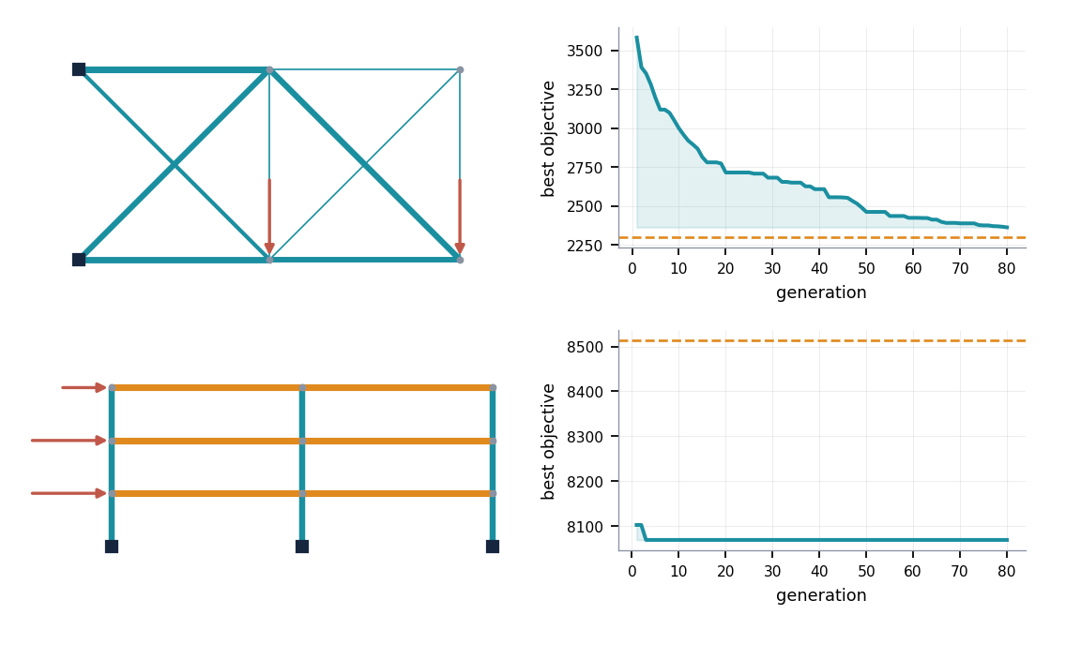
Fig. 3. Steel studies: optimized geometry (member thickness ∝ √A) and convergence for the 10-bar truss (top) and the discrete 3-storey MRF (bottom); dashed lines mark published references.
4.2 Frequency-targeted sizing and penalty design
The 10-bar truss with 454 kg lumped masses must place f₁ on a 14 Hz target [5]. Under a violation-count penalty the search collapses to a 19 kg design at 1.17 Hz—numerically “least infeasible” by count, physically meaningless—and the case had accordingly been misreported as unattainable. With the frequency-error penalty of Eq. (2) the same GA finds feasible designs inside a ±1% band at 2574 kg (Fig. 4), and tightening the band converges the optimal mass monotonically to the published value: 2503 kg (±2%), 2573 kg (±1%), 2611 kg (±0.5%), versus 2637.85 kg at exactly 14 Hz [5]. The companion 72-bar problem lands at 3.92 Hz and 283.7 kg against the published 287.1 kg. The lesson generalizes: when the constraint, not the objective, encodes the engineering intent, the penalty should be built from the constraint’s own metric.
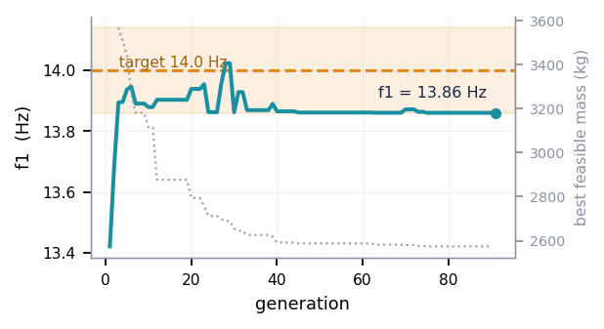
Fig. 4. Frequency convergence of the 10-bar problem: best-design f₁ per generation entering the ±1% target band (shaded); dotted grey line, best feasible mass.
4.3 Reinforced concrete: full flexural search spaces
Figure 5 shows the three RC member studies at the default route. The beam optimum (728.3 kg CO₂) drives its top steel to the 226 mm² hanger minimum—compression steel is not carbon-economical at this span—and lands flexure exactly at 100%, the textbook singly-governed optimum recovered from a doubly-reinforced search space. The column result is the framework’s most instructive: at its small eccentricity (e/h ≈ 0.20, compression-controlled) the optimizer places more steel on the compression face (739 vs 300 mm²), pins the total ratio on the ACI 1% floor, and beats the best symmetric cage by 4.7% (163.0 vs 171.0 kg)—strain-compatibility behaviour a fixed symmetric formulation cannot express. The three-storey frame (5301.9 kg) finishes with beam hogging flexure and column P–M interaction simultaneously active at 100% and a deep, narrow column shaped by the strong-column/weak-beam provision; the footing (1155.8 kg) is a genuine multi-constraint corner with soil bearing, punching shear and flexure all active.
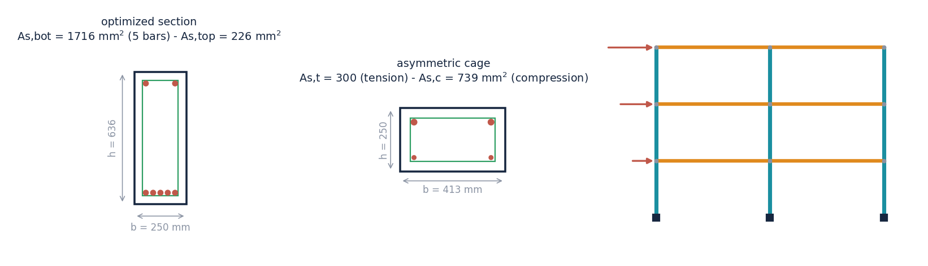
Fig. 5. RC optima at the default route: beam section with both optimized layers; asymmetric column cage (tension face bottom); three-storey frame elevation (member thickness to scale).
4.4 Production-route study: what the steel decision buys
Re-optimizing the beam, column and footing under each route of Table 2 yields Fig. 6. Two effects separate cleanly. The accounting effect—cheaper-carbon steel at fixed design—would scale only the steel share; the design effect is larger: because the optimizer re-balances materials, moving from BEDEC to low-carbon EAF rebar cuts the optimal footprint by 56% for the beam (728 → 323 kg) while its optimal steel mass rises 57% (140 → 220 kg) in a shallower section; the column drops 49% (163 → 82 kg) with roughly double the steel in a smaller section; the footing, whose plan dimensions are pinned by the geotechnical bearing check, is least elastic at −22%. The framework thus quantifies, per member, how much of decarbonization is available through procurement alone and how the optimal design itself migrates—precisely the intuition the educational deployment aims to build.
Table 4. Route study: optimal embodied CO₂ and steel mass at the optimum (two seeds per cell; default-route values in bold column one of Table 1).
Route (kg CO₂/kg) | Factor | Beam: CO₂ (steel) | Column: CO₂ (steel) | Footing: CO₂ (steel)
BEDEC placed rebar | 2.82 | 728 kg (140 kg) | 163 kg (30 kg) | 1154 kg (108 kg)
BF–BOF primary | 1.99 | 609 kg (149 kg) | 138 kg (30 kg) | 1065 kg (108 kg)
World average | 1.85 | 588 kg (156 kg) | 134 kg (30 kg) | 1049 kg (108 kg)
EAF scrap, grid | 0.67 | 386 kg (178 kg) | 98 kg (41 kg) | 931 kg (122 kg)
EAF, low-carbon | 0.36 | 323 kg (220 kg) | 82 kg (61 kg) | 895 kg (124 kg)
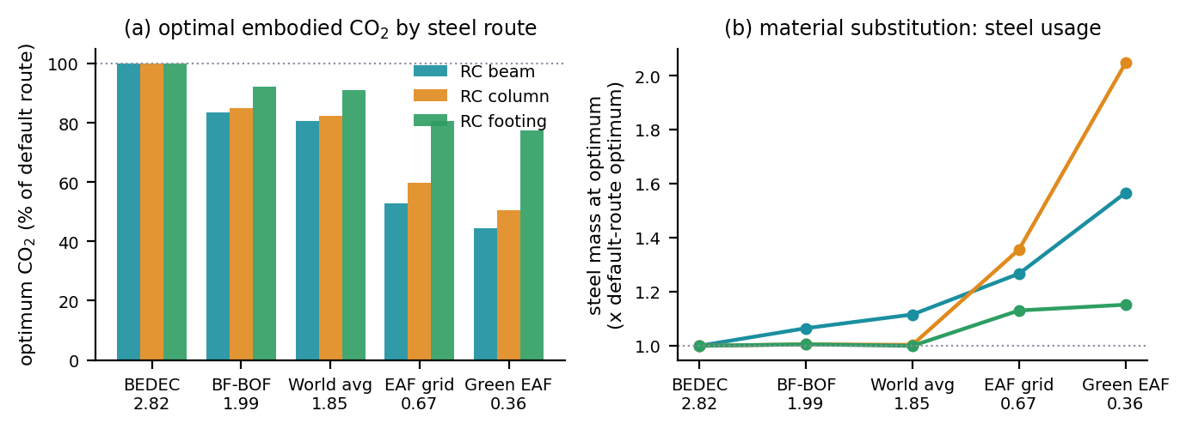
Fig. 6. Route study: (a) optimal embodied CO₂ normalized by the default-route optimum; (b) steel mass at the optimum, showing systematic concrete-to-steel substitution as the rebar factor falls.
Four further checks bound these conclusions (Fig. 8 and supplementary Figs. S1–S6). Cost–CO₂ Pareto fronts show a shallow trade near the cost optimum at the BEDEC route—about 1.5% (beam) to 2.4% (column) of CO₂ saved per 1% of cost—confirming that meaningful carbon savings are affordable; in price–emission ratio space the cost- and carbon-optimal designs coincide only along the locus where the emission ratio equals the price ratio, so the divergence is a property of the ratios rather than of the assumed prices; eight-seed GA replicates scatter by at most 0.6 percentage points on every member-level benchmark, the discrete MRF reproducing its brute-force optimum in every run; and re-optimizing the complete frame under each objective closes the frozen-demand assumption of the section study: governing force envelopes shift by less than 4% between optima, while the system-level cross-penalties (+4.3% CO₂ for the cost-optimal frame at BEDEC; +2.8% cost for the carbon-optimal frame) mirror the section-level values.
4.5 Cost-optimal versus carbon-optimal sections
To make the objective-function comparison concrete at the detailing level, the governing beam and column sections of the reference frame were re-designed over their full (h, As) planes under three objectives—minimum cost at representative placed prices (90 €/m³ concrete, 1.30 €/kg steel, 25 €/m² formwork) and minimum CO₂ at the BEDEC and green-EAF rebar factors—with the governing force envelopes frozen at the reference-frame values, an assumption closed to within 4% above. Figure 7 draws the six optima to a common scale with practical reinforcement (single-diameter symmetric sets at ≥25 mm clear spacing; corner-anchored perimeter cages for the columns, whose interaction analysis idealizes the steel in two extreme layers identically for all objectives), and Table 5 lists the parameters. All six sections sit at 100% utilisation of their governing check, yet they are three genuinely different members: at the BEDEC factor the carbon optimum is the deep, lightly reinforced section—the beam gains 133 mm of depth and sheds a third of its steel (ρ falling from 1.70% to 0.84%, ductility εt doubling to 0.014, links relaxing from Ø10@180 to @245)—and the column deepens by 81 mm with its cage on the ACI 1% floor, whereas under green-EAF rebar the optimum swings to the shallow, steel-rich corner (6Ø20 in two layers; a 6Ø25 perimeter cage at ρ = 1.96%), leaving the cost-optimal section bracketed between the two carbon designs in every parameter.
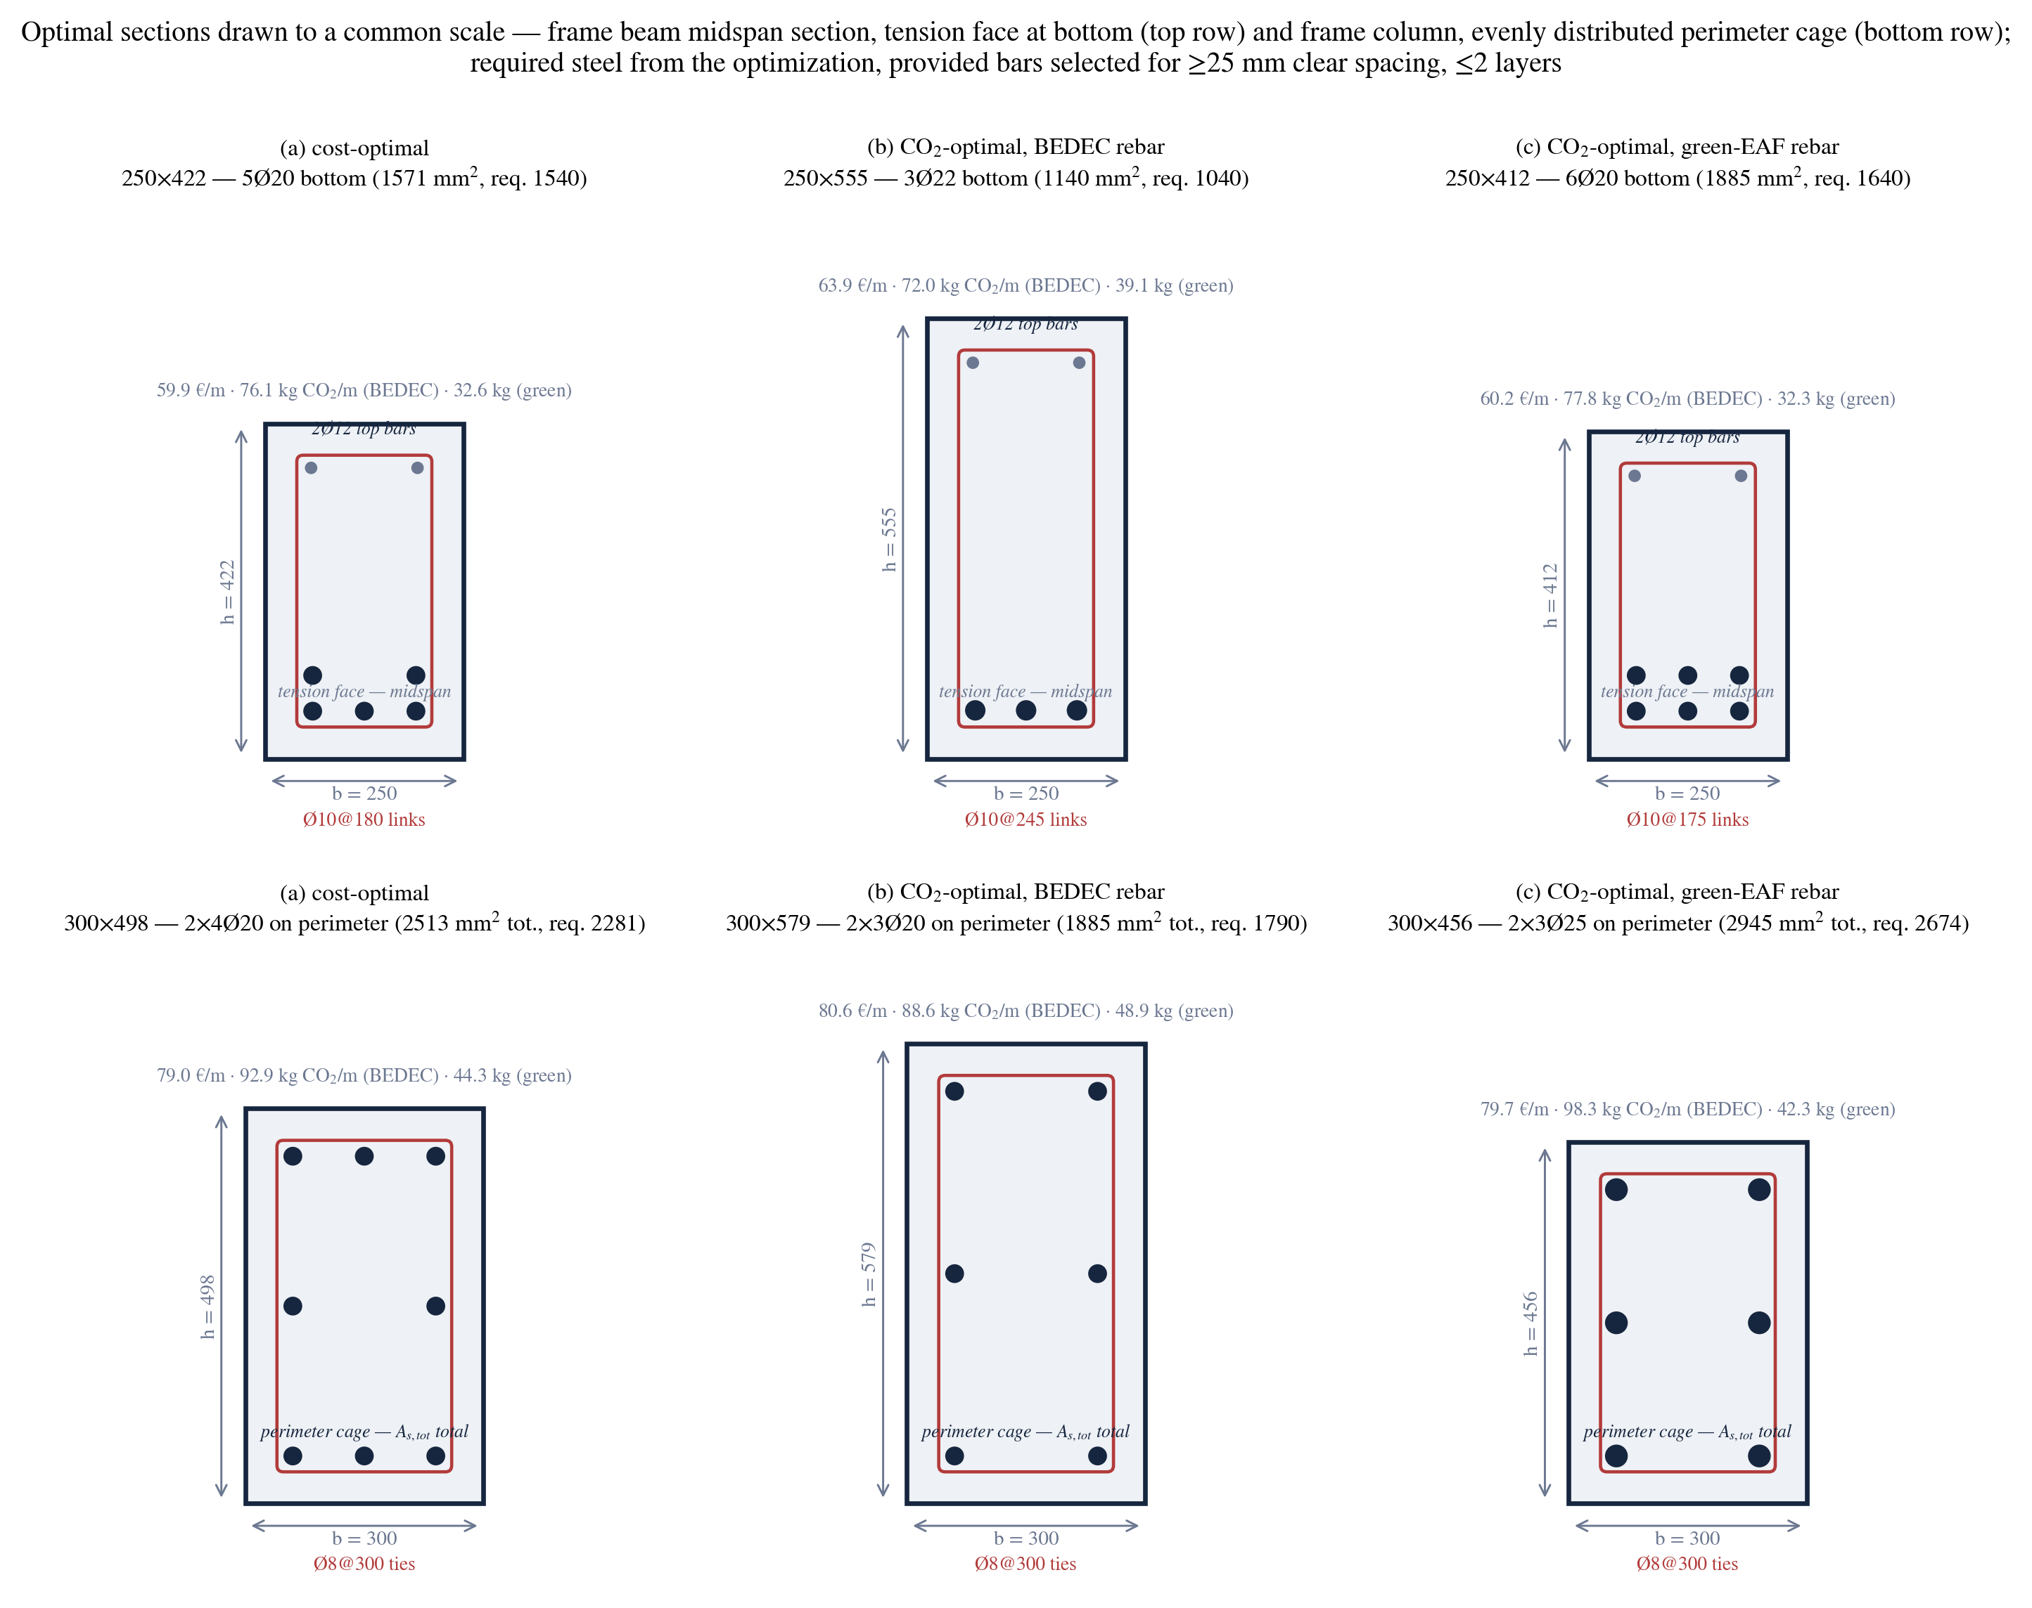
Fig. 7. The six optimal sections drawn to a common scale (beam midspan convention, tension face at bottom; corner-anchored perimeter column cages), with practical bar schedules never under-providing the required areas; each design sits at 100% utilisation of its governing limit state.
Table 5. Parameters of the six optimal sections (required steel from the optimization; bars as drawn in Fig. 7).
Member · objective | b × h (mm) | Bars | ρ (%) | Steel (kg/m) | Cost (€/m) | CO₂ 2.82 / 0.36
Beam · cost | 250 × 422 | 5Ø20 + 2Ø12 | 1.70 | 17.7 | 59.9 | 76.1 / 32.6
Beam · CO₂ BEDEC | 250 × 555 | 3Ø22 + 2Ø12 | 0.84 | 13.4 | 63.9 | 72.0 / 39.1
Beam · CO₂ green | 250 × 412 | 6Ø20 + 2Ø12 | 1.86 | 18.5 | 60.2 | 77.8 / 32.3
Column · cost | 300 × 498 | 8Ø20 perimeter | 1.53 | 19.8 | 79.0 | 92.9 / 44.3
Column · CO₂ BEDEC | 300 × 579 | 6Ø20 perimeter | 1.03 | 16.1 | 80.6 | 88.6 / 48.9
Column · CO₂ green | 300 × 456 | 6Ø25 perimeter | 1.96 | 22.8 | 79.7 | 98.3 / 42.3
Figure 8 places the same comparison in objective space: cost–CO₂ Pareto fronts of the two section design planes, one front per steel-production route, with the cost and carbon optima marking the ends. Near the cost optimum at the BEDEC route the front is shallow—about 1.5% (beam) to 2.4% (column) of CO₂ saved per 1% of cost—so meaningful carbon savings are nearly free, while the end-to-end span of each front quantifies the full price of carbon-first design (+6.7% cost for the beam at BEDEC, +0.6% under green rebar). The bracketing of Fig. 7 and the route-dependent ordering of the fronts share one explanation: a kilogram of reinforcement substitutes for 0.0144 m³ of concrete in monetary terms, 0.0125 m³ in BEDEC carbon terms, and only 0.0016 m³ under green-EAF rebar, so cost- and carbon-optimal designs nearly coincide for conventional steel—the classical finding [16, 18]—and diverge in the steel-rich direction precisely as the supply chain decarbonizes. For the educational deployment this is the central lesson of the study: the code boundary admits a family of equally safe designs, and the objective function merely selects the point—a choice the workspace lets students make, redraw and price in minutes.
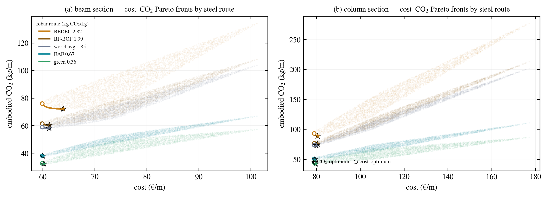
Fig. 8. Cost–CO₂ Pareto fronts of the beam (a) and column (b) design planes by steel route; circles mark cost optima, stars carbon optima.
5. Conclusions, limitations and prospects
This paper presented a verified, open, interactive framework that unifies minimum-weight steel sizing, code-based member design under both AISC design philosophies, and minimum-embodied-carbon RC design across fifteen benchmarks solved by a transparent real-coded GA. Its contributions are methodological as much as infrastructural: complete RC flexural search spaces resolved by doubly-reinforced strain compatibility, an asymmetric-column formulation that recovers correct compression-controlled behaviour and a 4.7% carbon saving over the symmetric convention; a frequency-error penalty that restores feasibility to a mis-labelled benchmark and converges to the published optimum as the tolerance tightens; a source-cited, selectable steel-production route that turns a fixed emission factor into a design decision, with demonstrated 22–56% reductions at the optimum and systematic material substitution; and a documentation discipline in which divergences from the literature (a 0.3% interaction margin deciding a discrete jump; a displacement interpretation binding harder than the classic one) are quantified rather than tuned away.
Limitations delimit the claims. Frame analysis is first-order elastic (with LRFD amplification where the benchmark requires it); serviceability uses a simplified effective inertia; the built-up beam module treats unstiffened doubly symmetric sections at Cb = 1; the RC frame is a planar idealization under a single lateral pattern; unit emissions are database-dependent snapshots and exclude life-cycle modules beyond cradle-to-site; costs are represented only through their proxy alignment with volume; and the GA, while robust on these dimensionalities, carries no global-optimality certificate outside the enumerable discrete case. Prospects follow directly: bi-objective cost–CO₂ Pareto fronts; Eurocode and bar-scheduling modules; nonlinear seismic checks for the frame family; whole-life carbon including modules A–D; and a controlled classroom study of the educational deployment. The framework’s structure—formulation, engine, accounting, optimizer, interface, each independently testable—was designed so that each of these is an extension, not a rewrite.
Data availability
The complete framework—engine, benchmark formulations, genetic algorithm, web workspace, verification tests, and the scripts that regenerate every figure, table and sample run in this paper from fixed seeds—is available as an open, dependency-light implementation (NumPy/SciPy/Flask) with a 26-test verification suite that pins every mechanical anchor used in this paper. The per-problem benchmark documentation (one page per problem: properties, cross-sections and a reproducible sample run) accompanies the code, together with a supplementary document collecting the validation studies: closed-form mechanics verification, cost–CO₂ Pareto fronts, the price–emission regime map, constraint-utilization audits at all optima, multi-seed statistics and the whole-frame closure study.

References
[1] Schmit, L.A., Farshi, B. (1974). Some approximation concepts for structural synthesis. AIAA Journal, 12(5), 692–699.
[2] Holland, J.H. (1975). Adaptation in Natural and Artificial Systems. University of Michigan Press, Ann Arbor.
[3] Goldberg, D.E. (1989). Genetic Algorithms in Search, Optimization and Machine Learning. Addison-Wesley, Reading, MA.
[4] Rajeev, S., Krishnamoorthy, C.S. (1992). Discrete optimization of structures using genetic algorithms. Journal of Structural Engineering, 118(5), 1233–1250.
[5] Sedaghati, R. (2005). Benchmark case studies in structural design optimization using the force method. International Journal of Solids and Structures, 42(21–22), 5848–5871.
[6] Grandhi, R.V. (1993). Structural optimization with frequency constraints — a review. AIAA Journal, 31(12), 2296–2303.
[7] Pezeshk, S., Camp, C.V., Chen, D. (2000). Design of nonlinear framed structures using genetic optimization. Journal of Structural Engineering, 126(3), 382–388.
[8] Camp, C.V., Bichon, B.J., Stovall, S.P. (2005). Design of steel frames using ant colony optimization. Journal of Structural Engineering, 131(3), 369–379.
[9] Değertekin, S.O. (2008). Optimum design of steel frames using harmony search algorithm. Structural and Multidisciplinary Optimization, 36(4), 393–401.
[10] Toğan, V. (2012). Design of planar steel frames using teaching–learning based optimization. Engineering Structures, 34, 225–232.
[11] Dumonteil, P. (1992). Simple equations for effective length factors. Engineering Journal, AISC, 29(3), 111–115.
[12] AISC (1994). Load and Resistance Factor Design Specification for Structural Steel Buildings, 2nd ed. American Institute of Steel Construction, Chicago.
[13] ACI Committee 318 (2019). Building Code Requirements for Structural Concrete (ACI 318-19). American Concrete Institute, Farmington Hills, MI.
[14] Camp, C.V., Pezeshk, S., Hansson, H. (2003). Flexural design of reinforced concrete frames using a genetic algorithm. Journal of Structural Engineering, 129(1), 105–115.
[15] Lee, C., Ahn, J. (2003). Flexural design of reinforced concrete frames by genetic algorithm. Journal of Structural Engineering, 129(6), 762–774.
[16] Paya-Zaforteza, I., Yepes, V., Hospitaler, A., González-Vidosa, F. (2009). CO2-optimization of reinforced concrete frames by simulated annealing. Engineering Structures, 31(7), 1501–1508.
[17] Yepes, V., González-Vidosa, F., Alcalá, J., Villalba, P. (2012). CO2-optimization design of reinforced concrete retaining walls based on a VNS-threshold acceptance strategy. Journal of Computing in Civil Engineering, 26(3), 378–386.
[18] Camp, C.V., Huq, F. (2013). CO2 and cost optimization of reinforced concrete frames using a big bang–big crunch algorithm. Engineering Structures, 48, 363–372.
[19] Camp, C.V., Assadollahi, A. (2013). CO2 and cost optimization of reinforced concrete footings using a hybrid big bang–big crunch algorithm. Structural and Multidisciplinary Optimization, 48(2), 411–426.
[20] de Medeiros, G.F., Kripka, M. (2014). Optimization of reinforced concrete columns according to different environmental impact assessment parameters. Engineering Structures, 59, 185–194.
[21] Yeo, D., Potra, F.A. (2015). Sustainable design of reinforced concrete structures through CO2 emission optimization. Journal of Structural Engineering, 141(3).
[22] Institut de Tecnologia de la Construcció de Catalunya (ITeC). BEDEC PR/PCT database of construction elements and unit environmental data. Barcelona (accessed 2026).
[23] World Steel Association (2024). Sustainability Indicators 2024 Report: CO2 emissions intensity by production route. Brussels.
[24] IEEFA (2022). Steel Fact Sheet: carbon intensity of BF–BOF, DRI–EAF and scrap–EAF routes. Institute for Energy Economics and Financial Analysis.
[25] Columbia Business School, Climate Knowledge Initiative (2023). Steel Sector Overview: production routes and emission intensities.
[26] New Steel Construction / Eurofer (2024). The carbon footprint of steel: primary and secondary route intensities by system expansion. British Constructional Steelwork Association.
[27] AISC (2016). Specification for Structural Steel Buildings (ANSI/AISC 360-16). American Institute of Steel Construction, Chicago.

