**Online exam**

The students will:

* design 10 simple questions and save these questions in JSON file or JavaScript list objects;
* read this JSON file or this list objects and display individually each question;
* add navigation buttons, so the exam taker can move from one question to the next or previous questions;
* store the answers from the exam taker;
* display the degree of the exam taker;
* store all exam taker’s answers in a new JSON file or text file, so the exam taker can continue the exam later. For example, when a wild event is occurred, such as there is no a connection with the host or there is a cut in the electricity.

The code must use class, where there are two classes: the exam class and the question class. The parent class is the exam, and the child class is the question. The question class sends the exam taker’s answer to the parent exam class.

**Online seller**

The students will:

* collect information about 10 simple products and save this information in JSON file or JavaScript list object;
* read this JSON file or this list objects and display all products;
* allow the user to click on one product and display the information about this product in details;
* add navigation buttons, therefore the user can move to the next and the previous product’s information.
* allow users to select a product for buying;
* display all products that the user has selected them for buying.

The code must use class, where there are two classes: the seller class and the product class. The parent class is the seller, and the child class is the product. The product class sends a message to the seller class, when the user selects this product.

**Tic-Tac-Toe Game**

When we google for tic-tac-toe game, and google displays the tic-tac-toe game as:

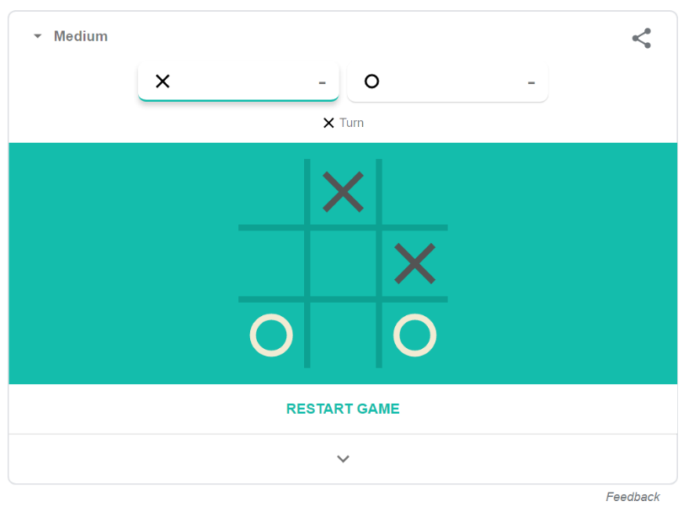

The students will design this game with more options:

* the user can select the background colour. For example, this background colour is green. The student will add new list of colours, and allow the user chose the colour.
* The user can select the colours of X and O.
* The current size of this game is 3x3. The students allow the user to choose the size of the game, such as 3x3, 4x4, or 5x5. The game will be drawn with the new size.

**Website layout**

The next figure shows different website layouts.

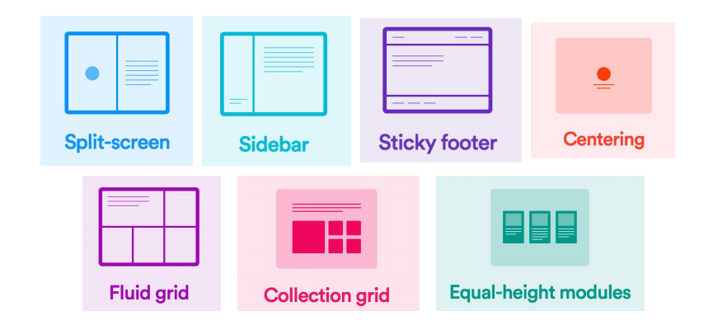

The students will:

* make one layout from this list of layouts.
* Show how their layout is related to one the professional websites, for example the website <https://www.atptour.com/en> has the next layout.
* collect information and display this information in their layout.

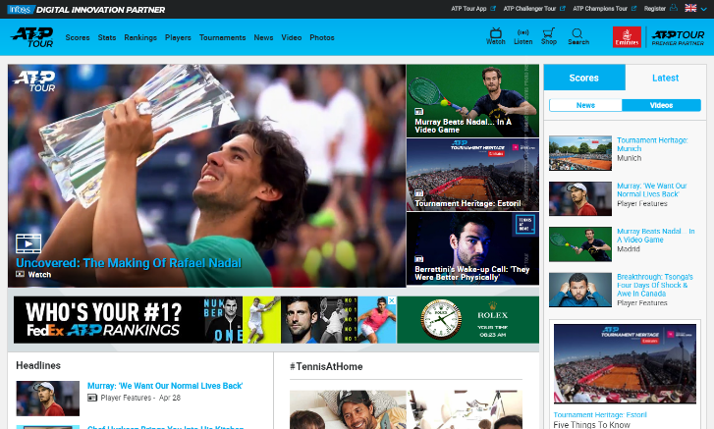

**Searching for the gifts**

We have five boxes, where one of them contains a hidden gift. The user clicks on one random box. If this box contains a gift, the website shows “You win in X steps, where X is the number of clicks on the boxes. When the user clicks on box without gift, the code increase X with one.

For Example:

Contains a hidden gift

Now, X contains zero value. When the user clicks on the first box, this box contains no gift. Therefore, the value of X increases with one. The user tries and clicks on the third box that contains the hidden gift. Therefore, the site shows the message “You win in 2 steps”.

The students will:

* design this game.
* allow the user to select the number of boxes and draw the new game.
* set the hidden gift in one random box.
* allow the user to click on any box.