Game Topic

*(Breakout Ball)*

Under Supervision of

Prof. Reda Abdelwahhab

Teaching Assistant

Eng. Abdelrahman Yonis

Submitted By

|  |  |  |  |
| --- | --- | --- | --- |
| **No.** | **Student Name** | **Student ID** | **Student Role In The Project** |
| 1 | Ahmed Mahran Mohammed Rabea | 16-00023 | Build cube , bricks and paddle |
| 2 | Ahmed Abdulhamied Abo Alkhair | 17-00095 | Score and Chances left |
| 3 | Abdullah Mahmoud Mohammed | 17-00009 | Previous Score and High Score |
| 4 | Obbai Ahmed Essam | 16-00045 | Mouse motion and keyboard control |

**Description**

In Breakout, to start the game click on left side of the mouse, the initial configuration of the world appears as shown on the right. The rectangles in the top part of the screen are bricks, and the slightly larger rectangle at the bottom is the paddle. The paddle is in a fixed position in the vertical dimension, but moves back and forth across the screen along with the keyboard until it reaches the edges of the window.

A complete game consists of three chances. On each chance, a ball is launched from the center of the window toward the bottom of the screen at a random angle. That ball bounces off the paddle and the walls of the world, in accordance with the physical principle generally expressed as “the angle of incidence equals the angle of reflection”.

After all the bricks in a particular column have been cleared, a path will open to the top wall. When this situation occurs, the ball will often bounce back and forth several times between the top wall and the upper line of bricks without the user ever having to worry about hitting the ball with the paddle. This condition is a reward for “breaking out”.

The game consists of four main principles that appear on the right side which is :

1. Score: Shows the number of points that are achieved in the game.
2. Chances left: Shows the number of attempts remaining for the player each time.
3. Previous score: Shows the old score when start new game with new chances.
4. High score: Explain the highest for the game, which recorded in the high-score table.

**Technologies Used**

* C++ Language

**Steps To Run**

1. Install visual studio code .
2. 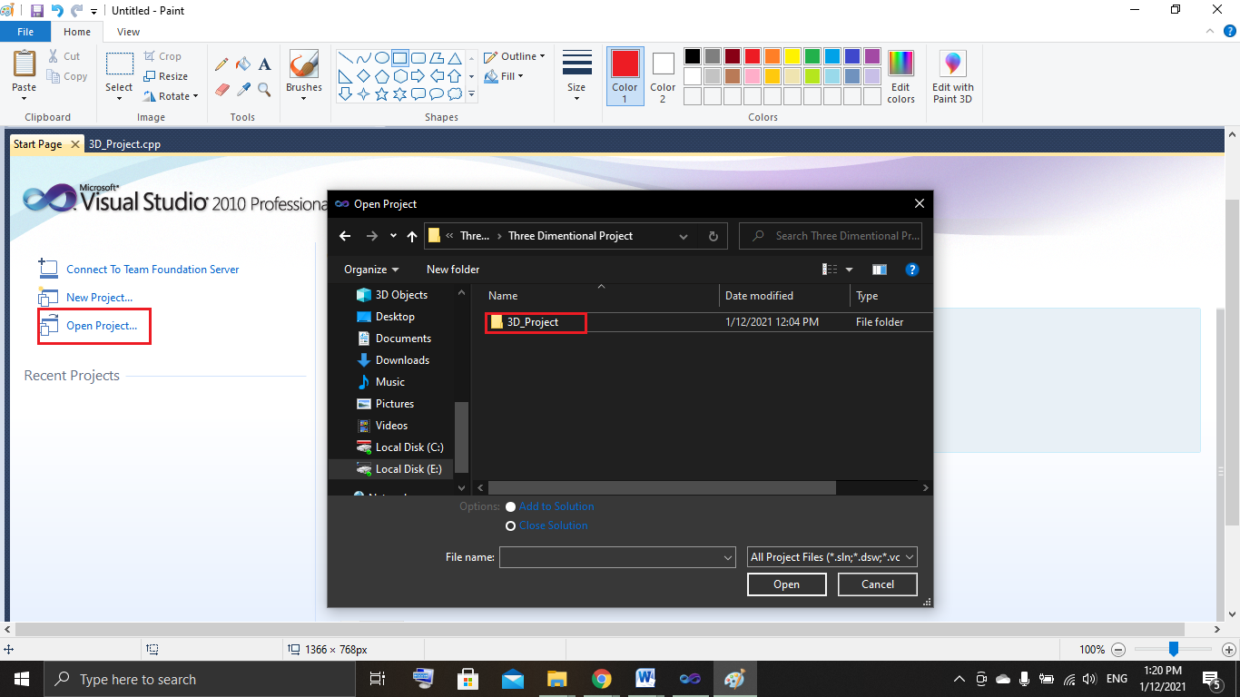Select open project 🡪 E:\First Semester 4rd year 2020-2021\Three Dimensional Graphics\Three Dimentional Project .
3. 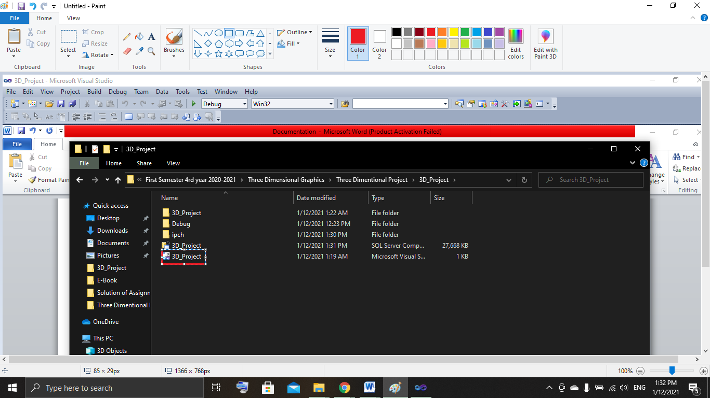Select 3D_Project.cpp .
4. Finally Run the game project .

