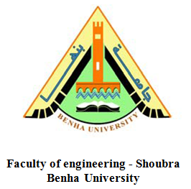

***Operating Systems Report***

**Name:** Ahmed Mohamed Mohamed Abdelkreem.

**B.N:** 132

**Date:** 29/5/2020

**Topic:** Operating Systems

**Github URL:**

**Application Brief:**

The operating system is one of the most important fields that all technology companies are interested in, because working in this field returns with great profit. The most famous examples of operating systems are Windows, macOS and Linux, where every home contains at least one device which has its own operating system that works on. This is what prompted the companies developing these systems to continue working on them, and also pushed many people to take an interest in this field and try to work on it**.**

***Screenshots:***

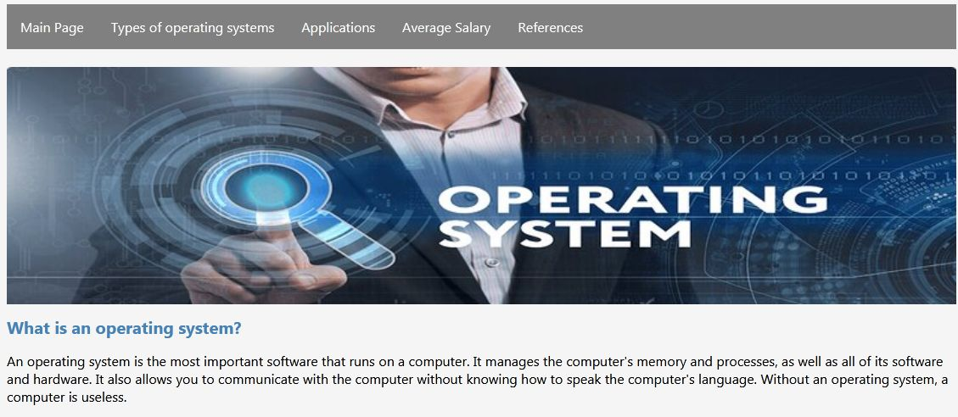

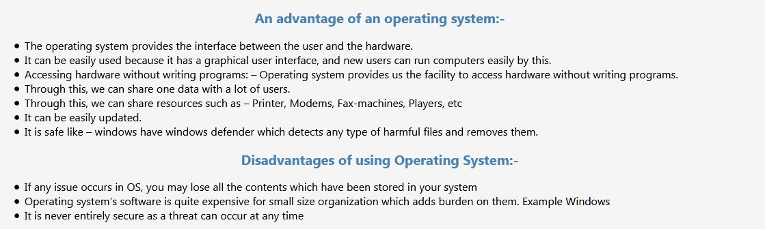

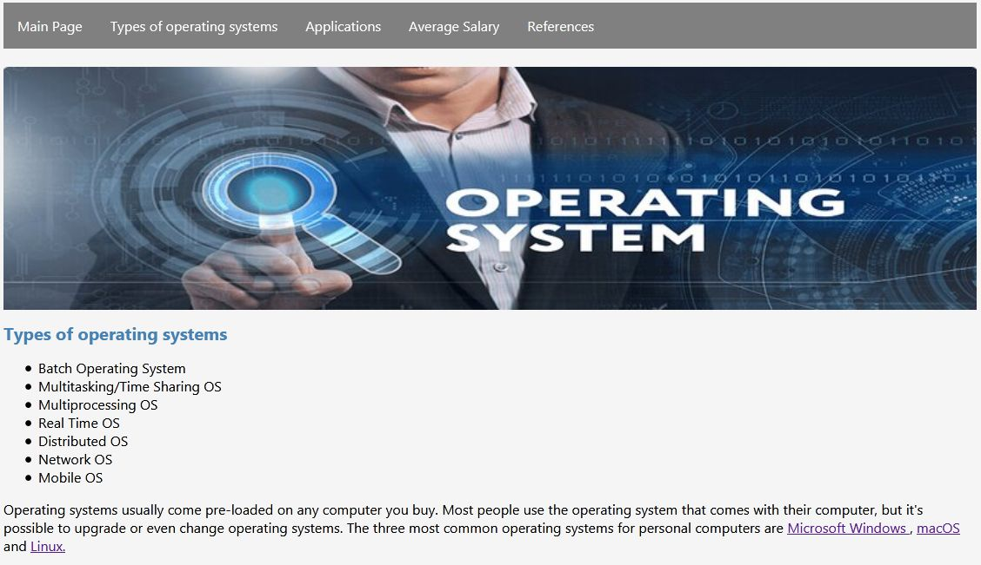

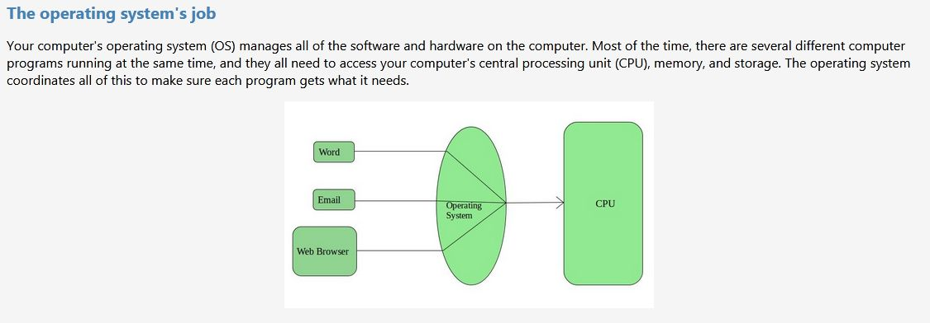

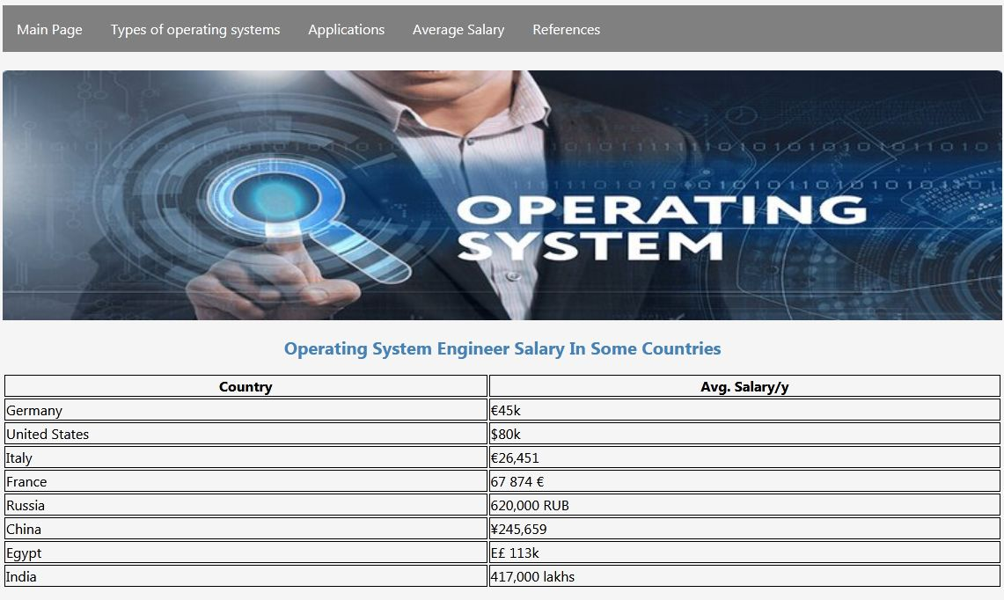

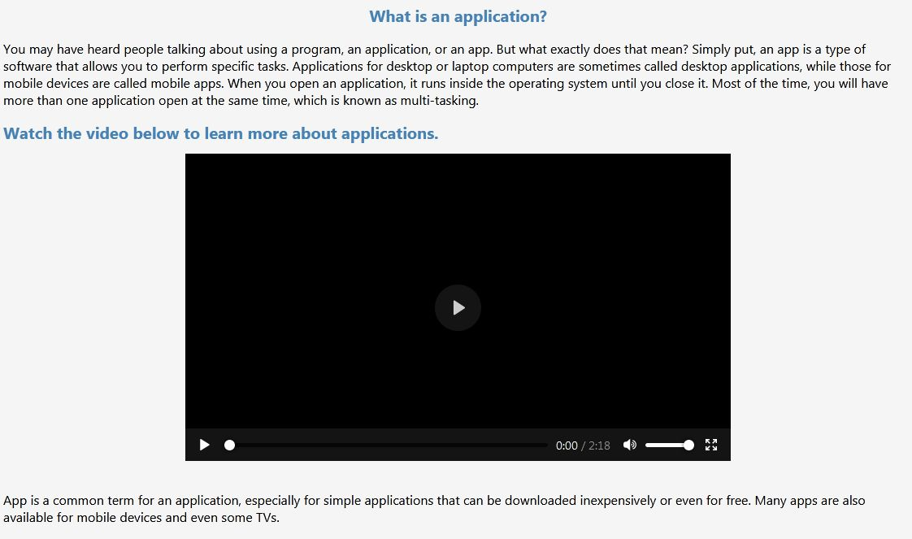

***Screenshots of source code:***



