
Advanced OOP
School ERP

Presented By:
Alhussien Mahmoud Hussien 241009243
Ahmed Adel 231018517
Omar Mohamed 241008763
Aya Sharaf 241009122
Eslam Alaa 231008565

Presented To:
Dr.Shady Zahran
Dr.Mostafa Mohammed
Contents

Table of figures……………………………………………………………………………………………………………………………….. 3
Section 1………………………………………………………………………………………………………………………………………… 4-8
Eror 1………………………………………………………………………………………………………………………………………… 4
Eror 2………………………………………………………………………………………………………………………………………… 5
Eror 3………………………………………………………………………………………………………………………………………… 6
Eror 4………………………………………………………………………………………………………………………………………… 7
Eror 5………………………………………………………………………………………………………………………………………… 8
Section 2………………………………………………………………………………………………………………………………………… 9
Section 3……………………………………………………………………………………………………………………………………… 10-1

Table Of Figures
Figure 1…………………………………………………………………………………………………………………………………………………………………4
Figure 2…………………………………………………………………………………………………………………………………………………………………5
Figure 3…………………………………………………………………………………………………………………………………………………………………6
Figure 4…………………………………………………………………………………………………………………………………………………………………7
Figure 5…………………………………………………………………………………………………………………………………………………………………8
Figure 6…………………………………………………………………………………………………………………………………………………………………9

Section 1: Erors
First Eror:
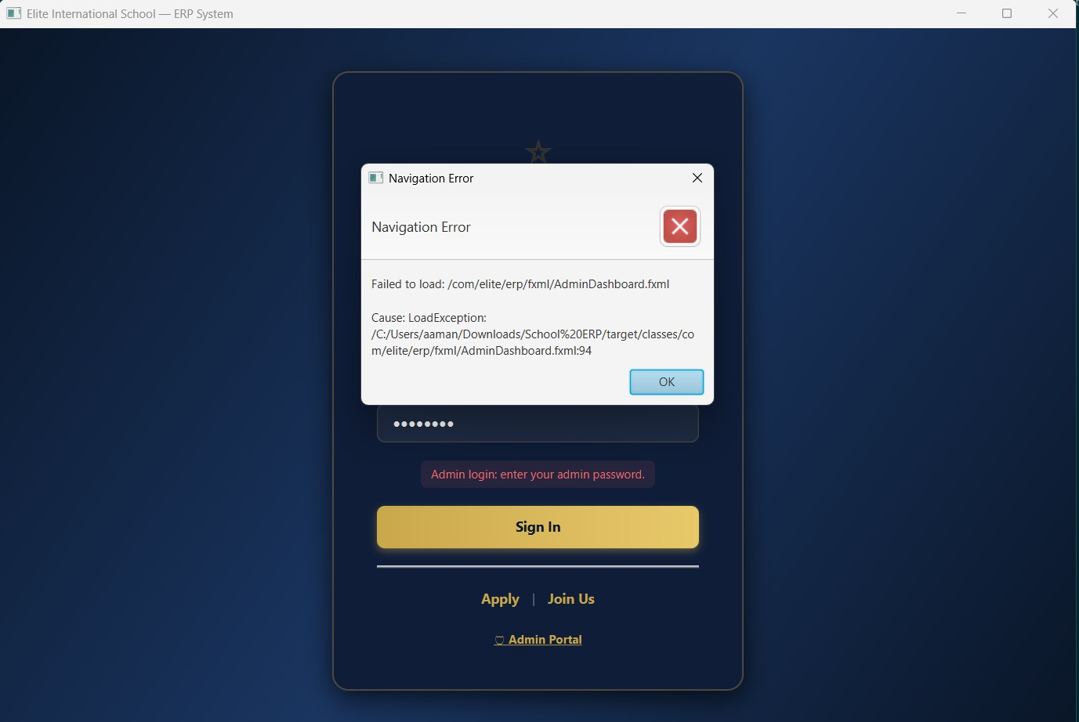
Figure 1.
Error Description: The application crashed and displayed a "Navigation Error" pop-up (LoadException) when attempting to load the Admin Panel after a user login attempt.

Cause: A mismatch occurred between AdminDashboard.fxml (specifically at line 94) and its corresponding Java Controller class. This occurs when an injected UI element has an fx:id or onAction event handler in the FXML that does not perfectly match the method or variable declared in the Controller.

Solution: Reviewed line 94 of the FXML file using Scene Builder and synchronized the @FXML variable names and action methods with the AdminDashboardController.java file.
Second Eror: Parent Dashboard FXGL Clash

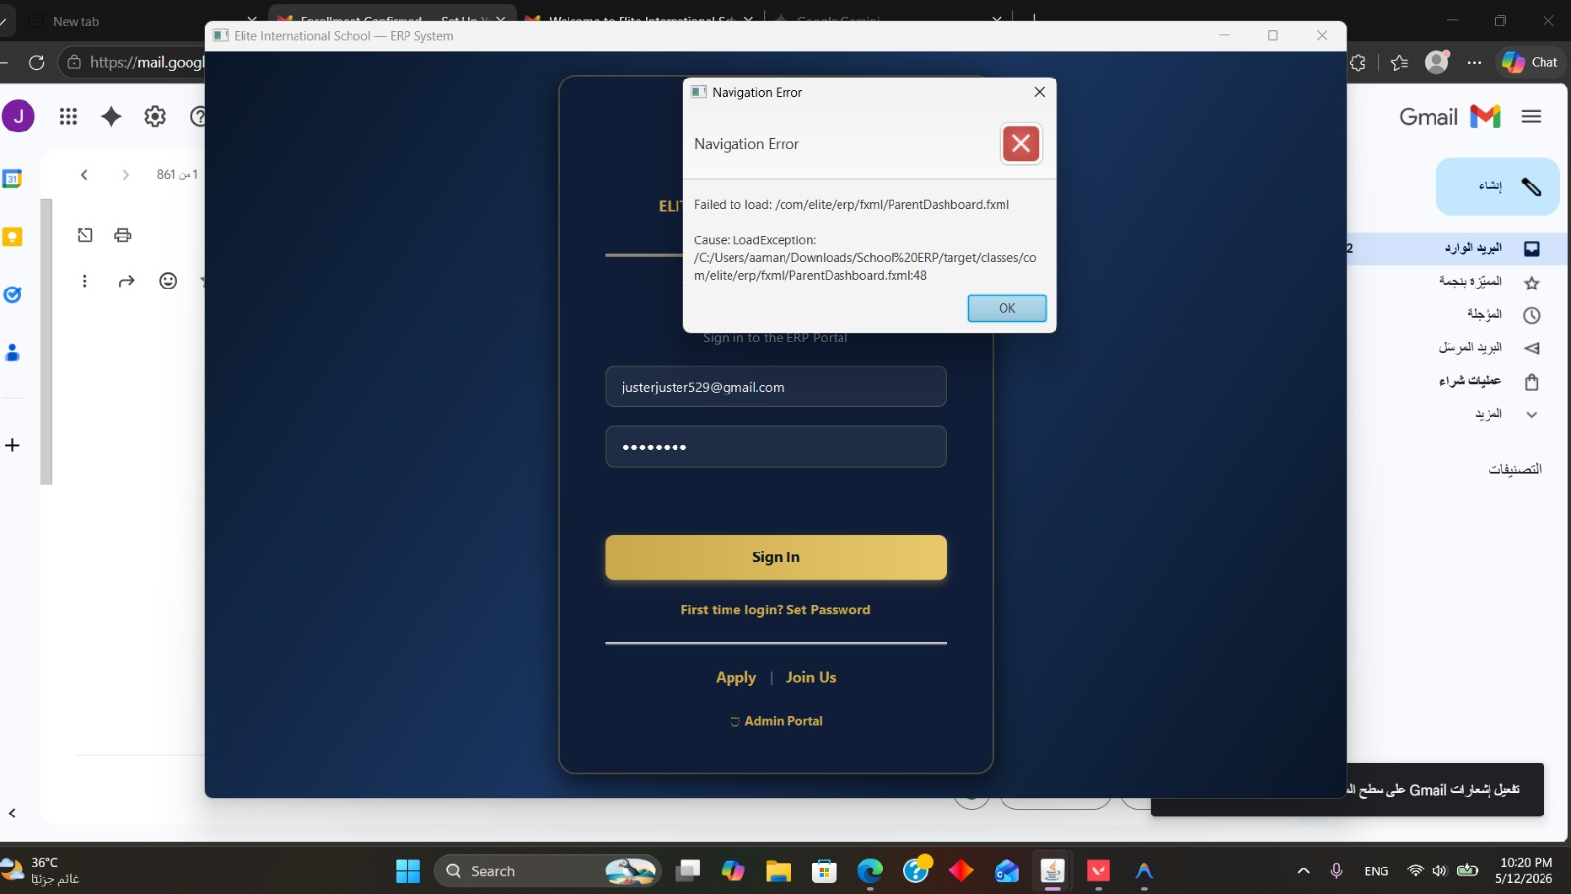
Figure 2.
Error Description: A LoadException triggered a Navigation Error when attempting to load the ParentDashboard.fxml file.

Cause: This error was caused by the mandatory FXGL chart integration on line 48. FXGL's GameApplication.launch() internal stage management conflicted with the standard JavaFX FXMLLoader process, causing the engine to crash when trying to render the parent view.

Solution: Re-architected the FXGL implementation to use an embedded mode. Instead of letting FXGL take over the primary window, the FXGL chart was wrapped and embedded inside a standard JavaFX StackPane sub-node.

Third Eror: Multithreading Compilation Interruption

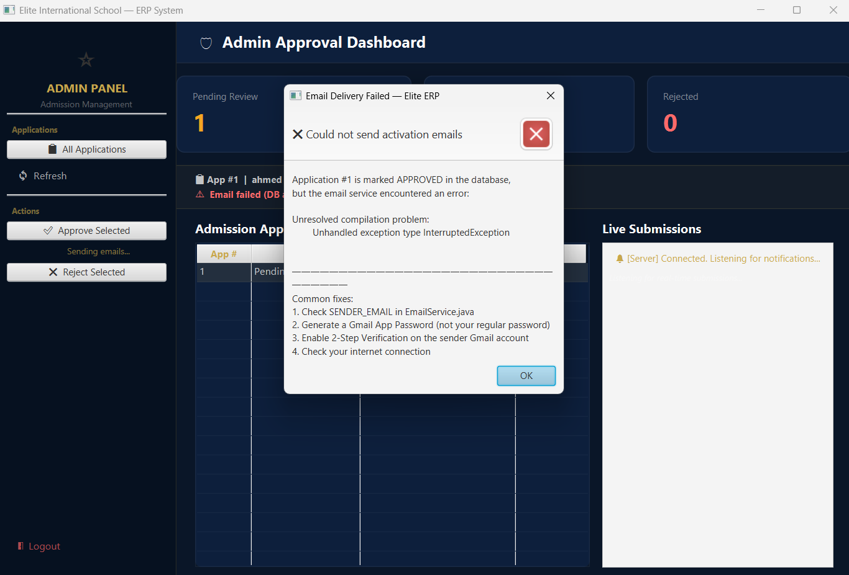
Figure 3.
Error Description: The application successfully updated a user application to "APPROVED" in the database, but the automated email delivery system failed with an "Unhandled exception type InterruptedException" message.

Cause: While implementing the mandatory Multithreading requirement , the background thread handling the SMTP email process was instructed to pause or wait, but the checked InterruptedException was not properly handled in the code block.

Solution: Wrapped the background Task execution and thread-blocking code inside a strict try-catch block that specifically catches InterruptedException and safely interrupts the thread to prevent silent failures.
Forth Eror: Email String Formatting Exception

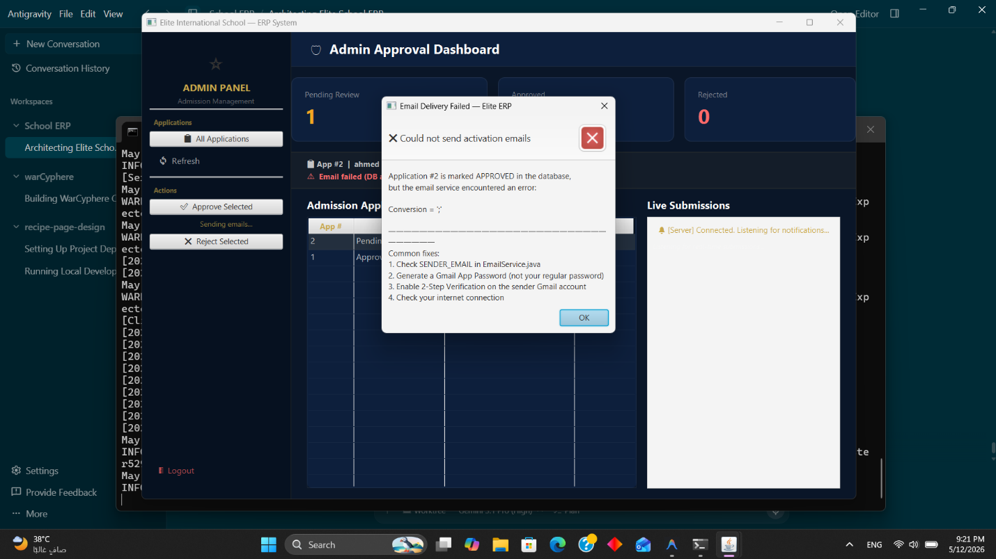
Figure 4.
Error Description: The email activation service failed to send the approval email to the applicant, throwing a Conversion = ';' runtime error.

Cause: A syntax error occurred inside String.format() within the EmailService.java class. The code attempted to format the HTML email template string containing a semicolon in a way that violated Java's format specifier rules (misinterpreting the semicolon as a formatting argument).

Solution: Corrected the string formatting logic within the email template to properly escape or handle punctuation, ensuring the SMTP service could parse the raw text without interpreting it as a dynamic variable.

Fifth Eror: InstaPay Payment Gateway Crash

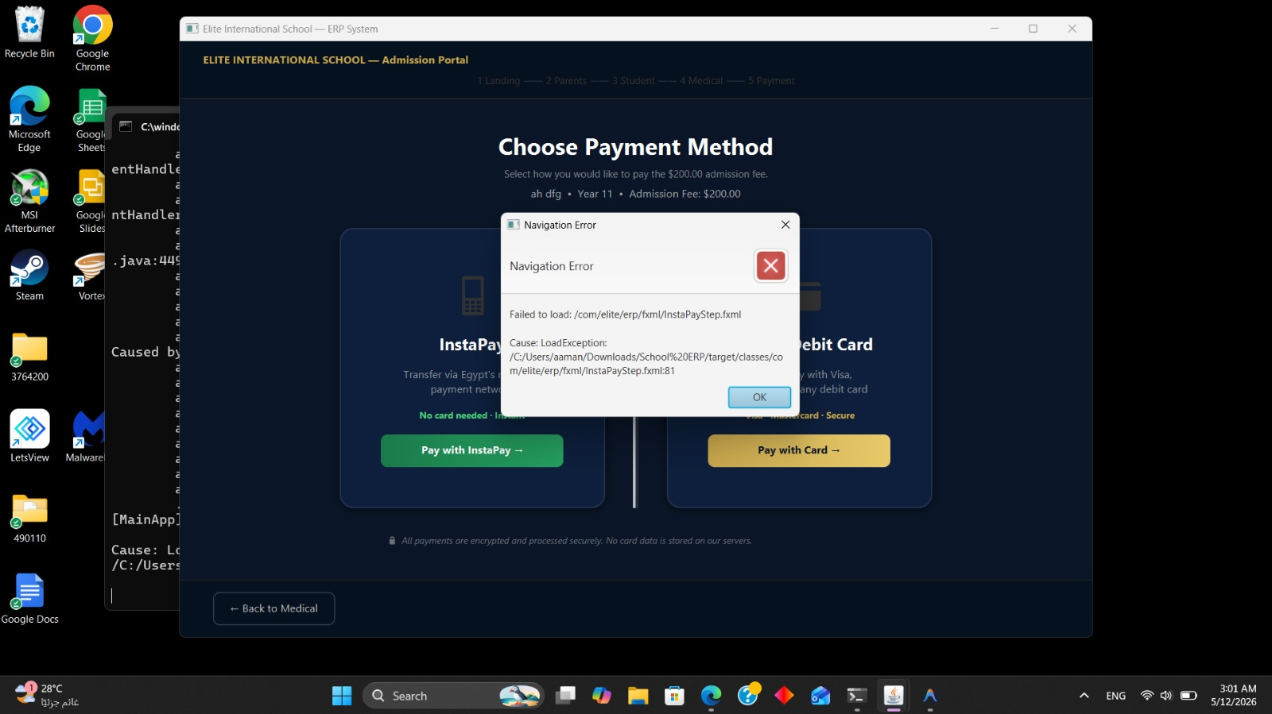
Figure 5.
Error Description: The admission portal crashed with a LoadException when the user clicked the button to proceed to the local payment step.

Cause: An initialization issue occurred at line 81 of InstaPayStep.fxml. This was likely caused by an unreferenced CSS class, a missing event handler for the "Pay with InstaPay" routing, or a null pointer when initializing the payment selection components.

Solution: Fixed the UI component bindings in Scene Builder and verified that the InstaPayStepController correctly initialized all required variables before allowing the FXMLLoader to render the scene to the user.

Section 2:
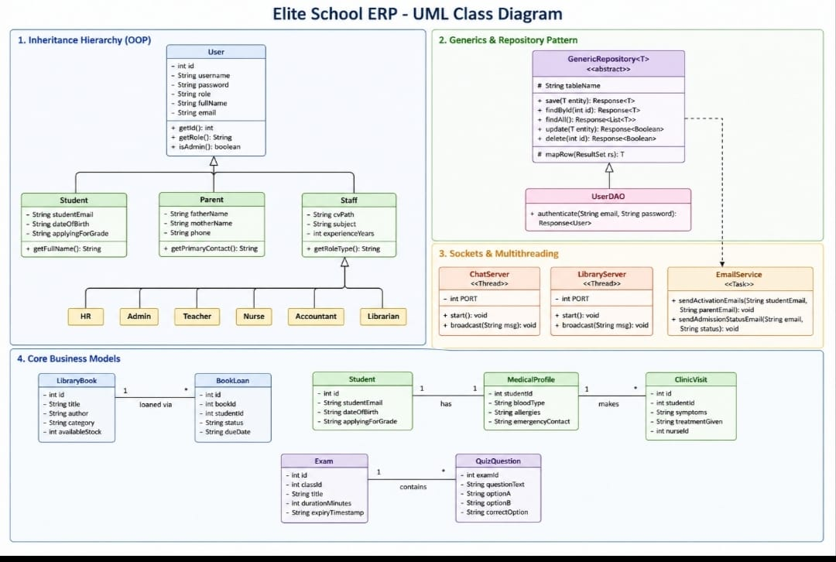
Figure 6: UML Diagram

Section 3: Code Snipet
Section C: Code Snippets Sample
a. Class, Constructor, and Methods
Explanation: The Student domain model demonstrates OOP Encapsulation by maintaining private fields accessible only through public getters and setters, ensuring data integrity across the ERP system.
Java
public class Student {
// ── Private fields (Encapsulation) ──────────────────────────────────────
private int id;
private String firstName;
private String lastName;
private String studentEmail;
// ── Constructors ─────────────────────────────────────────────────────────
public Student() {}
public Student(String firstName, String lastName, String studentEmail) {
this.firstName = firstName;
this.lastName = lastName;
this.studentEmail = studentEmail;
}
// ── Getters & Setters ────────────────────────────────────────────────────
public int getId() { return id; }
public void setId(int id) { this.id = id; }
public String getFirstName() { return firstName; }
public void setFirstName(String firstName) { this.firstName = firstName; }
}

b. JavaFX Stage Configuration
Explanation: This snippet configures the JavaFX Stage to launch a secure, undecorated, full-screen, always-on-top window for the Lockdown Exam, utilizing a focus listener to instantly terminate the exam if the student attempts to switch away to cheat.
Java
private void setupLockdownStage() {
if (timerLabel.getScene() != null && timerLabel.getScene().getWindow() instanceof Stage) {
stage = (Stage) timerLabel.getScene().getWindow();
stage.initStyle(StageStyle.UNDECORATED);
stage.setFullScreen(true);
stage.setAlwaysOnTop(true);
// Anti-Cheat Focus Listener
stage.focusedProperty().addListener((obs, wasFocused, isNowFocused) -> {
if (!isNowFocused && !isSubmitted) {
submitWithPenalty();
}
});
// Prevent closing via OS
stage.setOnCloseRequest(e -> {
if (!isSubmitted) e.consume();
});
}
}

c. JDBC Database Programming
Explanation: This method executes an UPDATE query via JDBC using a PreparedStatement to safely modify a user's details without SQL injection risks, leveraging a try-with-resources block for automatic connection closure.
Java
@Override
public Response<Boolean> update(User u) {
String sql = "UPDATE users SET full_name=?, email=?, role=? WHERE id=?";
try (Connection conn = DatabaseManager.getConnection();
PreparedStatement ps = conn.prepareStatement(sql)) {
ps.setString(1, u.getFullName());
ps.setString(2, u.getEmail());
ps.setString(3, u.getRole());
ps.setInt (4, u.getId());
return Response.success(ps.executeUpdate() > 0);
} catch (SQLException e) {
return Response.failure(e.getMessage());
}
}
d. Multithreading
Explanation: The Nurse Dashboard employs a javafx.concurrent.Task running on a background daemon thread to query the SQLite inventory database every 30 seconds, using Platform.runLater() to safely push UI updates without freezing the application.

Java
private void startInventoryMonitor() {
Task<Void> monitorTask = new Task<>() {
@Override
protected Void call() throws Exception {
while (!isCancelled()) {
Platform.runLater(() -> {
refreshInventoryTable();
inventoryThreadLabel.setText("🔄 Last checked: " + java.time.LocalTime.now().withNano(0));
});
Thread.sleep(30_000); // 30-second interval
}
return null;
}
};
Thread monitorThread = new Thread(monitorTask, "InventoryMonitor-Thread");
monitorThread.setDaemon(true);
monitorThread.start();
}
e. Socket Programming
Explanation: The Student Clinic Portal implements client-side TCP Socket programming to instantly transmit an "EMERGENCY|" packet over Port 9997 to the server when the panic button is clicked, wrapping the network call in a separate thread.

Java
@FXML
private void requestNurse() {
String message = "EMERGENCY|Student (ID:" + studentDbId + ") needs urgent nurse assistance!";
new Thread(() -> {
try (Socket socket = new Socket("localhost", 9997);
PrintWriter out = new PrintWriter(new OutputStreamWriter(socket.getOutputStream()), true)) {
out.println(message); // Transmit alert to Server
Platform.runLater(() -> {
setStatus("✅ Alert sent! The nurse has been notified.", "#4CD97B");
});
} catch (Exception e) {
Platform.runLater(() -> setStatus("❌ Server offline.", "#FF6B6B"));
}
}, "NurseAlert-Thread").start();
}
f. Generics Implementation
Explanation: The IRepository<T> interface enforces strict type safety across all database Data Access Objects (DAOs) using a generic type parameter <T>, standardizing polymorphic CRUD operations like save(T entity).

Java
/**
* Generic repository interface — demonstrates Java Generics + Polymorphism.
* Every concrete DAO implements this interface, enabling polymorphic usage.
*
* @param <T> Domain entity type
*/
public interface IRepository<T> {
Response<T> save(T entity);
Response<T> findById(int id);
Response<List<T>> findAll();
Response<Boolean> update(T entity);
Response<Boolean> delete(int id);
}

