MBIS5023
Machine Learning for Data Analytics

A2A Open AI-Assisted Process Report
AI-Assisted Improvement of a Breast Cancer Convolutional Neural Network
Field | Value
Student | Ahmed Al Rafsan
Selected A1 artefact | Breast Cancer Wisconsin (Diagnostic) CNN
Report date | 21 July 2026
Repository | https://github.com/Ahmed-Al-Rafsan/mbis5023-breast-cancer-ai-improvement
Approximate word count | Approximately 2,640 words (excluding cover, tables, references and appendices)

This report documents an academic machine learning project. The model is not intended for clinical diagnosis.

Contents
Executive summary
1. Baseline selection and diagnosis
2. AI-assisted improvement plan and prompt strategy
3. Technical improvement process
4. Evaluation and interpretation
5. Version and change management
6. Ethical reflection and limitations
7. Conclusion
References
Appendix A: AI prompt and output evidence
Appendix B: AI disclosure statement
Appendix C: Git change evidence

Executive summary
This report documents how I improved the Breast Cancer Wisconsin classification project that was selected from my A1 portfolio. The original artefact met the basic requirement of using a convolutional neural network, but it was closer to a first working version than a reliable machine learning pipeline. The main weaknesses were the use of raw feature scales, no separate validation stage, fixed-length training, limited control of class imbalance, and an evaluation that did not give enough attention to malignant false negatives.
I used ChatGPT (OpenAI, 2026) as an AI assistant for planning, code review, model design, debugging guidance and documentation. I did not accept its suggestions automatically. Each technical suggestion was checked against the assessment requirement, implemented in code and verified through execution. The improved workflow used training-only standardisation, stratified train/validation/test splitting, a deeper one-dimensional CNN, batch normalisation, dropout, class-weighted loss, weight decay and validation-based early stopping.
The improvement was evaluated on the same untouched test set. The baseline CNN achieved 0.9211 accuracy and 0.8095 malignant recall, with eight malignant cases incorrectly classified as benign. The improved model achieved 0.9649 accuracy and 0.9524 malignant recall, with two false negatives. Its ROC-AUC increased from 0.9669 to 0.9964. The public GitHub repository records the work through six commits on the main branch, covering the baseline artefact, model-evaluation evidence, AI/process documentation and the final report upload. The final result is a stronger and more reproducible academic project, although it remains unsuitable for real clinical decision-making.

1. Baseline selection and diagnosis
I selected the Breast Cancer Wisconsin (Diagnostic) project (Wolberg, Street and Mangasarian, 1995) from the A1 portfolio because it had a clear classification objective, a recognised dataset and an important practical concern: distinguishing malignant tumours from benign tumours. The data contains 569 records and 30 numerical predictors after removing the identifier and the empty column. The target variable contains 357 benign and 212 malignant cases. This project was also suitable for improvement because the portfolio task specifically required a convolutional neural network, so I could keep the original direction while improving the quality of the pipeline.
The baseline model was intentionally kept simple so that the improvement process could be measured clearly. It used one Conv1d layer with eight filters, a ReLU activation, a flattening layer and one output neuron. It was trained for a fixed number of epochs using binary cross-entropy and Adam. The raw feature values were passed directly into the network. This created a scale problem because measurements such as area and perimeter are numerically much larger than smoothness or symmetry. A neural network can still learn from these values, but optimisation becomes less stable and some features can dominate the early gradient updates.
The second weakness was the absence of a separate validation set. The baseline used a training pool and one test set. Without validation data, there was no independent signal for choosing the best epoch or stopping training when generalisation stopped improving. A fixed epoch count can finish too early or continue after the useful learning stage. It also gives weak evidence that the chosen model state was selected fairly.
The third weakness was the loss function. The baseline used ordinary binary cross-entropy and did not give extra attention to the malignant class. The class distribution is not extremely imbalanced, but the consequences of errors are not equal in this project. A false negative means that a malignant record is predicted as benign. For this reason, accuracy alone was not a sufficient success measure. The baseline result confirmed the problem: overall accuracy was 0.9211, but malignant recall was only 0.8095 and eight malignant cases were missed.
The baseline also lacked a systematic version history and AI evidence. The notebook showed the final code, but it did not clearly show which suggestions were accepted, rejected or modified. It also did not separate data-pipeline changes from architecture changes. I therefore set four improvement priorities: reduce false negatives, create leakage-safe validation, improve reproducibility, and make every important change traceable.

Baseline limitations and improvement priorities
Baseline issue | Observed risk | Improvement priority
Raw feature scales | Large-value variables can dominate optimisation. | Fit StandardScaler on training data only.
No validation stage | No fair basis for early stopping or model selection. | Create a stratified validation subset.
Ordinary loss | Malignant false negatives are not given extra attention. | Use positive-class weighting.
Simple architecture | Limited regularisation and representation depth. | Add a second convolution, batch normalisation and dropout.
Accuracy-led review | Strong overall accuracy can hide poor malignant recall. | Report recall, F1, specificity, ROC-AUC and error counts.
Weak process evidence | Changes are difficult to trace or defend. | Use staged commits and process logs.

2. AI-assisted improvement plan and prompt strategy
I used ChatGPT as a structured reviewer rather than as an automatic answer generator. My first instruction was broad: convert the supplied portfolio brief and dataset into a complete CNN workflow. The AI proposed exploration, cleaning, preprocessing, training, validation and multiple evaluation metrics. I accepted this structure because it matched the portfolio requirements, but I still checked the code outputs and the final HTML file.
The prompt strategy then became more focused. I asked for weaknesses in the first-pass model, a stronger CNN workflow, evaluation that did not rely only on accuracy, and a critical review of whether the result could be treated as medical evidence. I also used the AI for practical file and environment issues. When a local notebook run failed because PyTorch was not installed, the AI correctly separated an environment problem from a model-code problem. I rejected the idea of using the failed local run as evidence and restored the fresh executed notebook instead.
Several AI suggestions were accepted after verification. Standardisation was accepted because the feature ranges were visibly different in the descriptive statistics. A stratified validation split was accepted because it preserved class proportions while supporting early stopping. Class-weighted loss was accepted because the baseline produced eight false negatives. Dropout, batch normalisation and weight decay were accepted as reasonable controls against unstable training and overfitting (Goodfellow, Bengio and Courville, 2016).
Some suggestions were rejected or modified. I did not replace the CNN with logistic regression or random forest, even though these models can perform strongly on tabular data, because the selected portfolio activity required a convolutional neural network. I also rejected any wording that treated the high ROC-AUC as clinical proof. The dataset is small, there is no external hospital validation, and the predictors are prepared measurements rather than raw medical images. The AI wording was edited into direct first-person explanations so that the report reflected my own decisions and the actual evidence.
Verification was performed in several ways. I executed the technical notebook with a fixed seed, checked the train/validation loss, calculated all metrics from the untouched test set, and compared the baseline and improved confusion matrices. I also reviewed the exported HTML from the top to the references, including the student name, results table, confusion matrix and ROC curve. This process made AI assistance auditable instead of treating its output as automatically correct.

3. Technical improvement process
The first technical change was data cleaning. The `id` field was removed because it is only a record identifier, and `Unnamed: 32` was removed because it was empty. The diagnosis was encoded as malignant = 1 and benign = 0. All 30 meaningful numerical predictors were retained. I considered feature selection and PCA, but I did not apply them in the final model. With only 30 predictors, dimensionality was manageable, and removing features would have added another selection decision that required separate validation.
The data was divided into a training/validation pool and an untouched test set using stratification. The test set contained 114 records and was not used for training, early stopping or model selection. The remaining data was split again into training and validation subsets. StandardScaler from scikit-learn (Pedregosa et al., 2011) was fitted only on the training subset and then applied to validation and test data. This detail was important because fitting the scaler on the whole dataset would allow information from the test distribution to influence the model.
The improved architecture used two Conv1d layers. The first layer produced 32 channels, followed by ReLU and batch normalisation. The second layer produced 64 channels, followed by ReLU and max pooling. The output was flattened and passed through a 64-unit dense layer with dropout before the final binary output. The 30 predictors were treated as a one-dimensional feature sequence. This does not mean that tabular columns have the same spatial meaning as image pixels; it is a practical architecture chosen to satisfy the CNN requirement while allowing local combinations of neighbouring feature positions to be learned.
The training procedure was also improved. I used BCEWithLogitsLoss from PyTorch (Paszke et al., 2019) rather than applying a sigmoid separately during training because it combines the operations in a numerically stable form. A positive-class weight was calculated from the benign-to-malignant ratio in the training data. This increased the penalty when a malignant training case was missed. Adam was used with a small weight-decay term. Training was allowed to continue for a high maximum number of epochs, but early stopping monitored validation loss with a patience of 25 epochs. The best model state was copied whenever validation loss improved and restored after training. In the executed run, training stopped at epoch 27 and the best validation loss was 0.1999.
Reproducibility controls were added across the notebook. Python, NumPy and PyTorch seeds were fixed at 2026. The same stratified split was used for both models, and the comparison used the same test records. Package requirements, folder structure, reproduction steps and a model card were added to the repository. These changes make it easier for another person to understand how the result was produced and where each output was saved.

Technical changes implemented
Area | Baseline | Improved approach
Data scale | Raw numerical values | Training-only standardisation
Data split | Training/test | Stratified training/validation/test
CNN | One convolution layer | Two convolutions, batch normalisation, pooling and dropout
Loss | Unweighted BCE | BCEWithLogitsLoss with positive-class weight
Training | Fixed epoch count | Validation-loss early stopping and best-state restoration
Evaluation | Mainly overall accuracy | Six metrics, confusion matrices and error counts
Reproducibility | Limited | Fixed seeds, requirements, model card and saved outputs
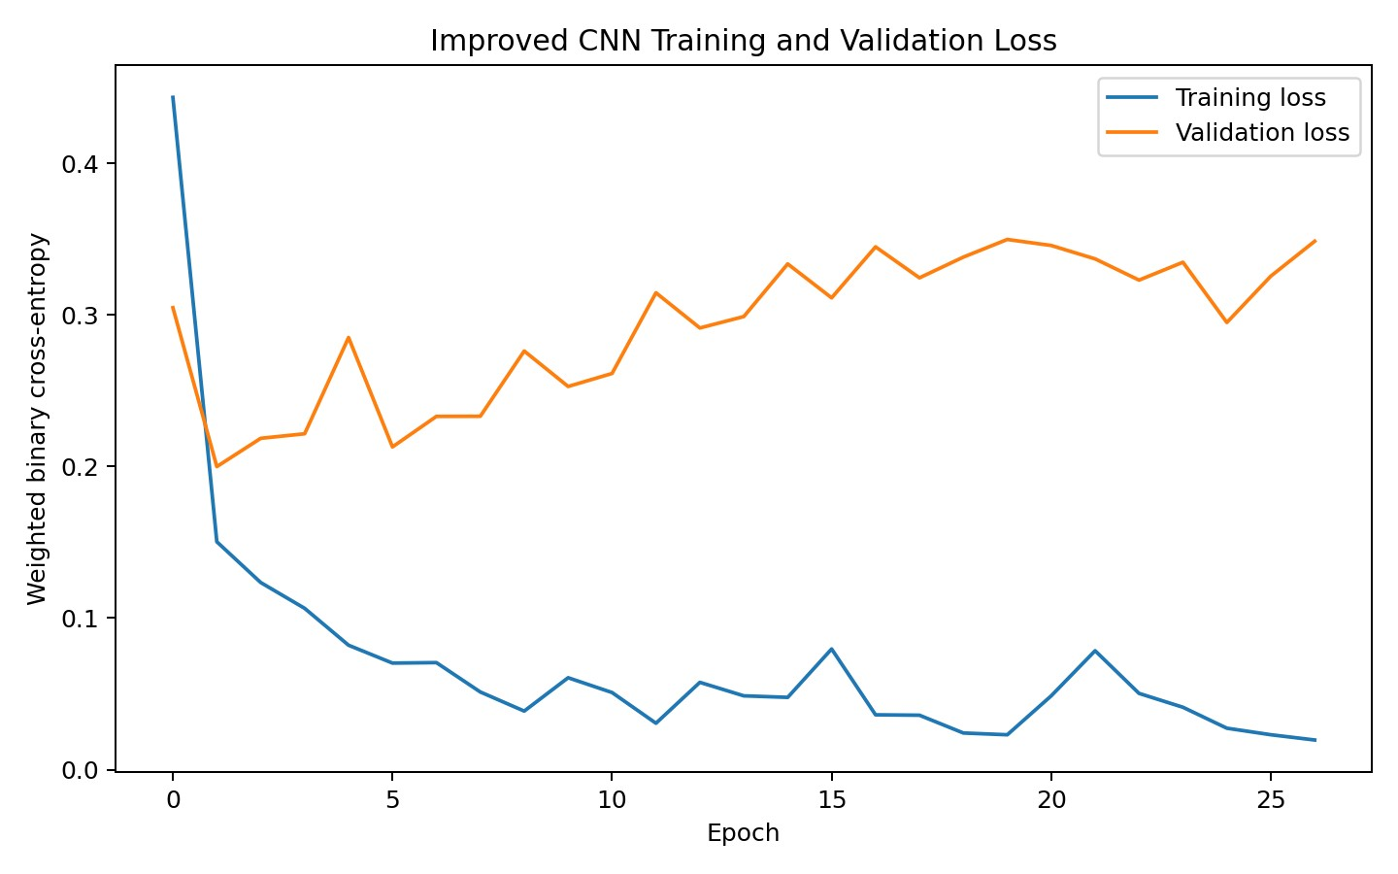
Figure 1. Training and validation loss for the improved CNN.

4. Evaluation and interpretation
The baseline and improved models were evaluated using accuracy, malignant precision, malignant recall, malignant F1, specificity, ROC-AUC, false negatives and false positives. This combination was chosen because no single metric tells the full story. Accuracy gives the overall result, but recall measures how many malignant cases were detected. Precision shows how reliable the malignant predictions were, while specificity measures recognition of benign cases. ROC-AUC evaluates separation across different decision thresholds.
The baseline model achieved 0.9211 accuracy, 0.9714 precision, 0.8095 recall, 0.8831 F1, 0.9861 specificity and 0.9669 ROC-AUC. Its confusion matrix contained 71 true benign predictions, one false positive, eight false negatives and 34 true malignant predictions. The high precision could look positive by itself, but the recall result showed that the model was too conservative when predicting malignancy.
The improved model achieved 0.9649 accuracy, 0.9524 precision, 0.9524 recall, 0.9524 F1, 0.9722 specificity and 0.9964 ROC-AUC. Its confusion matrix contained 70 true benign predictions, two false positives, two false negatives and 40 true malignant predictions. The most important improvement was the reduction of false negatives from eight to two. Malignant recall increased by about 0.143, while accuracy increased by about 0.044.
Precision decreased slightly from 0.9714 to 0.9524 and false positives increased from one to two. I accepted this trade-off because the improved model detected six additional malignant cases and only added one extra benign false alarm. In the context of this academic problem, that is a more defensible balance than preserving very high precision while missing more malignant cases.
The ROC curve also improved, but the result should be interpreted carefully. A ROC-AUC of 0.9964 shows excellent separation on this particular test split, not guaranteed performance on new hospitals, populations or measurement processes. Repeated cross-validation, probability calibration and external validation would be valuable future work. It would also be useful to compare the CNN with simpler tabular models. The final conclusion is therefore limited: the AI-assisted pipeline improved this portfolio artefact and reduced the key error type on the supplied dataset.
I also kept the classification threshold at 0.50 for a fair first comparison. It would be possible to lower the threshold to increase malignant recall further, but that decision would increase false positives and should be selected using validation data and a stated cost framework. I did not tune the threshold on the test set because that would weaken the independence of the final evaluation. This was an important human decision: the improvement came from the pipeline and training procedure, not from repeatedly adjusting the final threshold after seeing test results.

Model performance comparison
Model | Accuracy | Precision | Recall | F1 | Specificity | ROC-AUC | FN | FP
Baseline CNN | 0.9211 | 0.9714 | 0.8095 | 0.8831 | 0.9861 | 0.9669 | 8 | 1
Improved CNN | 0.9649 | 0.9524 | 0.9524 | 0.9524 | 0.9722 | 0.9964 | 2 | 2
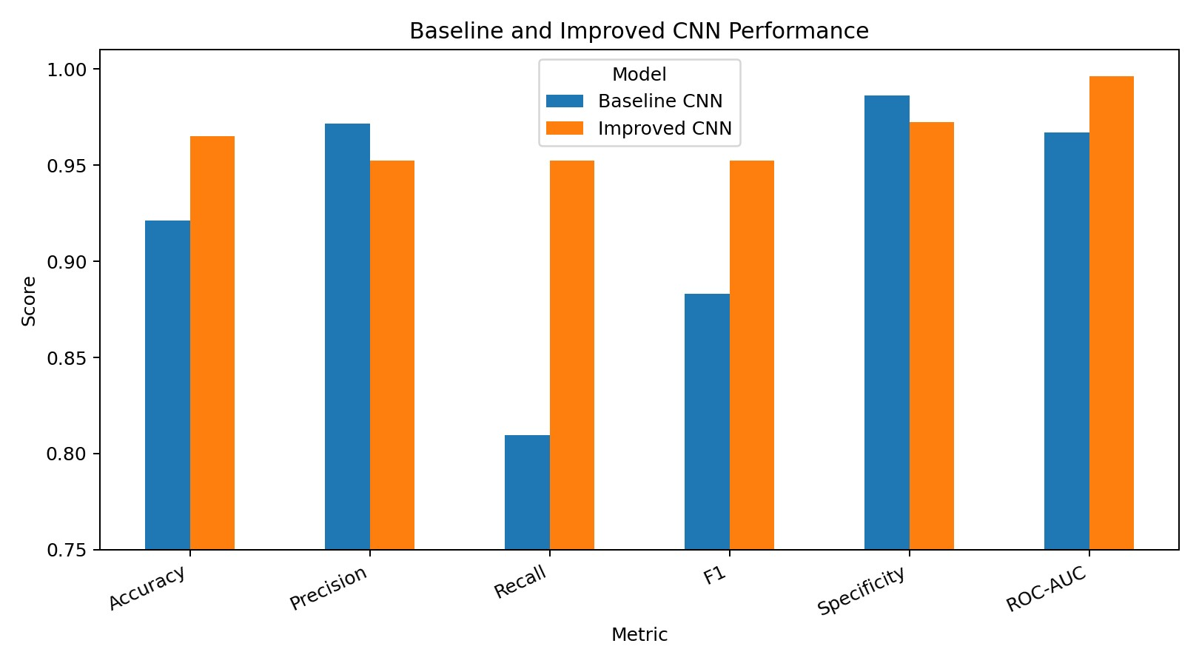
Figure 2. Comparison of baseline and improved model metrics.
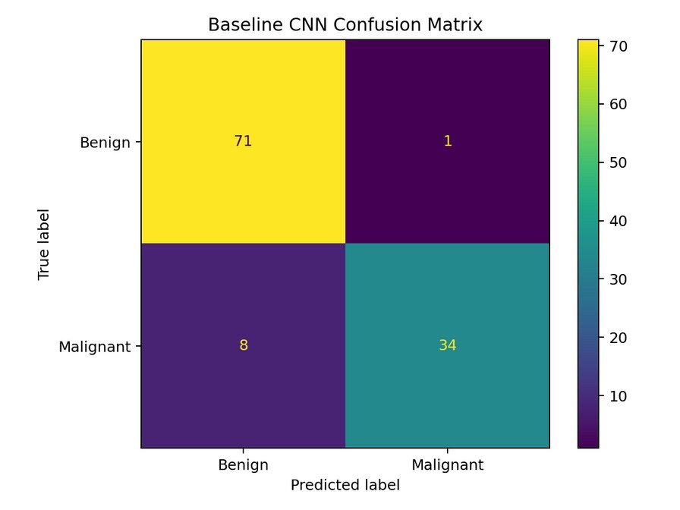
Figure 3a. Baseline confusion matrix.
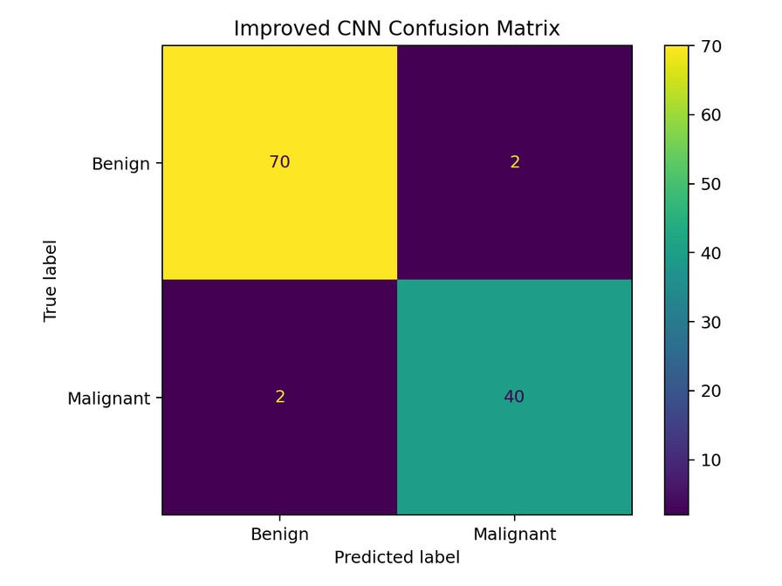
Figure 3b. Improved confusion matrix.
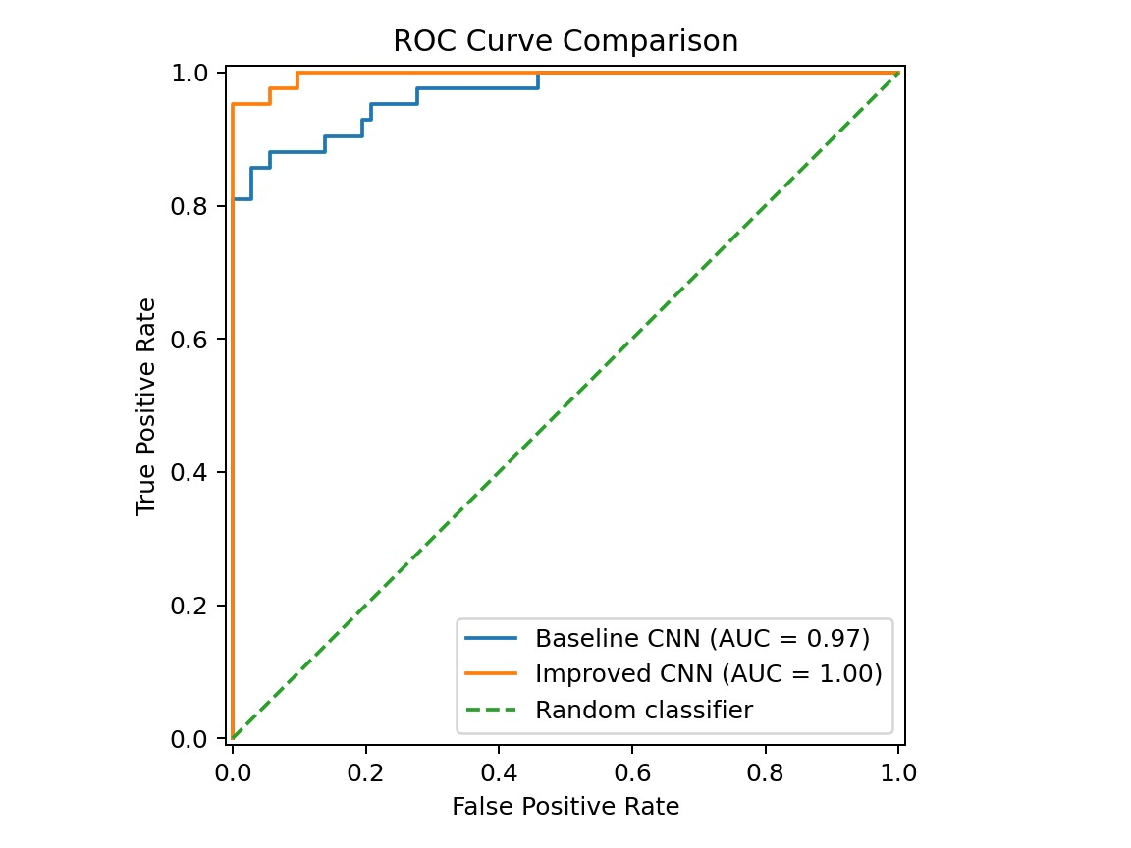
Figure 4. ROC curve comparison on the untouched test set.

5. Version and change management
I used GitHub to make the project stages traceable (Chacon and Straub, 2014). The repository is organised into `data`, `docs`, `notebooks`, `results` and `report` folders. Because this was a short individual project and the repository was populated through the GitHub web interface, I used staged commits on the `main` branch rather than inventing feature branches, pull requests or merge history that did not occur.
The first commit, `dc6cbe9`, added the supplied dataset, the executed CNN notebook, the README and the package requirements. The second commit, `a29fa1c`, added the saved evaluation evidence, including the baseline and improved confusion matrices, training and validation loss, metric comparison files and ROC curves. The third commit, `880ca4e`, added the AI prompt/output log, change log, GitHub evidence note and model card. Three further commits were used to add and reorganise the `report/` folder containing this PDF, bringing the total to six commits on the main branch.
This staged history separates the baseline artefact, quantitative evidence, process documentation and the final report deliverable. The commit messages describe the purpose of each change instead of using vague labels such as "update". The results folder stores the comparison CSV and generated plots, while the docs folder records accepted, rejected and modified AI suggestions. The report was finalised only after these public commits were checked.
The public repository address is `https://github.com/Ahmed-Al-Rafsan/mbis5023-breast-cancer-ai-improvement`. At the time this report was finalised, the repository contained six genuine commits on the `main` branch. No branch, pull-request or merge evidence is claimed because those workflows were not used. This limitation is stated openly so the evidence remains accurate and defensible.

Repository change evidence
Commit | Branch | Purpose | Evidence
dc6cbe9 | main | Baseline artefact | Dataset, executed notebook, README and requirements
a29fa1c | main | Evaluation evidence | Metric CSV, comparison chart, loss curve, confusion matrices and ROC curves
880ca4e | main | AI and process documentation | Prompt/output log, change log, GitHub evidence note and model card
(later commits) | main | Report folder | Report PDF added, reorganised and finalised in the `report/` folder

6. Ethical reflection and limitations
This project uses a public academic dataset, and no private patient information was entered into the AI tool. Even so, the topic requires careful language. The model predicts labels within a supplied dataset; it does not diagnose a person. A clinical system would require independent data, governance, security, calibration, bias testing, expert review and regulatory approval.
AI use also created academic responsibilities. ChatGPT helped with code, structure and wording, but I remained responsible for the final choices. I disclosed the tool and its tasks, recorded significant prompt summaries, and explained accepted, rejected and modified suggestions. Outputs were checked through code execution, metrics, plots and human review. I did not use the local `torch` error as a project result, and I removed unsupported claims about branch and merge history before finalising the report.
There are technical limitations as well. The dataset is small, the test set contains only 114 records, and one fixed split can produce optimistic or pessimistic results. The CNN treats the columns as an ordered sequence even though their order is not naturally spatial. The very high ROC-AUC may partly reflect the strong separability of this well-known dataset. Future work should include repeated stratified cross-validation, comparison with simpler models, probability calibration, feature-order sensitivity testing and external validation.
The improvement process nevertheless achieved its purpose. It changed the project from a basic working CNN into a more transparent pipeline with stronger false-negative control, reproducible training, broader evaluation and a genuine staged GitHub history.

7. Conclusion
The A1 breast cancer project was a useful baseline, but it had clear limitations in scaling, validation, error priorities and traceability. AI assistance helped identify and structure the improvements, while human judgement was used to keep the CNN requirement, prioritise malignant recall, reject clinical overclaiming and verify every reported result.
The improved model increased accuracy from 0.9211 to 0.9649 and malignant recall from 0.8095 to 0.9524. False negatives fell from eight to two. The repository records the baseline artefact, evaluation evidence, AI/process documentation and the final report through six purpose-based commits on the main branch. The final project is therefore stronger technically and easier to audit, reproduce and defend. Its value remains academic, and the report does not claim that it is ready for medical use.

References
Chacon, S. and Straub, B. (2014) Pro Git. 2nd edn. New York: Apress.
Goodfellow, I., Bengio, Y. and Courville, A. (2016) Deep Learning. Cambridge, MA: MIT Press.
OpenAI (2026) ChatGPT. Available at: https://chatgpt.com/ (Accessed: 21 July 2026).
Paszke, A. et al. (2019) 'PyTorch: An imperative style, high-performance deep learning library', Advances in Neural Information Processing Systems, 32.
Pedregosa, F. et al. (2011) 'Scikit-learn: Machine learning in Python', Journal of Machine Learning Research, 12, pp. 2825-2830.
Wolberg, W.H., Street, W.N. and Mangasarian, O.L. (1995) Breast Cancer Wisconsin (Diagnostic). UCI Machine Learning Repository.

Appendix A: AI prompt and output evidence
Significant prompts are summarised where iterations were repetitive. The full project log is also stored in docs/AI_prompt_output_log.md.
Iteration | Prompt summary | Decision and verification
1 | Create a complete CNN workflow from the supplied breast-cancer portfolio brief and dataset. | Accepted the end-to-end structure; verified the exported notebook and HTML.
2 | Complete the package without asking for additional format decisions. | Accepted notebook, HTML and data package after checking all sections.
3 | Identify weaknesses in the first-pass model and propose technical priorities. | Accepted scale, validation, false-negative and traceability priorities.
4 | Suggest a stronger CNN while keeping the convolutional-network requirement. | Accepted standardisation, deeper CNN, class weighting, dropout and early stopping; rejected changing the project to a non-CNN model.
5 | Design evaluation beyond accuracy and prioritise malignant cases. | Accepted recall, F1, specificity, ROC-AUC, confusion matrices and error counts.
6 | Critique whether the result can be treated as medical evidence. | Accepted limitations and rejected clinical overclaiming.
7 | Resolve a local ModuleNotFoundError for torch. | Treated it as an environment issue; restored the fresh executed notebook rather than using failed output.
8 | Prepare an original process report with transparent AI disclosure. | Edited the draft for factual accuracy, direct language and consistency with actual evidence.

Appendix B: AI disclosure statement
AI tool used: ChatGPT by OpenAI.
Tasks supported: interpretation of the assessment requirements, baseline critique, code generation and review, model-architecture suggestions, debugging guidance, evaluation design, report drafting and document formatting.
Human contribution and control: I selected the project, retained the CNN requirement, decided which AI suggestions to accept or reject, reviewed the code outputs, checked the metrics and plots, limited the conclusions, and remained responsible for the final submission.
Verification: AI-generated code was executed in the project environment. Reported values were copied from the saved notebook outputs and model comparison CSV. The exported HTML was visually reviewed. The repository address, folder structure and public commit identifiers were checked against the GitHub repository before finalisation.
Privacy: Only the supplied public academic dataset and project information were used. No private patient data, confidential organisational data or unauthorised personal information was uploaded.
Limitations of AI use: AI suggestions can be technically plausible but incorrect or inappropriate. For this reason, suggestions were not treated as evidence until they were executed, compared or reviewed.

Appendix C: Git change evidence
dc6cbe9 Add baseline dataset and CNN notebook
a29fa1c Add model evaluation results
880ca4e Add AI prompt log and change documentation
(later) Add and organise the report/ folder containing this PDF
Repository address: https://github.com/Ahmed-Al-Rafsan/mbis5023-breast-cancer-ai-improvement
The repository was populated through the GitHub web interface and contains genuine staged commits on the main branch. No branch, pull-request or merge history is claimed.

