[New Receipt] dEPLOYMENT Pulse v3.81

# Project description.

Customized receipt for Domino’s Pizza Oman, with more option and more organized.

# deployment guides

1. **Copy the provided Zip file to the PULSEBOS C Drive.**
2. **Extract the File to get the following sub Files:**

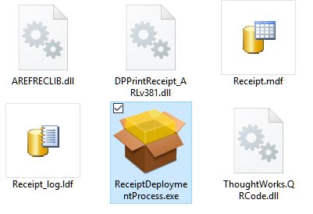

1. **Make sure no one is using the Pulse application.**
2. **Run the Auto deployment process by double click on [ReceiptDeploymentProcess.exe] file.**
3. **Wait until the procedure to finish.**

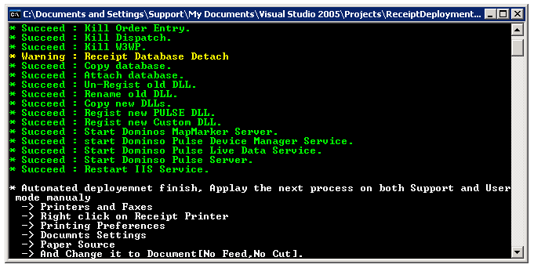

1. **If no error appears, Apply the following steps to both [Support] and [User] Mode:**

* **In Printers and Faxes, right click on the Receipt**

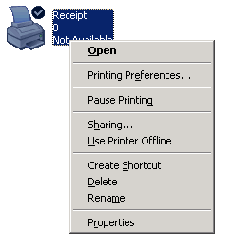

* **Click on Printing Preferences**
* **At document settings tab,** Press on “**Layout**” Tab.

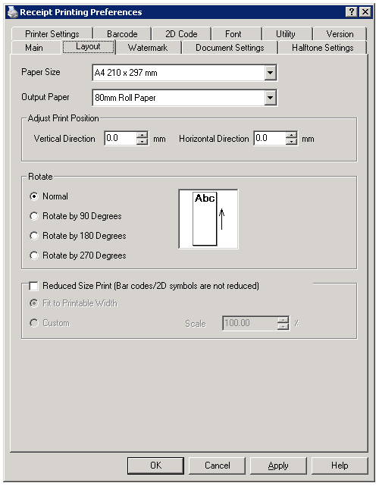

* Now in Paper size list, select User Defined Paper Size.

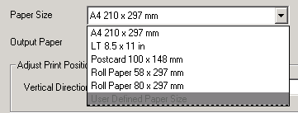

* In the new windows, Rename the new user profile to “**Max Length**”, and change the Paper Length to **3276.0** as this is the maximum allowed length for printing.

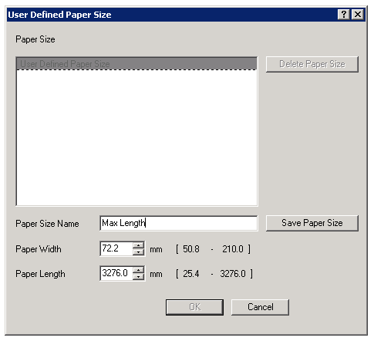

* Now Press “**Save Paper Size**” to generate new profile

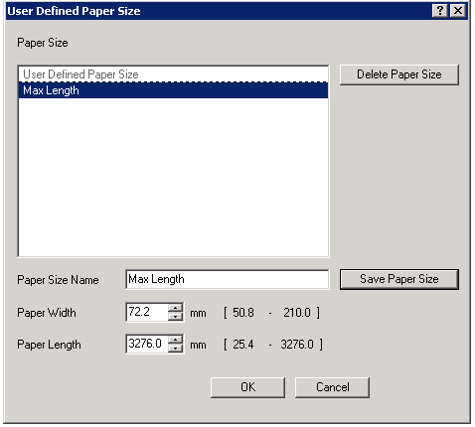

* Click OK to apply the profile and make sure the new profile is selected

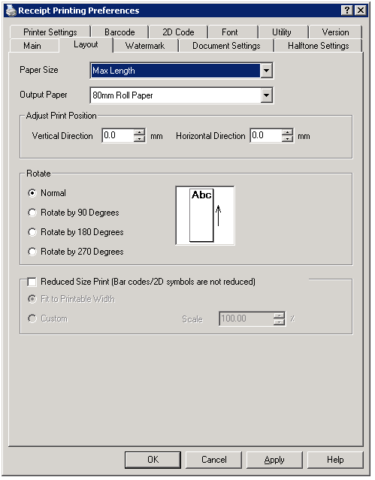

* **Go to document settings tab, press on Paper Source.**

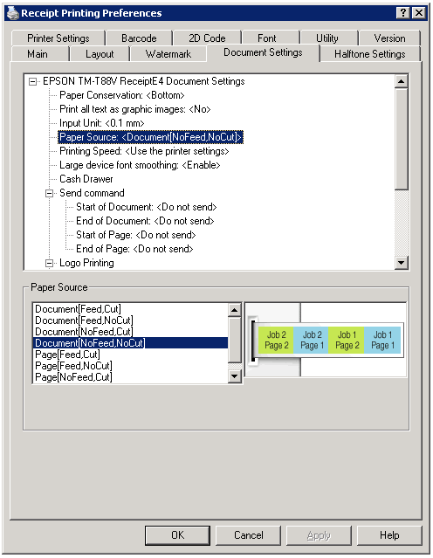

* **Change the paper source to be Document [NoFeed, NoCut]**
* **Press OK to save settings.**

1. Login as a **[user]**, and got to “**Printers and Faxes**”.

* Right Click on the “**Receipt**” printer, then select “**Printing preferences..**”.
* Press on “**Layout**” Tab.
* In the Paper Size list, you will find the new profile exist, just select it.



* Go to **“Document Settings”** Tab, and press **on “Paper Source”**
* Change the paper source to be **Document [NoFeed, NoCut]**



1. **Open Pulse Application**
   * **Back Office**
   * **Setup**
   * **Option**
   * **Store Parameters**
   * **Printing**
   * **And make sure that ARLv381 Receipt is selected.**

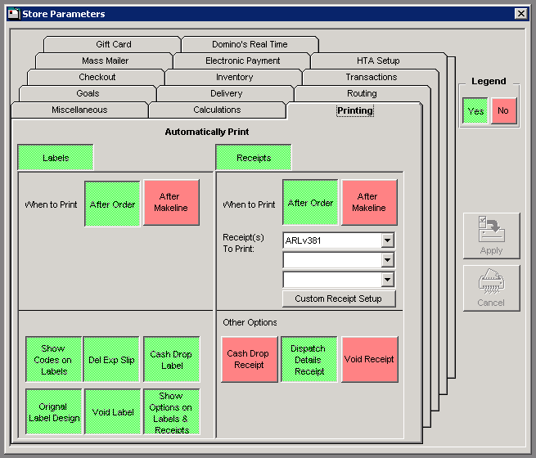

* **Restart Pulse If needed.**

# Project Features

* **Update Receipt Images :**

UPDATE Receipt.dbo.rcpImage SET Value =

(SELECT BulkColumn FROM Openrowset( Bulk 'C:\Receipt\Promotion_Image.jpg', Single_Blob) as img)

WHERE Name = 'Promotion'

Change the text at [where statement] to one of these names to update it :

Brand Logo : 'Logo'

Promotion Image : 'Promotion'

Tail Image General : 'AdvOnly'

Tail Image From Call Center: 'AdvCC'

Tail Image From Internet : 'AdvGOLOWeb'

Tail Image From Mobile : 'AdvGOLOMobile'

Tail Image From Store : 'AdvWalkin'

* **Enable Promotion Image :**

UPDATE Receipt.dbo.rcpConfig

SET Value = 1

WHERE Name = 'Promotion_Enable'

* **Change the Reprint time out (0 = unlimited)**

UPDATE Receipt.dbo.rcpVariable

SET Value = 60

WHERE Name = 'Reprint_Timeout'

# sanity test plan

* Make a new order, or reprint one to check Local orders.
* Make an order throw GOLO [Call Center or Web].

# Support plan

L1 Support

**Common issues if the printer is printing:**

* **The printer is cutting the paper 2 time at the end.**

In Printing Preferences, Change the Paper source to Document [No Feed, No Cut] in user/support mode.

* **The printer feed whit space before/after printing**

In Printing Preferences, Change the Paper source to Document [No Feed, No Cut] in user/support mode.

* **Printing Text is near to Right/Left.**

Check Paper Roll alignment inside the printer.

* **Receipt is not printing from GOLO, only printing locally.**

Restart IIS, WinHTTP and World Wide Web Services.

If the problem still exists, restart PULSEBOS.

* **The Printer is still printing old receipt.**

Make sure the selected receipt is ARLv381 in Back Office > Setup > Option > Store Parameters > Printing

* **Store Coordinate is wrong / Store name is wrong**

Change store name / coordinate in table [Receipt.dbo.rcpVariable], then run the following query on Receipt Database.

EXEC Receipt.dbo.spUpdateStoreLocation

**If the Printer is not printing, run the following query in PulseBos SQL Server to find the error code and message:**

SELECT Message_Code,Message_Text

FROM Receipt.dbo.rcpLog

WHERE Order_Date = '2017-01-01' -- Change with order date

AND Order_Number = 1 -- change with order Number

And check with the following Info/Errors list:

* **INF001**:

Order printed successfully.

* **INF002**:

Order Re-printed successfully.

* **INF003**:

Reprint Denied, due to Receipt Configuration.

-Change “Allow-Reprint” Flag to True to enable reprint.

* **INF004**:

Order Previewed.

* **INF005**:

Reprint Denied, due to Reprint time exceeded.

* **INF006:**

Reprint non-paid orders are not allowed.

* **ERR001**

Database issue, unable to read variables and order details.

-Check Receipt database availability.

-Check connection.

-Check credentials.

-Make Sure receipt database version is last version.

-Check Hard Disk Free space.

* **ERR004**

Unable to create topping part.

-Check the order details.

* **ERR005**

An issue in half/half pizza.

-Check the order details.

* **ERR006**

Unable to set store & customer coordinates

-Check order details and order comment.

* **ERR007**

Printer Error.

-Check Printer Name / properties

-Check Pulse printing settings.

* **ERR008**

Customer location is not set in the correct format, when the Order received.

* **ERR009**

Error while generating QR box

-Contact L2 Support.

* **ERR010**

General fatal error.

-Contact L2 Support.

* **ERR012**

Error in Preview module.

-Contact L2 Support.

* **ERR014**

Clean Log table issue.

-Contact L2 Support.

* **ERR015**

Unable to retrieve store details from the main server.

-Check Server details in table [Receipt.dbo.rcpVariable].

-Check internet connectivity.

# L2 Support

If you still facing any trouble, please send an email including the following information to KSA NOC Team.

**NOC@alamarfoods.com**

* Store Number.
* Order Number [if only single order problem].
* Order Date.
* Message Code from Log table [ex ERRR001].
* Message Text from Log table.
* Printing status [Printing Locally only, GOLO Only, reprint only ... etc.].
* Number of orders that have the problem.
* Problem explanation.