

**Faculty of engineering - Shoubra**

**Benha University**

**Research Project**

in fulfillment of the requirements of

|  |  |
| --- | --- |
| **Department** | **Engineering Mathematics and Physics** |
| **Division** | **-----------------** |
| **Academic Year** | **2019-2020 Preparatory** |
| **Course name** | **Computer** |
| **Course code** | **ECE001** |

**Title: -**

**Artificial Intelligence** By:

|  |  |  |  |
| --- | --- | --- | --- |
|  | Name | Edu mail | B.N |
| 1 | احمد محمد عبدالفتاح اسماعيل | Ahmed195130@feng.bu.edu.eg | 126 |

**Link to GitHub website:**

**Approved by:**

|  |  |
| --- | --- |
| Examiners committee | Signature |
| Dr. Ahmed Bayoumi |  |
| Dr. Shady Elmashad |  |
| Dr. Abdelhamid Attaby |  |

**Application brief**

Artificial Intelligence ( AI), the ability of a computer-controlled robot or digital computer to perform tasks commonly associated with intelligent beings. The term is often applied to the project of developing systems endowed with human characteristic intellectual processes such as the ability to reason, to discover meaning, to generalize or to learn from past experience. Since the digital computer 's development in the 1940s, it has been shown that computers can be programmed to perform very complex tasks – such as discovering proofs for mathematical theorems or playing chess with great skill. Nevertheless, despite continuing advances in computer processing speed and memory capacity, no programs are yet available that can match human flexibility over wider domains or tasks requiring a great deal of daily knowledge. On the other hand, some programs have achieved the performance levels of human experts and professionals in performing certain specific tasks, so that in this limited sense, artificial intelligence is found in applications as diverse as medical diagnosis, computer search engines and recognition of voice or handwriting.

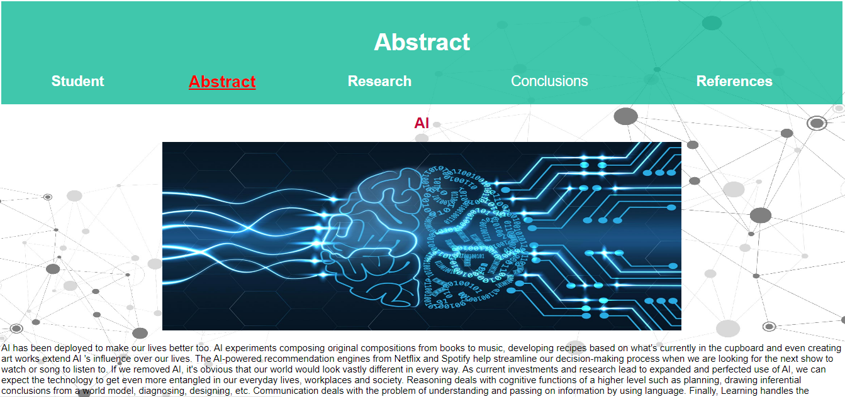**Screen shots**

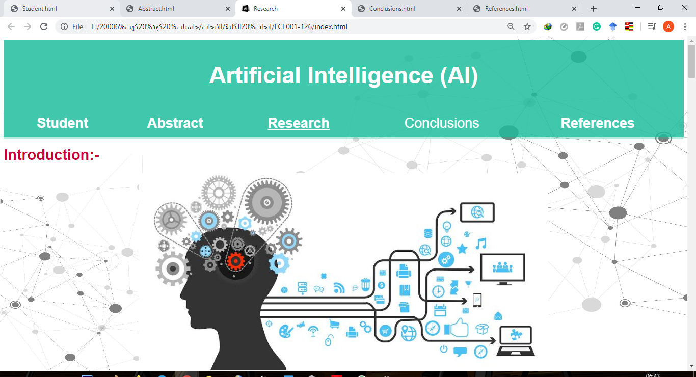

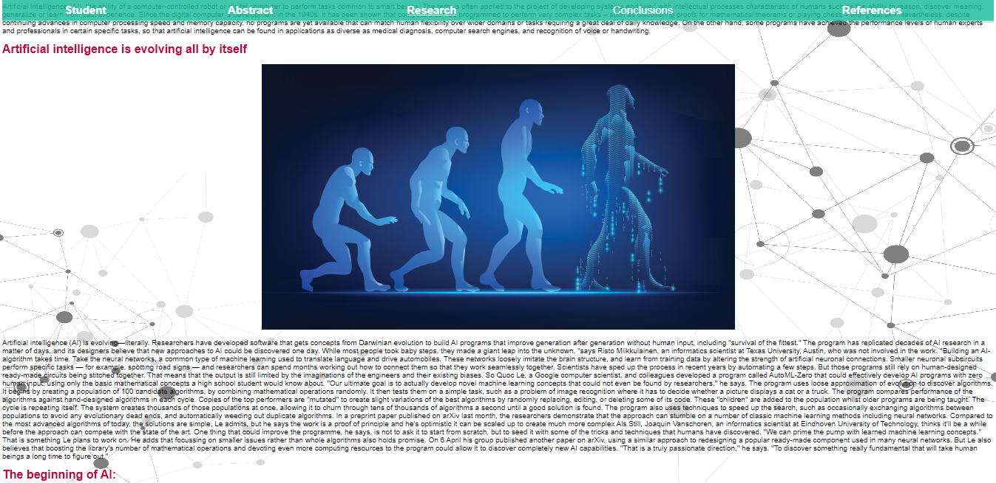

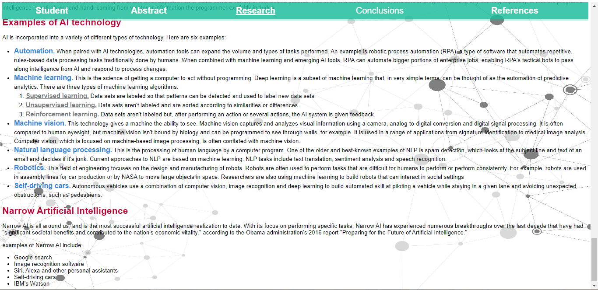

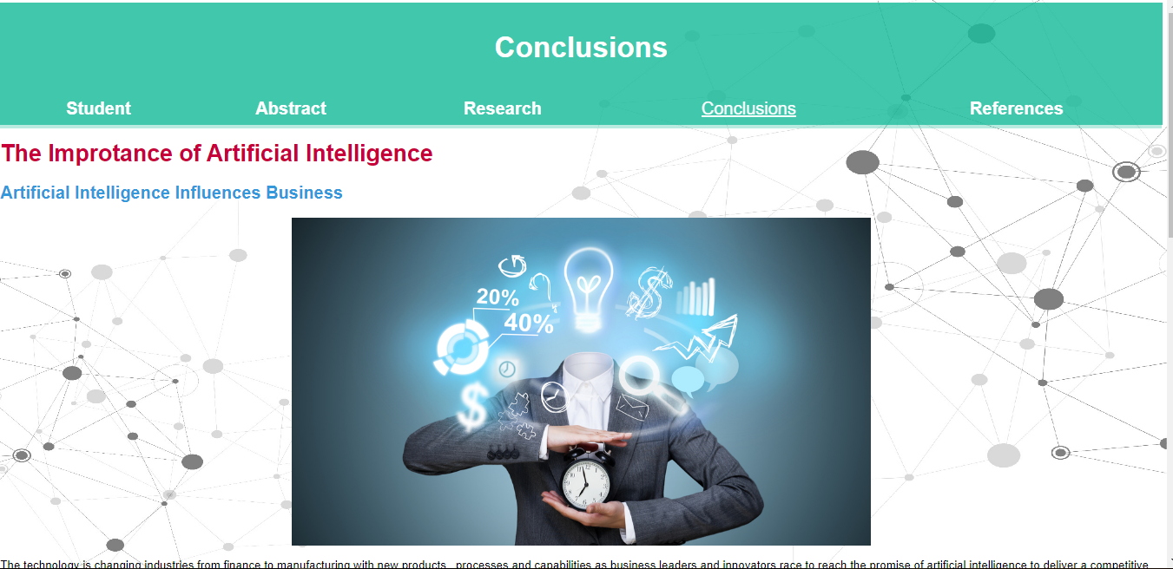

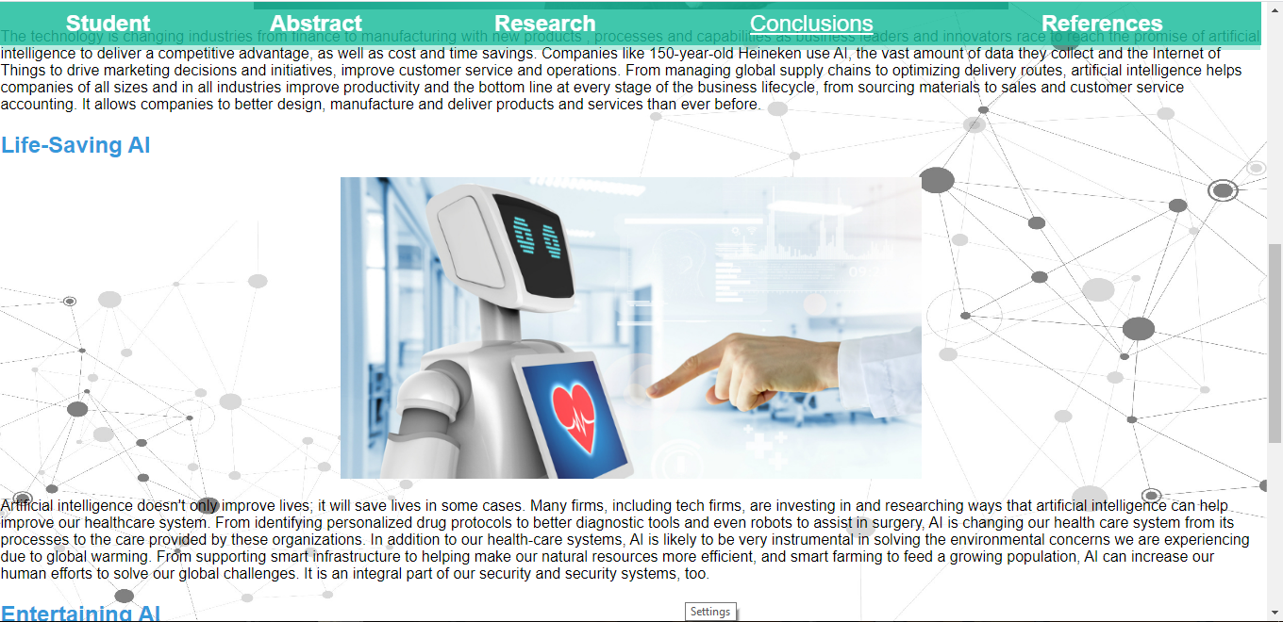

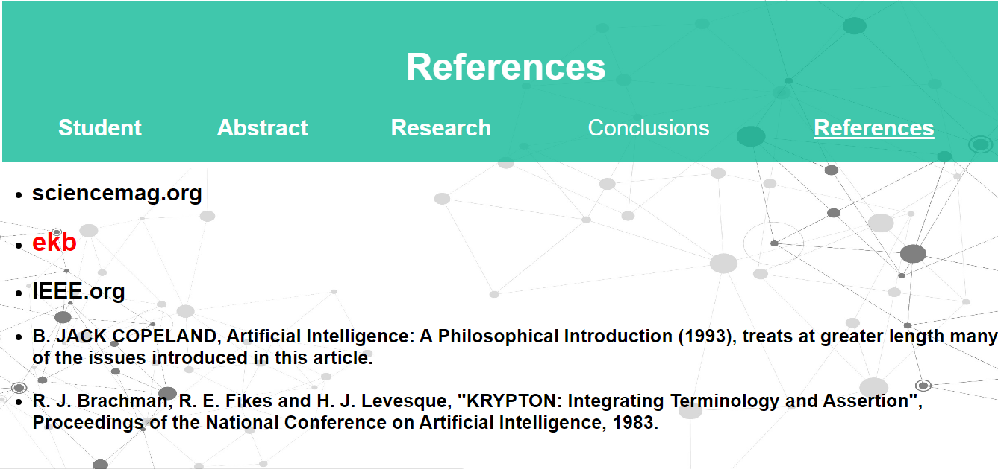

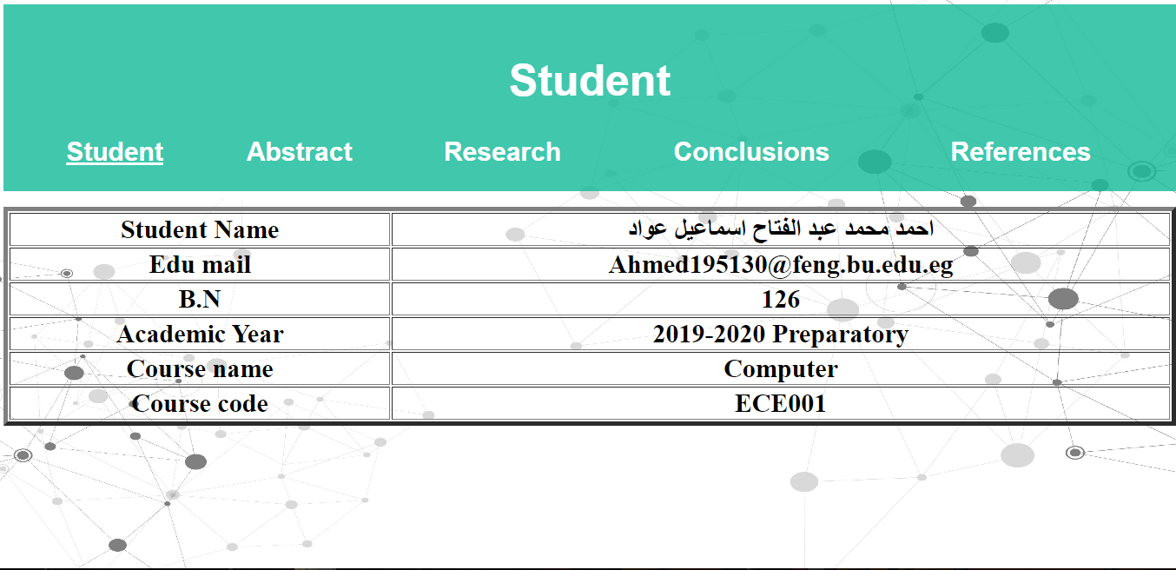

**Source code**

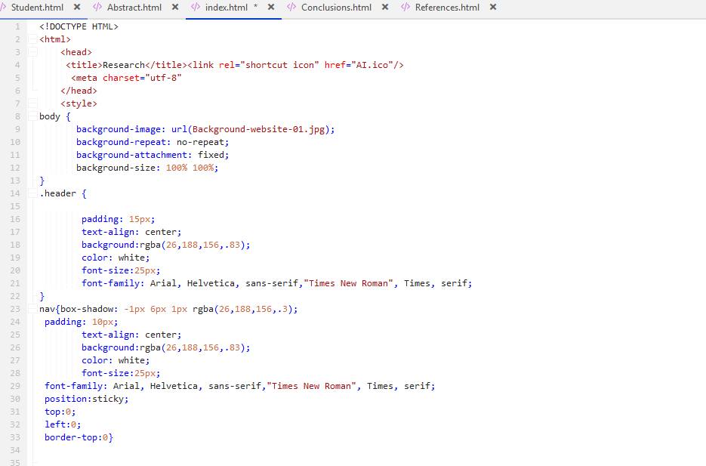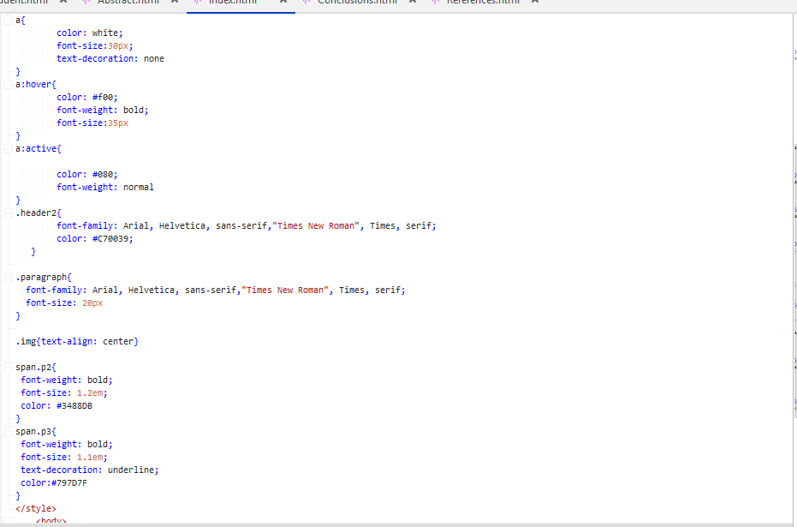**style**

links, headers, images & paragraphs

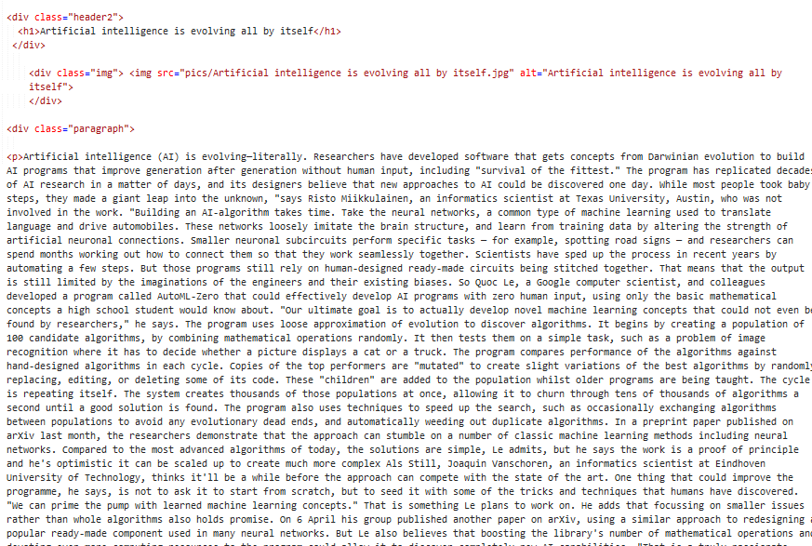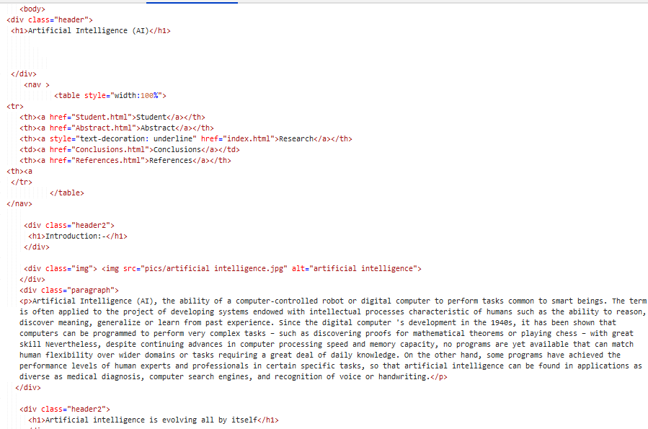

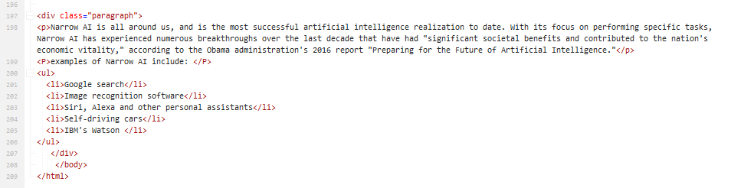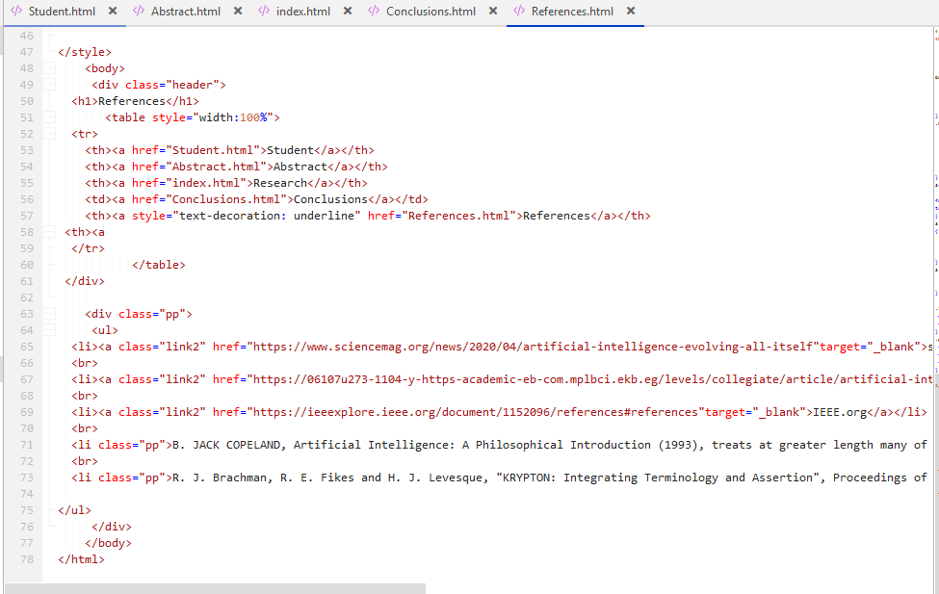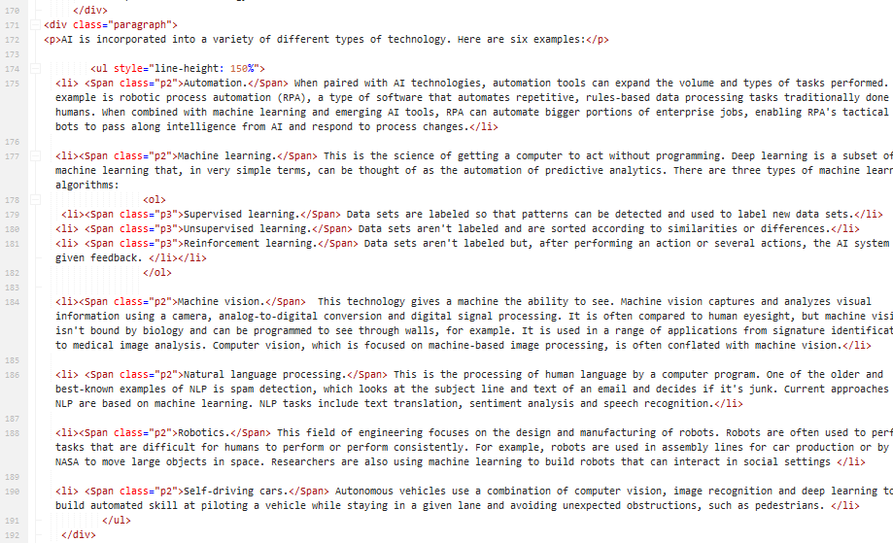**lists**

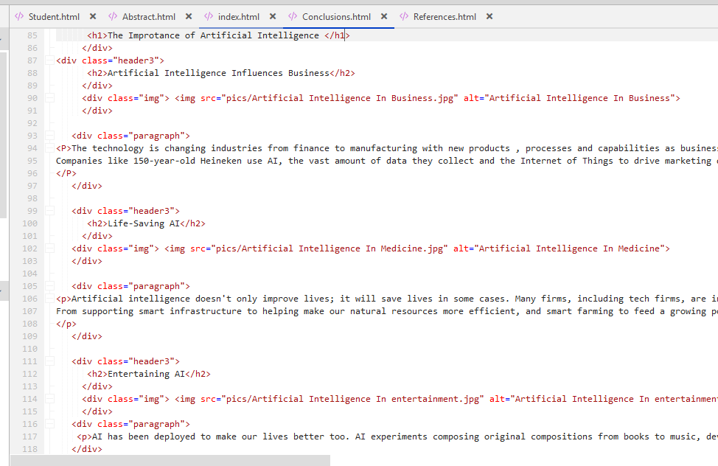**conclusion**

**Tables**

