**Name: Ahmed Azzam**

**Date: 6th March 2021**

**Project: Map-Reduce in Haskell (Word Count) with Result view over YESOD/SQLite web**

**Environment Preparation:**

1. Ubuntu Linux Machine
2. Microsoft visual studio install through download from <https://go.microsoft.com/fwlink/?LinkID=760868>
3. If the file downloaded into download folder then
4. From Linux terminal navigate to downloads path and run sudo apt install “ the downloaded file.deb”

Example sudo apt install code_1.54.1-1614898113_amd64.deb

1. Install Haskell language support in Vstudio

**Stack Tool Install for building Haskell Projects :**

1. From Linux terminal run “ Sudo apt install curl “
2. You might need sudo apt-get update first
3. Stack tool will be required through running the following command on Ubuntu

“curl -sSL https://get.haskellstack.org/ | sh “

You might need sudo before also

**Or if I doesn’t work then manual download through** <https://docs.haskellstack.org/en/stable/install_and_upgrade/#ubuntu>

1. From Linux terminal run “stack upgrade --binary-only”

**Running Map Reduce project:**

* Unzip the folder attached MapReduce-Haskell-project-master.zip and Copy the folder MapReduce-Haskell-project-master into /Downloads

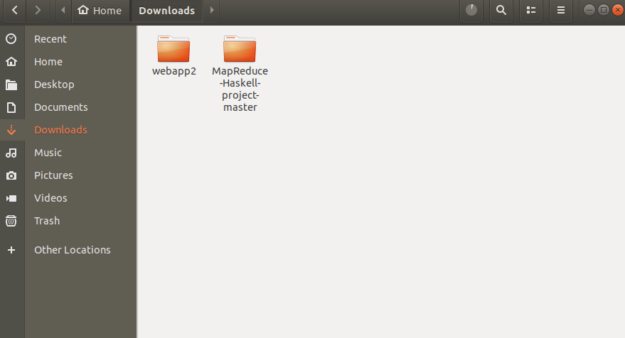

* Open Visual Studio and open the folder “MapReduce-Haskell-project-master”
* Right click as per below and select open in integrated terminal

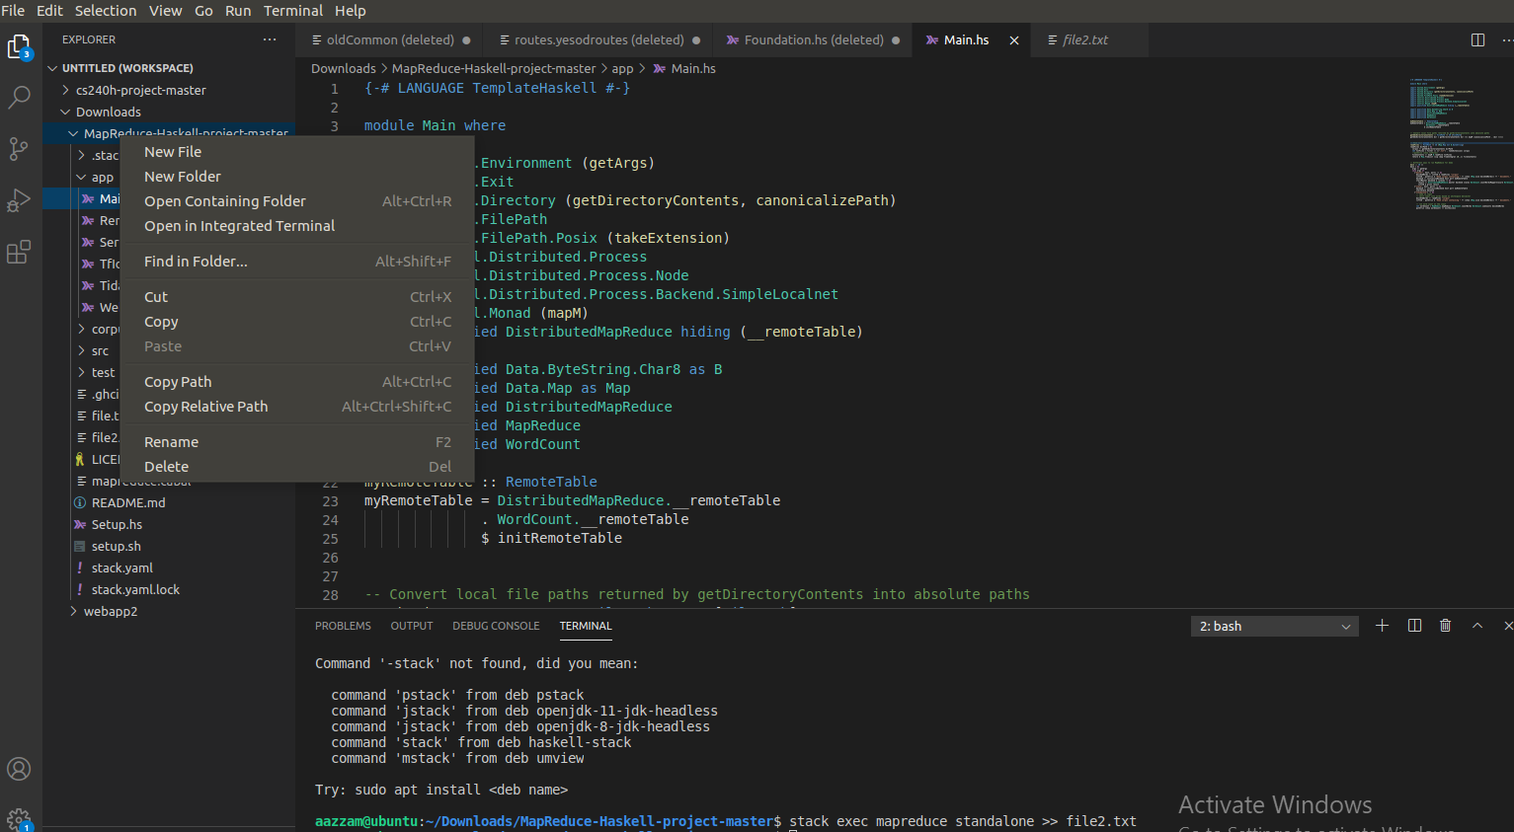

* From Linux terminal run “ stack setup”
* From Linux terminal run “ stack build” (this will install the GHC)
* From Linux terminal “stack exec mapreduce standalone >> file.txt”
* To know the time taken you can run the above command again but write time before it

“ time stack exec mapreduce standalone”

**Running YESOD framework detailed info on ( <https://www.yesodweb.com/page/quickstart> )**

* Packages required From Linux terminal run “sudo apt-get install -y build-essential zlib1g-dev ”
* From Linux terminal when inside the /Downloads folder run “stack new webapp2 yesodweb/sqlite && cd webapp2”
* From given attachments Copy all files from inside the webapp2 folder in zip file named webapp2.zip into the created location under webapp2 destination replacing all files and merging all folders
* Put the file from map reduce (file.txt) in config folder under

/home/”the user logged on “/Downloads/webapp2/config

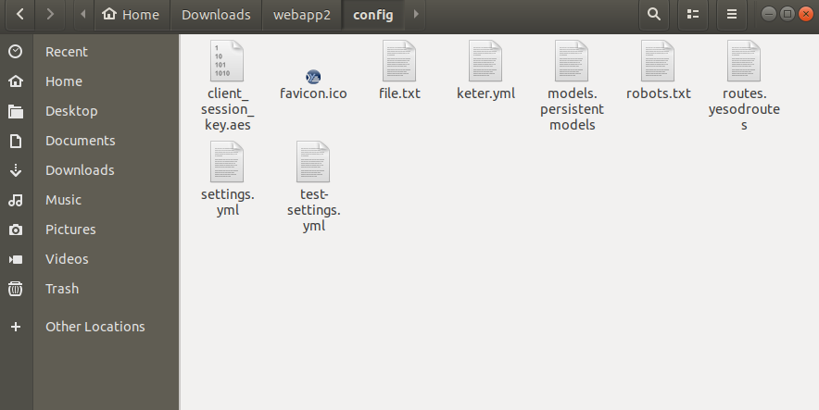

* From Linux terminal run stack install yesod-bin --install-ghc
* From Linux terminal we need to make sure we are inside the folder **webapp2** and then we run

stack build

* From Linux terminal we need to make sure we are inside the folder **webapp2** and then we run stack exec -- yesod devel

In this case the server will be up at <http://localhost:3000/>

* View your Yesod site at <http://localhost:3000/>

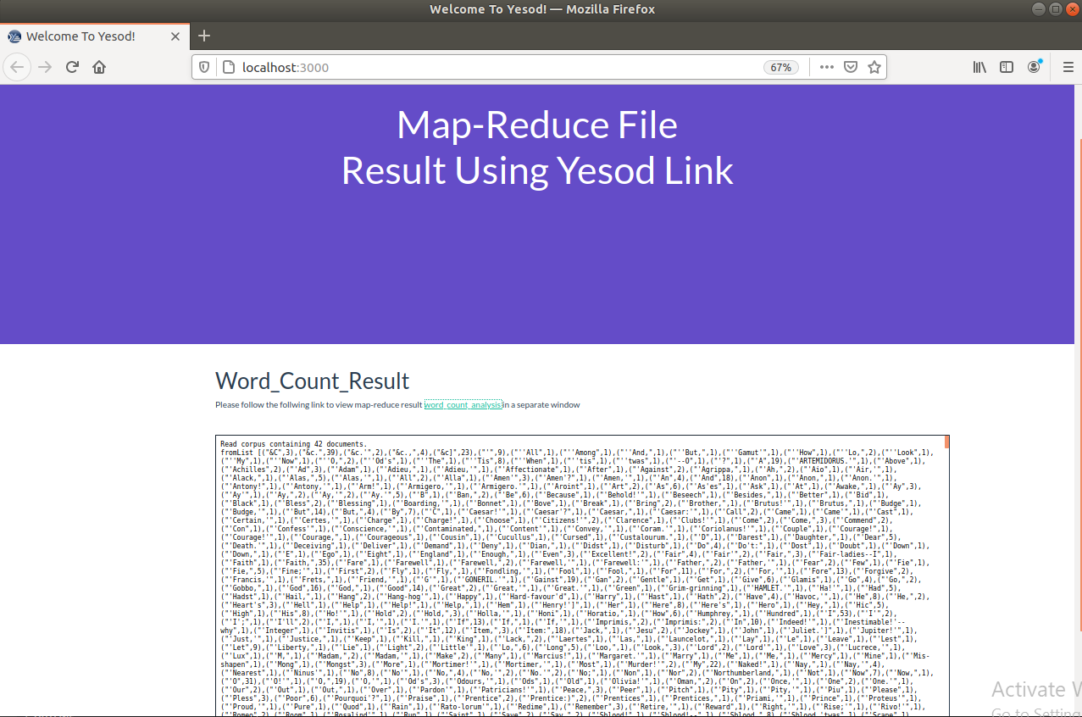

* If we clicked on **word_count_analysis** it will open in a separate windows as below, then we can search any word we need to check its count 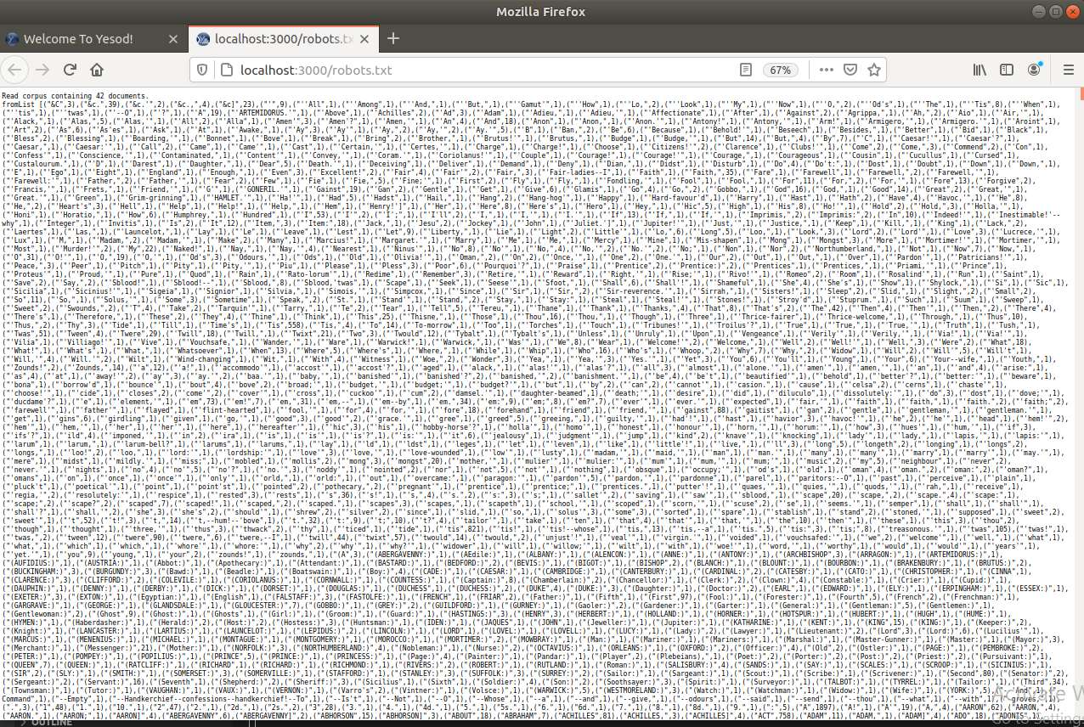
* We can also login using dummy account it will be saved in SQLite