**Title**: Diamond Data Analysis Report

**Subtitle**: Analysis Based on Visualizations Using Seaborn, Pandas, and Matplotlib

**Executive Summary**

"This report presents an analysis of the diamond dataset using visualizations. Key findings include a clear relationship between carat size and price, trends showing how diamonds with higher cut quality (Ideal) tend to be priced higher, and an observation that diamonds with the highest clarity grades also tend to have the highest price points."

**Data Overview**

**Data Source**: Describe where the diamond dataset comes from, its features (e.g., carat, price, clarity), and its dimensions (number of records and variables).

**Data Cleaning & Preprocessing**: Briefly explain any data cleaning steps, such as handling missing values, outliers, or data type conversions.

**Visual Analysis and Results**

1. **Distribution of Diamond Clarity**

**Visualization**: A **boxplot** showing the distribution of “cut” and “clarity”

**Chart:**

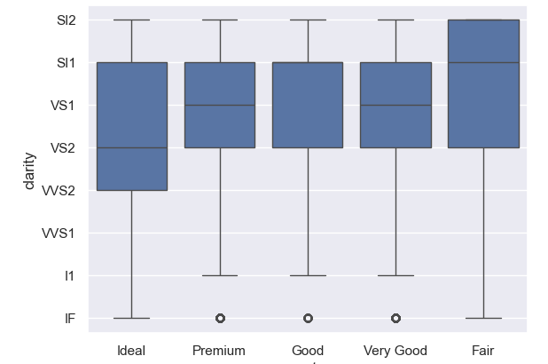

1. **Cut vs clarity with different modes of colors**

**Visualization :** A **boxplot** showing the distribution of “cut” and “clarity”

**Chart:**

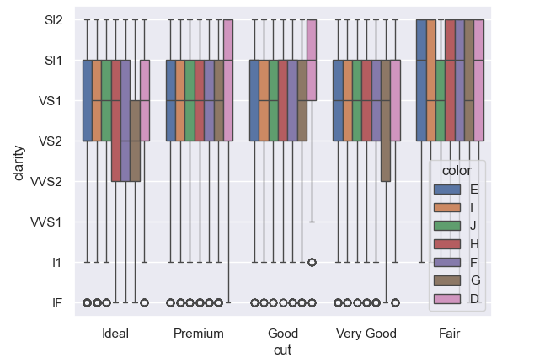

1. **Distribution of “depth” and “Price”**

**Visualization :** A **Scatter** showing the distribution of “depth” and “price”

**Chart:**

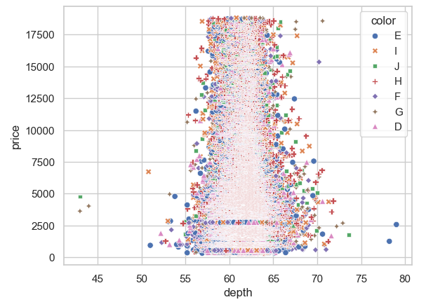

1. **“CUT” vs “Price”**

**Visualization:** A **Box** showing the distribution of “CUT” and “price”

**Chart:**

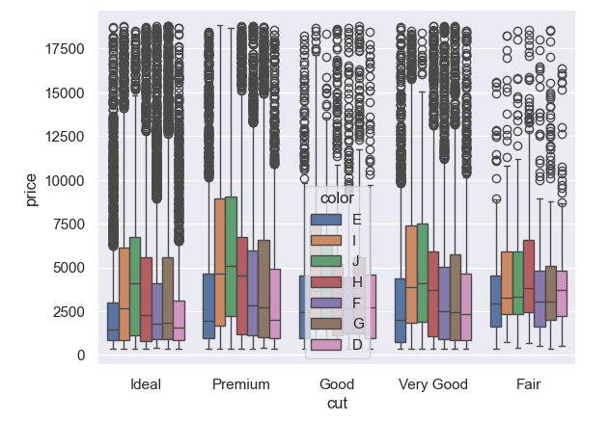

1. **An over view of Data set with the help of diamond CSV file**

**Visualization:** A **Pair Plot** showing the distribution of all over diamond CSV File

**Chart:**

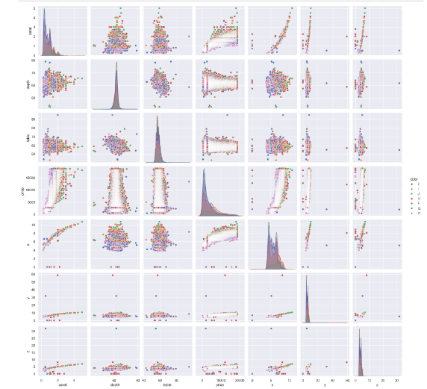

1. **Maximum and minimum with “cut” and “Depth”**

**Visualization:** A **line Plot** showing the minimum and maximum of “cut” and “depth”

**Chart:**

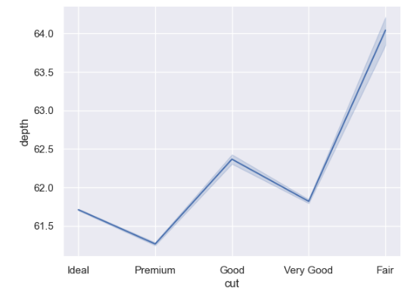

1. **Minimum and maximum with different views**

**Visualization:** A **line Plot** showing the minimum and maximum of “cut” and “depth” With different views

**Charts:**

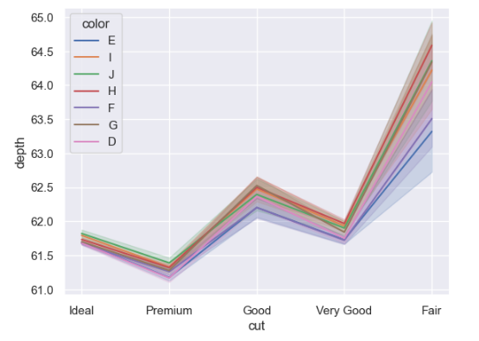

1. **“Mean” and “median” with “cut” and “prices”**

**Visualization:** A **bar Plot** showing the “Mean” and “median” of “cut” and “prices”.

**Charts:**

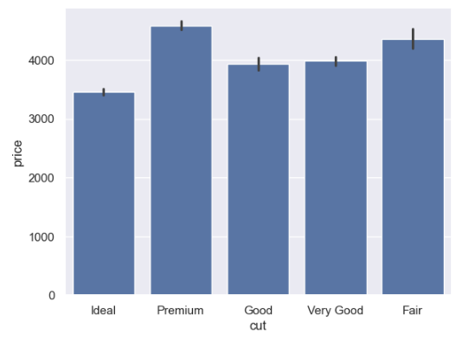

1. **“Mean” and “median” with Different views**

**Visualization:** A **bar Plot** showing the minimum and maximum of “cut” and “prices” With different views

**Chart:**

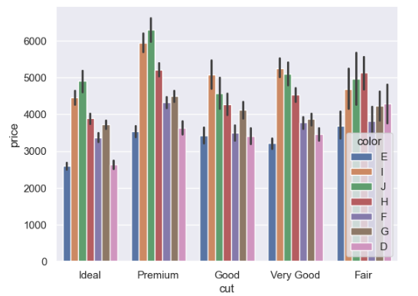

1. **Maximum is darkest and minimum is lightest with “depth” and “Prices”**

**Visualization:** A **Scatter Plot** showing the minimum with darkest color and maximum with lightest color of “depth” and “prices”

**Charts:**

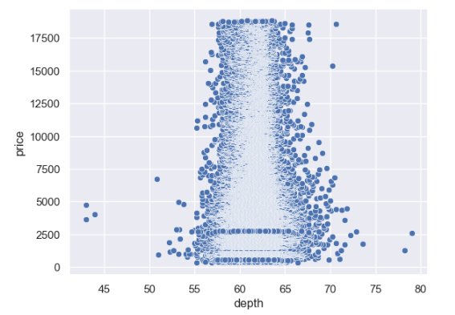

1. **It shows the Scatter plot and Marginal histograph with “cut” and “clarity”**

**Visualization:** A **Joint Plot** showing with Scatter plot and histograph plot “Cut” and “clarity”

**Chart:**

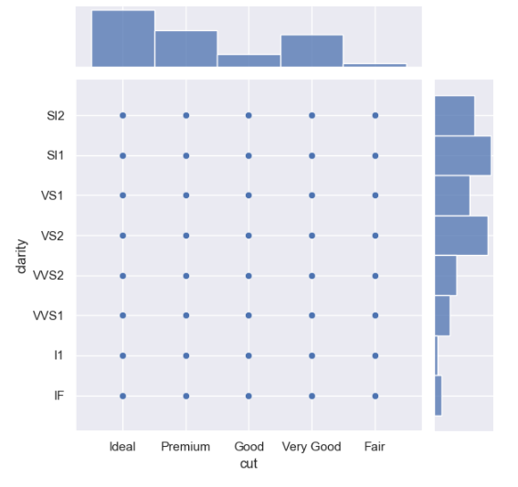

1. **Joint plot with Different view with “cut” and “clarity”**

**Visualization:** A **Joint Plot** showing different views with “Cut” and “clarity”

**Chart:**

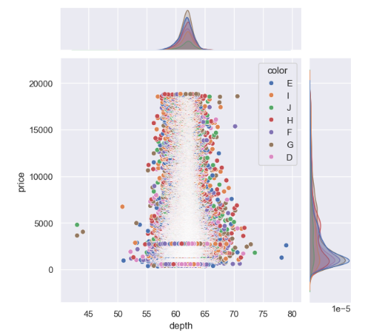

1. **It shows the minimum and maximum value with “Cut” and “Clarity”**

**Visualization:** A **Bar Plot** showing the minimum and maximum values with “Cut” and “clarity”

**Charts:**

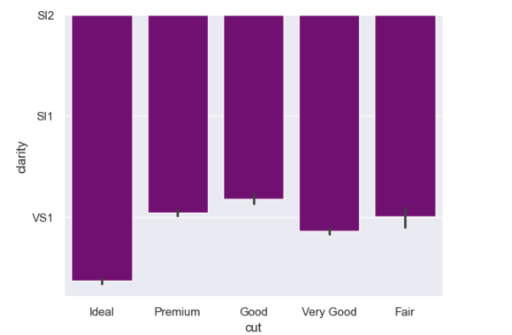

1. **Joint plot with Different view with “carat” and “color”**

**Visualization:** A **Joint Plot** showing different views with “Cut” and “color”

**Chart:**

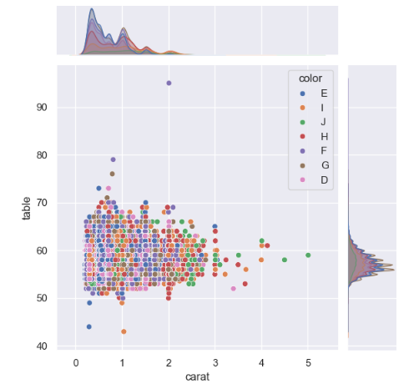

1. **It shows the reading with “cut” and “prices”**

**Visualization:** A **histograph** showing the reading of “Cut” and “price”

**Chart:**

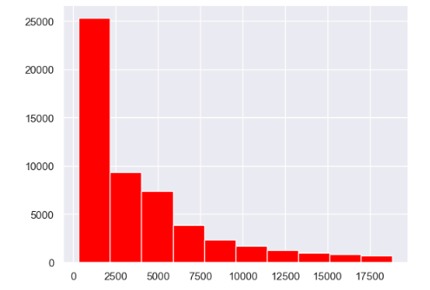

**conclusion**

"In conclusion, the analysis of the diamond dataset reveals strong relationships between carat size, cut quality, and price. The findings suggest that diamonds with higher carat sizes and better cuts tend to fetch higher prices, and can guide future pricing strategies and marketing efforts."

**Final Thoughts:**

The key to an effective report is **clarity** and **structure**. Your visualizations should serve as the foundation for communicating insights, but it's essential to provide context and explain how each chart contributes to your overall findings. As a Data Engineer, your ability to translate technical insights into actionable business recommendations will add significant value to the report.