



Team members:

* Mahmoud Mohamed Mahmoud ElNahrawy
* Mohamed Ramadan ElGafary
* Ahmed Mahmoud ElArgawy
* Adham Hassan Badawy
* Hazem Mohamed Anwar
* Ahmed Mohamed Esmail

Problem statement

* MasterTech, an electronics e-commerce platform, currently relies on outdated manual processes to manage product inventory, customer orders, and sales data. This inefficient system leads to frequent errors, delayed order processing, and challenges in tracking inventory levels. Customers face difficulties in navigating available products, managing orders, and receiving prompt support, while the team struggles to analyze sales trends and make informed business decisions due to the lack of a centralized and automated system.
* To address these issues, MasterTech aims to implement an Online E-commerce Management System (OEMS). The objectives of this   
  OEMS are to enhance accessibility for customers,   
  automate key processes, and provide actionable   
  insights for better decision-making. By adopting   
  this online platform, MasterTech seeks to   
  improve operational efficiency, foster   
  seamless customer experiences, and   
  drive growth in a competitive marketplace.

Stakeholders

* E-commerce Team
* Customers
* Business Administrators
* IT Department: Provides technical support and expertise for implementing and maintaining the Online E-commerce Management System (OEMS).
* Vendors/Developers: External parties involved in the development, customization, and support of the OEMS software.

System boundaries

E-commerce Team: Can add, edit, update, or delete information related to products, orders, and customer profiles.

Customers: Can access and interact with their own accounts to manage orders, update personal information, view purchase history, and track order status.

Product Search and Management: Customers can browse and search for products, add them to their carts, and manage their purchases online.

Administrators: Responsible for system maintenance, configuration, inventory oversight, and resolving technical issues to ensure smooth platform operations.

Data Integrity and Security: Ensures secure storage and management of customer, product, and transaction data within a centralized database, protecting sensitive information.

External Integrations: The system is interconnected with external services, such as payment gateways for online transactions and third-party logistics systems for shipping and delivery tracking.

System Constraints

|  |  |
| --- | --- |
| **Source** | **Constraint** |
| **Operational** | Product information, customer profiles, and order data must be transferred accurately from existing systems to the new platform.  Each product, customer, and order must have a unique identifier to prevent conflicts and ensure data integrity |
| **Technical** | Developed using modern web development technologies  Hosted on a cloud-based platform. |
| **Personal** | * Total project cost capped at $500,000, covering development, infrastructure, deployment, and ongoing maintenance. |
| **Economic** | Total cost $500,000, including development costs, infrastructure, and ongoing maintenance. |
| **Political** | * Strict access controls, encryption protocols, and GDPR compliance must be implemented to ensure the security and confidentiality of customer and transaction data. * Regular data audits and quality checks are required to maintain data accuracy and meet regulatory standards. |
| **Schedule** | * Start at 13/10/2024 * End at 13/12/2024 |

Functional   
Requirements

**E-commerce Team**

* Add new products to the system, including details such as name, category, brand, SKU, price, stock quantity, and description.
* Edit existing product records to update information, adjust pricing, or mark products as in-stock/out-of-stock.
* Delete outdated or irrelevant product listings from the system.
* Register new customer accounts, capturing details such as name, contact information, and purchase history.
* Edit customer profiles to update contact information or account preferences.
* View and manage order history, including processing new orders, returns, and cancellations.
* Update stock availability in real-time based on product purchases, returns, and restocks.
* Manage product reservations or pre-orders, notifying customers when items become available.
* Handle customer inquiries and notifications regarding order status, shipping updates, and stock availability.

**Customers**

* Search for products by name, brand, category, SKU, or keyword.
* Browse products by category, brand, price range, or newly added items.
* View detailed information about each product, including specifications, pricing, reviews, and availability status.
* Register for a customer account or update personal information, such as contact details and shipping preferences.
* Add products to their shopping cart, manage cart items, and proceed to checkout.
* Track order status, view order history, and manage returns or cancellations.
* Place product reservations, pre-orders, or notify availability requests.
* Receive notifications for order confirmations, shipping updates, and product restocks.

**Business Administrator**

* Manage the users in the system (e-commerce team and customers).
* Add or delete users from the system.
* Oversee and control system operations, ensuring smooth functioning.
* Maintain the platform, including system configurations and security protocols.
* Monitor inventory levels, order trends, and platform performance through centralized dashboards.
* Generate reports on sales, inventory, and user activity to support data-driven decisions.

**Non-functional**

**Security and encryption**

* Ensure clear password rules, including minimum length, special characters, and complexity requirements.
* Ability to configure the number of failed login attempts before an account is temporarily blocked, with automated recovery after a set time.
* Encrypt all system communications using TLS standards to ensure secure data transfer.
* Passwords must be stored securely using a hashing algorithm (e.g., bcrypt or SHA-256).
* Ensure all data in the database is encrypted to maintain confidentiality and data integrity.
* Ability to configure an IP allowlist for secure access to the system.
* Enable multi-factor authentication (MFA) for customers and the e-commerce team using phone-based verification.

**Performance**

* The system must support continuous data growth and ensure fast database response times for product searches, order processing, and inventory updates.
* Provide acknowledgment to customers within 1 second after order placement or account verification.
* The system must support at least 10,000 concurrent users without performance degradation.
* The user interface (UI) must respond within 3 seconds for all key actions, such as product searches, page loads, and transactions.

**Integration with other systems**

* Ability to seamlessly integrate with external systems, such as:
  + Payment gateways (e.g., Stripe, PayPal).
  + Third-party logistics systems for shipping and delivery tracking.
  + External databases for real-time stock updates or product catalogs.

**Logs**

* Maintain logs for all critical database operations, such as insert, update, delete, and retrieve actions.
* Keep detailed logs for user activities and transactions to support monitoring and auditing.

**Maintainability**

* The system must support efficient data backup and restore functionality to ensure minimal data loss.
* Track and log system errors or issues for troubleshooting and improvement.
* Schedule maintenance activities during non-peak hours to minimize disruption.
* System upgrades should take no longer than 10 minutes to complete.

**Reliability**

* The system must be highly resilient to technology disruptions, crashes, or downtimes.
* Implement redundancy mechanisms to ensure 99.9% uptime availability.

**Recovery**

* Ensure that the system can recover from failures or crashes within 5 minutes or less.
* Data must remain intact during recovery to ensure business continuity.

**Interfaces**

* All system interfaces must be responsive across various devices, including desktop, mobile, and tablet screens, using modern tools like Bootstrap and CSS.
* The design should incorporate white, red, and green as primary theme colors.
* Enable tooltips to improve user experience by providing clear instructions and guidance.
* Ensure compatibility with assistive technologies and adhere to accessibility standards to accommodate users with disabilities.
* Simplify the interface design to create an intuitive and pleasant user experience.

**Archiving**

* System records, including sales, orders, and inventory data, must be archived regularly and easily retrievable when needed.
* Ensure archived data is well-organized and securely maintained.

**Languages**

* The system interface must support English as the default language.
* Allow flexibility for future integration of additional languages.

**Hardware**

* Ability to integrate with external hardware systems such as:
  + Barcode scanners for inventory management.
  + Thermal printers for invoice and receipt generation.
  + Point-of-sale (POS) systems for in-store sales processing.

**System structure:**

* Web/App Layer: Handles all user interactions, including customers, the e-commerce team, and business administrators.
* Database Layer: Manages secure storage of product information, order details, user data, and logs.

**Use case**

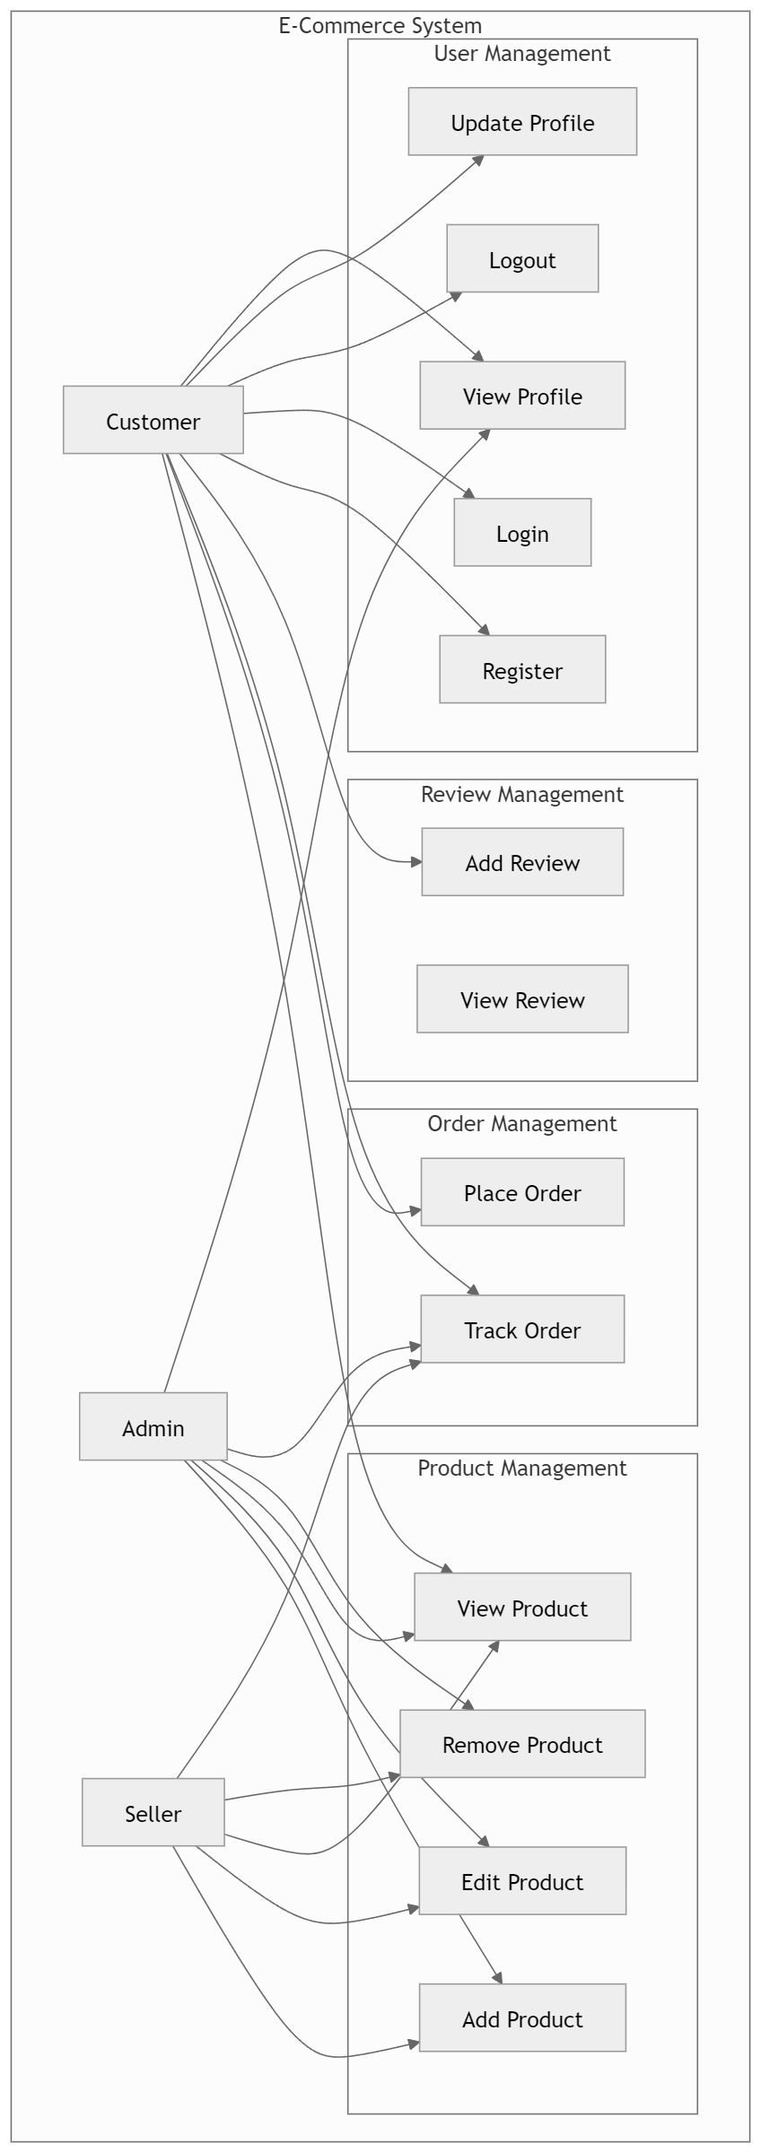

Sequence Diagram

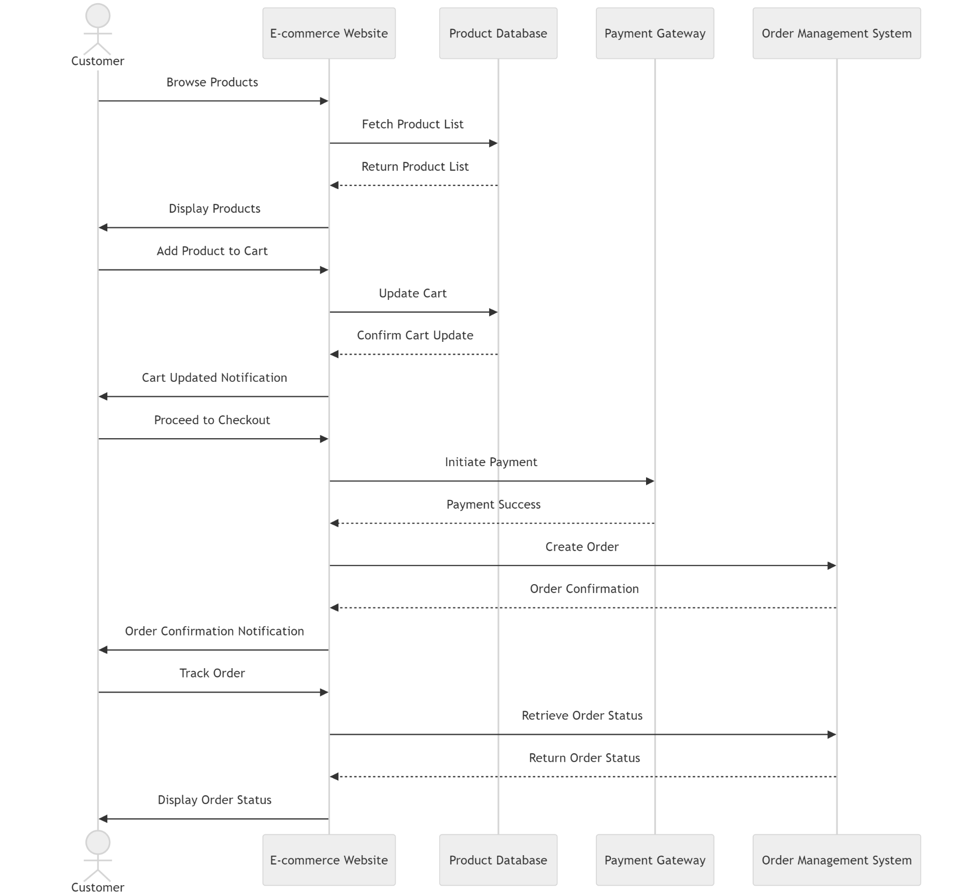

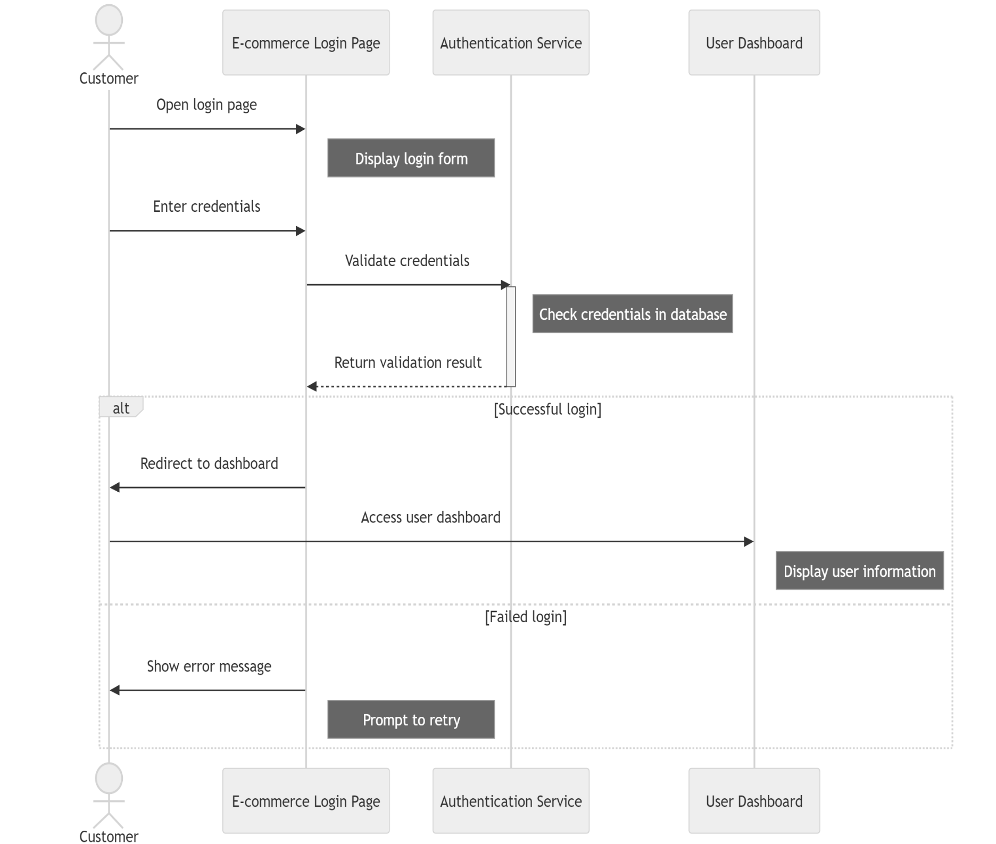

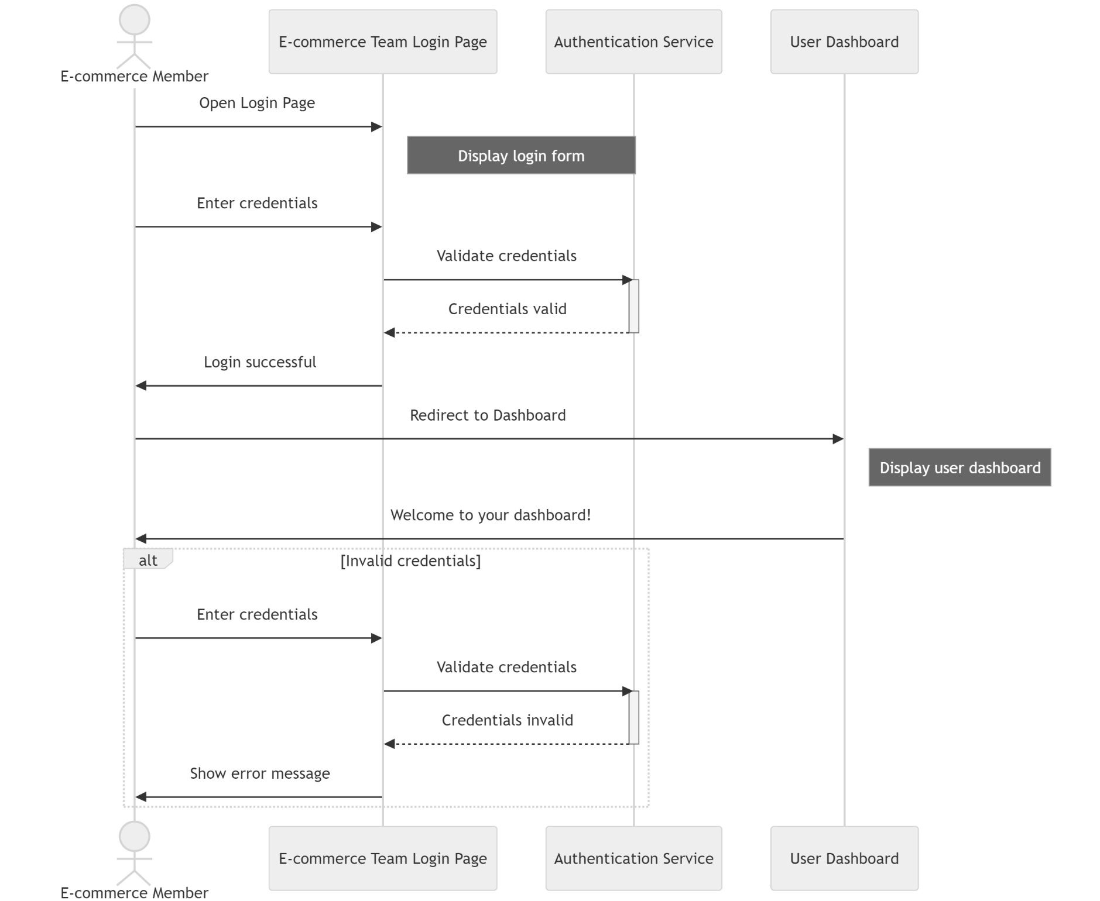

**Activity Diagram**

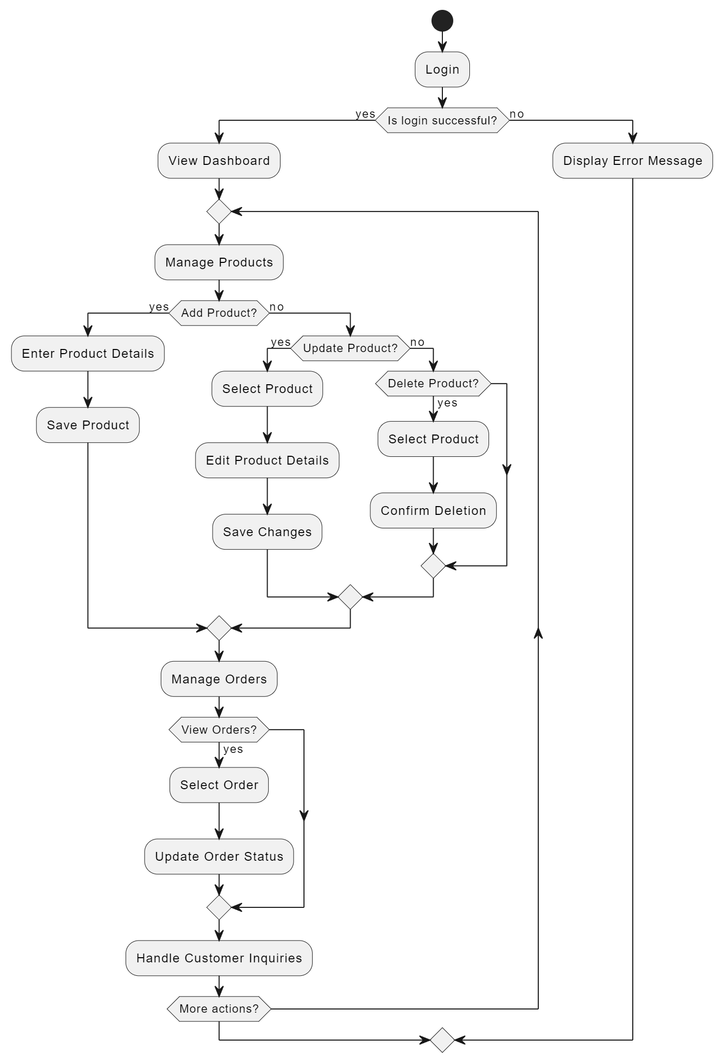



**Class Diagram**

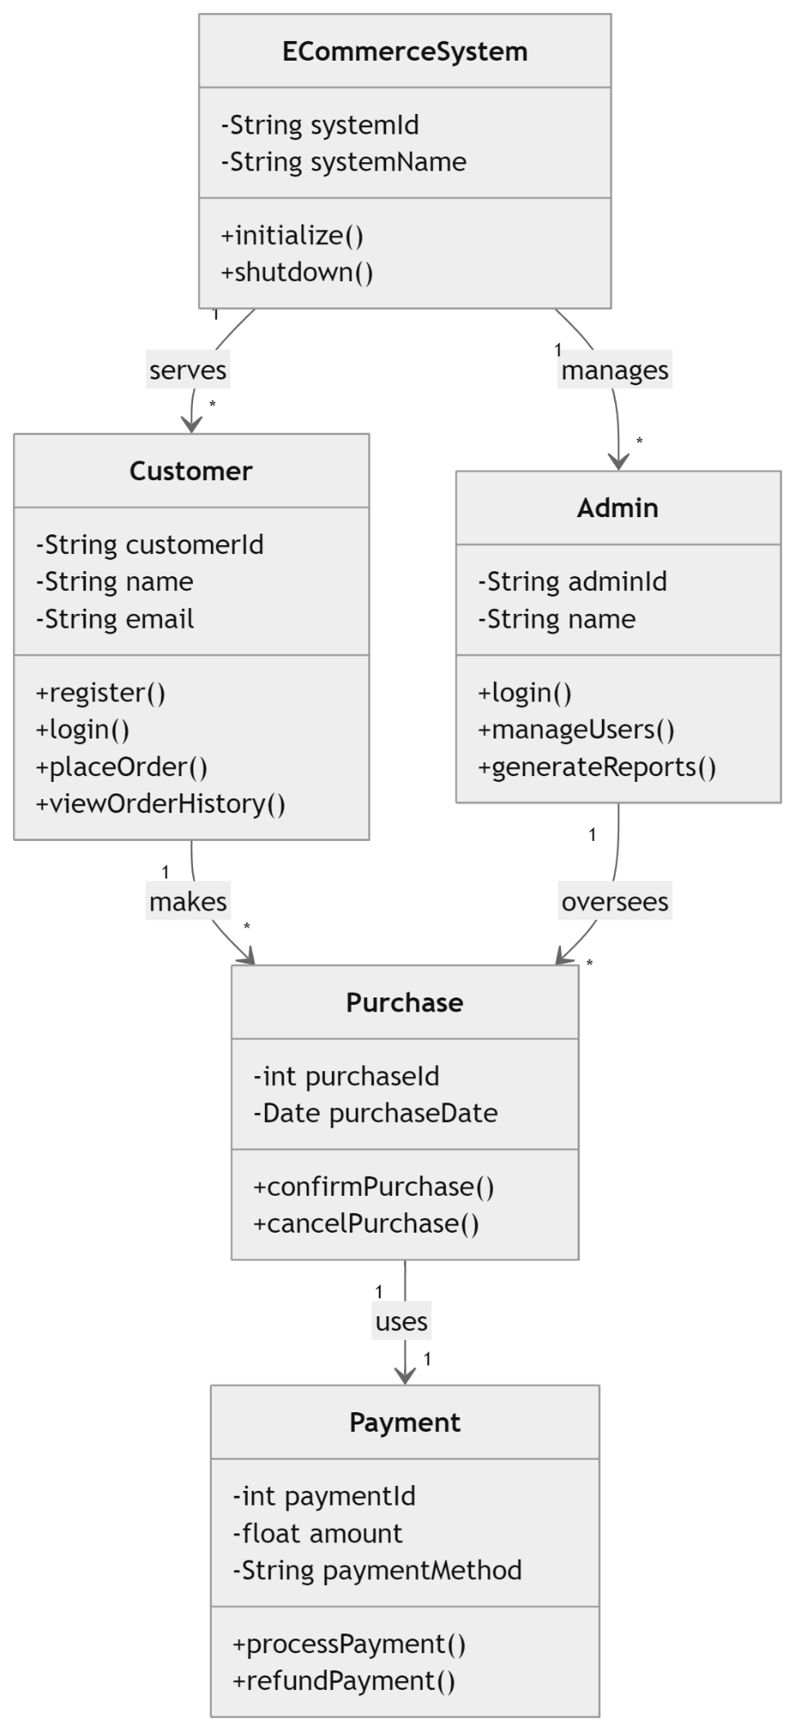

**Context Diagram**

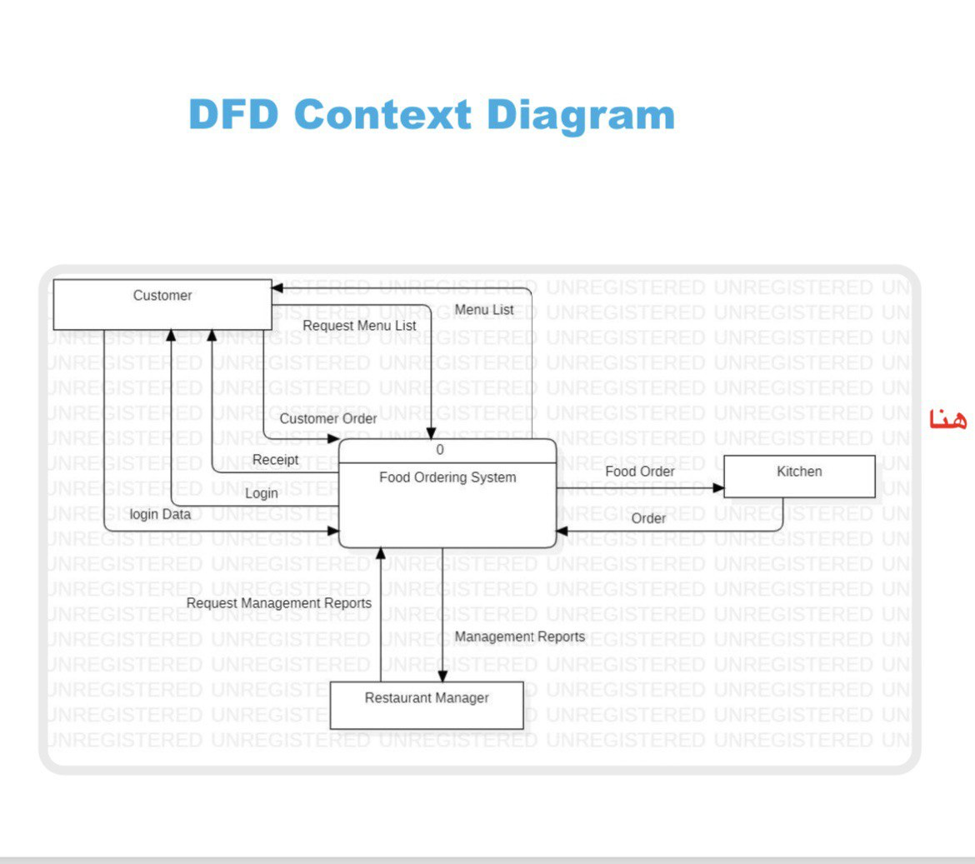

E-commerce System

Inventory

Database

Product order

Request inventory

Product view