**Damietta University**

**Faculty of Computers and Artificial Intelligence**

**Advanced System Analysis and Design, 2023/2024**

**[Digital Inventory Management system]**

**Team Members:**

* **Salma Mohamed Fatheldin Abdrabou**

**ID: 806146817**

* **Ahmed Ibrahim Elzayat**

**ID: 804616513**

* **Khaled Shawky Ghaly**
* **ID: 804621866**

## **1. System Request—Digital Inventory Management Project**

**1.1 Project Sponsor**

* Salma Mohamed, Assistant Vice, IT Team Leader
* Ahmed Elzayat, manager
* Khaled Ghaly, vice president

**1.2 Business Need:**

The existing manual system for inventory management is inefficient, time-consuming, and costly. There is a need to transition to a digitalized system to save time, reduce costs, and improve efficiency by providing accurate and current details about inventory levels.

**1.3 Business Requirements:**

* Utilize software and hardware to automate inventory processes.
* Determine the quantity and type of each product.
* Maintain optimal inventory levels.
* Provide reporting capabilities for product status, movement, and delivery time.
* Offer online user support.

**1.4 Business Value:**

* Time and cost savings by eliminating manual record-keeping and report generation.
* Potential reduction in workforce due to automation.
* Increased sales through up-to-date inventory information.
* Improved customer service and satisfaction through online support and availability.

**1.5 Special Issues and Constraints:**

* Project deadline is set for December 17.
* System accessibility over the internet is necessary.

## 2. Objectives:

* Develop a user-friendly interface for inventory updates and vendor orders.
* Maintain accurate inventory levels to optimize stock.
* Reduce manual efforts in inventory management.
* Generate reports to analyze inventory performance.

## 3. Methodology:

Agile methodology will be employed for development due to its flexibility in accommodating changing requirements and ensuring alignment with stakeholder expectations.

By adhering to these points, the project aims to streamline inventory management processes, enhance efficiency, and improve overall business operations.

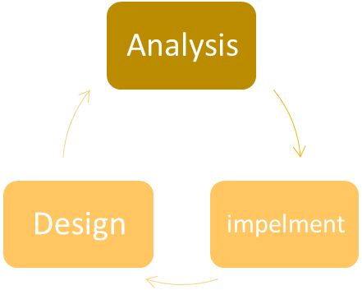

planning

feedback

## 4. Actors:

* Inventory Manager
* Purchasing Manager
* Supplier
* Business Analyst

## 5. Functional Requirements:

1. **Authenticate Users:**
   * Users must log in securely with unique credentials.
   * Assign different access rights based on user roles (e.g., administrator, manager, staff).
2. **Manage Inventory:**
   * Add, edit, and delete products with relevant details such as name, description, category, unit price, and quantity.
   * Automatically update inventory levels upon each transaction (e.g., sales, purchases, returns).
3. **Process Orders:**
   * Create and process purchase orders for restocking inventory.
   * Adjust inventory levels automatically upon receiving goods from suppliers.
   * Record and track order status (e.g., pending, processed, shipped, received).
4. **Generate Reports and Analytics:**
   * Generate reports on inventory levels, stock movements, and product performance.
   * Analyze sales trends, demand forecasts, and inventory turnover rates.
   * Provide insights to optimize stock levels and purchasing decisions.
5. **Send Alerts and Notifications:**
   * Send alerts for low stock levels, overdue orders, or other inventory-related issues.
   * Notify users about important updates, such as order confirmations or product arrivals.

## 6. Non-Functional Requirements:

1. **Performance:**
   * The system should respond to user actions within 2 seconds under normal load conditions.
   * It should be able to handle a concurrent user load of at least 100 users without significant performance degradation.
2. **Reliability:**
   * The system should have an uptime of at least 99.9%.
   * It should be resilient to hardware failures or network interruptions, with automatic failover mechanisms in place.
3. **Scalability:**
   * The system should be able to scale horizontally to accommodate increased workload and data volume.
4. **Security:**
   * User data must be encrypted during transmission and storage using industry-standard encryption algorithms.
   * The system should undergo regular security audits and vulnerability assessments to identify and mitigate potential risks.
5. **Usability:**
   * The user interface should be intuitive and easy to navigate, requiring minimal training for users to operate.
   * The system should support multiple languages and localization preferences.
6. **Compatibility:**
   * The system should be compatible with major web browsers (e.g., Chrome, Firefox, Safari, Edge) and operating systems (e.g., Windows, macOS, Linux).
7. **Maintainability:**
   * The system should be modular and well-documented to facilitate future enhancements and maintenance.
   * Codebase should follow coding standards and best practices, with version control and issue tracking tools in place.
8. **Availability:**
   * The system should be available 24/7, with scheduled maintenance windows communicated in advance to users.

## 7. Use Cases:

## 8. Context Diagram:

## 9. DFD Level 1:

# 10. Block Diagram:

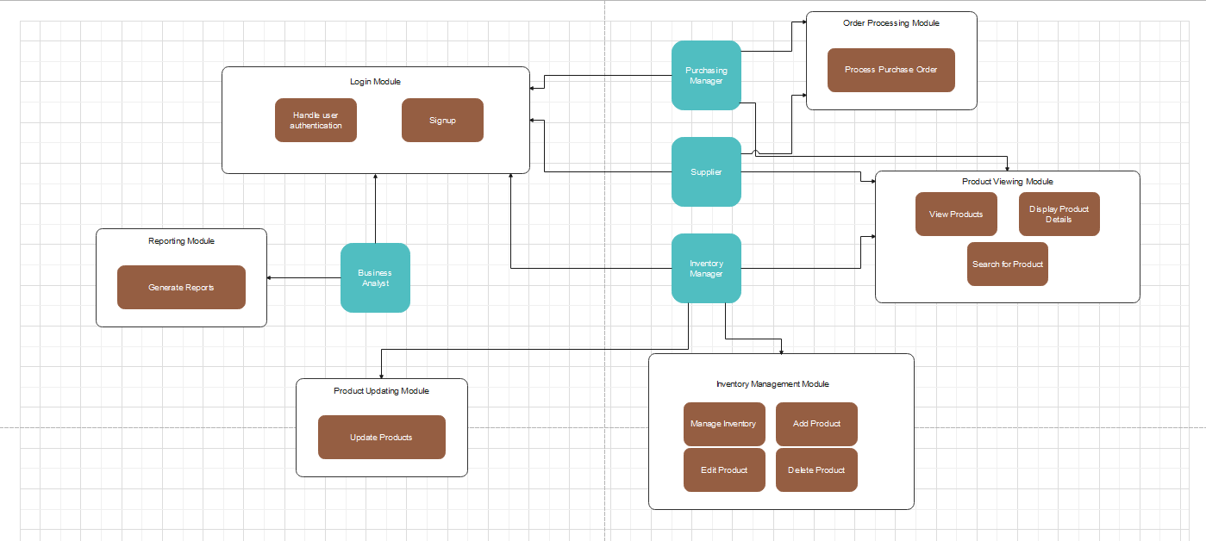

# 11. Flowcharts:

# 12. Class Diagram:

# 13. Sequence Diagram:

### View Product:

### Report:

## 14. Sprints and User Story:

**Sprint#1:** registration:

As a user:

* create an account.
* authenticate email.

**Sprint#2:** manage Inventory:

As a manager:

* + Create products/ category.
  + view products/ category name, description.
  + update product name, description, and details.
  + remove products/ category.

**Sprint#3:** restocking inventory:

As a purchase manager:

* + creating purchase orders.
  + processing purchase orders for restocking inventory.
  + recording/tracking order status (e.g., pending, processed, shipped, received).

**Sprint#4:** analyze Inventory:

As a business analyst:

* analyzing sales trends.
* analyzing demand forecasts, and to prevent inventory failure rates.
* analyzing optimizing stock levels and purchasing decisions.

**Sprint#5:** Generate Reports:

As a business analyst:

* getting daily basic reports on inventory levels.
* getting reports on stock movements.
* getting reports on product performance every quarter.

**Sprint#6:** Send Alerts and Notifications:

As a supplier:

* + receive alerts for low stock levels and overdue orders.
  + receive alerts for other inventory-related issues.
  + receive alerts for important updates such as order confirmations or product arrivals.

## 15. UI Screens:

#### Login Screen:

#### Home Screen:

#### Input Screen:

#### Output Screen:

