To: Security Operations Center (SOC) Management
From: Ahmed Emad Nasr, SOC Analyst
Date: March 17, 2026
Subject: Cyber Threat Intelligence Brief – Cloud Migration & Aviation Sector Threats

1. Executive Summary
As our organization in the aviation sector transitions its infrastructure to the cloud, it is critical to assess the specific threat landscape associated with this environment. This intelligence brief identifies a primary Advanced Persistent Threat (APT) group known to target our sector, highlights their relevant tactics and tools, and outlines actionable defensive strategies to secure our Office 365 and cloud integrations.
2. Threat Actor Profile
* Threat Group: APT33
* Activity: Active since at least 2013.
* Target Profile: This group has a documented history of conducting operations against organizations across multiple industries, with a distinct and particular interest in the aviation and energy sectors.
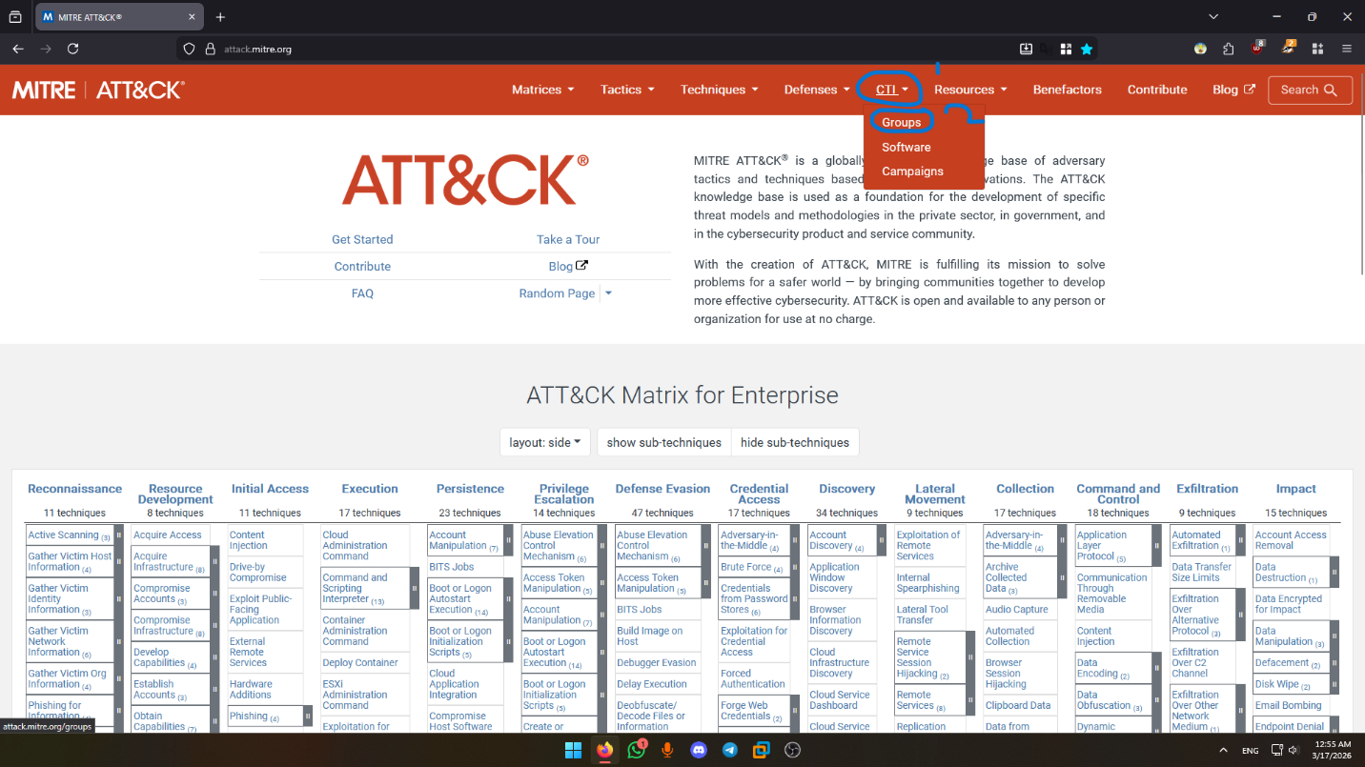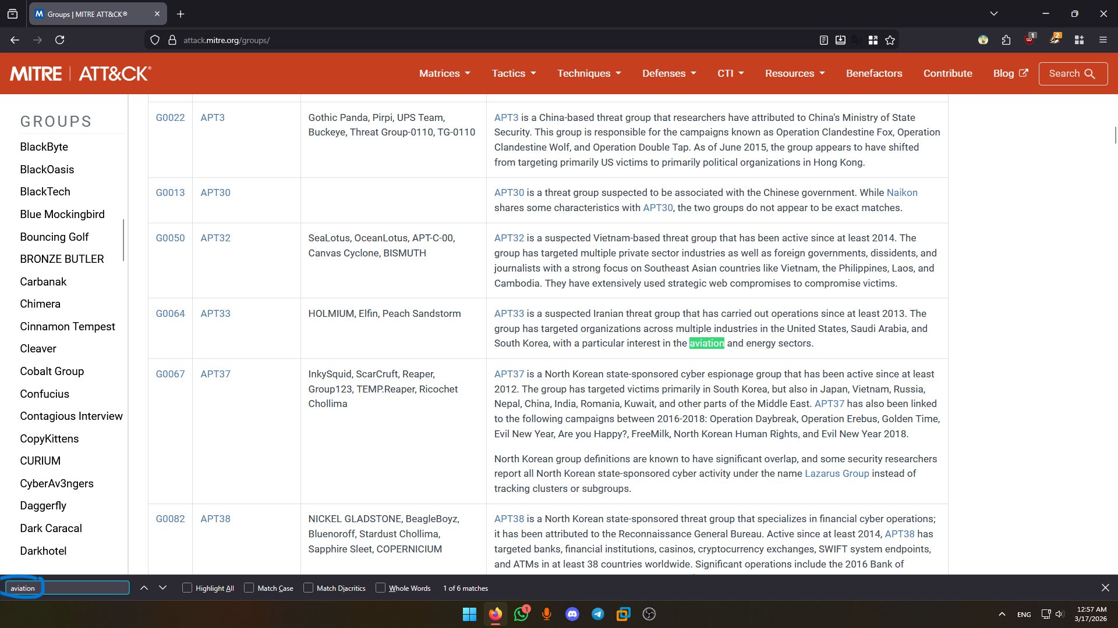

3. Key Tactics, Techniques, and Procedures (TTPs)
* Primary Sub-technique: Cloud Accounts (T1078.004)
* Context & Tooling: APT33 frequently targets cloud infrastructure, specifically focusing on Microsoft Office 365. The group utilizes compromised Office 365 accounts in tandem with a publicly available post-exploitation tool called Ruler to attempt to gain remote control over corporate endpoints. 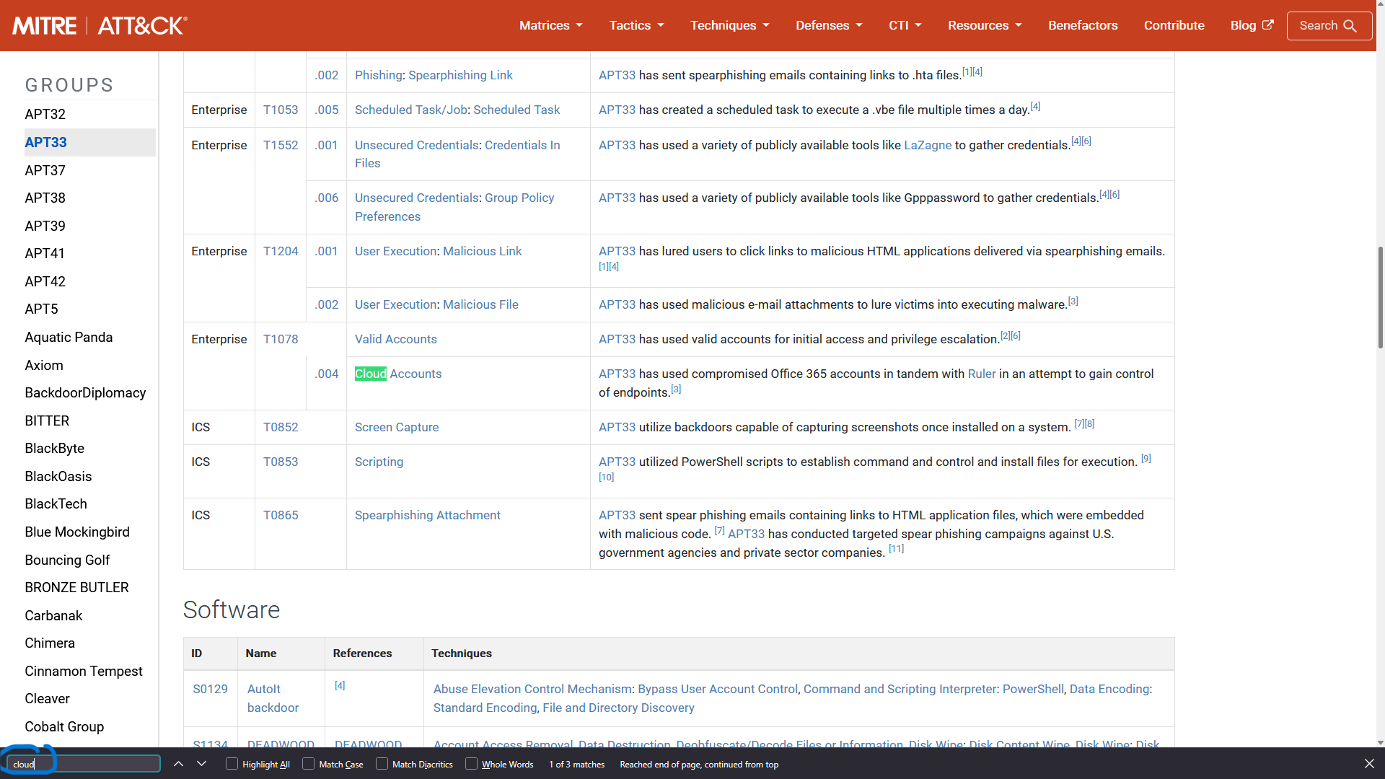

4. Defensive Recommendations
To address potential gaps in our defensive coverage during the cloud migration, the following mitigation and detection strategies must be prioritized:

* Mitigation Strategy: Implement User Account Management (M1018).
- Action: We must enforce a policy to periodically review all user accounts and immediately remove or disable those that are inactive, orphaned, or unnecessary. This directly reduces the attack surface for the Cloud Accounts technique.

* Detection Strategy: Implement Detection Strategy DET0546.
- Action: Deploy monitoring rules mapped to DET0546 to actively identify the "Detection of Abused or Compromised Cloud Accounts for Access and Persistence." This will help the SOC quickly catch anomalous authentication activity or API calls that exceed normal scope.
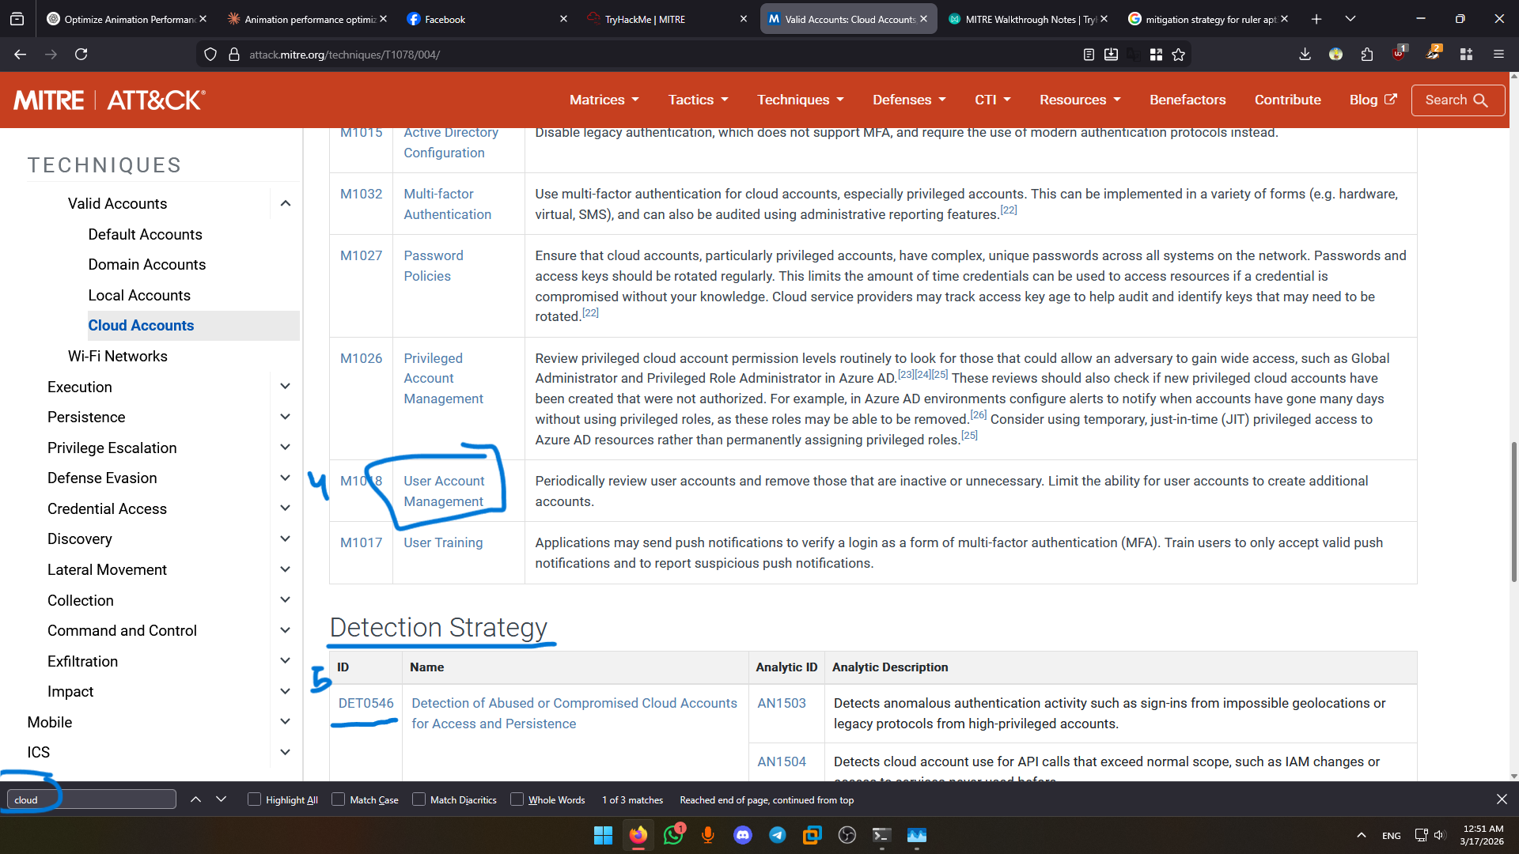

5. Conclusion
Securing our Office 365 environment against unauthorized access is a high priority. By strictly managing account lifecycles (M1018) and configuring our SIEM to detect compromised cloud account behavior (DET0546), we can significantly reduce the risk posed by adversaries like APT33.

