DIGITAL FORENSICS
DATA RECOVERY EXECUTION REPORT

Analytical Tool: Autopsy 4.23.0
Case Name: Ahmed_Emad_Nasr
Case Number: 7
Report Date: May 1, 2026

Prepared By
Ahmed Emad Nasr
Digital Forensics Investigator
ahmed.em.nasr@gmail.com | +201018166445

CONFIDENTIAL — For Authorized Use Only

1. Case Overview
This report documents the complete digital forensic data recovery operation conducted using Autopsy 4.23.0 on a target USB drive labeled 3OMDA (H:). The investigation was formally assigned to Case Number 7 and followed a structured five-phase methodology: case initialization, data source configuration, ingest processing, deleted file analysis, and report generation. All findings are supported by forensic screenshots captured at each step.

Field | Value
Case Name | Ahmed_Emad_Nasr
Case Number | 7
Case Type | Single-User
Analytical Tool | Autopsy 4.23.0
Investigator | Ahmed Emad Nasr
Contact Email | ahmed.em.nasr@gmail.com
Phone | +201018166445
Base Directory | E:\3omda2\Cases\Autopsy
Case Data Path | E:\3omda2\Cases\Autopsy\Ahmed_Emad_Nasr
Timezone | (GMT+2:00) Africa/Cairo
Target Drive | 3OMDA (H:) — 14.4 GB
Report Generated | May 1, 2026
2. Case Initialization
The investigation commenced with a formal case creation in Autopsy 4.23.0. This step establishes the chain-of-custody foundation and ensures all evidence is stored in an organized, auditable directory structure.
2.1 Application Launch
Autopsy 4.23.0 was launched on the forensic workstation. The Welcome dialog presented three options: New Case, Open Recent Case, and Open Case. The investigator selected New Case to initiate a fresh forensic case.

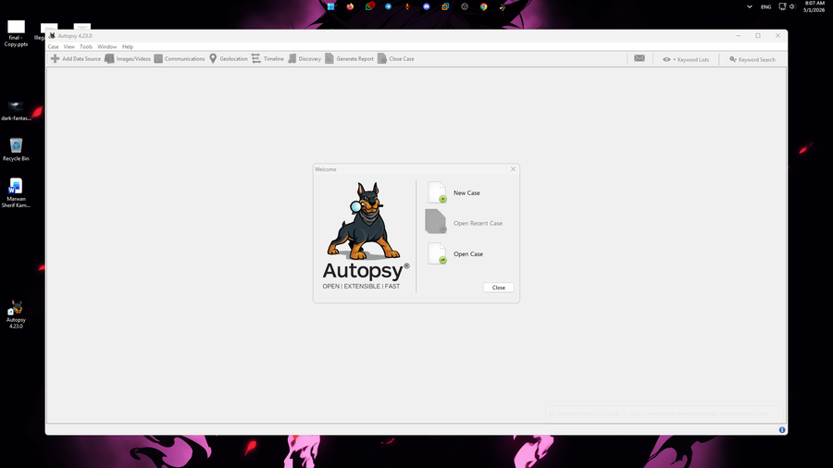
Figure 1: Autopsy 4.23.0 Welcome Screen — Application Launch
2.2 Case Information Configuration
The New Case Information wizard was completed with the following parameters:
- Case Name: Ahmed_Emad_Nasr
- Base Directory: E:\3omda2\Cases\Autopsy
- Case Type: Single-User
- Auto-generated Storage Path: E:\3omda2\Cases\Autopsy\Ahmed_Emad_Nasr

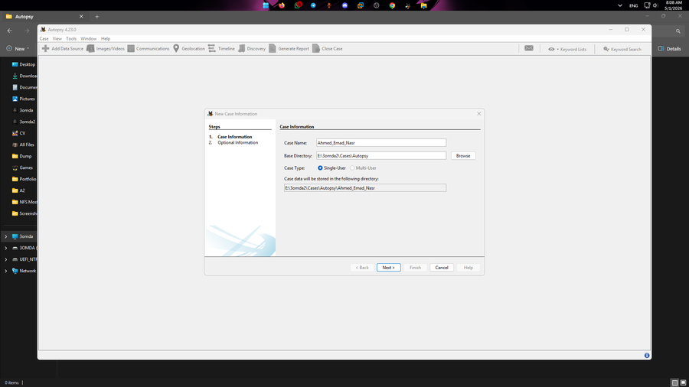
Figure 2: New Case Information — Case Name and Base Directory Configuration
2.3 Examiner Metadata
The second wizard step captured examiner identification. This information is embedded into all generated reports as the formal attribution record.

Parameter | Value
Case Number | 7
Examiner Name | Ahmed Emad Nasr
Phone | +201018166445
Email | ahmed.em.nasr@gmail.com
Notes | NA
Organization | Not Specified

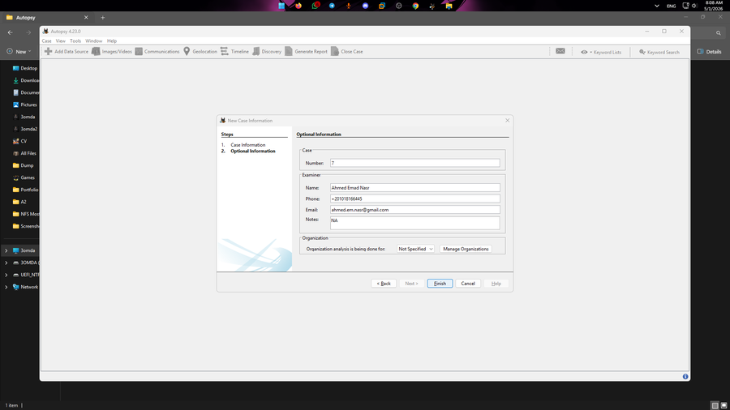
Figure 3: New Case Optional Information — Examiner Metadata Entry

3. Data Source Configuration
Following case initialization, the target USB drive was integrated into the forensic case through a five-step wizard: Select Host, Select Data Source Type, Select Data Source, Configure Ingest, and Add Data Source.
3.1 Host Configuration
The option "Generate new host name based on data source name" was selected, allowing Autopsy to automatically assign a host identifier derived from the target drive label. This ensures traceability between the host record and the physical evidence source.

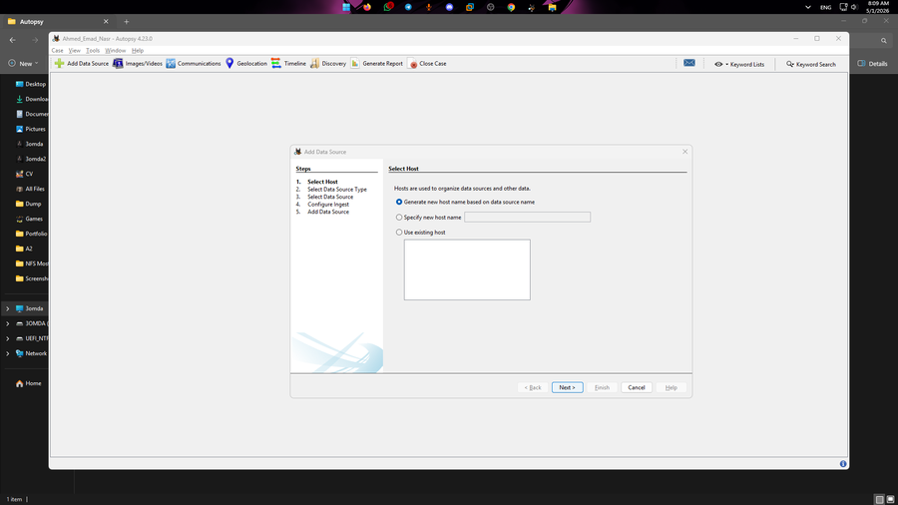
Figure 4: Add Data Source — Step 1: Host Configuration
3.2 Data Source Type — Initial Selection (Disk Image)
Initially, "Disk Image or VM File" was selected from the available data source types. This selection was subsequently corrected in the next step to reflect the actual analysis mode.

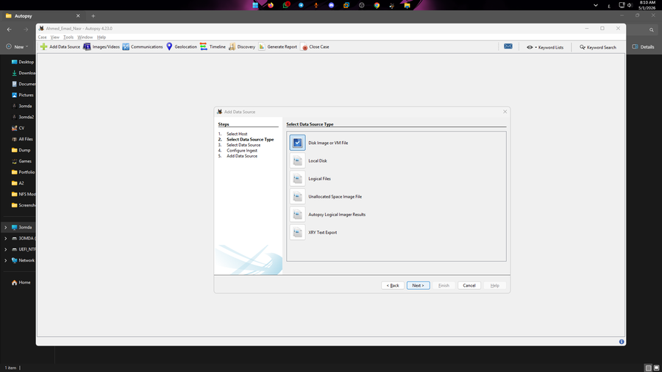
Figure 5: Data Source Type — Initial Selection: Disk Image or VM File
3.3 Data Source Type — Corrected Selection (Local Disk)
The data source type was corrected to "Local Disk" to perform direct live analysis of the physically connected USB drive. This is the appropriate selection when a pre-acquired forensic image is not available and the original media is accessible.

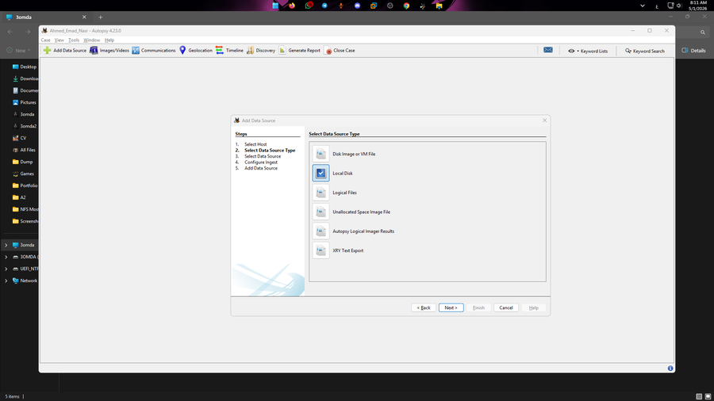
Figure 6: Data Source Type — Corrected Selection: Local Disk
3.4 Target Drive Identification and Parameters
The Select Local Disk dialog enumerated all connected drives. The investigator selected the target volume and configured the forensic acquisition parameters:

Parameter | Value
Target Drive | 3OMDA (H:)
Drive Size | 14.4 GB
Timezone | (GMT+2:00) Africa/Cairo
Ignore Orphan Files in FAT | Unchecked — ensures full unallocated space search
Create VHD Image | Unchecked — live analysis mode
Sector Size | Auto Detect

The "Ignore orphan files in FAT file systems" checkbox was deliberately left unchecked. This is a critical forensic decision: leaving it unchecked directs Autopsy to search all unallocated disk sectors, maximizing the probability of recovering deleted file artifacts.

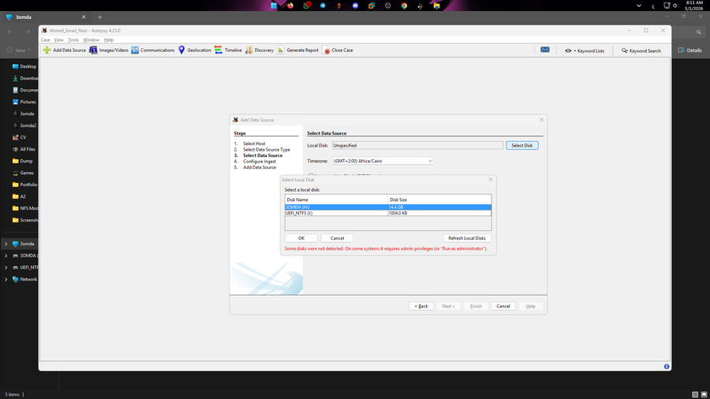
Figure 7: Select Local Disk — Target Drive: 3OMDA (H:), 14.4 GB

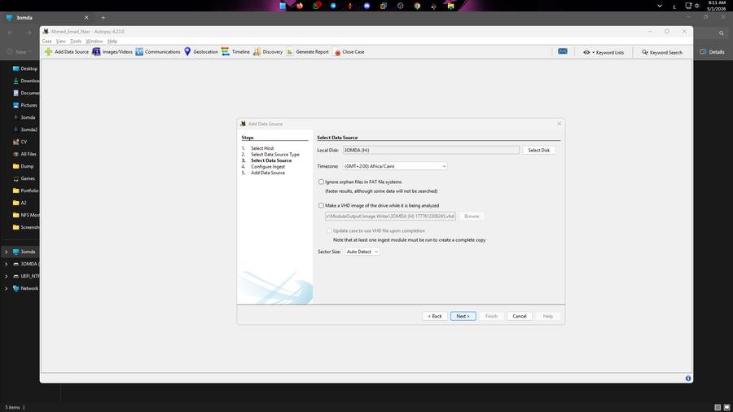
Figure 8: Data Source Configuration — Timezone, FAT Options, and Sector Size Settings

4. Ingest Module Processing & Troubleshooting
The Configure Ingest step specifies which analytical modules are applied during data ingestion. These modules parse raw disk sectors and extract forensic artifacts including deleted files, file hashes, keyword matches, metadata, and more.
4.1 Ingest Scope and Module Selection
The ingest was configured to operate on "All Files, Directories, and Unallocated Space" to ensure maximum forensic coverage. The following modules were enabled:

- Recent Activity — Extracts web browsing history, downloads, and recent user activity
- Hash Lookup — Computes MD5/SHA-256 hashes and checks against known databases
- File Type Identification — Identifies file types by internal signature, independent of file extension
- Extension Mismatch Detector — Flags files where the extension does not match the internal signature
- Embedded File Extractor — Extracts embedded files from archives, office documents, and containers
- Picture Analyzer — Reads EXIF metadata from image files
- Keyword Search — Performs indexed keyword searching across all file content
- Email Parser — Parses email databases and message stores
- Encryption Detection — Identifies potentially encrypted files
- Interesting Files Identifier — Flags files matching predefined forensic patterns
- Central Repository — Correlates artifacts against a shared reference database
- PhotoRec Carver — Performs signature-based file carving in unallocated space
- Virtual Machine Extractor — Extracts disk images stored in VM containers

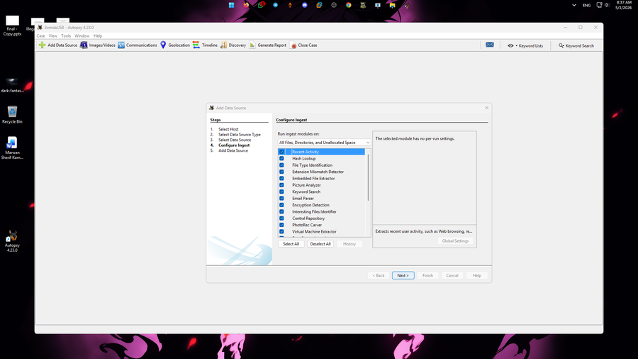
Figure 9: Configure Ingest — All Modules Selected, Scope: All Files, Directories, and Unallocated Space
4.2 Ingest Module Startup Failure

⚠ INGEST MODULE STARTUP FAILURE
Error Message: "Unable to start up one or more ingest modules, ingest cancelled. Please disable the failed modules or fix the errors before restarting ingest."
Root Cause — Cyber Triage Malware Scanner: No Cyber Triage license could be loaded. Cyber Triage processing will be disabled.

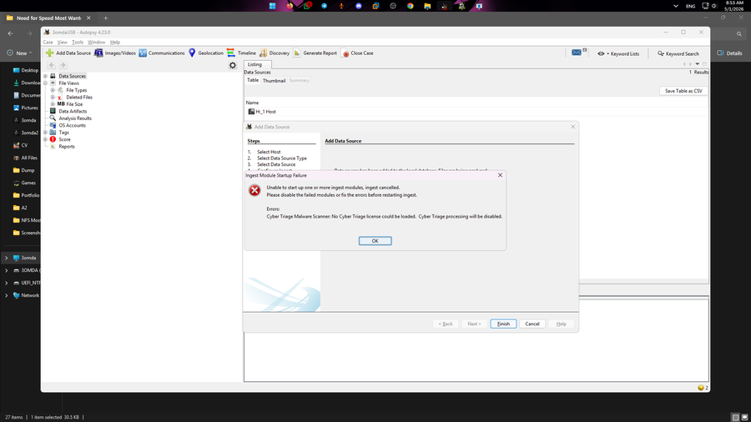
Figure 10: Ingest Module Startup Failure — Cyber Triage License Error
4.3 Resolution — Cyber Triage Module Deselected
To resolve the failure and continue the recovery process, the Cyber Triage Malware Scanner module was deselected from the ingest module list. The ingest process was restarted. The system confirmed successful integration of the data source.

✔ RESOLUTION APPLIED SUCCESSFULLY
After deselecting the Cyber Triage module, the ingest process restarted without error. Autopsy confirmed: "Data source has been added to the local database. Files are being analyzed." All remaining 12 modules continued processing.

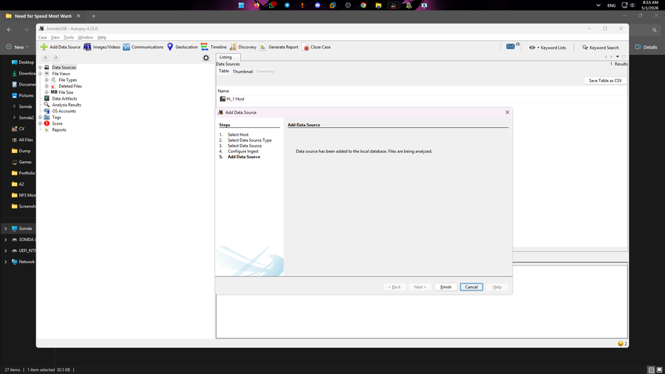
Figure 11: Data Source Successfully Added — Files Being Analyzed (Post-Resolution)

5. Data Analysis & Deleted File Identification
Upon successful ingestion, the file system was queried to identify deleted and unallocated content. The Autopsy directory tree was navigated to: Data Sources > File Views > Deleted Files > File System.
5.1 Analysis Methodology
- Navigation Path: Data Sources → File Views → Deleted Files → File System (40,884 entries)
- Total Files Indexed: 10,000+ entries displayed across 5 pages in the File System view
- Total Deleted File System Entries: 40,884
- Deletion Marker: Red X icon in the Name column
- Allocation Flag: "Unallocated" displayed in both Flags(Dir) and Flags(Meta) columns
- Timestamps: Modified Time, Change Time, Access Time, and Created Time recorded for each artifact

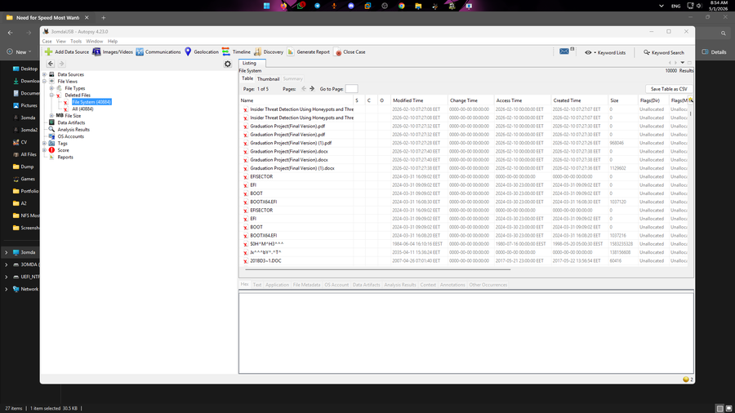
Figure 13: Deleted Files — File System View Showing 40,884 Unallocated Entries with Key Artifacts
5.2 Key Artifacts Recovered
The table below documents the primary forensic artifacts identified in the deleted file system. All entries carry an Unallocated status and were identified with the red X deletion marker.

File Name | Type | Size | Status | Modified Time
Insider Threat Detection... (1) | Research Doc | 0 KB | Deleted | 2026-02-10 07:27:08
Insider Threat Detection... (2) | Research Doc | 0 KB | Deleted | 2026-02-10 07:27:08
Graduation Project(Final Version).pdf | PDF | 0 KB | Deleted | 2026-02-10 07:27:32
Graduation Project(Final Version).pdf (2) | PDF | ~968 KB | Deleted | 2026-02-10 07:27:28
Graduation Project(Final Version).docx | DOCX | 0 KB | Deleted | 2026-02-10 07:27:40
Graduation Project(Final Version).docx (2) | DOCX | ~1.10 MB | Deleted | 2026-02-10 07:27:38
EFISECTOR | Boot Record | 0 bytes | Deleted | 2024-03-31 16:09:02
EFI | Boot Dir | 0 bytes | Deleted | 2024-03-31 09:09:02
BOOT | Boot Dir | 0 bytes | Deleted | 2024-03-31 09:09:02
BOOTX64.EFI (1) | EFI File | ~1.01 MB | Deleted | 2024-03-31 16:08:30
BOOTX64.EFI (2) | EFI File | ~1.01 MB | Deleted | 2024-03-31 16:10:18

5.3 Artifact Analysis Notes
- Graduation Project Files: Multiple versions of both .pdf and .docx graduation project documents were recovered. One PDF instance (~968 KB) and one DOCX instance (~1.10 MB) retained recoverable data, indicating the files were deleted but not fully overwritten. Zero-byte instances suggest partial overwriting or fragmented FAT allocation.
- Research Documents: Two instances of a file beginning "Insider Threat Detection Using Honeypots and Thre..." were found. The truncated filename indicates a document related to cybersecurity research, consistent with the graduation project theme.
- Boot Records: EFI, BOOT, BOOTX64.EFI, and EFISECTOR entries with 2024-03-31 timestamps indicate the USB drive was previously configured as a UEFI bootable device.
- Legacy/Slack Entries: Artifacts with timestamps as early as 1980-1984 are characteristic of file system metadata remnants, FAT slack space, or raw data fragments typical of reused removable media.

6. Report Generation
The final forensic workflow phase involved generating a formal evidence report using Autopsy's built-in reporting engine. The report compiles all analyzed artifacts, tagged items, metadata, and timeline events into a single document.
6.1 Report Configuration
Parameter | Value
Report Module | HTML Report
Format | HTML — Cross-platform, browser-readable
Header Text | Investigator : Ahmed Emad Nasr
Footer Text | (Not specified)
Scope | All results and tagged items
Other Available Formats | Excel, Files-Text, Data Source Summary, TSK Body File, Google Earth KML, CASE-UCO, Portable Case

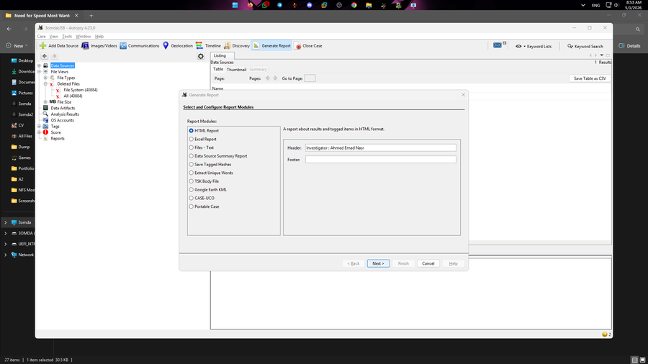
Figure 12: Generate Report Dialog — HTML Report Selected with Custom Investigator Header
6.2 Report Contents
The HTML format was selected for cross-platform accessibility. The generated report includes:
- All tagged and bookmarked forensic items
- File metadata extracted from all analyzed files (name, size, timestamps, hashes)
- MACB timeline: Modified, Accessed, Changed, and Born (Created) timestamps
- Hash values (MD5, SHA-256) for all processed files
- Complete deleted file listing with allocation status flags
- Analysis results from all active ingest modules

7. Summary & Conclusions
The digital forensic data recovery operation was completed successfully using Autopsy 4.23.0. The investigation proceeded through all five standard forensic phases. One operational error was encountered and resolved. The target 14.4 GB USB drive yielded 40,884 deleted file system entries, including recoverable graduation project documents and research materials.

Outcome | Result
Case Created | Successful — Ahmed_Emad_Nasr, Case No. 7
Data Source Integrated | Successful — 3OMDA (H:), 14.4 GB USB Drive
Ingest Error | Cyber Triage Malware Scanner — Missing License
Error Resolution | Module deselected; ingest restarted and completed
Files Indexed | 40,884 deleted file system entries identified
Key Documents Recovered | Graduation Project .pdf (~968 KB) and .docx (~1.10 MB)
Research Doc Recovered | Insider Threat Detection document (2 instances)
Boot Artifacts Recovered | EFI, BOOT, BOOTX64.EFI, EFISECTOR
Forensic Report Generated | HTML Report — Investigator: Ahmed Emad Nasr

The recovery of graduation project files with substantial file sizes indicates that meaningful content is likely recoverable through further forensic carving of the unallocated sectors. The Autopsy-generated HTML report constitutes the formal forensic package documenting all findings from this case.

8. Investigator Certification
I, Ahmed Emad Nasr, certify that the information contained in this report accurately and completely represents the digital forensic examination conducted on Case Number 7. All procedures were performed in accordance with accepted digital forensic standards. The evidence has been handled with due care to preserve its integrity, and all findings are based solely on observable data recovered from the target medium.

_____________________________________________
Ahmed Emad Nasr — Digital Forensics Investigator
ahmed.em.nasr@gmail.com | +201018166445
Case No. 7 | May 1, 2026

CONFIDENTIAL — This report is intended solely for authorized use in relation to the stated forensic investigation. Unauthorized disclosure or reproduction is prohibited.

