**––**

**Spring 2023**

**Big Data Project**

Supervised by:

**Dr. Lydia Wahid**

**Eng. Omar Samir Galal**

Presented by:

**Team 12**

|  |  |  |
| --- | --- | --- |
| B.N. | Sec | Name |
| 7 | 1 | Ahmed Emad |
| 11 | 1 | Ahmed Mahmoud Hafez |
| 33 | 2 | Nour El-din Moustafa |
| 41 | 2 | Youssef Atef Abdo |

**Idea:**

Heart disease is the leading cause of death globally, and its prevalence is increasing rapidly. Early detection and prevention of heart disease are crucial for reducing mortality rates and improving the quality of life for patients.

We suggest a big data project that aims to develop a predictive model for the early detection of heart disease.

**Project pipeline**

1. Data preprocessing

* Every categorical class changed to numerical
  + change columns that contain values of Yes / No with 0 / 1
  + change sex column that contain Male / Female with 1 / 0
  + convert Age Category, Race, Diabetic and GenHealth columns with increasing values
* Check If non-values exist and deal with it

1. Data visualization and insights

***Show distribution for each categorical class***

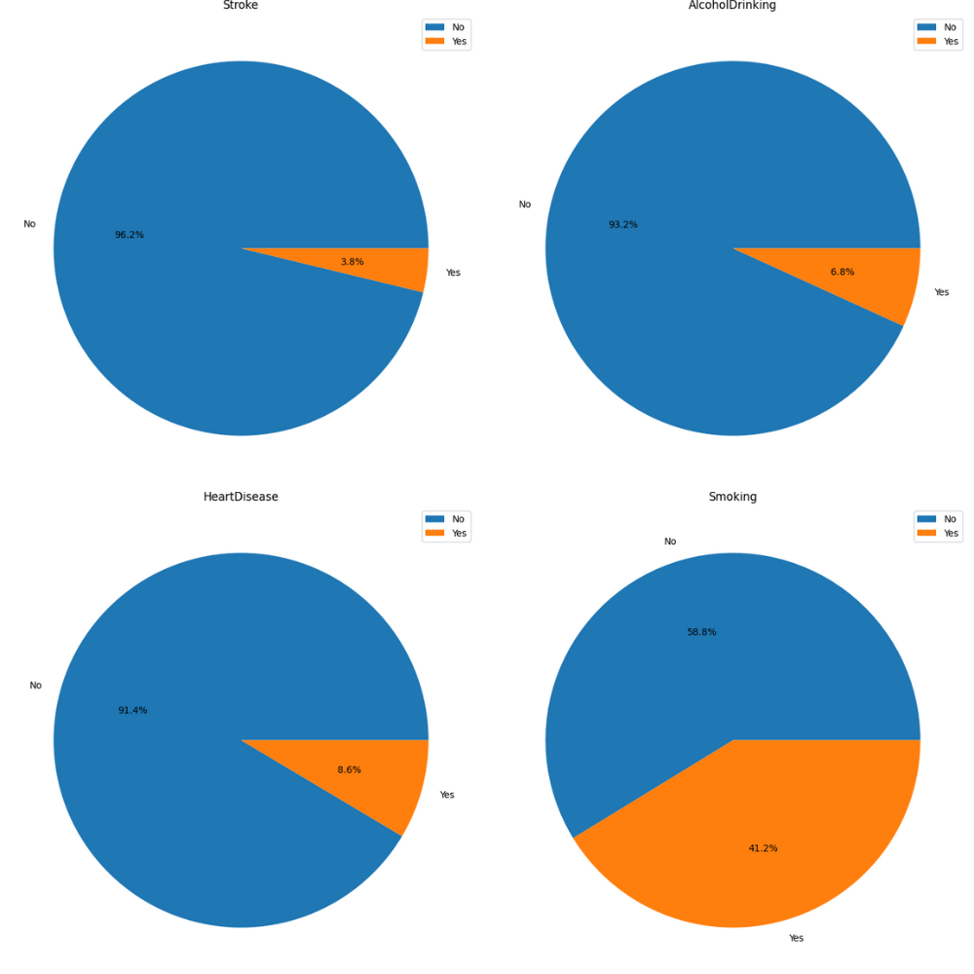

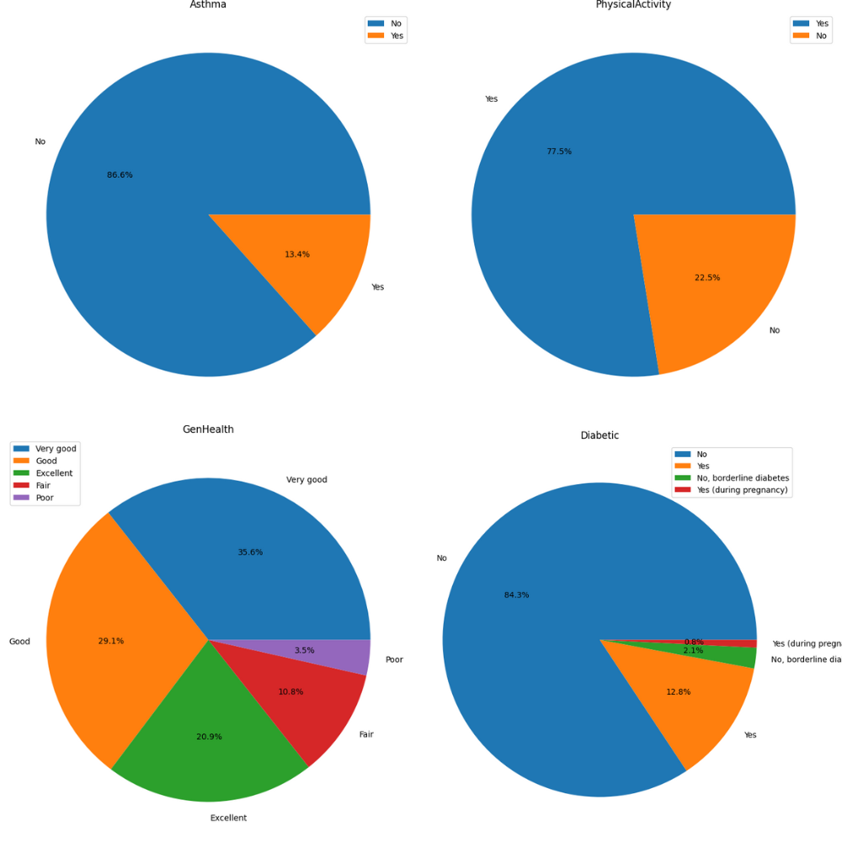

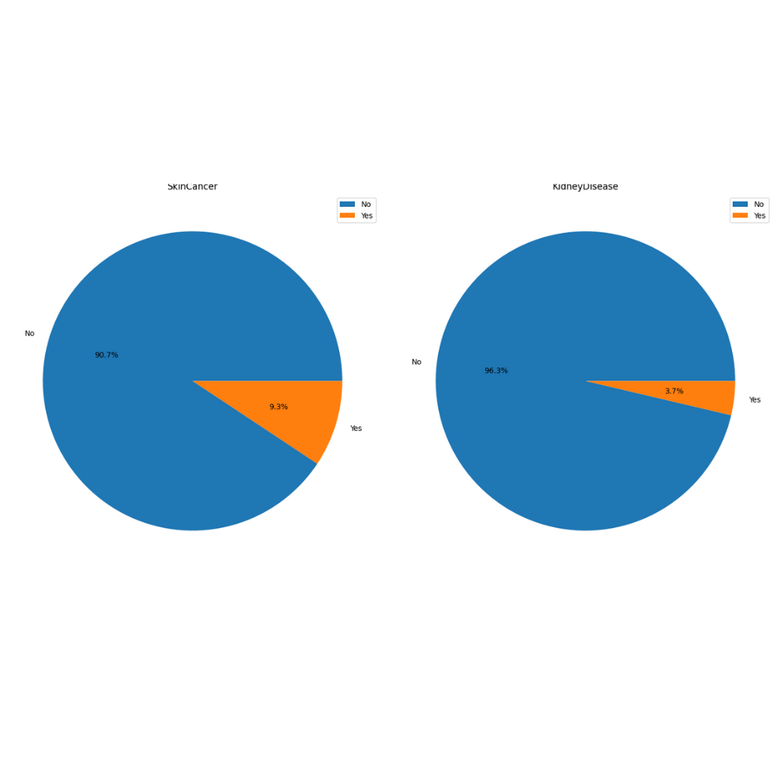

|  |  |
| --- | --- |
|  |  |
| this graph shows male have slightly more diabetes than female | this graph shows female are smoking less than man |

|  |  |  |  |
| --- | --- | --- | --- |
|  |  |  |  |
| BMI average is between 20 and 40 and there are many outliers | Distribution of physical health | Distribution of Mental health | between 5 and 8 hours and there are outliers |

|  |
| --- |
| 1 - no smoking → good physical health |
| 2- the bigger the age 🡪 more heart disease to have |
| 3- smoking → diff walking |

Association Rules

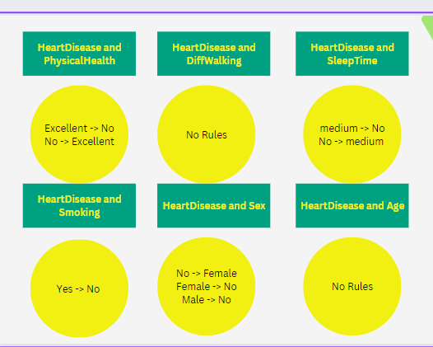

* ***Excellent health leads to low heart disease***
* ***Sleeping fair hours (5-8) of sleeping saves you from heart diseases***
* ***Gender has no effect of increasing probability of Heart diseases***

Model/Classifier training

- For all models we used: we did RandomOversampler to balance the classes.

1. We used Naive Bayes , SVM and logistic regression from MLlib in PySpark. Those are ready made models.
2. Then we used map-reduce functions to implement Naive Bayes:

* We calculated the prior probabilities of the features and the classes we have.
  + The map phase was used to generate key-value pair <feature, 1>
  + The reduce phase was used to aggregate the number of each attribute value.
* We calculated the conditional probabilities of each feature given each class.
  + The map phase was used to generate key-value pair <(feature, class), 1>
  + The reduce phase was used to aggregate.
  + Then another map phase was done to calculate the conditional probabilities by dividing the totalCount of the (featureValue, class) by the totalCount of the class.

|  |  |
| --- | --- |
| map-reduce prior | map-reduce cond |

1. Results and Evaluation

|  |  |  |
| --- | --- | --- |
| **Model** | **Accuracy (F1-score)** | **Macro Avg** |
| Logistic Regression | 76% | 76% |
| Naive Bayes | 65% | 62% |
| SVM | 76% | 76% |
| Naive Bayes | 75% | 75% |

Unsuccessful trials

*Just a note that SVM takes a very long time*

Any Enhancements and future work

*We want to implement KNN using map-reduce*.