# Turkey Ankara Ayranci Anadolu High School's Sign Language Digits'

**Model 1 on gray images:**

Model: "sequential"

_________________________________________________________________

Layer (type) Output Shape Param #

=================================================================

dense (Dense) (None, 150) 614550

dense_1 (Dense) (None, 150) 22650

dense_2 (Dense) (None, 10) 1510

=================================================================

Total params: 638,710

Trainable params: 638,710

Non-trainable params: 0

_________________________________________________________________

Accuracy: [0.9044486284255981, 0.7748184204101562, 2.0673136711120605]

Cross validation: [0.7036363482475281, 0.8963636159896851, 0.8852459192276001]

F1 score: [1.9078072309494019, 2.015913724899292, 1.95198655128479]

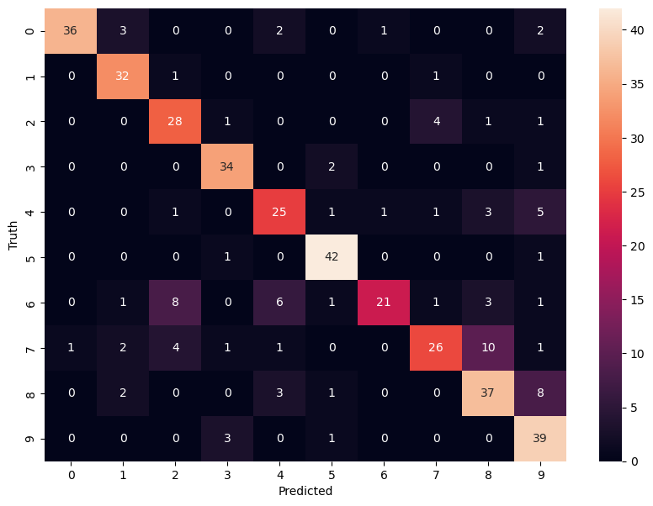

**Model 2 on gray images:**

Model: "sequential_1"

_________________________________________________________________

Layer (type) Output Shape Param #

=================================================================

dense_3 (Dense) (None, 120) 491640

dense_4 (Dense) (None, 160) 19360

dense_5 (Dense) (None, 80) 12880

dense_6 (Dense) (None, 10) 810

=================================================================

Total params: 524,690

Trainable params: 524,690

Non-trainable params: 0

_________________________________________________________________

Accuracy: [0.6792094707489014, 0.823244571685791, 2.173330307006836]

Cross validation: [0.9163636565208435, 0.921818196773529, 0.9526411890983582]

F1 score: [2.053602933883667, 2.1063032150268555, 2.0439860820770264]

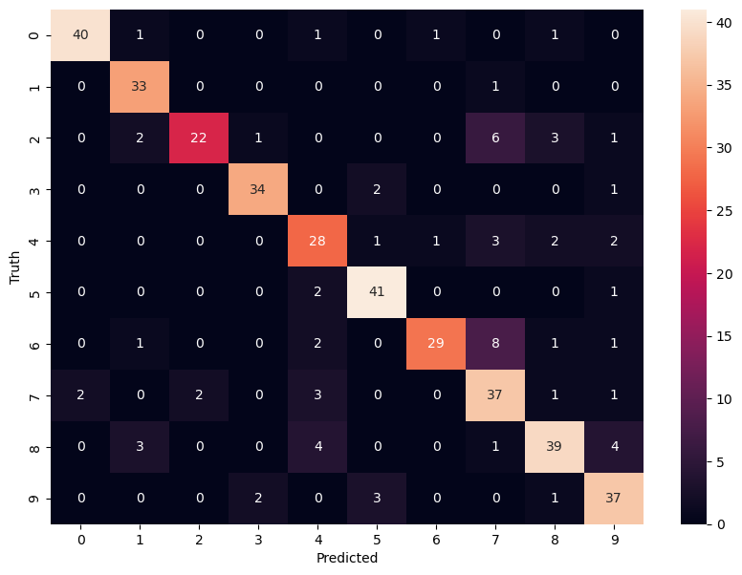

**CNN model on RGB images:**

Model: "sequential_4"

_________________________________________________________________

Layer (type) Output Shape Param #

=================================================================

conv2d_2 (Conv2D) (None, 61, 61, 32) 1568

max_pooling2d_2 (MaxPooling (None, 30, 30, 32) 0

2D)

conv2d_3 (Conv2D) (None, 28, 28, 64) 18496

max_pooling2d_3 (MaxPooling (None, 14, 14, 64) 0

2D)

flatten_1 (Flatten) (None, 12544) 0

dense_12 (Dense) (None, 64) 802880

dense_13 (Dense) (None, 10) 650

=================================================================

Total params: 823,594

Trainable params: 823,594

Non-trainable params: 0

_________________________________________________________________

Accuracy: [0.48335933685302734, 0.9055690169334412, 1.879773497581482]

Cross validation: [0.8909090757369995, 0.9690909385681152, 0.9581056237220764]

F score: [1.6623615026474, 1.664803385734558, 1.6971402168273926]

**SVM on RGB images:**

Model SVM accuracy is: 0.8111380145278451