Report task CMMI interview
- Task 1
The objective of this task is to Detect vessels on every frame of both cameras. For that I used YOLO ( You will only look once [1]). YOLO works by divide the image into S*S grid and if the centre of the object lies in a cell, then the cell is responsible for detecting the object. YOLO used COCO dataset [2]. In This model, we used pretrained YOLO model (yolov10n.pt) from ultralytics latest release with python 3.10. In YOLO the boat class is 8. one way to improve the detection is to by fine tune the model using new collected dataset.
The process will be: 1) data collection from the camera.
2) data annotation using tools such as CVAT (assign bounding boxes to the objects in the frame.
3) fine tune the models (optimize the weights for better prediction of the desired class)
4) evaluate the model by using metrices such as recall, precision and F1 score
$$Recall=\frac{True positive}{True positive+False negative }$$
$$precision =\frac{True positive}{True positive+False positive }$$
$${F1 }_{score}=\frac{2*recall*precision}{recall+precision }$$
In that model I used pretrained model, so I didn’t do that. The results are provided as two json files as requested. Figure 1 shows example of the results from the model.
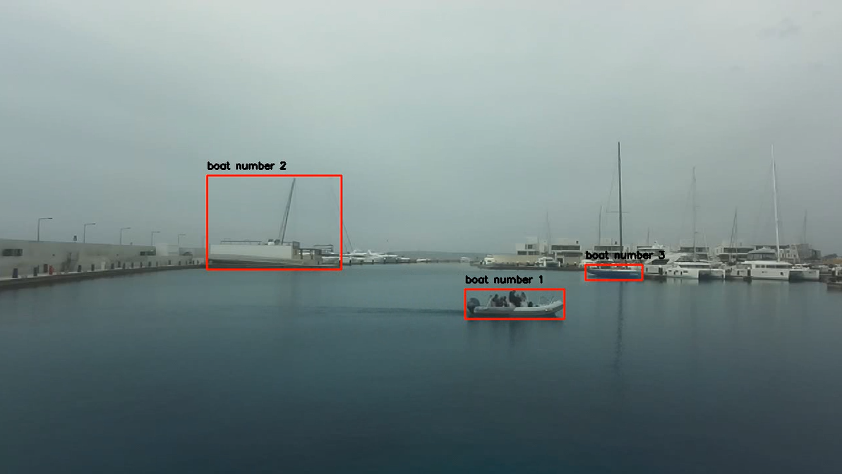
Figure 1 the detected boats in a frame
- Task 2
The objective of this task is to detect the depth of the objects in the photo at pixel level mask. Depth estimation is based on collecting images from two cameras. Then calculate the disparity between the two images, use the baseline depth which is the horizontal distance between the two camera and the focal length in pixel to estimate depth between the camera and an object using the equation
$$distance \left(mm\right)=b\left(mm\right)*\frac{f_{c}\left(pixel\right)}{disparity \left(pixel \right)}$$
Furthermore, monocular depth estimation has achieved great results in finding depth for an object using deep learning. To compute the distance I used algorithm known as MIDAS[3]. MIDAS was developed for monocular depth estimation. MIDAS was initially developed in 2019 . They released 3 types of models. Midas small model which relies completely on convolutional neural network. Midas hybrid and large and both uses transformer introduced in attention is all you need [4]. Even with Midas it was challenging to estimate the distance specially if the boat is not in front of the camera. Midas produced pixel level depth as showed in Figure 2 . The only issue is that it is normalized and there is no information available in how this normalization was done. one way to tackle this challenge is by using a point in the space for which the distance is known and then find a scaling factor between the actual depth and the computed one. yet, it is not Totally accurate. it gives a good estimation about how far which object from the other object or from the camera and it is capable of accurately estimating nearby object which is good enough. It is not easy to estimate the object distance specially in a cloudy condition where there are not many variations in colours. For instance in this work [5] they had 20 % error in the estimation within 100 m and that error becomes 76.7 % when estimating within 500 m .

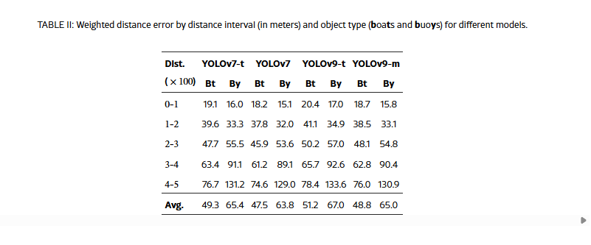
As I mentioned we need to use a scaling factor to scale from the distance in Figure 2 to the distance in Figure 3 . one-way to do it is by using the distance to a fixed object. I used the actual depth from one of the frames for RIB calculated it using haversine distance [6] to estimate distance in real world for every pixel in the photo .
$$scaling factor=\frac{distance in the depth map }{real world distance }$$

$$Distance in real world =\frac{scaling factor }{depth map from Midas }$$

One of the challenges was I cannot produce 127 numpy array and store them in json file that the Midas model is too big to run for 127 frames in the right and 127 frame in the left and store a list of the distance at a pixel level. My computer returned the error message showed in Figure 4 which means I cannot computationally complete collecting the data then even zipped files with just 12 frames are 75 Mb which I cannot upload to GitHub , I will upload it to my google drive and you can download it from there and you can download the remaining data from the script , the information will be in the readme file .
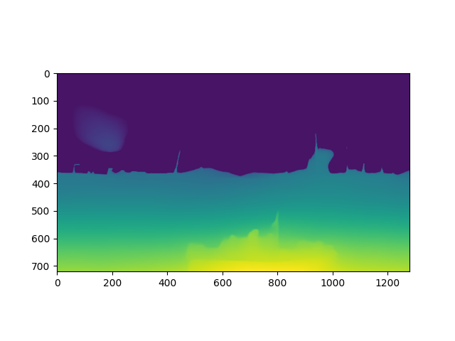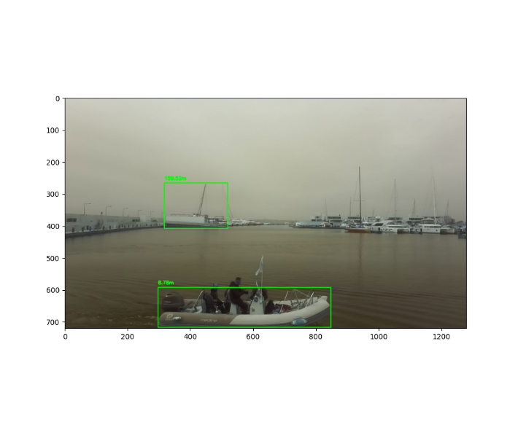
Figure 2 shows relative distance for objects in the image with higher values indicate closer objects and lower values indicates objects that are far from the camera in the left and the actual computed distances in the right
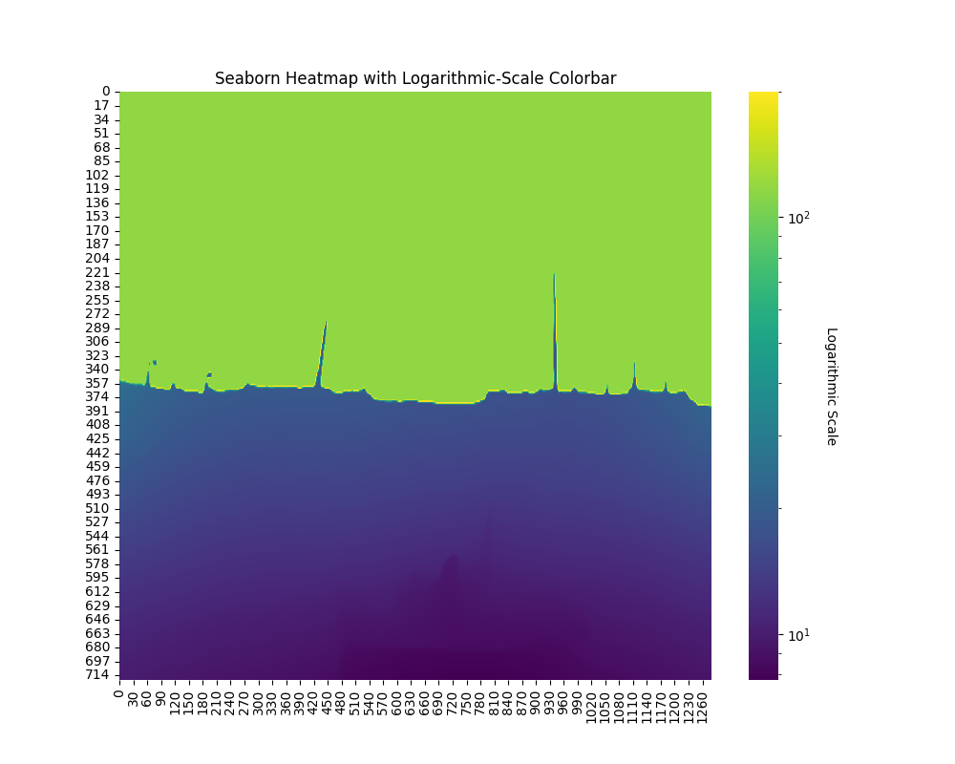
Figure 3 depth map of the same frame with the values indicating the distances of the objects in m
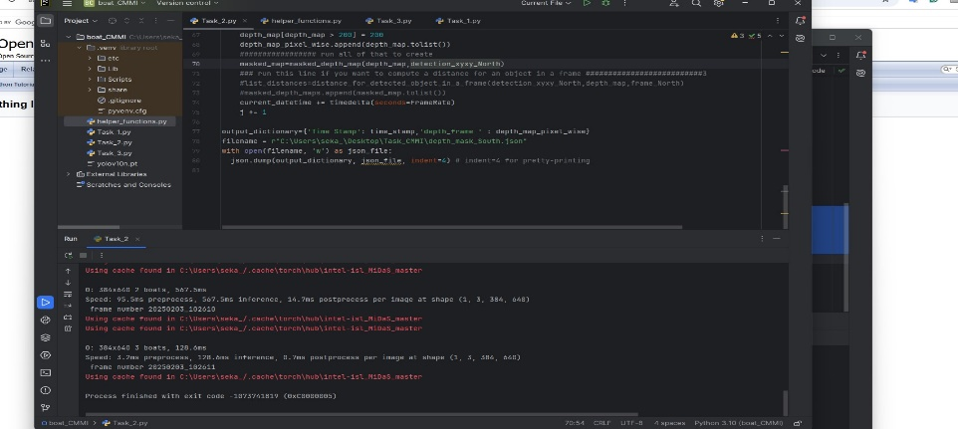
Figure 4 The error message when trying to store the depth maps for all 127 frames
In conclusion, the relative depth was computed using Midas and then it was used to estimate the actual depth and then the numpy 2d matrix was stored at a list in the json file . if you are interested in .npy file I can get them and upload them to github or you can do it and run the script.

- Task 3
In the third task it is required to perform object tracking, I used deep sort to track the object and created two mp4 files with the tracked objects. Deep sort is based on the sort algorithm [7]and using Kalman filter for object tracking. It starts to give IDs to the object and remember the object for a period that you can classify when running the algorithm. an example of the result is shown in Figure 1

- References
[1] J. Redmon, S. Divvala, R. Girshick, and A. Farhadi, “You Only Look Once: Unified, Real-Time Object Detection,” May 09, 2016, arXiv: arXiv:1506.02640. doi: 10.48550/arXiv.1506.02640.
[2] T.-Y. Lin et al., “Microsoft COCO: Common Objects in Context,” Feb. 21, 2015, arXiv: arXiv:1405.0312. doi: 10.48550/arXiv.1405.0312.
[3] R. Ranftl, K. Lasinger, D. Hafner, K. Schindler, and V. Koltun, “Towards Robust Monocular Depth Estimation: Mixing Datasets for Zero-shot Cross-dataset Transfer,” Aug. 25, 2020, arXiv: arXiv:1907.01341. doi: 10.48550/arXiv.1907.01341.
[4] A. Vaswani et al., “Attention Is All You Need,” Aug. 02, 2023, arXiv: arXiv:1706.03762. doi: 10.48550/arXiv.1706.03762.
[5] “Approximate Supervised Object Distance Estimation on Unmanned Surface Vehicles.” Accessed: Jul. 07, 2025. [Online]. Available: https://arxiv.org/html/2501.05567v1
[6] “Haversine formula,” Wikipedia. May 27, 2025. Accessed: Jul. 07, 2025. [Online]. Available: https://en.wikipedia.org/w/index.php?title=Haversine_formula&oldid=1292620990
[7] N. Wojke, A. Bewley, and D. Paulus, “Simple Online and Realtime Tracking with a Deep Association Metric,” Mar. 21, 2017, arXiv: arXiv:1703.07402. doi: 10.48550/arXiv.1703.07402.

