Project 1

Authors

Ahmed Shehata 1991-03-21

Alexandria

Egypt

2021-03-12

Table of Contents

1 Task 3

1.1 Problem statement 3

1.2 Do home teams have advantage ? 3

Appendix 8

# Task

## Problem statement

In this task, this project is trying to answer a simple question ‘is playing at home consider as an advantage for the home team in the English premier league. The data that has been used in this project is gathered form open source database Kaggle. this data consists of the results for 11 European competitions’ matches. Here I will just focus in the English premier league but using the same script the analysis can be done for different countries. Furthermore, when focusing in single season the report just focuses in 2008/2009 season, but it can be done for any other season in the data using the same script.

## Do home teams have advantage ?

When taking a first look at the data given in Figure 1 you can see a clear advantage for the home teams in comparison to the away teams but is the advantage really clear as appear in the data .

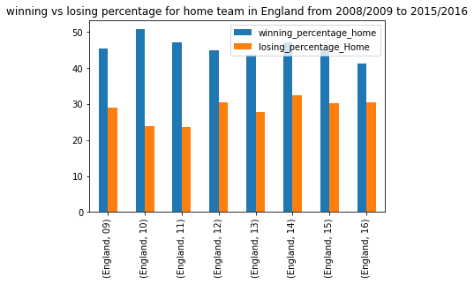

Figure 1 winning vs losing percentage rate for home team in England

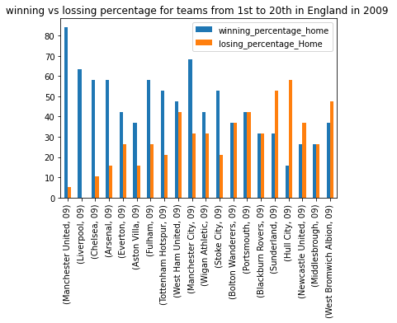

Figure 2 winning vs losing percentage for the 20 teams from 1 st to 20th respectively in 2008/2009 season in England

When taking a deeper look at the data you can see that the teams in the upper half of the table have advantage when they play at home. A team such as Liverpool didn’t lose at home, despite drawing a lot, but yet their home record of not losing in a season is impressive record. Furthermore, the champion Manchester united has almost more than 80% winning percentage at home which indicate clear advantage for the home teams. Despite that, the data from the teams from 12th to 20th doesn`t support this claim at all. the 8 teams have more, or equal home losses record than their winning record in 2008 /2009 as shown in Figure 2.

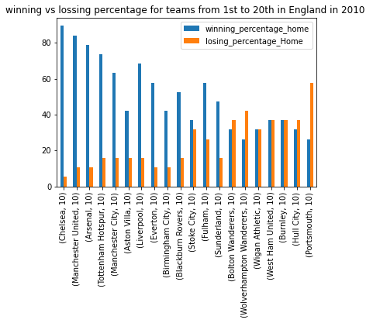

Figure 3 winning vs losing percentage for the 20 teams from 1 st to 20th respectively in 2009/2010 season in England

The data from the 2009 /2010 season shown in Figure 3 shows the same pattern where the more we move down in the table the home advantage start to fade away so now to be able to answer this questions we have to compare the winning rate at home vs away for the 20 teams in this two seasons .

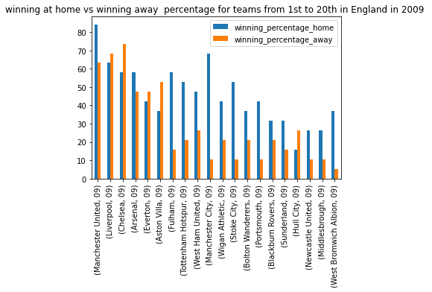

Figure 4 winning home vs away percentage for the 20 teams from 1 st to 20th respectively in 2008/2009 season in England

In 2009 in Figure 4 the away record for some teams specially the team in the upper half of the table was better than the home record while and here comes the interesting part in 2010 in Figure 5 there I clear advantage for the amount of winning in home soil in comparison to the away winning rate . but take closer look to the data shows that it supports the home team advantage. the reason for that is some teams such as Hull city which didn’t win a single game away from home had a record of almost 30 % winning rate at home and despite that they lost almost 40% of their home games but yet they managed to win almost 5 games at home while they were not able to win a single game away from home .the same can be said about Burnley and west ham united who managed to win just single game away while they were able to win almost 7 games at home

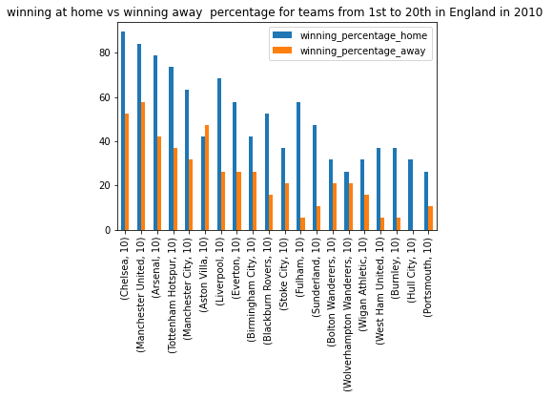

Figure 5 winning home vs away percentage for the 20 teams from 1 st to 20th respectively in 2009/2010 season in England

Appendix

Project_1.py in the attachment