
Group 24 Data science assignment 1 + Assignment 2

Earthquake 1995 – 2023
Ahmed Gamal 247546
Mohamed Hesham 248519
Ahmed Aboshesha 248002
Karim Mohamed 240829

The goal of this project is to analyze the ‘Earthquakes’ dataset and extract from it the correct data. Graphs and charts are drawn to show relationships. The dataset describes all the factors and information about all earthquakes throughout the last 27 years. This is all to improve earthquake detection and save lives.

Assignment 1:

Ahmed Gamal’s Question 1:
Does the density and distribution of seismic monitoring stations vary by region, and are certain geographic areas better equipped with earthquake detection coverage than others?

To Analyze regional differences in monitoring quality I used bar plots were used to compare key indicators including the number of stations (nst), azimuthal gap (gap) and distance to the nearest station (dmin).

The analysis reveals regional differences in seismic monitoring coverage. Asia shows the highest number of stations, which means high seismic activity. Europe demonstrates relatively lower station density due to lower earthquake frequency in many areas. On other hand, North America exhibits a low distance to the nearest station but high gap. That means the stations are close to each other but not distributed.

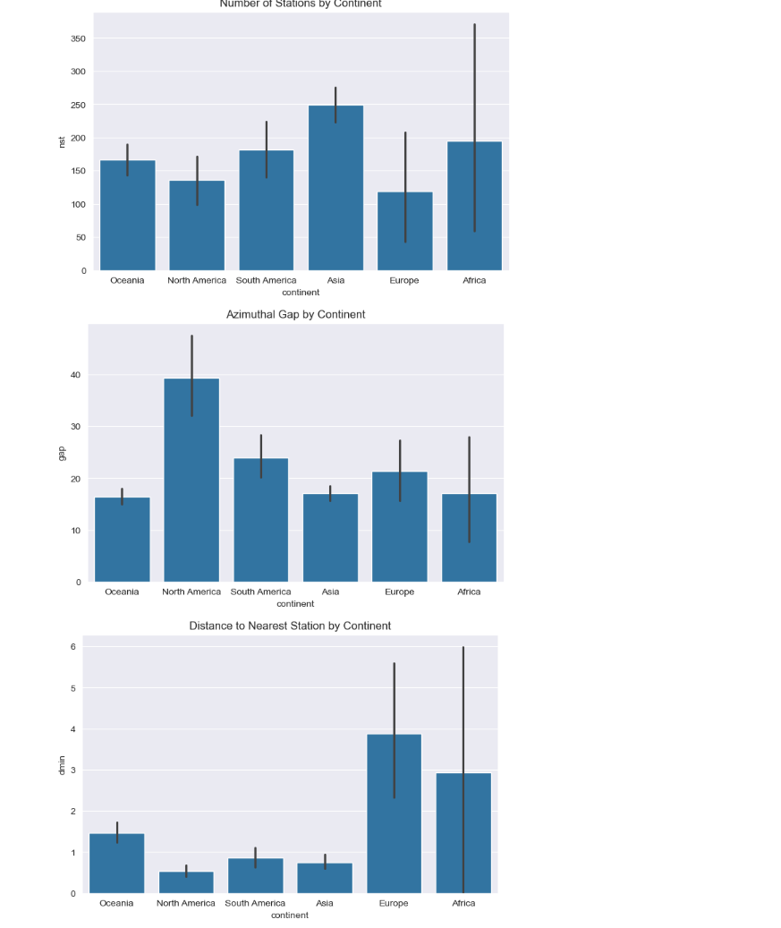

Ahmed Gamal’s Question 2:

Do earthquakes that trigger tsunami warnings operate under a distinct alert classification system compared to those categorized as standard seismic events?

To examine the relationship between tsunami occurrence and alert classification. The heatmap was chosen to display the frequency of combinations between alert levels and tsunami events.

The heatmap analysis shows a clear relationship between tsunami events and alert classification. Tsunami triggered earthquake are more frequently with alert levels such as green and yellow. While non tsunami events are largely concentrated in No warning issued. This pattern suggests that monitoring systems adopt a precautionary approach, assigning alert levels more consistently when there is a potential tsunami risk.

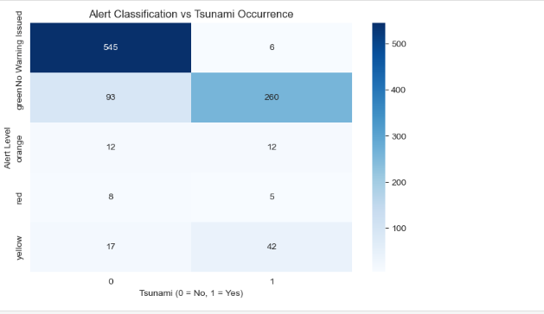

Ahmed Gamal’s Question 3:

How does data quality change over time and have earthquake detection improved in the last 27 years?

To examine the changes over time. The line plots were used to show the yearly average of the number of stations and gap. The plots help track trends in monitoring infrastructure and coverage quality over the studied period.

The time series analysis indicates a significant improvement in monitoring infrastructure between 2000 and 2012 where the number of stations increased. This growth likely reflects technological advancements and increased investment in seismic monitoring systems. After 2013 there was a huge decrease in number of stations which may be due to changes in reporting practices rather than an actual decrease in monitoring capability.

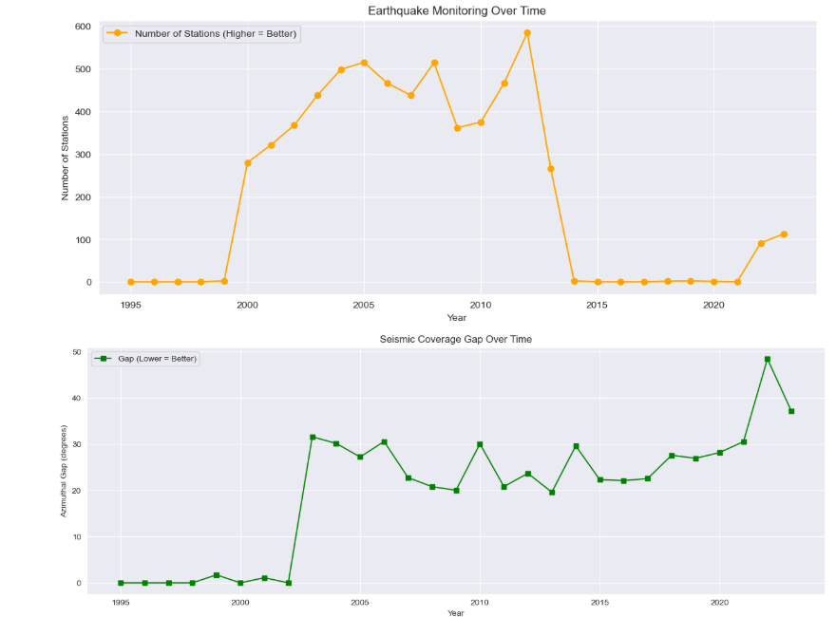

Ahmed Abousheaisha Question 1:
What degree of correlation (depth/magnitude) do tangible measurements yield versus perceived severity via human perception (CDI, MMI, SIG) by region?
According to the correlation heat map, magnitude has a moderate positive relationship with perceived severity (e.g. SIG ≈ 0.51), while depth has at least a marginally negative relationship (e.g. MMI ≈ -0.52). As such, magnitude is better at predicting how much damage someone will experience than depth alone, which is useful when assessing risk and prioritizing emergency response.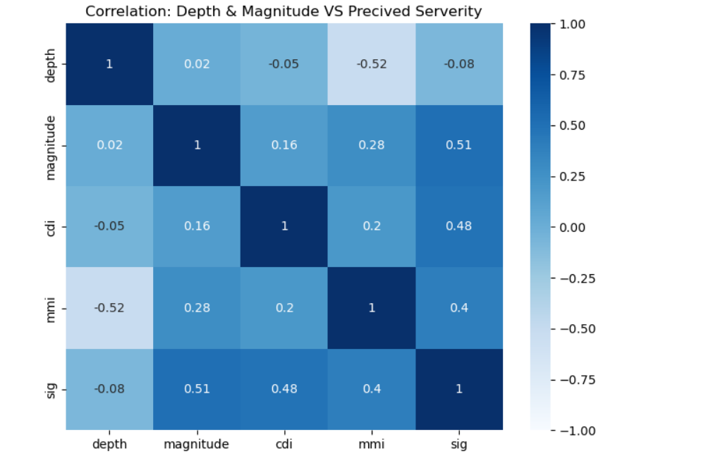

Ahmed Abousheaisha Question 2:
Is there a statistically significant relationship between earthquake magnitude and reported damage severity (SIG) across regions?
According to the boxplot, there is a direct relationship between increasing magnitude (7+) of earthquake and increased severity of damage (SIG) and also that there is more variability of SIG at this level than at lower levels (6 to 7). The increase in both median and range of SIG across all 7 continents suggests that there is a direct correlation between magnitude and damage severity. Consequently, the magnitude of the earthquake is a good predictor of how much damage will be reported as SIGs, thus making it critical for risk assessment and for prioritizing response to these emergencies.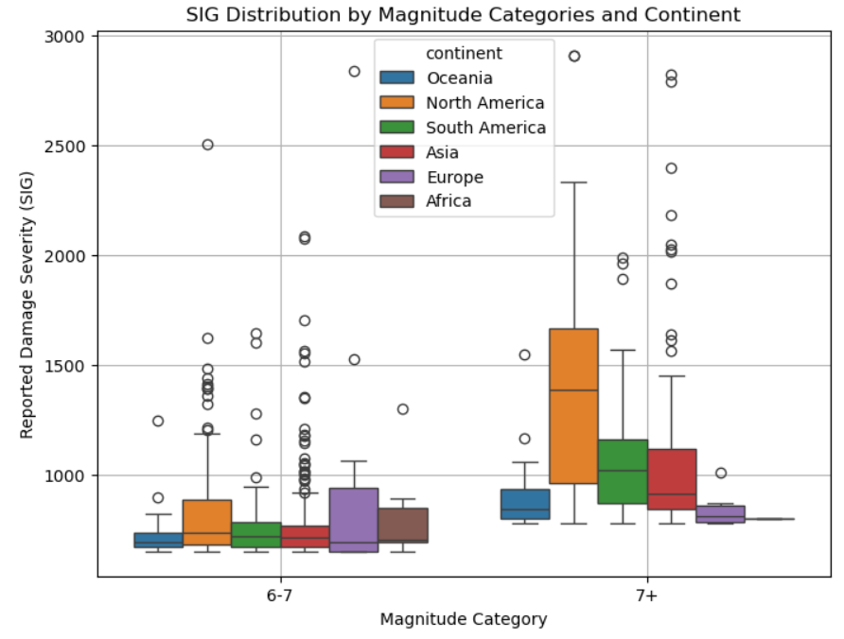

Ahmed Abousheaisha Question 3:
Are there noticeably different (more variable) uncertainty indicators (greater GAP and fewer NST) for deeper earthquakes compared to shallower earthquakes?
Boxplots that compare GAP and NST by depth category indicate an ever-increasing level of uncertainty for all depths, as evidenced by the greater variability of shallow earthquakes in GAP (more data sources). The lack of reporting stations (lower NST) for deep earthquakes results in less variability but ultimately inconsistent data quality for both shallow and deep events. Overall, data quality of seismic networks should improve as depth category reporting stations consolidate.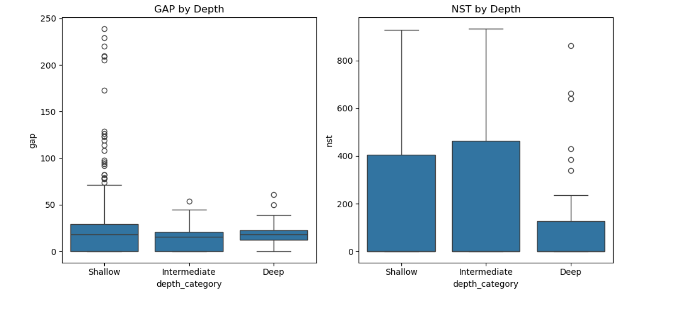

Karim Mohamed Question 1:
Is there a relationship between the depth of an earthquake and the number of seismic stations (NST) that detect it, and do deeper earthquakes tend to be recorded by fewer stations?

Yes, there is a weak negative relationship between depth and NST.
Key insights:
The correlation between depth and NST is about -0.10.
Shallow earthquakes have the highest average NST.
Deep earthquakes have the lowest average NST.
Relationship:
As depth increases, NST tends to decrease slightly.
Earthquakes that happen deeper in the ground are usually picked up by fewer recording stations, but this isn't always a hard and fast rule.

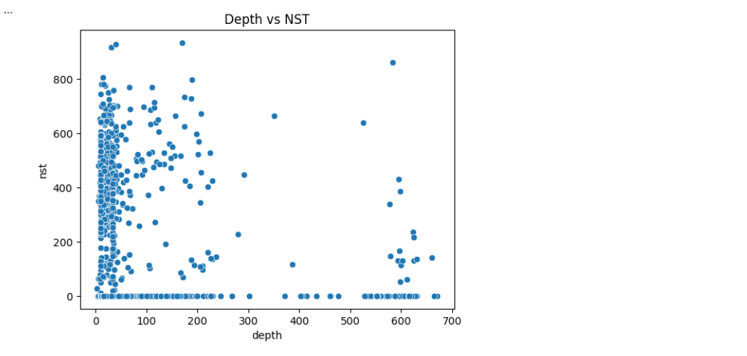

Karim Mohamed Question 2:
Question 2:
Do earthquakes that occur closer to coastal areas have a higher probability of generating tsunami alerts compared to earthquakes that occur inland?

Yes, coastal earthquakes have a higher tsunami probability than inland earthquakes.
Key insights:
Coastal tsunami probability is about 40%.
Inland tsunami probability is about 32.4%.
Relationship:
Earthquakes near sea or ocean locations are more likely to have tsunami alerts.
The difference is visible, but not very large.
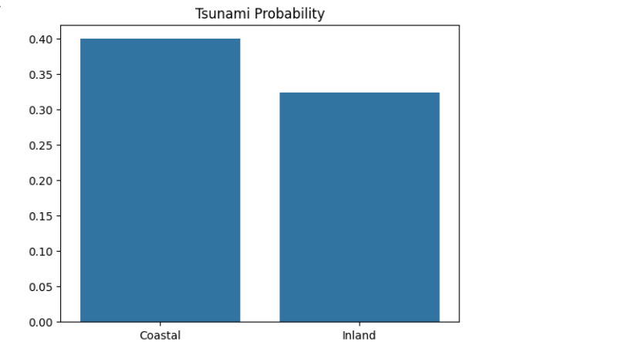

Karim Mohamed Question 3:
Has the average magnitude of detected earthquakes changed over the last 27 years, and could this change be related to improvements in earthquake monitoring technology?

The size of earthquakes has stayed pretty much the same over the past 27 years.
Key insights:
The line on the graph is pretty flat, it doesn't really go down much.
Earthquakes don't seem to be getting stronger or weaker over time, at least when you look at the average magnitude. It's pretty steady, with no real trend upwards or downwards.
Relationship:
The data doesn't really suggest that having better equipment to track earthquakes has a big impact on the size of the earthquakes we see.
Monitoring improvements are better judged using coverage and station data, not average magnitude alone.
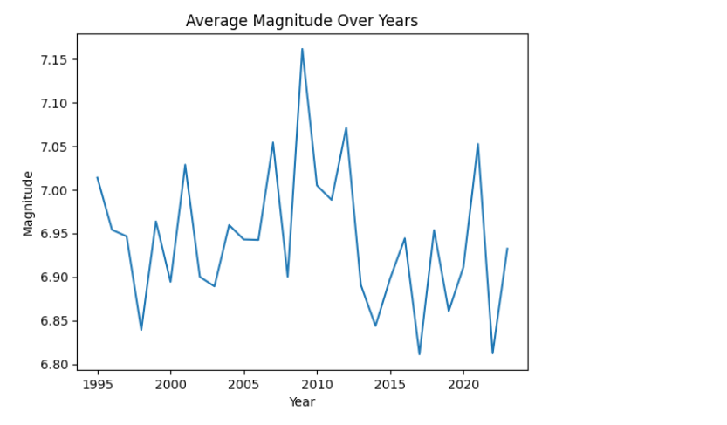

Mohamed Hesham 248519 Question 1:
Are shallow earthquakes (Ones with a small depth) more likely to cause a tsunami than deeper earthquakes for earthquakes with similar magnitude?

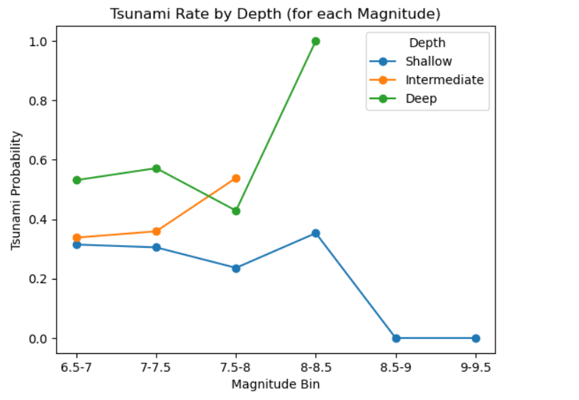
After doing the required data analysis and visualization, this was the graph that resulted. This line graph shows the magnitudes of the earthquakes split into several bins on the x axis, while on the y axis, it shows tsunami probability, which is caclculated by finding the mean whether the tsunamis happened or not (1-0) for each magnitude bin.
The results show clearly that the deeper earthquakes have a much higher history of causing tsunamis when the the magnitude is similar. shallow earthquakes for the same magnitudes have consistently less rate of tsunamis than deep and intermediate depths. This means that shallow earthquakes are less likely to cause a tsunami than deeper earthquakes for earthquakes of the same magnitude. So the answer to question 1 is: no. Which is weird because shallow earthquakes are more likely to cause a tsunami scientifically speaking.

This is useful because it encourages better research on the depth of earthquakes and how they actually happen and occur. It is inevitable that we find the source of earthquakes if we dig deeper!

Mohamed Hesham 248519 Question 2:
Does the Magnitude and the location of the earthquake have any affect on whether the tsunami happens or not?

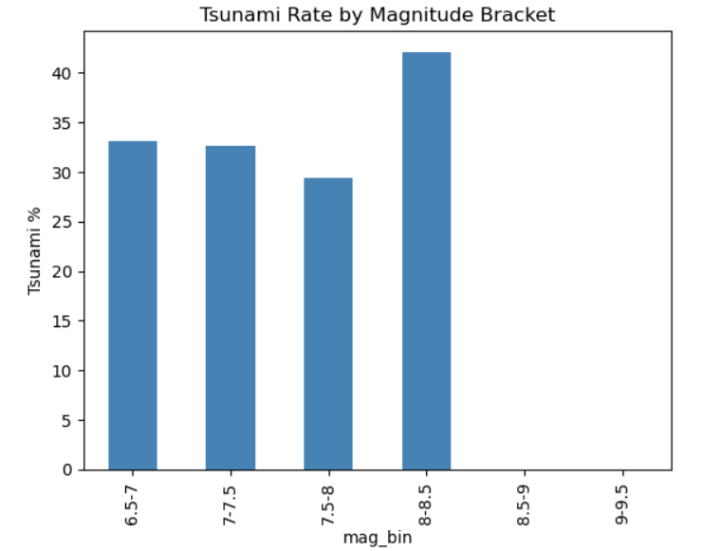
This bar chart shows that the tsunami percentage does not depend on the magnitude. Yes 8-8.5 has a much higher than normal, but the trend shows that it was constant or even decreasing until that sudden spike from 8-8.5. There isn’t enough information to see the data of 8.5 to 9.5. However, the location does affect the rate of tsunami occurrence as shows in the map in the notebook (Coastlines have a higher rate of tsunamis).

Final answer to question 2: Yes partly and No partly. The magnitude has no effect but the location does have an effect. Also the bar chart shows that magnitude does not have any relation with whether a tsunami happens or no.

This helps us in better understanding which types of earthquakes would most likely cause a tsunami. Which is essential for authorities to know as they are the ones to decide whether there is a tsunami warning or not on the spot.

Mohamed Hesham 248519 Question 3:
Which Magtype shows values closest to what the humans actually felt and percieved (Which magtype is the most accurate or most humanlike in feeling)?
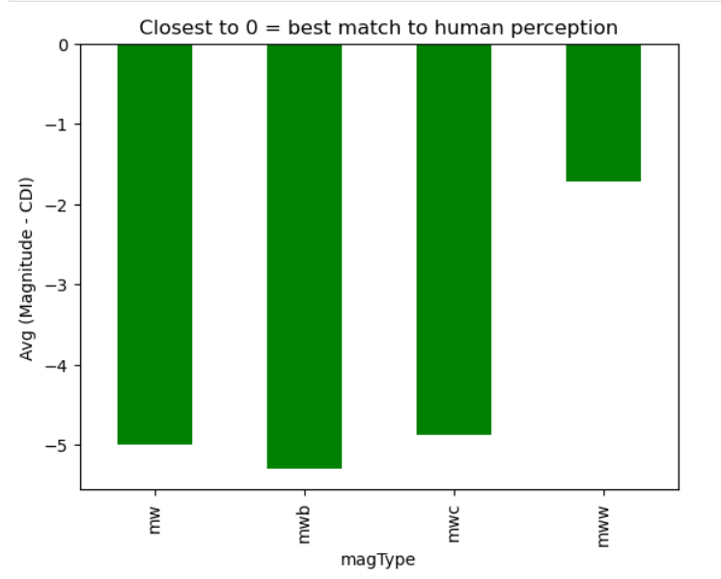
Answer to Question 3: Without a doubt, mww is the best magtype for measuring earthquake magnitudes. The further away the bar is from 0, the more errors/mistakes the magtype (The method of measuring) made. With 0 meaning no mistakes were made. It is obvious that mww is the closest to 0 and is the smallest bar in length.

The importance of finding this out is to make the best measuring type the main measuring type in all regions and locations. This is to measure better and find the actual locations which are in danger.

Mohamed Hesham 248519 Question 4:
What are the Top 10 most dangerous countries (Countries with the biggest mean for magnitudes)?

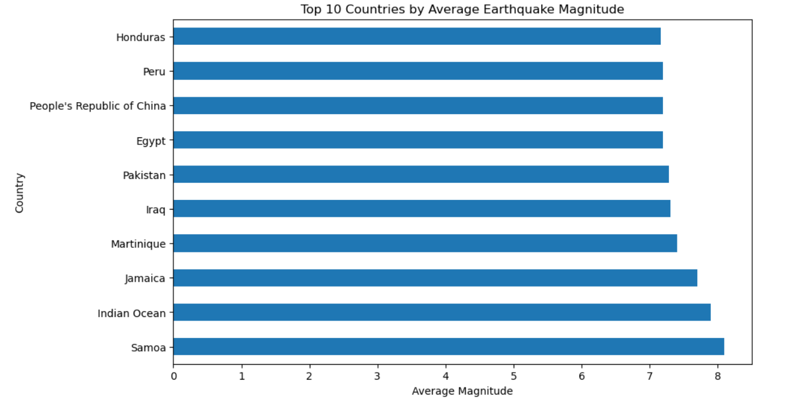
Samoa has had the highest mean of magnitudes over the last couple of years. Perhaps this is due to it being in the pacific ring of fire.
This helps us in identifying the most dangerous countries and make them better prepared to face earthquakes.

Mohamed Hesham 248519 Question 5 :
Which land types/features have higher magnitudes on average?

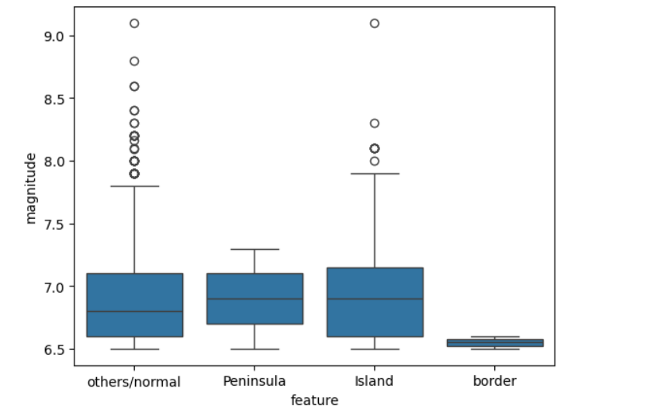
This boxplot shows the distribution of magnitudes of all earthquakes, split by type.
Border areas posses the smallest IQR. Which either means that border areas were consistent and low (maybe because border areas are inland) or there isn’t enough data on border areas. Islands and peninsulas have the highest medians (More than normal places). All the features bar border have a similar iqr. The maximum and median of island seem to be the highest.
Others/Normal seem to have a lot of outliers which can make it seem that they have higher magnitudes on average. This is an illusion which happens because others/normal places have a much bigger area on average, which makes have a much higher probability of experiencing an outlier because more total earthquakes happen there.

This is significant because it encourages us to further improve the infrastructure and safety in islands as they are more prone to earthquakes.
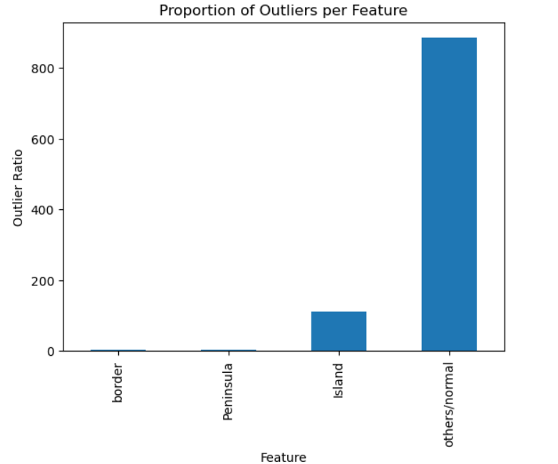
This bar chart proves that it is true that others/normal had a much higher sample size.

Mohamed Hesham 248519 Question 6 :
Is the human perception (CDI) affected by the distance the city is from the source of the earthquake.

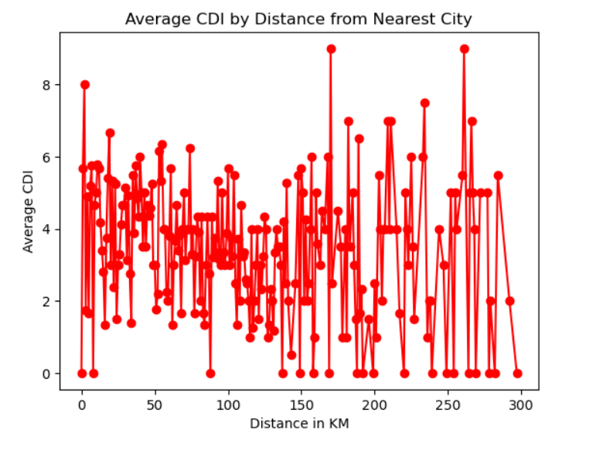

This graph shows the average Human Perception at all distances from cities. This graph shows that there is no trend. The lines look random and keep going up and down. This makes sense because humans can feel earthquakes in all kinds of ways. Maybe average personality of the city matters, which certainly isn’t available in this dataset. Maybe the magnitude is the controlling factor.

Assignment 2

Data Scraping:
Data scraping for this topic was done using a Wikipedia. Wikipedia had a page with a table with a set of a lot of earthquakes that happened throughout history. We took that table, scrapped from it its data using beautiful soup, and then integrated with the phase 1 dataset.
Challenged faces while scrapping:
- The page we scrapped had a lot of missing columns/information
- After integrating with the old dataset, there was a lot of nulls
- A lot of websites with good data needed interactive scrapping (Selenium) so scrapping wasn’t done on them
After integration there were a lot of nulls (Columns that aren’t in the new dataset). And if we had dropped these columns, there would have been basically nothing to do data analysis on. So we decided to fill these null columns: (cdi, mmi, sig, nst, dmin and some more) With the averages of the data we already have, but not just any average, it was filled with the average of the mean/median (depending on case) of the magnitudes of that group or the country. So it wasn’t just a random median or mean. Most nulls got a different number.
Data loss: The data will not be that accurate because a lot of it was filled using median and means. This was the only fix available though because if dropped these columns, there would have been nothing to do visualizations on.

Hypothesis testing:
This hypothesis testing is trying to see the relationship between between magnitudes and tsunami occurrences.

H0: Null Hypothesis: Magnitude is not related to whether a tsunami happens or not (Variables are independant) at 5% Significance Level¶
H1: Alternative Hypothesis: Magnitude is related to whether a tsunami happens or not (Variables are dependedant) at 5% Significance level

Solved using the chi squared method:
Resultant table:
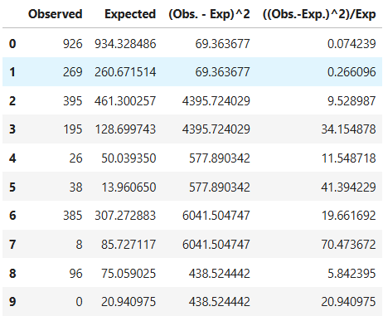
Degree of freedom = (r-1)(c-1)
= ( 5 - 1 ) * (2 - 1) = 4
With 95% degree of freedom and a degree of freedom of: 4

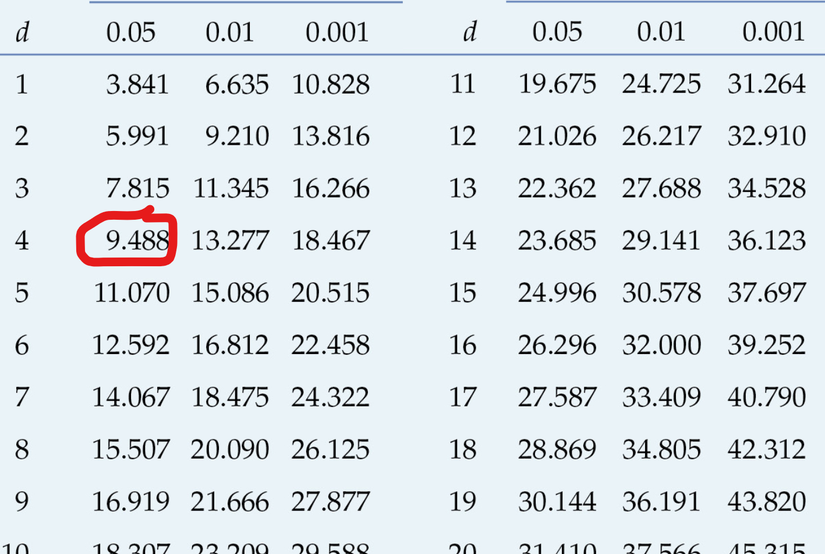
Chiscore after summation: 213.885
Table value: 9.488
213.885 > 9.487 so we reject the null hypothesis (This means magnitude is related to whether a tsunami happens or not)

Questions and visualization:
Ahmed Gamal 247546:

Ahmed Gamal question 1:
Does earthquake depth affect the probability of tsunami occurrence across different regions?

The depth affects the tsunami probability, but it depends strongly on the region. Tsunami probability generally increases from shallow to deep earthquakes. Oceania shows the highest risk at all due to its location in the pacific. Asia has a moderate and stable probability because many earthquake occur in land. Africa and Europe show low probabilities due to limited oceanic zones.
Depth alone does not determine tsunami risk. The geographic location plays a major role as ocean based regions show higher probability.

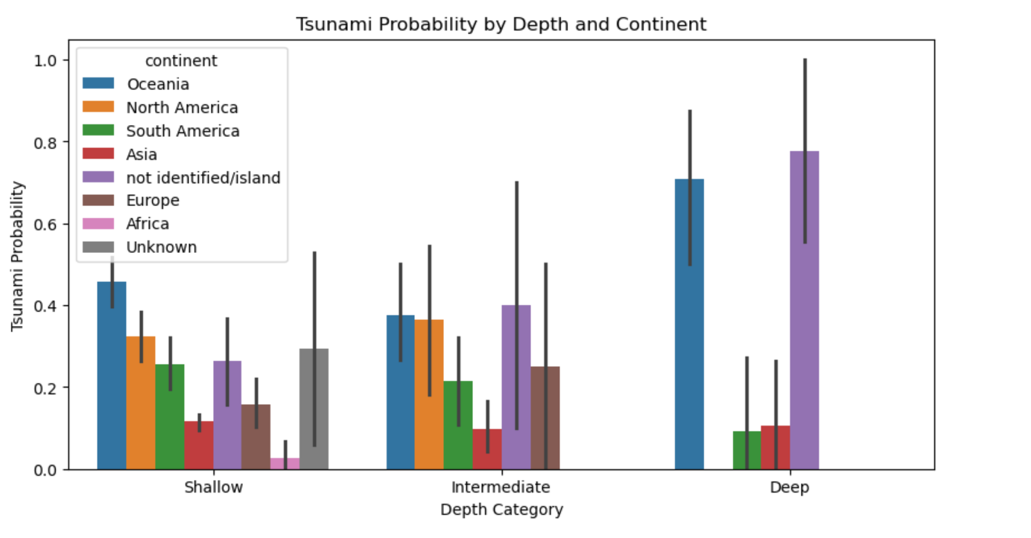

Ahmed Gamal question 2:
Does better monitoring (NST, GAP) affect earthquake magnitude detection?

No strong relationship between exists between monitoring quality and earthquake magnitude. Magnitude are similar across all NST values, showing weak correlation. Higher NST values slightly higher detected magnitude. Lower GAP is associated with clearer detection of large earthquakes.
Earthquake magnitude is determined by physical processes. Not monitoring systems. However, better monitoring improves detection accuracy especially moderate levels.

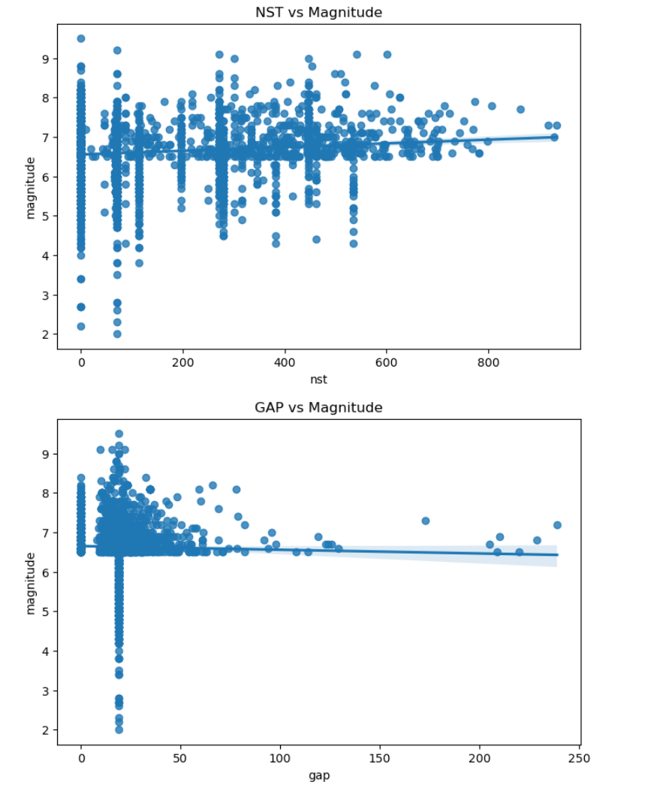

Ahmed Gamal Question 3:
How does distance to nearest station (dmin) affect data quality?

Dmin affects both GAP and NST. But the relation is not simple. Small dmin shows high variety in both GAP and NST. Larger dmin leads to lower NST. GAP becomes more stable at higher dmin values.
Small distance doesn’t always means good quality.

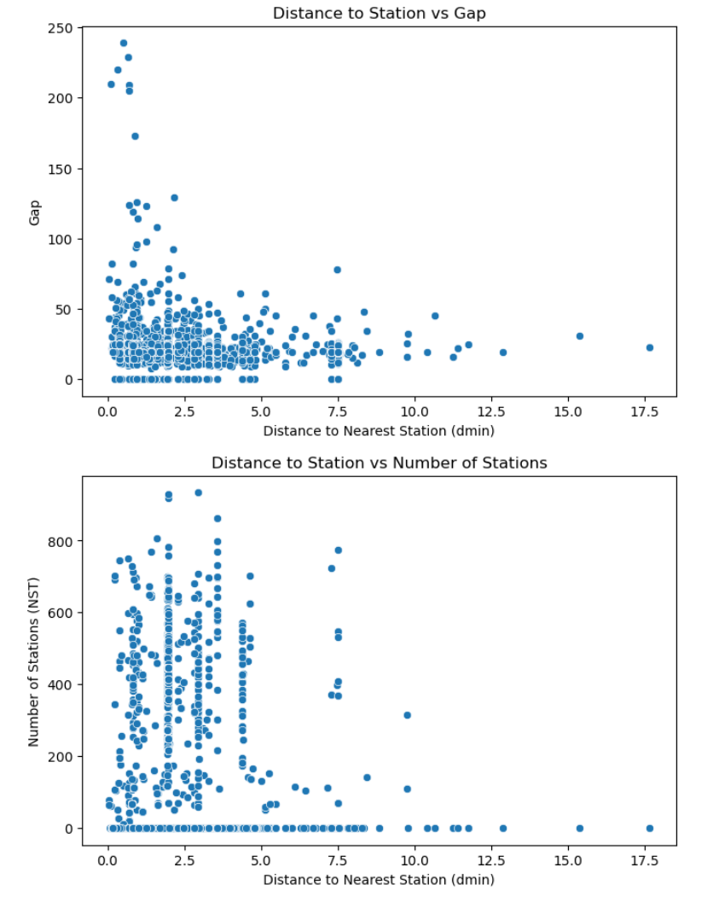

Ahmed Gamal question 4:
Do earthquakes differ between day and night?

There is no big difference in magnitude or detection quality between the day and night. Magnitude are nearly equal for day and night. Gap values are also similar across both periods.
Earthquake is a natural process and not dependent on the time.
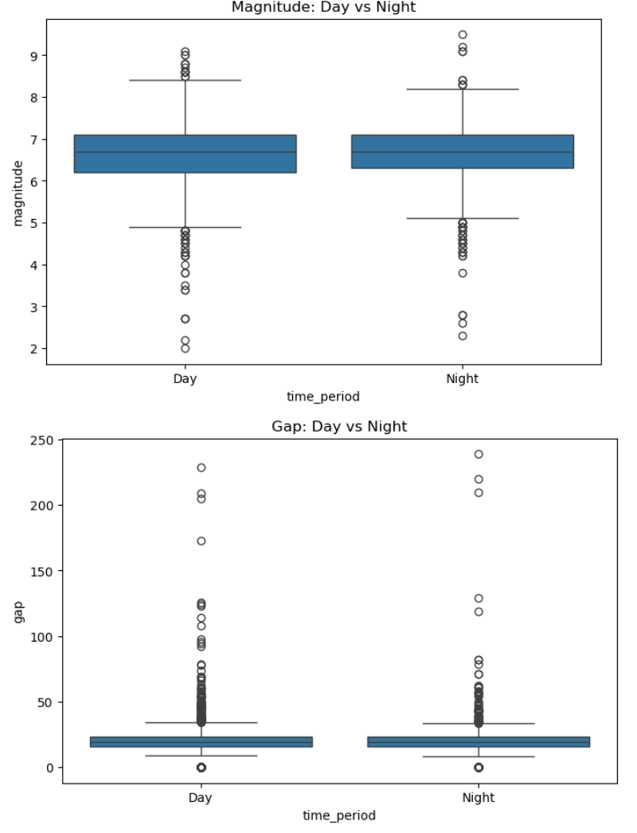

Ahmed Gamal question 5:
What is the distribution of alerts?
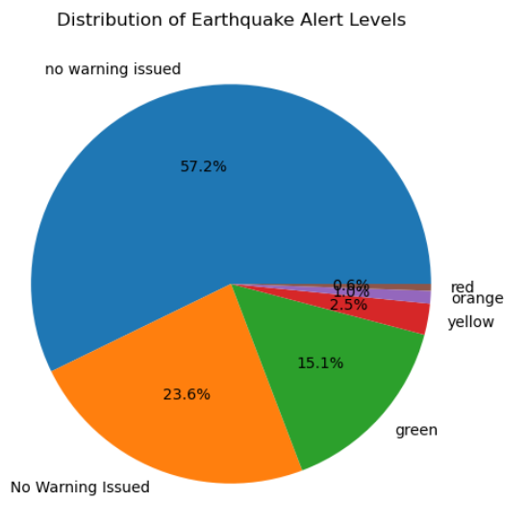
The vast majority of alerts (When they happened) were green, meaning that governments didn’t take earthquakes too seriously. Also for the majority of earthquakes, alerts didn’t even happen, meaning that governments don’t really put much effort to protect people from earthquakes, or, there is less infrastructure to sound the alarms.
Governments need to take better care and put more effort into saving people’s lives.

Ahmed Abousheaisha 248002:

Ahmed Abousheaisha Question 1:
What has changed over time with respect to earthquake and frequency after analyzing new scraped data?
According to the graph, there has been an overall increase in the total frequency of earthquakes throughout the history of the world through time. In the early years, (i.e., approximately 1900-1950), the number of earthquakes that had been recorded was relatively low (and quite stable). However, starting after that (specifically in the 1970’s), the number of earthquakes has clearly increased, with the number showing some fluctuations. More recent years have an overall much higher total count than before and the upward trend line on the graph reinforces the fact that the frequency of earthquakes has increased overall, throughout time.
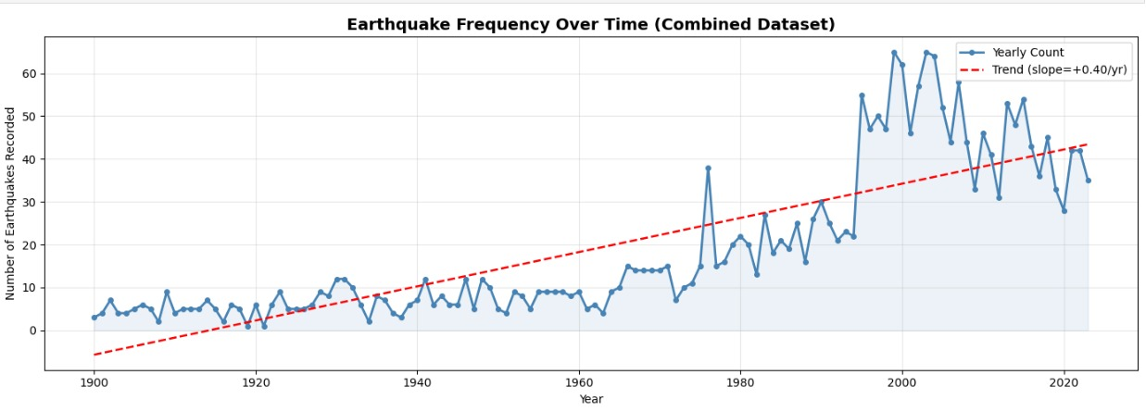

Ahmed Abousheaisha Question 2:
Are there significant differences among various geographical areas (or nations) for depth of earthquakes and amount of damage caused (SIG)?
There is clear variation among the different regions when it comes to earthquake depth and associated damage caused by earthquakes (SIG). Some regions, such as Oceania and South America, often have earthquakes that occur at deeper depths compared to other parts of the world. Higher average levels of damage (SIG) can be found in most countries in North America and Asia than in other regions. Africa, on the other hand, typically has shallower earthquakes, along with lower levels of associated damage than other regions. While the average depth and amount of damage caused by earthquakes will noticeably differ by region, location has a major influence on what characteristics and impacts can be expected from an earthquake.
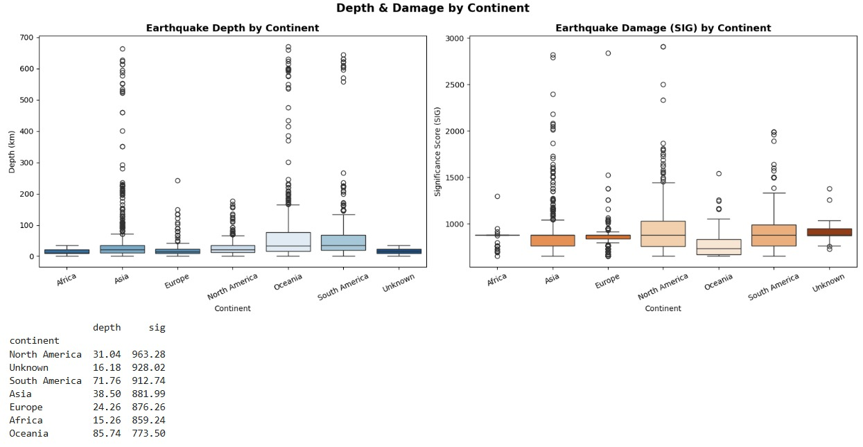

Ahmed Abousheaisha Question 3:
Does the overall relationship between depth of earthquake and extent of damage (SIG) depend on each earthquake's size?
Yes, Generally speaking, the greater the depth of an earthquake will have a negative impact on the amount of damage caused by that earthquake; however, an earthquake of a large enough magnitude can create much more damage than an earthquake of lower magnitude, particularly if the depth of the earthquake is less than or equal to 20 km. On the other hand, small magnitude earthquakes don't cause much, if any, damage, especially when they occur more than 20 km deep. Thus, magnitude is a major factor that determines how much damage will be related to the depth of an earthquake.
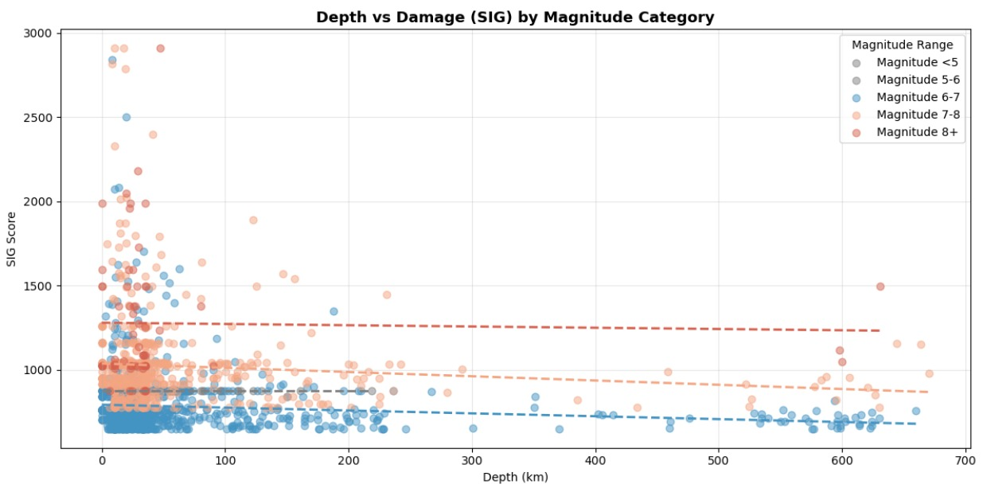

Ahmed Abousheaisha Question 4:
(Re do of question in phase 1 but with new data set): Is tsunami affected by magnitude?
From the analysis done, the graph shows that there is in fact a positive correlation between magnitudes and the probability of tsunamis happening. The higher the magnitude, the higher the tsunami percentage. Note: Magnitude isn’t the only factor.
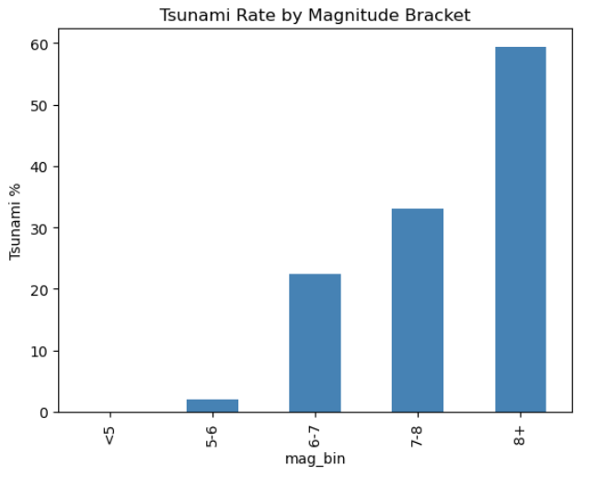

Karim Mohamed 240829:

Karim Mohamed Question 1:
How does magnitude vary across different depth levels?
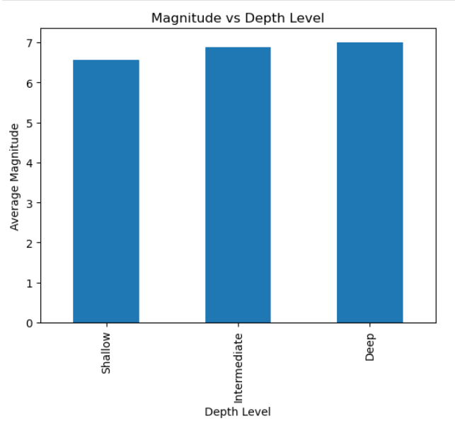
The bar chart shows that earthquakes happen roughly equally at all depth levels. This bar chart shows similar values (Between 6.5 and 7) as the average magnitude between all depth types. It makes sense, as the magnitude of the earthquake is always measured from source (Not what people felt). So whether the source is deep or shallow, it will always be similar.

Karim Mohamed Question 2:
Which magnitude range occurs most frequently?
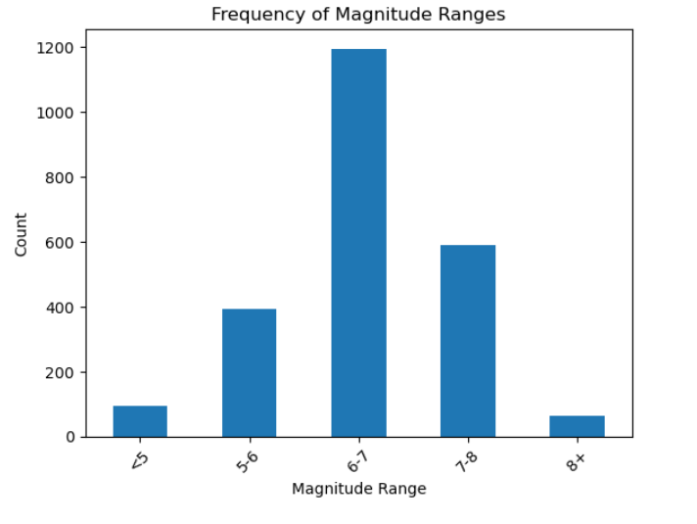
The most common types of earthquakes are the ones that are not too strong yet not too weak. Moderate earthquakes occur more frequently than to both extremes. Weaker earthquakes are less because they are harder to detect. Stronger earthquakes are also less because they are extremely rare and require a rare combination of tectonics to occur.

Karim Mohamed Question 3:
Do shallow earthquakes produce higher damage?
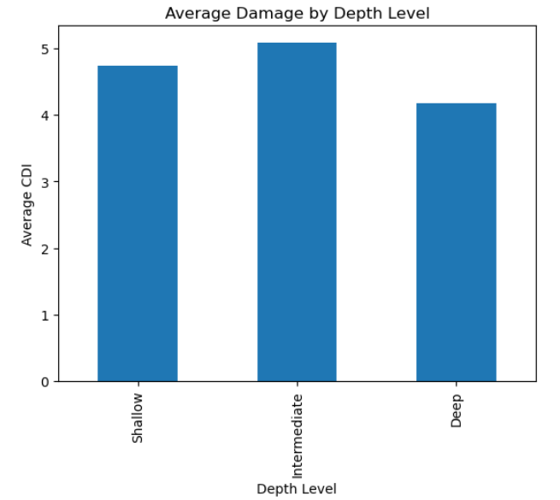
This chart shows that shallow and intermediate earthquakes tend to produce higher damage than deep earthquakes. This may be due to them being closer to the surface. The source is closer so the seismic waves have less area to travel.

Mohamed Hesham 248519:

Mohamed Hesham 248519 Question 1:
Do earthquakes with similar magnitude have different impacts depending on location?
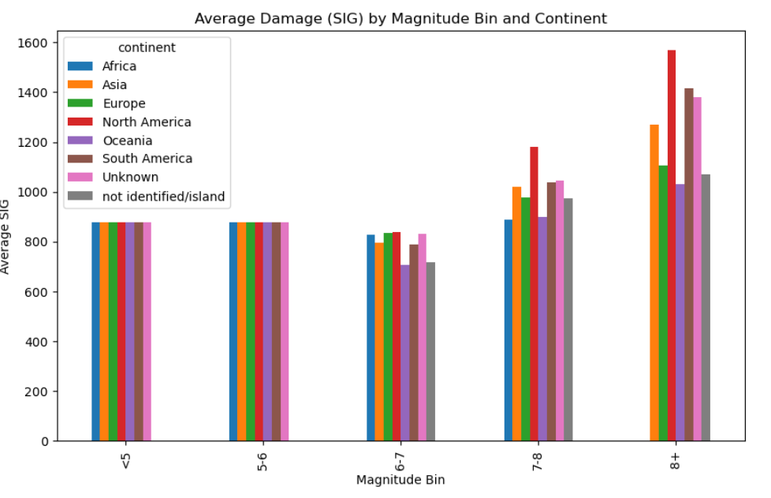
This bar chart splits into magnitude bins, and in these magnitude bins, it calculates the average of significance (Damage) for each magnitude bin based on the region/continent. For weak earthquakes, its similar. However, for the larger earthquakes, the regions have different damage done for the same magnitudes. This shows that it is not only the magnitude of the earthquake that affects the outcome. There are so many other factors like: Infrastructure, economy, how alert are the people, sea level, etc..)

Mohamed Hesham 248519 Question 2:
Do earthquakes that occur at night have a higher death rate than the earthquakes that occur during the day?
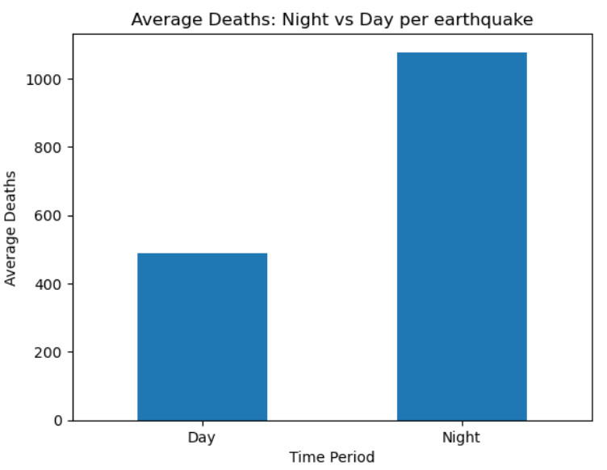
This bar chart groups all earthquakes that happened at night and all that happened at day, then it gets the average for each group. It is evident from the bar chart that there is much more cases of deceased people from the night time earthquakes. This may be due to a lot of things:
- People are less alert during the night (At home, sleeping, relaxing)
- There is poorer vision at night to escape from the rubble (it is dark)
- There are less rescue services at night.
Even though the magnitudes are quite similar for day and night, there ends up being more deaths at night.

Mohamed Hesham 248519 Question 3:
Is there a threshold magnitude that beyond it, the deaths skyrocket?
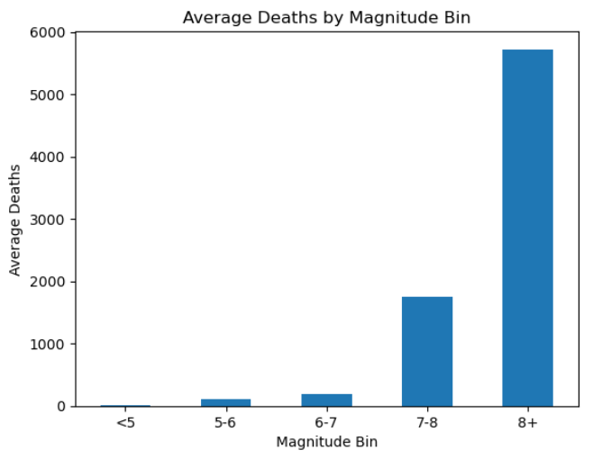
While it has been established that magnitude isn’t the only factor when it comes to how disastrous an earthquake, it is quite obvious from this graph that there is a strong correlation between magnitude of an earthquake and the number of deaths. With it skyrocketing after magnitude of 8. So magnitude isn’t the only factor, but it is the biggest factor

Mohamed Hesham 248519 Question 4:
Has the average number of deaths per earthquake changed over time?
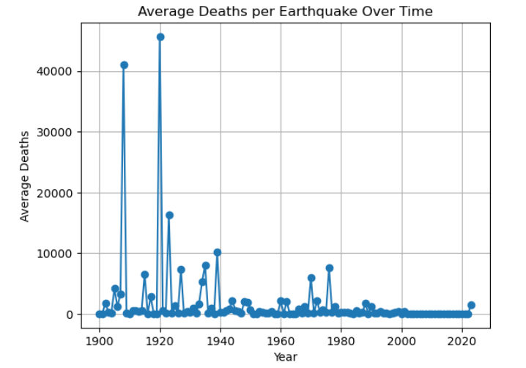
In the past the deaths were much more than today. There were also much more spikes (outliers) in the past. Today deaths per year from earthquakes seem to be constant from year to year. This is because of how the modern world operates. Better healthcare, better services, better infrastructure (Less rubble) and best overall research.

Mohamed Hesham 248519 Question 5:
Are there earthquakes with high magnitude but low deaths and vice versa?
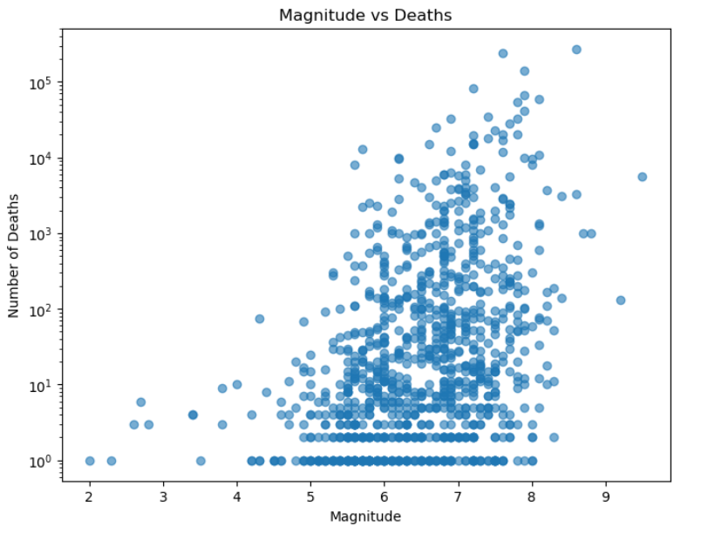
This graph shows the scattering between magnitudes of an earthquake and how much deaths each one caused.
While for the most part there is a positive trend between magnitude and number of deaths (as magnitude increases the number of deaths tend to increase). There are some earthquakes in this graph that have a high magnitude and a small number of deaths, while there are other earthquakes that have a lower magnitude but a higher number of deaths. This shows that the magnitude isn’t the only factor affecting how devastating an earthquake is. This graph shows that there are other factors.

Mohamed Hesham 248519 Question 6:
Is the number of deaths different for locations when the magnitude is the same?

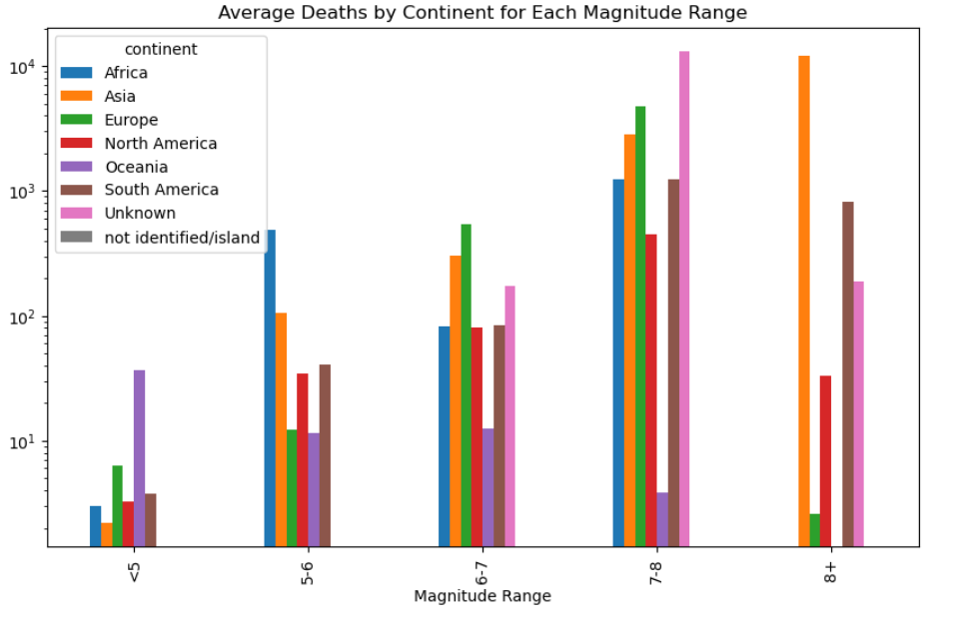
This graph shows that the deaths do differ between same magnitude earthquakes for different locations. This is because of different levels of advancement of every region and country. Also coastal cities could be more of risk to death because they are at risk of tsunamis.

