**Department of Computer Engineering**



**Cairo University**

**Faculty of Engineering**

**Cognitive Robotics**

**Assignment 1**

**Submitted to**

Eng. Mohamed Shawky

**Submitted by**

|  |  |  |  |
| --- | --- | --- | --- |
| **Name** | **Sec** | **BN** | **Code** |
| **Ahmed Hany Farouk Tawfik** | **1** | **10** | **9202213** |

**Requirement 1:**

With initial Pose

position = (350, 185)

angle = 200

The map

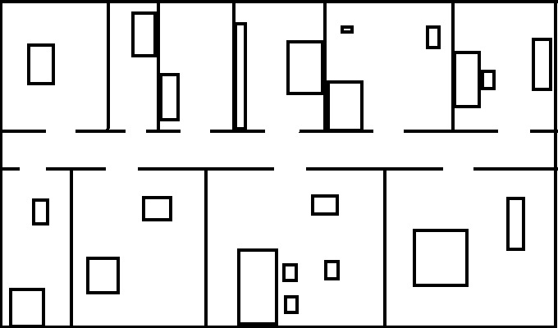

After Drawing Robot

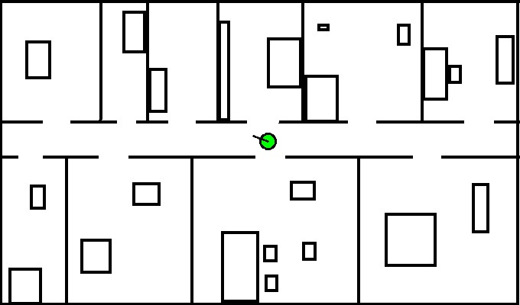

After Ray Casting

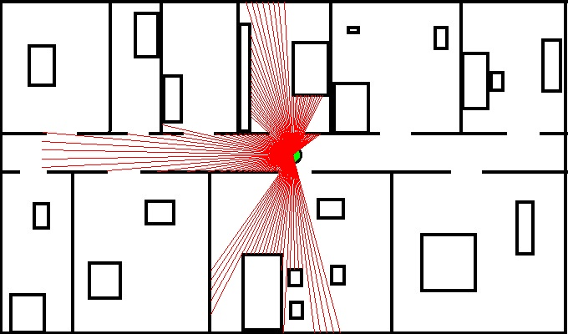

**Requirement 2:**

Likelihood filed at sigma = 1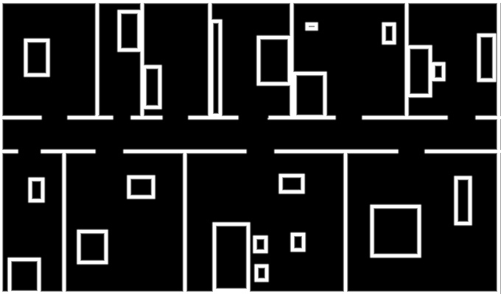

Likelihood filed at sigma = 5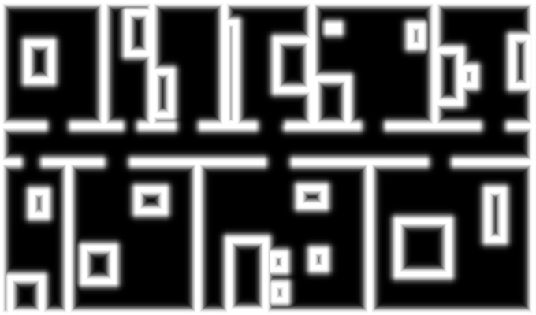

Likelihood filed at sigma = 10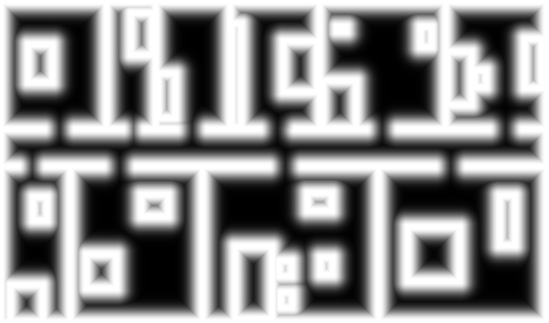

Likelihood filed at sigma = 15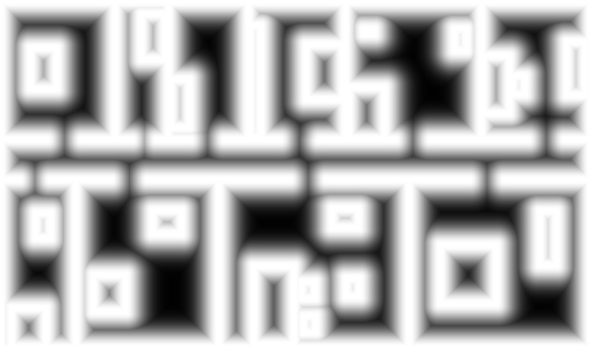

Likelihood filed at sigma = 20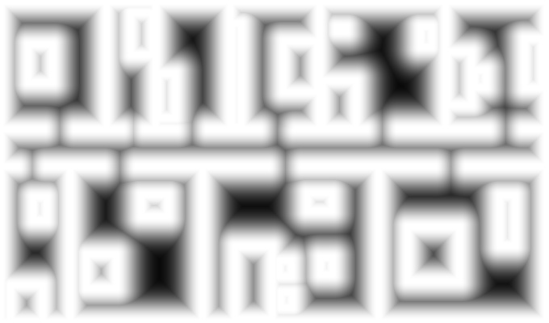

Likelihood filed at sigma = 25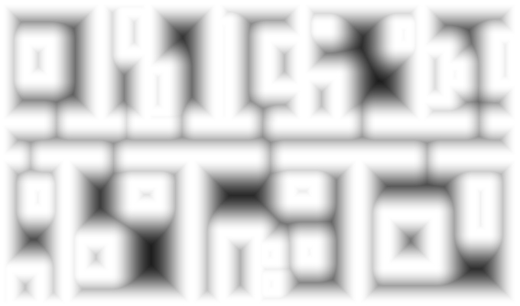

Probability map of distance = 0.1 and sigma = 1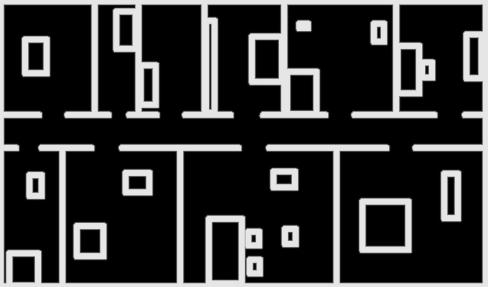

Probability map of distance = 0.3 and sigma = 1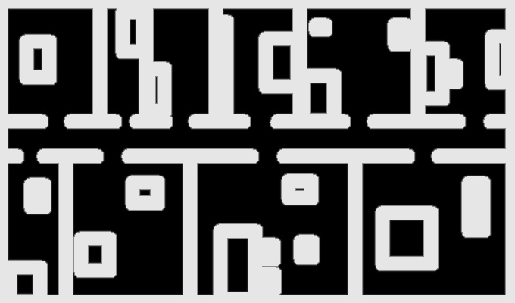

Probability map of distance = 0.5 and sigma = 1

Probability map of distance = 1 and sigma = 1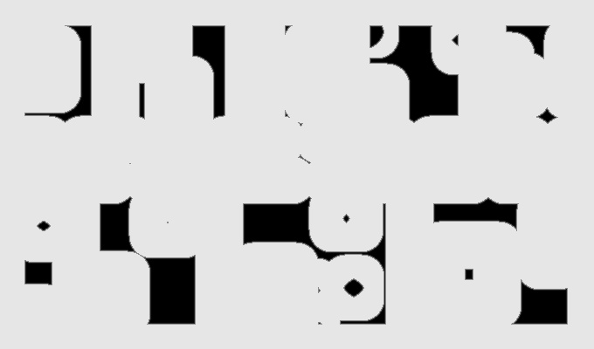

Probability map of distance = 3 and sigma = 1

Probability map of distance = 5 and sigma = 1

Probability map of distance = 10 and sigma = 1

Probability map of distance = 0.1 and sigma = 5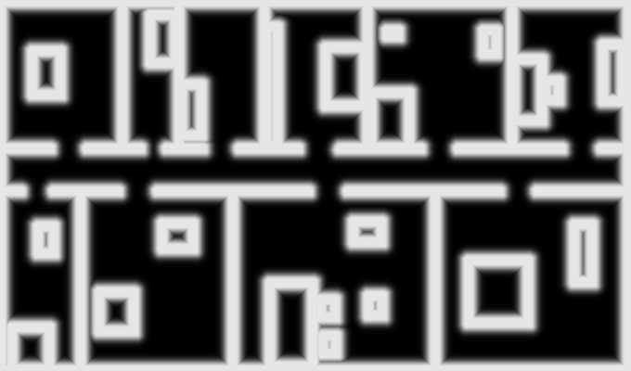

Probability map of distance = 0.3 and sigma = 5

Probability map of distance = 0.5 and sigma = 5

Probability map of distance = 1 and sigma = 5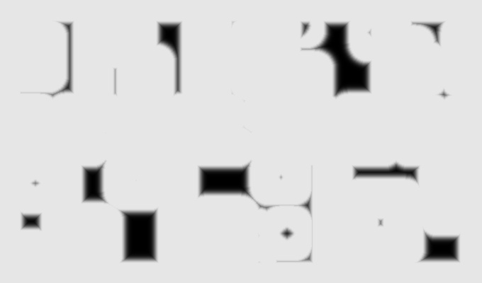

Probability map of distance = 3 and sigma = 5

Probability map of distance = 5 and sigma = 5

Probability map of distance = 10 and sigma = 5

Probability map of distance = 0.1 and sigma = 10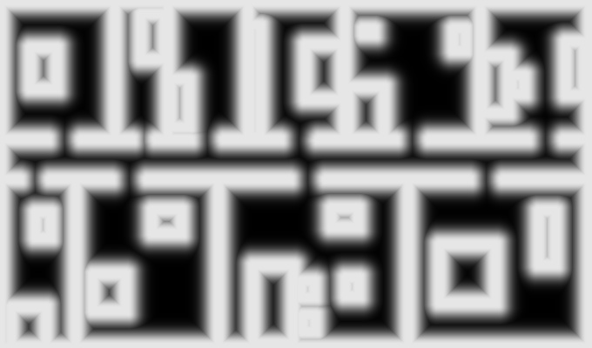

Probability map of distance = 0.3 and sigma = 10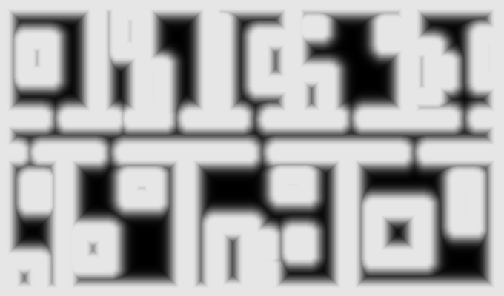

Probability map of distance = 0.5 and sigma = 10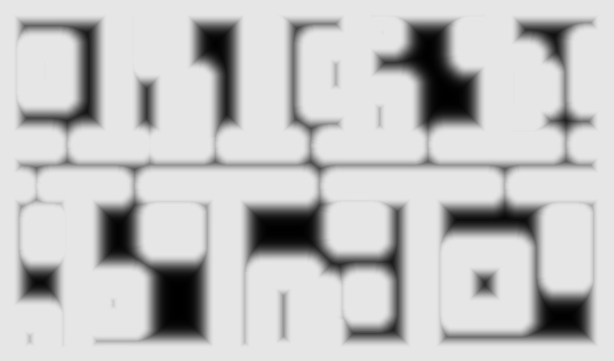

Probability map of distance = 1 and sigma = 10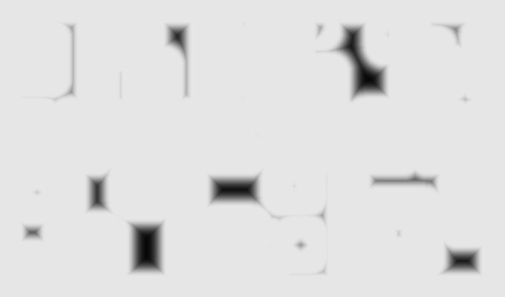

Probability map of distance = 3 and sigma = 10

Probability map of distance = 5 and sigma = 10

Probability map of distance = 10 and sigma = 10

Probability map of distance = 0.1 and sigma = 15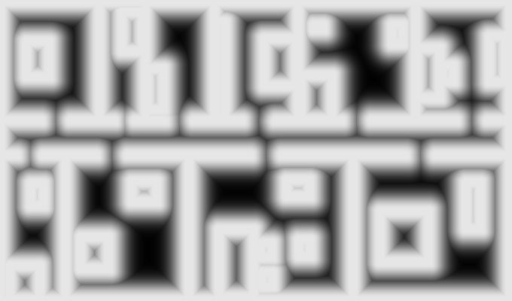

Probability map of distance = 0.3 and sigma = 15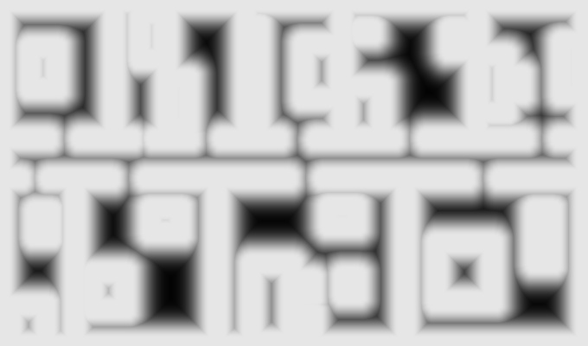

Probability map of distance = 0.5 and sigma = 15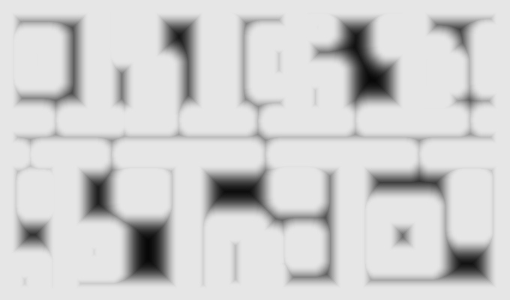

Probability map of distance = 1 and sigma = 15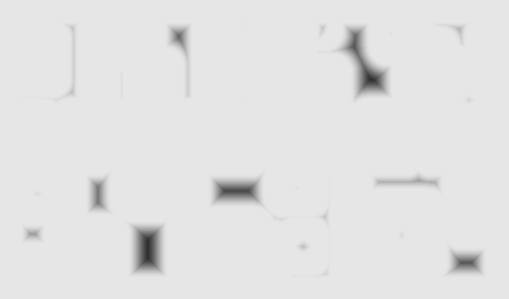

Probability map of distance = 3 and sigma = 15

Probability map of distance = 5 and sigma = 15

Probability map of distance = 10 and sigma = 15

Probability map of distance = 0.1 and sigma = 20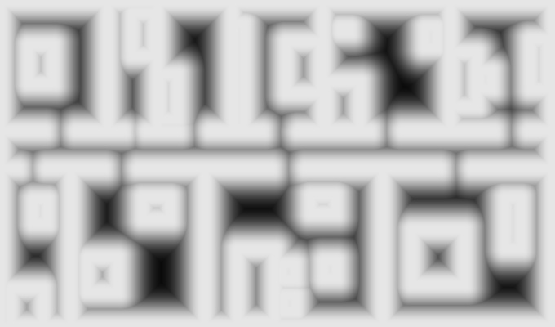

Probability map of distance = 0.3 and sigma = 20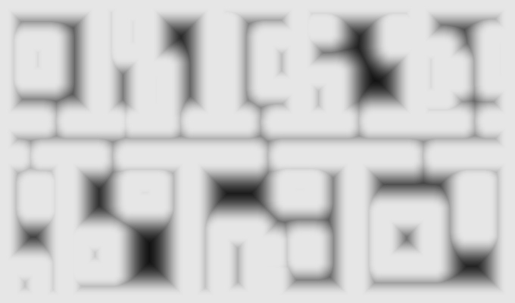

Probability map of distance = 0.5 and sigma = 20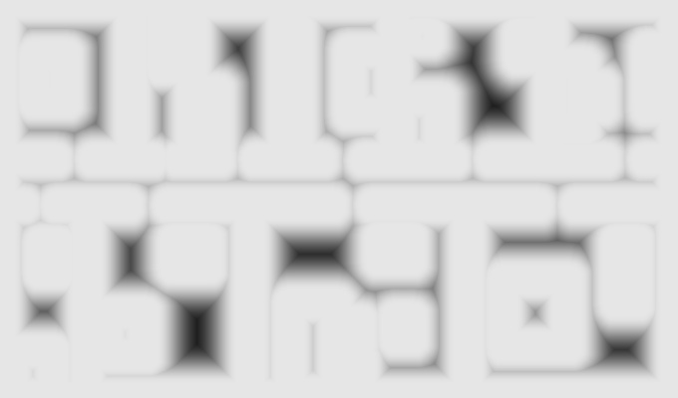

Probability map of distance = 1 and sigma = 20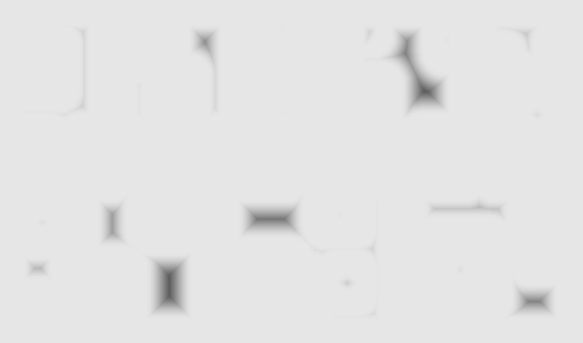

Probability map of distance = 3 and sigma = 20

Probability map of distance = 5 and sigma = 20

Probability map of distance = 10 and sigma = 20

Probability map of distance = 0.1 and sigma = 25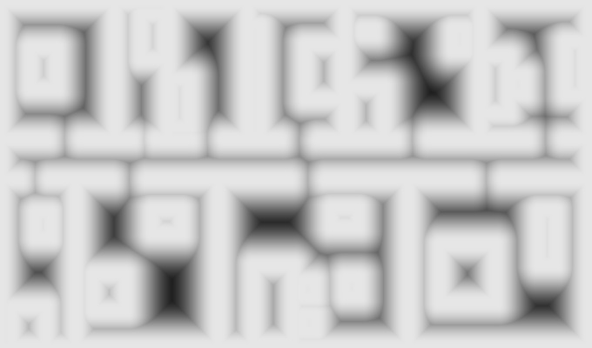

Probability map of distance = 0.3 and sigma = 25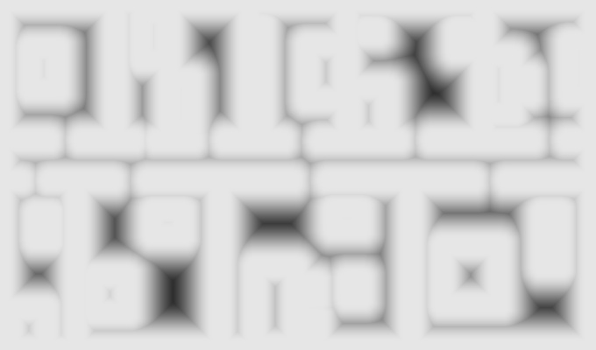

Probability map of distance = 0.5 and sigma = 25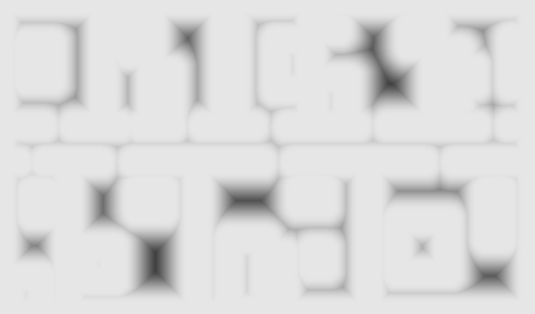

Probability map of distance = 1 and sigma = 25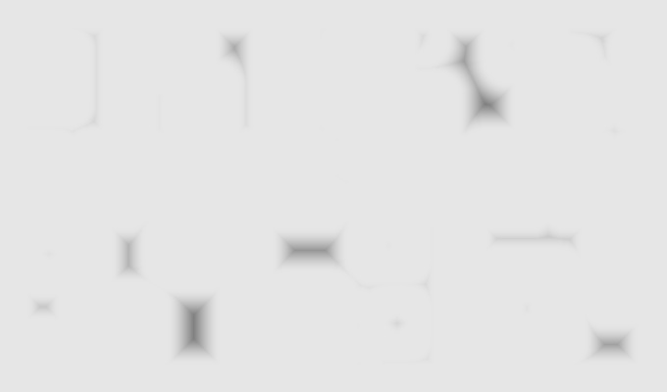

Probability map of distance = 3 and sigma = 25

Probability map of distance = 5 and sigma = 25

Probability map of distance = 10 and sigma = 25

**We get that from distance 3m it gave white image regardless of the sigma value.**