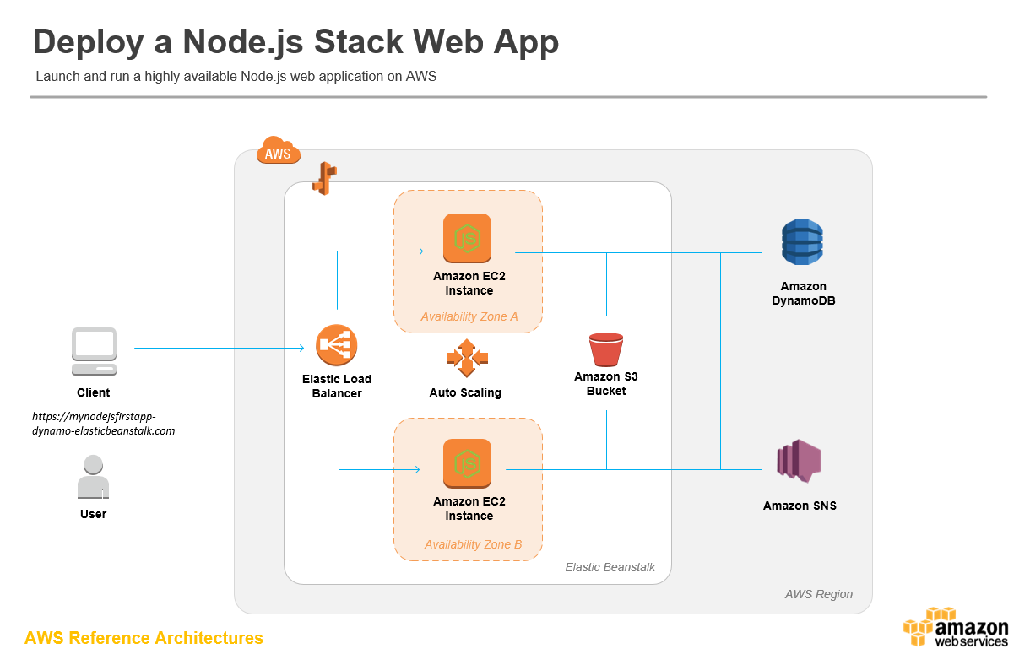

1)frontend bucket:

<http://myawsbucket-75139724081.s3-website-us-east-1.amazonaws.com/>

2)Api Bucket:

<http://udigramapi-env.eba-2kvaphpz.us-east-1.elasticbeanstalk.com/>

3)DATABASE

Endpoint

database-1.ciac8rgjyuqq.us-east-1.rds.amazonaws.com

POSTGRES DATABASE

PORT 5432