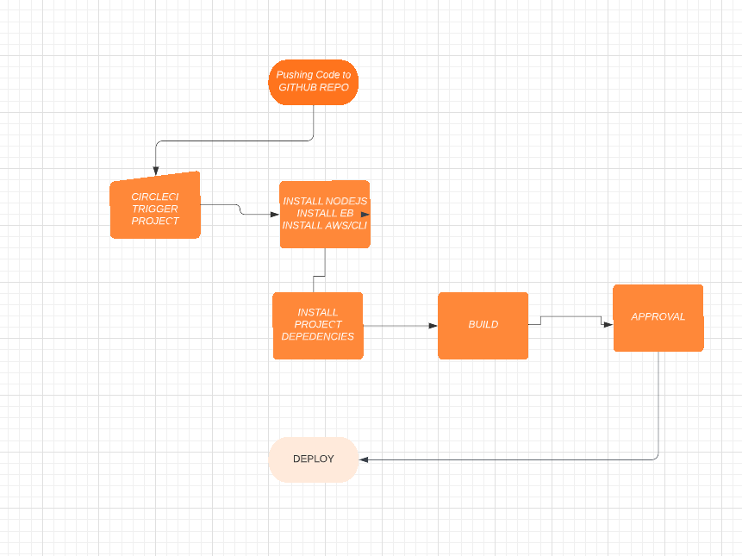

PipeLine Process:

1. The developer push his code on github rep .
2. Create circleCI account and link you github with it.
3. circleCI will triger the workflow every time you push the code.
4. circleCI will install all requirements in the code .
5. circleCI will build the app
6. after building stage circleci will ask for approve to deploy
7. deploying stage will start