
Mastering Embedded System Online Diploma
www.learn-in-depth.com

First Term (Final Project 1)
Eng. Ahmed Hassan Ibrahim

My Profile:
https://www.learn-in-depth-store.com/profile/ahmed-hassan-ese63658/profile

Table of Contents
No table of contents entries found.

Case Study:
A client requires the delivery of a software system with the following functionality:
- A pressure controller alerts the cabin crew with an alarm whenever the cabin pressure exceeds 20 bars.
- The alarm remains active for 60 seconds.
- The system records and stores the measured pressure values.
Pressure Controller – Assumptions
- Controller setup and shutdown procedures are outside the scope of this model.
- Maintenance operations are not considered.
- The pressure sensor is assumed to be fault-free.
- The alarm is assumed to operate without failure.
- The controller is never affected by power outages.

SDLC:
For this project, the Waterfall Model will be adopted as the SDLC approach. The development will follow a sequential process, where each phase must be completed before moving to the following:
- Requirements Analysis
- Space Exploration/ partitioning
- System Analysis
- System Design
- Implementation (Coding)

Requirements:
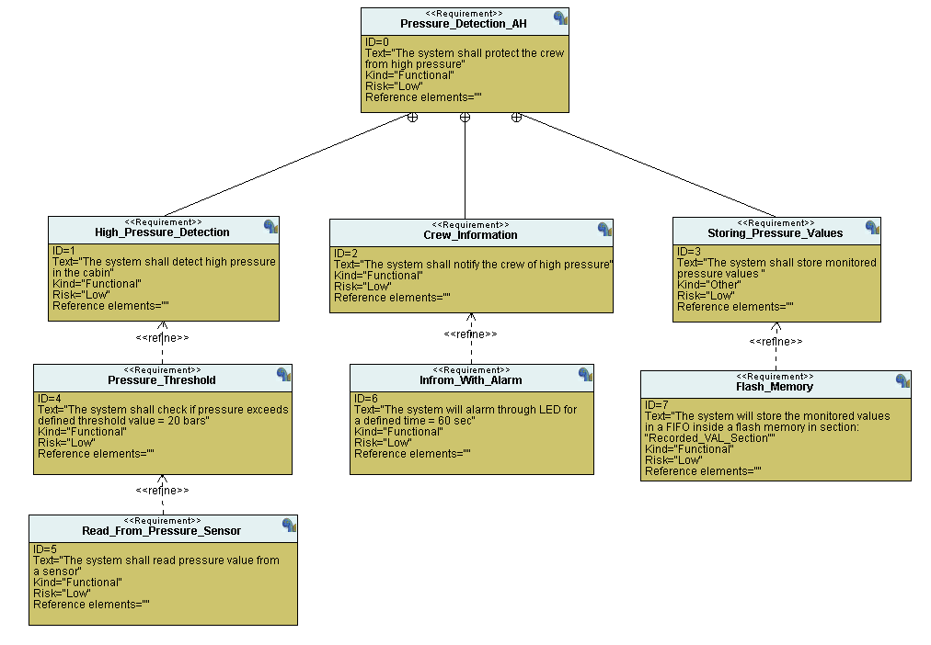

System Analysis:

Use Case Diagram:
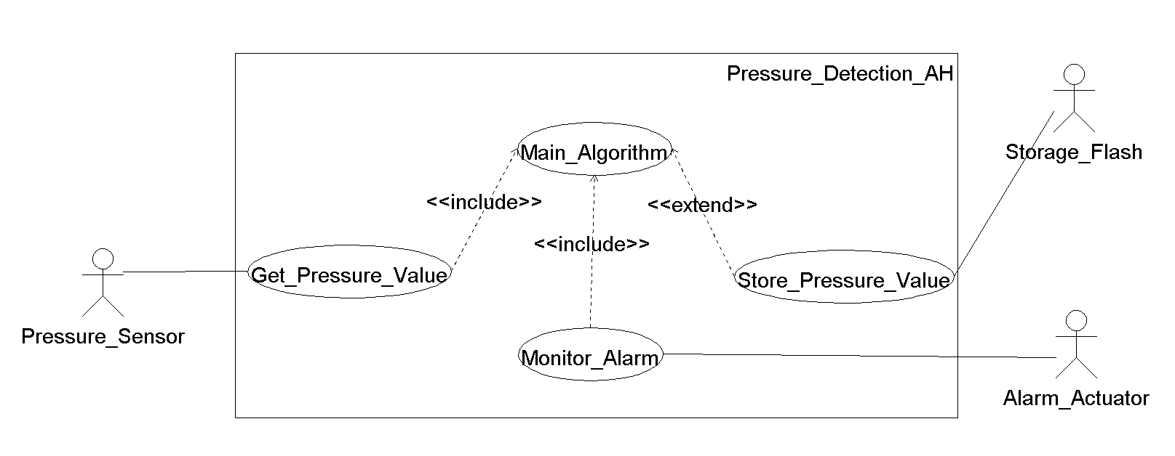

Activity Diagram:
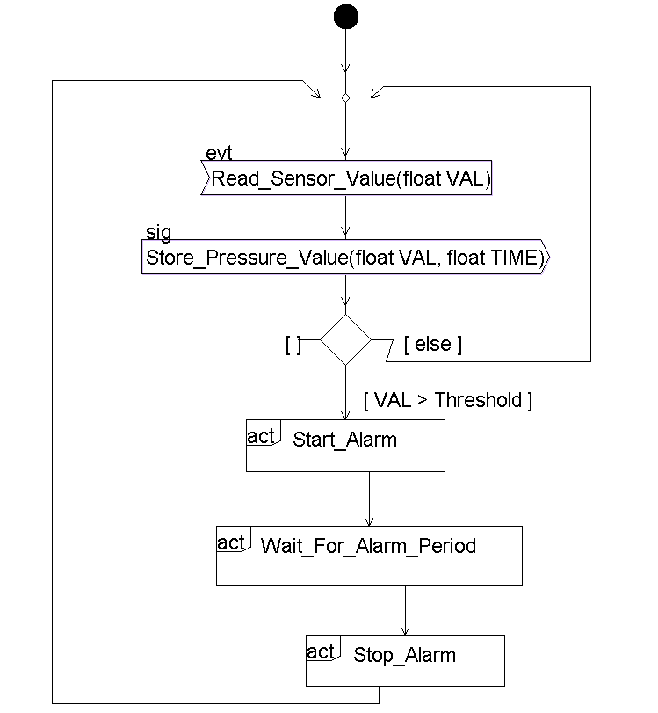

Sequence Diagram:
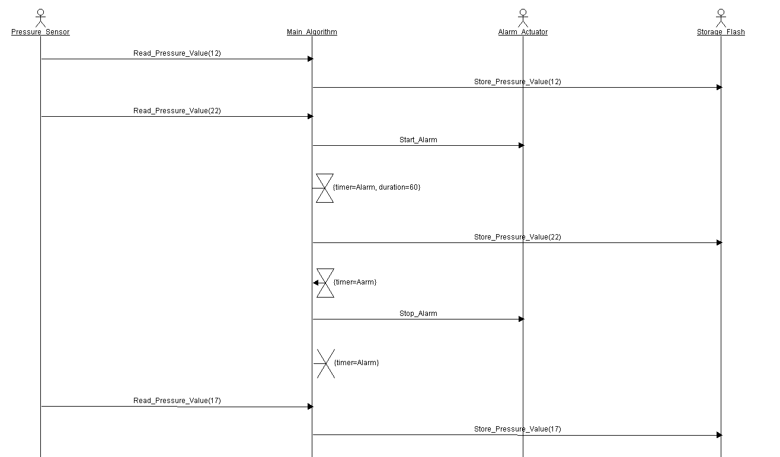

System Design:
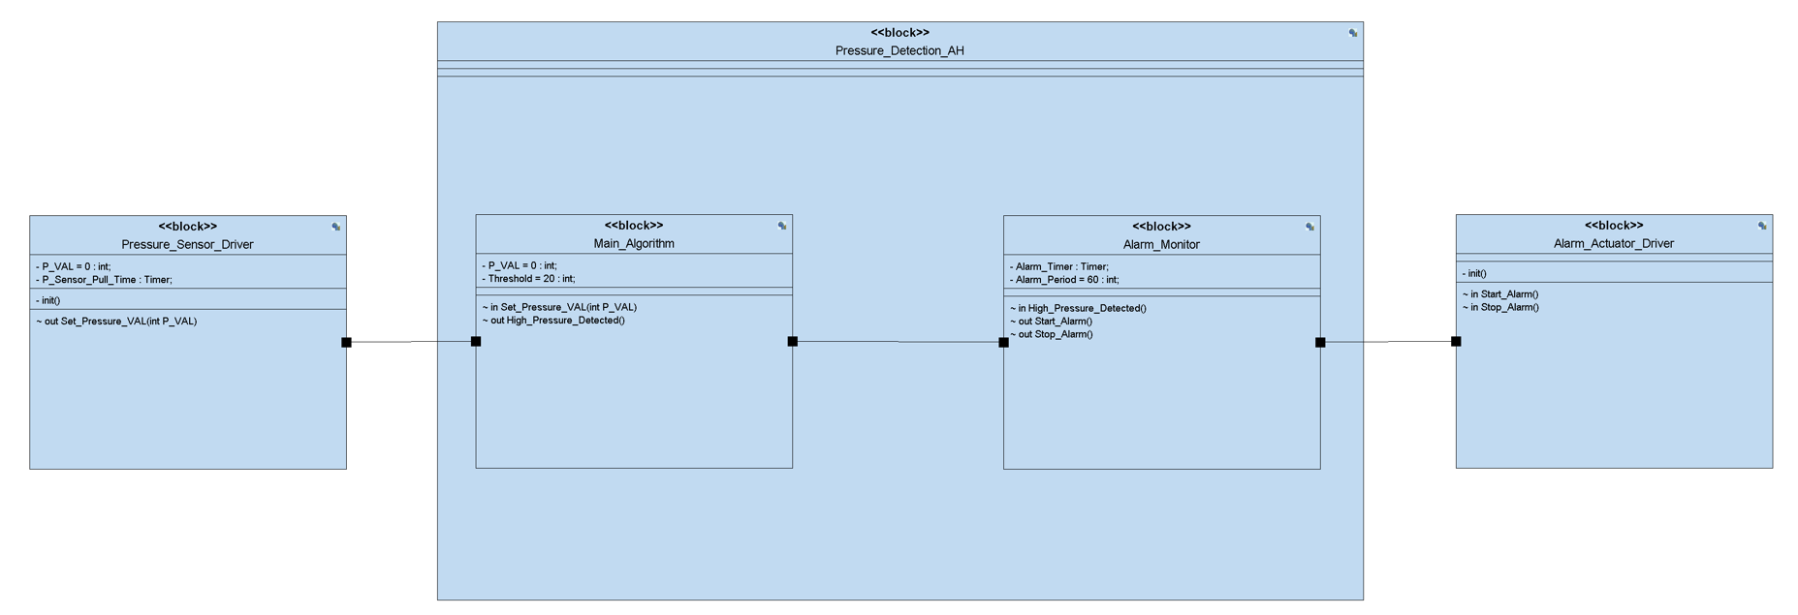

- Block: Pressure_Sensor_Driver
  - Purpose: Reads the cabin pressure from the pressure sensor at regular intervals.
  - Variables:
    - P_VAL: stores the latest measured pressure value.
    - P_Sensor_Poll_Time: timer for periodic sensor polling.
  - Signals:
    - Set_Pressure_VAL(int P_VAL): sends the measured pressure value to the main algorithm.
- Block: Main_Algorithm
  - Purpose: Implements the core decision logic by comparing the measured pressure against the threshold (20 bars).
  - Variables:
    - P_VAL: the most recent pressure reading.
    - Threshold: the defined pressure limit (20 bars).
  - Signals:
    - Set_Pressure_VAL(int P_VAL): receives the measured pressure value from the sensor driver.
    - High_Pressure_Detected(): notifies the alarm monitor when the threshold is exceeded.
- Block: Alarm_Monitor
  - Purpose: Manages the alarm operation when high pressure is detected. Ensure the alarm runs for 60 seconds before stopping.
  - Variables:
    - Alarm_Timer: timer to track alarm duration.
    - Alarm_Period: duration of the alarm (60 seconds).
  - Signals:
    - High_Pressure_Detected(): receives the trigger from the main algorithm.
    - Start_Alarm(): starts the alarm through the actuator driver.
    - Stop_Alarm(): stops the alarm after 60 seconds.
- Block: Alarm_Actuator_Driver
  - Purpose: Interfaces with and controls the actual alarm actuator.
  - Signals:
    - Start_Alarm(): activates the alarm.
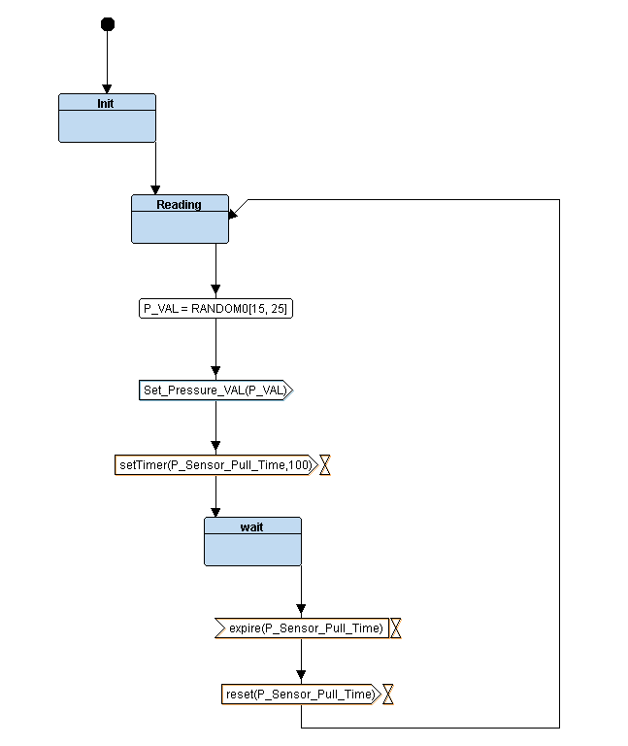
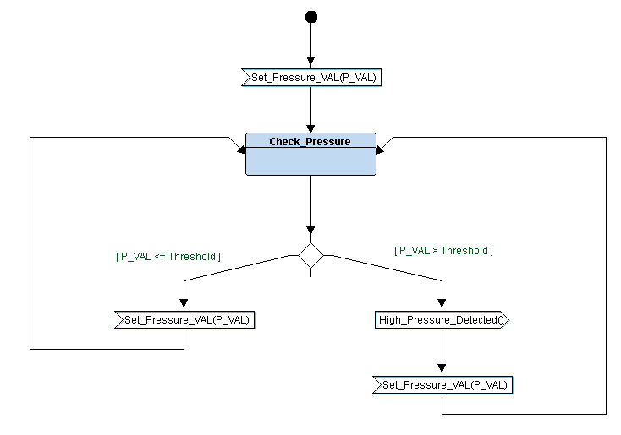
    - Stop_Alarm(): deactivates the alarm.
Pressure_Driver
Main_Algorithm

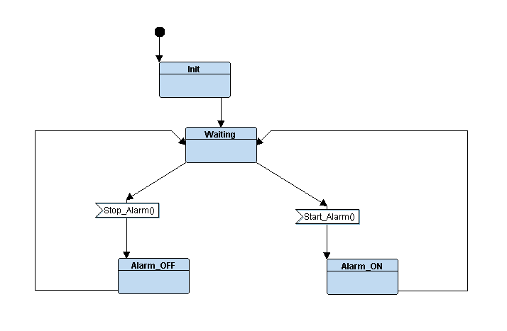
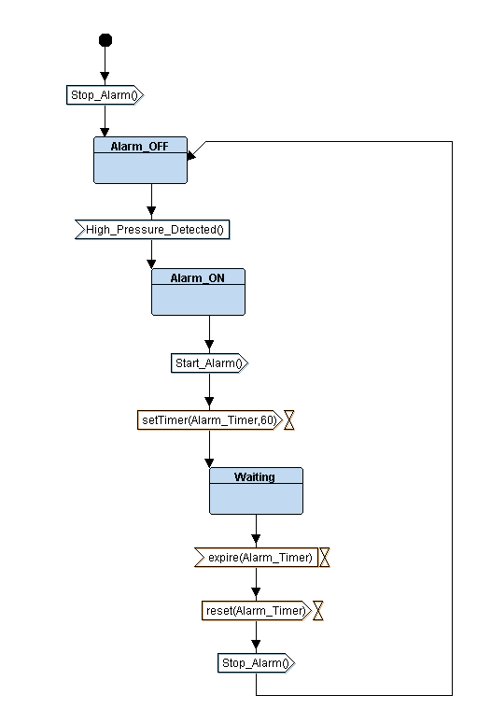
Alarm_Actuator
Alarm_Monitor

Trace Simulation:
