



**AL-HIKMA UNIVERSITY**

**COLLAGE**

2020

AC-DC Converter

Second Stage

Morning study

Prepared By: Ahmed Ihsan Ali

Computer Technology Engineering Department

Supervised by Marwan AL-Jemeli

Abstract— 2

Introduction 2

Performance parameters 2

Definition 2

Basic rectifier structures 4

Introduction 4

Single-phase systems 4

Half-wave rectifier 4

RECTIFIERS 4

Full-wave rectifier — centre-tapped 5

RECTIFIERS 5

Full-wave rectifier — bridge 6

References 7

# Abstract—

In particle accelerators, rectifiers are used to convert the AC voltage into DC or low-frequency AC to supply loads like magnets or klystrons. Some loads require high currents, others high voltages, and others both high current and high voltage. This presentation deals with the particular class of line commutated rectifiers (the switching techniques are treated elsewhere). The basic principles of rectification are presented. The effects of real world parameters are then taken into consideration. Some aspects related to the filtering of the harmonics both on the DC side and on the AC side are presented. Some protection issues associated with the use of thyristors and diodes are also treated. An example of power converter design, referring to a currently operating magnet power supply, is included. An extended bibliography (including some internet links) ends this presentation.

Introduction

In particle accelerators, electrons or other charged particles are forced to move along orbits or trajectories by means of magnetic fields. The intensity of the magnetic fields needed to obtain the desired effects is related to the energy of the particles. Electromagnets, conventional hot ones or superconducting ones, are normally used. The excitation current in the magnets can range from some amperes for small orbit correction coils to some hundreds or thousands of amperes (see, for example, Refs. [1] and [2]). The power converters needed to cover such a wide current range have widely differing structures and characteristics and, for the same power requirement, several solutions are often possible. In this paper I show the topologies and the characteristics of a particular class of rectifiers—the line commutated ones—that was and still is widely used in particle accelerator facilities. Even today, in the ‘PWM Era’, line commutated rectifiers are operating. Moreover, Switch Mode Power Supplies (SMPS) very often include in their structure ‘conventional’ rectifiers as input or output stages or both. Since the currents in the magnets have either to be varied according to the energy (or the required changes in the orbit) of the particles or at least have to be ramped from the turn on values to their final values (this is quite important if the time constant of the load — a magnet string — is high), the rectifiers use thyristor-based structures or mixed ones (diodes and thyristors or diodes/thyristors and transistors). The effects on the rectifier behaviour of the inductive components of the load and of the AC line will be investigated. The use of passive filters to reduce the harmonic content (ripple) of the voltage and current at the output of the rectifier will be discussed. Even if this is not a specific topic for this lecture, some protection issues related to the components (snubber and bucket circuits) and to the converter as a whole will be briefly mentioned. The studies to reduce the harmonics on the line-current and to improve the power factor (Refs. [3], [4]) and the use of Pulse-Width Modulation (PWM) techniques have brought forth more sophisticated rectifier designs with the absorption of a quasi-sinusoidal waveform of the line current 133 with minimum lag with respect to the line voltage (the so-called power factor correction). Unity power factor converters will just be mentioned in this lecture but there is a vast literature about them (see, for example, Refs. [5] and [6]).

Performance parameters

## Definition

Before starting to examine different topologies for single-phase or multi-phase rectifiers, we should define some parameters. These parameters are needed to compare the performances among the different structures

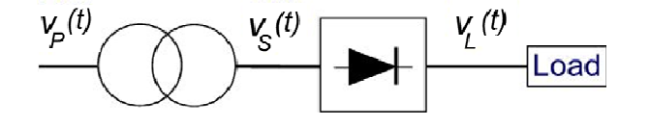

Fig. 1: Generic scheme of a rectifier

Let us assume we have ideal switches (diodes or thyristors) with zero commutation time (i.e., instantaneous turn on and off) and zero on-resistance (i.e., when conducting they present neither voltage drop nor losses). The load itself is an ideal resistance. The generic scheme is shown in Fig. 1. At the input of the rectifier there are one or more AC voltages from the secondary of the transformer. At the output of the rectifier, on the load, there is also a time-dependent voltage. This voltage, as will be shown, is a combination of the voltages at the input of the rectifier stage. The DC voltage on the load is the average over the period T of the output voltage of the rectifier:

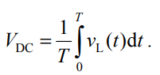

Similarly, it is possible to define the r.m.s. voltage on the load:

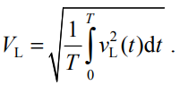

The ratio of the two voltages is the Form Factor (FF):

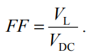

This parameter is quite important since it is an index of the efficiency of the rectification process. Having assumed the load to be purely resistive, it is possible to define the currents as

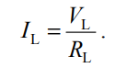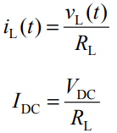

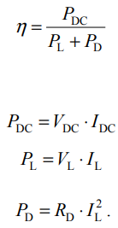

The rectification ratio (η), also known as rectification efficiency, is expressed by

In Eq. (10), PD represents the losses in the rectifier (RD is the equivalent resistance of the rectifier). By developing Eq. (7), using Eqs. (5) and (26), we get:

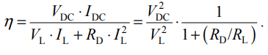

We have assumed ideal switches, with no losses, that is RD = 0. Therefore

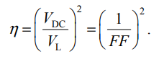

The Ripple Factor (RF) is another important parameter used to describe the quality of the rectification. It represents the smoothness of the voltage waveform at the output of the rectifier (we have to keep in mind that our goal is to obtain a voltage and a current in the load as steady as possible). The RF is defined as the ratio of the effective AC component of the load voltage versus the DC voltage:

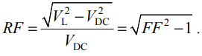

A transformer is most often used both to introduce a galvanic isolation between the rectifier input and the AC mains and to adjust the rectifier AC input voltage to a level suitable for the required application. One of the parameters used to define the characteristics of the transformer is the Transformer Utilization Factor (TUF):

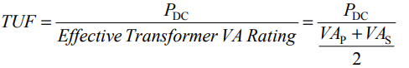

where VAP and VAS are the power ratings at the primary and secondary of the transformer. It should be noted that some authors (e.g., Ref. [7]) use only the term VAS as ‘Effective Transformer VA Rating’. Here, a more complete definition, the average of primary and secondary VA ratings, has been chosen (e.g., Ref. [8] or Ref. [9]). This is why different TUF values are found in the literature for those topologies—the ‘single-way’ ones—with different power ratings at primary and secondary. In order to compare the different topologies, it is useful to also take into consideration some parameters related to the switches—diodes or thyristors—like, for example, the Peak Inverse Voltage (PIV) during the blocking state of the device or the maximum current in the load. In practice, one has to choose devices with a peak repetitive reverse voltage (VRRM as reported on the data sheets) and a peak repetitive forward current (IFRM) higher than the PIV and maximum load current.

# Basic rectifier structures

## Introduction

As previously mentioned, from the particle physics point of view, the ideal power converter is the one that supplies the best direct current to the load (e.g., magnet or klystron): very low ripple, very high stability, etc. As we shall see later, this goal is achieved by using three-phase systems (on the primary winding of the transformer; at the input of the rectifier more phases can be present) and full-wave rectifiers (the stability issue is more related to the control of the converter than to its structure). Nevertheless, single-phase rectifiers are still in use both as low-power stand-alone converters (up to some kilowatts) and as output stage in Switched Mode Power Supplies (SMPS). In this section, we shall see the main topologies for single-phase and multi-phase rectifiers. The half-wave ones are reported just for comparison. We assume that all voltages at the input of the rectifiers have sinusoidal waveforms with period Tmains = 20 ms (corresponding to fmains = 50 Hz). With the usual definition

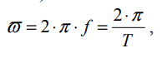

the generic AC voltage has the following expression:

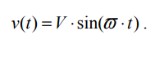

In this section we assume pure resistive loads and ideal switches as defined in the previous section. In Section 5 we shall see how things change in the real world.

## Single-phase systems

### Half-wave rectifier

This is the simplest structure (Fig. 2). Only one diode is placed at the secondary of the transformer.

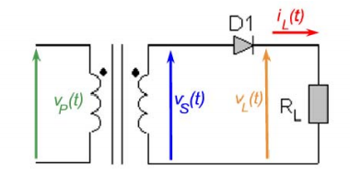

Fig. 2: Structure of the single-phase, single-way, half-wave rectifier

Figure 3 shows the waveforms of the voltage at the secondary and of the current in the load. Since the load is a resistance, the voltage on the load is proportional to the current.

#### RECTIFIERS

It is quite evident why this type of rectifier is called half-wave: the rectification process occurs only during half-periods. It is also called single-way because the load current iL(t) always circulates in the secondary winding in the same direction.

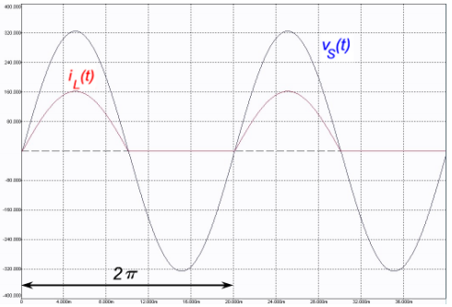

Fig. 3: Waveforms of the single-phase, single-way, half-wave rectifier

Using the definitions reported in the previous section, we get the following results:

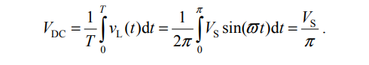

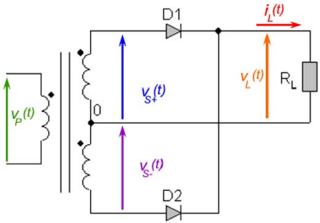And, similarly, we can calculate the other parameters:

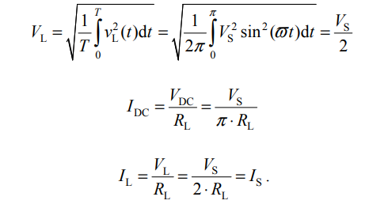

The current in the secondary of the transformer can flow only when the diode conducts and therefore it is equal to the current in the load:

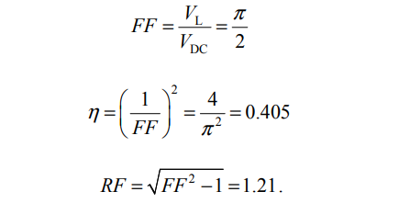

The poor performance of this rectifier is also confirmed by the utilization of the transformer. From Eq. (14), we get TUF = 0.323 (or TUF = 0.286 according to some authors). A direct current flows in the secondary of the transformer. This may result in saturation of the core, which has to be sized accordingly. From Fig. 3 it is clear that the inverse voltage seen by the diode in its blocking state is the negative half-wave of vS(t). Similarly, the current that flows across the diode is the same as flows in the load. For this topology, one has to choose diodes with

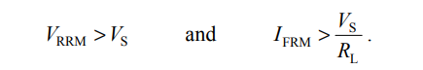

### Full-wave rectifier — centre-tapped

In order to use both halves of the secondary AC voltage waveform, one can use two diodes and create a return path for the current by adding a tap at the centre of the secondary winding (Fig. 4). This is the so-called centre-tapped rectifier.

Diode D1 conducts during the positive half-wave of the voltage. Diode D2 conducts in the negative half. The current always flows from the common point of the diodes, through the load and back to the central tap of the transformer. As shown in

Fig. 4: Structure of the single-phase, single-way, full-wave rectifier

Fig. 5, the rectification occurs during the whole period of the voltage. This is a full-wave rectifier. It has to be noted that in this case as well the current flows in the same direction through the two halves of the secondary winding. Therefore this is also a single-way structure.

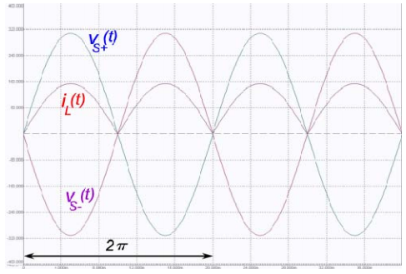

Fig. 5: Waveforms of the single-phase, single-way, full-wave rectifier

#### RECTIFIERS

Using the definitions reported in the previous section and the symmetries, we get the following results:

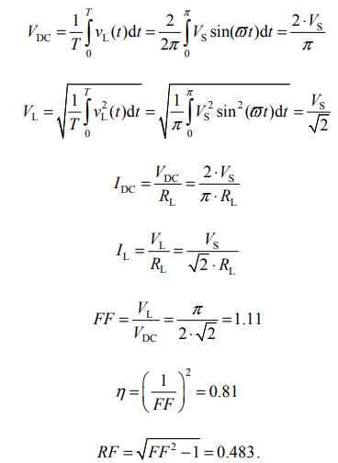

As it is a single-way topology, there is a direct current in both the secondary windings; this results in a low TUF (compared to the bridge solutions, see next section). TUF = 0.671 (or 0.572 TUF = according to some authors). (33) Even though this solution is much better than the previous one, there are some drawbacks. As can be seen from Fig. 4, when a diode is conducting, the other, which is in the blocking state, sees the inverse voltage of both windings of the secondary. The PIV of the diodes is higher. From the diode current point of view, this topology is equivalent to two half-waves acting alternately. For this topology, one has to choose diodes with

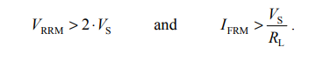

### Full-wave rectifier — bridge

The bridge structure is the best single-phase rectifier (Figs. 6 and 7). At the cost of two more diodes, several advantages are obtained. This is a full-wave rectifier, but compared with the centre-tapped solution it uses a simpler transformer, with a single secondary and no additional taps.

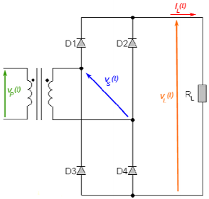

Fig. 6: Structure of the single-phase, double-way, full-wave bridge rectifier

The rectification takes place by the conduction of couples of diodes. Diodes D1 and D4 are conducting during the positive half-wave of the voltage. Diode D2 and D3 are conducting during the negative half. This is a double-way topology. In each half-cycle the current flows in both directions in the secondary winding but always in the same direction in the load. There is no DC component in the winding and the core can be smaller than that for a centre-tapped rectifier with the same DC power rating. Since this is a full-wave topology, Eqs. (28) to (32) are still valid but the transformer utilization factor is different. A sinusoidal current flows in both the primary and secondary windings, therefore VAP = VAS. From the definition (14), using (26) and (28) and considering that iS (t) = iL(t) we get

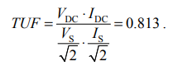

This is considerably higher than the TUF of the centre-tapped structure shown in (33).

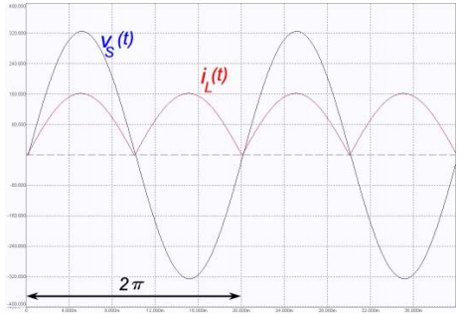

Fig. 7: Waveforms of the single-phase, double-way, full-wave bridge rectifier

Looking at the PIV of the diodes, VS is the highest voltage seen by each diode in its blocking state. Therefore the diodes must have

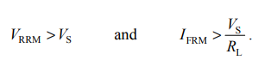

Summing up: at the cost of two more diodes with reduced voltage ratings, we have a full-wave rectifier, which, compared to the centre-tapped case of Section 3.2.2, for the same VDC and PDC requires a simpler and smaller transformer (23% oversized instead of 75%).

# References

[1] F. Bordry et al., Soft switching (ZVZCS) high-current, low-voltage modular power converter [13 kA, 16 V], Proc. EPE 2001, Graz.

[2] S.A. Griffiths et al., A power converter overview for the diamond storage ring magnets, Proc. EPAC 2002, Paris.

[3] A.W. Kelley and W.F. Yadusky, Rectifier design for minimum line-current harmonics and maximum power factor, IEEE Trans. Power Electron. 7 (1992) 332.

[4] A.W. Kelley and W.F. Yadusky, Phase-controlled rectifier line-current harmonics and power factor as a function of firing angle and output filter inductance, Proc. APEC’90.

[5] J.W. Kolar, Status of the techniques of three-phase PWM rectifier system with low effects on the mains, Tutorial Notes at EPE 99, Lausanne.