Hotel Booking System – Sprint 1

B- Development Methodology: Scrum

1. Sprint Overview
Sprint Duration: Feb 13 – Feb 28 (2 weeks)
Sprint Goal: Implement multi-level user authentication and enable the admin to add and view rooms.
Module Name: User Management and Room Management
Team Members: - Member 1: Ahmed Ijaz - Member 2: Shayan Asad - Member 3: Sardar Muneeb Ur Rehman

2. Sprint Backlog

Selected User Stories for Sprint 1

US-1: Multi-Level User Authentication
As a user, I want to log in with different access levels (admin, guest), So that each user can access only the features allowed for their role.
Sub-User Stories: - US-1.1: Login form validation (username/password) - US-1.2: Admin role access - US-1.3: Staff role access - US-1.4: Customer role access

US-2: Admin Adds Rooms
As an admin, I want to add rooms to the system, So that they are available for booking.
Sub-User Stories: - US-2.1: Enter room details (type, price, capacity) - US-2.2: Validate input fields - US-2.3: Save room data to database

US-3: Admin Views Rooms
As an admin, I want to view all rooms, So that I can monitor available rooms and their details.
Sub-User Stories: - US-3.1: Retrieve room list from database - US-3.2: Display room information in a table - US-3.3: Search/filter rooms by type or price

Tasks Breakdown
Member 1: - Implement multi-level authentication logic (US-1.2, US-1.3, US-1.4) - Create login UI and input validation (US-1.1) - Test authentication workflow
Member 2: - Implement RoomDAO for database operations (US-2.3, US-3.1) - Develop RoomService methods for add/view (US-2.2, US-3.2) - Unit test backend logic
Member 3: - Design room management UI (add/view rooms) (US-2.1, US-3.2) - Connect UI with backend service layer - Perform system testing for room management
Documentation Tasks (All Members): - Update project docs and sprint backlog - Maintain Scrum board and task tracking

3. Structured Specifications (4 Examples)

Specification 1: Multi-Level Authentication (US-1)
Preconditions: - User is registered - Database is connected
Main Flow: 1. User opens login form. 2. Enters username and password. 3. System validates credentials. 4. System checks user role and grants access.
Alternate Flow: - Invalid credentials → Show error message.
Postconditions: - User is logged in with correct access level.

Specification 2: Add Room (US-2)
Preconditions: - Admin is logged in - Database is connected
Main Flow: 1. Admin opens ‘Add Room’ form. 2. Enters room type, price, and capacity. 3. System validates input. 4. Room data is saved in the database.
Postconditions: - New room is available for booking.

Specification 3: View Rooms (US-3)
Preconditions: - Admin is logged in - Database contains room records
Main Flow: 1. Admin opens ‘View Rooms’ page. 2. System fetches room list. 3. System displays room details in a table. 4. Admin can search or filter rooms.
Postconditions: - Room list is displayed correctly with accurate details.

Specification 4: Input Validation for Add Room (US-2.2)
Preconditions: - Admin is on ‘Add Room’ form
Main Flow: 1. Admin enters room details. 2. System checks for empty fields. 3. System validates data types (price numeric, capacity integer). 4. Error messages shown for invalid input.
Postconditions: - Only valid room data is stored in database.

4. Scrum Board

Snapshot 1 (Beginning of Sprint)
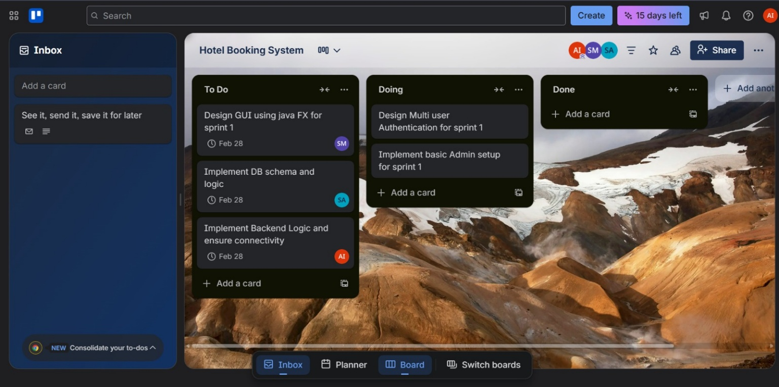

Snapshot 2 (Mid-Sprint)
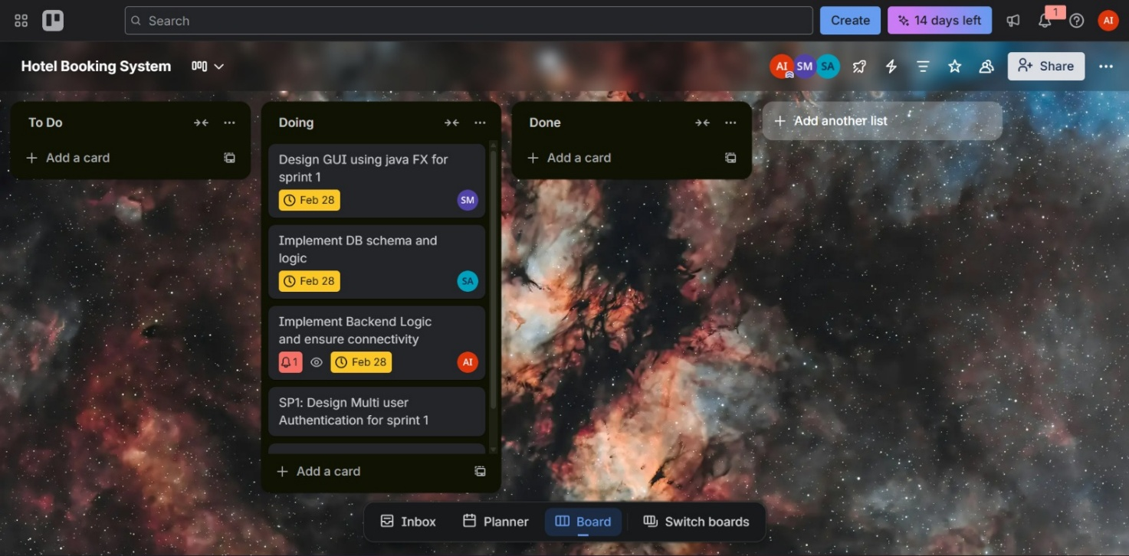

Snapshot 3 (End of Sprint)
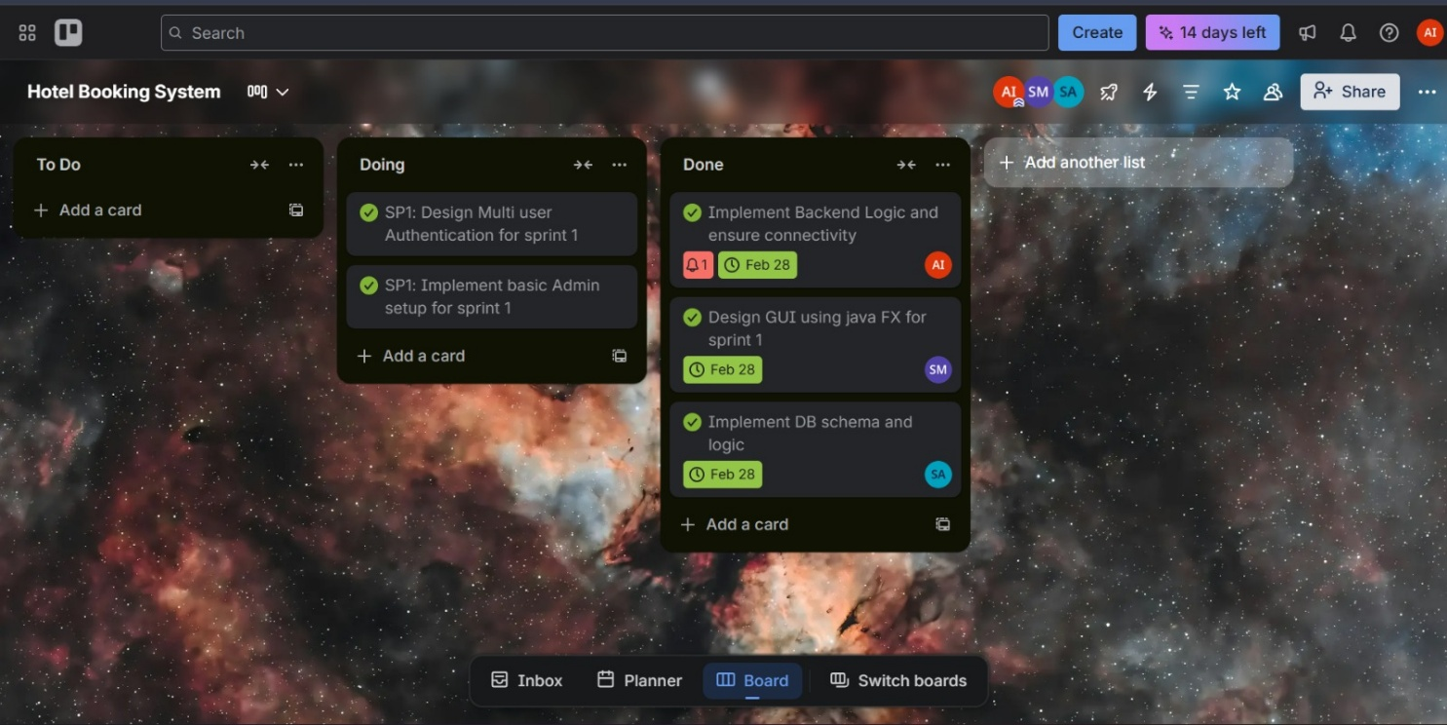

5. Burn-Down Chart for Sprint 1
