MLOps Assignment 1

Report
student-ml-api — Professional CI/CD Workflow with FastAPI, Docker, and GHCR
Student: Ahmed Ijaz
Roll no: 23i-0644
MLOPS-A
Repository: https://github.com/Ahmed-Ijaz-A/student-ml-api

Part 1–2: Application and Tests
The API was implemented in FastAPI with two endpoints:
- GET /health — returns application status and version metadata
- POST /predict — accepts {"value": <number>} and returns a doubled prediction
Four automated tests were written using FastAPI's TestClient, covering: successful health check, successful prediction, missing input (422), and invalid input type (422). All tests pass locally via pytest.

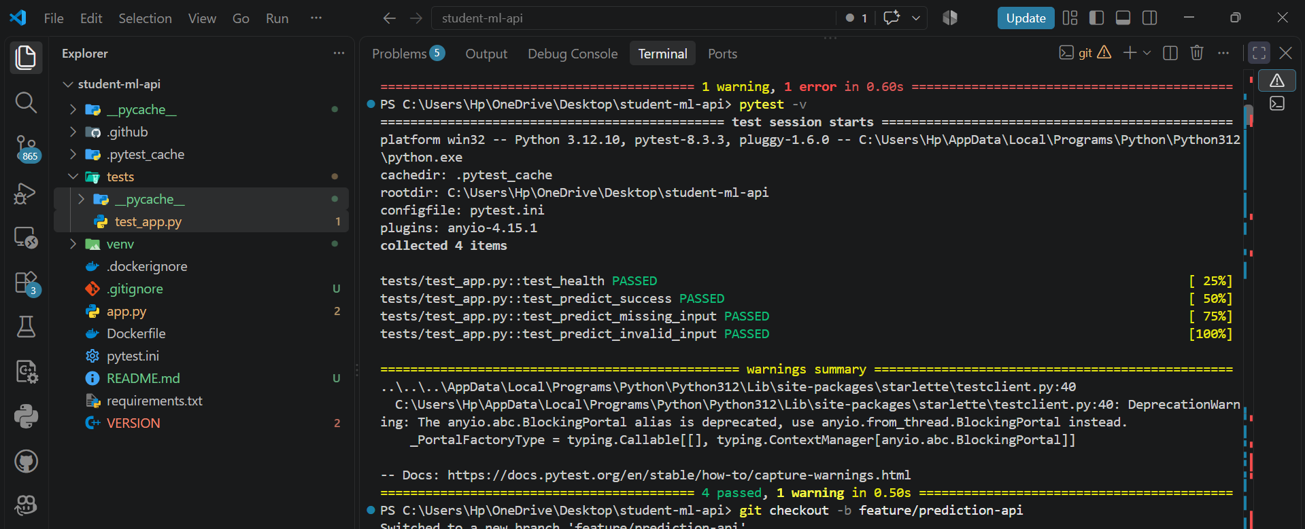

Part 3–4: Git Workflow and Pull Requests
Development followed a feature-branch workflow. No work was committed directly to main. Two professionally documented PRs were opened:
- PR #1 — feature/prediction-api → main (initial FastAPI implementation)
- PR #3/#4 — feature/model-metadata → main (v1.1.0 health endpoint update)
Each PR description included Summary, Changes, Testing Performed, Docker Impact, and a completion checklist, following the required template.
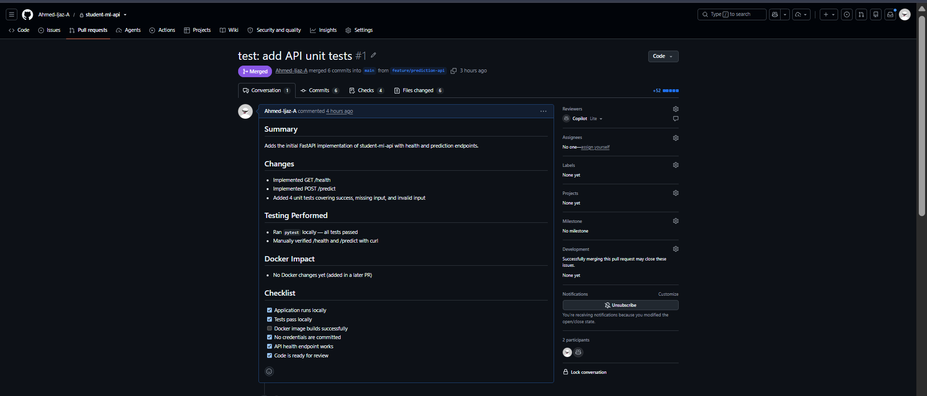
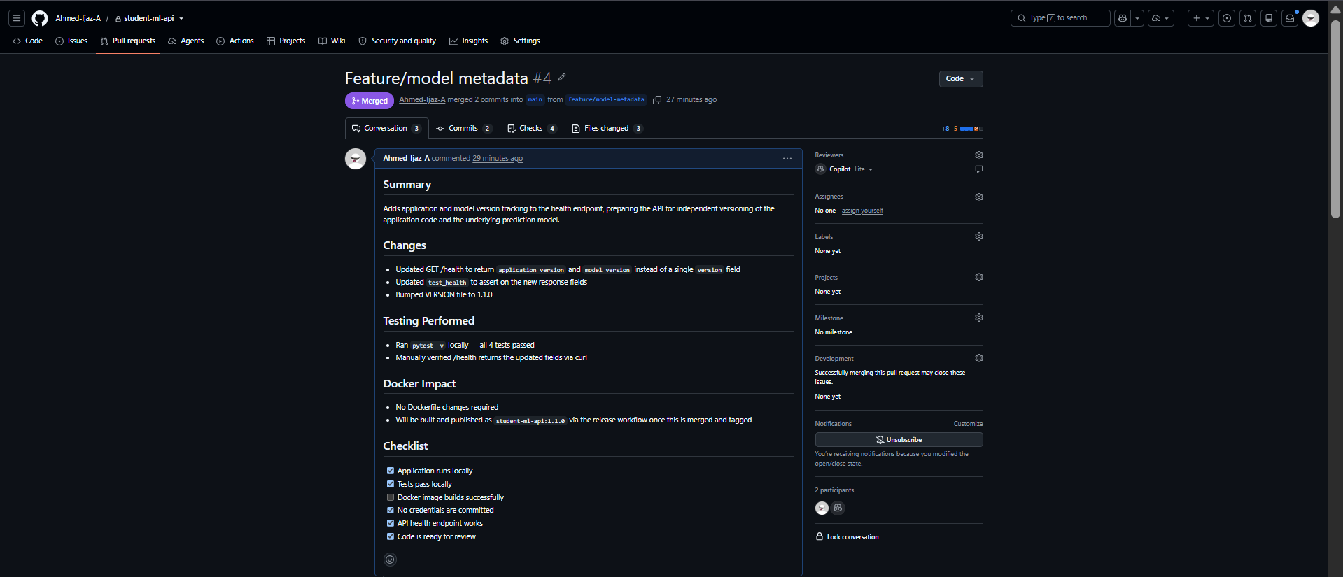

Part 5: GitHub Actions CI
A ci.yml workflow was created to run on every pull request targeting main. It contains two sequential jobs: test (checkout, Python setup, dependency install, pytest) and docker-build-check (Docker Buildx setup, docker build validation). The Docker image is validated but not pushed at this stage.
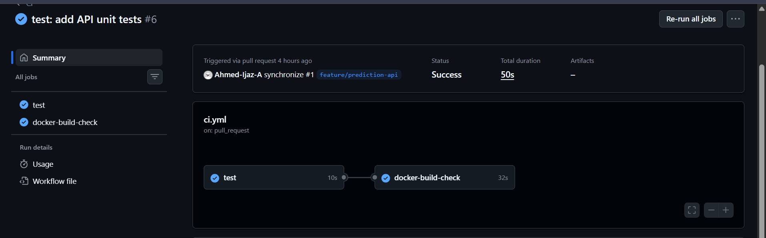

Part 6: Deliberate Failure Demonstration
A test assertion in test_health was deliberately changed to an incorrect expected value, committed, and pushed. This produced a failed CI run, which was captured as evidence. The assertion was then corrected and pushed again, restoring a passing CI run.
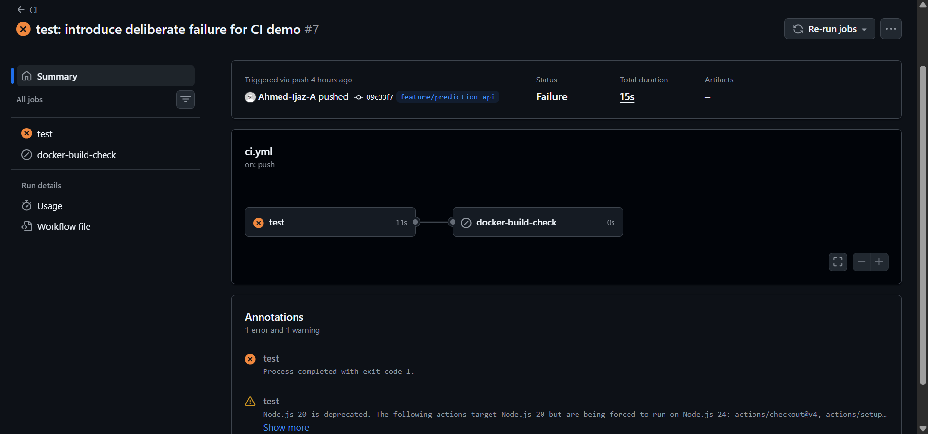
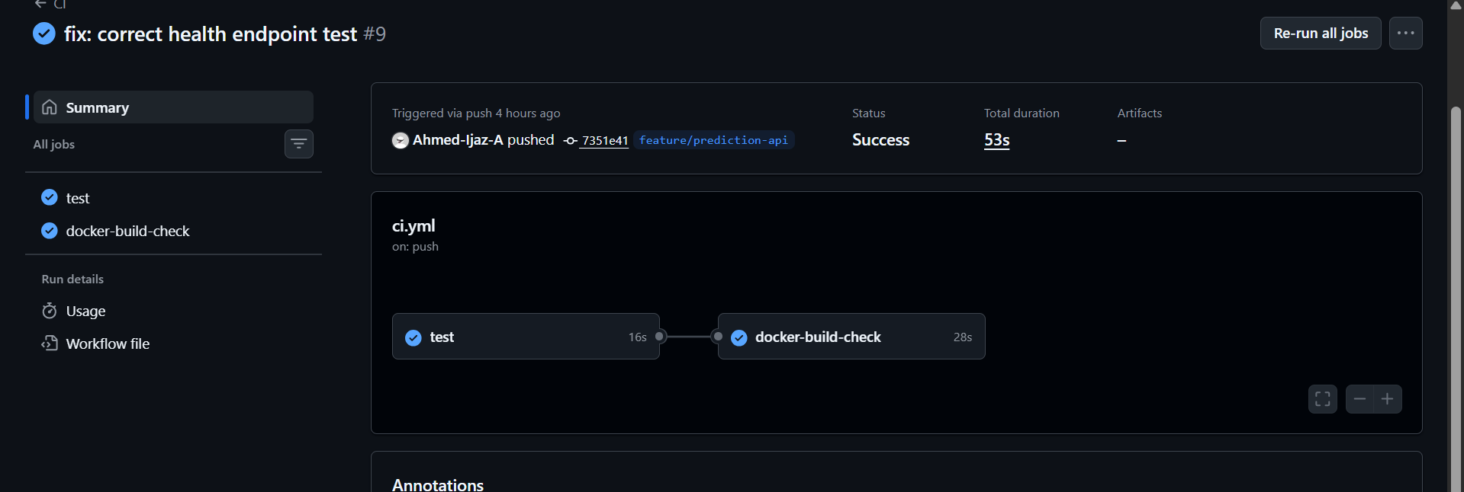

Part 7: Branch Protection
Branch protection was configured on main with the following rules:
- Require a pull request before merging
- Require status checks to pass before merging (CI test and docker-build-check jobs)
Note: the 'require approving review' rule was briefly enabled and then disabled, since this is a solo project and no second reviewer is available to approve PRs — a practical, documented tradeoff for a single-contributor repository.

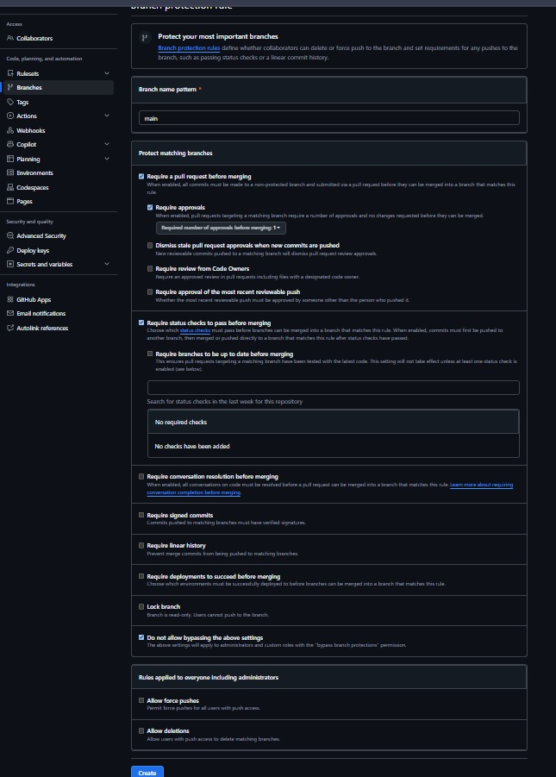

Part 8: Merge Strategy
Squash and Merge was selected for both PRs. Rationale: it keeps main's history clean with a single, descriptive commit per feature, avoiding clutter from in-progress or fixup commits made on the feature branch, while still preserving full traceability back to the originating PR.

Part 9–11: Dockerfile and Local Container Verification
A production-oriented Dockerfile was created using an explicit python:3.11-slim base image (not 'latest'), with WORKDIR /app, dependency installation via --no-cache-dir before application code is copied (for build-cache efficiency), an EXPOSE 5000 directive, and a uvicorn CMD. A .dockerignore excludes .git, .github, __pycache__, *.pyc, .venv, .env, tests, and README.md.
The image was built locally as student-ml-api:1.0.0 and run as a container. The following commands were used to verify and inspect it:
docker build -t student-ml-api:1.0.0 . docker run -d --name student-ml-api -p 5000:5000 student-ml-api:1.0.0 curl http://localhost:5000/health docker images docker ps docker logs student-ml-api docker inspect student-ml-api docker exec -it student-ml-api sh

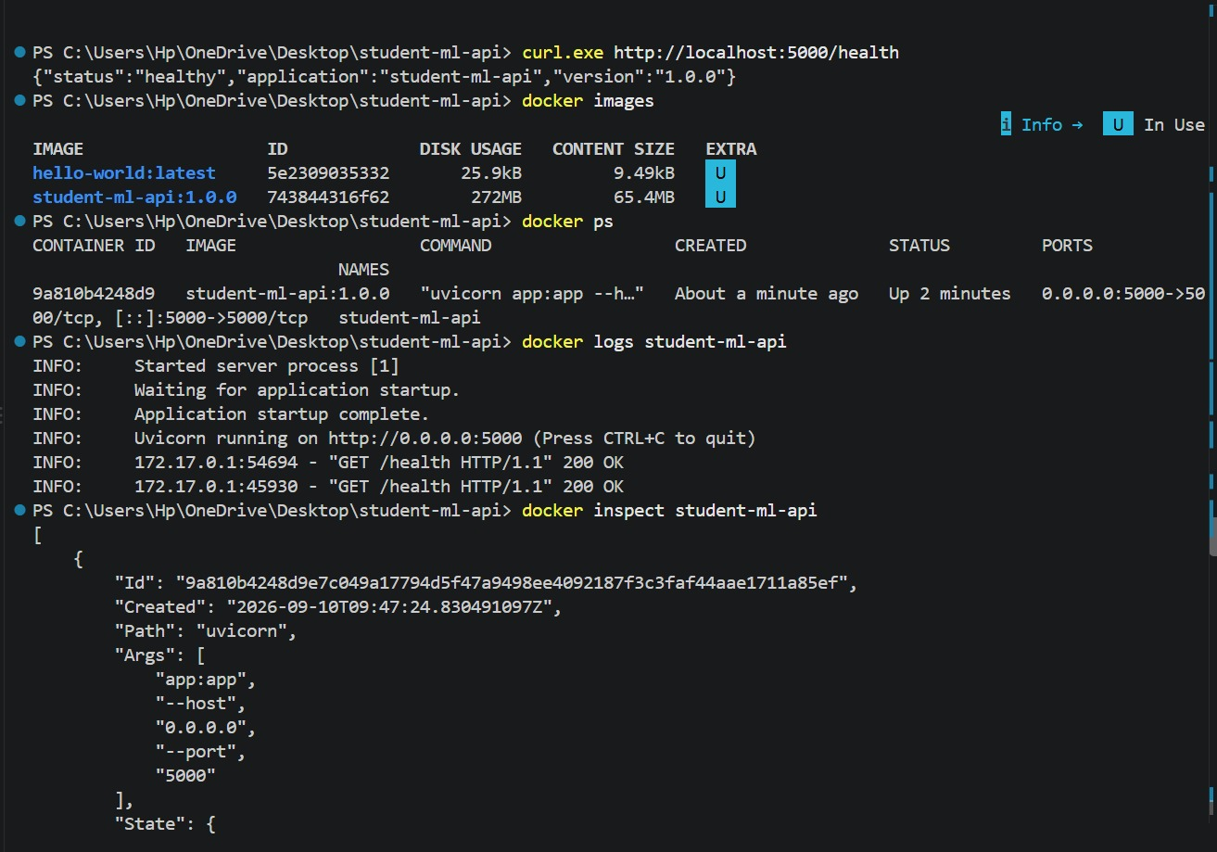

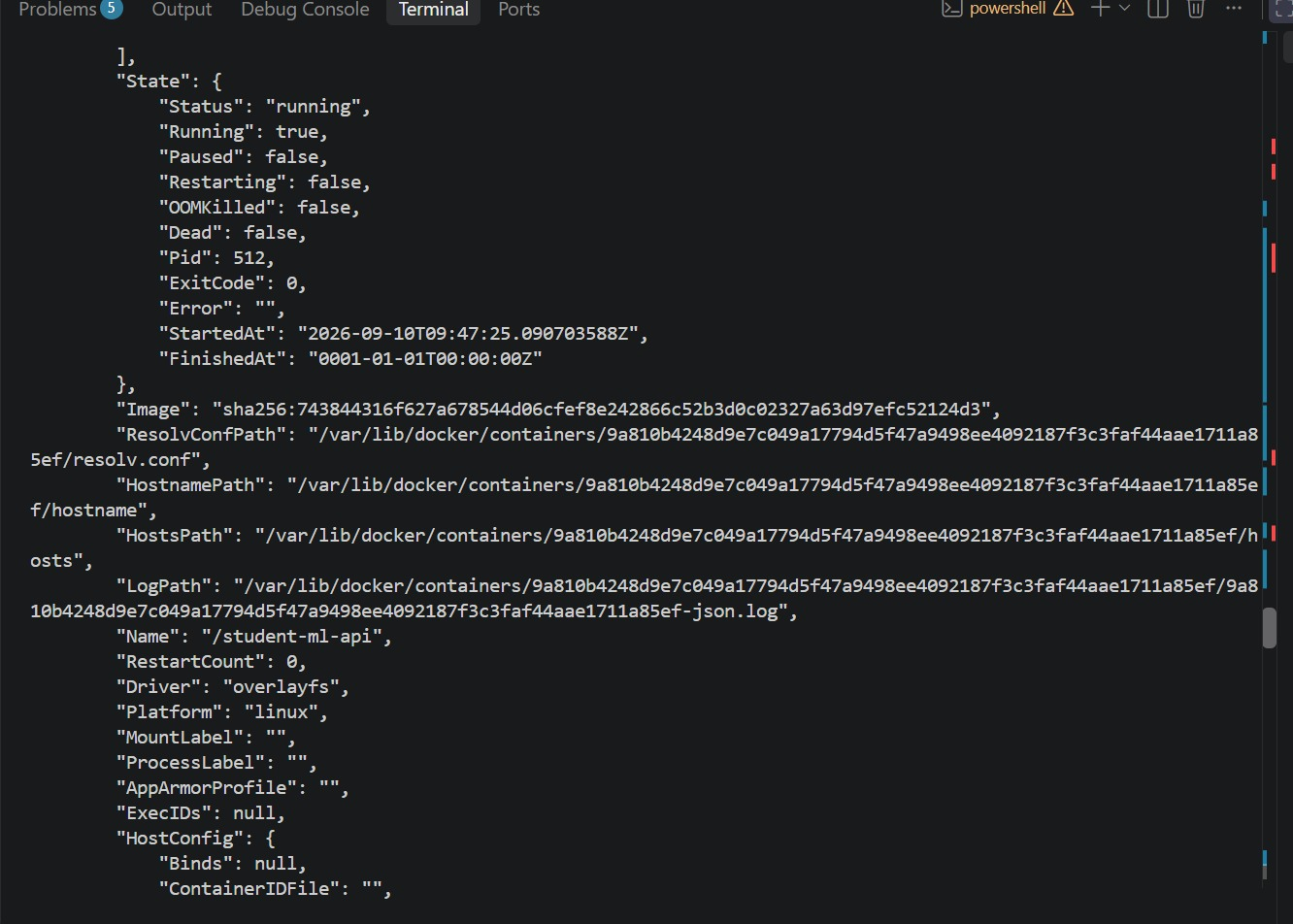

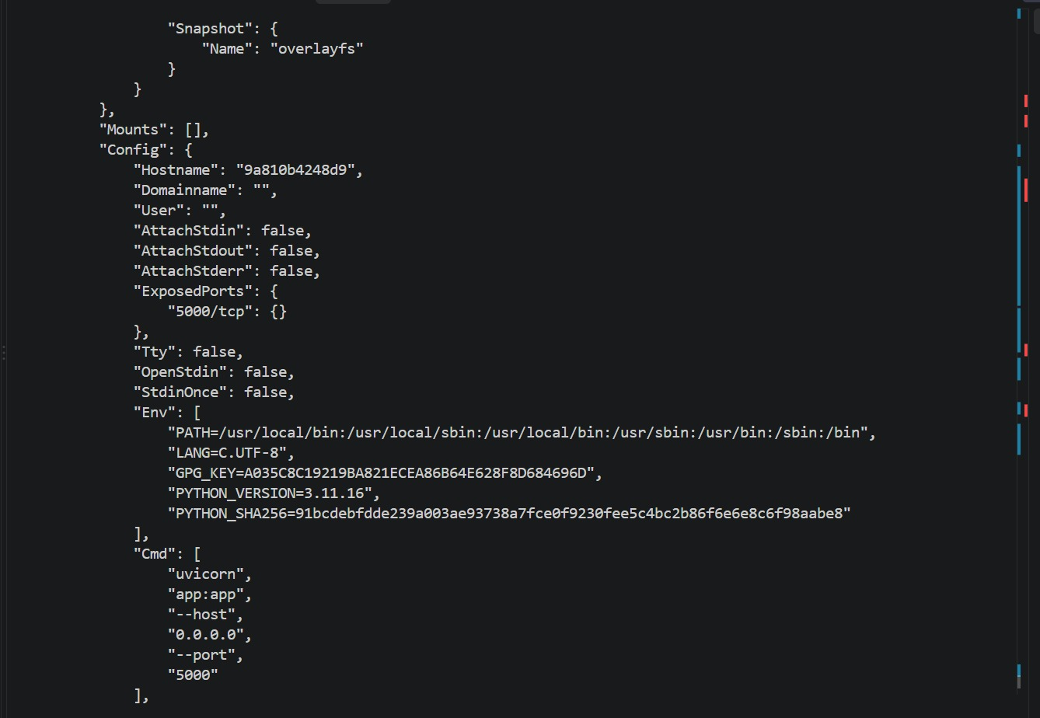

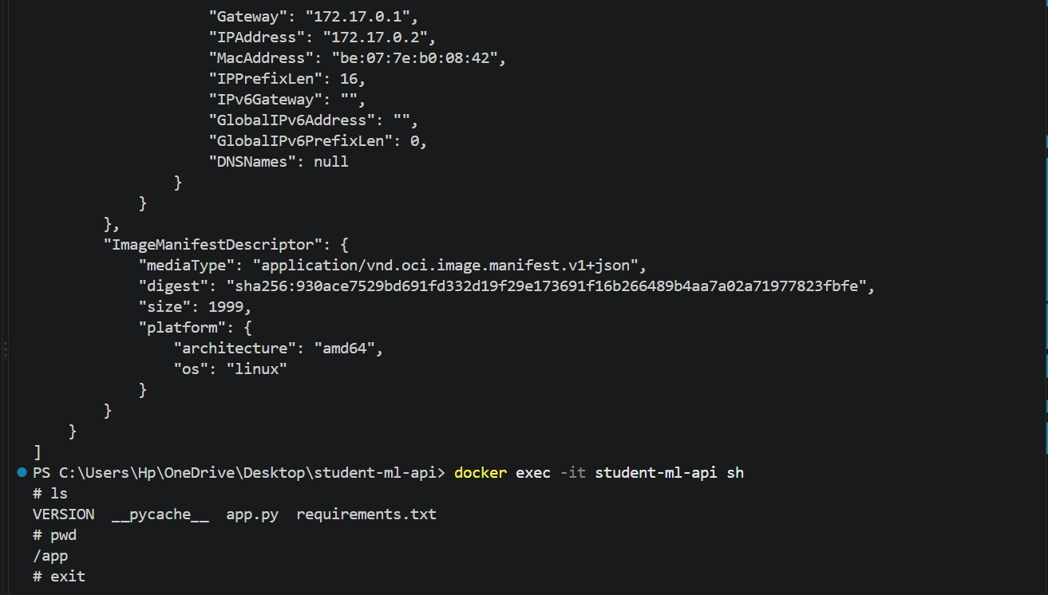

Part 12–17: Registry Publishing and Reproducibility
GitHub Container Registry (GHCR) was used. A release.yml workflow triggers only on semantic-version tag pushes (v*.*.*), derives the version number from the tag automatically (no hard-coded version string), authenticates to GHCR, and publishes three tags per release: the semantic version, latest, and the commit SHA.
After merging PR #1 and pushing tag v1.0.0, the release workflow ran successfully and published the image to GHCR.
Image Digest (v1.0.0):
sha256:e3781b7d5de5c3b63d2f2983d8caf1f45e86a49173ff8b6a4c52b711063bdd93
Reproducibility was verified by removing the local image entirely and pulling the same artifact back from the registry, then confirming it still serves a working /health endpoint without any rebuild:
docker rmi student-ml-api:1.0.0 docker pull ghcr.io/ahmed-ijaz-a/student-ml-api:1.0.0 docker run -d --name repro-test -p 5001:5000 ghcr.io/ahmed-ijaz-a/student-ml-api:1.0.0 curl http://localhost:5001/health

Part 18–19: Version 1.1.0
A second feature branch (feature/model-metadata) updated GET /health to return application_version and model_version fields separately, reflecting that application code and model versioning can evolve independently. Tests were updated accordingly. The full PR process was repeated — no direct pushes to main. After merge, tag v1.1.0 was pushed, triggering the release workflow and publishing 1.1.0, with latest updated to point to it while 1.0.0 remained available.
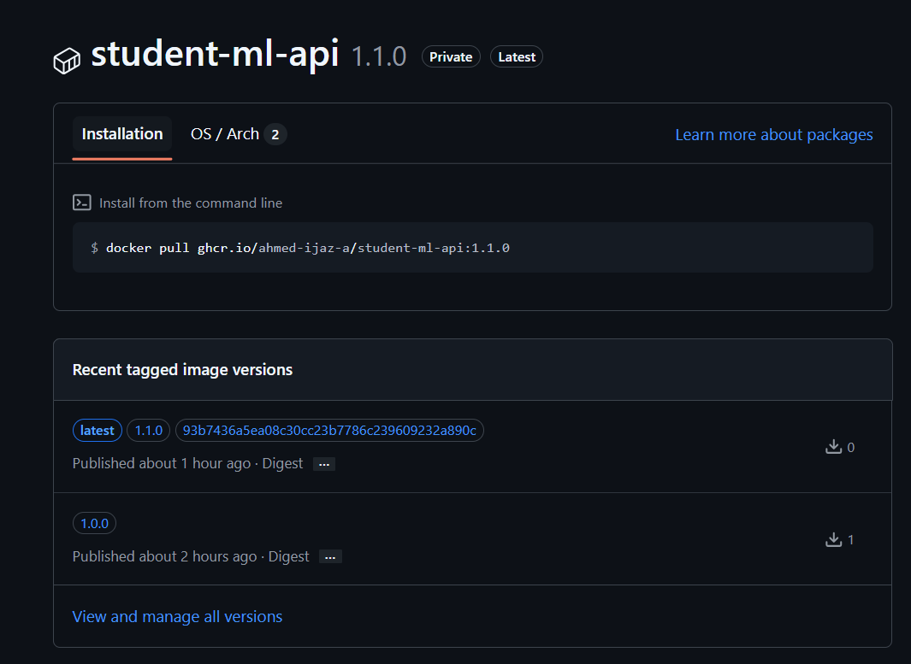

Part 20: Rollback Exercise
Without modifying source code or rebuilding, version 1.0.0 was restored directly from the registry by simply running that already-published, immutable image:
docker run -d --name rollback-test -p 5002:5000 ghcr.io/ahmed-ijaz-a/student-ml-api:1.0.0 curl http://localhost:5002/health
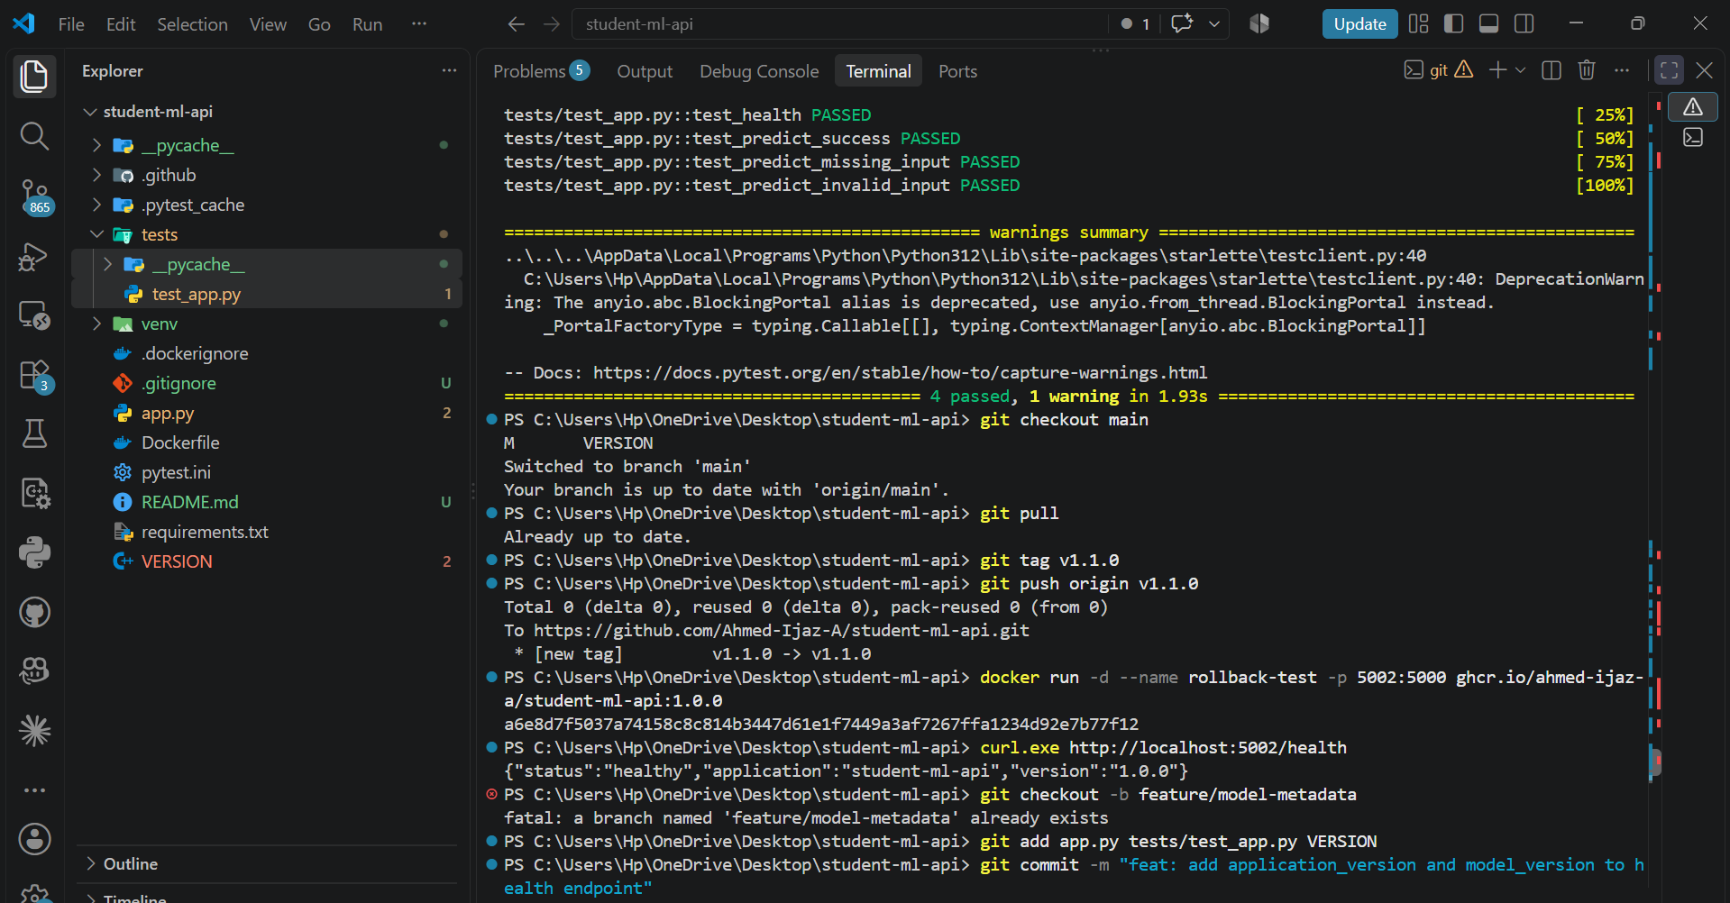
This registry-based rollback is faster and more reliable than a source-based rollback (git clone, pip install, python app.py) because it reuses a pre-built, already-tested, immutable artifact — there is no build step, no dependency resolution, and no risk of environment drift (e.g. a package version no longer resolving the same way it did at build time). A source-based rollback re-executes the entire build process on the fly, which can fail for reasons unrelated to the actual application code.

Part 21: Traceability — Version 1.1.0
PR Number | #4
Merge Commit SHA | 06c0642
Git Tag | v1.1.0
Docker Image Tag | student-ml-api:1.1.0
Image Digest | sha256:5dd09f8e1e6fb6f448b3d0520816ef6d76beca216acaa0e81698499c7f835171

Part 22: CI vs. Release Workflow Separation
The two workflows are kept strictly separate. ci.yml runs on every pull request to main and only tests and validates a Docker build — it never publishes an artifact. release.yml runs only on semantic-version tag pushes and is the sole path that authenticates to and publishes to the registry.
Publishing Docker images directly from every pull request is undesirable because a PR represents unreviewed, unmerged, in-progress work — publishing from it would let unapproved code produce real, pullable artifacts, pollute the registry with noise from abandoned or iterated-on branches, and break the guarantee that every published image traces back to a reviewed, merged commit on main. It would also make 'latest' meaningless, since it could shift on every open PR rather than reflecting an actual release.

Part 23: Image Metadata (OCI Labels)
The release workflow attaches OCI labels to each built image, including org.opencontainers.image.version, org.opencontainers.image.revision (the git commit SHA), and org.opencontainers.image.source (the repository URL). This makes every published image traceable back to the exact commit and repository that produced it, verifiable via docker inspect.
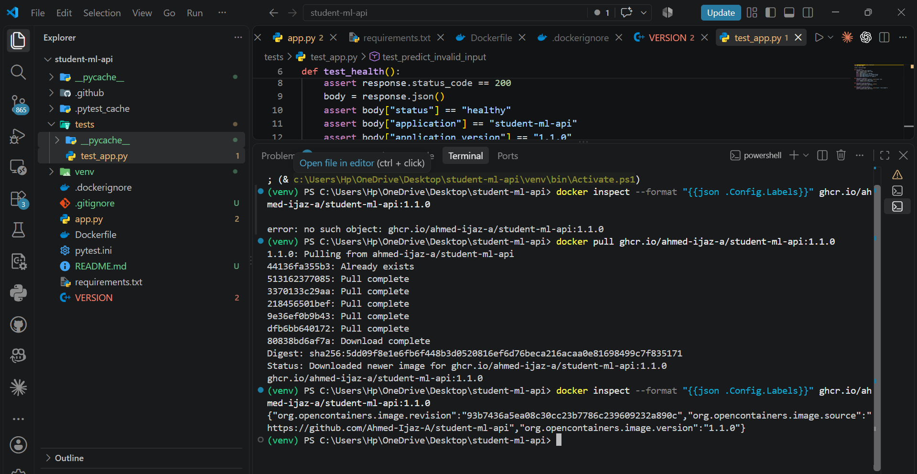

Part 24: Commit-SHA Image Tag
In addition to the semantic version and latest tags, the release workflow publishes a third tag using the full git commit SHA (e.g. student-ml-api:<sha>). Unlike latest or even a semantic version tag (which could technically be re-pushed), a commit-SHA tag is unambiguous and immutable — it always points to the exact source snapshot that produced it, which is invaluable when debugging a production incident and needing to know precisely which code is running.

Part 25: Docker Build Cache Analysis
The Dockerfile deliberately orders steps as: COPY requirements.txt → RUN pip install → COPY app.py, rather than COPY . . → RUN pip install. Modifying only app.py and rebuilding shows the dependency-install layer as CACHED, since requirements.txt was unchanged; the rebuild completes quickly. Modifying requirements.txt and rebuilding shows the install layer re-executing, as expected.
This ordering is preferable to COPY . . because with COPY . ., any file change — including a single-line code edit — invalidates Docker's layer cache from that point onward, forcing a full pip install on every single build. Separating dependency files from application code means the (usually slow) dependency-install layer is only re-run when dependencies actually change, making everyday CI and local builds significantly faster.

Part 26: Failure Analysis

Failure 1: Failed pytest
Symptom: CI run showed a red X on the test job.
Root Cause: a test assertion was deliberately changed to expect an incorrect value ('wrong' instead of 'healthy').
Evidence: see Part 6 screenshots above.
Correction: the assertion was reverted to the correct expected value and pushed, restoring a passing run.

Failure 2: Wrong container port
Symptom: curl to http://localhost:5000/health returned a connection error while the container was running.
Root Cause: the container was started with a host port mapping that did not match the port used in the curl command (e.g. -p 6000:5000, while curl targeted 5000).
Correction: the -p flag was corrected so the host port matched the port being tested, after which the health check succeeded.

