FINAL YEAR PROJECT PROPOSAL
Investify
A leakage-resistant, personalised investment advisory system whose explanations can be checked by machine.
FIELD | VALUE
Short title | F26-003-QuantamentalAI
Supervisor | Mr. Irfan Ullah
Department | Software Engineering, FAST NUCES Islamabad
Team | Ahmed Javaid 22I-2530  Rafay Ul Haq 22I-2520  Soban Ahmad 22I-2460
Stream | A — research-derived
SDG | 4 — Quality Education

Contents

1. Introduction
Investify is an investment advisory system for individual retail investors. A user tells us about their finances and their comfort with risk, then asks about a company they are considering. The system returns a Buy, Hold or Sell view for the coming week, an honest confidence figure attached to it, and a plain-English explanation of what drove that view.
Two things separate this from a normal prediction app, and they are the parts we are actually building.
First, the system is built so that it cannot accidentally see the future. Financial prediction tools are extremely easy to build wrong in a way that makes them look brilliant — you let a piece of information from tomorrow reach today's calculation, and your accuracy jumps, and nothing in the output tells you anything went wrong. We build the machinery that makes the absence of that mistake a test we pass rather than a claim we make.
Second, every explanation the system produces is checked against the numbers that produced it. The language model that writes the explanation is not allowed to state a figure, a direction or a cause that the underlying model did not actually produce. A separate piece of code checks each claim, and an explanation that fails is never shown to the user.

2. Problem Statement

The surface problem
A retail investor deciding whether to buy a stock has to weigh price history, technical indicators and a large volume of news and social commentary at the same time. The tools available to them issue the same signal to everybody, regardless of whether the person asking has stable income and thirty years to recover, or is putting in money they may need next year.
The workflow being replaced is unaided human judgement. A non-expert reads news of unknown reliability, looks at chart indicators of unknown relevance, and forms a view with no stated confidence and no record of what it was based on. Because there is no record, the view cannot be checked afterwards. Because there is no confidence attached, a weak signal and a strong one look identical.

WHO IS AFFECTED
STAKEHOLDER | WHAT THEY NEED | HOW THAT SHAPES THE DESIGN
Individual retail investor  primary user | A defensible view with an honest confidence figure, and an explanation they can interrogate rather than take on trust. Fails them if it sounds certain and is wrong. | Drives calibrated probabilities rather than raw scores, and drives the verifier — an explanation the user cannot check is not a feature.
Whoever runs an instance  operator | Something installable, schedulable and auditable, with known behaviour when a data source goes down. | Drives the degraded-state requirement, the failure table and the handover package.
Any institution hosting it | No implied investment advice and no claim the evidence cannot support. | Drives the non-advice framing, the refusal to trade, and the pre-committed null-result path.
Supervisor  academic approver | Results that are honestly bounded and reproducible. | Drives pre-registration of the ablation and metrics, and change control on scope.

Only the first two actually operate the system. We note that rather than inflating the list — the honest position is that this is a single-user tool with a small number of genuinely distinct interests around it.

The harder problem underneath it
Tools of this kind are almost never evaluated honestly. Predicting short-term returns on heavily traded assets sits very close to pure noise, and a large share of the impressive results reported in this area come from temporal leakage — information that would not have been available at the moment of the decision quietly reaching the calculation.
A system that leaks does not simply perform worse. It produces confident, well-explained, completely worthless recommendations, and nothing in its own output reveals this. On top of that, when a language model is used to explain a recommendation, there is normally nothing stopping it from stating a number or a cause the underlying model never produced.
These two failures compound. A leaking system with a fluent explanation layer is the most convincing wrong answer it is possible to build.

3. Project Idea
Investify covers a deliberately small universe of assets so that the data behind every decision is dense enough to mean something: eight to twelve high-attention US equities (AAPL, TSLA, NVDA, AMZN, MSFT, META, AMD, PLTR and similar), chosen because both news and social commentary about them is plentiful.
A user registers and completes a short risk assessment. We measure two different things and reconcile them:
- Risk capacity — what their finances can actually absorb, from income stability, age, dependants, emergency-fund cover and investment horizon.
- Risk tolerance — how they feel about losses, measured with the Grable–Lytton Financial Risk Tolerance Scale, an instrument already validated in the literature.
These can conflict — someone wealthy but anxious, someone constrained but bold. We resolve the conflict by taking the more restrictive of the two, which is standard financial-planning practice, rather than averaging them, which would let a comfortable score hide a hard financial constraint.
When the user asks about a company, the system assembles three kinds of input: technical indicators computed from price history, sentiment scored separately from formal news and from informal social discussion, and the user's stored risk profile. A calibrated XGBoost model turns those into a Buy, Hold or Sell decision with a genuine probability attached. TreeSHAP then breaks that decision down into the contribution of each individual feature. A small local language model turns that breakdown into readable English, and a verifier checks every claim in what it wrote before the user ever sees it.
The system does not place trades, connect to a brokerage, or constitute financial advice. It is a research and educational prototype.

4. Contribution

WHAT WE DO NOT CLAIM
We claim no novelty in scoring financial sentiment, in using gradient boosting over sentiment and technical features, in generating text from SHAP attributions, or in QLoRA fine-tuning. All four are established prior work and we treat them as engineering inputs. We make no claim of profit of any kind.

WHAT WE DO CLAIM
- A leakage-audited point-in-time evaluation harness. News and social text arrives continuously; price bars arrive on a trading calendar with weekends, holidays and half-days. We align the two under strict as-of rules, fit all scaling inside the training window only, and prove the absence of look-ahead bias with automated tests, negative controls and a permanently installed deliberately-broken configuration that must keep being detected.
- A deterministic verifier for generated explanations. Because the explainer's input is entirely structured and numeric, whether an explanation is grounded is decidable by code rather than a matter of another model's opinion. We check every number, sign, ranking and feature name against the source record, and refuse to emit an explanation that fails.
- A cross-register divergence feature set with a pre-registered ablation. Formal news and informal social discussion are scored separately and their disagreement is encoded as a feature. Whether that disagreement carries any predictive value is declared as an experiment before we see the result, so a null finding is reportable rather than quietly dropped.
CONTRIBUTION STATEMENT
Published work reports directional prediction from financial sentiment features under gradient boosting with SHAP attribution, evaluated with leakage controls that are frequently weaker than stated. We reproduce that pipeline as engineering input. Our contribution is to place it inside a harness whose freedom from look-ahead bias is testable, and beneath an explanation layer whose faithfulness is decidable, evaluated with falsifiable negative controls and a pre-registered ablation.

WHAT WE WILL BUILD TO PROVE IT
Six objectives, each of which produces evidence rather than only a component:
- Point-in-time data engineering. Build an append-only store that aligns news, social text and market data across two incompatible calendars, and prove the absence of look-ahead bias through automated tests, negative controls at two label geometries, and a permanent deliberately-leaked configuration that must keep being caught.
- Dual-register sentiment. Score news-register and social-register text separately, encode their disagreement as a feature, and test whether that disagreement carries predictive value through an ablation declared before results are seen.
- A calibrated, risk-conditioned decision engine. Train a calibrated XGBoost model at the 1-week horizon, benchmark it against a transparent linear baseline under purged walk-forward cross-validation, and attribute every decision with TreeSHAP.
- Lightweight risk conditioning. Measure financial capacity and psychological tolerance, reconcile them by the binding constraint, and carry the result into the decision as features rather than rescaling afterwards.
- Verifiably grounded explanation. Build the deterministic verifier first, establish a prompted baseline against it, then QLoRA-distil a small local model and compare the three configurations on claim-level groundedness.
- A deployed, measured system. Ship a container on a cloud virtual machine that someone outside the team can install and operate from documented steps, with every non-functional bound measured rather than asserted.

SDG ALIGNMENT
SDG 4, Quality Education, in its financial-literacy aspect. The system's purpose is to make the reasoning behind an investment signal inspectable by someone who is not an expert: every recommendation is decomposed into what drove it and rendered in language whose correctness is machine-checked, so the user can learn why a signal exists and how much confidence it deserves rather than being handed a verdict. This alignment is context only — it is not the technical contribution and not part of the complex computing problem.

5. The Complex Computing Problem
Stated at requirement level, before naming any method, model or framework:
NOTE
Build a retail decision-support product that must produce and justify position recommendations from news, social and market observations arriving on different clocks and incompatible trading calendars; must guarantee that no information unavailable at decision time can influence a reported result; must express uncertainty honestly where the underlying signal sits at or near the noise floor; must keep every user-facing justification checkably consistent with the computation that produced it; and must reconcile a user's financial capacity with their stated risk tolerance where the two conflict — under conditions where an unfounded recommendation carries direct financial consequence for a non-expert, and where a silently leaked evaluation makes a worthless system appear skilful.

We claim seven of the nine Seoul Accord characteristics and state plainly where the other two are weak.
# | CHARACTERISTIC | EVIDENCE IN THIS PROJECT
1 | Conflicting requirements | Usefulness against honesty at the noise floor; personalisation against the privacy of the financial facts we collect; fluent explanation against verifiable grounding; risk capacity against stated tolerance.
2 | No obvious solution | There is no standard procedure for proving the absence of look-ahead bias across sources that run on different clocks and calendars.
3 | Depth of knowledge | Label geometry and overlap, purging and embargo, probability calibration, Shapley attribution for tree ensembles, and constrained decoding — each applied from principles rather than by recipe.
4 | Unfamiliar issues | Point-in-time correctness, storing both event and ingestion time, retroactive price revision and cross-calendar as-of joins are not encountered in routine application development.
5 | Beyond standard practice | No framework supplies a leakage audit or a claim-level groundedness verifier. Both are designed and built by the team and neither can be obtained off the shelf.
7 | Significant consequences | A confidently wrong recommendation, or an explanation asserting a cause the model did not use, has direct financial and trust consequences for a non-expert user.
9 | Ill-defined requirements | Whether exploitable signal exists at this horizon is genuinely unknown at the outset. This is why the negative controls, the pre-registered ablation and the pre-committed null-result path exist.

Stated honestly as weak. Characteristic 6, diverse stakeholders, is real but modest — several parties have different success criteria but only two operate the system. Characteristic 8, interdependence, is present through the coupling between store, feature matrix and evaluation harness, but the sub-problems are more sequential than mutually interacting. Neither is claimed strongly.

WHY ROUTINE DEVELOPMENT IS NOT ENOUGH
A competent student with good tooling could assemble a sentiment-to-classifier-to-attribution-to-interface pipeline in a few days. What that version would get wrong is precise: it would leak, silently, in a direction that makes it look better rather than worse, and it would produce fluent explanations nobody could check. The remaining difficulty lives in temporal correctness, verification and evaluation design, and that is where this project puts its work.

6. Existing Solutions and Their Drawbacks
SOLUTION | APPROACH | EVIDENCE-BASED LIMITATION | WHAT IT MEANS FOR US
PortfolioPilot | AI portfolio analysis, risk assessment, optimisation | Focused on portfolio construction; temporal leakage is not an explicitly evaluated component | Confirms demand; does not address our evaluation question
Danelfin | AI stock scores from technical, fundamental and sentiment signals | Proprietary methodology; the pipeline cannot be reproduced or inspected; individual risk tolerance is not central | Drives our commitment to per-prediction SHAP attribution and an inspectable pipeline
Magnifi | AI investment discovery and conversational assistance | Discovery and portfolio assistance rather than leakage-controlled historical prediction | Conversation alone is not the gap
Professional terminals  (Bloomberg, Refinitiv) | Licensed feeds with vendor sentiment scoring | Published pricing places them far outside retail reach; sentiment scoring is proprietary and not inspectable; no personal risk conditioning | The workflow has value but does not serve our user or answer our question
Retail sentiment and charting apps  (StockTwits, TradingView) | Display aggregate social sentiment or indicator signals | Present raw signals rather than a calibrated decision; no stated look-ahead controls; no attribution tying a signal to its drivers | The gap is not displaying signals. It is calibration, temporal correctness and verified explanation.
Published FinBERT + XGBoost + SHAP pipelines | Per-ticker news sentiment aggregated to a date, fed to a tree model with TreeSHAP attribution | Alignment is by calendar date, so publication order relative to the price bar is not enforced; results reported in a notebook setting; explanations are not machine-checked | Our closest prior work. Our delta is enforcing what these papers assume, and measuring what happens when it is not enforced.
Current manual workflow | Human judgement over news and charts | Unmeasured, not reproducible, no confidence attached, no record of the evidence used | This is the comparator for user acceptance

TO COMPLETE BEFORE DEFENCE
Closest prior departmental FYP. Structural overlap must be checked against the departmental archive and this row filled in — not inferred from title similarity. If the archive contains no structurally overlapping project, state that explicitly with the date the check was performed.

7. Committed Scope

COMMITTED CORE MUST SHIP
ELEMENT | COMMITMENT
Asset universe | 8–12 high-attention US equities, selected for density of both news and social coverage. This is the only surface on which learned-engine claims are made.
Cryptocurrency | 4–5 assets (BTC, ETH, SOL, DOGE, ADA), price data only, used solely as a harness generalisation test. Crypto trades continuously while equities do not, which subjects our as-of machinery to a second, incompatible time regime. Its role is to prove our calendar layer is a genuine abstraction rather than NYSE assumptions in disguise. No social corpus is collected and no learned-engine claim is made for crypto.
Horizons | 1 week is the only horizon shown to the user. 1-day and 1-month are evaluated alongside it as a horizon sweep, reported with confidence intervals. 1-day additionally serves as a standing negative control.
Risk profiling | Capacity from financial facts, tolerance from the Grable–Lytton instrument, reconciled by the binding constraint into a three-tier profile with a fixed loss-aversion coefficient (λ = 2.25).
Sentiment | FinBERT on news-register headlines; an empirically selected model on social-register text. Divergence between the two encoded as a feature and tested by pre-registered ablation.
Decision engine | Calibrated XGBoost benchmarked against a transparent linear baseline, under purged walk-forward cross-validation, with TreeSHAP attribution on every decision.
Explanation | Deterministic verifier, constrained-decoding explainer, deterministic template fallback, and a QLoRA-distilled local model compared against a prompted baseline and the teacher.
Leakage harness | Point-in-time store, two-calendar as-of joins, fold-local scaling, negative controls at two label geometries, permanent leak canary, and a live-versus-backtest parity test.
System | FastAPI service and Streamlit interface, containerised and deployed to a cloud virtual machine, installable by someone outside the team.

FUTURE EXTENSIONS ONLY ONCE THE CORE IS SECURE
- Speculative-spike caution flag — price and volume anomaly corroborated by a surge in mention volume, always a caution and never a verdict. Time-boxed to three working days.
- Expansion beyond the initial universe toward a broader slice of the S&P 500.
- Portfolio-level recommendations rather than single-company analysis.
- Additional financial and macroeconomic indicators.

EXPLICITLY OUT OF SCOPE
- Live trading, order execution or brokerage integration. The system is advisory and educational only.
- Six-month and longer horizons.
- Prospect-theory lottery elicitation of an individual loss-aversion coefficient.
- Crypto social-text corpora and any crypto-specific learned-engine claim.
- Contextual and revealed-preference Bayesian adaptation of the risk profile.
- Fractional Kelly position sizing. Position size is a deterministic volatility-scaled mapping.
- On-chain contract analysis and any fraud or rug-pull verdict.
- Combinatorial purged cross-validation, SHAP interaction values, and multi-model ensembles.
- A long, statistically powered forward paper trade. The forward window is a short illustration reported separately.

8. System Flow
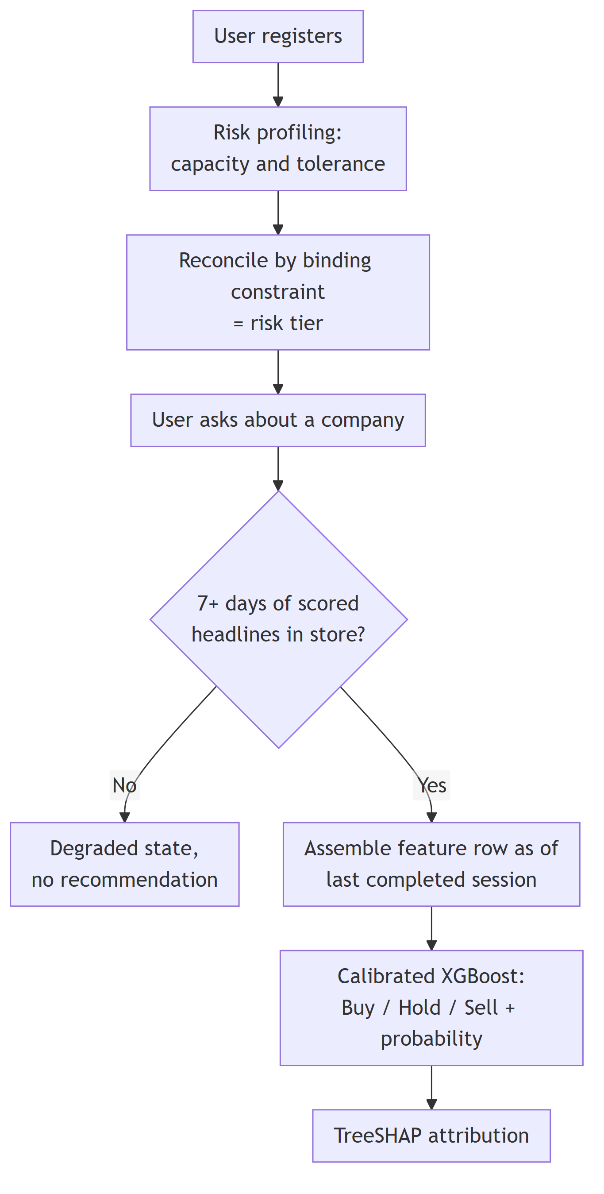
Figure 1. Onboarding and decision. The system declines to answer rather than recommending from thin data.
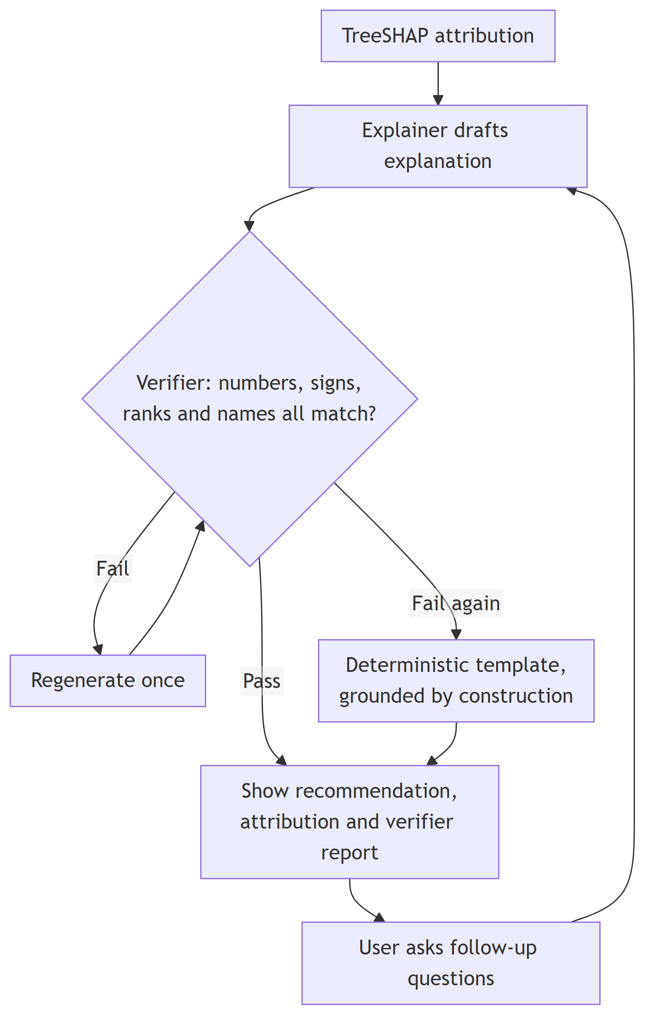
Figure 2. Explanation and verification. A failed explanation is regenerated once, then replaced by a grounded template. Nothing unverified reaches the user, and follow-up questions re-enter the same verified path.

9. High-Level Architecture
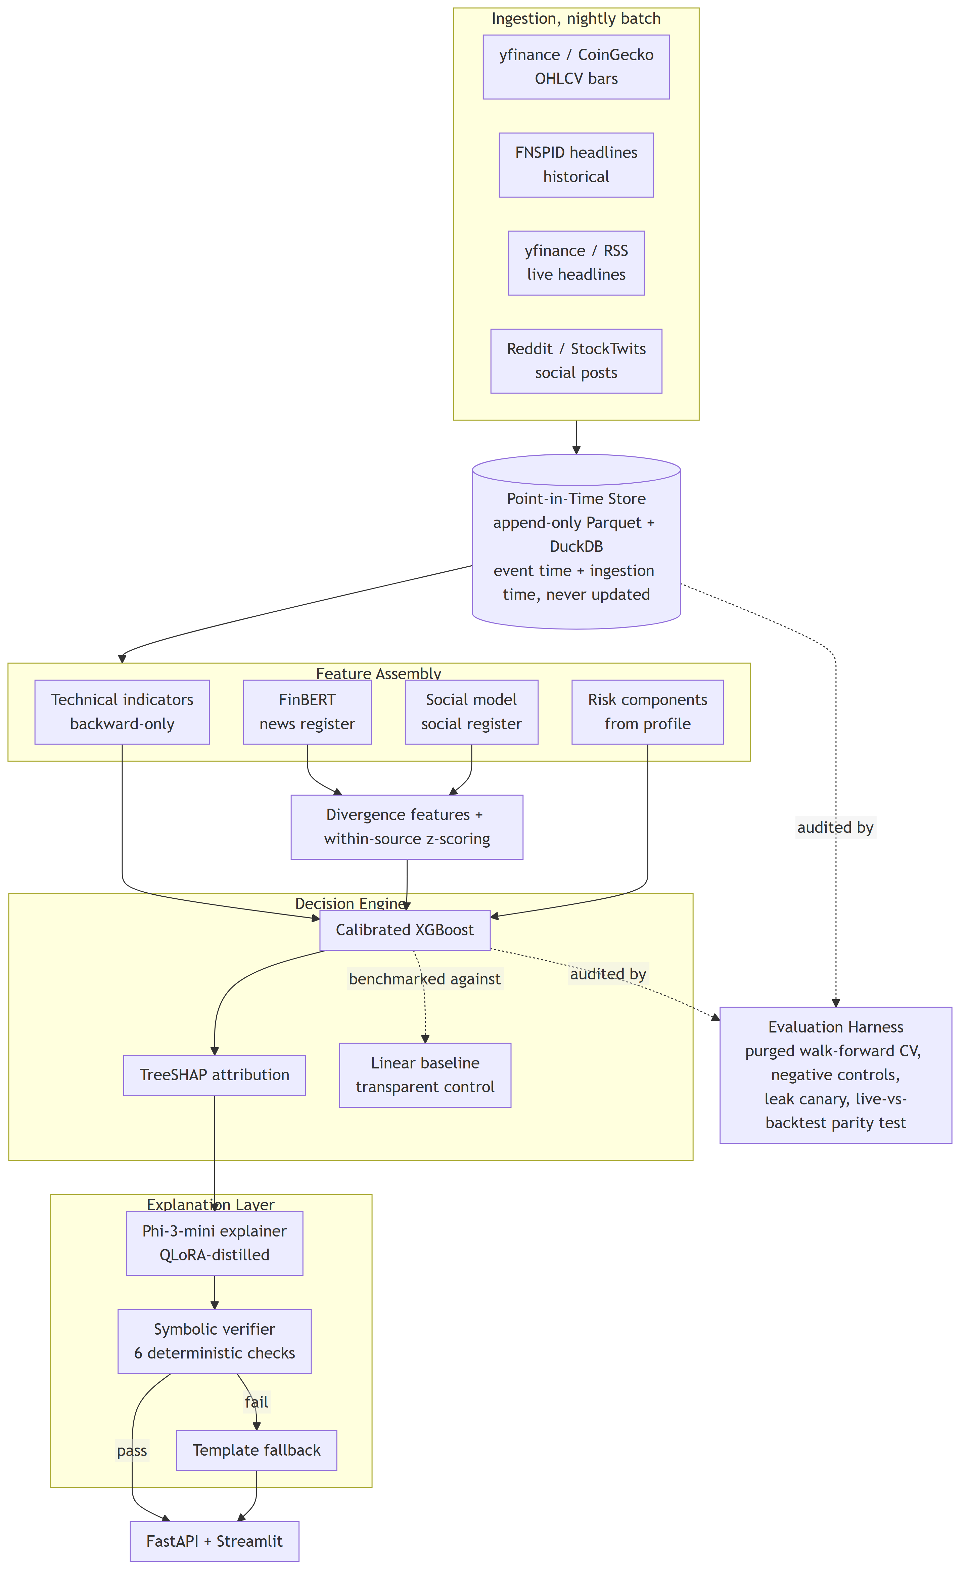
Figure 3. Component architecture. Sentiment perceives, the engine decides, TreeSHAP attributes numerically, the verifier adjudicates what may be said, and the language model communicates. The evaluation harness audits the store and the engine.
THE ONE SENTENCE THAT EXPLAINS THE DESIGN
The language model is the system's mouth, not its brain. It never decides anything. It receives a completed decision with its numeric breakdown and renders it in English, and a deterministic checker decides what it is allowed to say.

10. Technical Design

10.1 Sentiment models
Two models are matched to two text registers — by the kind of writing, not by the kind of asset. Both run off the shelf; neither is fine-tuned.
FinBERT (ProsusAI/finbert) scores news-register text. It is a BERT-base transformer further trained on financial text for three-class sentiment. Input is a single headline; output is a probability across positive, neutral and negative.
A social-register model scores short informal posts. CryptoBERT was trained on exactly this kind of writing but carries crypto-domain vocabulary; a general social sentiment model is the alternative. We select empirically, not by assumption: a time-boxed study scores both against roughly 200 hand-labelled equity social posts, and the winner is documented with its measured agreement. If neither clears a usable threshold, we fall back to news-only sentiment, drop the divergence features and report the ablation as not applicable. That is a declared branch, not an improvisation.
Per-article scores are aggregated per company per day into mean polarity, 3-day momentum, 7-day momentum, mention volume and dispersion — computed identically for both registers, so the two are directly comparable. All scores are cached by document hash, because re-scoring is by far the largest recurring cost.

10.2 What the data is for, and why it is shaped this way
This is worth stating plainly because it is commonly misunderstood. The training table is small — roughly 30,000 rows of about 30 numbers, a few megabytes. One row is one company on one day:
GROUP | FEATURES
Technical | RSI(14), MACD histogram, distance from SMA-200, Bollinger position, OBV slope
News register | mean polarity, 3-day momentum, 7-day momentum, mention volume, dispersion
Social register | mean polarity, 3-day momentum, 7-day momentum, mention volume, dispersion
Divergence | news minus social polarity; sentiment against technical direction
Regime | realised 20-day volatility, market regime
Risk | tier, capacity sub-score, tolerance sub-score, λ
Label | volatility-adjusted forward 5-day return, mapped to Buy / Hold / Sell

So why does the source corpus need to be large? Because those five sentiment numbers are aggregates over documents. If a company has two articles on a given day, mean polarity is noise. If it has forty, it is a measurement. The corpus is large because the aggregate needs support — enough documents per company per day, not a large total. This is exactly why the universe is curated for coverage density rather than chosen for variety.

10.3 Where the text comes from
Historical text: FNSPID (Dong et al., 2024) — article-level financial news with publication timestamps and explicit ticker tags, covering to 2023. We chose it over alternatives such as GDELT for a blunt reason: GDELT does not provide article text at all, only URLs and its own generic tone score, so it cannot feed FinBERT without building a web scraper, and its free-text organisation names would require an entity-resolution step to map onto tickers.
Live text: yfinance news and financial RSS feeds — free, no API key, queried per company, returning headline, publisher and timestamp.
We score headlines, not article bodies. This is a deliberate choice with a specific purpose: the live sources give us headlines, so training on headlines keeps the same kind of text on both sides of the train/serve boundary. Scoring bodies historically and headlines live would be two different measurements wearing one name. It also costs us very little, because documents are truncated to 128 tokens regardless — roughly headline length.
Residual density differences are handled by within-source rolling z-scoring, so a sentiment feature means "unusually high attention for this source" rather than a raw count that shifts when the source changes.

10.4 When data is fetched, and why the timing matters
- Historical backfill — a one-time bulk pull of the full span into the point-in-time store. Done entirely offline, never at prediction time.
- Nightly batch scoring — the sentiment models run once per day over that day's new headlines and posts, writing cached results keyed by document hash. This is what keeps prediction fast; running a transformer over hundreds of documents inside a user request would be far too slow.
- At prediction time — the system reads the most recent already-scored feature row, runs XGBoost and TreeSHAP (both milliseconds), then calls the explainer (a few seconds).
The cutoff is the session close — 16:00 America/New_York for equities, and 00:00 UTC for continuously traded assets. A headline published at 16:05 belongs to the next session, not the one that has just ended. Every stored text record is stamped with the session it belongs to at ingestion time, and that stamp is what the feature builder joins on.
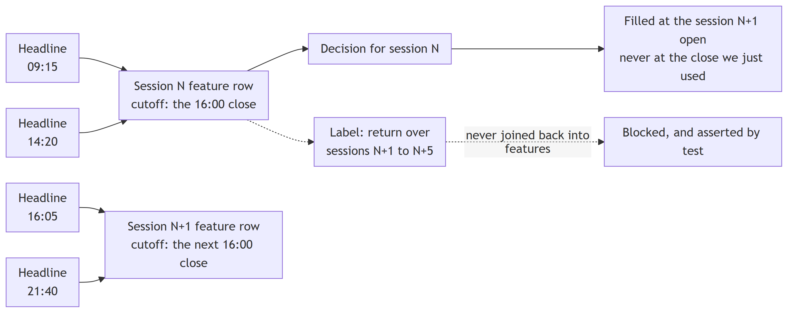
Figure 4. The cutoff rule. Text is assigned to a session by publication time, never by calendar date. Anything after the close belongs to the next session, the fill happens at the next open, and the label lives entirely in a future the features cannot see.
This offline/online split is what makes the point-in-time guarantee enforceable in practice. Because sentiment for a given session is only ever computed from documents published strictly before that session's cutoff, there is no code path through which a same-session event can reach a same-session recommendation.
OPERATIONAL CONSEQUENCE
Live news sources return only a shallow window of recent items — you cannot backfill history from them. Because the 3-day and 7-day momentum features need at least a week of accumulated scored headlines, forward-window logging starts in week 1 and runs continuously. A freshly deployed instance reports a degraded state until it has enough history, rather than answering from thin data.

10.5 Decision engine
XGBoost is an algorithm, not a pre-trained model — unlike FinBERT, there is nothing to download. The decision trees do not exist until we build them from our own feature matrix, and no pre-trained artefact could exist for us anyway, because no one else has this feature space.
Training uses purged walk-forward cross-validation with an expanding window: fold 1 trains on the earliest period and tests on the next, fold 2 trains on everything up to that point and tests on the one after, and so on, with a five-day embargo at each fold boundary. All normalisation statistics — every scaler, every mean and standard deviation — are fitted inside the training fold only, never across the full series, because a scaler fitted on all the data has already seen the test period. Hyperparameters are tuned with Optuna under a fixed budget using the histogram tree method. Class imbalance is handled with class weights, and macro-F1 is the reported metric.
One model is trained per horizon. The 1-week model is the only one exposed to users; the 1-day and 1-month models exist solely inside the evaluation sweep, and the 1-day model doubles as a standing leakage control. All three share the same feature matrix, the same folds and the same tuning budget — only the label geometry differs, which is precisely what makes comparing them meaningful. There is no ensemble and no voting.
Probabilities are calibrated with isotonic regression on a held-out fold, so that a reported 62% actually means 62%. Calibration quality is itself reported as a Brier score and a reliability curve.
Confidence comes from two grounded sources rather than from an ensemble: the calibrated class probability, and whether the learned engine agrees with the transparent linear baseline. A single well-calibrated model plus a principled agreement check replaces multi-model voting, which would multiply cost without conferring authority.

10.6 How sentiment is weighted
Nobody sets a weight. XGBoost learns how much to rely on each feature, and learns it conditionally — a tree can encode "when volatility is low, sentiment momentum matters; when volatility is high, ignore it." That conditional weighting is the advantage over a fixed formula, and it is measurable after the fact through mean absolute SHAP value per feature group.
The interpretable baseline, C = R·S + (1 − R)·T, does use an explicit hand-set sentiment weight. That is precisely why it is the control: the thesis question is whether learning a conditional weighting beats setting a fixed one.
When the two sentiment models disagree, the system does not arbitrate — the disagreement becomes a feature. News polarity, social polarity and their difference all enter the model separately, and the model learns what divergence means. Whether it means anything at all is exactly what the pre-registered ablation tests.

10.7 Explanation layer
A small local language model receives the engine's structured output — decision, calibrated probability, top SHAP contributions, risk tier — and renders it in plain English, then answers follow-up questions. It never states a verdict the engine did not produce.
The verifier is built before the model, so what the explainer is allowed to say is defined and testable before any fine-tuning is attempted.
Distillation works as follows: decision records are passed to an open-weight teacher model under a strict grounding prompt; the teacher's outputs are filtered by the verifier before entering the training set, so the training data is itself known-grounded; Phi-3-mini is then QLoRA-adapted on those filtered pairs. QLoRA exists purely to make this fit ordinary hardware — the base weights are loaded in 4-bit (about 1.9 GB instead of 7.6 GB) and only small adapter matrices are trained, well under 1% of the model.
The teacher is open-weight because frontier-provider terms restrict using outputs to develop competing models; an open-weight teacher removes the question entirely. Because groundedness here is enforced by the verifier rather than learned, a well-prompted model may match the fine-tune. That is an anticipated and legitimate result — the deliverable is the controlled comparison, not a predetermined winner.

10.8 A worked example, end to end
Everything above describes parts. This is one complete trip through the system, with real shapes and plausible numbers, so the whole thing can be checked as a single idea.

STEP 1 — THE USER
Age band 18–30, income somewhat variable, two dependants, one to three months of emergency-fund cover, horizon three to five years. Capacity computes to moderate. The Grable–Lytton questionnaire returns a moderately high tolerance. The two disagree, so the binding constraint applies and the stored tier is the more restrictive of the two: moderate, with a loss-aversion coefficient of 2.25.

STEP 2 — THE QUESTION, AND WHAT THE SYSTEM READS
The user asks about NVDA on a Tuesday evening. The most recent complete feature row is Monday’s, because Tuesday’s session has not closed yet. The system reads that row — about thirty numbers:
GROUP | VALUES AS OF THE MONDAY CLOSE
Technical | rsi_14 38.2 · macd_hist −0.41 · dist_sma200 −0.061 · bollinger_pos 0.22 · obv_slope −0.003
News register | polarity +0.31 · mom_3d +0.12 · mom_7d −0.04 · volume_z +1.8 · dispersion 0.44
Social register | polarity −0.18 · mom_3d −0.22 · mom_7d −0.15 · volume_z +2.6 · dispersion 0.71
Divergence | news_minus_social +0.49
Regime | vol_20d 0.034 · regime elevated
Risk | tier moderate · capacity 0.55 · tolerance 0.67 · lambda 2.25

Note what the row already encodes: news is mildly positive while social discussion has turned negative, and both are being talked about unusually heavily. The engine has never been told what that combination means — it learns that, or it does not.

STEP 3 — THE DECISION
XGBoost returns class scores and isotonic calibration converts them into probabilities: Buy 0.34 · Hold 0.58 · Sell 0.08. The verdict is Hold at 58% confidence. The transparent linear baseline also says Hold, so the agreement check raises confidence rather than lowering it.

STEP 4 — TREESHAP SAYS WHY
FEATURE | CONTRIBUTION | READING
divergence_news_social | +0.14 | News and social disagree — the largest single push toward Hold
social_mom_3d | +0.09 | Social sentiment falling over three days
vol_20d | +0.05 | Elevated volatility favours waiting
dist_sma200 | +0.03 | Price sitting below its long average
rsi_14 | −0.06 | Oversold — pushes away from Hold, toward Buy

These, plus the remaining smaller contributions and the base value, sum exactly to the model output. That summation is the property FR-6 tests on every emitted decision.

STEP 5 — THE EXPLAINER DRAFTS ENGLISH
GENERATED EXPLANATION
“NVDA leans Hold at 58% confidence. The strongest driver is a disagreement between the two sentiment registers: news coverage is mildly positive at +0.31 while social discussion has turned negative at −0.18, and that divergence pushes toward waiting. Social sentiment momentum has fallen over the last three days. RSI at 38.2 is mildly oversold and pushes the other way, toward Buy, but not far enough to change the verdict. Volatility is elevated. On your moderate risk tier, this is not a signal the system would act on.”

STEP 6 — THE VERIFIER CHECKS EVERY CLAIM BEFORE ANYONE SEES IT
CLAIM | CHECK | RESULT
“Hold at 58%” | numeric | matches 0.58 within 0.5 pp — pass
“news … +0.31” | numeric | matches news_polarity — pass
“social … −0.18” | numeric | matches social_polarity — pass
“RSI at 38.2” | numeric | matches rsi_14 — pass
“divergence pushes toward waiting” | sign | its contribution to Hold is +0.14, positive — pass
“RSI pushes toward Buy” | sign | its contribution to Hold is −0.06, negative — pass
“social momentum has fallen” | sign | social_mom_3d is −0.22 — pass
“volatility is elevated” | — | nothing in the record defines “elevated” — flagged unverifiable

Eight atomic claims: seven verifiable and all seven correct, one unverifiable. That gives numeric fidelity 1.00, directional consistency 1.00, claim recall 0.88 and unverifiable rate 0.125 — clearing all four thresholds in section 12, so the explanation is released to the user. Had the model written “72% confidence”, or claimed RSI pushed toward Hold, it would have been regenerated once and then replaced by the deterministic template.
WHY THIS EXAMPLE IS THE WHOLE PROJECT IN MINIATURE
The answer is Hold at 58% — a weak signal, honestly reported as weak. A leaking system would have returned something like Buy at 84%, with an explanation just as fluent, and nothing on the screen would have looked any different to the user.
That is what the two contributions are for. The harness is what stops the 84% from being fabricated in the first place; the verifier is what stops the explanation from describing a decision the model did not actually make. Neither is visible in the output, which is precisely why both have to be tested rather than asserted.

11. Leakage Controls
This is the first of our two core contributions. Leakage has several independent sources, and each needs its own control.
SOURCE OF LEAKAGE | CONTROL
Text mapped to the wrong session | Equities map to exchange sessions through a trading calendar: text arriving after the close maps to the following session, never the same bar. Weekends, holidays and half-days handled explicitly. Crypto uses a continuous 24-hour window. Both run behind one interface.
Joining forwards in time | Backward as-of joins with an explicit maximum look-back. Never a nearest-in-time join, which can silently reach into the future.
Forward-looking feature windows | Every rolling window is backward-only, enforced by automated test. A single centred window is enough to destroy an entire evaluation.
Scaling fitted on test data | All normalisation statistics fitted inside the training fold only, asserted by test.
Labels overlapping fold boundaries | Purged walk-forward splitter with a five-day embargo at each fold boundary. A 1-week label spans five sessions, so a training row near the boundary can carry an outcome reaching into the test period; purging drops those rows and the embargo adds a gap. Retained because it is cheap and correct, but not presented as the primary defence — under an expanding walk-forward, training is already strictly before test, so only the boundary itself is ever contaminated. The real protections are backward-only features and the walk-forward structure.
Retroactive price revision | Price snapshots are versioned and content-hashed, so later split and dividend adjustments cannot leak backwards into historical rows.
Executing at an unknowable price | No fill timestamp may precede its signal timestamp. A signal computed from a session's close is filled at the next session's open.
Timezone and daylight saving | A real timezone database, never fixed offsets. The same UTC timestamp falls before the opening bell in winter and after it in summer.

PROVING THE CONTROLS WORK
Controls that are never tested are assertions. Ours are tested three ways:
- Negative controls at two label geometries. Configurations where no exploitable signal should exist must come out at chance. Two are required rather than one, because a short-horizon control cannot detect leakage caused by overlapping label windows.
- A permanent leak canary. A deliberately broken configuration is kept in the test suite forever and must keep being detected. The build fails both when a clean control shows signal and when the canary stops firing — because a detector that has stopped detecting is worse than no detector.
- A live-versus-backtest parity test. Pin the system's clock to a historical date, run the live inference path and the backtest path over the same data, and assert they produce identical features and an identical decision. Without this, we would have proven the harness is clean while the deployed system runs different code.

12. Explanation Verification
This is the second core contribution. Because the explainer's input is entirely structured and numeric, whether an explanation is grounded is decidable by code — we do not need another language model to judge it. Six checks:
- Numeric extraction. Every number in the generated text is extracted, preferably from a machine-readable payload emitted alongside the prose under a constrained grammar, with pattern matching over free prose as fallback.
- Tolerance matching. Each extracted number must match the source record within a declared tolerance.
- Sign and direction. If the text claims a feature pushed the decision towards Buy, that feature's contribution for the Buy class must actually be positive. A sign mismatch is a hallucination by definition.
- Rank consistency. The explanation must cite features from the top contributors and must not promote a minor one to a headline cause.
- Closed-vocabulary validation. Every feature name mentioned must belong to the known feature set.
- Claim-level scoring. The output is decomposed into atomic claims, each classified as verifiably correct, verifiably incorrect, or unverifiable.
WHY ONE SCORE IS NOT ENOUGH
A groundedness score alone is gameable, and we say so: a model that speaks vaguely enough to make every claim unverifiable scores a perfect 1.0 while saying nothing. A high score with low claim recall is therefore recorded as a failure, not a pass. Acceptance is stated over the whole set — numeric fidelity, directional consistency, claim recall and unverifiable-claim rate — never over the headline number alone.

ACCEPTANCE THRESHOLDS FOR THE SHIPPED CONFIGURATION
MEASURE | THRESHOLD | WHAT IT CATCHES
Numeric fidelity | ≥ 0.98 | A stated figure that does not match the record within tolerance
Directional consistency | ≥ 0.95 | A feature described as pushing one way when its contribution points the other
Claim recall | ≥ 0.80 | An explanation that stays safe by saying almost nothing
Unverifiable-claim rate | ≤ 0.15 | Fluent hedging that cannot be checked either way

Feature-name fabrication is impossible by construction inside the structured payload under constrained decoding, and detectable by closed-vocabulary validation in the free prose. The two halves carry different guarantees and we do not claim the stronger one for both.
Any explanation failing verification is regenerated once and then replaced by a deterministic template that is grounded by construction, so the system never emits an unverified explanation to a user.
Three configurations — prompted baseline, distilled student, and teacher — are compared on the same held-out records. Because verifier gating pushes all three towards ceiling, the primary comparison is scored before gating, on raw generations, which is where the differences actually live. A subset of explanations is annotated independently by two team members and inter-rater agreement reported, validating the automated verifier against human judgement.

13. Requirements

FUNCTIONAL REQUIREMENTS
ID | THE SYSTEM SHALL… | ACCEPTANCE CRITERION
FR-1 | store market and text records with both a source event timestamp and an ingestion timestamp, appending only and never updating a stored row | Automated test asserts no update path exists and that replaying an ingest produces no duplicates under content-hash dedup
FR-2 | map every text record to the next tradable session for session-bound assets, and to the containing 24-hour window for continuously traded assets | Unit tests over weekends, market holidays, half-days and after-close timestamps
FR-3 | join text features to price bars using a backward as-of join with an explicit maximum look-back, never a nearest-in-time join | Hardest requirement Nominated because its violation is silent — a verification failure announces itself, leakage does not. All three parts must pass: (a) the automated leakage suite passes; (b) both negative controls sit at chance under purged walk-forward CV; (c) the mutation test fires — deliberately reintroducing a same-bar join or a centred window causes a control to breach its interval, showing the suite detects leakage rather than merely failing to find it
FR-4 | fit all normalisation statistics inside the training fold only | Test asserts scaler parameters differ across folds and are never derived from test rows
FR-5 | produce a Buy, Hold or Sell decision with a calibrated probability for a named company at the 1-week horizon | Brier score and reliability curve reported on a held-out fold
FR-6 | attribute every decision to its driving features using TreeSHAP | Every emitted decision carries an attribution vector summing to the model output less the base value, within tolerance
FR-7 | elicit a user's risk capacity and tolerance and reconcile them by the binding constraint into a three-tier profile | Given conflicting capacity and tolerance inputs, the stored tier equals the more restrictive of the two
FR-8 | verify every generated explanation against its source record and refuse to emit one that fails | Over a held-out set of 200 explanations, zero emitted explanations contain a numeric, directional, rank or feature-name claim contradicting the record. The shipped configuration meets numeric fidelity ≥ 0.98, directional consistency ≥ 0.95, claim recall ≥ 0.80 and unverifiable-claim rate ≤ 0.15 — stated over the whole set, because a high score on any one alone is gameable
FR-9 | report a claim-level groundedness score with precision, recall and unverifiable rate on request | The interface displays the per-claim verifier report alongside every explanation
FR-10 | run the negative-control configurations on every evaluation run and raise a leakage alarm when a control exceeds its threshold | CI fails the build when a control breaches its interval, and separately when the leak canary fails to breach it
FR-11 | compute identical features and an identical decision through the live path and the backtest path for the same historical date | Parity test with the clock pinned to a past date; feature vectors match within float tolerance and decisions are identical
FR-12 | report a labelled degraded state, rather than a recommendation, when a required source is unavailable or history is insufficient | Fault-injection test: with a feed disabled, or with fewer than seven days of scored headlines, the system returns a labelled degraded response and never a silently stale recommendation
FR-13 | persist, for every recommendation, the model version, data snapshot hash and timestamps used | A stored recommendation is re-derived from its persisted references and matches the original decision and probability
FR-14 | display a non-advice notice and the prediction horizon with every recommendation | Present in every response path, including the template fallback and the degraded state
FR-15 | be installable and startable on a clean host from documented steps by a person who did not build it | A person outside the team performs the install and records the time taken and every step that failed

NON-FUNCTIONAL REQUIREMENTS
ID | REQUIREMENT | BOUND | ENVIRONMENT
NFR-1 | Decision and attribution path — feature assembly, inference, TreeSHAP, verification. Excludes language generation. | < 800 ms p95 | Target VM, warm cache
NFR-2 | Sentiment scoring throughput | ≥ 150 docs/sec | 16 GB-class GPU, fp16, 128 tokens
NFR-3 | TreeSHAP attribution per prediction | < 50 ms | CPU
NFR-4 | Peak resident memory at inference | < 4 GB | Target VM
NFR-5 | QLoRA fine-tuning run | ≤ 4 GPU-hours  within 16 GB | 16 GB-class GPU (T4, L4 or RTX 5080); the GPU used is reported with the measurement
NFR-6 | Explanation generation including verification | < 5 s | Target VM, CPU
NFR-7 | Nightly incremental ingest and scoring, full universe | < 30 min | GPU plus local store
NFR-8 | Full purged walk-forward sweep with hyperparameter search | < 90 min | CPU — this workload does not benefit from a GPU at this data scale

Every bound is deliberately conservative relative to published benchmarks so that it can be met live. Measurements are taken with wall-clock percentiles, profiling for hotspots, and memory instrumentation, with microbenchmarks in CI so a regression fails the build rather than surfacing at the demonstration. Any bound contradicted by measurement is revised through change control, not quietly lowered.

14. Deployment
The system is deployed as a Docker image on a small cloud virtual machine (2 vCPU, 8 GB class, free or student tier). The image contains the FastAPI service, the Streamlit interface, the DuckDB and Parquet store, and the explainer served locally in a quantised format needing roughly 2–3 GB and running at interactive speed on CPU.
No GPU is required in production. Inference is CPU-feasible once sentiment is cached, the store is embedded rather than a managed service, and the explainer is deliberately small. GPU is needed only for corpus scoring and the fine-tune, both of which are offline and one-off.
Configuration comes from environment variables and a mounted config file; no credential, key or path is hard-coded. Secrets are injected at run time and never present in the image or repository. A documented first-run path provisions the store and verifies its integrity before the service accepts requests.

FAILURE AND DEGRADED OPERATION
FAILURE | DETECTED BY | BEHAVIOUR
Live feed unavailable | Timeout, health probe | Serve from last good cached features and display the staleness of the data behind the recommendation. Never silently serve stale data as fresh.
Insufficient history | Store check at request time | Labelled degraded response. Momentum features need at least seven days of accumulated scored headlines.
Explainer unavailable or slow | NFR-6 timeout | Fall back to the deterministic template. The decision and attribution are unaffected, because the model is not the brain.
Explanation fails verification | The verifier | Regenerate once, then substitute the template. An unverified explanation is never emitted.
Leakage alarm fires | CI and the evaluation run | Build fails and results are quarantined pending audit. Modelling work halts rather than continuing under a known alarm.
Partial write or store corruption | Content-hash validation on read | Append-only design means the last complete partition is always recoverable; the resumable job runner re-ingests from the last checkpoint.

BARRIERS WE DO NOT CLAIM TO SOLVE
Regulation — an output resembling Buy, Hold or Sell sits adjacent to financial-advice regulation, which is why the system is framed and labelled as educational and refuses to execute trades. Privacy — the risk profile collects income, dependants and emergency-fund bands as self-declared ranges; this is personal financial data, it stays local to the deployment and never leaves it, which constrains any future hosted multi-tenant version. Licensing — corpus terms restrict redistribution, so the handover package ships manifests and acquisition scripts rather than the corpora themselves. Trust — a system that reports honest null results is less appealing than one claiming skill, and we accept that as the cost of the design.

15. Testing, Evaluation and Acceptance
These are three different questions needing three different kinds of evidence.

15.1 Testing — does it behave as specified?
Unit tests on as-of join semantics, session mapping across weekends, holidays and half-days, fold-local scaling, and content-hash idempotency. Integration tests on the full feature-matrix build. System tests against every functional requirement, traced through a requirements traceability matrix. Defects recorded by severity, with no open critical defects at release.

15.2 Evaluation — is it any good?
Purged, embargoed walk-forward cross-validation against two benchmarks: the transparent linear formula and a stratified-random classifier.
METRIC CHOICE, STATED DELIBERATELY
We report classification and calibration quality, not trading-strategy returns. Metrics are macro-F1 with precision and recall, Brier score and reliability curve, lift over a stratified-random baseline, agreement with the linear baseline, and the divergence-ablation delta.
We deliberately do not report Sharpe ratio, cumulative return or maximum drawdown. Those measure a trading strategy, and this system does not trade — it advises a person who decides for themselves. They would also be far noisier than classification metrics at our effective sample size. Reporting them would imply a profit claim we explicitly do not make.

Statistical power, stated honestly. Roughly a decade of daily data across ten-odd companies looks like tens of thousands of rows, but at a 1-week horizon the non-overlapping sample is far smaller, and those observations are heavily correlated because the companies are all large US names moving with one market. The effective sample size for a market-level claim is nearer the number of independent weeks than the row count. The pre-registered ablation is powered to detect a change in macro-F1 of roughly 0.02 or larger; smaller effects are reported as indeterminate rather than as null.
The horizon sweep reports 1-day, 1-week and 1-month with confidence intervals. We expect 1-day to sit at chance by construction and 1-month to be indeterminate rather than negative — at that horizon there are only about a hundred independent observations, which is not enough to detect a modest effect. The result is reported as a decay curve, not as a disproof.

15.3 Acceptance — will the people it is for actually use it?
ELEMENT | PLAN
Method | Supervised task sessions of roughly 30 minutes, run on the deployed instance rather than a local build. A structured expert review covers the domain-soundness question that task sessions cannot answer.
Participants | Six to eight people from the actual target population — those who currently invest or are actively considering it, drawn from the student and early-career population — plus one finance faculty member as expert reviewer. Numbers are small and we do not over-claim from them.
Tasks | Read a recommendation with its attribution and verifier report, then state in their own words what the system is telling them, why, and how much confidence they would place in it. A second task presents a deliberately low-confidence recommendation, to test whether uncertainty is communicated or lost.
Measures | Task completion, time taken, assistance needed, errors of interpretation, and whether the participant correctly identifies the top driving feature. The verifier report's legibility to a non-author is a specific risk we are testing, not assuming.
Consent and privacy | Participants supply no real financial data; the risk questionnaire is completed with supplied scenario values. Written consent is recorded before each session.

Recruitment begins well before the final weeks. If the participant definition has to change — for example because ethical approval requires a narrower population — the substitution is recorded under change control before the sessions run, not declared at the final defence.

16. Team Responsibilities and Timeline
Each member holds primary technical ownership of work they can explain, justify against an alternative, predict the failure modes of, and modify under questioning.
MEMBER | PRIMARY OWNERSHIP | WHAT THEY MUST BE ABLE TO DEFEND
Soban Ahmad  22I-2460  The decision and its justification | Decision engine, feature engineering, label geometry, probability calibration, TreeSHAP, hyperparameter budget. The deterministic verifier, constrained-decoding grammar, prompted baseline, QLoRA distillation and the three-way comparison. | Why isotonic calibration and what it costs; why path-dependent rather than interventional attribution; what breaks in attribution as the feature set grows; why groundedness is decidable here and not in general; why a groundedness score alone is gameable and what is reported instead.
Ahmed Javaid  22I-2530  The harness and correctness machinery | Point-in-time store, event/ingestion time schema, versioning and reproducibility, two-calendar session mapping, technical indicators, evaluation harness, leakage test suite, parity test, container build and cloud deployment. | Why a backward as-of join and what a nearest-in-time join would do; why one negative control is insufficient; why purging is not the primary defence; what happens to the join under a half-day session or a 24/7 asset; where fold-local scaling would silently fail.
Rafay Ul Haq  22I-2520  Perception, personalisation and evidence | Risk capacity and tolerance elicitation and reconciliation; dual-register sentiment pipeline and the hand-labelled equity social benchmark; degraded operation, staleness detection and fault injection; human inter-rater validation of the verifier; acceptance study design and execution; FastAPI service and Streamlit interface including the verifier report display. | Why capacity and tolerance reconcile by binding constraint rather than by average; why λ is fixed rather than elicited; why sentiment models are routed by text register rather than by asset; how the labelling study was designed and what its declared fallback is; what the system does when a feed dies or history is thin, and how that was tested.

SCOPE TEST
Removing any one member removes a meaningful technical responsibility and its evidence. Without Soban there is no calibrated engine and no verified explanation layer. Without Ahmed there is no point-in-time harness, no leakage audit and no deployed system. Without Rafay there is no risk conditioning, no sentiment benchmark, no degraded-operation guarantee, no human validation of the verifier and no acceptance evidence.
The hand-labelled benchmark is a deliverable in its own right, not a step towards one. If no social model transfers usably to equity text, "no model transfers" is itself the finding, and the benchmark remains a curated resource. The contribution survives either outcome.

Shared responsibilities — architecture, integration, quality assurance, ethics and security, repository discipline and the final defence — remain team-wide. Soban and Ahmed pair on the leakage audit, since it spans both their modules and is the project's highest-consequence correctness task. Integration risk is managed explicitly: the feature-matrix contract, the record schema passed between engine and explainer, and the join semantics are frozen in week 3 before anyone builds against them, and the full pipeline runs end to end weekly from week 8 so integration failures surface continuously rather than at the end.

TIMELINE — FOUR ITERATIONS
ITERATION | DELIVERABLE — EACH IS A LIVE WORKING DEMO, FRONTEND AND BACKEND | LEAD
Weeks 1–3  Foundation | Literature review and departmental archive check complete. Data access and licences confirmed. Feature-matrix and decision-record contracts frozen. As-of join skeleton on real text. Forward-window logging switched on and left running. | All
Iteration 1  Mid-1, week 7 | Ingestion hardened. Two-calendar session mapping. Technical indicators. News sentiment features. Social model selection study. Interpretable linear baseline running end to end. Leakage suite green and mutation test firing. Thin Streamlit slice: one company, baseline verdict, leakage-suite status. Requirements and design baselined. | Ahmed (harness)  Rafay (sentiment, UI)
Iteration 2  Final-1, week 12 | XGBoost engine at 1 week. Probability calibration. TreeSHAP. Purged walk-forward CV. Divergence features with pre-registered ablation. Deterministic template explainer. FastAPI and Streamlit. Containerisation and first deployment attempted. Comparison baseline measured. | Soban (engine)  Ahmed (deployment)
Iteration 3  Mid-2, week 18 | Verifier and constrained-decoding grammar. Prompted-explainer baseline scored. Verifier-filtered training set. All non-functional requirements measured. Fault injection and degraded operation. Parity test. Acceptance study prepared and approvals obtained. Committed scope integrated, system testing complete. | Soban (verifier)  Rafay (degraded ops, acceptance)
Iteration 4  Final-2, week 24 | QLoRA fine-tune and three-way groundedness comparison. Harness generalisation test on the continuously-traded universe. Full evaluation, ablation and horizon sweep. Acceptance sessions run. Deployed system installed and operated by someone outside the team. Handover package and complete report. | All

GO / NO-GO GATES
GATE | PASS CRITERIA | ACTION ON FAILURE
A  week 7 | Leakage-free feature matrix produced; as-of join and session-mapping tests pass; fold-local scaling enforced; both negative controls at chance; and the mutation test fires. | Freeze all feature work and fix the pipeline. Under no circumstances proceed to modelling on a matrix that has not passed. If the mutation test does not fire, the detector itself is broken and must be repaired before any result is believed.
B  week 12 | The learned engine beats the linear baseline on macro-F1 and is better calibrated, out of sample under purged walk-forward CV, with both controls still at chance. | If a control shows apparent signal, treat it as a leakage alarm — halt and audit before anything else. If the engine simply does not beat the baseline, report the null result honestly and shift emphasis to the harness and the verifier, both of which remain complete contributions. This path is pre-committed, not improvised.
C  week 18 | The prompted explainer plus verifier already meets the FR-8 thresholds, and the system is deployed and reachable on the target VM. | Fix the verifier and the prompt before attempting any fine-tune. Passing this gate is what keeps the QLoRA work off the critical path.

MINIMUM DEFENSIBLE OUTCOME
Even if the fine-tune is abandoned entirely and the engine never beats its baseline, what remains is: a leakage-audited point-in-time harness across two incompatible calendars with controls demonstrated to detect real leaks; a calibrated decision engine benchmarked against a transparent baseline under purged cross-validation; per-decision attribution; a symbolically verified explainer; a deployed, documented, user-accepted system; and a measured performance envelope.

17. Risks and Limitations
RISK | IMPACT | MITIGATION
Point-in-time text misaligned, producing silent leakage | High | As-of join and two-calendar unit tests; fold-local scaling enforced by test; controls at both label geometries; permanent leak canary; Gate A; technical-only fallback
Decision engine does not beat the baseline | Medium | Null-result reporting pre-registered; project value rests on the harness and verifier rather than on outperformance
A control shows apparent signal | High | Treated as evidence of a leak, never of skill — halt and audit at Gate B. Note the converse trap: short-horizon news effects are documented in the literature, so a positive control is not proof of a leak. If no leak is found after audit, we report the anomaly rather than assume either explanation.
Historical corpus coverage ends before the deployment year | Medium | Backtest window bounded to the corpus; the live forward window reported separately as an out-of-regime illustration, never as a continuation. Within-source z-scoring and headline-only scoring keep the feature definition stable across the boundary.
Social-register model unsuitable for equity text | Medium | Time-boxed validation study against a hand-labelled sample; declared fallback to news-only sentiment with divergence features dropped; the benchmark remains a deliverable either way
Groundedness comparison saturates and is uninformative | Medium | Primary comparison scored before gating, on raw generations, where the differences exist; post-gate reported separately as shipped behaviour
Deployment slips to the final weeks | High | First container build and cloud deployment scheduled at Iteration 3, not at the end; Gate C requires the system reachable on the target VM
Integration failure across three owners | High | Contracts frozen week 3; weekly end-to-end integration from week 8; CI on joins and leakage checks

LIMITATIONS, STATED UP FRONT
- Survivorship and selection bias. The universe is curated with hindsight for coverage density and consists entirely of surviving, high-attention names. External validity is correspondingly limited.
- Single market, largely single regime. No claim is made that results transfer to other markets or volatility regimes. Crypto is included to exercise the harness, not to support a second modelling claim.
- Statistical power is limited, as set out in §15.2. The 1-month horizon in particular is expected to be indeterminate rather than conclusive.
- Coverage density is confounded with mention-volume features. A company that listed partway through the window has a shorter history, and a change in corpus coverage is indistinguishable from a change in attention.
- Hardware figures are budgets, not constants, and will be replaced by measured values.
- The verifier cannot catch everything. It adjudicates numeric, directional, rank and entity claims against the record. It cannot judge whether the underlying decision was wise, nor detect a fluent but unverifiable statement — which is why the unverifiable-claim rate is reported alongside the groundedness score.
- The risk instrument was validated on a different population, and the loss-aversion coefficient is a population estimate applied uniformly within a tier.
- Acceptance findings are limited by participant numbers. Six to eight participants can tell us whether the recommendation, the confidence and the explanation are intelligible and trusted appropriately. They cannot establish adoption behaviour, and we do not claim they can.
- Prior published results are not treated as targets. Comparable published pipelines frequently use weaker leakage controls than those specified here, so their headline accuracies are not a fair benchmark.

ETHICS AND DISCLOSURE
Research and educational prototype only; not financial advice; not for live trading. Sentiment is susceptible to manipulation. Look-ahead bias is guarded structurally and tested automatically. Personal financial data stays local to the deployment. Acceptance participants give informed written consent. An AI usage log is maintained alongside the dependency disclosure sheet, updated as work proceeds and countersigned by the supervisor; each member remains individually responsible for explaining, justifying and modifying the components they own, irrespective of how the code was produced. After approval, any change to committed scope, core method, deployment target, non-functional targets, evaluation metrics or ownership is recorded and approved before it is acted upon.

18. References
- Kahneman, D. and Tversky, A. (1979). Prospect Theory: An Analysis of Decision under Risk. Econometrica, 47(2), 263–291.
- Tversky, A. and Kahneman, D. (1992). Advances in Prospect Theory: Cumulative Representation of Uncertainty. Journal of Risk and Uncertainty, 5, 297–323.
- Grable, J. and Lytton, R. (1999). Financial Risk Tolerance Revisited: The Development of a Risk Assessment Instrument. Financial Services Review, 8(3), 163–181.
- Vaswani, A., et al. (2017). Attention Is All You Need. NeurIPS 2017. arXiv:1706.03762.
- Devlin, J., et al. (2019). BERT: Pre-training of Deep Bidirectional Transformers for Language Understanding. NAACL 2019. arXiv:1810.04805.
- Yang, Y., et al. (2020). FinBERT: A Pretrained Language Model for Financial Communications. arXiv:2006.08097.
- ElKulako (2023). CryptoBERT: Sentiment Classification of Cryptocurrency-Related Social Media. Hugging Face: ElKulako/cryptobert.
- Chen, T. and Guestrin, C. (2016). XGBoost: A Scalable Tree Boosting System. KDD 2016.
- Akiba, T., et al. (2019). Optuna: A Next-generation Hyperparameter Optimization Framework. KDD 2019. arXiv:1907.10902.
- Lundberg, S. and Lee, S. (2017). A Unified Approach to Interpreting Model Predictions. NeurIPS 2017.
- Lundberg, S., Erion, G. and Lee, S. (2018). Consistent Individualized Feature Attribution for Tree Ensembles. arXiv:1802.03888.
- López de Prado, M. (2018). Advances in Financial Machine Learning. Wiley. (Purging and embargo, ch. 7.)
- Hu, E. J., et al. (2022). LoRA: Low-Rank Adaptation of Large Language Models. ICLR 2022. arXiv:2106.09685.
- Dettmers, T., et al. (2023). QLoRA: Efficient Finetuning of Quantized LLMs. NeurIPS 2023. arXiv:2305.14314.
- Hinton, G., Vinyals, O. and Dean, J. (2015). Distilling the Knowledge in a Neural Network. arXiv:1503.02531.
- Dong, Z., et al. (2024). FNSPID: A Comprehensive Financial News Dataset in Time Series. arXiv:2402.06698.
- Kamps, J. and Kleinberg, B. (2018). To the Moon: Defining and Detecting Cryptocurrency Pump-and-Dumps. Crime Science, 7(18).
- McNemar, Q. (1947). Note on the sampling error of the difference between correlated proportions or percentages. Psychometrika, 12(2), 153–157.
- Seoul Accord (2023). Section D: Graduate Attributes.
- FAST School of Computing. FYP Idea Selection and Proposal Readiness Guide.
TO ADD BEFORE DEFENCE
The full citation for the closest prior published pipeline referenced in §06 (Mathematics 2025, 13(17), 2747). The delta statement in §04 is built against it, so it must appear here in full.

Investify · short title F26-003-QuantamentalAI · Department of Software Engineering, FAST School of Computing, NUCES Islamabad. Prepared for proposal defence. Scope is committed as stated in §07; any subsequent change is recorded and approved under change control before being acted upon.

