Version

1.0

York university

Lassonde School of Engineering

Venn Diagram Visual Tool User Manual

EECS2311 - Group #17

Venn Diagram Visual Tool User Manual

Table of Contents

Running the Application 1

Customizing Titles 3

Customizing Venn Diagram Circles 7

Customizing Text Boxes 9

Dragging Text Boxes 12

# Running the application on different operating Systems

# Linux

To run the VennApplication.jar on a Linux Operating System:

1. Open the terminal with CTRL + ALT + T.
2. Change directory to where the .**jar** file is located.
3. Type the following command on the terminal: java –jar VennApplication.jar & in order to run the **jar** application in the background.

# Windows

Running the VennApplication.jar is relatively simple:

1. Open the directory where the VennApplication.jar is located.
2. Double-Click on the **VennApplication.jar**, and a new window with the application will pop-up.

# Mac OS

1. First verify that Java is installed in the MacOS system.
2. If Java is installed, simply double-click on the **VennApplication.jar** file, and the new application window will pop up.
3. If the above process does not work, simply right click on the file and open it with JAR Launcher.

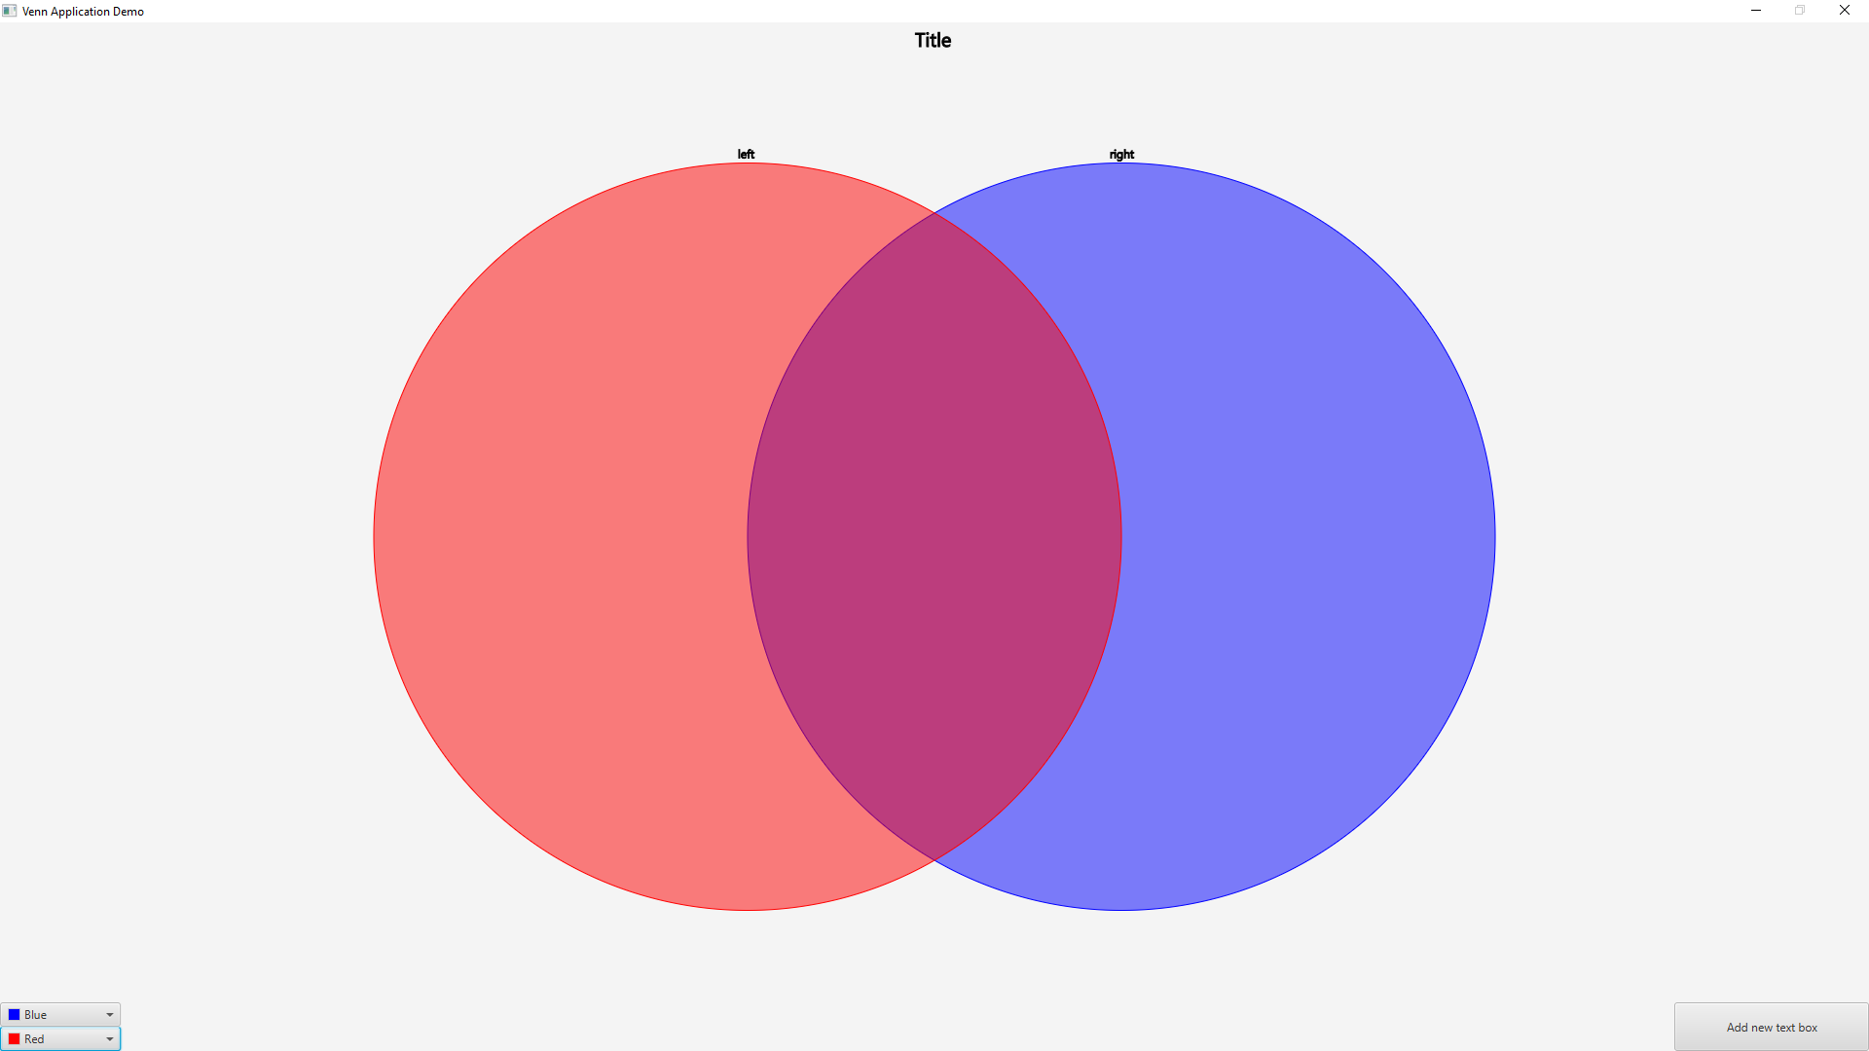

Fig: Default state of the VennApplication after being executed for the first time

# Customizing Titles

# How to Customize the Title of the Venn Diagram

1. Move the mouse cursor above the default Title located at the top of the user interface.

2. Right Click on the default title with the mouse cursor.

3. A Text Editor Interface will open where you can change the text to your preferred title.

4. Click ‘Finish’.

# User Case Scenario: Making the title “Venn Diagram Demo”

1. Move the mouse cursor above the default Title located at the top of the user interface.

2. Right Click on the default title with the mouse cursor.

3. A Text Editor Interface will open, change the text box to “Venn Diagram Demo”.

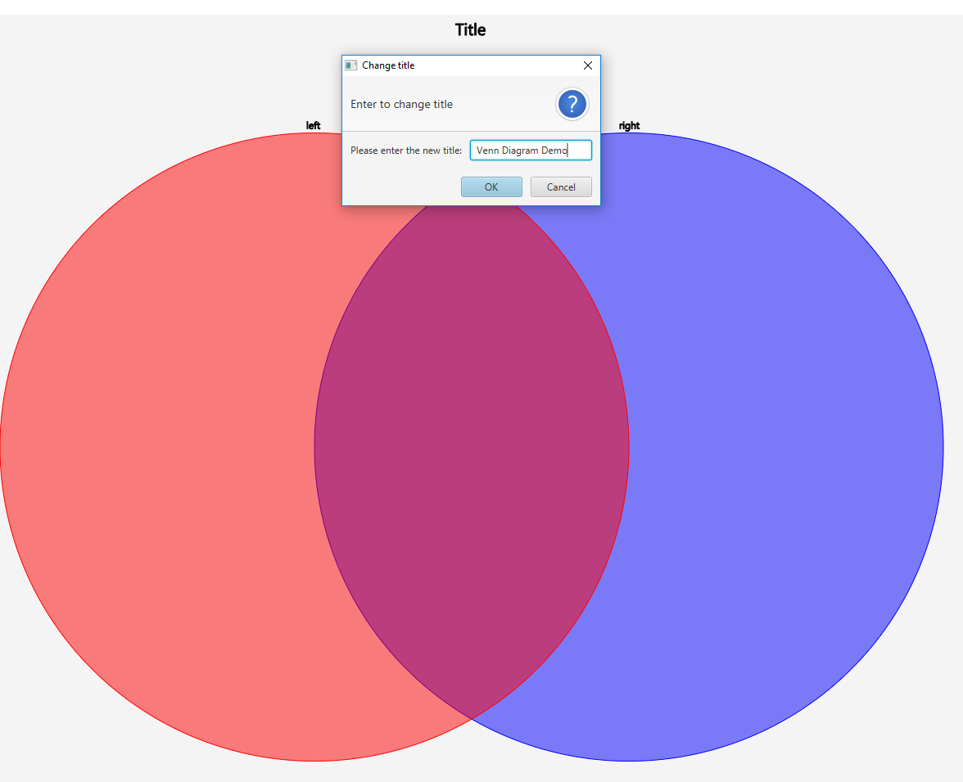

Fig: After right-clicking on the default “Title”

4. Click ‘OK’.

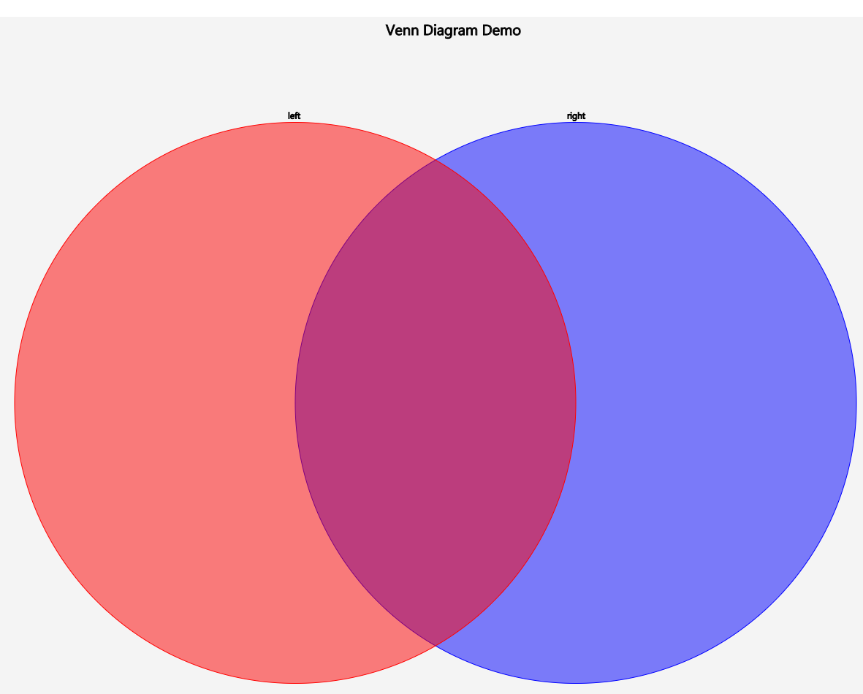

Fig: New title name taking effect after clicking “OK”

# How to Customize the Circle Titles of the Venn Diagram

1. Move the mouse cursor above one of the default Circle Titles located above the Venn diagram circles.

2. Right Click on the default text with the mouse cursor.

3. A Text Editor Interface will open where you can change the text to your preferred title of that circle.

4. Click ‘Finish’.

# User Case Scenario: Making the left circles title “Left Circle Demo”

1. Move the mouse cursor above the left circles default title located above the Venn diagrams left circle.

2. Right Click on the default text with the mouse cursor.

3. A Text Editor Interface will open, change the text of the circle title to “Left Circle Demo”.

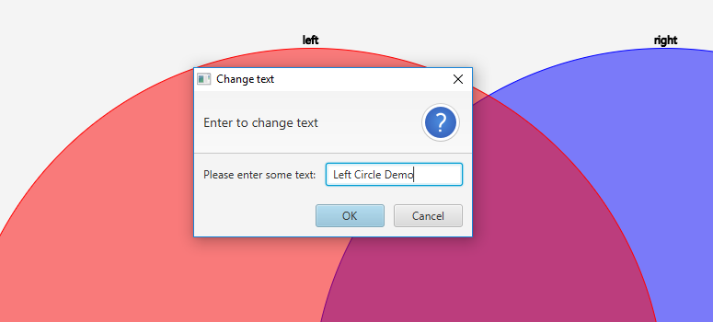

Fig: After right-clicking on the default “left”

4. Click ‘OK’.

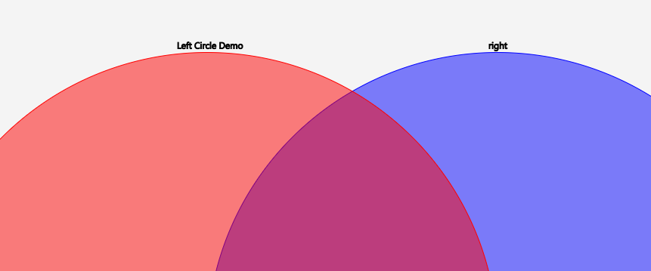

Fig: New title name for the left circle taking effect after clicking “OK”

5. The same procedure could be repeated in order to change the title name for the right circle as well

Customizing Venn Diagram Circles

# How to Customize the Circles Color

# 1. Select one of the Color Pallet buttons located at the bottom left corner of the window.

# 2. A selection of colours will open, click your preferred color for the circle.

# User Case Scenario: Making the left circles colour red

# Select the ‘Left’ Color Pallet button located at the bottom left corner of the window.

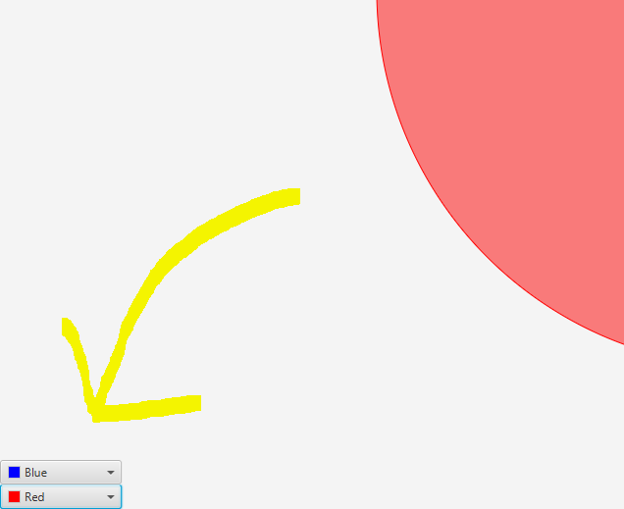

Fig: Color boxes located at the bottom-left corner of the window

# 2. A selection of colours will open, select a red colour.

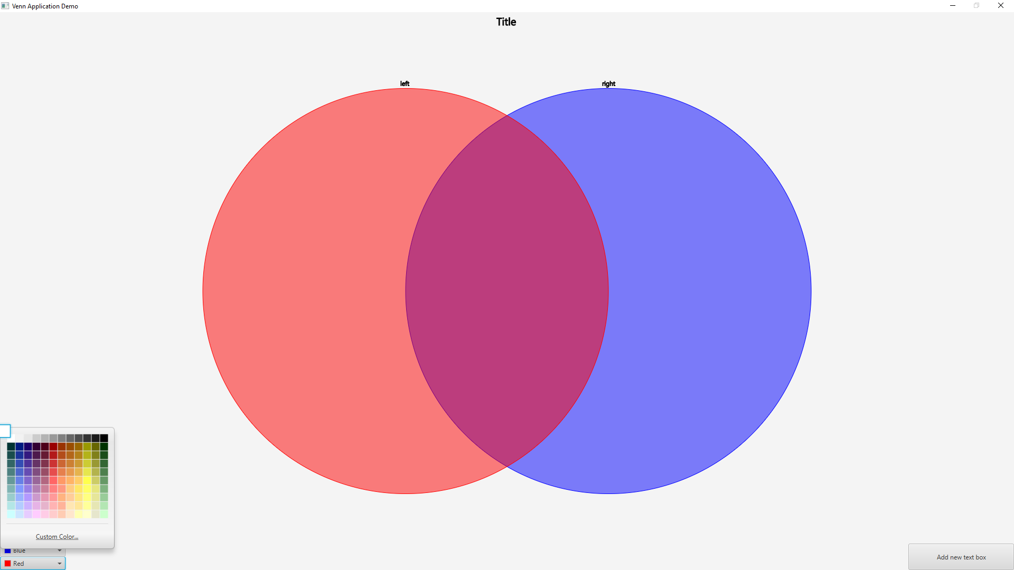

Fig: Selection of colors to choose from, after clicking on each of the boxes

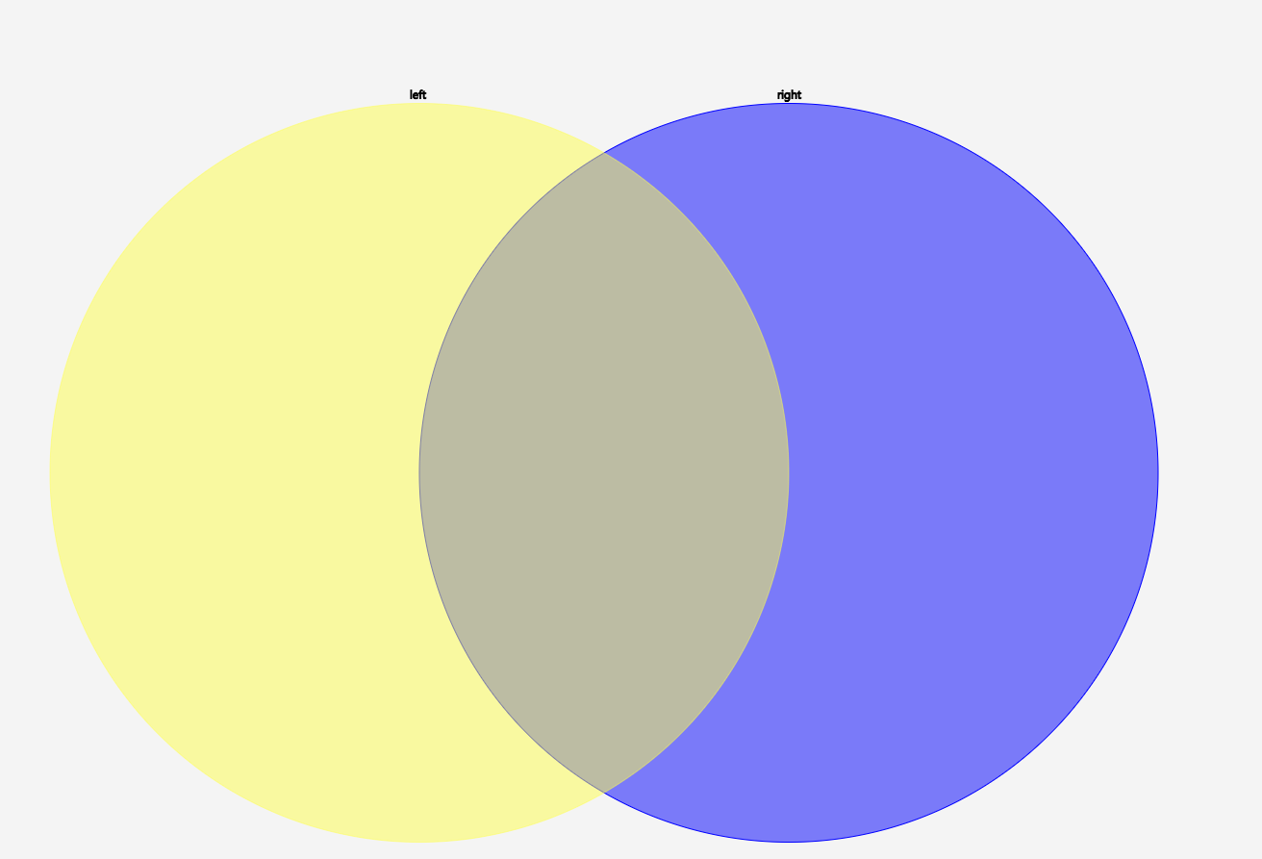

Fig: New color applied to the left circle after selection. The same procedure could be repeated in order to change the color for the right circle as well.

Customizing Text Boxes

# Adding a Text Box to the Universal List

1. Select the 'Add Text Box' button located at the bottom right of the window.

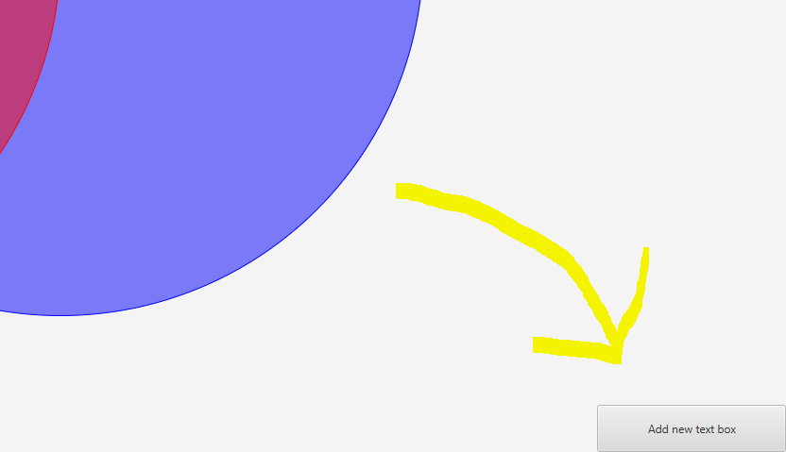

2. Text Box is added to Universal List, located at the right side of the window.

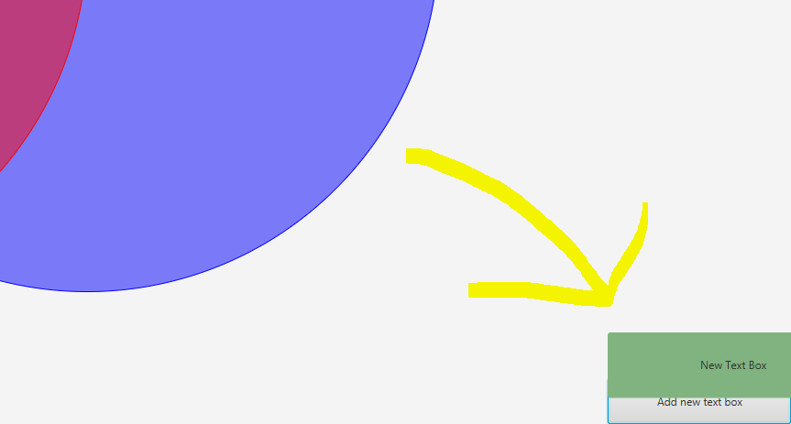

# Changing the text of a Text Box

1. Right click select a Text Box with the cursor.

2. Modify Text to user preference in the text editor window that pops up.

3. Click ‘Finish’

# User Case Scenario: Making the text of a Text Box “Text Box Demo”

1. Right click select a Text Box with the cursor.

2. Modify Text to “Text Box Demo” in the text editor window that pops up.

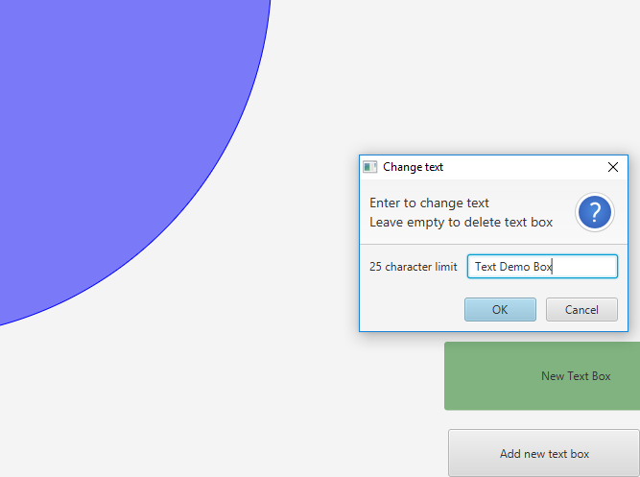

Fig: After right-clicking on the text box

3. Click ‘OK’

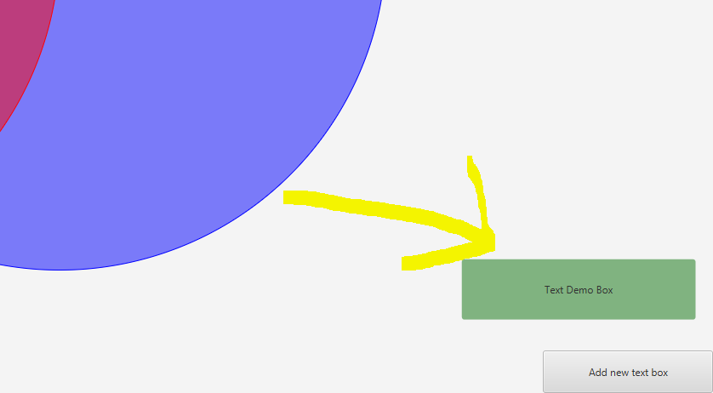

Fig: After clicking “OK”, the text box with the newly added text is formed

# Dragging a Text Box into a Venn Diagram Section

1. Select a Text Box with the cursor.

2. Keep selecting the Text Box while dragging it over to one of the three Venn Diagram Sections.

3. Drop the Text Box.

# User Case Scenario: Dragging a Text Box into the middle section of the Venn Diagram

1. Select a Text Box you want to drag over with the cursor.

2. Keep selecting the Text Box while dragging it over to the middle section, located between the two Venn Diagram circles, of the Venn Diagram.

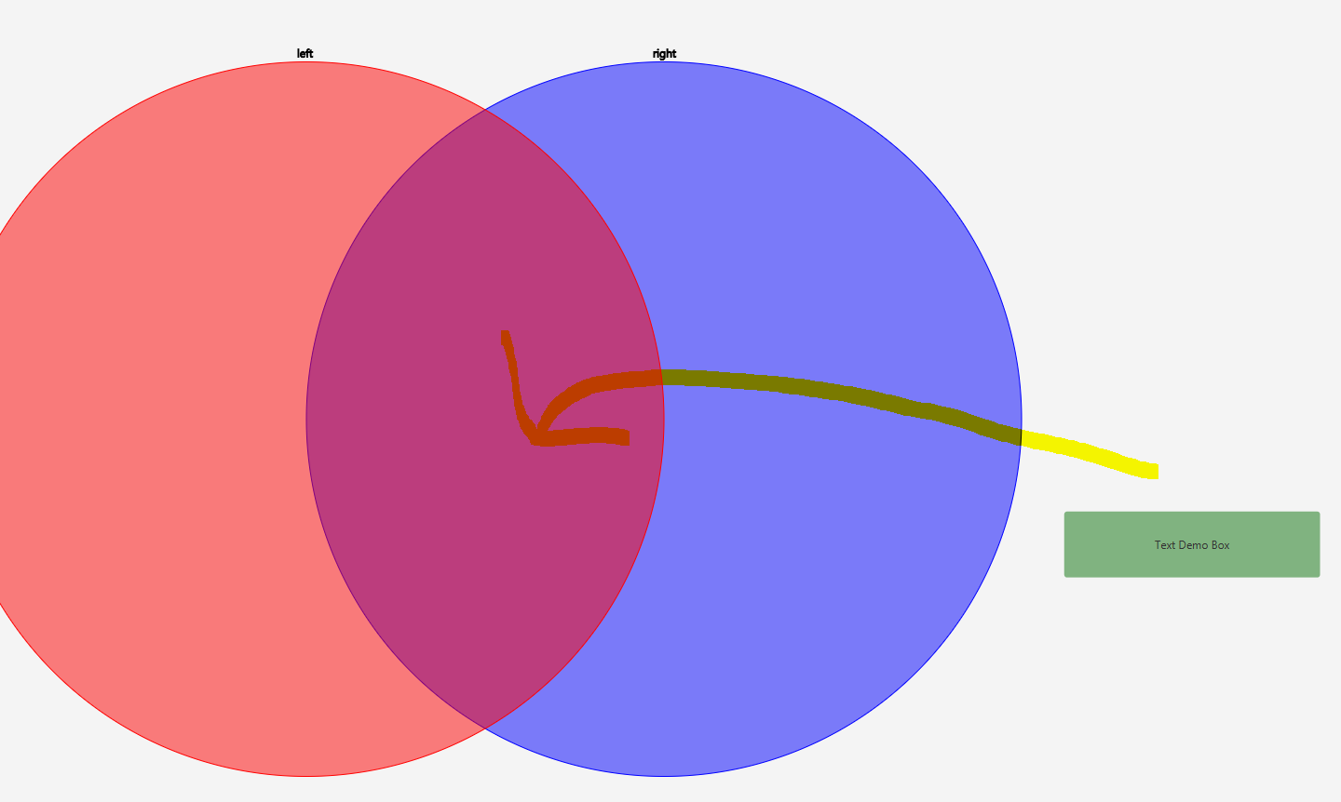

Fig: Keep dragging the box to the desired location.

3. Drop the Text Box.

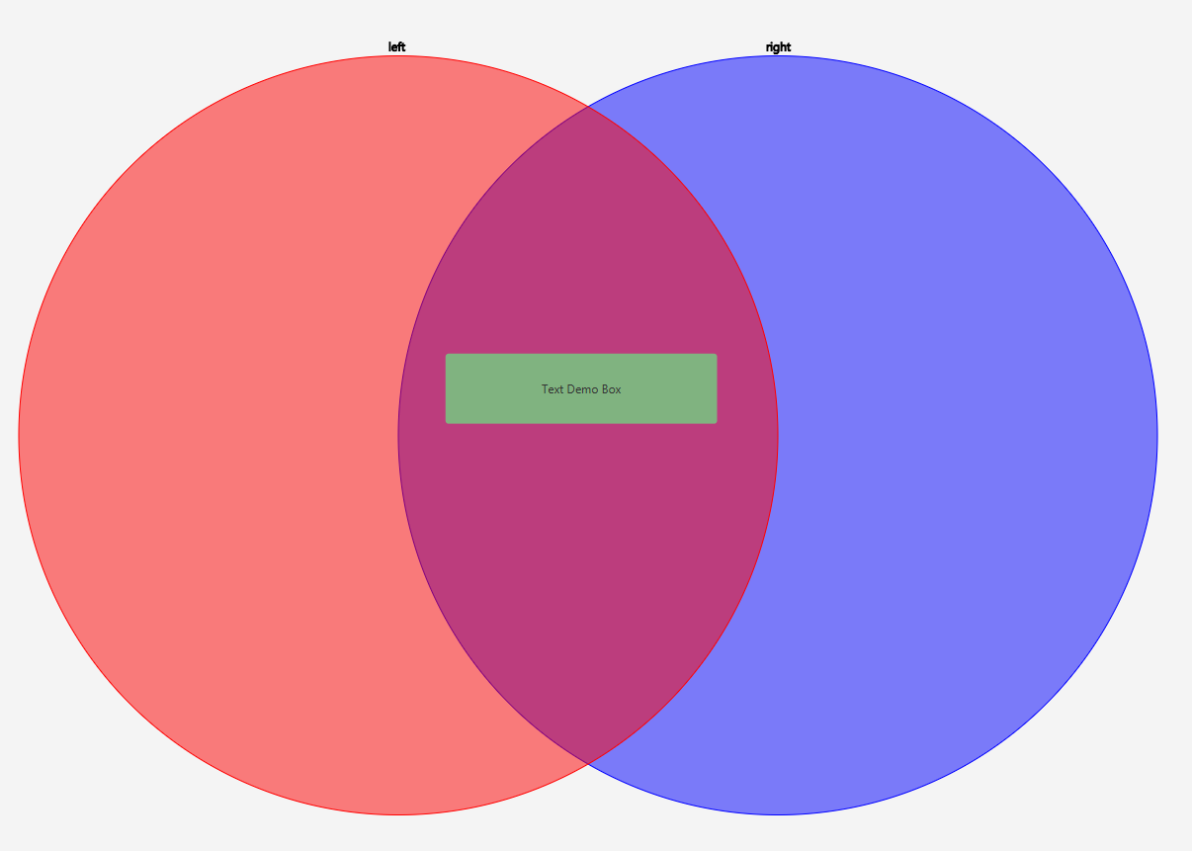

Fig: After dragging and dropping text box to desired location

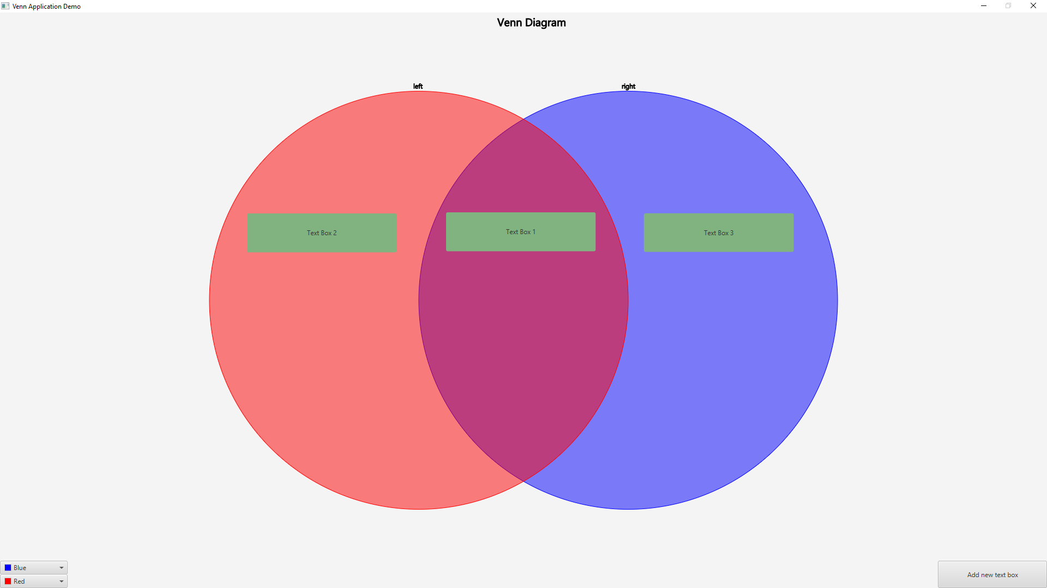

Fig: Final state of the application showcasing text boxes being dragged and dropped in the left and right circles, along with their intersections.