***Business Requirement Document***

**Document Control**

|  |  |  |
| --- | --- | --- |
| **History** | | |
| **Date** | **Version** | **Comments** |
| 01/04/2024 | 0.1 | Initial Draft |

**Table of Contents**

Contents

a. Introduction 3

1.1 Document purpose 4

1.2 Intended Audience 4

1.3 Business Goals/Objectives/Benefits to be achieved 4

1.4 Stakeholders 4

1.5 Assumptions & Constraints 4

b. Business Requirements & Process Description/Flow 4

c. Admin: 5

d. Service provider: 6

e. Service Consumer: 7

## Introduction

### Document purpose

The purpose of this document is to describe business requirements of Admin and User journey to generate business and software/system requirements acceptable to the stakeholders.

### Intended Audience

The main intended audience for this document is the business owners of the proposed system. This document should be readable by business owners of the proposed solution. Business owner must verify that their business requirements have been documented here completely, accurately and unambiguously.

Since the requirements are documented here in Technology-independent manner, the end-users of the system should be able to comprehend the requirements easily from this document

### Business Goals/Objectives/Benefits to be achieved

To describe the flows, action and powers for each user in the system. Also, to achieve full picture for all users.

### Stakeholders

|  |  |
| --- | --- |
| **#** | **Stakeholder Name** |
| 1 | Web Team |
| 2 | Back-end Team |

### Assumptions & Constraints

|  |  |
| --- | --- |
| **#** | **Key Assumptions** |
| 1 | In Order to use CRUD operations to a vehicle as an owner / agency user should have a VEHICLE_OWNER privilege |

## Business Requirements & Process Description/Flow

This section will describe all system interactions regarding user management action, power and flow for each user.

## Admin:

**Pre-defined meta-data:**

1. No sign up for the admin user
2. Admin will be created by Developer
3. Admin will have username will have a normal login screen with record of AD || ADMIN privilege.

* **Actions**
* After login admin will be routed directly to his landing dashboard and will have the below information and analytics.
* Admin will be able to view total number of Users (Active, Deleted).
* Admin will be able total number of Service providers (Active, Deleted).
* Admin will be able total number of vehicles as per there status.
* **Powers**

1. **Power on Users (Service providers – Service Consumer)**

* Admin can add any kind of user except Admin.
* Admin can list all users except (Admin) even if the user is deleted and can un-delete the user.
* Admin can sort service providers & users with the highest rates.
* Admin can list all created (service providers, users) according to filter creation date or editing date (from and to) not exceeding today.
* Admin can edit any user data except user type will be only view.
* Admin can delete (soft delete) all kind of users.
* Admin will view each user actions from the audit actions table (this screen will be shown on the view of single user view as a table of audit for each user).

1. **Power on Vehicles**

* Admin can list all vehicles.
* Admin can list all vehicle with all coming criteria (status, creation date , updated date, name) with capability of sorting by pervious criteria.
* Admin can assign list or a single vehicle to user.
* Admin can edit vehicles assigned to users by selecting the user then select a specific item from the list of vehicles assigned to user.
* Admin can delete (Soft delete) vehicles assigned to specified users if not in use.
* **Flow**

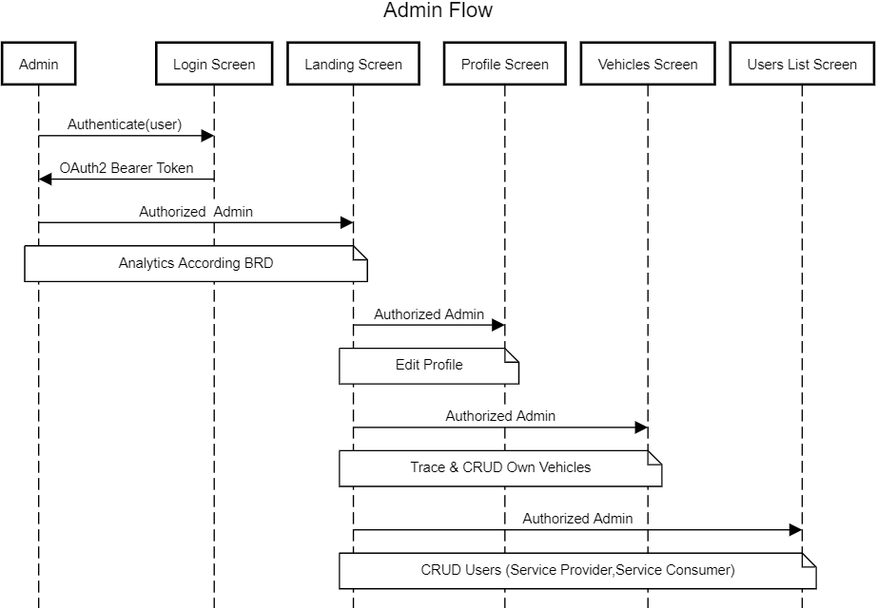

## Service provider:

This section will describe service provider.

**Pre-defined meta-data:**

1. Sign up for the service provider user from the clicking (be a service **provider) button**
2. User experience should be different from normal user journey
3. Service provider will have user name will have normal login screen with record of SP || SERVICE_PROVIDER privilege

* **Actions**
* After login service provider will be routed directly to his own landing dashboard and will have the below information and analytics.
* Service provider will be able total number of vehicles and there status.
* Service provider will be able to view top 10 high requested vehicles.
* Service provider will be able to view top 10 high rated vehicles.
* Service provider will be able to view last week analytics of service providing.
* Service provider will be able to view highest consumers and most 3 rental days.
* **Powers**

**Power on vehicles**

* Service provider can list all vehicles.
* Service provider can list all vehicle according search criteria (status, creation date, updated date, name, etc…) with capability of sorting by pervious criteria.
* Service provider can assign list or a single vehicle to user.
* Service provider can edit vehicles assigned.
* Service provider can delete (Soft delete) vehicles if not in use.
* **Flow**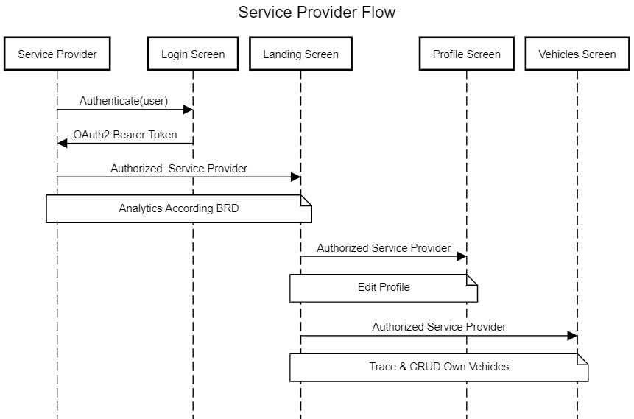

## Service Consumer:

This section will describe service Consumer.

**Pre-defined meta-data:**

1. Sign up for the service provider user from clicking **sign up** button.
2. Service provider will have user name will have normal login screen with record of SC || SERVICE_CONSUMER privilege.

* **Actions**
* After login service consumer will be routed directly to his own landing page which will contain all recommended vehicles according to past search logs analytics.
* Service consumer will see the latest vehicles added to the system.
* Service consumer will be able to view the top 10 high requested vehicles.
* Service consumer will be able to view the top 10 high rated vehicles.
* Service consumer will be able to view the latest rented vehicles.
* **Powers**

**Power on vehicles**

* Service consumer can list all vehicles.
* Service consumer can list all vehicle according search criteria (name, type, model, etc.…) with capability of sorting by pervious criteria.
* Service consumer request only one at a time vehicle.
* Service consumer can edit vehicles requested if not accepted or not delivered yet.
* **Flow**

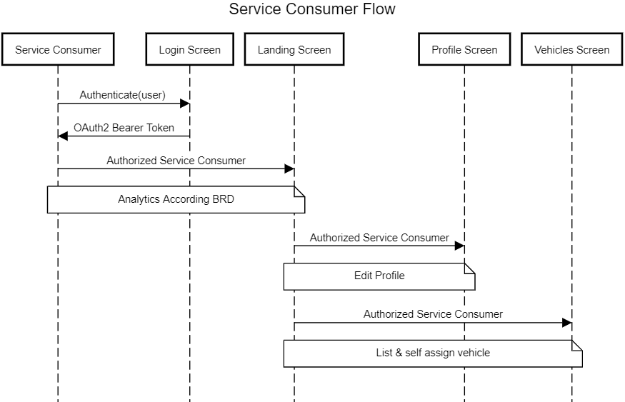

**Class Diagram:**

**Use-Case Diagram**

**ERD**

