Girouette Display System
Technical Specification

Author : Ahmed Memni
March 30, 2026

Table of Contents
1 Overview 1
2 Functional Requirements 2
3 Non-Functional Requirements 2
4 Text Handling Rules 2
5 RS232 Configuration and communication 2
6 User Interface Design 4
7 Mode Input Mapping 5
8 Display Modes 5
8.1 Mode 1: Full Screen (1 Line) 6
8.2 Mode 2: Full Screen (2 Lines) 6
8.3 Mode 3: CLEAR 6
8.4 Mode 4: Route + Text 7
8.5 Mode 5: Scrolling -text +Fixed Route 7
8.6 Mode 6: Scrolling Two screens 7
8.7 Mode 7: Blink 8
9 Error Handling 8
10 Conclusion 9

Overview
This document specifies the Girouette display system including:
- User Interface behavior
- RS232 communication protocol
- Message formatting rules

Functional Requirements
- The system shall allow selecting a display mode.
- The system shall allow entering:
  - Route number (optional depending on mode)
  - Text (1–2 lines depending on mode)
- The system shall preview the display in real time.
- The system shall generate and send RS232 messages.
- The system shall log sent messages (HEX + ASCII).

Non-Functional Requirements
- Real-time responsiveness
- Reliable serial communication
- Modular architecture
- Dark UI consistency

Text Handling Rules
- Maximum: 17 characters per line
- Padding: ASCII space (0x20)
- Charset: Letters and numbers only turned into hexadecimal ascii codes

RS232 Configuration and communication
- Port: /dev/ttyS8
- Baud rate: 9600
- Data bits: 8
- Parity: None
- Stop bits: 1
- Flow control: None
Transmission Model:
The RS232 communication is based on a continuous byte stream.
The system does not send multiple independent streams simultaneously. Instead, it sends multiple message frames sequentially over a single serial connection.
Each display update corresponds to one complete RS232 frame. When multiple updates are required, the system transmits multiple frames one after another.
Transmission behavior:
- Each message frame starts with control characters (ENQ)
- Each frame ends with an end-of-transmission marker (EOT)
- Frames are sent sequentially in the same stream
- A small delay may be introduced between frames to ensure proper processing by the receiver
Important:
- Frames must not overlap or be interleaved
- A new frame must only be sent after the previous one is fully transmitted

User Interface Design
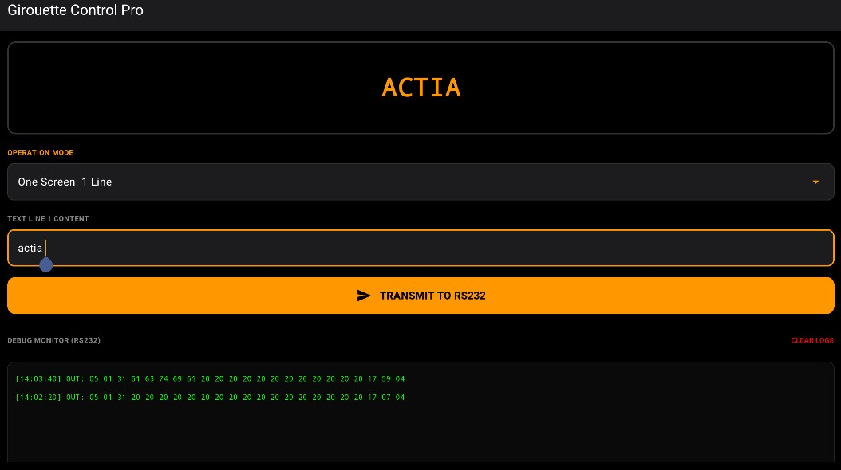
Figure 1: Girouette Screen Layout

The Girouette screen follows a structured vertical layout composed of four main sections:
- Preview Area (Top) A visual representation of the girouette display. This area updates in real time and reflects exactly how the message will appear on the physical device depending on:
  - Selected mode
  - Entered text
- Mode Selection (Slider / Selector) A horizontal selector (slider or dropdown) allowing the user to choose the display mode. Changing the mode dynamically updates:
  - The preview
  - The available input fields
- Input Fields (Dynamic) Input fields appear depending on the selected mode:
All text fields:
  - Are limited to 17 characters
  - Enforce input validation in real time
All Route fields:
  - Are limited to 3 numbers
  - Enforce input validation in real time
- RS232 Log Output (Bottom) A log box displaying the last message sent via RS232.
The log includes:
  - HEX representation
  - ASCII representation
This allows debugging and validation of transmitted data

Mode Input Mapping

Mode | Route | Text
1 | No | 1
2 | No | 2
3 | No | 0
4 | Yes | 1
5 | Yes | 1
6 | Yes | 2
7 | No | 1

Display Modes
Input Rule
All inputs will be represented using X,Y,Z,W.
Inputs are padded with spaces where needed (ASCII space = 0x20).

Mode 1: Full Screen (1 Line)
The screen displays a single full line of text across the entire display.
Preconfiguration: Text (input represented by X)
[Hex] = 05 05 41 17 4B 41 17 58 30 17 44 (Input X With Padding ASCII) 0A 20 20 20 20 20 20 20 20 20
20 20 20 20 20 20 20 20 04 30 31 38 39 35 41 34
ASCII (Example):
[ASCII] = <ENQ><ENQ> A <ETB>KA <ETB>X0 <ETB>DXXXXXXXXXXXXXXXXX <LF>
_________________ <EOT> 01895 A4

Mode 2: Full Screen (2 Lines)
The screen displays two full lines of text.
Preconfiguration: Text1 (Input represented by X) Text2 (Input represented by Y) HEX :
[Hex] = 05 05 41 17 4B 41 17 58 30 17 44 (INPUT X With Padding ASCII) 0A (INPUT Y With Padding ASCII) 04 30 32 30 35 37 41 34
ASCII (Example):
[ASCII] = <ENQ><ENQ>A <ETB>KA <ETB>X0 <ETB>DXXXXXXXXXXXXXXXXX<LF>
YYYYYYYYYYYYYYYY <EOT> 02057 A4

Mode 3: CLEAR
The screen is cleared (completely blank).
Exact messages sent:
[Hex] = 05 05 41 17 4B 41 17 58 30 17 44 20 20 20 20 20 20 20 20
20 20 20 20 20 20 20 20 20 0A 20 20 20 20 20 20 20 20 20 20
20 20 20 20 20 20 20 04 30 31 35 38 30 41 34

ASCII:
[ASCII] = <ENQ><ENQ>A <ETB>KA <ETB>X0 <ETB>D_________________ <LF>
_________________ <EOT> 01580 A4

Mode 4: Route + Text
The screen displays the route number on the left and the associated text on the right.
Preconfiguration: Route (Input represented by W) Text (Input represented by X )
HEX :
[Hex] = 05 05 41 17 58 30 17 30 30 30 30 30 17 43 17 4E 4D 31 (Input W ASCII) 18 43 17 30 32 4E 30 30 17 43 17 4E 4E 31 (Input X With Padding Ascii) 04 30 32 32 32 32 41 34
ASCII:
[ASCII] = <ENQ><ENQ> A <ETB>X0 <ETB>00000<ETB>C <ETB>NM1WWW <CAN>C <ETB>02N00<ETB>C <ETB>NN1XXXXXXXXXXXXXXXXX <EOT> 02222 A4

Mode 5: Scrolling
The screen displays a scrolling text (right to left) with a fixed route number.
Preconfiguration: Route (Input represented by W) Text (Input represented by X )
HEX :
[hex] = 05 05 41 17 58 30 17 30 30 30 30 30 17 43 17 4E 4D 31 (Input W ASCII) 18 43 17 35 31 (Input X With Padding ASCII) 04 30 33 30 34 31 41 34
ASCII:
[ASCII] = <ENQ><ENQ> A <ETB>X0 <ETB>00000<ETB>C <ETB>NM1WWW
<CAN>C<ETB>51A005E<ETB>C <ETB>NN1XXXXXXXXXXXXXXXXX<EOT> 03207 A4

Mode 6: Scrolling Two screens
The screen alternates between two scrolling screens, each containing a fixed route number and scrolling text.
Preconfiguration : Route1 (Input represented by W) Text1 (Input represented by X ) Route2 (Input represented by Z) Text2 (Input represented by Y )
HEX :
[hex] = 05 05 41 17 58 30 17 30 30 30 30 30 17 43 17 4E 4D 31 (Input W ASCII) 18 43 17 35 31 41 30 30 35 45 17 43 17 4E 4E 31 (Input X With Padding ASCII) 18 43 18 33 17 30 30 30 30 30 17 43 17 4E 4D 31 (Input Z ASCII) 18 43 17 30 32 4E 30 30 17 43 17 4E 4E 31 (INPUT Y With Padding ASCII) 18 43 18 33 04 30 34 34 32 32 41 34
ASCII:
[ASCII] = <ENQ><ENQ> A <ETB>X0 <ETB>00000<ETB>C <ETB>NM1WWW
<CAN>C<ETB>51A005E<ETB>C <ETB>NN1XXXXXXXXXXXXXXXXX <CAN>C<CAN>3
<ETB>00000<ETB>C <ETB>NM1ZZZ <CAN>C <ETB>02N00<ETB>C
<ETB>NN1YYYYYYYYYYYYYYYY <CAN>C<CAN>3 <EOT> 04422 A4

Mode 7: Blink
The screen alternates between displaying the text and a blank screen.
Preconfiguration: Text (Input represented by X )
HEX:
[hex] = 05 05 41 17 58 30 17 30 30 39 30 30 17 46 17 43 17 4E 4D
(Input X With Padding ASCII) 04 30 32 31 35 35 41 34
ASCII:
[ASCII] = <ENQ><ENQ> A <ETB>X0 <ETB>00900<ETB>F<ETB>C <ETB>NM1XXXXXXXXXXXXXXXXX <EOT> 02155 A4

Error Handling
• If serial port fails to open:
- Display error message
- Disable send button

10 Conclusion
This document fully defines:
- UI behavior
- Input constraints
- RS232 protocol
- Message examples
It serves as a complete reference for implementation and integration.

