Zewail City of Science, Technology and Innovation University of Science and Technology
School of Computational Sciences and Artificial Intelligence
CSAI 203 - Fall 2025

Introduction to Software Engineering
All-in-one AI Project Management and DevOps Platform
Software Requirements Specification (SRS) Document
Team Number: #21
Team Members:
Ahmed Mohsen Abdelsattar 202301138
Jana Ahmed Mohamed 202301800
Ali Bahaa Eldin Elrouby 202301680
Mazen Ahmed Galal 202300900
Hany Mohamed Abdulfattah 202302380

Representative Contact info: s-ahmed.mabdelsattar@zewailcity.edu.eg
Date: 6/11/2025
1. Introduction
1.1 Purpose
This Software Requirements Specification (SRS) describes the complete details of the AI Project Management System (AIPMS). AIPMS is a next-generation web-based platform that unifies the best features of Jira, ClickUp, and Azure DevOps, while introducing AI-driven tools and automation features to make project management more intelligent, efficient, and adaptive to user needs.The main purpose of AIPMS is to simplify and enhance the entire project lifecycle, from planning and task assignment to execution, monitoring, and delivery, by using artificial intelligence to analyze data, predict risks, and provide actionable insights. AIPMS aims to reduce manual effort, improve collaboration, and ensure transparency across teams and stakeholders by integrating smart functionalities. This document defines the system’s purpose, functions, features, and constraints, and will guide the design, development, and testing stages.
1.2 Scope (Problem, Objectives, Scope)
AIPMS provides a central platform for managing software projects with the help of artificial intelligence. It offers advanced features such as predicting task delays, automatic sprint planning, emotion-based workload balancing, and AI-generated reports.
It also includes integrations with:
- GitHub (for code management)
- Google Drive (for file sharing and documentation)
- Slack (for team communication)
- Email services (for notifications and summaries)
- Other project management apps (like Trello and Asana for data import/export)
Objectives:
- Improve team productivity and reduce manual work.
- Use AI to predict and avoid project risks.
- Offer real-time collaboration and communication tools.
- Provide accurate and automatic reporting.
1.3 Definitions, Acronyms, and Abbreviations
Term | Definition
AIPMS | AI Project Management System
AI | Artificial Intelligence
PM | Project Manager
API | Application Programming Interface
UI | User Interface
ML | Machine Learning

1.4 References
- IEEE Std 830-1998 – Software Requirements Specification standard.
- Jira, ClickUp, Azure DevOps documentation.
- Slack API and GitHub API official documentation.
- Official documentation for Flask, HTML5, CSS3, and ECMAScript 2020+.
1.5 Overview
Section 2 details the product’s architecture and user groups. Section 3 covers the mandatory functional and non-functional requirements, including the modeling artifacts (Use Cases and Domain Model) required for the subsequent design phase.
2. Overall Description
2.1 Product Perspective
AIPMS is a web and mobile application hosted on the cloud. It will act as a hub for project teams to collaborate, plan tasks, track progress, and gain AI-driven insights. The system connects easily with GitHub, Slack, Google Drive, and email platforms to sync all project data in one place.

2.2 Product Functions
AIPMS will include both traditional project management functions and new intelligent AI-based features:
- Create and manage projects, tasks, and sprints.
- Assign roles and permissions.
- Track task progress and project timelines.
- Integrate with GitHub for version control.
- Smart Sprint Planner: Automatically adjusts sprints when delays occur.
- Natural Language Task Creator: Converts plain text or speech into tasks.
- Effort Estimator: Predicts effort and time for new tasks.
- Chat Assistant (AI Bot): Helps users by chat commands.
- Goal Mapper: Displays visual roadmaps for long-term planning.
- (Optional) Auto-Summary Reports: Generates reports and dashboards for managers automatically.
2.3 User Classes and Characteristics (Stakeholders and Target Users)
User Class | Characteristics | Priority
Developer | Execute assigned tasks and update progress. | High
Project Manager (PM) | Focuses on process adherence, resource allocation, and reporting. | High
Administrators | Handle permissions and integrations. | Medium
Clients | View reports and results | Low

2.4 Operating Environment
- Web Browsers: Chrome, Edge, Firefox, Safari
- Server: Cloud (Azure / AWS)
- Database: PostgreSQL and MongoDB
- AI Engine: TensorFlow and PyTorch
2.5 Design and Implementation Constraints
- Technology Stack: Strict adherence to HTML, CSS, JavaScript, and Flask (Python). No reliance on any Java frameworks or compiled languages for core logic.
- Must comply with GDPR and data protection laws.
- Must be scalable for at least 10,000 users.
- AI models should provide clear explanations for results.
- Must support integrations with GitHub, Slack, Google Drive, and Email APIs.
2.6 User Documentation
- User manual (PDF and online help).
- Step-by-step onboarding tutorials.
- Video guides for AI features and integrations.
2.7 Assumptions and Dependencies
- Users have stable internet access.
- Third-party integrations (GitHub, Slack, Google Drive, Email) remain available.
- AI features depend on data volume and model accuracy.
- Deployment requires a hosting environment capable of running a Python/Flask application and a relational database.
3. Specific Requirements
3.1 Functional Requirements (FR) Detailed Description & Scenarios
This section describes in detail the functional capabilities of the AI Project Management System (AIPMS). Each functionality is supported by multiple user scenarios to illustrate its purpose and expected system behavior.
AIPMS is designed to support the complete lifecycle of project management, from planning and execution to collaboration and delivery, enhanced with AI automation, data analytics, and integrations with third-party platforms.
FR1: User Authentication and Role Management
Description:
The system must allow secure user registration and login using email, Google, or company credentials. It should support multiple roles such as Admin, Project Manager, Team Member, and Client with different permissions.
Scenarios:
- A new user signs up using their company Google account and is automatically added to the organization’s workspace.
- A project manager invites a developer by email and assigns the “Team Member” role.
- The admin restricts client users from viewing internal communication channels.
FR2: Task Creation, Editing, and Assignment
Description:
The system shall allow users to create, edit, and assign tasks within projects. Tasks include details such as title, description, assignee, priority, due date, and status.
Scenarios:
- A project manager creates a new task “Design login page” and assigns it to a frontend developer.
- A developer edits a task’s deadline and marks it as “In Review.”
- The system automatically updates task ownership when a team member is reassigned.
FR3: Automatic Sprint Adjustment
Description:
The system shall automatically adjust sprint timelines when AI predicts delays. Adjustments include rescheduling tasks and reallocating resources.
Scenarios:
- When several high-priority tasks are behind schedule, the system extends the sprint duration or shifts tasks to the next sprint.
- AI recommends reducing workload for overburdened members.
FR4: GitHub Integration
Description:
The system shall integrate with GitHub to sync commits, branches, and pull requests with corresponding tasks.
Scenarios:
- A developer commits code referencing task ID #143; AIPMS updates that task to “In Progress.”
- The system closes a task automatically once the linked pull request is merged.
FR5: Google Drive File Management
Description:
The system shall allow users to attach, access, and share files from Google Drive within each task or project.
Scenarios:
- A designer attaches the latest mockups from Google Drive.
- AIPMS automatically syncs the updated file version when changes occur in Drive.
FR6: Slack and Email Notifications
Description:
The system shall send updates, reminders, and important alerts through Slack and Email channels based on user preferences.
Scenarios:
- A team member receives a Slack message when a new task is assigned.
- The project manager gets an email summary of weekly progress.
FR7: Auto-Generated Documentation
Description:
The system shall automatically generate documentation from completed tasks, notes, and commits.
Scenarios:
- When a sprint ends, AIPMS compiles all relevant updates and produces a technical summary.
- AI converts daily task notes into a structured project document.
FR8: Customizable Light and Dark Themes
Description:
The system shall allow users to switch between light and dark UI themes for accessibility and comfort.
Scenarios:
- A user working at night switches to dark mode.
- The system remembers each user’s preferred theme across sessions.
FR9: Multilingual Support
Description:
The system shall support multiple languages to accommodate international teams.
Scenarios:
- A user selects Arabic or French as their preferred interface language.
- AI automatically translates task descriptions and notifications into the chosen language.
FR10: Admin Access Control
Description:
The system shall allow admins to manage permissions, restrict data access, and define visibility levels for each role.
Scenarios:
- The admin restricts clients from viewing internal sprint boards.
- A new user role “Intern” is added with limited editing privileges.
FR11: Project Compliance Check
Description:
The system shall verify project compliance with organizational policies and industry standards before closure.
Scenarios:
- Before marking a project as complete, AIPMS checks if all mandatory documentation and tests are finished.

FR12 (optional) : Automated Reporting
Description:
The system shall generate weekly and monthly reports summarizing project progress, team performance, and key insights automatically.
Scenarios:
- At the end of each week, a report is automatically generated and shared with the project manager.
- The report highlights overdue tasks and top contributors.
3.2 Use Case Model
3.2.1 Use Case Diagrams:
Diagram 1:
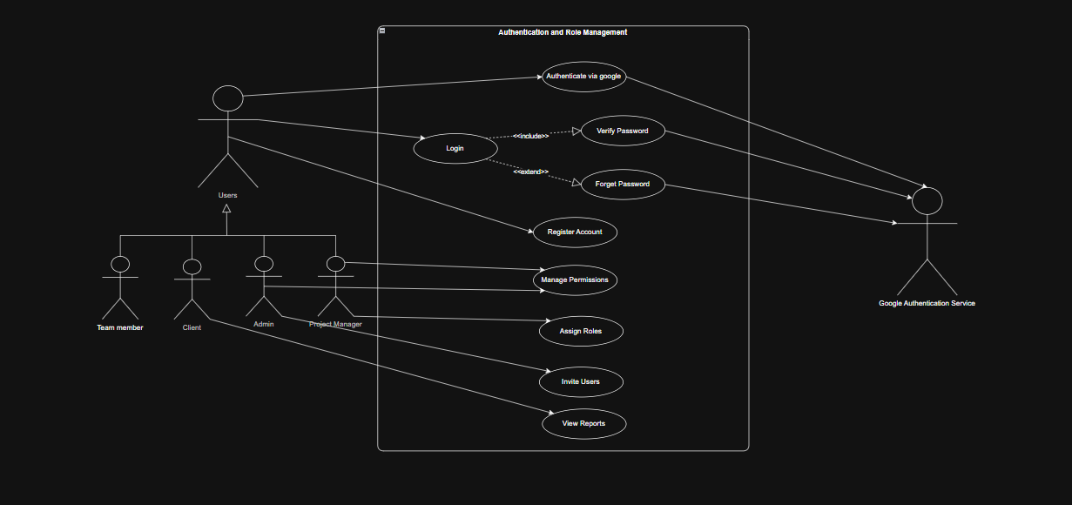
Diagram 2:
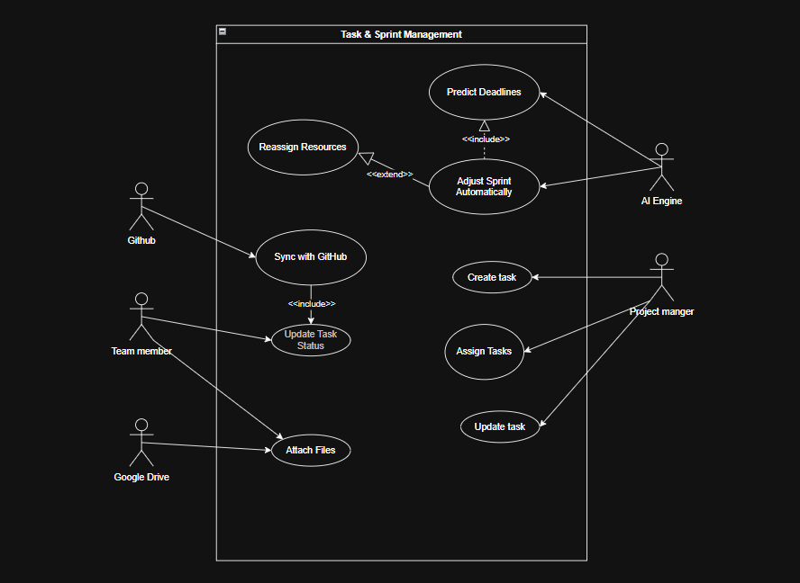
Diagram 3:
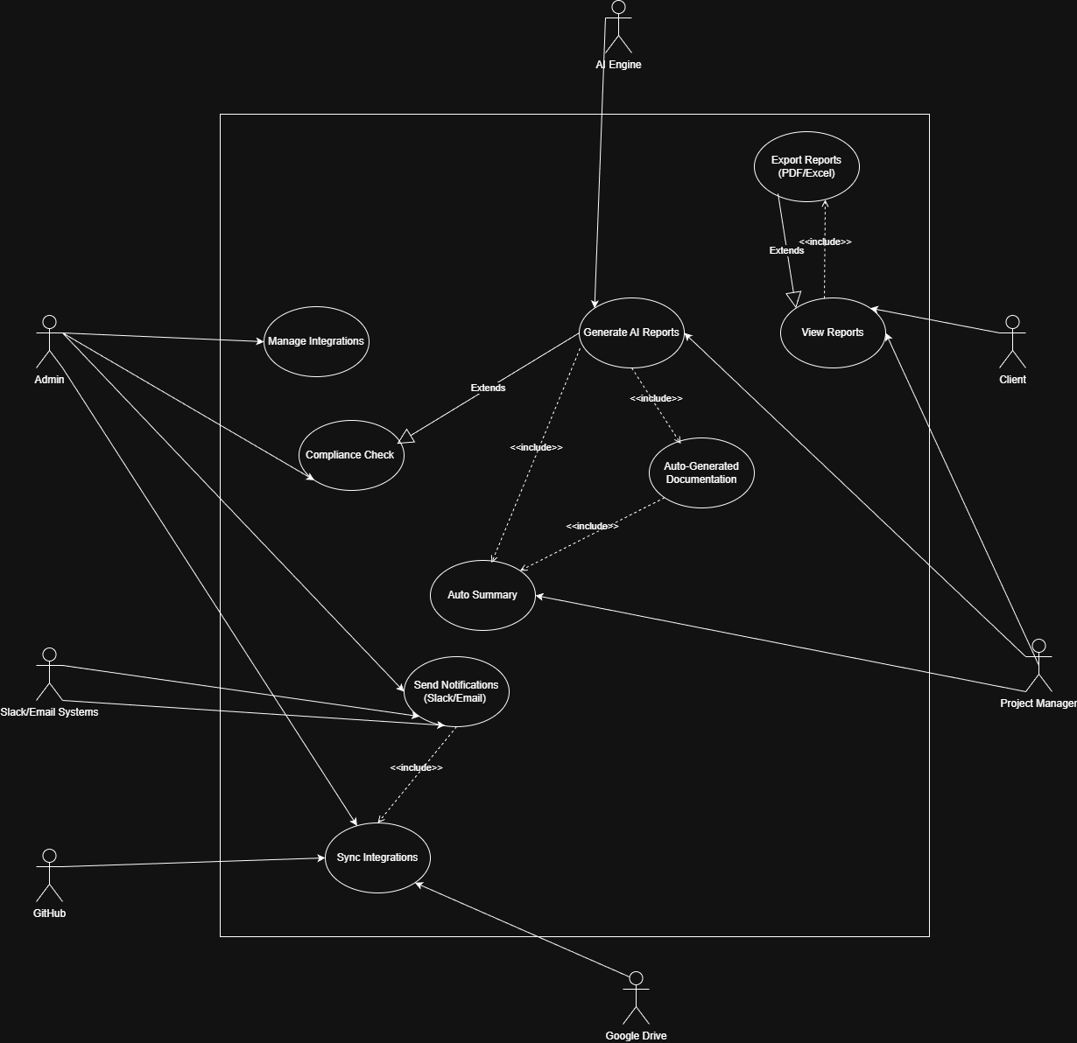
3.2.2 Use Case Descriptions (IEEE Template)
Diagram 1:
This use case diagram represents the authentication processes and role-based access control within the system. It identifies the different types of system users (Team Member, Client, Admin, Project Manager) and the actions they can perform related to accessing the system, managing accounts, and controlling permissions. The diagram also includes external integration with the Google Authentication Service.

The following use cases are defined in this diagram:

● Register Account:
Allows any User (General) to create a new account in the system.
Relationships: Initiated by User (General).

● Login:
Enables an existing User (General) to log in using valid credentials.
Relationships:
– Initiated by User (General).
– <<include>> Verify Password (password must be verified during login).
– <<extend>> Forget Password (user may optionally recover their password).

● Verify Password:
Confirms that the user’s supplied password matches stored authentication data.
Relationships: Included in Login (<<include>>).

● Forget Password:
Allows the user to reset or recover their password when they cannot remember it.
Relationships: Extends Login (<<extend>>).

● Authenticate via Google:
Provides an alternative login/registration method using the Google Authentication Service.
Relationships:
– Initiated by User (General).
– Interacts with the external Google Authentication Service actor.

● Manage Permissions:
Allows the Admin to manage and configure access rights within the system.
Relationships: Initiated by the Admin.

● Assign Roles:
Enables the Admin to assign predefined roles (Team Member, Client, Project Manager, Admin) to users.
Relationships:
– Initiated by Admin.
– Included in Manage Permissions (<<include>>).

● Invite Users:
Allows a Project Manager to invite new or existing individuals to join the system or a project.
Relationships: Initiated by Project Manager.

● View Reports:
Allows Admins or Project Managers to access system-level or project-level reports.
Relationships: Initiated by Admin or Project Manager.

Diagram 2:
This use case diagram represents the processes involved in managing tasks and sprint activities within the system. It identifies the key actors (Project Manager, Team Member, AI Engine, GitHub, Google Drive) and their interactions with task creation, assignment, updates, sprint automation, and system integrations. The diagram also highlights AI-driven decision-making and external synchronization with GitHub and cloud storage services.

The following use cases are defined in this diagram:

● Create Task:
Allows the Project Manager to create a new task by defining its details, requirements, and deadlines.
Relationships: Initiated by the Project Manager.

● Assign Tasks:
Enables the Project Manager to assign existing tasks to specific Team Members.
Relationships: Initiated by the Project Manager.

● Update Task:
Allows the Project Manager to modify existing task details such as titles, descriptions, or deadlines.
Relationships: Initiated by the Project Manager.

● Update Task Status:
Allows a Team Member to update the progress of a task (e.g., started, in progress, completed).
Relationships:
– Initiated by the Team Member.
– <<include>> Sync with GitHub (status may be updated automatically based on repository activity).

● Attach Files:
Enables a Team Member to upload and attach files to a task via integrated cloud storage.
Relationships:
– Initiated by the Team Member.
– Interacts with the external Google Drive actor.

● Sync with GitHub:
Synchronizes GitHub repository activity (commits, branches, pull requests) with the task system.
Relationships:
– Initiated by GitHub (external system).
– Included in Update Task Status (<<include>>).

● Adjust Sprint Automatically:
Uses AI insights to automatically adjust sprint timelines, workloads, or priorities.
Relationships:
– Initiated by the AI Engine.
– <<include>> Predict Deadlines.
– <<extend>> Reassign Resources (AI may optionally reallocate workloads if needed).

● Predict Deadlines:
Generates AI-based predictions for task and sprint deadlines using system analytics.
Relationships:
– Initiated by the AI Engine.
– Included in Adjust Sprint Automatically (<<include>>).

● Reassign Resources:
Automatically reallocates team members or workload when sprint conditions require adjustment.
Relationships:
– Initiated indirectly through Adjust Sprint Automatically.
– Extends Adjust Sprint Automatically (<<extend>>).

Diagram 3:
This use case diagram represents the processes involved in reporting, automated documentation, system notifications, and third-party integrations. It identifies the main actors (Project Manager, Admin, Client, AI Engine, Slack/Email Systems, Google Drive, GitHub) and their interactions with the system. The diagram highlights the system’s ability to generate AI-based reports, automate documentation, export files, and synchronize data with integrated external services.

The following use cases are defined in this diagram:

● Generate AI Reports:
Allows the Project Manager to generate detailed AI-powered reports based on project data, performance metrics, and integrated analytics.
Relationships:
– Initiated by the Project Manager.
– Interacts with the AI Engine (provides predictions and data insights).
– <<include>> Auto Summary (summary may be generated as part of the reporting process).
– <<include>> Auto-Generated Documentation (documentation may be generated automatically alongside reports).
– <<extend>> Compliance Check (an optional compliance validation may be performed).

● View Reports:
Allows the Project Manager or Client to open and view generated reports within the system.
Relationships:
– Initiated by the Project Manager or Client.
– <<include>> Export Reports (PDF/Excel) (users must view a report before exporting it).

● Export Reports (PDF/Excel):
Enables the user to export generated reports into files such as PDF or Excel for external sharing or documentation.
Relationships:
– Initiated by users who can View Reports.
– <<extend>> View Reports (exporting is an optional extension of viewing a report).

● Auto Summary:
Automatically generates a concise summary of the report’s key insights and performance data.
Relationships:
– Initiated by the Project Manager.
– <<include>> Generate AI Reports (summary generation depends on the main report generation).
– <<include>> Auto-Generated Documentation (documentation includes a mandatory summary section).

● Auto-Generated Documentation:
Creates automatically compiled documentation from the generated reports, including charts, summaries, metrics, and structured project insights.
Relationships:
– Included in Generate AI Reports (<<include>>).
– <<include>> Auto Summary (a summary must always be part of the documentation output).

● Compliance Check:
Validates whether the generated report meets required compliance or quality standards.
Relationships:
– Initiated by the Admin.
– <<extend>> Generate AI Reports (optional compliance verification step).

● Send Notifications (Slack/Email):
Allows the system to send notifications (e.g., report-ready alerts, compliance alerts) through integrated communication channels such as Slack or email.
Relationships:
– Initiated by the Admin.
– Interacts with external Slack/Email System actors.
– <<include>> Sync Integrations (sending notifications requires active integration setups).

● Sync Integrations:
Synchronizes external services such as GitHub, Google Drive, and Slack/Email with the system to maintain updated access tokens and connectivity.
Relationships:
– Initiated by the Admin.
– Interacts with GitHub, Google Drive, and Slack/Email external actors.
– Included in Send Notifications (<<include>>).

● Manage Integrations:
Allows the Admin to enable, disable, update, or configure third-party integrations used by the system.
Relationships:
– Initiated by the Admin.
– No include/extend relationships.
3.3 Domain Model
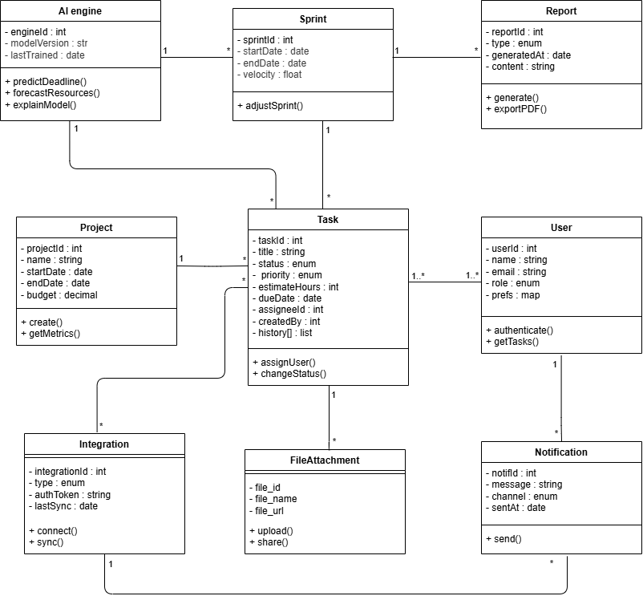
3.3.1 Conceptual Class Diagram

3.3.2 Class Descriptions
1. User
Description:
Represents any individual who interacts with the system (team member, project manager, or admin). Users are responsible for creating, assigning, and tracking tasks. Each user receives notifications and may integrate their workspace with external tools.
Attributes:
- userID : int — Unique identifier for each user.
- name : string — Full name of the user.
- email : string — User’s registered email address.
- role : string — Defines the access level (Admin, Developer, Manager, Viewer).
Methods:
- createTask() — Creates a new task under a project or sprint.
- assignTask() — Assigns a task to a team member.
- viewReport() — Views project reports.
- receiveNotification() — Handles system or integration notifications.
Relationships:
- 1..* association with Task (a user can create/own many tasks).
- 1 association with Notification (user receives notifications).
- 1..* association with Project (user participates in multiple projects).
2. Task
Description:
Represents the fundamental unit of work within a project or sprint. Tasks can be created, updated, and tracked, with AI predicting deadlines and priority adjustments.
Attributes:
- taskID : int — Unique identifier of the task.
- title : string — Short description of the task.
- description : string — Detailed information about the task.
- status : string — Task state (e.g., To Do, In Progress, Done).
- deadline : date — AI-predicted or user-defined completion date.
Methods:
- updateStatus() — Updates the current task status.
- attachFile() — Links a file or document to the task.
- linkIntegration() — Syncs related GitHub commits or external data.
Relationships:
- 1..* association with User (each task is created or assigned to one or more users).
- 1 composition with Sprint (a sprint contains multiple tasks).
- 1 aggregation with FileAttachment (a task can have attached files).
- 1 association with AI Engine (AI predicts deadlines and adjusts schedules).
3. Sprint
Description:
A defined time-boxed iteration in a project. It organizes multiple tasks and reports progress. AI models analyze velocity, predict completion, and suggest adjustments.
Attributes:
- sprintID : int — Unique sprint identifier.
- startDate : date — Sprint start date.
- endDate : date — Sprint end date.
- velocity : float — Speed of task completion based on past data.
Methods:
- addTask() — Includes a task in the sprint.
- generateSprintReport() — Produces a sprint progress report.
Relationships:
- 1..* composition with Task (each sprint contains many tasks).
- 1 association with Project (belongs to one project).
- 1 association with Report (each sprint generates reports).
- 1 association with AI Engine (AI adjusts sprint scope and duration).

4. Project
Description:
Represents a complete project in the system. Each project includes multiple sprints, tasks, and associated users.
Attributes:
- projectID : int — Unique identifier for each project.
- name : string — Project name.
- description : string — Summary of the project scope and goals.
- startDate : date — Project start date.
- endDate : date — Project completion date.
Methods:
- createSprint() — Starts a new sprint for the project.
- addMember() — Adds users to the project.
- generateProjectReport() — Compiles all reports related to this project.
Relationships:
- 1..* composition with Sprint (a project has one or more sprints).
- 1..* association with User (many users work on a project).
- 1 association with Report (reports summarize project performance).
5. Report
Description:
Provides visual and textual summaries of project or sprint performance. It can include AI analytics, risk assessments, and velocity trends.
Attributes:
- reportID : int — Unique identifier of the report.
- type : string — Report type (e.g., sprint, project, AI analysis).
- date : date — Date of report generation.
- content : string — Summary and analytics details.
Methods:
- generateReport() — Creates a report automatically.
- exportReport() — Exports reports as PDF or Excel files.
Relationships:
- 1 association with Sprint (each sprint generates one or more reports).
- 1 association with Project (summary reports per project).
6. AI Engine
Description:
Acts as the system’s intelligence core, analyzing historical data, predicting deadlines, estimating workloads, and detecting potential risks.
Attributes:
- modelVersion : string — Version of the AI model.
- lastTrained : date — Date the model was last trained.

Methods:
- predictDeadline() — Predicts task completion times.
- forecastVelocity() — Forecasts sprint completion trends.
- analyzeRisk() — Detects risks based on communication and data patterns.
Relationships:
- 1..* association with Sprint and Task (analyzes both).
- 1 association with Project (provides project-level insights).
7. Integration
Description:
Handles system connections with third-party services such as GitHub, Google Drive, Slack, and Email for data syncing and communication.
Attributes:
- integrationID : int — Unique integration record.
- serviceName : string — Name of the connected service.
- apiKey : string — Authentication key for the integration.
Methods:
- syncData() — Syncs commits, messages, or files.
- fetchData() — Retrieves information from integrated platforms.
Relationships:
- 1..* association with FileAttachment (Google Drive).
- 1..* association with Task (GitHub sync).
- 1..* association with Notification (Slack/Email updates).

8. FileAttachment
Description:
Represents any file uploaded or linked to a task (documents, reports, screenshots).
Attributes:
- fileID : int — Unique identifier.
- fileName : string — File name.
- fileURL : string — Cloud or local storage link.
Methods:
- uploadFile() — Uploads a file to the system.
- shareFile() — Shares the file with other team members.
Relationships:
- 1 aggregation with Task (a task may have many attached files).
- 1 association with Integration (Google Drive or other services).
9. Notification
Description:
Handles system alerts, task reminders, and integration updates. Notifications are sent to users via connected communication channels.
Attributes:
- notificationID : int — Unique notification ID.
- channel : string — Slack, Email, or in-app.
- message : string — Notification content.
- timestamp : datetime — Time sent.

Methods:
- sendNotification() — Delivers the notification.
- markAsRead() — Marks it as viewed by the user.
Relationships:
- 1..* association with User (users receive notifications).
- 1 dependency with Integration (uses third-party channels).

3.4 Non-Functional Requirements (Testable)
ID | Requirement | Test Plan | Success Criteria
NFR1 | Performance: UI Load Time (Client-side Rendering) | Client-Side Profiling: Use Chrome DevTools to measure the load time of the main Project Board with 500 Work Items displayed. | The First Contentful Paint (FCP) must be 2 seconds on standard corporate network conditions.
NFR2 | Performance: Flask API Latency | Load Testing (Flask Endpoint): Use locust (a Python-based load testing tool) to simulate 100 concurrent users accessing the /api/risk_analysis Flask endpoint. | The P90 latency for the AI calculation endpoint must be 300ms during the sustained load period.
NFR3 | Portability: The UI must display and function identically across Chrome, Edge, Firefox, and Safari | Cross-Browser Testing: Use automated tools (like Selenium or Cypress) to run a suite of core functional tests (task creation, sprint adjustment) on the latest stable versions of the four target browsers. | All core functional tests must pass successfully on all specified browsers, and no significant visual defects (e.g., layout breaks, overlapping text) must be observed at the minimum 360px screen width.

3.5 External Interface Requirements
3.5.1 User Interface
- Simple dashboard layout.
- Drag-and-drop task organization.
- Charts for progress, time, and budget.
- Technology: HTML5, CSS3, JavaScript.

3.5.2 Hardware Interface
No specific hardware interfaces are required for end-users beyond a modern computing device.
3.5.3 Software Interface
- GitHub API (commits, branches).
- Slack API (notifications, chat).
- Google Drive API (file upload/download).
- Email API (SMTP).
3.5.4 Communication Interface
- HTTPS for secure data transfer.
- WebSocket for live updates.
- REST APIs for third-party services.

4. Appendices
4.1 Appendix A: Data Dictionary
Field | Type | Description
user_id | Integer | Unique user ID
project_id | Integer | Unique project ID
integration_type | String | GitHub, Slack, Drive, etc.
motivation_score | Float | AI-generated engagement value
risk_level | Enum | Low, Medium, High

4.2 Appendix B: Glossary
- FCP: First Contentful Paint.
- Sprint: A short cycle of development tasks.
- Backlog: A list of upcoming or pending tasks.

