Zewail City of Science, Technology and Innovation University of Science and Technology
School of Computational Sciences and Artificial Intelligence
CSAI 203 - Fall 2025

Introduction to Software Engineering
All-in-one AI Project Management and DevOps Platform
Software Requirements Specification (SRS) Document
Team Number: #21
Team Members:
Ahmed Mohsen Abdelsattar 202301138
Jana Ahmed Mohamed 202301800
Ali Bahaa Eldin Elrouby 202301680
Mazen Ahmed Galal 202300900
Hany Mohamed Abdulfattah 202302380

Representative Contact info: s-ahmed.mabdelsattar@zewailcity.edu.eg
Date: 6/11/2025
1. Introduction
1.1 Purpose
This Software Requirements Specification (SRS) describes the complete details of the AI Project Management System (AIPMS). AIPMS is a next-generation web-based platform that unifies the best features of Jira, ClickUp, and Azure DevOps, while introducing AI-driven tools and automation features to make project management more intelligent, efficient, and adaptive to user needs.The main purpose of AIPMS is to simplify and enhance the entire project lifecycle, from planning and task assignment to execution, monitoring, and delivery, by using artificial intelligence to analyze data, predict risks, and provide actionable insights. AIPMS aims to reduce manual effort, improve collaboration, and ensure transparency across teams and stakeholders by integrating smart functionalities. This document defines the system’s purpose, functions, features, and constraints, and will guide the design, development, and testing stages.
1.2 Scope (Problem, Objectives, Scope)
AIPMS provides a central platform for managing software projects with the help of artificial intelligence. It offers advanced features such as predicting task delays, automatic sprint planning, emotion-based workload balancing, and AI-generated reports.
It also includes integrations with:
- GitHub (for code management)
- Google Drive (for file sharing and documentation)
- Slack (for team communication)
- Email services (for notifications and summaries)
- Other project management apps (like Trello and Asana for data import/export)
Objectives:
- Improve team productivity and reduce manual work.
- Use AI to predict and avoid project risks.
- Offer real-time collaboration and communication tools.
- Provide accurate and automatic reporting.
1.3 Definitions, Acronyms, and Abbreviations
Term | Definition
AIPMS | AI Project Management System
AI | Artificial Intelligence
PM | Project Manager
API | Application Programming Interface
UI | User Interface
ML | Machine Learning

1.4 References
- IEEE Std 830-1998 – Software Requirements Specification standard.
- Jira, ClickUp, Azure DevOps documentation.
- Slack API and GitHub API official documentation.
- Official documentation for Flask, HTML5, CSS3, and ECMAScript 2020+.
1.5 Overview
Section 2 details the product’s architecture and user groups. Section 3 covers the mandatory functional and non-functional requirements, including the modeling artifacts (Use Cases and Domain Model) required for the subsequent design phase.
2. Overall Description
2.1 Product Perspective
AIPMS is a web and mobile application hosted on the cloud. It will act as a hub for project teams to collaborate, plan tasks, track progress, and gain AI-driven insights. The system connects easily with GitHub, Slack, Google Drive, and email platforms to sync all project data in one place.

2.2 Product Functions
AIPMS will include both traditional project management functions and new intelligent AI-based features:
- Create and manage projects, tasks, and sprints.
- Assign roles and permissions.
- Track task progress and project timelines.
- Integrate with GitHub for version control.
- Smart Sprint Planner: Automatically adjusts sprints when delays occur.
- Natural Language Task Creator: Converts plain text or speech into tasks.
- Effort Estimator: Predicts effort and time for new tasks.
- Auto-Summary Reports: Generates reports and dashboards for managers automatically.
- Chat Assistant (AI Bot): Helps users by chat commands.
- Goal Mapper: Displays visual roadmaps for long-term planning.
2.3 User Classes and Characteristics (Stakeholders and Target Users)
User Class | Characteristics | Priority
Developer | Execute assigned tasks and update progress. | High
Project Manager (PM) | Focuses on process adherence, resource allocation, and reporting. | High
Administrators | Handle permissions and integrations. | Medium
Clients | View reports and results | Low

2.4 Operating Environment
- Web Browsers: Chrome, Edge, Firefox, Safari
- Server: Cloud (Azure / AWS)
- Database: PostgreSQL and MongoDB
- AI Engine: TensorFlow and PyTorch

2.5 Design and Implementation Constraints
- Technology Stack: Strict adherence to HTML, CSS, JavaScript, and Flask (Python). No reliance on any Java frameworks or compiled languages for core logic.
- Must comply with GDPR and data protection laws.
- Must be scalable for at least 10,000 users.
- AI models should provide clear explanations for results.
- Must support integrations with GitHub, Slack, Google Drive, and Email APIs.
2.6 User Documentation
- User manual (PDF and online help).
- Step-by-step onboarding tutorials.
- Video guides for AI features and integrations.
2.7 Assumptions and Dependencies
- Users have stable internet access.
- Third-party integrations (GitHub, Slack, Google Drive, Email) remain available.
- AI features depend on data volume and model accuracy.
- Deployment requires a hosting environment capable of running a Python/Flask application and a relational database.
3. Specific Requirements
3.1 Functional Requirements (FR) Detailed Description & Scenarios
This section describes in detail the functional capabilities of the AI Project Management System (AIPMS). Each functionality is supported by multiple user scenarios to illustrate its purpose and expected system behavior.
AIPMS is designed to support the complete lifecycle of project management, from planning and execution to collaboration and delivery, enhanced with AI automation, data analytics, and integrations with third-party platforms.

FR1: User Authentication and Role Management
Description:
The system must allow secure user registration and login using email, Google, or company credentials. It should support multiple roles such as Admin, Project Manager, Team Member, and Client with different permissions.
Scenarios:
- A new user signs up using their company Google account and is automatically added to the organization’s workspace.
- A project manager invites a developer by email and assigns the “Team Member” role.
- The admin restricts client users from viewing internal communication channels.
FR2: Task Creation, Editing, and Assignment
Description:
The system shall allow users to create, edit, and assign tasks within projects. Tasks include details such as title, description, assignee, priority, due date, and status.
Scenarios:
- A project manager creates a new task “Design login page” and assigns it to a frontend developer.
- A developer edits a task’s deadline and marks it as “In Review.”
- The system automatically updates task ownership when a team member is reassigned.
FR3: Automatic Sprint Adjustment
Description:
The system shall automatically adjust sprint timelines when AI predicts delays. Adjustments include rescheduling tasks and reallocating resources.
Scenarios:
- When several high-priority tasks are behind schedule, the system extends the sprint duration or shifts tasks to the next sprint.
- AI recommends reducing workload for overburdened members.

FR4: GitHub Integration
Description:
The system shall integrate with GitHub to sync commits, branches, and pull requests with corresponding tasks.
Scenarios:
- A developer commits code referencing task ID #143; AIPMS updates that task to “In Progress.”
- The system closes a task automatically once the linked pull request is merged.
FR5: Google Drive File Management
Description:
The system shall allow users to attach, access, and share files from Google Drive within each task or project.
Scenarios:
- A designer attaches the latest mockups from Google Drive.
- AIPMS automatically syncs the updated file version when changes occur in Drive.
FR6: Slack and Email Notifications
Description:
The system shall send updates, reminders, and important alerts through Slack and Email channels based on user preferences.
Scenarios:
- A team member receives a Slack message when a new task is assigned.
- The project manager gets an email summary of weekly progress.
FR7: Automated Reporting
Description:
The system shall generate weekly and monthly reports summarizing project progress, team performance, and key insights automatically.
Scenarios:
- At the end of each week, a report is automatically generated and shared with the project manager.
- The report highlights overdue tasks and top contributors.
FR8: Auto-Generated Documentation
Description:
The system shall automatically generate documentation from completed tasks, notes, and commits.
Scenarios:
- When a sprint ends, AIPMS compiles all relevant updates and produces a technical summary.
- AI converts daily task notes into a structured project document.
FR9: Customizable Light and Dark Themes
Description:
The system shall allow users to switch between light and dark UI themes for accessibility and comfort.
Scenarios:
- A user working at night switches to dark mode.
- The system remembers each user’s preferred theme across sessions.
FR10: Multilingual Support
Description:
The system shall support multiple languages to accommodate international teams.
Scenarios:
- A user selects Arabic or French as their preferred interface language.
- AI automatically translates task descriptions and notifications into the chosen language.
FR11: Admin Access Control
Description:
The system shall allow admins to manage permissions, restrict data access, and define visibility levels for each role.
Scenarios:
- The admin restricts clients from viewing internal sprint boards.
- A new user role “Intern” is added with limited editing privileges.

FR12: Project Compliance Check
Description:
The system shall verify project compliance with organizational policies and industry standards before closure.
Scenarios:
- Before marking a project as complete, AIPMS checks if all mandatory documentation and tests are finished.
3.2 Use Case Model
3.2.1 Use Case Diagrams:
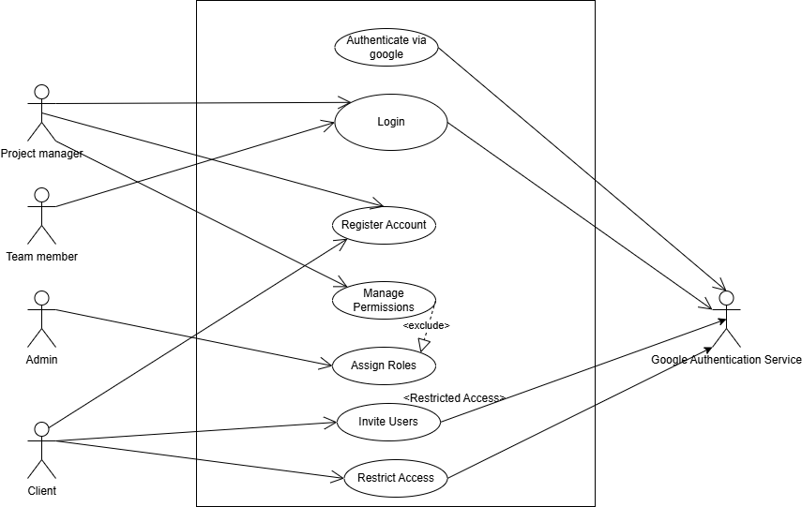
Diagram 1:

Diagram 2:
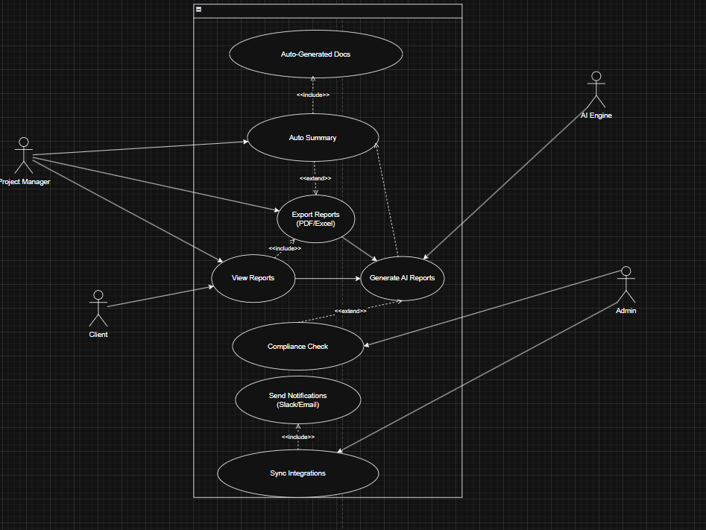

Diagram 3:

3.2.2 Use Case Descriptions (IEEE Template)
Diagram 1:
This use case diagram illustrates the processes involved in user authentication, registration, and high-level access control within the system. It defines the different types of users (actors) and their specific capabilities related to managing accounts and system permissions. The primary functions covered include user login/registration, integration with external authentication services (Google), and the administrative tasks of managing user roles and permissions.
The following use cases are defined within this diagram:
- Register Account:
  - Description: This use case allows a new User (General) to create a new account in the system.
  - Relationships: Interacts with User (General).
- Login:
  - Description: This use case allows an existing User (General) to gain access to the system by providing valid credentials.
  - Relationships: Interacts with User (General).
- Authenticate via Google:
  - Description: This use case allows a User (General) to register or log in using their existing Google account credentials. It provides an alternative to the standard email/password method.
  - Relationships:
    - This use case is triggered during the Login or Register Account process.
    - It is initiated by the User (General).
    - It interacts directly with the external Google Authentication Service actor to validate the user's identity.
- Invite Users:
  - Description: This use case enables a Project Manager to send invitations to new or existing individuals to join the system and be added to a project, typically as a Team Member or Client.
  - Relationships: Initiated by the Project Manager.
- Manage Permissions:
  - Description: This is the primary use case for the Admin to control system-wide access. It allows the Admin to define and modify what different roles (e.g., Project Manager, Team Member) can see and do within the application.
  - Relationships:
    - Initiated by the Admin.
- Assign Roles:
  - Description: This use case allows the Admin to assign a specific role (e.g., Admin, Project Manager) to a user account, thereby granting them a pre-defined set of permissions.
  - Relationships:
    - Initiated by the Admin.
    - <<include>>: This functionality is included as a mandatory part of the Manage Permissions use case. An Admin must be able to assign roles to effectively manage permissions.
- Restrict Access:
  - Description: This use case allows an Admin to apply specific, granular restrictions to a user or role, overriding default permissions. This is used for exceptional cases where access needs to be limited.
  - Relationships:
    - Initiated by the Admin.
    - <<extend>>: This is an optional extension of the Manage Permissions use case. The admin may choose to perform this action while managing permissions, but it is not a mandatory step.
Diagram 2:
This case diagram illustrates the processes for an AI Reporting System. It defines the different types of users (actors) and their specific capabilities related to generating, viewing, and managing automated reports. The primary functions covered include report generation, data summarization, compliance checks, and system notifications.
The following use cases are defined within this diagram:
Generate AI Reports
- Description: This is the central use case of the system. It allows a user to create complex reports based on data provided by the AI Engine.
- Relationships:
  - Initiated by the Project Manager.
  - Interacts with the AI Engine (actor), which provides the data for the report.
  - Can be optionally extended by the Auto Summary use case.
  - Can be optionally extended by the Compliance Check use case.
View Reports
- Description: This use case allows users to access and read generated reports within the system.
- Relationships:
  - Initiated by the Project Manager.
  - Also initiated by the Client.
  - <<include>>: This functionality is included as a mandatory part of the Export Reports use case.
Auto Summary
- Description: This use case creates a condensed, high-level summary of a full report.
- Relationships:
  - Initiated by the Project Manager.
  - <<extend>>: This is an optional extension of the Generate AI Reports use case. The Project Manager may choose to add a summary during report generation, but it is not a mandatory step.
  - <<include>>: This functionality is included as a mandatory part of the Auto-Generated Docs use case.
Auto-Generated Docs
- Description: This use case involves creating a full documentation set automatically, based on the report data.
- Relationships:
  - <<include>>: This use case must include the functionality of Auto Summary as part of its process.
  - (This use case is initiated through its relationship with Auto Summary).
Export Reports (PDF/Excel)
- Description: This use case allows a user to download a report in a specific file format, such as PDF or Excel.
- Relationships:
  - <<include>>: This use case must include the functionality of View Reports (a user must view or access a report to export it).
  - (This use case is initiated by a user who can View Reports, i.e., a Project Manager or Client).
Compliance Check
- Description: This use case allows an Admin to run a check against a report to ensure it meets specific compliance standards or regulations.
- Relationships:
  - Initiated by the Admin.
  - <<extend>>: This is an optional extension of the Generate AI Reports use case. An Admin may choose to run this check, but it is not a mandatory part of report generation.
Sync Integrations
- Description: This use case allows an Admin to manage and authenticate the connections to third-party services, such as Slack or email clients.
- Relationships:
  - Initiated by the Admin.
  - <<include>>: This functionality is included as a mandatory part of the Send Notifications use case.
Send Notifications (Slack/Email)
- Description: This use case allows the Admin to configure and send out system notifications, such as when a report is ready or a check is complete.
- Relationships:
  - Initiated by the Admin.
  - <<include>>: This use case must include the Sync Integrations functionality to know where and how to send the notifications.

Diagram 3:
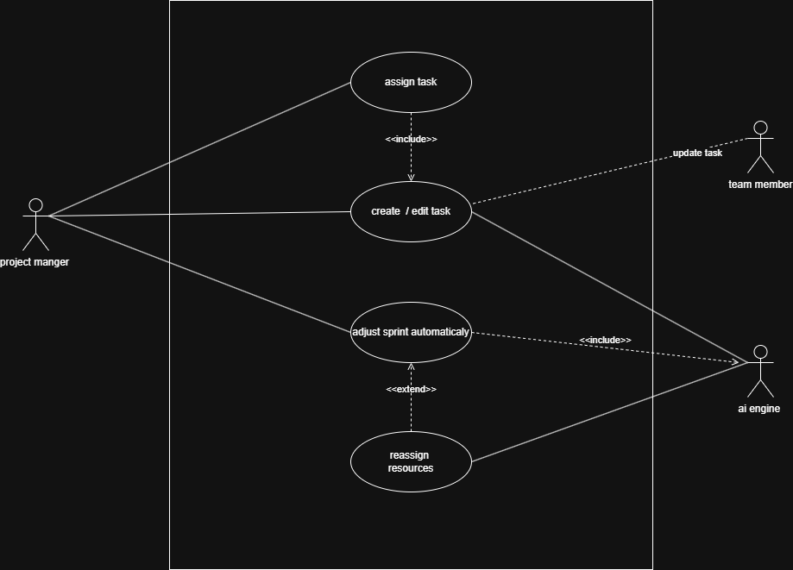

This use case diagram illustrates the processes involved in managing project tasks, sprints, and automated scheduling using AI. It defines how different actors—such as the Project Manager, Team Members, and AI Engine—interact with the system to create, update, and optimize tasks. The diagram also includes integration with external services like Google Drive and GitHub for file attachment and version control synchronization.
The primary functions covered include creating and editing tasks, assigning responsibilities, updating task statuses, AI-driven sprint adjustments, and automated reporting.

Defined Use Cases

Create / Edit Task
Description:
This use case allows a Project Manager or Team Member to create new tasks or edit existing ones. The tasks can include details such as title, description, priority, due date, and assigned team members.
Relationships:
- Initiated by the Project Manager or Team Member.
- <<include>>: The “Attach Files” use case is included as part of task creation or editing (optional attachment functionality).
- <<include>>: The “Sync with GitHub” use case may be triggered automatically when the task is linked to a code repository.

Assign Task
Description:
This use case enables the Project Manager to assign created tasks to specific Team Members (Developers or Designers).
Relationships:
- Initiated by the Project Manager.
- <<include>>: Works closely with “Create / Edit Task,” as a task must exist before assignment.

Update Task Status
Description:
This use case allows Team Members to update the progress of their assigned tasks (e.g., from “To Do” to “In Progress” or “Completed”).
Relationships:
- Initiated by the Team Member.
- <<include>>: The “Sync with GitHub” use case ensures that task progress updates correspond with commits or pull requests in the linked repository.

Attach Files (Google Drive)
Description:
This use case enables users to attach relevant files or documents from Google Drive to a task.
Relationships:
- Initiated by Project Manager or Team Member.
- Interacts with the external actor Google Drive.
- <<include>>: This functionality is included as part of the “Create / Edit Task” use case.

Sync with GitHub
Description:
This use case synchronizes task data and code-related updates between the project management system and GitHub. It ensures real-time reflection of development progress.
Relationships:
- Initiated by the system automatically or by a Team Member.
- Interacts with the GitHub external actor.
- <<include>>: This use case is included in “Update Task Status” and “Create / Edit Task.”

Adjust Sprint Automatically
Description:
This use case leverages the AI Engine to automatically adjust sprint timelines, task priorities, and resource allocation based on project progress, team velocity, and deadlines.
Relationships:
- Initiated by the AI Engine or triggered by the Project Manager.
- <<include>>: This use case includes “Predict Deadlines.”
- <<extend>>: This use case may extend “Reassign Resources” if a scheduling conflict or delay is detected.
- Interacts directly with the AI Engine actor.

Predict Deadlines
Description:
This use case allows the AI Engine to analyze task data and historical patterns to predict realistic completion dates for tasks or entire sprints.
Relationships:
- Initiated by the AI Engine.
- <<include>>: Included as a mandatory part of the “Adjust Sprint Automatically” use case.

Reassign Resources
Description:
This use case enables the Project Manager or the AI Engine to redistribute tasks among Team Members when workload imbalance or delays are identified.
Relationships:
- Initiated by the Project Manager or AI Engine.
- <<extend>>: This functionality is an optional extension of “Adjust Sprint Automatically.” It is performed when sprint optimization identifies inefficiencies.

Generate Sprint Report
Description:
This use case allows the Project Manager to generate detailed sprint performance reports. Reports may include completed tasks, pending issues, and time efficiency analytics.
Relationships:
- Initiated by the Project Manager.
- May use data generated by the AI Engine (predicted vs. actual performance).

3.3 Domain Model
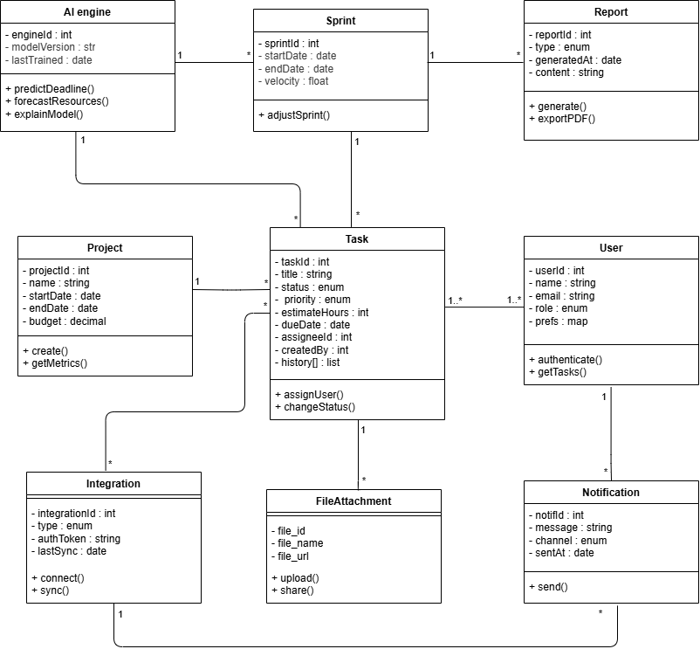
3.3.1 Conceptual Class Diagram

3.3.2 Class Descriptions
1. User
Description:
Represents any individual who interacts with the system (team member, project manager, or admin). Users are responsible for creating, assigning, and tracking tasks. Each user receives notifications and may integrate their workspace with external tools.
Attributes:
- userID : int — Unique identifier for each user.
- name : string — Full name of the user.
- email : string — User’s registered email address.
- role : string — Defines the access level (Admin, Developer, Manager, Viewer).
Methods:
- createTask() — Creates a new task under a project or sprint.
- assignTask() — Assigns a task to a team member.
- viewReport() — Views project reports.
- receiveNotification() — Handles system or integration notifications.
Relationships:
- 1..* association with Task (a user can create/own many tasks).
- 1 association with Notification (user receives notifications).
- 1..* association with Project (user participates in multiple projects).
2. Task
Description:
Represents the fundamental unit of work within a project or sprint. Tasks can be created, updated, and tracked, with AI predicting deadlines and priority adjustments.
Attributes:
- taskID : int — Unique identifier of the task.
- title : string — Short description of the task.
- description : string — Detailed information about the task.
- status : string — Task state (e.g., To Do, In Progress, Done).
- deadline : date — AI-predicted or user-defined completion date.
Methods:
- updateStatus() — Updates the current task status.
- attachFile() — Links a file or document to the task.
- linkIntegration() — Syncs related GitHub commits or external data.
Relationships:
- 1..* association with User (each task is created or assigned to one or more users).
- 1 composition with Sprint (a sprint contains multiple tasks).
- 1 aggregation with FileAttachment (a task can have attached files).
- 1 association with AI Engine (AI predicts deadlines and adjusts schedules).
3. Sprint
Description:
A defined time-boxed iteration in a project. It organizes multiple tasks and reports progress. AI models analyze velocity, predict completion, and suggest adjustments.
Attributes:
- sprintID : int — Unique sprint identifier.
- startDate : date — Sprint start date.
- endDate : date — Sprint end date.
- velocity : float — Speed of task completion based on past data.
Methods:
- addTask() — Includes a task in the sprint.
- generateSprintReport() — Produces a sprint progress report.
Relationships:
- 1..* composition with Task (each sprint contains many tasks).
- 1 association with Project (belongs to one project).
- 1 association with Report (each sprint generates reports).
- 1 association with AI Engine (AI adjusts sprint scope and duration).
4. Project
Description:
Represents a complete project in the system. Each project includes multiple sprints, tasks, and associated users.
Attributes:
- projectID : int — Unique identifier for each project.
- name : string — Project name.
- description : string — Summary of the project scope and goals.
- startDate : date — Project start date.
- endDate : date — Project completion date.
Methods:
- createSprint() — Starts a new sprint for the project.
- addMember() — Adds users to the project.
- generateProjectReport() — Compiles all reports related to this project.
Relationships:
- 1..* composition with Sprint (a project has one or more sprints).
- 1..* association with User (many users work on a project).
- 1 association with Report (reports summarize project performance).
5. Report
Description:
Provides visual and textual summaries of project or sprint performance. It can include AI analytics, risk assessments, and velocity trends.
Attributes:
- reportID : int — Unique identifier of the report.
- type : string — Report type (e.g., sprint, project, AI analysis).
- date : date — Date of report generation.
- content : string — Summary and analytics details.
Methods:
- generateReport() — Creates a report automatically.
- exportReport() — Exports reports as PDF or Excel files.
Relationships:
- 1 association with Sprint (each sprint generates one or more reports).
- 1 association with Project (summary reports per project).
6. AI Engine
Description:
Acts as the system’s intelligence core, analyzing historical data, predicting deadlines, estimating workloads, and detecting potential risks.
Attributes:
- modelVersion : string — Version of the AI model.
- lastTrained : date — Date the model was last trained.

Methods:
- predictDeadline() — Predicts task completion times.
- forecastVelocity() — Forecasts sprint completion trends.
- analyzeRisk() — Detects risks based on communication and data patterns.
Relationships:
- 1..* association with Sprint and Task (analyzes both).
- 1 association with Project (provides project-level insights).
7. Integration
Description:
Handles system connections with third-party services such as GitHub, Google Drive, Slack, and Email for data syncing and communication.
Attributes:
- integrationID : int — Unique integration record.
- serviceName : string — Name of the connected service.
- apiKey : string — Authentication key for the integration.
Methods:
- syncData() — Syncs commits, messages, or files.
- fetchData() — Retrieves information from integrated platforms.
Relationships:
- 1..* association with FileAttachment (Google Drive).
- 1..* association with Task (GitHub sync).
- 1..* association with Notification (Slack/Email updates).

8. FileAttachment
Description:
Represents any file uploaded or linked to a task (documents, reports, screenshots).
Attributes:
- fileID : int — Unique identifier.
- fileName : string — File name.
- fileURL : string — Cloud or local storage link.
Methods:
- uploadFile() — Uploads a file to the system.
- shareFile() — Shares the file with other team members.
Relationships:
- 1 aggregation with Task (a task may have many attached files).
- 1 association with Integration (Google Drive or other services).
9. Notification
Description:
Handles system alerts, task reminders, and integration updates. Notifications are sent to users via connected communication channels.
Attributes:
- notificationID : int — Unique notification ID.
- channel : string — Slack, Email, or in-app.
- message : string — Notification content.
- timestamp : datetime — Time sent.

Methods:
- sendNotification() — Delivers the notification.
- markAsRead() — Marks it as viewed by the user.
Relationships:
- 1..* association with User (users receive notifications).
- 1 dependency with Integration (uses third-party channels).

3.4 Non-Functional Requirements (Testable)
ID | Requirement | Test Plan | Success Criteria
NFR1 | Performance: UI Load Time (Client-side Rendering) | Client-Side Profiling: Use Chrome DevTools to measure the load time of the main Project Board with 500 Work Items displayed. | The First Contentful Paint (FCP) must be 2 seconds on standard corporate network conditions.
NFR2 | Performance: Flask API Latency | Load Testing (Flask Endpoint): Use locust (a Python-based load testing tool) to simulate 100 concurrent users accessing the /api/risk_analysis Flask endpoint. | The P90 latency for the AI calculation endpoint must be 300ms during the sustained load period.
NFR3 | Usability: Error Feedback | Manual Testing: QA testers intentionally trigger validation errors (e.g., leaving a mandatory field blank/ | Error messages must be displayed within the context of the user action, be human-readable, and explain how to resolve the error (not just state failure).

3.5 External Interface Requirements
3.5.1 User Interface
- Simple dashboard layout.
- Drag-and-drop task organization.
- Charts for progress, time, and budget.
- Technology: HTML5, CSS3, JavaScript.

3.5.2 Hardware Interface
No specific hardware interfaces are required for end-users beyond a modern computing device.
3.5.3 Software Interface
- GitHub API (commits, branches).
- Slack API (notifications, chat).
- Google Drive API (file upload/download).
- Email API (SMTP).
3.5.4 Communication Interface
- HTTPS for secure data transfer.
- WebSocket for live updates.
- REST APIs for third-party services.
4. Appendices
4.1 Appendix A: Data Dictionary
Field | Type | Description
user_id | Integer | Unique user ID
project_id | Integer | Unique project ID
integration_type | String | GitHub, Slack, Drive, etc.
motivation_score | Float | AI-generated engagement value
risk_level | Enum | Low, Medium, High

4.2 Appendix B: Glossary
- FCP: First Contentful Paint.
- Sprint: A short cycle of development tasks.
- Backlog: A list of upcoming or pending tasks.

