**Q1.**

Code:

|  |
| --- |
| ***package Q_01;  import javax.swing.*;  public class Q_01 {  public static void main(String[] args) {   JFrame window = new JFrame();  window.setTitle("Welcome to Java");  window.setSize(800,600);  window.setVisible(true);  } }*** |

**Output:**

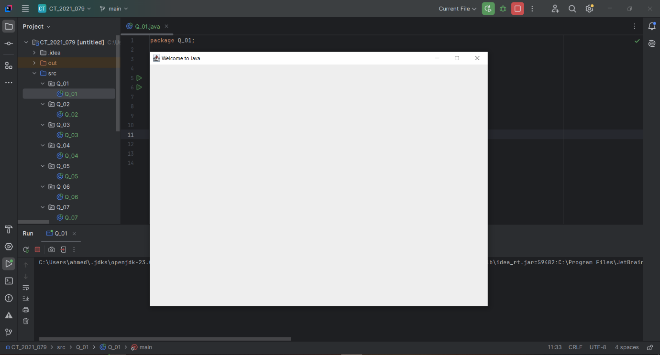

**Q2.**

Code:

|  |
| --- |
| ***package Q_02;  import javax.swing.*; import java.util.Scanner;  public class Q_02 {  public static void main(String[] args) {   Scanner scanner = new Scanner(System.in);  System.out.println("Enter Your First Name:");  String firstname = scanner.next();  System.out.println("Enter Your Last Name:");  String lastname = scanner.next();   JFrame window = new JFrame();  window.setTitle(firstname+" "+lastname);  window.setSize(800,600);  window.setVisible(true);  }  }*** |

**Output :**

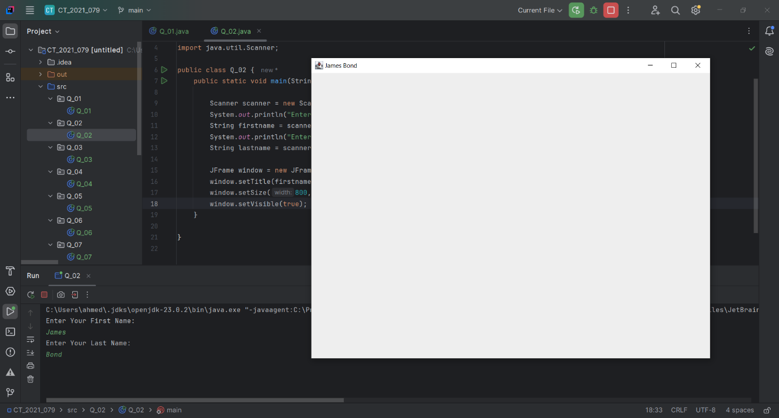

**Q3.**

Code:

|  |
| --- |
| ***package Q_03;  import javax.swing.*; import java.util.Scanner;  public class Q_03 {  public static void main(String[] args) {   Scanner scanner = new Scanner(System.in);  System.out.println("Enter Your First Name:");  String firstname = scanner.next();  System.out.println("Enter Your Middle Name:");  String middlename = scanner.next();  System.out.println("Enter Your Last Name:");  String lastname = scanner.next();   String initial = middlename.substring(0,1);   JFrame window = new JFrame();  window.setTitle(firstname + " " + initial + ". " + lastname);  window.setSize(800, 600);  window.setVisible(true);  } }*** |

**Output :**

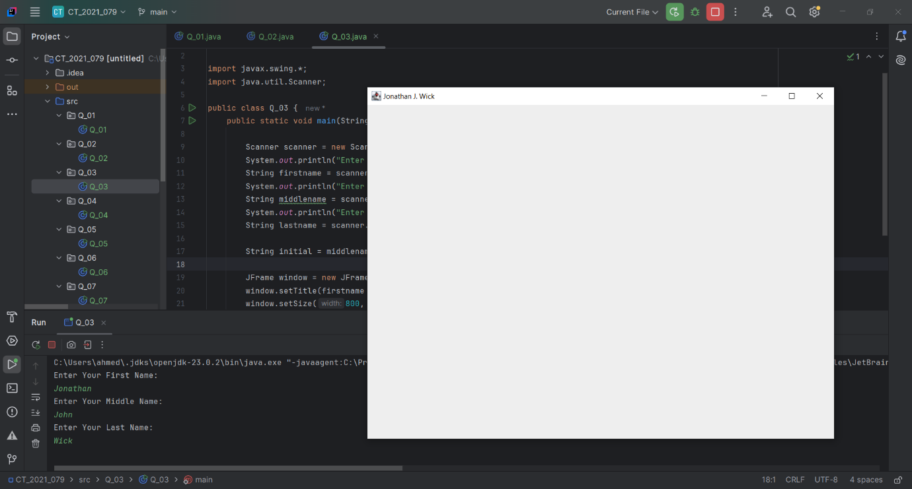

**Q4.**

Code:

|  |
| --- |
| ***package Q_04;  import javax.swing.*; import java.text.SimpleDateFormat; import java.util.Date;  public class Q_04 {  public static void main(String[] args) {   Date date = new Date();  JFrame window = new JFrame();  SimpleDateFormat sdf = new SimpleDateFormat("dd MMMM yyyy");   String title = sdf.format(date);   window.setSize(800,600);  window.setTitle(title);  window.setVisible(true);  } }*** |

**Output :**

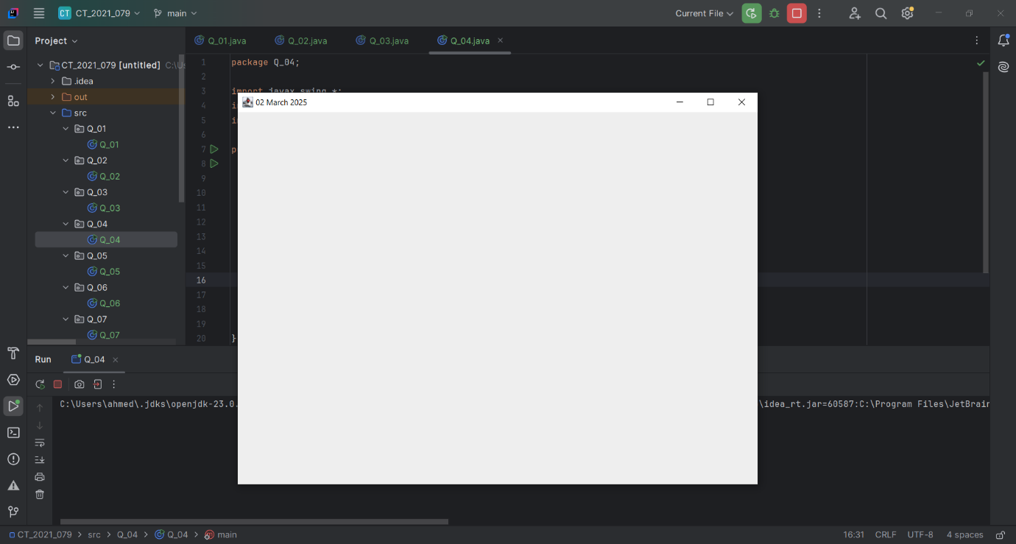

**Q5.**

Code:

|  |
| --- |
| ***package Q_05;  import javax.swing.*; import java.text.SimpleDateFormat; import java.util.Date;  public class Q_05 {  public static void main(String[] args) {   JFrame window = new JFrame();  Date date = new Date();  SimpleDateFormat sdf = new SimpleDateFormat("EEEE, MMMM dd, yyyy");   String heading = sdf.format(date);   window.setVisible(true);  window.setSize(500,300);  window.setTitle(heading);  } }*** |

**Output :**

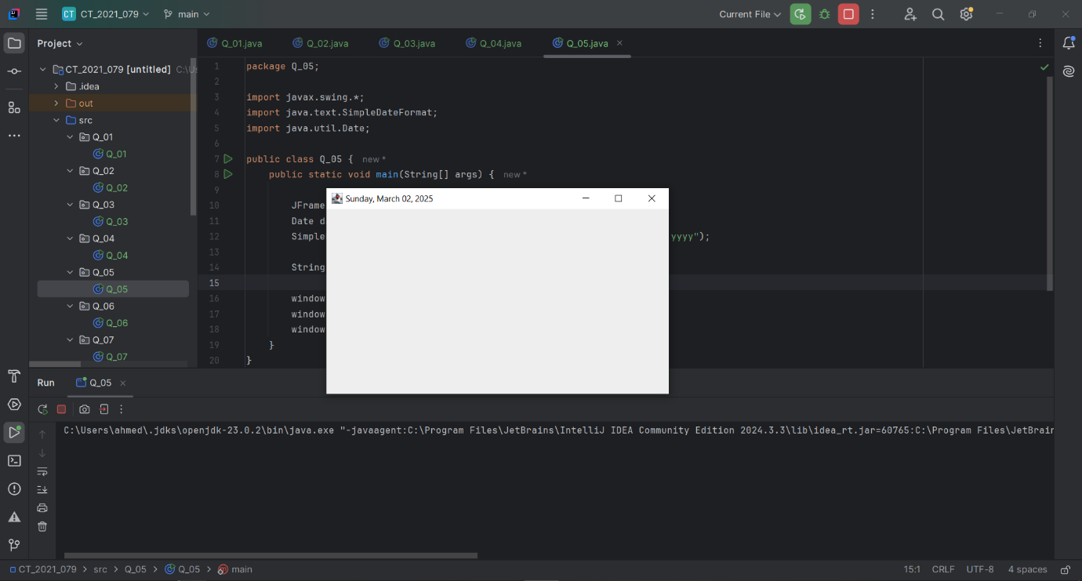

**Q6.**

Code:

|  |
| --- |
| ***package Q_06;  import javax.swing.*; import java.util.Scanner;  public class Q_06 {  public static void main(String[] args) {   Scanner scanner = new Scanner(System.in);  System.out.println("Enter Title:");  String title = scanner.next();  System.out.println("Enter Height:");  int height = scanner.nextInt();  System.out.println("Enter Width:");  int width = scanner.nextInt();   JFrame window = new JFrame();  window.setVisible(true);  window.setSize(width,height);  window.setTitle(title+" ");  } }***  ***myWindow.setTitle(title);  myWindow.setVisible(true);  } }*** |

**Output :**

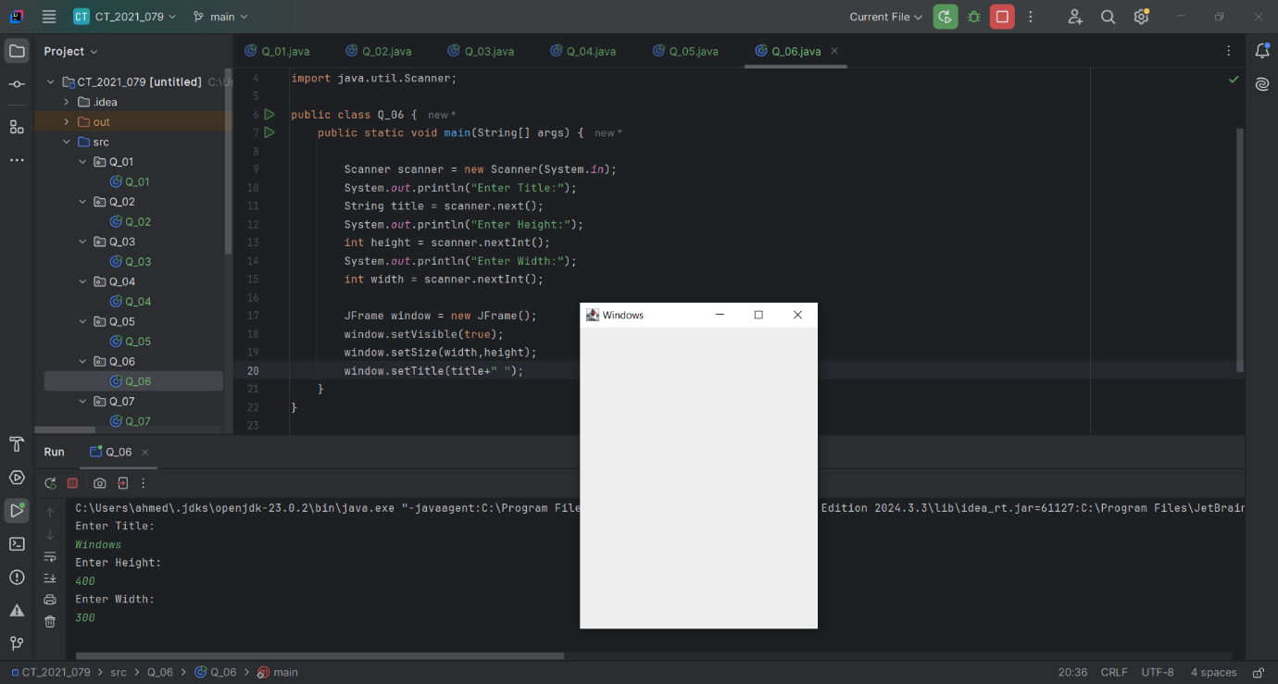

**Q7.**

Code:

|  |
| --- |
| ***package Q_07;  import javax.swing.*; import java.text.SimpleDateFormat; import java.util.Date; import java.util.Scanner;  public class Q_07 {  public static void main(String[] args) {   JFrame window = new JFrame();  Scanner scanner = new Scanner(System.in);  Date date = new Date();   SimpleDateFormat sdf = new SimpleDateFormat("hh:mm:ss a");   String title = sdf.format(date);   window.setVisible(true);  window.setSize(400,500);  window.setTitle(title);  } }*** |

**Output :**

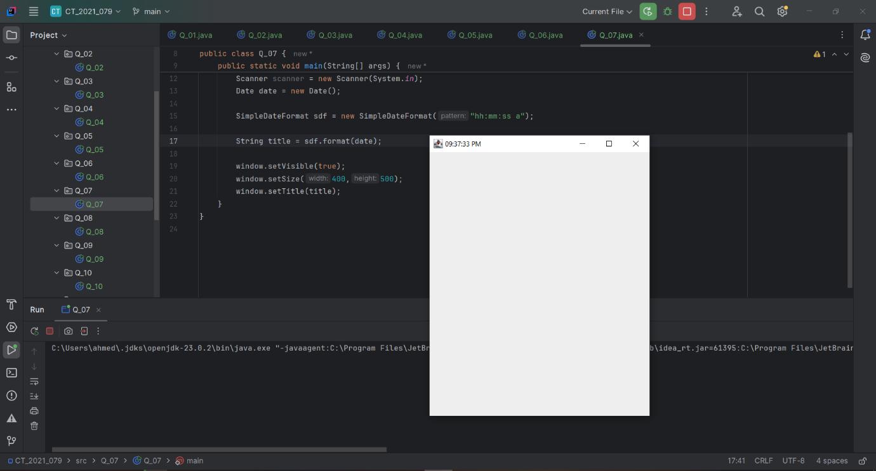

**Q8.**

Code:

|  |
| --- |
| ***package Q_08; import java.util.*;  public class Q_08 {  public static void main(String[] args) {  String word ,a,b ;  //new array  Scanner scanner = new Scanner(System.in);  System.out.println("Enter the word :");  word = scanner.nextLine();   String[] sentence = word.split("!",2);   if (sentence.length == 2){  System.out.println(sentence[0].trim());  System.out.println(sentence[1].trim());  }  } }*** |

**Output :**

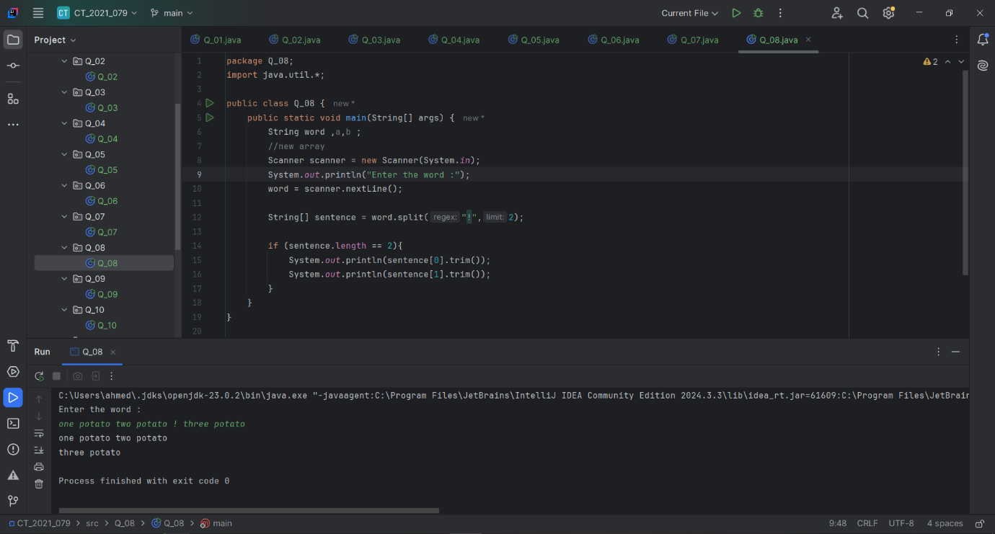

**Q9.**

Code:

|  |
| --- |
| ***package Q_09; import java.util.*;  public class Q_09 {  public static void main(String[] args) {  Scanner scanner = new Scanner(System.in);  System.out.println("Enter the text : ");  String text = scanner.nextLine();  int length = text.length();   System.out.println(length);  System.out.println(text.charAt(0));  System.out.println(text.charAt(length-1));   } }*** |

**Output :**

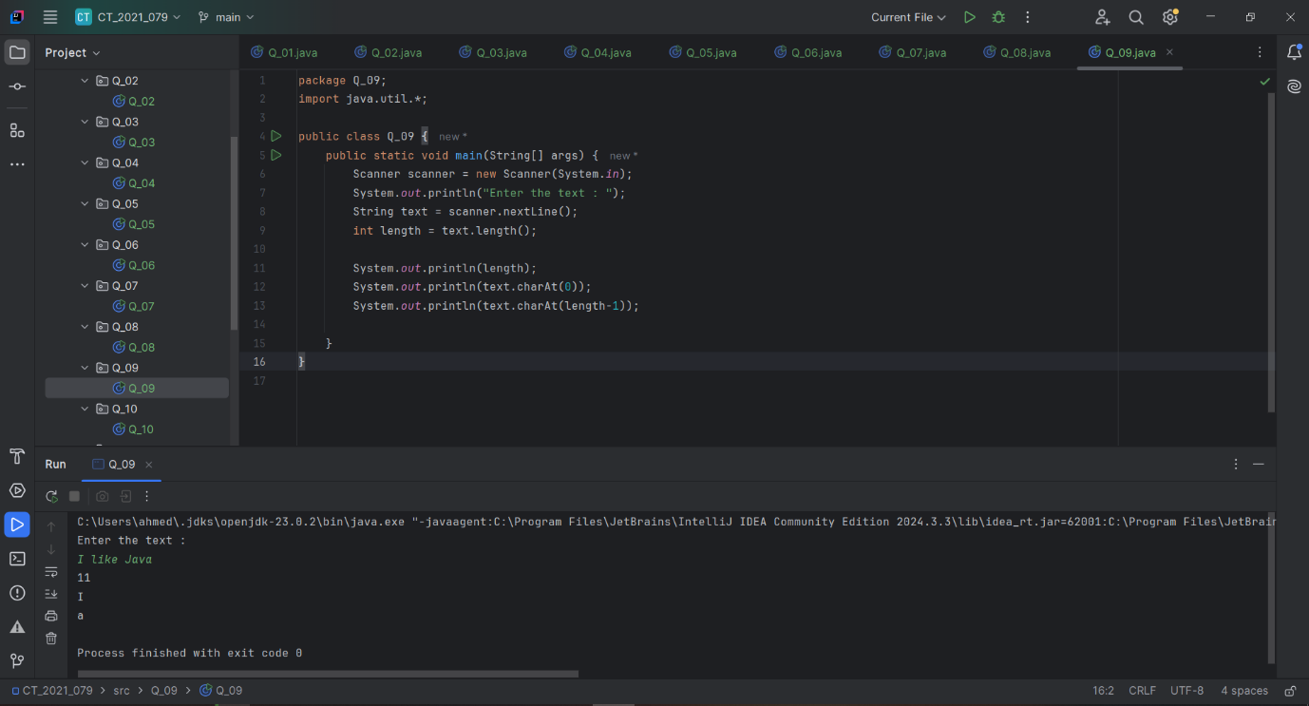

**Q10.**

Code:

|  |
| --- |
| ***package Q_10; import java.util.Scanner;  public class Q_10 {  public static void main(String[] args) {  Scanner scanner =new Scanner(System.in);  System.out.println("Enter the odd length String : ");  String text = scanner.nextLine();   int length = text.length();  char middle_letter;  middle_letter = text.charAt((length / 2));  System.out.println(middle_letter);    } }*** |

**Output:**

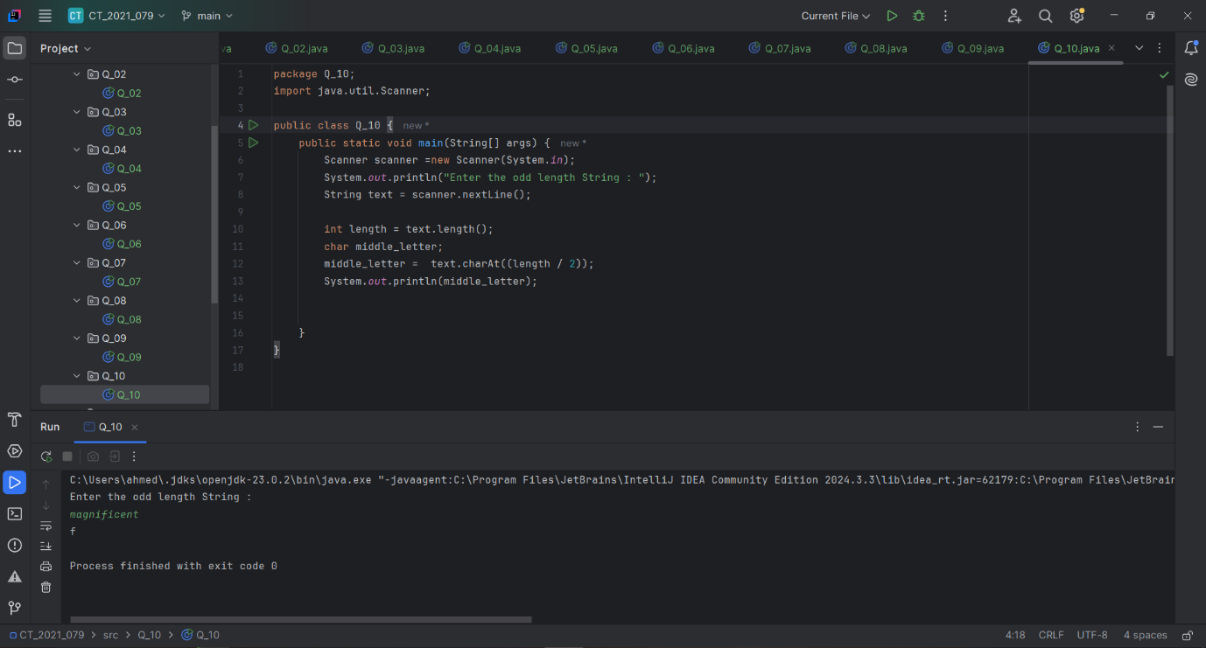

**Q11.**

Code:

|  |
| --- |
| ***package Q_11;  import java.util.*;  public class Q_11 {  public static void main(String[] args) {  Scanner scanner = new Scanner(System.in);  System.out.println("Enter the full name (first middle last) with spaces :");  String text = scanner.nextLine();  System.out.println(text);   String[] parts = text.split(" ");  String fname = parts[0];  String mname = parts[1];  String lname = parts[2];   System.out.println(lname+","+" "+fname+" "+mname.charAt(0)+".");   } }*** |

**Output :**

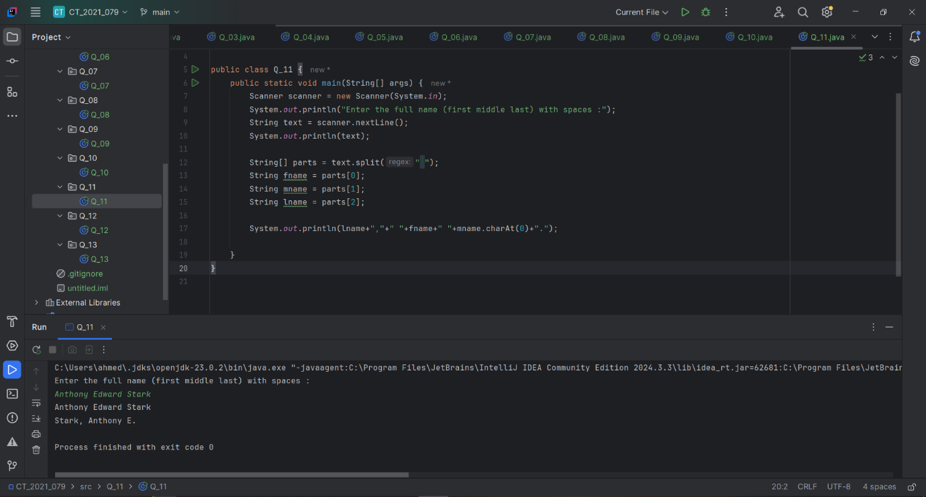

**Q12.**

Code:

|  |
| --- |
| ***package Q_12; import javax.swing.*;  public class Q_12 {  public static void main(String[] args) {  JFrame myWindow;  myWindow = new JFrame();  myWindow.setSize(300,200);  myWindow.setLocation(50,100);  myWindow.setTitle("My First Frame");  myWindow.setVisible(true);   } }*** |

**Output :**

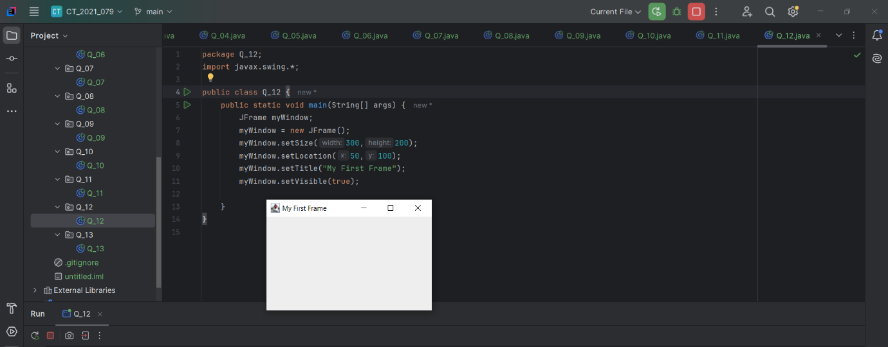

**Q13. Extra Practice**

Code:

|  |
| --- |
| ***package Q_13;  import javax.swing.*; class Q_13 {  public static void main(String[] args) {  JFrame myWindow;  myWindow = new JFrame();  myWindow.setSize(500, 250);  myWindow.setTitle("UOK");  myWindow.setVisible(true);  try {Thread.sleep(500);} catch(Exception e) { }  myWindow.setVisible(false);  try {Thread.sleep(500);} catch(Exception e) { }  myWindow.setVisible(true);  } }*** |

**Output :**

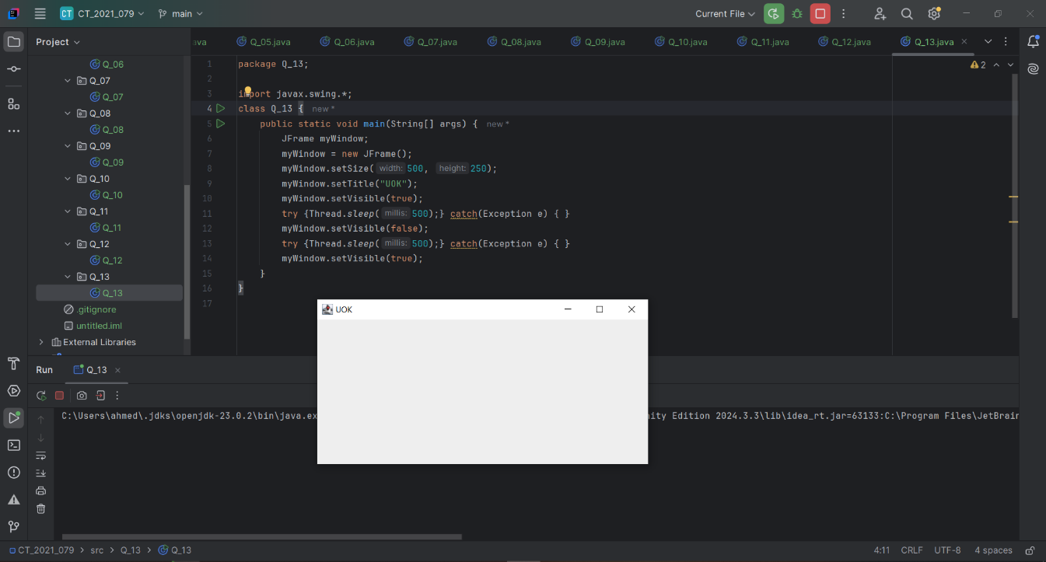

A window is created and displayed using JFrame.

The window appears, disappears briefly, and then reappears after delays of **500ms each** using Thread.sleep(500).

The visibility of the window can be controlled dynamically using setVisible(true/false).