**CT/2021/079 AHMED M.N**

**Q1.**

Code:

|  |
| --- |
| ***package Q_01; import java.text.DecimalFormat;  public class Q_01 {  public static void main(String[] args) {  int A = 2 , B = 4 , C = 6;  int X = 3 , Y = 5;  double a,b,c,d; // for answers  System.out.println("A=" + A + " B=" + B + " C=" + C + " X=" + X + " Y=" + Y);  DecimalFormat df = new DecimalFormat("0.00");   a = Math.sqrt((Math.pow(B,2)) + (4*A*C));  System.out.println("The square root of B^2 + 4AC : " + df.format(a));   b = Math.sqrt(X + (4 * Math.pow(Y,3)));  System.out.println("The square root of X + 4Y^3 : " + df.format(b));   double product = X*Y;  c = Math.cbrt(product);  System.out.println("The cube root of the product of X and Y :" + df.format(c));   final double PI = 3.14;  double Radius = 7;   d = PI*Radius*Radius;  System.out.println("Area of the circle : " + df.format(d));  } }*** |

**Output:**

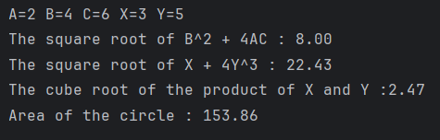

**Q2.**

Code:

|  |
| --- |
| ***package Q_02; import java.text.DecimalFormat; import java.util.Scanner;  public class Q_02 {  public static void main(String[] args) {  double cm,totalInches,in;  int ft;  Scanner Input = new Scanner(System.in);  System.out.print("Enter the value in centimeters : ");  cm = Input.nextDouble();   totalInches = cm / 2.54;  ft = (int) totalInches / 12;  in = totalInches - (ft * 12);   DecimalFormat df = new DecimalFormat("0.00");  System.out.println(cm + " Centimeters = " + ft + " feets and " + df.format(in) + " inches");   } }*** |

**Output :**

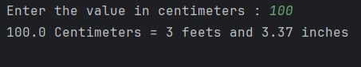

**Q3.**

Code:

|  |
| --- |
| ***package Q_03; package Q_03;  import java.util.Scanner;  public class Q_03 {  public static void main(String[] args) {  double Celsius,Fahrenheit;  Scanner Input = new Scanner(System.in);  System.out.print("Enter the temperature in Celsius : ");  Celsius = Input.nextDouble();   Fahrenheit = (1.8 * Celsius) + 32;   System.out.println("Fahrenheit Value is : " + Fahrenheit);  } }*** |

**Output :**

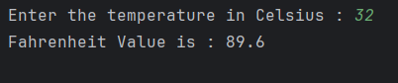

**Q4.**

Code:

|  |
| --- |
| ***package Q_04;  import java.util.Scanner;  public class Q_04 {  public static void main(String[] args) {  int bodyWeight,calories;  Scanner Input = new Scanner(System.in);  System.out.print("Enter the body weight in pounds : ");  bodyWeight = Input.nextInt();   calories = bodyWeight * 19;   System.out.println("You need " + calories + " calories in one day" );   } }***  ***window.setVisible(true);  } }*** |

**Output :**

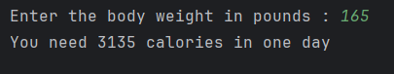

**Q5.**

Code:

|  |
| --- |
| ***package Q_05; import java.util.Scanner;  public class Q_05 {  public static void main(String[] args) {  double Celsius,Fahrenheit;  Scanner Input = new Scanner(System.in);  System.out.print("Enter the temperature in Fahrenheit : ");  Fahrenheit = Input.nextDouble();  Celsius = (5.0/9) * (Fahrenheit - 32);  System.out.println("Celsius Value is : " + Celsius);  } }*** |

**Output :**

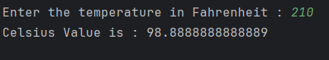

**Q6.**

Code:

|  |
| --- |
| ***package Q_06;  import java.util.Scanner; import java.time.Year;  public class Q_06 {  public static void main(String[] args) {  int birthYear,Age;  Scanner Input = new Scanner(System.in);  System.out.print("What is your birth year? : ");  birthYear = Input.nextInt();  int currentYear = Year.now().getValue();  //System.out.println("Current Year: " + currentYear);   Age = currentYear - birthYear;  System.out.println("You were born in "+birthYear+" and will be (are) "+ Age + " this year.");   } }*** |

**Output :**

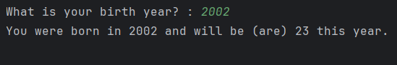

**Q7.**

Code:

|  |
| --- |
| ***package Q_07;  import java.text.DecimalFormat; import java.util.Scanner;  public class Q_07 {  public static void main(String[] args) {  double W,H,BMI;  Scanner Input = new Scanner(System.in);  System.out.print("Enter your weight in Kg : ");  W = Input.nextDouble();  System.out.print("Enter your height in cm : ");  H = Input.nextDouble();   BMI = W / Math.pow((H/100),2);  DecimalFormat df = new DecimalFormat("0.00");  System.out.println("BMI : " + df.format(BMI));  } }*** |

**Output :**

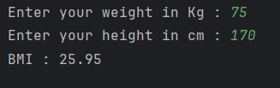

**Q8.**

Code:

|  |
| --- |
| ***package Q_08; import java.text.DecimalFormat; import java.util.Scanner;  public class Q_08 {  public static void main(String[] args) {  double R,V; // R - Radius V - Volume  final double PI = 3.14;  Scanner Input = new Scanner(System.in);  System.out.print("Enter the Radius : ");  R = Input.nextDouble();  V = (4/3.0) * (PI * Math.pow(R,3));  DecimalFormat df = new DecimalFormat("0.00");  System.out.println("Volume of a sphere is : " + df.format(V));  } }*** |

**Output :**

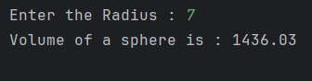

**Q9.**

Code:

|  |
| --- |
| ***package Q_09; import java.text.DecimalFormat; import java.util.Scanner;  public class Q_09 {  public static void main(String[] args) {  double P,R; // P - Invest amount in dollars R - Interest rate compounded annually  int N; // N - Number of years  double M; // Amount of money earned after N years   Scanner Input = new Scanner(System.in);  System.out.print("Enter the invest amount in dollars : ");  P = Input.nextDouble();   System.out.print("Enter interest rate compounded annually : ");  R = Input.nextDouble();   System.out.print("Enter the number of years : ");  N = Input.nextInt();   M = P * Math.pow((1+(R/100)),N);  DecimalFormat df = new DecimalFormat("0.00");   System.out.print("Amount of money earned after " + N + " years : " + df.format(M) + " $");  } }*** |

**Output :**

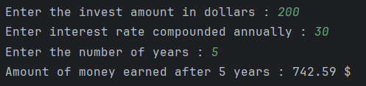

**Q10.**

Code:

|  |
| --- |
| ***package Q_10; import java.text.DecimalFormat; import java.util.Scanner;  public class Q_10 {  public static void main(String[] args) {  double loanAmount,annualInterestRate;  int loanPeriod;  final int MONTHS_IN_YEAR = 12;  Scanner Input = new Scanner(System.in);  System.out.print("Enter the Loan amount : ");  loanAmount = Input.nextDouble();   System.out.print("Enter the Annual interest rate : ");  annualInterestRate = Input.nextDouble();   System.out.print("Enter the loan period in years : ");  loanPeriod = Input.nextInt();   double monthlyInterestRate = annualInterestRate / 100.0 / MONTHS_IN_YEAR;  int numberOfPayments = loanPeriod * MONTHS_IN_YEAR;  double monthlyPayment = (loanAmount * monthlyInterestRate) / (1 - Math.pow(1/(1+monthlyInterestRate),numberOfPayments));  double totalPayment = monthlyPayment * numberOfPayments;   DecimalFormat df = new DecimalFormat("0.00");  System.out.println("Monthly Payment : " + df.format(monthlyPayment));  System.out.println("Total Payment : " + df.format(totalPayment));   } }*** |

**Output:**

