Benchmarking Modern VLMs for Visual Problem Solving: A Comparative Study of Qwen3-vl, Qwen2.5-vl, and LLaVA-NeXT.

A THESIS SUBMITTED TO
THE INSTITUTE OF GRADUATE PROGRAMS
OF
İSTANBUL BİLGİ UNIVERSITY

Ahmed sameh yousry mohamed ahmed
IN PARTIAL FULFILLMENT OF THE REQUIREMENTS
FOR
THE DEGREE OF MASTER OF SCIENCE
IN
COMPUTER ENGINEERING

2026
Benchmarking Modern VLMs for Visual Problem Solving: A Comparative Study of Qwen3-vl, Qwen2.5-vl, and LLaVA-NeXT.

Ahmed Sameh Yousry Mohamed Ahmed
123750004

Assoc. Prof. Dr. Tuğba Dalyan
Istanbul Bilgi University
Choose an item. Jury Name Jury Surname
Name of University
Choose an item. Jury Name Jury Surname
Name of University
Choose an item. Jury Name Jury Surname
Name of University
Choose an item. Jury Name Jury Surname
Name of University
Choose an item. Co-Supervisor Name Co-Supervisor Surname
Co-Supervisor
Name of University

Date of Approval: Choose your defense date.

Name Surname: Ahmed Sameh Yousry Mohamed Ahmed

Signature:

I hereby declare that all information in this document has been obtained and presented in accordance with academic rules and ethical conduct. I also declare that, as required by these rules and conduct, I have fully cited and referenced all material and results that are not original to this work.

ABSTRACT
All theses must have an abstract. The abstract provides readers with a general opinion about the thesis. In the first paragraph of this section, the subject of the thesis must be explained. In other paragraphs, the scope and purposes of the performed study must be explained individually, utilized methods must be mentioned briefly, and the main conclusions must be included as well. The abstract of Master theses must be at least 150 words, and must not exceed 350 words. It should not extend to the second page. Doctoral theses do not have word limit. Both Master and Doctoral theses must have Five (5) Keywords in English. Abstract page is paginated as “iv”. Initial letters of keywords must be capitalized. This is an abstract. It must be a maximum of 350 words. It should not extend to the second page.

.

Keywords: Word1; Word2; Word3; Word4; Word5

ÖZ
This page is titled as Öz. All theses must have an Öz. Öz is the exact Turkish translation of the abstract titled as Öz. Öz is the Turkish translation of the abstract. It also must have exact translation of the Five (5) Keywords of the abstract as Anahtar Kelimeler. The abstract of Master theses must be at least 150 words, and must not exceed 350 words. It should not extend to the second page. Doctoral theses do not have word limit. Both Master and Doctoral theses must have Five (5) Keywords in English. Initial letters of keywords must be capitalized. Öz page is paginated as “v”.

Anahtar Kelimeler: Sözcük1; Sözcük2; Sözcük3; Sözcük4; Sözcük5

This page is for Dedication

ACKNOWLEDGMENTS
An Acknowledgments page is optional; however, if there is an Acknowledgments page, it should be titled Acknowledgments and included in the Table of Contents. The Acknowledgments section refers to the people and/or institutions who helped the student academically or otherwise throughout the thesis writing process. There is no word limit. The acknowledgments page is paginated as “vii” if the thesis has it, and if it is more than one page, pagination must continue with Romans.

TABLE OF CONTENTS
ABSTRACT iv
ÖZ v
ACKNOWLEDGMENTS vii
TABLE OF CONTENTS viii
LIST OF TABLES x
LIST OF FIGURES xi
LIST OF SYMBOLS xii
LIST OF ABBREVIATIONS xiii
1. INTRODUCTION 1
1.1. Tables and Figures 2
1.1.1. Equations 5
1.1.1.1. Forth Level Title 6
1.1.1.1.1. Fifth Level Title 6
2. LITERATURE REVIEW 9
2.1. Subheading 9
2.2. Reference Styles 11
2.2.1. IEEE In-Text Referencing 11
2.2.1.1.1.1. Title Example 11
2.2.2. APA In-Text Referencing 11
2.2.3. MLA In-Text Referencing 12
2.2.4. The Chicago Manual of Style 12
3. CHAPTER NAME 13
3.1. Heading 2 13
3.1.1. Heading 3 13
4. CONCLUSION 14
REFERENCES 15
APPENDICES
Appendix A. Result of the Evaluation by the Ethics Committee 21
Appendix B. Appendix Title 22
Appendix C. Appendix Title 23

LIST OF TABLES
Table 1.1. Insert Table Caption Here 2
Table 2.1. Insert Table Caption Here 10
Table 2.2. Insert Table Caption Here 12
Table 3.1. Insert Table Caption Here 13

LIST OF FIGURES
Figure 1.1. Sales Amount of Products 3
Figure 1.2. Book Sales of Five Different Genre for First Six Months 4
Figure 1.3. An Example of Syzygy (Celestial Alignment) Above the La Silla Observatory Chile 5
Figure 1.4. İstanbul Bilgi University 6
Figure 1.5. İstanbul Bilgi University, Graduate Programs at Bilgi 7
Figure 2.1. İstanbul Bilgi University 12

LIST OF SYMBOLS
L([a,∞]): length of unbounded interval
M(I): measure of interval I
$\overline{R^{p}}$: extended p-dimensional space

LIST OF ABBREVIATIONS
AI: Artificial Intelligence
BMI: Body Mass Index
ML: Machine Learning

INTRODUCTION
First chapter starts with INTRODUCTION. Each chapter starts with the main heading which includes title of the chapter in the first line without numbering. INTRODUCTION, LITERATURE SURVEY, etc.. They are all centered. Only new chapters should begin with a new page. Table of Contents automatically assign them.
The introduction chapter should include the main theme, research questions, the scope of the theoretical framework, the methodological approach, main assumptions and findings. This chapter should also state how the thesis contributes to the existing literature from a theoretical and empirical perspective. The introduction is one of the most important chapters of the thesis as it outlines how the thesis proceeds with each following chapter.
This chapter guides the reader on why the thesis topic is important and what the reader should expect to find in the rest of the thesis. The first chapter title is all CAPITALIZED and BOLD with Times New Roman typeface at 12 pt., centered in the first line without chapter number. Line spacing should be 1,5. There must be 4 pt spacing before and 42 pt spacing after your main headings.
Subheadings should follow 1.1. Xxx (All initials of the sub-heading Capitalized and in Bold with Times New Roman typeface at 12 pt).
As the Introduction is the first chapter of the main sections of the thesis, it must be paginated using Arabic numerals and start with 1, centered at the bottom of the page.
Introduction chapter, in general, does not have tables, figures etc. However, if there are tables or figures or as such, they should be numbered as for example Table 1.1. …. (Table name should be in bold, initials capitalized with Times New Roman typeface at 12pt at the top of the table, Source should be at the bottom-centered, in italic with Times New Roman typeface at 11 pt).

Tables and Figures
Within a chapter, the presentation of subsections must be continuous; partially filled pages of text are acceptable only on non-textual pages, such as those presenting tables and illustrations. Tables and figures should be included in relevant sections following principles of page layout set forth above. The tables and figures should be placed on the nearest place where they are mentioned. More than one table and figure may be presented in the same page. However, in case numerous tables and figures are required to be presented on the same page, tables and figures may be placed in the Appendices section on the condition that they are referred in relevant section. There are a few examples about table format. However, students must follow appropriate referencing styles designated for each program.
Number and heading of each table are written on one line above table and number and heading of each figure are written on one line above figure. Table numbers are indicated with Arabic numerals (1, 2, 3 ……). Word “Table” and numbers of table are written with Bold characters. Reference of tables are given as Table 1.1. The only typeface accepted by the Institute is Times New Roman. Body text of theses must be typed using this typeface with font size set at 12.

Table 1.1. Insert Table Caption Here
Table Head | Table Column Head
 | X₁ | X₂ | X₃
A | 10 | 5.5 | 10
B | 20 | 5.5 | 15
C | 30 | 14 | 12.2
Total | 60 | 25 | 37.2
(Source: Gartner, Top IoT technology trends that will drive digital business innovation, 2018.)

Source of data used in tables is indicated in the middle below the table. While writing heading and source of table, first letter of each word is written with capital letter. Providing references should be performed in a manner that complies citation method used in entire thesis. Table name should be in bold, initials capitalized with Times New Roman typeface at 12 pt at the top of the table, Source should be at the bottom and centered, in italic with Times New Roman typeface at 11 pt.
Numbers of figures are presented in Arabic numerals (1, 2, 3…). Heading and number of figure are written with bold characters, initials capitalized with Times New Roman typeface at 12 pt at the top of the table, Source should be at the bottom in the middle, in italic with Times New Roman typeface at 11 pt. The term figure can refer to illustrations or images that are displayed or reproduced separately from the text. Illustrations or images, in this case, can refer to a wide range of visual materials, including photographs, maps, drawings, and charts placed within a text. Figures can be used to more easily refer to illustrations cited in your writing. This is particularly helpful where there are several cited illustrations. There are a few examples about figures. However, students must follow appropriate referencing styles designated for each program.

Figure 1.1. Sales Amount of Products

(Source: Dalyan, T., & Dikici, H. (2023). Internet of Things: A survey on products.)

Figure 1.2. Book Sales of Five Different Genre for First Six Months

Tables and figures, these should be numerated in order having the first number presents section number, and having second number presents order number of table (or figure) in section, i.e, in main sections Table 1.1., Table 1.2., Table 2.1., Figure 1.1. An example of a textual reference to a figure might look like the following: "as Figure 1.1. shows..."; "when comparing Figures 1.2. and 1.3." You can find several examples from different sources form different citation examples.

Figure 1.3. An Example of Syzygy (Celestial Alignment) Above the La Silla Observatory Chile
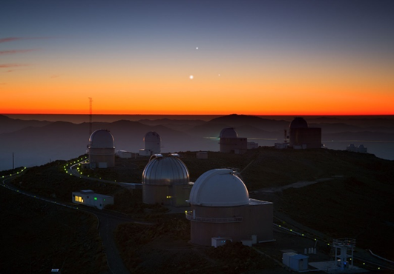
(Photograph by Yuri Beletsky, Three Planets Dance over La Silla, June 3, 2013, European Southern observatory, https://www.eso.org/public/images/potw1322a/).

Equations
The word “equations” stands here for all specially designated expressions such as equations, cases, and formulae. Equations must be written using an equation editor and they must be numbered in order of their appearance. Equations must be centered and their numbers must be right-justified. Equation numbers must be written with chapter numbers (or letters, for appendices) and must be Arabic numbers in parantheses like “(1.1)”, “(1.2)”, “(A.1)”.
A space of 12-points should be left before and after the equation. Within the text, equations must be referred to without use of the word “Equation”, as in “The summation in (1.1), …”, except at the beginning of the sentence: “Equation in (1.1) is …”.

$x= \sum_{i=0}^{n}{2^{i}}$ (1.1)
Usage of SI system of units is encouraged. If a different system should be used, combination with another system must be avoided, e.g., current in amperes and magnetic field in oersteds. There may be an exception if the unit from a different system is an identifier in trade, such as “3.5-inch disk drive”. Units must be spelled out when they appear in text, e.g., “. . . a few henries”, instead of “… a few H”.

Forth Level Title
Lorem ipsum dolor sit amet, consectetuer adipiscing elit. Maecenas porttitor congue massa. Fusce posuere, magna sed pulvinar ultricies, purus lectus malesuada libero, sit amet commodo magna eros quis urna.

Fifth Level Title
Lorem ipsum dolor sit amet, consectetuer adipiscing elit. Maecenas porttitor congue massa. Fusce posuere, magna sed pulvinar ultricies, purus lectus malesuada libero, sit amet commodo magna eros quis urna.

Figure 1.4. İstanbul Bilgi University
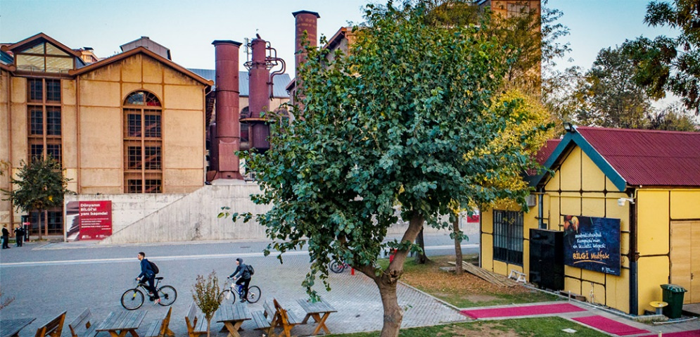
(Source: Istanbul Bilgi University (İstanbul: Name Surname, 2023), showing the entrance of İstanbul Bilgi University, Gastronomy and Library. Reproduced by permission of İstanbul Bilgi University.)

Figure 1.5. İstanbul Bilgi University, Graduate Programs at Bilgi

(Source: Istanbul Bilgi University: Istanbul Bilgi University Press, (2023), 38, Fig. 2)

LITERATURE REVIEW
The chapters following the Introduction are specific to each academic program. For example, social sciences theses follow the introduction with a chapter on the theoretical framework or the literature review. The title of this chapter might be named following the theoretical concerns. In natural sciences, the literature review chapter evaluates the existing work. Other programs have their own chapter flow.
Chapters following the Introduction start with the chapter title, all CAPITALIZED and BOLD with Times New Roman typeface at 12 pt., centered in the first line without chapter number.

Subheading
Subheadings should follow 2.1. Xxx (All initials of the sub-heading Capitalized and in Bold with Times New Roman typeface at 12 pt.).
First letters of second-degree sub-headings are written “in Capital and left justified”, such as 2.1.1. Xxx. There must be 24 pt spacing before and 18 pt spacing after your sub-headings. At least two lines gap left after sub-heading corresponds bottom of the page. Otherwise, text must be started from the next page. The decimal system must be used to outline the main heading and subheadings.
Only new chapters should begin with a new page. Table of Contents automatically assigns the chapter titles with their page numbers in the template.
If there are tables or figures or as such, they should be numbered as for example Table 2.1. Xxx (Table name should be in bold, centered and initials capitalized with Times New Roman typeface at 12pt at the top of the table, Source should be at the bottom centered, in italic with Times New Roman typeface at 11 pt). Tables throughout the document must have the same format and style. Please ensure consistency.
Within a chapter, subsections must be presented continuously; partially filled pages of text are acceptable only on non-textual pages, such as those presenting tables and illustrations. Tables and figures should be included in relevant sections following the principles of page layout set forth above. The tables and figures should be placed nearest where they are mentioned. More than one table and figure may be presented on the same page.
If you have a table that is cut in two between pages, the second part must also have the title. In case of cutting short tables in half, placing the table on the next page is advised.
However, if numerous tables and figures are required to be presented on the same page, they may be placed in the Appendices section on the condition that they are referred to in the relevant section.
The pagination of the chapters after the Introduction is with Arabic numerals, continuing from the previous chapters.
If you have a source for your table, then use Source: keywords and explain your source based on your reference style. If you have no source, then it is not necessary to write a source.
Table 2.1. Insert Table Caption Here
 | Attribute₁ | Attribute₂ | Attribute₃
A | 10 | aaa | 22.6
B | 20 | bbb | 0.0
C | 30 | ccc | 15.2
D | 40 | ddd | 13.0
E | 50 | eee | 15.5
F | 60 | fff | 13
G | 70 | ggg | 17
H | 80 | hhh | 18
I | 90 | iii | 19.5
J | 100 | jjjj | 10.5
K | 110 | kkk | 21
L | 120 | llll | 20.4
M | 130 | mmm | 15.4
N | 140 | nnnn | 10
O | 150 | ooo | 12
P | 160 | ppp | 9.7

Reference Styles
Below you can find some reference style examples. Students must learn style of references from their advisors and check for updates in the styles from their own websites.

IEEE In-Text Referencing
The purpose of this section is to give some usage of IEEE- In-Text Referencing examples. In this study [1], the authors proposed a model to address the problem of .... In yet another study, Altun [2] has argued lorem ipsum dolor sit amet, consectetuer adipiscing elit.

Title Example
Lorem ipsum dolor sit amet, consectetuer adipiscing elit. Maecenas porttitor congue massa. Fusce posuere, magna sed pulvinar ultricies, purus lectus malesuada libero, sit amet commodo magna eros quis urna. Nunc viverra imperdiet enim. Fusce est. Vivamus a tellus. Pellentesque habitant morbi tristique senectus et netus et malesuada fames ac turpis egestas. Proin pharetra nonummy pede. Mauris et orci.

APA In-Text Referencing
The purpose of this section is to give some usage of APA In-Text Referencing examples. In this study, Grady et al. (2019) proposed a model to address the problem of .... In yet another study, the theory was first put forward (APA, 2021).
Table 2.2. Insert Table Caption Here
Name of Methods | A | B | C |  | D
M1 | 1 | 0 | 0 |  | 0
M2 | 1 | 0 | 1 |  | 1
M3 | 0 | 1 | 1 |  | 1
M4 | 0 | 0 | 0 |  | 1

MLA In-Text Referencing
The purpose of this section is to give some usage of MLA- In-Text Referencing examples.
Naomi Baron proposed that reading is “just half of literacy. The other half is writing” (194).

Figure 2.1. İstanbul Bilgi University
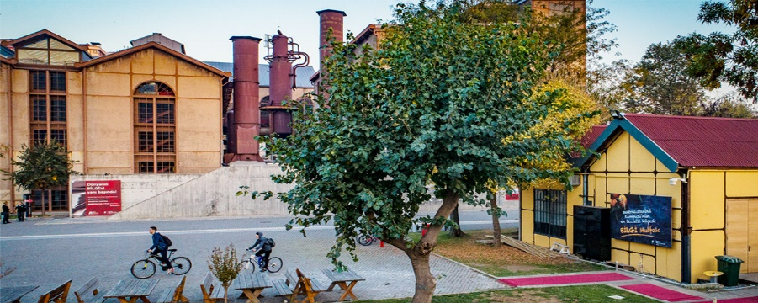
(Source: (İstanbul: Name Surname, 2023), showing the entrance of İstanbul Bilgi University, Gastronomy and Library. Reproduced by permission of İstanbul Bilgi University.)

The Chicago Manual of Style
The purpose of this section is to give some usage of the Chicago Manual of Style - In-Text Referencing examples. As of May 1, 2017, Yale’s home page announced that… In the study, graduate quality and income inequality were studied (Keng, Lin, and Orazem 2017, 9–10).

CHAPTER NAME
Lorem ipsum dolor sit amet, consectetuer adipiscing elit. Maecenas porttitor congue massa. Fusce posuere, magna sed pulvinar ultricies, purus lectus malesuada libero, sit amet commodo magna eros quis urna. Nunc viverra imperdiet enim. Fusce est. Vivamus a tellus. Pellentesque habitant morbi tristique senectus et netus et malesuada fames ac turpis egestas. Proin pharetra nonummy pede. Mauris et orci.
Aenean nec lorem. In porttitor. Donec laoreet nonummy augue. Suspendisse dui purus, scelerisque at, vulputate vitae, pretium mattis, nunc. Mauris eget neque at sem venenatis eleifend. Ut nonummy.

Heading 2
Lorem ipsum dolor sit amet, consectetuer adipiscing elit. Maecenas porttitor congue massa. Fusce posuere, magna sed pulvinar ultricies, purus lectus malesuada libero, sit amet commodo magna eros quis urna.

Heading 3
Lorem ipsum dolor sit amet, consectetuer adipiscing elit. Maecenas porttitor congue massa. Fusce posuere, magna sed pulvinar ultricies, purus lectus malesuada libero, sit amet commodo magna eros quis urna.

Table 3.1. Insert Table Caption Here
 | Attribute₁ | Attribute₂ | Attribute₃
A | 10 | aaa | 22.6
B | 20 | bbb | 0.0
C | 30 | ccc | 15.2

CONCLUSION
The conclusion chapter evaluates the entire thesis from an analytical perspective. It summarizes the main perspective, theoretical framework, and the contributions of the thesis work; however, it is not a simple summary. It evaluates the literature in the light of the work the student undertakes and provides insight into future studies. The student should not delve into new topics in this chapter and should refrain from relying on references not used in the earlier chapters.
The chapter titled Conclusion is written all CAPITALIZED and BOLD with Times New Roman typeface at 12 pt., centered in the first line without chapter number.
Theses should avoid subheadings in the Conclusion chapter as much as possible. However, if there are subheadings, they should follow the same subheading rules used in the previous chapters.
The Conclusion chapter must be paginated using Arabic numerals and continuous from the previous sections, centered at the bottom of the page.
The Conclusion chapter, in general, does not have tables, figures etc. However, if there are tables or figures or as such, they should be numbered in the style of the previous chapters.

REFERENCES
The chapter titled References is written all CAPITALIZED and BOLD with Times New Roman typeface at 12pt.
All materials referred to within text, footnotes, list of tables, and similar illustrative lists must be included in the References.
The resources not directly referred to in the text must not be placed in the References section, even if they contributed to the preparation process.
References chapter is a separate section of the thesis. Do not put separate references for each chapter.
There are some examples of each styles in the following and text. Students must follow appropriate referencing styles designated for each program as follows.
Please ensure that references in this section are formatted in Times New Roman, 12 pt, justified, line-spaced by 1.5, and listed alphabetically. Use a hanging indentation of 1.25 cm starting from the second line. Each source should have 0 pt spacing before and 8 pt spacing after. Additionally, remember to add space between paragraphs of the same style. Hyperlinks and links with underlining are not allowed.

The Chicago Manual of Style:
Keng, Shao-Hsun, Chun-Hung Lin, and Peter F. Orazem. 2017. “Expanding College Access in Taiwan, 1978–2014: Effects on Graduate Quality and Income Inequality.” Journal of Human Capital 11, no. 1 (Spring): 1–34. https://doi.org/10.1086/690235.
The Chicago Manual of Style. Author-Date: Sample Citations. Last modified 2017. https://www.chicagomanualofstyle.org/tools_citationguide/citation-guide-2.html
Yale University. n.d. “About Yale: Yale Facts.” Accessed May 1, 2017. https://www.yale.edu/about-yale/yale-facts.
APA Style:
American Psychological Association. (2021, October). Webpage on a Website References, American Psychological Association. https://apastyle.apa.org/style-grammar-guidelines/references/examples/webpage-website-references#3
Grady, J. S., Her, M., Moreno, G., Perez, C., & Yelinek, J. (2019). Emotions in storybooks: A comparison of storybooks that represent ethnic and racial groups in the United States. Psychology of Popular Media Culture, 8(3), 207–217. https://doi.org/10.1037/ppm0000185
MLA Style:
Baron, Naomi S. “Redefining Reading: The Impact of Digital Communication Media.” PMLA, vol. 128, no. 1, Jan. 2013, pp. 193–200.
“Works Cited: A Quick Guide.” The MLA Style Center, Modern Language Association of America, 2018, style.mla.org/works-cited-a-quick-guide/.
IEEE Style:
[1] A. Altun, “Understanding hypertext in the context of reading on the web: Language learners’ experience,” Current Issues in Education, vol. 6, no. 12, July, 2005. [Online serial]. Available: http://cie.ed.asu.edu/volume6/number12/. [Accessed Dec. 2, 2007].
[2] IEEE, “IEEE Referencing Guide” IEEE, ETSI-TR-101, 2018. [Online]. Available: https://ieeeauthorcenter.ieee.org/wp-content/uploads/IEEE-Reference-Guide.pdf. [Accessed: Nov. 12, 2023].
For Law Programs:
Students must learn style of references from their advisors. Certain Law Programs use following citation rules:
Citation to Single Authored Books
The first reference to a book with a single author consists of the author's name and surname, the title of the work, the place and the year of the publication. The author's name and surname are written in bold letters (e.g. Uğur Alacakaptan, Suçun Unsurları, 2. Bası, Ankara Üniversitesi Hukuk Fakültesi Yayınları, Ankara 1975). In subsequent references to the work, the author's surname and page number information is given (For example; Alacakaptan, s. 75). If more than one work of the same author is cited in the work, an appropriate abbreviation is chosen for each work (e.g., Alacakaptan, Unsurlar, s. 75).
Citation to Books with Multiple Authors:
In the first references to books with multiple authors, the names and surnames of the authors, the title of the work, the place and year of publication are indicated by placing an apostrophe between them. (For example, Bülent Tahiroğlu / Belgin Erdoğmuş, Roma Hukuku Dersleri: Tarihi Giriş, Hukuk Tarihi, Genel Kavramlar, Usul Hukuku, 7. Bası, Der Yayınevi, İstanbul 2009). In subsequent references to the work, the authors' surnames and page numbers are given by placing an apostrophe between them (e.g. Tahiroğlu/Erdoğmuş, s. 175).
Citation to Edited Books
In the first reference to the edited book, the name and surname of the editor, the title of the work, the place and year of publication shall be indicated. (For example; M. Murat İnceoğlu (edt.), Prof. Dr. Belgin Erdoğmuş’a Armağan, Der Yayınevi, İstanbul 2011).
Citation to Translated Books
In the first references to translated books, the name and surname of the translator are indicated in parentheses after the beginning of the source (e.g. Ernest Hirş, Pratik Hukukta Metot, (Transleated by: Volf Çernis), Güncellenmiş 8. baskı, Banka ve Ticaret Hukuku Araştırma Enstitüsü, Ankara 2000). In subsequent references to the work, the surnames of the authors and the page number information are given by placing an apostrophe between them (For example; Hirş (Translated by Çernis), p. 50).
Citation to Electronic Books
In the first references to electronic books, the name and surname of the author, the title of the work, the place and year of publication, and the internet address accessed are given. The date of access to the internet address is indicated with the abbreviation "e.t." in parentheses immediately after the accessed internet address. (e.g.; Mehmet Bedii Kaya, KVKK Reformu: 2024 Değişiklikleri (Dijital Baskı 1.0), 2024, https://mbkaya.com/hukuk/kvkk-reformu.pdf (e.t. 23/3/2024)). In subsequent references to the work, you need to give author’s surname and page number (Kaya, p. 42).
Citation to Master's and Doctoral Theses Published on the National Thesis Center Page of the Council of Higher Education and Not Otherwise Published by the Author
In the first citation, the name and surname of the author, the title of the work, the graduate or doctoral program in which the thesis was completed, the place and year of publication of the thesis, and the information in parentheses that the thesis has not been published elsewhere. (e.g., Kaan Erdi, Deniz İş Hukuku’nda İşveren Sıfatı ve İşverenin Yükümlülükleri, İstanbul Bilgi Üniversitesi Lisansüstü Programlar Enstitüsü Hukuk Yüksek Lisans Programı, İstanbul 2023 (unpublished master thesis)).
Citation to an Article Published in an Academic Journal
The name and surname of the author, the title of the article (in quotation marks), the name of the journal in which it was published, the year, the volume and the page number of the citation (For example, Turgut Tarhanlı, “Sabit Yer Uyduları ve Sabit Yörünge”, Milletlerarası Hukuk ve Milletlerarası Özel Hukuk Bülteni, Volume: 6, Issue: 2, İstanbul 2011, p. 146).
Citation to an Article with Multiple Authors Published in an Academic Journal
The names and surnames of the authors, the title of the article (written in quotation marks), the name of the journal in which it was published, its year, volume and the cited page number are included (For example, M. Murat İnceoğlu / Ece Baş Süzel / Asuman Aytekin İnceoğlu, “Tort Statute of Limitations and Innocence” Karinesi”, In Memory of Prof. Dr. Özer Seliçi, Bahçeşehir University Faculty of Law Journal, Year: 2016, Volume: 11, Issue: 145-146, p. 150). In subsequent references to the work, the authors' surnames and page numbers are given (For example, İnceoğlu/Baş Süzel/Aytekin İnceoğlu, p. 147). If more than one work of the same Authors is cited in the work, a suitable abbreviation is chosen for each work (For example, İnceoğlu/Baş Süzel/Aytekin İnceoğlu, Zamanaşımı, p. 147).
Citation to a Book Chapter in an Edited Book
After the name and surname of the author, the title of the article (in quotation marks), the name and surname of the editor, the title of the work, the place and year of publication and the page number cited are indicated by placing a colon. (For example Kübra Doğan Yenisey, “Roma Hukukunun Modern İş Hukuku Üzerindeki Etkilerine Bir Bakış”: M. Murat İnceoğlu (ed.), Prof. Dr. Belgin Erdoğmuş’a Armağan, Der Yayınevi, İstanbul 2011, p. 160). In subsequent references to the work, the author's surname and page number are given (For example, Doğan Yenisey, p. 55). If more than one work of the same Author is cited in the work, a suitable abbreviation is chosen for each work (For example, Doğan Yenisey, Roman Law, p. 55).
Citation to a Translated Article
In initial references to translated articles, the translator's name and surname are shown in parentheses after the title of the source. The title of the article is written in quotation marks. Erwin Seidl, “On the Methods of Roman Lawyers”, (Trans.: Belgin Erdoğmuş), Istanbul University Faculty of Law Journal, Year: 1969, Volume: 35, Issue: 1 - 4, p. 448). In subsequent references to the work, the Author's surname, the Translator's surname and the page number are given in parentheses (For example, Seidl (Translated by: Erdoğmuş), p. 450).
Citation to an Article Published in an Electronic Book
After the name and surname of the author, the title of the article (written in quotation marks), the name and surname of the editor, the title of the work, the place and year of publication, and the cited page number, the internet address accessed is given. Immediately after the internet address accessed, the date of access to the internet address is indicated with the abbreviation "e.t." in parentheses. For example; Leyla Keser / Mehmet Bedii Kaya, "Multistakeholder as Governance Groups: Observations from Case Studies: Turkish Internet Improvement Board": Urs Gasser / Ryan Budish / Sarah Myers West (Eds.), The Berkman Center for Internet & Society Research Publication Series, Cambridge 2015,https://dash.harvard.edu/bitstream/handle/1/16140635/Berkman_2015-1-revision.pdf;jsessionid=B56D64EF90ACBD0FC2B23063F9AE7557?sequence=1(e.t. 23/9/2022).
Institutions, Organizations, Public Authorities, Non-Governmental Organizations, etc. Citation to Reports, Books and Other Publications Published by Organizations
The name of the publishing organization, the name of the publication, the year, if any, the volume and the page number referred to (e.g. United Nations, United Nations Commission on International Trade Law, Yearbook, Volume: V, 1974, New York 1975, p. 82). If it is possible to access this publication over the internet, the internet address accessed and the date of access to the internet address in parentheses immediately after it is given with the abbreviation "e.t.".
Citation to Türkiye Büyük Millet Meclisi
Information on the legislation is given in the Türkiye Büyük Millet Meclisi (For example; TBMM, Türk Ticaret Kanunu Tasarısı ve Adalet Komisyonu Raporu (1/324), Sıra Sayısı: 96, Dönem: 23, Yasama Yılı: 2).
Reference to Judicial Decisions
The judicial body that rendered the decision, the number of the dispute, the decision number and the date of the decision (For example, Yargıtay 2. Ceza Dairesi, E: 2011/2-395, K: 2012/89, T: 13/3/2012).
Reference to Decisions of the European Court of Human Rights
The judicial body that rendered the judgment, the parties to the dispute, the judgment number, the date of the judgment and the cited paragraph number (e.g. AİHM, Çam v. Turkey, no. 51500/08, 23/5/2016, para. 18).
Reference to Constitutional Court Decisions
In the decisions of the Constitutional Court, the judicial body that made the decision, the name of the applicant in italics, the number of the decision, the date of the decision and the date of publication of the decision in the official gazette and the referenced paragraph number are included. AYM; başvurucu ismi, B. No: 2021/56667, 13/2/2024, RG T: 22/3/2024, Sayı: 32497.
Citation to Legislation
The name of the legislation, its number, and the official gazette in which it was published are given (e.g., 25 Ağustos 1924 tarihli ve deniz ticaret vasıtalarının rehni ve imtiyazı ve Devlet gemilerinin muafiyetleri ile alâkalı bazı kaidelerin tevhidi hakkındaki 1926 tarihli Milletlerarası 4 sözleşmeye katılmamız hakkında Kanun T: 14/2/1955, No: 6469; RG T: 22/2/1955, Sayı: 8937).

APPENDICES
- Result of the Evaluation by the Ethics Committee
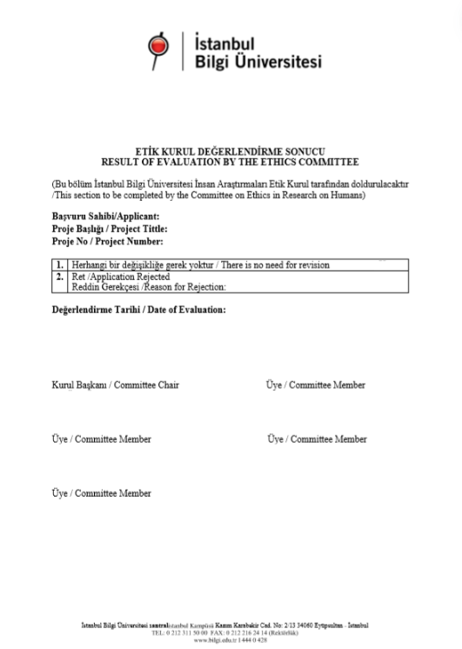

- Appendix Title
Add appendix here

- Appendix Title
Add appendix here

