We assume that internal.example.com is a real server

1. Check Default DNS resolution ( /etc/resolve.conf )VS. 8.8.8.8

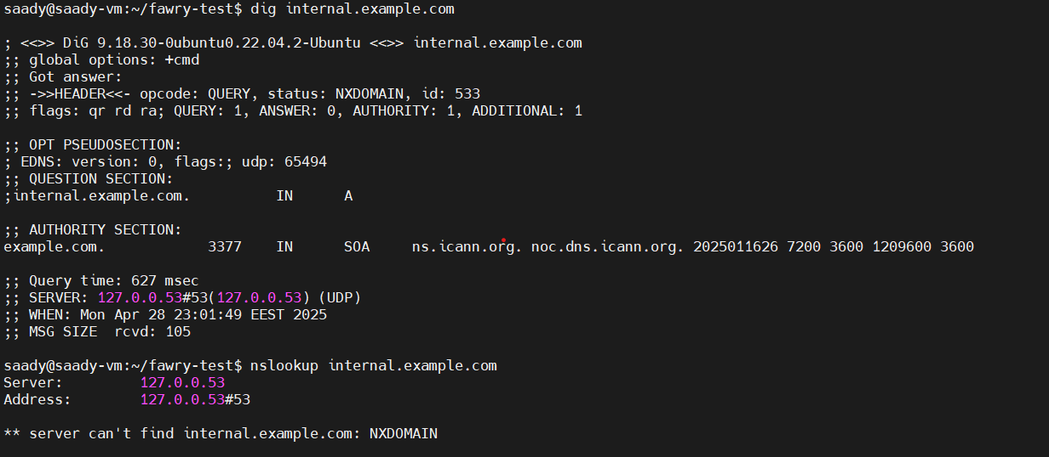

If that only has a problem so the issue is in local DNS Server

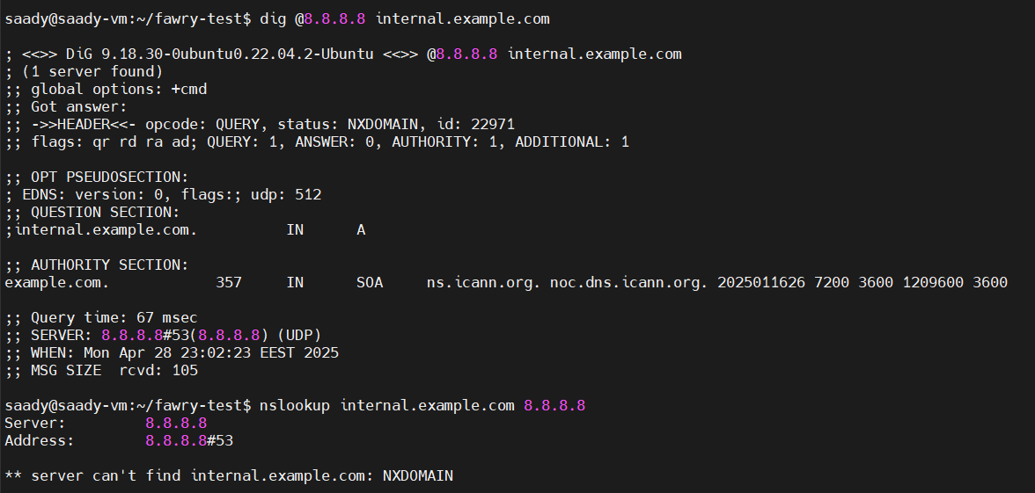

But if the issue in both DNS and 8.8.8.8, so the issue in the domain or the network

|  |
| --- |
| DNS Server Misconfigured |

|  |
| --- |
| Missing DNS Record |

It could be looking at /etc/hosts at first before DNS --- we solve it by edit /etc/nsswitch

Or We can add this in /etc/hosts to check the server too

echo “10.20.30.31 internal.example.com” >> /etc/hosts

2. Diagnose Service Reachability: Confirm whether the web service (port 80 or 443) is reachable on the resolved IP. Use curl, telnet, netstat, or ss to find if the service is listening and responding.

-- Assume we have an IP for “internal.example.com” 10.20.30.31

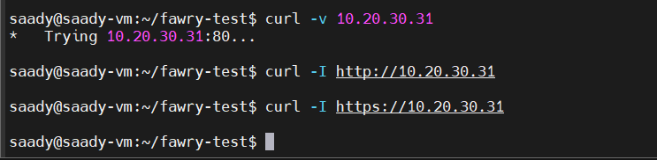

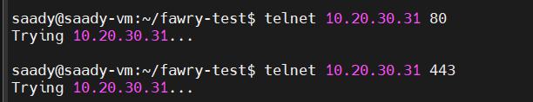

It could be because of the firewall or the SELinux if it’s working

* To solve it we can run these

Sudo setenforce 0 --- or add labels for the httpd object

sudo firewall-cmd --add-port=80/tcp or 443/tcp

sudo firewall-cmd --permanent --add-port=443/tcp or 80/tcp

Or edit the listening port /etc/nginx/nginx.conf