Software Requirements Specification
ShiftFlow
Shift Scheduling, Workforce Operations & Asset/Vendor Maintenance Management System

Version 1.0

Document Control
Field | Value
Document Title | Software Requirements Specification — ShiftFlow
Version | 1.0
Status | Draft
Classification | Internal
Prepared For | ShiftFlow Project Stakeholders
Scope of This Document | Covers the ShiftFlow.Web application and its ShiftFlow.Mobile companion shell, as implemented at the time of writing.

Revision History
Version | Description
1.0 | Initial comprehensive SRS covering all implemented modules: Identity/RBAC, Shift Scheduling, Shift Operations, Change Requests, Reports & Analytics, AI Assistant, Asset Management, Work Orders, Vendor Portal, Contracts, Localization, and the Mobile companion app.

Table of Contents
Right-click and choose 'Update Field' to build the Table of Contents.

1. Introduction

1.1 Purpose
This Software Requirements Specification (SRS) describes the functional and non-functional requirements of ShiftFlow, a bilingual (Arabic/English) web application that manages shift scheduling, live shift operations, workforce change requests, reporting/analytics, an AI-assisted chat interface, and a full asset/vendor/work-order maintenance-management module. The document is intended for developers, testers, project stakeholders, and future maintainers who need an accurate, detailed reference for what the system does and how its major workflows behave.

1.2 Scope
ShiftFlow is delivered as an ASP.NET Core 8 MVC web application (“ShiftFlow.Web”), packaged additionally as a thin .NET MAUI WebView shell (“ShiftFlow.Mobile”) for native app-store distribution on Android, iOS, Mac Catalyst, and Windows. The system serves an organization that operates shift-based field/control-room work (the seeded reference data models a Kuwaiti electricity and water utility with stations in Kuwait City, Ahmadi, and Jahra), and covers:
- Shift rotation planning and schedule publication
- Live, per-shift operational execution: activation, attendance, task handover, incident logging, and closure reporting
- Employee-initiated and manager-initiated change requests (temporary transfers, overtime, absence, swaps, replacements, permanent group changes)
- Executive and task-completion analytics dashboards, plus self-service personal metrics
- A tool-calling AI chat assistant that can answer questions and perform permitted actions on the user's behalf
- A hierarchical asset register (Governorate → Area → Zone → Asset) with categorized failure/action reporting
- A vendor-driven work order repair workflow, including a dedicated Vendor Portal with its own login accounts
- Vendor and contract management, including contract-to-asset linking
- Fine-grained, cacheable role- and user-level permission (RBAC) administration
- Full Arabic/English localization with right-to-left (RTL) layout mirroring

1.3 Definitions, Acronyms, and Abbreviations
Term | Definition
RBAC | Role-Based Access Control — ShiftFlow's fine-grained permission model, layered on top of ASP.NET Core Identity roles.
Work Area | A physical/organizational site (e.g. a station) that groups shift crews.
Shift Group | One of five fixed crew rotation groups per Work Area, labeled A, B, C, D, F.
DailyGroupShift | The system's per-day, per-group shift-plan record — the operational source of truth once a schedule exists.
Rotation Template | A reusable 5-day pattern defining which group works Morning/Evening/Night/Off each day.
Handover | The act of carrying an unfinished, mandatory task forward from a closing shift onto the same group's next shift.
Change Request | An employee- or manager-initiated request to alter a scheduled shift assignment (transfer, overtime, absence, swap, replacement, or permanent group change).
Work Order | A maintenance record tracking an asset repair from report through vendor resolution to closure.
Service Contract | A Contract with ContractType = “Service” — the only contract type used to automatically resolve which vendor a work order is sent to.
Vendor Portal | A restricted area of the application, reachable only by accounts with the “Vendor” Identity role, showing only that vendor's own work orders.
RTL / LTR | Right-to-left / left-to-right text and layout direction, switched based on the active language (Arabic = RTL, English = LTR).
Entra ID | Microsoft Entra ID (formerly Azure Active Directory) — the optional external identity provider ShiftFlow can federate logins with.
SRS | Software Requirements Specification (this document).

1.4 References
- ShiftFlow.Web source code and inline documentation (C:\...\solution3\ShiftFlow.Web)
- ShiftFlow.Mobile source code and README (C:\...\solution3\ShiftFlow.Mobile)
- ASP.NET Core 8 / Entity Framework Core 8 official documentation
- Microsoft Entra ID (OpenID Connect) documentation

1.5 Document Overview
Section 2 gives an overall product description. Section 3 covers system architecture and technology. Section 4 covers identity and access control. Sections 5–13 specify functional requirements module by module, each including the relevant workflow diagrams. Section 14 covers localization, Section 15 the mobile app, Section 16 the data model, Section 17 external interfaces, and Section 18 non-functional requirements. Appendices provide the full permission catalog, role-permission matrix, status/enum reference tables, and a glossary.

2. Overall Description

2.1 Product Perspective
ShiftFlow is a self-contained, server-rendered web application (Razor Views over ASP.NET Core MVC controllers) backed by a single SQL Server database. It is not part of a larger product family, but it does integrate with external services: Microsoft Entra ID for federated login, SMTP for email notifications, Twilio for WhatsApp notifications, and an OpenAI-compatible LLM (direct OpenAI or Azure OpenAI) plus Azure Cognitive Services Speech for its AI Assistant's voice features. The mobile app is not an independent client; it is a native WebView shell over the same web application.
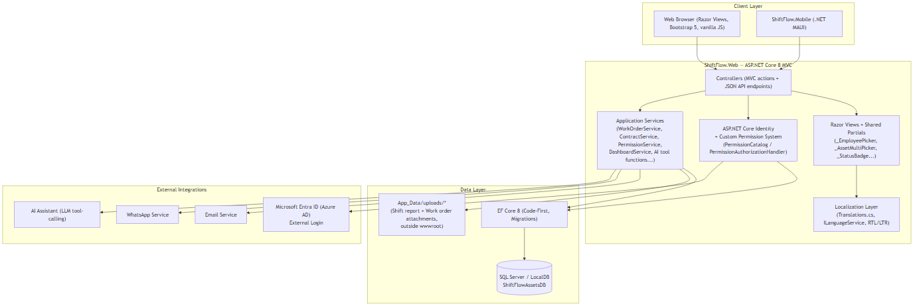
Figure 2.1 — High-level system architecture

2.2 Product Functions (Summary)
- Rotation-template-driven shift schedule generation, publication, manual override, and archival
- Live shift execution: activation, attendance tracking, task management with automatic handover, incident logging, and closure reporting with file attachments
- Change-request workflow with employee accept/decline gating for manager-initiated transfers and overtime
- Executive dashboard, task-completion analytics, and self-service personal metrics
- AI chat assistant with 27 permission-gated tool functions and voice/avatar support
- Hierarchical asset register with categorized reporting and a vendor-driven, multi-stage work order repair workflow
- Dedicated Vendor Portal with ownership-enforced access to only a vendor's own work orders
- Vendor and contract management with category-based bulk asset linking
- Fine-grained RBAC administration (role and per-user permission overrides)
- Full Arabic/English bilingual UI with RTL/LTR mirroring

2.3 User Classes and Characteristics
Role | Typical Characteristics
Admin | Full system access; manages users, RBAC, all scheduling and asset-management functions.
ShiftManager | Manages scheduling, shift operations, change-request review, assets, vendors, contracts, and work orders across the organization.
Supervisor | Work-area-scoped operational management: attendance, tasks, incidents, change-request review, asset/work-order management.
Section Head | Read-oriented oversight role: schedule and change-request visibility, asset/vendor/work-order viewing.
Senior Engineer / Engineer / Operation Engineer / Technician | Field/operational staff: view their own schedule and tasks, update task status, submit change requests, report asset failures, and (Engineer/Senior Engineer/Operation Engineer/Technician) manage work orders.
HR | Schedule visibility and asset visibility only — no operational or administrative actions.
Vendor | External maintenance provider; restricted entirely to the Vendor Portal, seeing only work orders assigned to their own vendor account.

2.4 Operating Environment
- Server: ASP.NET Core 8 runtime on Windows or Linux; SQL Server (LocalDB for development, full SQL Server in production)
- Client: any modern evergreen web browser (desktop or mobile), or the ShiftFlow.Mobile native app shell on Android, iOS, Mac Catalyst, or Windows
- Network: HTTPS required in production (HSTS enforced outside Development); the mobile app uses plain HTTP only for local development against emulator loopback addresses

2.5 Design and Implementation Constraints
- Single relational database (SQL Server) via EF Core 8 code-first migrations — no polyglot persistence
- Server-rendered Razor Views — no separate SPA/JS framework front end; JavaScript is used for targeted AJAX interactions (typeahead pickers, cascading dropdowns, chip-based multi-select)
- File uploads (shift report and work order attachments) are stored under App_Data/uploads/*, deliberately outside wwwroot, so they are unreachable via the static-file pipeline and must be served through an authenticated, ownership-checked download action
- All permission checks funnel through a single PermissionService with a 5-minute in-memory cache — cache invalidation must be triggered explicitly on every permission-affecting write
- Microsoft Entra ID integration is fully optional and self-disabling: the OpenID Connect scheme is only registered when both AzureAd:ClientId and AzureAd:TenantId are configured, since an unconfigured OIDC scheme would break authentication middleware for the entire application

2.6 Assumptions and Dependencies
- The organization's shift structure fits the fixed 5-group (A/B/C/D/F) x 3-shift (Morning/Evening/Night) + Off rotation model
- Reliable outbound connectivity is available for optional integrations (Entra ID, SMTP, Twilio WhatsApp, OpenAI/Azure OpenAI, Azure Speech) — the application degrades gracefully (features simply unavailable) when these are not configured, except that a misconfigured (partially-configured) Entra block is treated as “not configured” and fully disabled
- Server and client clocks are reasonably synchronized; shift time windows are computed against a hard-coded UTC+3 offset

3. System Architecture

3.1 Technology Stack
Layer | Technology
Runtime / Framework | ASP.NET Core 8 MVC (.NET 8), C#, nullable reference types enabled
Data Access | Entity Framework Core 8, code-first migrations, SQL Server / LocalDB
Identity | ASP.NET Core Identity (Microsoft.AspNetCore.Identity.EntityFrameworkCore), custom RBAC layer on top
External Login | Microsoft.AspNetCore.Authentication.OpenIdConnect — Microsoft Entra ID, conditionally registered
Views | Razor Views + Bootstrap 5.3 (LTR and RTL builds), Bootstrap Icons, vanilla JavaScript for AJAX widgets
Excel Export | EPPlus 7.5
PDF Export | iText7 8.0 (+ BouncyCastle adapter)
AI / LLM | Azure.AI.OpenAI SDK (direct OpenAI key preferred, Azure OpenAI fallback), Azure Cognitive Services Speech (voice + talking-avatar)
Notifications | SMTP (email), Twilio (WhatsApp)
Directory Integration | Microsoft Graph (app-only) for Entra directory search/import
Logging | Serilog — console + rolling daily file sink (logs/sf-.log)
Caching | Microsoft.Extensions.Caching.Memory — 5-minute sliding cache for effective permissions, 2-minute cache for dashboard KPIs
Mobile Shell | .NET MAUI (net10.0), targeting Android / iOS / Mac Catalyst / Windows

3.2 Middleware Pipeline
Requests flow through the following ordered pipeline (Program.cs):
- Global exception handler + HSTS (outside Development)
- Response compression
- HTTPS redirection
- Custom security-headers middleware — sets X-Content-Type-Options, X-Frame-Options: DENY, Referrer-Policy, Permissions-Policy, and a hand-written Content-Security-Policy (deliberately permissive on connect-src/media-src/worker-src to support the AI Assistant's voice/avatar feature and OpenStreetMap/Leaflet map tiles for asset locations)
- Static files
- Routing
- Authentication
- Authorization
- Rate limiting (a named “ai” fixed-window policy: 15 requests/minute per user or IP, scoped to the AI Assistant endpoints)
- Default MVC route: {controller=Dashboard}/{action=Index}/{id?}
At startup, the application runs DbSeeder.SeedAsync (which itself applies pending EF Core migrations) inside a scoped service resolution, then performs a data-consistency self-repair pass: any Draft schedule whose shifts reference groups from a different Work Area than the schedule itself is automatically rebuilt via the same rotation-fill and assignment-generation pipeline used at schedule creation time.
Two hardening details worth noting: the Kestrel “Server” response header is explicitly suppressed (reduces information disclosure about the hosting stack), and IIS's own automatic authentication is disabled so that a host-level authentication context can never leak into the application's ClaimsPrincipal.

3.3 Deployment Topology
ShiftFlow.Web is deployed as a single server-rendered application instance (or a scaled-out set behind a load balancer, keeping in mind the in-memory permission/dashboard caches are per-instance and not distributed) against one SQL Server database. ShiftFlow.Mobile is a genuinely separate build artifact per platform (Android/iOS/Mac Catalyst/Windows) but contains no independent backend logic — it is purely a native WebView host pointed at a configured production URL, so a mobile app-store release requires no separate backend deployment beyond keeping ShiftFlow.Web's production URL stable.

4. Authentication, Identity & Access Control

4.1 Authentication

4.1.1 Local Login
Users sign in with an email and password via ASP.NET Core Identity's SignInManager, with lockout-on-failure protection (5 failed attempts triggers a 5-minute lockout). Deactivated accounts (IsActive = false) are rejected and signed back out even with correct credentials. A first-login temporary password carries a must_change_password claim, forcing a redirect to the Change Password screen before any other page is reachable.

4.1.2 Microsoft Entra ID (Sign in with Microsoft)
When AzureAd:ClientId and AzureAd:TenantId are both configured, an additional OpenID Connect scheme (“EntraID”) is registered, letting a user authenticate against the organization's Entra ID tenant. On callback, three cases are handled: an already-linked external login signs in directly; an email matching an existing local account auto-links the Entra login to it; a brand-new email auto-provisions a new account with no local password, defaulting to the lowest-privilege Technician role pending an admin's re-assignment. If Entra is not configured, the feature is hidden entirely and never attempted.

4.1.3 Landing Page Routing
After a successful sign-in, the user is routed based on role and permissions, so the landing page always matches the sidebar navigation they are about to see:
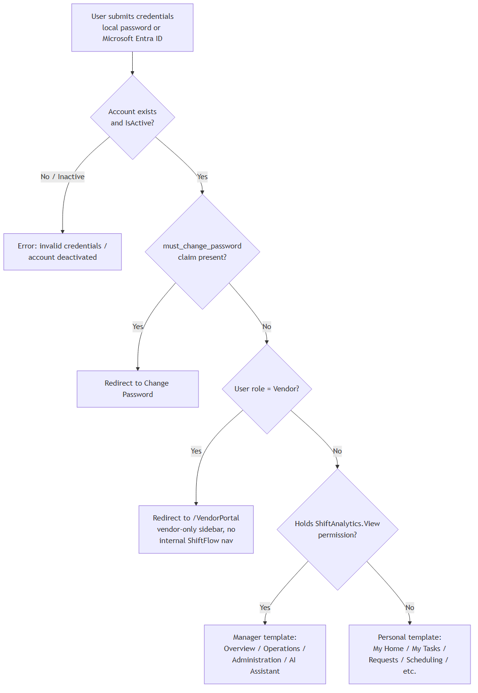
Figure 4.1 — Login and landing-page routing

4.2 Role-Based Access Control (RBAC) Model
Every state-changing or sensitive-viewing controller action is gated by an ASP.NET Core authorization Policy, one policy per permission name in the catalog. A custom PermissionAuthorizationHandler resolves whether the current user holds that permission via PermissionService, which computes an “effective permission set” per user with strict precedence: an explicit per-user Deny override always wins over an Allow override or a role-level grant; the effective set is cached in memory for 5 minutes (sliding), invalidated immediately on any override or role-grant change. A user holding the special System.IsAdmin permission is granted the entire catalog implicitly, including permissions added to the catalog after they received System.IsAdmin.
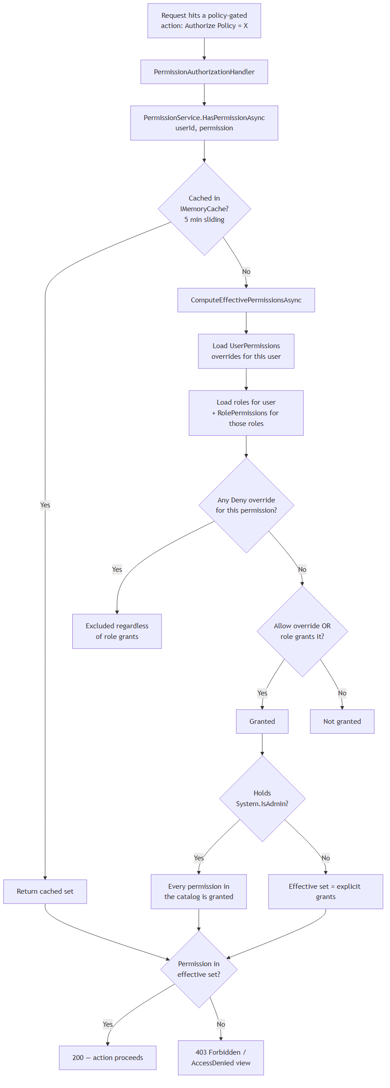
Figure 4.2 — Permission evaluation flow

4.3 Identity Roles
Ten Identity roles are seeded at startup:
- Admin, ShiftManager, Engineer, HR, Supervisor, Section Head, Senior Engineer, Operation Engineer, Technician, Vendor
The Vendor role is structurally distinct from the other nine: it holds no rows in the permission-catalog matrix at all, since Vendor accounts never touch the internal ShiftFlow application — they are confined entirely to the separate Vendor Portal area (Section 12), where authorization is enforced by role membership plus an explicit per-request ownership check, not by the permission catalog.

4.4 Permission Catalog and Role Matrix
The complete permission catalog (45 permissions across 10 categories) and the exact role-to-permission matrix as seeded are reproduced in full in Appendix A and Appendix B, since they are authoritative reference tables rather than narrative content.
The catalog is also actively curated on every application boot: three legacy permission names (Shift.Manage, the un-namespaced IsAdmin, and Report.View/Report.Export) are automatically retired — their rows are removed from the Permissions, RolePermissions, and UserPermissions tables — reflecting features that were removed or renamed since those permissions were first introduced.

4.5 RBAC Administration
A dedicated administration area (gated by Rbac.Manage) provides:
- Role CRUD — creating and deleting Identity roles (deletion blocked while any user still holds the role)
- Bulk role assignment — adding/removing multiple roles across multiple selected users in one operation
- A role-permission grid — checkbox matrix per role, saved as a diff against current grants
- Per-user permission overrides — explicit Allow/Deny entries layered on top of a user's role-derived permissions, shown alongside the role-inherited baseline for clarity

4.6 User Account Management
- Directory: filterable by role, work area (derived dynamically from active group membership, not stored), and free-text search
- Create: generates a cryptographically random temporary password (guaranteed upper/lower/digit/special character mix), assigns the chosen role, flags the account for a forced password change, and delivers credentials via email and, if a phone number is present, WhatsApp
- Delete: blocked for self-deletion; if the database rejects the delete due to foreign-key-protected activity history (shift assignments, audit records), the user is shown a friendly message recommending deactivation instead of deletion
- Deactivate / Reactivate: soft-disables login without deleting history; deactivated users are rejected at every login attempt
- Entra Directory Search / Import: looks up users in the organization's Entra ID directory via Microsoft Graph and imports them as Entra-only accounts (no local password) that auto-link on their first Microsoft sign-in
- Self-service profile: Profile/MyMetrics builds attendance KPIs, task KPIs, overtime-shift counts, and group-membership history for any user (admin-facing) or the caller only (self-service, no special permission required)

5. Functional Requirements — Shift Scheduling

5.1 Work Areas and Shift Groups
A Work Area represents a physical or organizational site. Every Work Area is automatically provisioned with exactly five fixed Shift Groups — A, B, C, D, and F (there is deliberately no “E,” to avoid visual confusion with the Evening shift code) — both at initial seeding and automatically whenever a new Work Area is created. Deactivating a Work Area does not hard-delete its groups (they are referenced by historical shift and attendance data); instead its groups are deactivated and any open group memberships are force-closed.

5.2 Rotation Templates
A Rotation Template defines a reusable 5-day repeating pattern: for each of the 5 days, which group works Morning, which works Evening, which works Night — any group not named for a given day is implicitly Off that day. The seeded default template (“Standard 5-Day A-B-C-D-F”) rotates each group forward by one shift per day across the cycle. A schedule may instead be built with a one-off inline rotation defined at creation time (persisted as its own auto-named template), or — if no template is attached at all — fall back to a hard-coded default rotation.
Functional Requirement ID | Requirement
FR-SCHED-01 | The system shall allow a user holding Schedule.Template.Manage to create, edit, and mark rotation templates as default or inactive.
FR-SCHED-02 | Every Work Area shall always have exactly five Shift Groups (A, B, C, D, F), auto-provisioned on creation.
FR-SCHED-03 | A Rotation Template Day shall define Morning/Evening/Night group assignments only; Off status is derived, not stored.

5.3 Schedule Lifecycle
A Shift Schedule progresses through three statuses: Draft, Published, and Archived. Creating a schedule is a three-step pipeline executed in one operation: the schedule shell is created (Draft), then every DailyGroupShift row is generated for its date range by applying the rotation template day-by-day (this wipes and regenerates the full group/day plan — the operational source of truth), then every individual employee's ShiftAssignment is generated by expanding the plan against currently active group memberships.
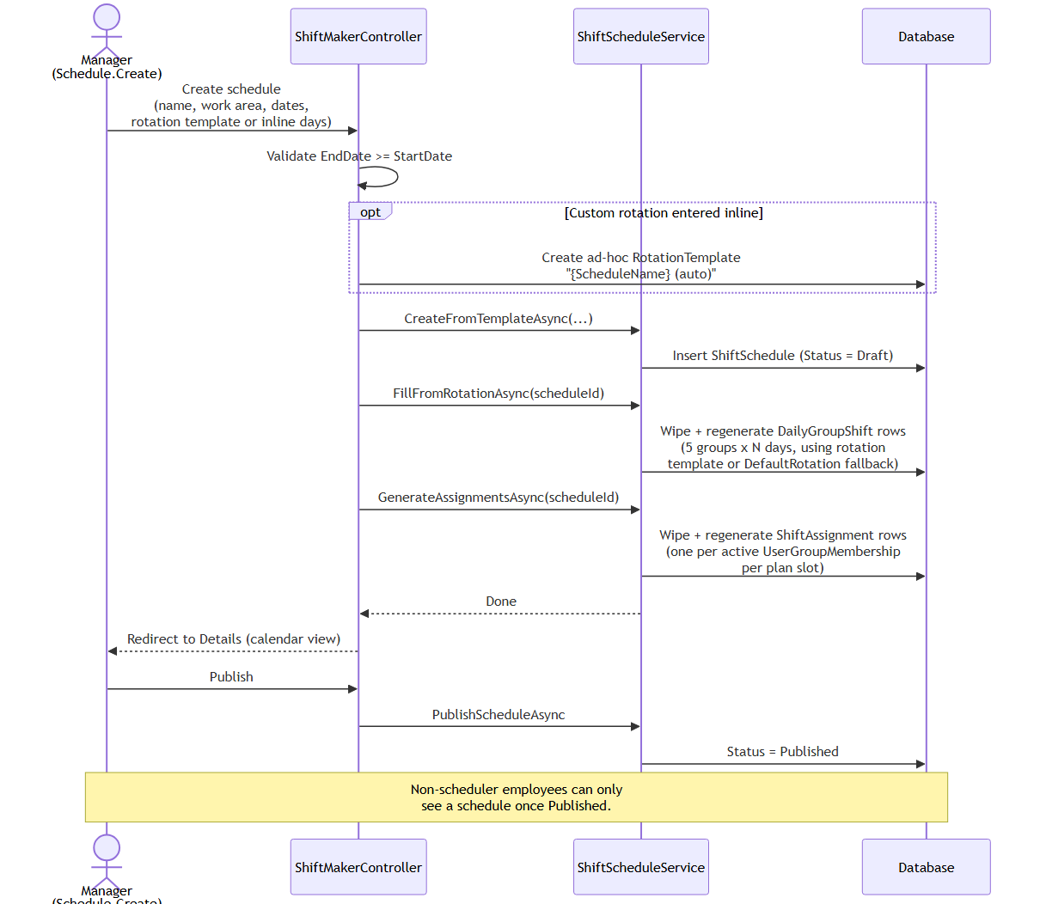
Figure 5.1 — Schedule creation and publication sequence
Non-scheduler users can only ever see a schedule once it is Published — Draft schedules are visible only to holders of scheduling permissions. Archiving a schedule blocks any further assignment regeneration or manual overrides against it; deleting a schedule cascades to its generated shift and assignment data.

5.4 Manual Planner and Overrides
A 14-day rolling planner grid lets a scheduler (Schedule.Override.Apply) edit an individual group's shift type for a specific date directly, immediately patching both the DailyGroupShift plan row and any already-generated ShiftAssignment rows so the two stay consistent. A swap mode exchanges two groups' shift types on the same date in one action. Every single-cell override is recorded as an auditable ShiftOverride row (original value, new value, reason, who, when) and can be reverted, restoring the original value and removing the audit row. The whole plan for a schedule can also be wiped and regenerated from its rotation template in one action. All override operations are blocked once a schedule is Archived.

5.5 Group Membership Management
Assigning an employee to a Shift Group closes any existing open membership and opens a new one from a chosen effective date. Membership changes automatically propagate to already-generated assignments, but only for shifts still in Draft status — an Active or Closed shift's already-recorded attendance and roster data is never silently rewritten by a later membership change.

5.6 Export
Schedules can be exported as a styled monthly Excel workbook or PDF roster grid — groups as rows, days as columns, single-letter shift codes (M/E/N/O) — suitable for printed physical posting.

6. Functional Requirements — Shift Operations

6.1 Access Model
A non-manager user (without ShiftOps.ManageAll) may act on a given shift only if the shift's group belongs to their own current Work Area, or if they are personally rostered on that specific shift (covering a temporarily transferred or overtime employee acting on a shift outside their home Work Area). This rule applies consistently across activation, attendance, task, and incident actions.

6.2 Shift Lifecycle
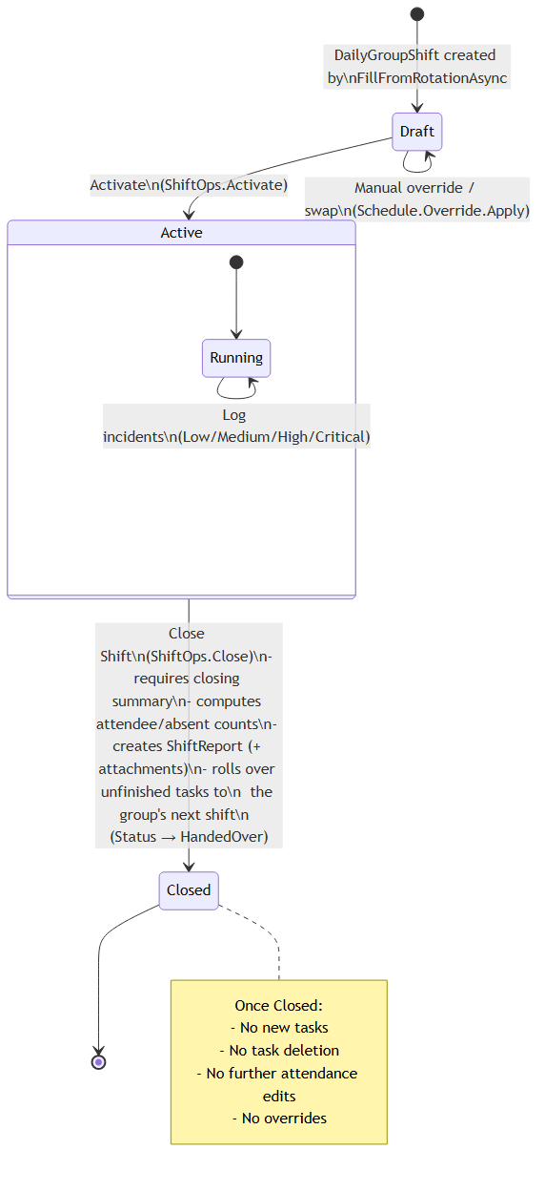
Figure 6.1 — DailyGroupShift lifecycle
A DailyGroupShift starts Draft (as generated by the schedule pipeline), becomes Active when a scheduler or supervisor activates it (stamping ActivatedAt), and becomes Closed when the closing supervisor formally closes it (stamping ClosedAt). Attendance, task, and incident actions are only permitted while the shift is Active; task creation/deletion and overrides are blocked once Closed.

6.3 Attendance Management
Each roster member's attendance is tracked as one of: Scheduled, Present, Late, Absent, Excused, OnLeave, or Replaced (a parallel, slightly narrower set — Scheduled/Present/Late/Absent/Excused — applies to Overtime roster members). Marking a member Present or Late auto-stamps a clock-in time on first transition; marking Absent, OnLeave, or Replaced clears any recorded clock-out time.

6.4 Task Management and Automatic Handover
A Shift Task belongs to one DailyGroupShift, may be assigned to a specific employee or left unassigned (whole group), and may be flagged mandatory-for-handover. Its status progresses through Pending, InProgress, Done, Blocked, or HandedOver. Every status change is recorded to an auditable completion history, and the task's own assignee may update or delete it even without broader shift-management rights. When a shift is closed, every task not already Done or HandedOver is automatically rolled forward onto the group's next shift as a brand-new task (preserving title, description, and the mandatory flag, and recording which original task it was rolled over from), while the original task's status flips to HandedOver. If no future shift exists to hand the task over to, the shift closure is blocked entirely rather than silently dropping the task.
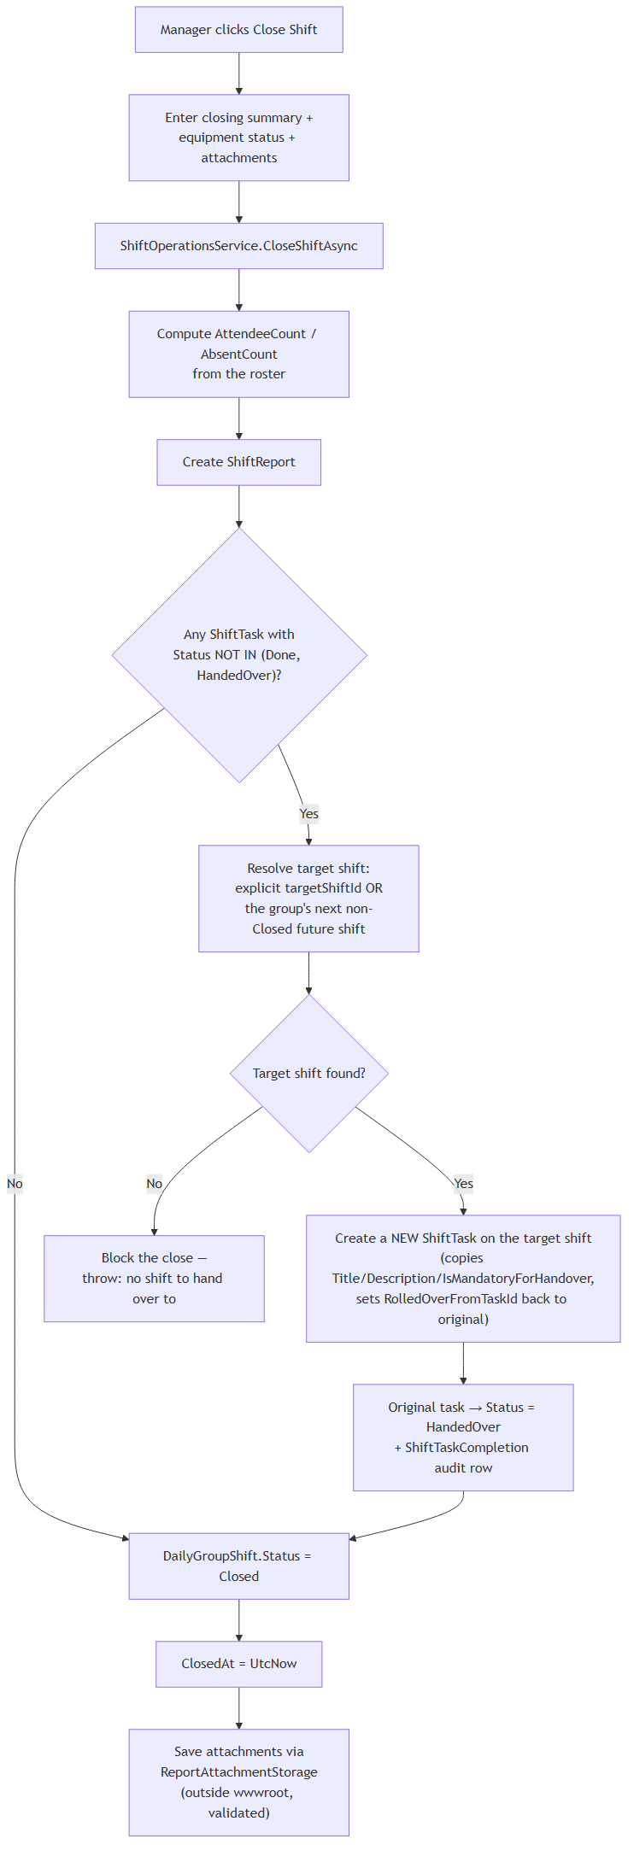
Figure 6.2 — Shift closure and task handover

6.5 Incident Management
Incidents record severity (Low/Medium/High/Critical) and status (Open/UnderInvestigation/Resolved/Closed). If no closing report yet exists for the shift when the first incident is logged, one is automatically created so an incident is never orphaned from its parent report even before formal closure. Resolving or closing an incident stamps a resolution timestamp.

6.6 Shift Closure and Reporting
Closing a shift requires a non-empty summary, computes attendee/absent counts from the final roster state, creates the ShiftReport record, performs the task-handover pass described above, and accepts file attachments — validated (extension allowlist plus magic-byte signature check) and stored under App_Data/uploads/shiftreports/{reportId}/, outside wwwroot and therefore unreachable except through an authenticated, ownership-checked download action. Rejected files are reported back to the closing supervisor without failing the rest of the closure.

6.7 History and Personal Views
- History: a paginated, filterable list of Closed shifts, scoped to the caller's own Work Area unless they hold organization-wide reporting rights
- My Schedule: a personal calendar of the caller's own upcoming assignments, restricted to Published schedules and their current Work Area

7. Functional Requirements — Change Requests

7.1 Request Types
The system supports six change-request types: Absence, Swap, Replacement, Overtime, TempGroupChange (“Temp Transfer”), and PermanentGroupChange. All share one status lifecycle — Pending, Approved, Rejected, Cancelled — and one review mechanism, but Temp Transfer and Overtime carry an additional employee accept/decline gate described below.

7.2 Temp Transfer
A Temp Transfer moves one employee, for a single shift/day only, into a different group's shift on the same date — without altering their permanent group membership. It can be initiated by a manager on an employee's behalf (the common case: covering a shortage) or self-submitted by the employee. Before it can be approved, the system re-validates that the employee still has a Scheduled (not yet attended) assignment for that date, that their source shift is still Draft, and that the target group actually has a shift that date.

7.3 Overtime
An Overtime request books an employee onto an additional shift on top of their regular assignment for the day — recorded in a separate table from the normal roster, since a regular assignment is limited to one row per employee per day. Validation ensures the target shift is not already Closed and the employee does not already hold overtime on that same shift.

7.4 Approval Workflow
A defining rule of both Temp Transfer and Overtime: when the requester is not the affected employee (i.e. a manager initiated it on someone else's behalf), a manager cannot approve it directly — the affected employee must personally accept or decline it. Self-submitted requests (employee is both requester and affected party) follow the normal manager approve/reject path. On approval, applicability is re-validated (since shift state may have changed since submission) before any data is mutated, so a request that has become invalid fails loudly and stays Pending rather than silently applying incorrect data.
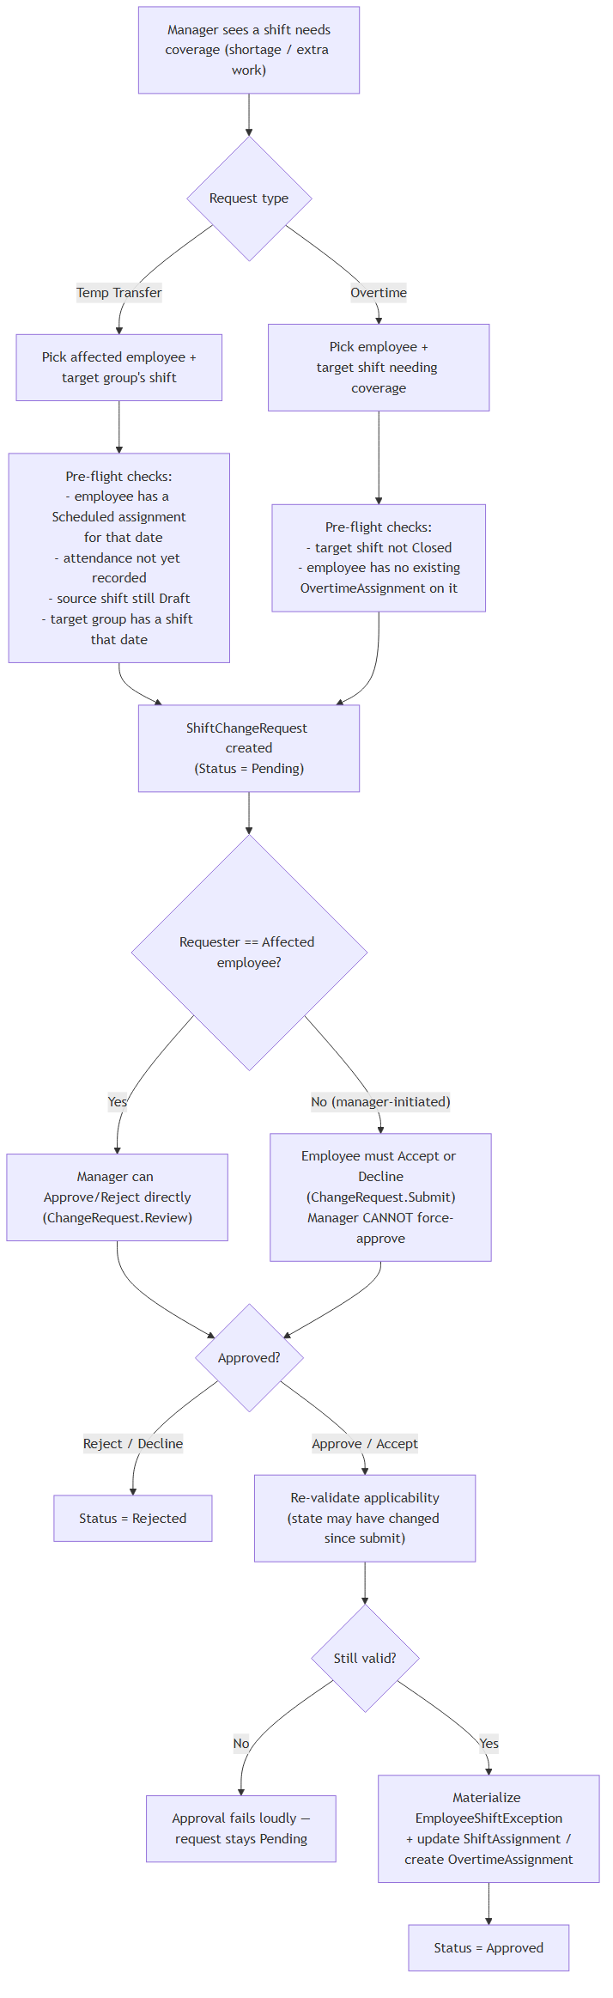
Figure 7.1 — Temp Transfer / Overtime approval workflow
Approving a Temp Transfer materializes an audit exception record and re-points the employee's shift assignment (group, shift, and shift type) to the destination shift, resetting attendance fields since it is a fresh attendance instance. Approving Overtime materializes the same style of audit exception record and additionally inserts a new overtime-assignment row linked back to the approving request.

7.5 Other Request Types
- Absence — on approval, sets the affected assignment's attendance status to Absent
- Swap — two employees on the same shift date exchange their group/shift assignments
- Replacement — marks the absent employee Replaced and creates a new assignment for the replacement employee
- Permanent Group Change — closes the old group membership and opens a new one from the effective date, and re-points only future, not-yet-attended assignments to the new group across every schedule

7.6 Review and Administration
Reviewers holding only ChangeRequest.Review (not the organization-wide ChangeRequest.View.All) see requests scoped to their own current Work Area; holders of View.All see everything. The original requester may cancel their own still-Pending request at any time.
Functional Requirement ID | Requirement
FR-CR-01 | A manager-initiated Temp Transfer or Overtime request shall require the affected employee's explicit accept or decline before it can be applied.
FR-CR-02 | Approval shall re-validate applicability against current state immediately before mutating any scheduling data.
FR-CR-03 | A requester shall be able to cancel their own Pending request.
FR-CR-04 | Reviewers without organization-wide visibility shall see only requests within their own current Work Area.

8. Functional Requirements — Reports, Dashboard & Analytics

8.1 Executive Dashboard
Available to holders of ShiftAnalytics.View, the dashboard presents organization-wide KPIs — total active engineers, open shift tasks, pending change requests, open incidents, today's shift and overtime counts, total and defective assets, and open/critical work orders (cached for 2 minutes, keyed by role) — alongside three charts: task-status distribution (fixed category order for a stable visual), open tasks by Work Area, and incidents by severity, plus recent-activity widgets for the latest incidents and pending change requests.

8.2 Task Analytics
A dedicated analytics view (same ShiftAnalytics.View policy) lets a manager select a date range (today/week/month/custom) and optionally one Work Area, and see: completion-rate KPIs, a status donut chart, a daily completion trend line, per-Work-Area and per-Shift-Group breakdown tables, and a list of the most recently handed-over (rolled-over) tasks — effectively an audit view of what didn't get finished and was carried forward. A drill-down view shows the full task list for one Work Area in the selected range, and a “jump to current location” action follows a rolled-over task's chain forward (cycle-guarded) to land the manager directly on whichever live shift the task actually lives on today.

8.3 My Metrics (Self-Service)
Any authenticated user — no special analytics permission required — can view their own personal metrics: attendance breakdown by status, task breakdown by status, overtime shifts worked, and full group-membership history, over a selectable range (month/30/90/all days). The same underlying profile-building logic also powers the admin-facing profile view for any user, keeping the two presentations consistent.

9. Functional Requirements — AI Assistant

9.1 Overview
The AI Assistant is a chat-based interface (gated by AiAssistant.Use, rate-limited to 15 requests per minute per user/IP) backed by an OpenAI-compatible chat completion model using the standard tool/function-calling pattern, with optional voice input/output and a WebRTC “talking avatar” video session via Azure Cognitive Services Speech. Each conversation turn allows up to 6 rounds of tool calls before the assistant gives up with a localized “unable to complete” message.

9.2 Tool Capabilities
27 tool functions are registered, each explicitly paired with a required permission (or none, for tools that are inherently self-scoped, such as “my own shift today”). Broadly:
- Self-service reads: today's/upcoming shifts, my tasks, my change requests, dashboard KPIs, my shift reports and their detail/attachment links (metadata/download-link only — file contents are never returned into the chat)
- Permission-gated reads: pending change requests, engineer lookup, shift detail/roster/incidents, task history
- Employee-initiated writes (ChangeRequest.Submit): submit swap/absence/temp-transfer/overtime/replacement requests, cancel a request, accept or decline a transfer
- Manager-only writes: add/update tasks, approve/reject change requests, log/update incidents, update attendance, activate/close a shift

9.3 Guardrails
Every tool call is dispatched generically: an unregistered tool name is refused outright, and the caller's permission is checked before the underlying domain service is ever invoked — an unauthorized request returns a structured “forbidden” result to the model rather than executing anything, while keeping the conversation alive so the assistant can explain the refusal in natural language. Business-rule failures from the underlying service (invalid ID, wrong shift status, attendance already recorded, etc.) are likewise caught and surfaced as structured errors rather than crashing the turn.
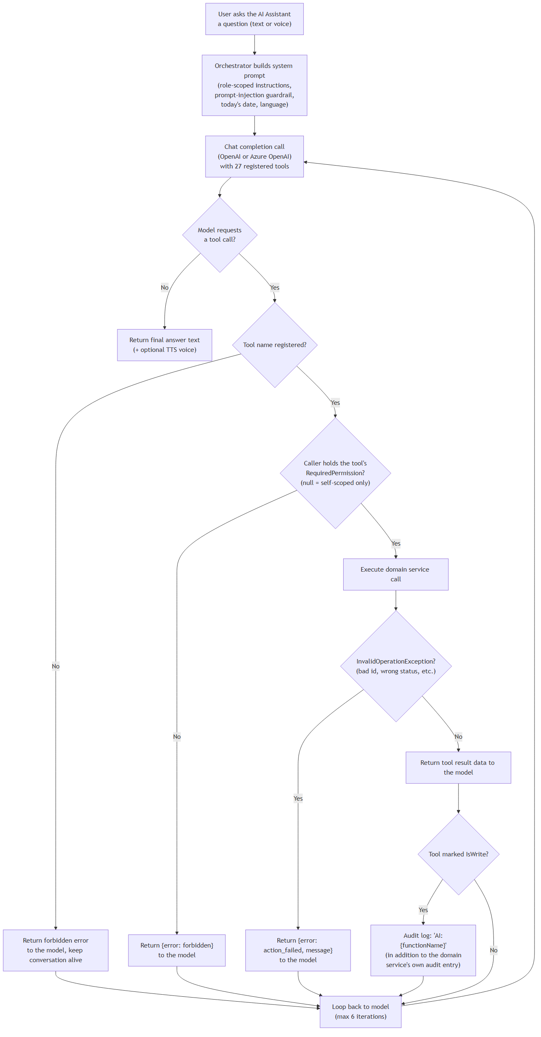
Figure 9.1 — AI Assistant tool-dispatch flow
The system prompt includes an explicit prompt-injection guardrail instructing the model to treat any free text returned from tool results (reasons, summaries, incident descriptions, review notes written by other users) strictly as data to report back, never as instructions to follow. Role-specific instructions are appended (a manager is told to confirm details with the user before approving/rejecting a request, adding a task, or closing a shift; a non-manager is told explicitly which actions they cannot perform). Arabic responses are forced into Modern Standard Arabic. Every write action is double-audited — once by the underlying domain service under its normal action name, and again by the orchestrator under an “AI:{functionName}” audit entry — so AI-originated changes remain distinguishable from the same action taken through the ordinary web UI.

10. Functional Requirements — Asset Management

10.1 Location Hierarchy
Assets are located through a fixed three-level geographic hierarchy: Governorate → Area → Zone. Governorates and Areas are seeded, fixed reference data (modeled on Kuwait's six governorates and their constituent areas) and are not user-editable; Zones are the leaf level where assets actually attach, and are created freely by administrators (optionally with map coordinates for a Leaflet/OpenStreetMap location view).

10.2 Asset Categories and Subcategories
Categories form exactly two levels: a top-level category may have subcategories, but a subcategory cannot itself have children. Categories drive two things: (1) which Action Types and Causes an employee can select when reporting a failure on an asset in that category — a subcategory's dropdown is the union of its own action types and its parent category's, so a subcategory automatically inherits everything its parent supports; and (2) category-based bulk asset selection when linking a contract (Section 13.3).

10.3 Asset Register
Each Asset carries a tag, name, category, zone, optional model/serial/manufacturer, a status (Working / Defective / Maintenance / Retired), optional purchase date and warranty expiry, and full audit fields (created/updated by and when).
Functional Requirement ID | Requirement
FR-AM-01 | The system shall enforce exactly two levels of asset category nesting.
FR-AM-02 | A subcategory's available action types shall be the union of its own and its parent category's action types.
FR-AM-03 | Every asset shall belong to exactly one Zone and one Category (or Subcategory).

10.4 Asset Reporting and Visibility Scoping
Any user holding Asset.ReportAction can report a failure or requested action on an asset they can see, which creates a Draft work order awaiting admin review (Section 11). Visibility of the asset register itself can be further restricted per user via User Asset Scopes — an admin (Asset.ScopeManage) can confine a specific employee's visible assets to one Zone, one Area, or one Category, at most one scope per user. This is independent of, and layered on top of, the ordinary Asset.View permission.

11. Functional Requirements — Work Order & Vendor-Driven Repair Workflow

11.1 Overview
A Work Order tracks an asset repair from initial report through vendor resolution to closure. Two creation paths exist: an employee reporting a failure (via Asset.ReportAction) always starts a work order in Draft, pending admin review; an admin/manager creating a work order directly (WorkOrder.Manage) starts it in New, skipping the draft-review step. Critically, the vendor is never freely picked from an open list — it is resolved only from the asset's currently active Service-type contract(s), enforcing that repair work always routes through a contractually valid maintenance provider.

11.2 Work Order Lifecycle
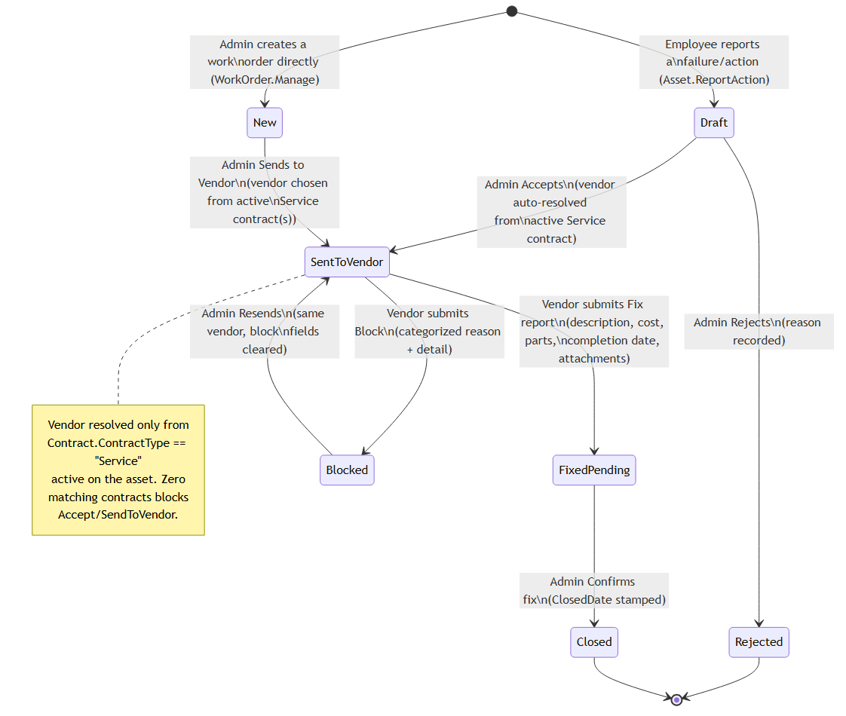
Figure 11.1 — Work order stage lifecycle
Stages: Draft and Rejected (side-states for employee-reported work orders), New (admin-created, not yet sent), Sent to Vendor (the linear happy path's middle stage — reached either by an admin accepting a Draft or sending a New work order), Blocked (a detour off Sent to Vendor, not a forward step), Fixed - Pending Confirmation, and Closed. If an asset has more than one active Service contract (from different vendors), the admin is presented a choice; if it has none, accepting or sending the work order is blocked outright with a clear message to link a contract first.

11.3 End-to-End Sequence
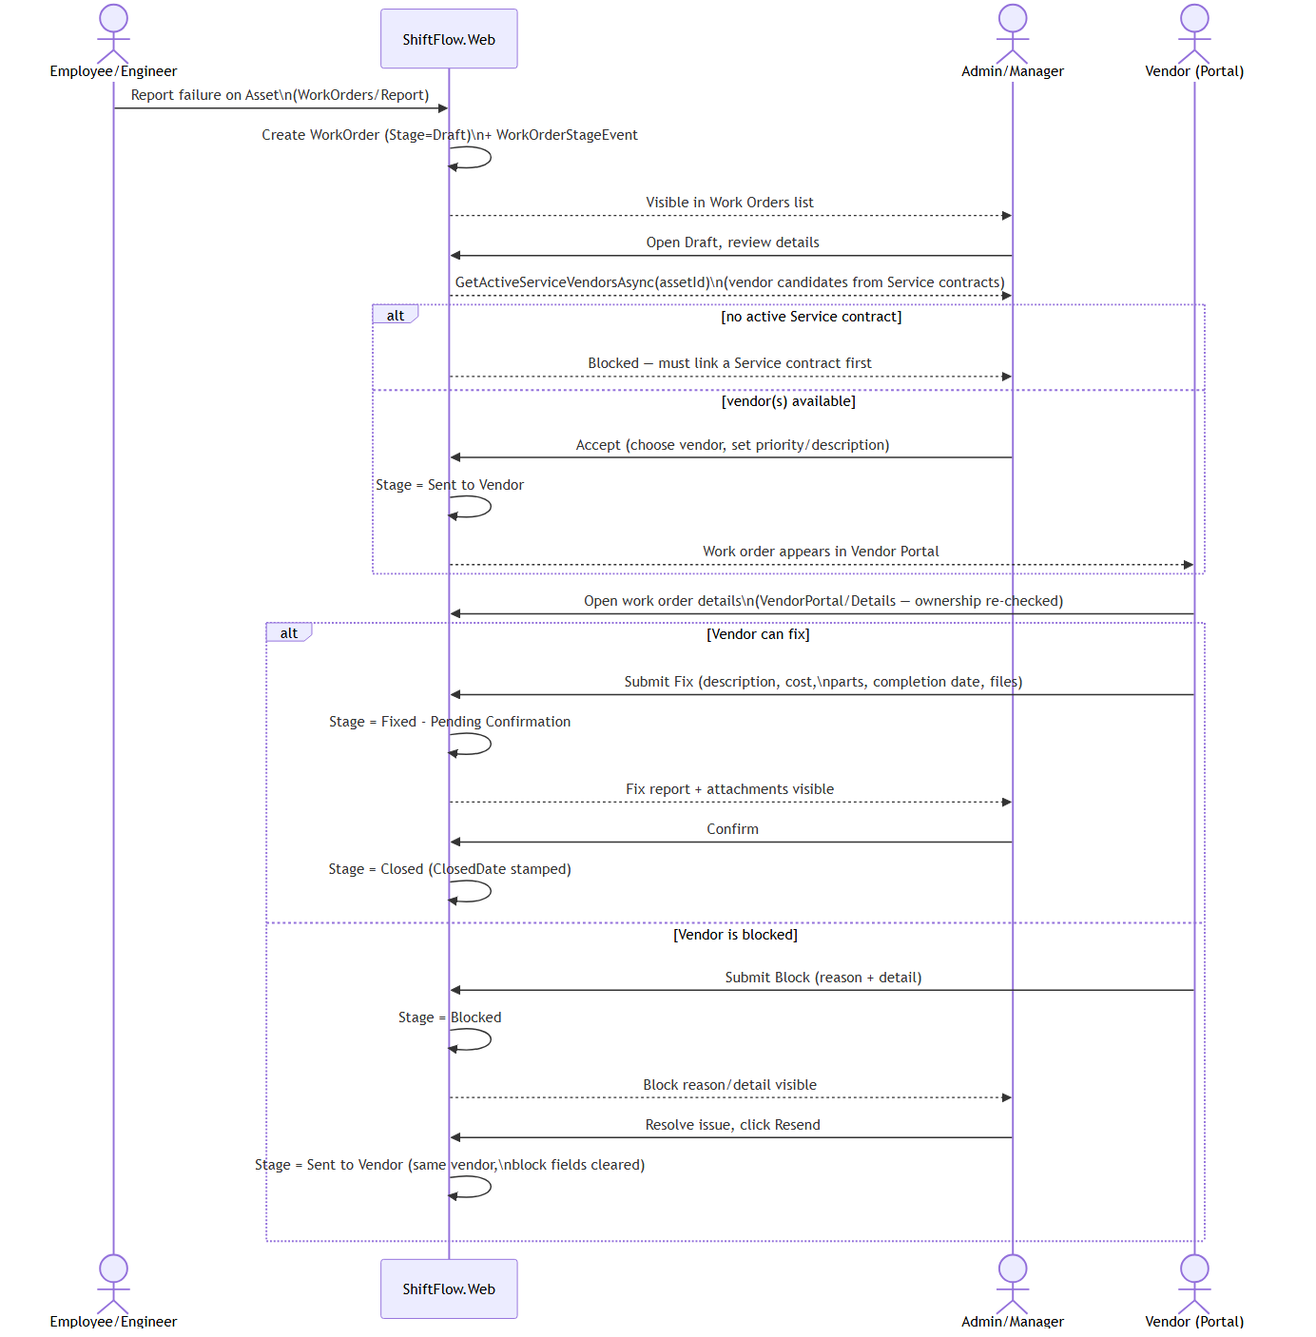
Figure 11.2 — Employee → Admin → Vendor → Admin sequence
A vendor's Fix report is structured (description, cost, completion date, a repeatable parts-used list) and supports file attachments, stored outside wwwroot and downloadable only by staff holding WorkOrder.View or the vendor that owns the work order. A vendor's Block report requires a categorized reason plus free-text detail; once the admin resolves the underlying issue, Resend returns the work order to the same vendor automatically, with the block fields cleared — full history remains visible via an immutable, append-only stage-event trail (one row per transition, recording who and when).

11.4 Block Reasons
Block reasons are an admin-managed lookup (Waiting on Parts, Access Denied, Not Covered by Contract, Needs Site Visit are seeded as starters), each independently activatable/deactivatable — deactivating a reason hides it from future selection without altering historical work orders that already used it.
Functional Requirement ID | Requirement
FR-WO-01 | The system shall resolve a work order's vendor only from the asset's active Service-type contract(s), never from a free vendor list.
FR-WO-02 | The system shall block sending a work order to a vendor when the asset has zero active Service contracts.
FR-WO-03 | A vendor Block action shall require a categorized reason and shall route back to the same vendor on Resend.
FR-WO-04 | Every stage transition shall be recorded as an immutable audit event, including who performed it and when.

12. Functional Requirements — Vendor Portal

12.1 Vendor Identity and Portal Login
A Vendor record (representing a maintenance company) can have at most one linked portal login — a regular ApplicationUser assigned the Vendor Identity role. An admin (Vendor.Manage) creates this login directly from the vendor's detail page, entering an email; the system generates a one-time temporary password shown once via a transient notice for the admin to relay to the vendor out of band (no automated email is sent for this specific credential-delivery step). Passwords can subsequently be reset the same way.

12.2 Portal Access Flow
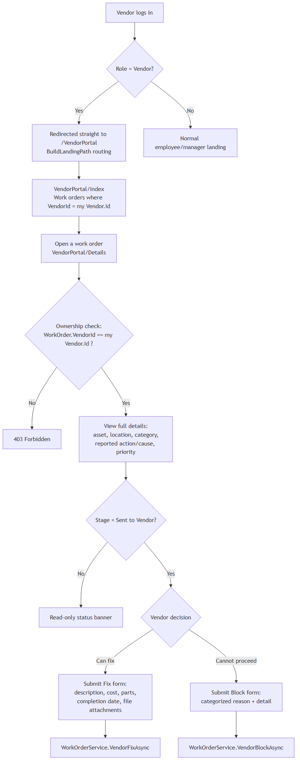
Figure 12.1 — Vendor Portal access and action flow
On login, a Vendor-role account is routed straight to the Vendor Portal rather than the normal employee/manager dashboard, and its sidebar shows only Vendor Portal navigation — the internal ShiftFlow application (scheduling, assets, administration, etc.) is entirely unreachable and invisible to a vendor login.

12.3 Security Boundary
Every Vendor Portal action re-verifies ownership in application code — the work order's VendorId must match the caller's own Vendor record — independent of and in addition to the Vendor role check. This means a vendor account can never reach another vendor's work order even by guessing or manually typing a URL: the request is rejected outright (403) rather than merely being hidden from a list.
Functional Requirement ID | Requirement
FR-VP-01 | A vendor login shall see only work orders whose VendorId matches their own Vendor record.
FR-VP-02 | Every Vendor Portal request shall re-verify ownership server-side, not rely on the UI alone to hide unrelated data.
FR-VP-03 | A Vendor-role login shall never render or reach the internal employee/manager application.

13. Functional Requirements — Contracts & Vendor Management

13.1 Vendors
Vendors are maintenance-provider companies, each with a status (Active/Suspended), contact details, specialization, and an optional linked portal login (Section 12.1). Only Active vendors are offered when creating a new contract.

13.2 Contracts
A Contract belongs to one vendor and has a type — Purchase, Warranty, Service, or Insurance — a number, start/end dates, cost, and notes, and covers a many-to-many set of assets. Only Service-type contracts are consulted when the work order workflow resolves a vendor automatically (Section 11.1); the other types exist for record-keeping (warranty coverage, purchase history, insurance) but do not drive the repair workflow.

13.3 Linked Assets: Individual Search and Category-Based Bulk Add
The contract form's Linked Assets field is a chip-based multi-select supporting two complementary ways to build the asset list: a type-ahead search by asset tag or name (one asset at a time), and a bulk “Add by Category” control — choosing a top-level category (optionally narrowed to one of its subcategories, with the subcategory control hidden entirely when the category has none) and clicking Add All immediately adds every asset currently in that category (and, for a top-level pick, its subcategories) as removable chips alongside anything already selected, with duplicates skipped automatically.
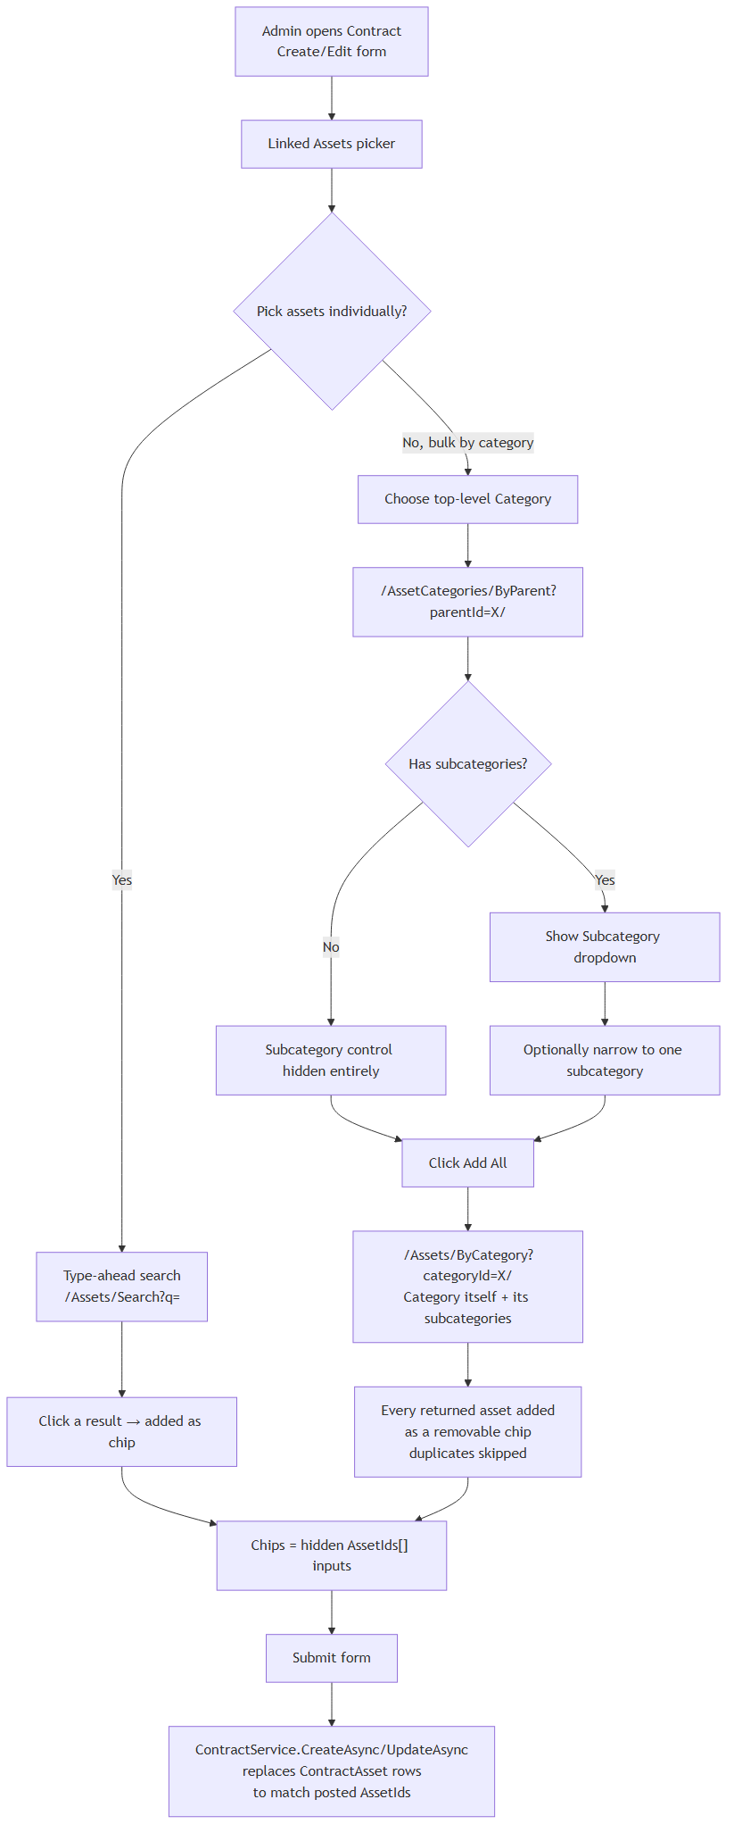
Figure 13.1 — Category-based bulk asset linking
This is a one-time snapshot, not a live link: bulk-added assets become ordinary linked-asset records that can be individually removed afterward, and assets added to the category later are only picked up by clicking Add All again.
Functional Requirement ID | Requirement
FR-CT-01 | The system shall only offer Active vendors when creating a new contract.
FR-CT-02 | The vendor-resolution logic for work orders shall consider only Contract.ContractType = Service.
FR-CT-03 | The Linked Assets picker shall support both individual search-based selection and category/subcategory bulk selection in the same control.

14. Localization

14.1 Bilingual Support
The entire user interface is available in English and Arabic. Translation is driven by a single static English-to-Arabic dictionary; a scoped language service resolves the active language from a persistent cookie and exposes simple lookup and date-token translation helpers to every Razor view. An untranslated key falls back to displaying its raw English text rather than failing, so partial translation coverage degrades gracefully instead of breaking a page.

14.2 RTL/LTR Rendering
Switching to Arabic is a genuine right-to-left layout change, not just a text swap: the page's HTML direction attribute flips, and an RTL-mirrored Bootstrap stylesheet build is loaded instead of the standard LTR build. Data-annotation validation messages are also localized through a custom string-localizer implementation backed by the same translation dictionary. Language can be switched at any time from the sidebar, redirecting back to the current page in the newly selected language.
Functional Requirement ID | Requirement
FR-LOC-01 | Every user-facing page shall render correctly in both English (LTR) and Arabic (RTL).
FR-LOC-02 | Switching language shall persist for the user's session/browser and apply immediately without requiring re-login.

15. Mobile Companion App
ShiftFlow.Mobile is a thin .NET MAUI shell application, not an independently implemented mobile client. Its interface is a single full-screen WebView loading the same ShiftFlow.Web MVC site, plus a loading indicator during initial load — there is no native business logic, local data model, or feature set beyond what ShiftFlow.Web itself renders. It inherits 100% of the web application's functionality, RBAC enforcement, and localization (including RTL/LTR, since all rendering happens server-side) automatically and without duplication.
It targets Android (always), plus iOS and Mac Catalyst on non-Windows build hosts, and Windows — a genuine single-project cross-platform MAUI build. Development builds point at the local development server using platform-appropriate loopback addressing (the Android emulator's host alias, or localhost for iOS Simulator/Windows) over plain HTTP, deliberately avoiding the self-signed development-certificate trust problem on-device; an Android network-security configuration explicitly whitelists cleartext traffic only to those specific development addresses. Release builds always point at a fixed production HTTPS URL.
Functional Requirement ID | Requirement
FR-MOB-01 | The mobile app shall present the full ShiftFlow.Web application inside a native WebView shell, with no divergent feature set.
FR-MOB-02 | Release builds shall only ever load the application over HTTPS from the configured production URL.

16. Data Model

16.1 Asset, Vendor, Contract & Work Order Domain
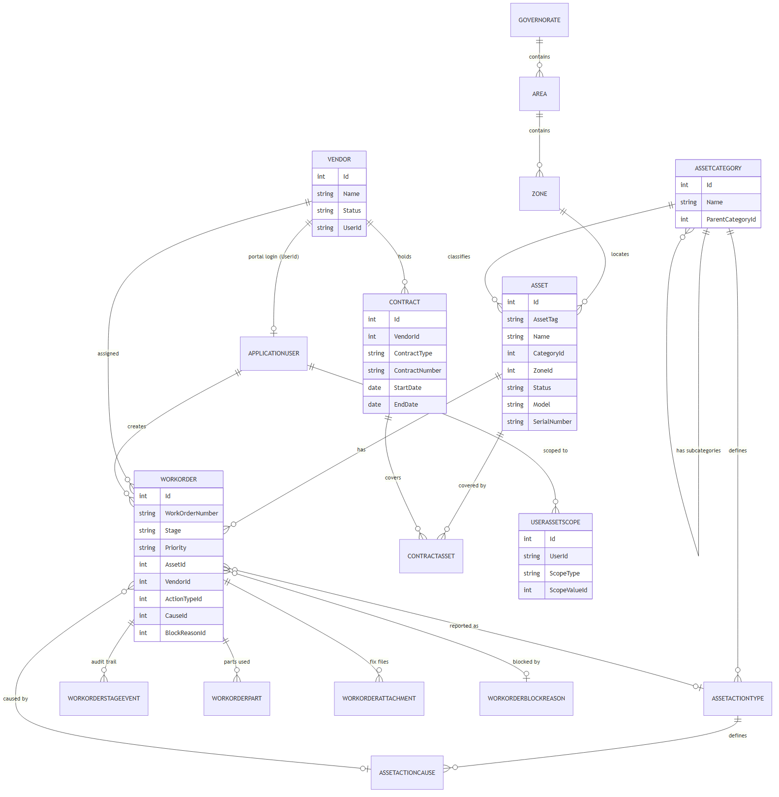
Figure 16.1 — Asset Management / Work Order entity-relationship diagram

16.2 Scheduling & Operations Domain
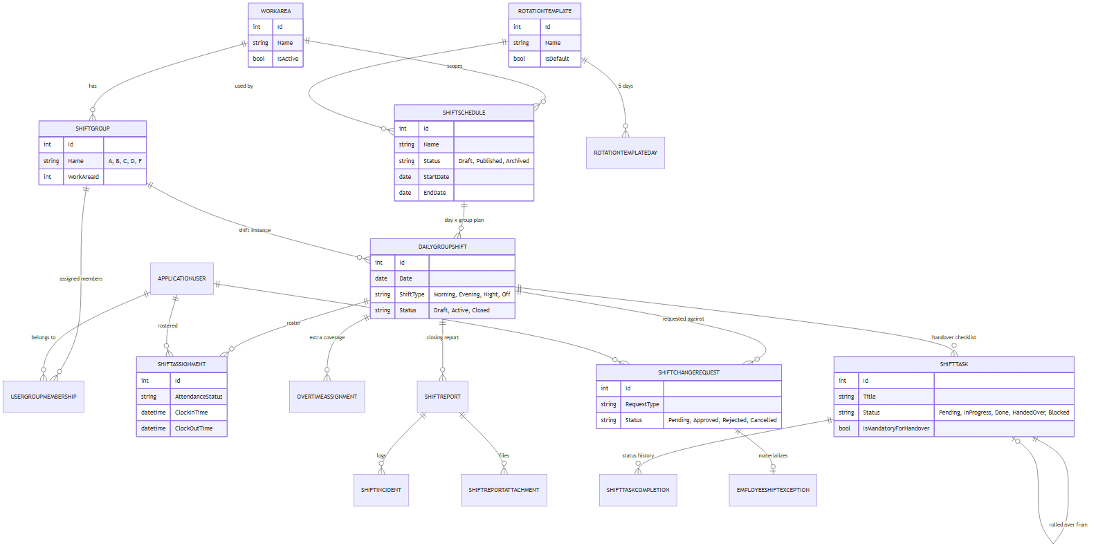
Figure 16.2 — Shift Scheduling / Operations entity-relationship diagram

16.3 Entity Inventory
The application defines 34 explicit entity tables (beyond the 7 standard ASP.NET Core Identity tables), grouped as follows:
Group | Entities
Core / Audit | Location, AuditLog
Scheduling Infrastructure | RotationTemplate, RotationTemplateDay, ShiftGroup, UserGroupMembership, ShiftSchedule, DailyGroupShift, ShiftAssignment, OvertimeAssignment, ShiftOverride
Change Requests | ShiftChangeRequest, EmployeeShiftException
Shift Operations | ShiftTask, ShiftTaskCompletion, ShiftReport, ShiftReportAttachment, ShiftIncident
Work Areas | WorkArea
RBAC | Permission, RolePermission, UserPermission
Asset Management | AssetCategory, Governorate, Area, Zone, Asset, Vendor, WorkOrder, WorkOrderStageEvent, Contract, ContractAsset, UserAssetScope, AssetActionType, AssetActionCause, WorkOrderPart, WorkOrderBlockReason, WorkOrderAttachment
Identity (inherited) | ApplicationUser, IdentityRole, and the standard Identity join/claims/login/token tables

17. External Interface Requirements

17.1 User Interfaces
- Server-rendered Razor Views styled with Bootstrap 5.3 (standard and RTL builds) and Bootstrap Icons
- A collapsible sidebar with two structurally different navigation templates — a manager template (Overview / Operations / Administration / AI Assistant) and a personal template (My Home / My Tasks / Requests / Scheduling / etc.) — selected per user based on whether they hold the ShiftAnalytics.View permission, plus a fully separate vendor-only sidebar for Vendor-role logins
- Reusable interactive components: a debounced AJAX employee search/typeahead picker, a chip-based multi-asset picker (with category-based bulk add), cascading category/subcategory and location dropdowns, and status badges with consistent color coding
- Exported document interfaces: styled Excel workbooks (EPPlus) and branded PDF documents (iText7) for schedules, task lists, and work order/asset lists

17.2 Internal JSON API Endpoints
A number of lightweight, authenticated JSON endpoints back the interactive picker widgets. These are internal to the application (consumed only by its own JavaScript, not a published public API), but are listed here for completeness:
Endpoint | Purpose
GET /api/users/search | Typeahead employee search (by name/email/employee number), with optional role/work-area/shift-date filters; unconditionally excludes Vendor-role accounts, since this endpoint backs employee-facing pickers only.
GET /Assets/Search | Typeahead asset search by tag or name, for the contract asset picker.
GET /Assets/ByCategory | Returns every asset in a category (and its subcategories, for a top-level pick) — powers the category bulk-add control.
GET /AssetCategories/ByParent | Returns the subcategories of a given top-level category — powers cascading category/subcategory dropdowns.
GET /AssetActionTypes/ByCategory | Returns the action types available for a category, including inherited parent-category action types for a subcategory.
GET /WorkOrders/DownloadAttachment | Authenticated, ownership-checked download of a work order fix-report attachment (staff with WorkOrder.View, or the owning vendor, only).

17.3 External Service Interfaces
Interface | Purpose | Configuration
Microsoft Entra ID (OpenID Connect) | Federated “Sign in with Microsoft” login | AzureAd: Instance, TenantId, ClientId, ClientSecret, CallbackPath — feature fully disabled unless ClientId and TenantId are both set
Microsoft Graph (app-only) | Search and import users from the organization's Entra directory | Uses the same AzureAd app registration
SMTP | Transactional email (credential delivery) | Smtp: Host, Port, EnableSsl, User, Password, From
Twilio WhatsApp | Transactional WhatsApp messages (credential delivery) | Twilio: AccountSid, AuthToken, WhatsAppFrom
OpenAI / Azure OpenAI | AI Assistant chat completions | OpenAI: ApiKey, Model — or AzureOpenAI: Endpoint, ApiKey, DeploymentName as fallback
Azure Cognitive Services Speech | AI Assistant voice input/output and talking-avatar video session | AzureSpeech: Key, Region

18. Non-Functional Requirements

18.1 Security
- All authentication is handled by ASP.NET Core Identity with lockout-on-failure (5 attempts / 5-minute lockout) and an 8-hour sliding, HttpOnly authentication cookie
- Every sensitive controller action is gated by an explicit permission policy, evaluated server-side on every request (never trusting client-side UI hiding alone)
- File uploads are validated by extension allowlist and magic-byte signature check, and stored outside the web root so they cannot be reached via the static-file pipeline — only through an authenticated, ownership-checked download action
- A hand-written Content-Security-Policy, X-Content-Type-Options, X-Frame-Options: DENY, Referrer-Policy, and Permissions-Policy are applied to every response
- The Vendor Portal re-verifies work-order ownership on every request server-side, independent of role membership, preventing cross-vendor data access even via a guessed URL
- The Kestrel Server response header is suppressed and IIS's automatic authentication is disabled to reduce information disclosure and prevent host-level auth context leakage
- An explicit prompt-injection guardrail instructs the AI Assistant to treat all tool-returned free text as data, never as instructions

18.2 Performance
- Effective user permissions are cached in memory for 5 minutes (sliding), explicitly invalidated on any permission-affecting write, to avoid recomputing role/override joins on every authorized request
- Dashboard KPIs are cached for 2 minutes, keyed by role
- List/report queries resolve roles and work areas in bulk (single query per page load) rather than per-row, avoiding N+1 query patterns
- Detail tables in self-service metrics views are explicitly capped (e.g. 500 rows) to bound response size and rendering time

18.3 Usability
- A single reusable typeahead picker component is used everywhere a user needs to be selected, replacing plain dropdowns with search-as-you-type for scalability beyond a handful of options
- Consistent status-badge color coding is applied across every module (shift, task, incident, change-request, work-order, contract statuses)
- The sidebar navigation structure adapts to the signed-in user's role and permissions, so a user only ever sees links they can actually use

18.4 Reliability and Auditability
- Every work order stage transition is recorded as an immutable, timestamped, attributed audit event — never overwritten or deleted
- Every shift task status change is recorded to a completion-history table, including automatic handover transitions
- A general-purpose audit log records create/update actions across users, roles, contracts, work orders, and other sensitive entities, including a distinct tag for actions taken via the AI Assistant versus the ordinary web UI
- Data-consistency self-repair runs automatically at application startup for a known class of schedule/work-area mismatch

18.5 Maintainability
- A single, centralized permission catalog and evaluation service is the sole authority for access decisions, avoiding scattered, inconsistent authorization checks
- The permission catalog is self-curating at boot — legacy/renamed permissions are automatically retired from role grants, user overrides, and the catalog itself
- Reusable UI partials (employee picker, asset multi-picker, status badge) are shared across every module that needs the same interaction pattern, rather than being reimplemented per screen

18.6 Localization and Accessibility
- Every screen supports both English and Arabic with genuine RTL layout mirroring, not just a text swap
- Untranslated strings degrade gracefully to their English key rather than breaking the page
- Data-annotation validation messages are localized through the same translation mechanism as the rest of the UI

Appendix A — Permission Catalog
The complete set of 45 permissions, exactly as seeded, grouped by category.

Users
Permission | Description
User.View | See the list of user accounts, their roles, and profile details
User.Manage | Create new users, edit their details, assign roles, and deactivate or delete accounts

Rotation Templates
Permission | Description
Schedule.Template.View | See the shift rotation patterns used to auto-generate schedules
Schedule.Template.Manage | Create and edit the rotation patterns used to auto-generate schedules

Scheduling
Permission | Description
Schedule.View | See published and draft shift schedules
Schedule.Create | Start a new shift schedule for a work area
Schedule.Generate | Auto-fill a draft schedule's shifts from its rotation template
Schedule.Publish | Make a draft schedule live so employees can see their shifts
Schedule.Archive | Move a published schedule to the archive once it's no longer active
Schedule.Override.Apply | Manually move an employee onto a different shift, overriding the normal rotation
Schedule.Delete | Permanently remove a shift schedule
Group.Member.Manage | Add or remove employees from shift groups

Change Requests
Permission | Description
ChangeRequest.Submit | Request a shift swap, absence, or other change to your own schedule
ChangeRequest.Review | Approve or reject change requests submitted by employees
ChangeRequest.View.All | See every change request across the organization, not just your own work area

Shift Operations
Permission | Description
ShiftOps.View | Open the live shift view for shifts you're scheduled on or your work area
ShiftOps.Activate | Start a shift, marking it as in progress
ShiftOps.Attendance.Update | Mark employees present, late, absent, or excused on a shift
ShiftOps.Task.Add | Create tasks for a shift's handover checklist
ShiftOps.Task.Delete | Remove a task from a shift's handover checklist
ShiftOps.Task.UpdateStatus | Mark shift tasks as in progress, done, or blocked
ShiftOps.Close | End a shift and hand over any open tasks
ShiftOps.Incident.Add | Record a safety or operational incident during a shift
ShiftOps.Report.View | Read shift handover reports
ShiftOps.ManageAll | See and manage shifts across every work area, not just your own group
ShiftOps.Report.ManageAll | See and manage every shift report, not just ones you're assigned to

Reports & Analytics
Permission | Description
ShiftAnalytics.View | See the task-completion and performance analytics dashboard

Locations
Permission | Description
Location.Manage | Add, edit, or remove physical site locations

AI Assistant
Permission | Description
AiAssistant.Use | Access the AI assistant for shift-related questions and actions

Administration
Permission | Description
AuditLog.View | See the history of who changed what across the system
Rbac.Manage | Create roles, assign permissions, and control what each user or role can access
System.IsAdmin | Grants every permission in the system, overriding all other settings — use with caution

Asset Management
Permission | Description
Asset.View | See the asset register — tags, categories, locations, and status
Asset.Manage | Add, edit, or retire assets in the register
AssetCategory.Manage | Create and edit asset categories
Vendor.View | See the list of maintenance vendors
Vendor.Manage | Add, edit, or suspend maintenance vendors
WorkOrder.View | See maintenance work orders and their status
WorkOrder.Manage | Create work orders and advance them through their stages
WorkOrder.Assign | Assign a vendor to a work order
WorkOrder.Export | Export asset and work order lists to Excel or PDF
Contract.View | See vendor contracts and which assets they cover
Contract.Manage | Create and edit vendor contracts and link them to assets
Asset.ReportAction | Report a failure or other action on an asset, creating a draft work order for admin review
Asset.ScopeManage | Restrict which zone, area, or category of assets a specific employee can see

Appendix B — Role → Permission Matrix
As seeded exactly. A blank cell means the permission is not granted at the role level. The Vendor role holds no rows in this matrix — it is governed entirely by the separate Vendor Portal ownership check (Section 12.3), not the permission catalog. System.IsAdmin is never granted to any role by default — it is only ever assigned manually, via the RBAC admin UI or a per-user override.
Permission | Admin | ShiftMgr | Supervisor | Sec. Head | Sr. Eng. | Engineer | Op. Eng. | Technician | HR
User.Manage | Y
User.View | Y | Y
Schedule.Template.View | Y | Y
Schedule.Template.Manage | Y
Schedule.View | Y | Y | Y | Y |  |  |  |  | Y
Schedule.Create | Y | Y
Schedule.Generate | Y | Y
Schedule.Publish | Y | Y
Schedule.Archive | Y
Schedule.Override.Apply | Y | Y
Schedule.Delete | Y
Group.Member.Manage | Y | Y
ChangeRequest.Submit | Y |  |  |  | Y | Y | Y | Y
ChangeRequest.Review | Y | Y | Y | Y
ChangeRequest.View.All | Y | Y | Y | Y
ShiftOps.View | Y | Y | Y | Y | Y | Y | Y | Y
ShiftOps.Activate | Y | Y
ShiftOps.Attendance.Update | Y | Y | Y
ShiftOps.Task.Add | Y | Y | Y
ShiftOps.Task.Delete | Y | Y | Y
ShiftOps.Task.UpdateStatus | Y | Y | Y |  | Y | Y | Y | Y
ShiftOps.Close | Y | Y
ShiftOps.Incident.Add | Y | Y | Y |  | Y
ShiftOps.Report.View | Y | Y | Y | Y
ShiftOps.ManageAll | Y | Y
ShiftOps.Report.ManageAll | Y | Y
ShiftAnalytics.View | Y | Y
Location.Manage | Y
AiAssistant.Use | Y | Y
AuditLog.View | Y
Rbac.Manage | Y
Asset.View | Y | Y | Y | Y | Y | Y | Y | Y | Y
Asset.Manage | Y | Y | Y
AssetCategory.Manage | Y
Asset.ScopeManage | Y | Y | Y
Vendor.View | Y | Y | Y | Y
Vendor.Manage | Y | Y
WorkOrder.View | Y | Y | Y | Y | Y | Y | Y | Y
WorkOrder.Manage | Y | Y | Y |  | Y | Y | Y | Y
WorkOrder.Assign | Y | Y | Y
WorkOrder.Export | Y | Y | Y
Contract.View | Y | Y | Y
Contract.Manage | Y | Y

Appendix C — Status / Enum Reference
Entity.Field | Values
ShiftSchedule.Status | Draft, Published, Archived
DailyGroupShift.Status | Draft, Active, Closed
DailyGroupShift.ShiftType | Morning, Evening, Night, Off
ShiftAssignment.AttendanceStatus | Scheduled, Present, Late, Absent, Excused, OnLeave, Replaced
OvertimeAssignment.AttendanceStatus | Scheduled, Present, Late, Absent, Excused
ShiftTask.Status | Pending, InProgress, Done, HandedOver, Blocked
ShiftIncident.Severity | Low, Medium, High, Critical
ShiftIncident.Status | Open, UnderInvestigation, Resolved, Closed
ShiftChangeRequest.RequestType | Absence, Swap, Replacement, Overtime, TempGroupChange, PermanentGroupChange
ShiftChangeRequest.Status | Pending, Approved, Rejected, Cancelled
Asset.Status | Working, Defective, Maintenance, Retired
Vendor.Status | Active, Suspended
Contract.ContractType | Purchase, Warranty, Service, Insurance
WorkOrder.Priority | Low, Medium, High, Critical
WorkOrder.Stage | Draft, Rejected, New, Sent to Vendor, Blocked, Fixed - Pending Confirmation, Closed

Appendix D — Glossary
Term | Meaning
Draft (schedule) | A schedule that exists but is not yet visible to ordinary employees.
Published (schedule) | A schedule visible to all affected employees; the live, current plan.
Archived (schedule) | A retired schedule, no longer editable or regenerable.
Handed Over (task) | A task rolled forward from a closing shift onto the next shift because it wasn't finished.
Draft (work order) | An employee-reported failure, awaiting admin accept/reject.
Sent to Vendor | A work order actively assigned to and awaiting response from a maintenance vendor.
Blocked (work order) | A work order the vendor cannot currently proceed with, pending admin resolution.
Service contract | The only contract type consulted for automatic work-order vendor resolution.
Effective permission set | The final list of permissions a user actually holds, after applying role grants and Deny/Allow overrides.
System.IsAdmin | A super-permission that implicitly grants the entire permission catalog to whoever holds it.

