Summations and Expansions
$$\sum_{k=1}^{n}{k= \frac{1}{2}} n(n+1)$$ |  |  | $$\sum_{k=1}^{n}{k^{4}= \frac{1}{30}} n(n+1)(2n+1)(3n^{2}+3n-1)$$
$$\sum_{k=1}^{n}{k^{2}= \frac{1}{6}} n(n+1)(2n+1)$$ |  |  | $$\sum_{k=1}^{n}{k^{5}= \frac{1}{12}} n^{2} {\left(n+1\right)}^{2}(2n^{2}+2n-1)$$
$$\sum_{k=1}^{n}{k^{3}= \frac{1}{4}} n^{2} {(n+1)}^{2}$$ |  |  | $$\sum_{k=1}^{n}{k^{6}= \frac{1}{42}} n(n+1)(2n+1)(3n^{4}+6n^{3}-3n+1)$$
$$\sum_{k=0}^{n}{C^{k}=\frac{C^{n+1}-1}{C-1}} ∀C∈(1,∞]$$ |  |  | $${\left(x+y\right)}^{n}=\sum_{i=0}^{n}{\left({n \atop i}\right)x^{n-i}y^{i}}$$
Arithmetic Sequence
$n_{th}$ term |  |  | $$a_{n}=a+\left(n-1\right)×d$$
Sum of the first$n$terms |  |  | $$S_{n}=\frac{n}{2} ( 2a+\left(n-1\right)×d )$$
Geometric Sequence
$n_{th}$ term |  |  | $$a_{n}=ar^{n-1}$$
Sum of the first $n_{th}$ terms |  |  | $$S_{n}=\frac{a\left(1-r^{n}\right)}{(1-r )}$$
Sum of the terms infinitely |  |  | $$S_{n}=\frac{a}{(1-r )} ∀ \left|r\right|<1$$
Harmonic Sequence
$n_{th}$ term |  |  | $$a_{n}=\frac{1}{a+\left(n-1\right)×d}$$
Sum of the first $n_{th}$ terms |  |  | $$S_{n}=\frac{1}{d}ln(\frac{2a+\left(2n-1\right)×d}{2a-d})$$
Trig. Identities
$$sin\left(A± B\right)= sin\left(A\right)cos\left(B\right)± cos(A) sin(B)$$ |  |  | $$sin\left(2A\right)= 2sin\left(A\right) cos(A)$$
$$cos\left(A± B\right)= cos\left(A\right) cos\left(B\right)∓\sin\left(A\right)\sin\left(B\right)$$ |  |  | $$cos\left(2A\right)= \cos^{2}\left(A\right)-\sin^{2}{(A)}$$
$$\tan\left(a±b\right)=\frac{\tan\left(a\right)±tan⁡(b)}{1+\tan\left(a\right) tan⁡(b)}$$ |  |  | $$tan\left(2A\right)= \frac{2 tan\left(A\right)}{(1 -\tan^{2}{(A) })}$$
Misc. Formulas
Law of sines | $$\frac{a}{sin\left(A\right)}=\frac{b}{sin\left(B\right)}=\frac{c}{sin\left(C\right)}=2r$$ |  | 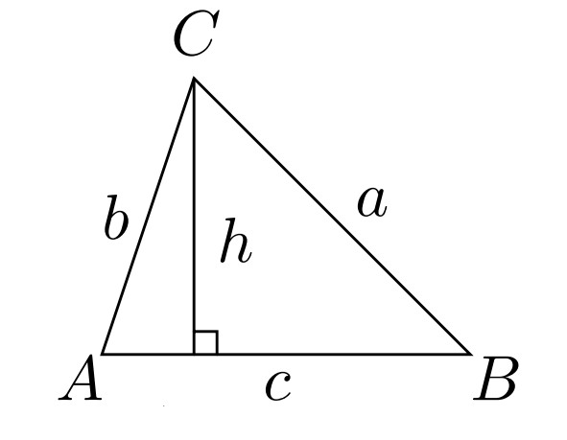
Law of cosines | $$c^{2}=a^{2}+b^{2}-2abcos\left(C\right)$$
Major diagonal in a reg. polygon |  |  | $$L×sin⁡(\frac{\left\lfloor \frac{n}{2}\right\rfloor ×π}{n})$$
Area from medians |  |  | $$\frac{4}{3} \sqrt{sm(sm-ma)(sm-mb)(sm-mc)}$$
$$dot\left(a,b\right)$$ |  |  | $$\left\|a\right\| \left\|b\right\| cos⁡(θ)$$
$$cross\left(a,b\right)$$ |  |  | $$\left\|a\right\| \left\|b\right\| sin⁡(θ)$$
Lattice points between two points |  |  | $$\gcd\left(\left|∆x\right|,\left|∆y\right|\right)+1$$
Polygon area |  |  | $$\frac{1}{2} \left|\sum_{i=1}^{n}{cross(p_{i}, p_{\left(i+1\right)\%n})}\right|$$
Polygon area (Pick’s Theorem) |  |  | $$Interior Pts.+\left(\frac{Boundary Pts.}{2}\right)-1$$
Regular polygon area |  |  | $\frac{1}{2}nr^{2}\sin\left(\frac{2π}{n}\right)$ ; r = radius circumcircle
 |  |  | $$\frac{nL^{2}}{4\tan\left(\frac{π}{n}\right)}$$
Regular polygon angle |  |  | $$\frac{\left(n-2\right)×180}{n}$$
Circular sector area |  | $$\frac{1}{2} r^{2}×α$$ | 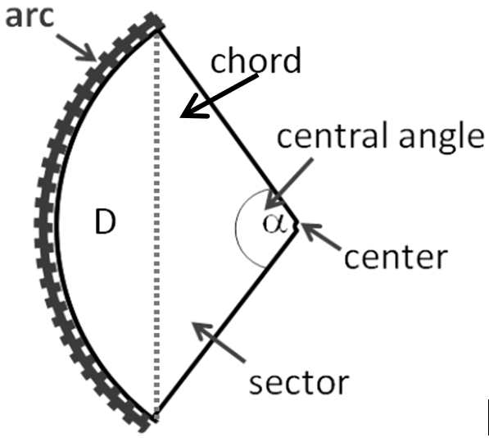
 |  | $$πr^{2}×\frac{α}{360}$$
D shape area |  | $$\frac{1}{2}r^{2}(α-sin\left(α\right))$$
Chord length |  | $$2 πr×sin⁡(\frac{α}{2})$$
Arc length |  | $$2πr×\frac{α}{360}$$
Spanning trees complete bipartite graph $K_{nm}$ |  |  | $$m^{n-1}×n^{m-1}$$
Cyclic quad. area |  |  | $$\sqrt{\left(s-a\right)(s-b)(s-c)(s-d)} ;s=\frac{a+b+c+d}{2}$$
Radius of circle inscribed in a triangle |  |  | $$\frac{2×Area}{perimeter}$$
Spanning trees in complete graph |  |  | $$n^{n-2}$$
Euler’s formula for planar graphs |  |  | $$Vertices-Edges+Faces=2$$
Derangements* |  |  | $$der\left(n\right)=\left(n-1\right)×(der\left(n-1\right)+der\left(n-2\right))$$
Distinct binary trees with n nodes |  |  | $$Cat\left(n\right)=\frac{C(2n,n)}{n+1}$$
Balanced expressions of $n$ pair of parentheses
Ways $n+1$factors can be parenthesized*
Triangulation of $n+2$ convex polygon
Monotonic paths along edges in $n×n$ grid
Triangulation of a Convex Polygon |  |  | Monotonic Paths
*Derangements: permutations of length n with no value positioned correctly
*n = 3, factors = {a,b,c,d} , we have (ab)(cd),a(b(cd)),((ab)c)d,(a(bc))(d),a((bc)d)

